ST. MICHAEL ROMAN CATHOLIC CHURCH

751 Locust Street

PO Box 103

St. Michael, Pennsylvania 15951

Rev. Msgr. David A. Lockard, Administrator MASSES:

(814) 495-9640 Saturday 4:00 pm



Sunday Morning 8:00 am

Secretary & Bookkeeper: 10:30 am

Michele Panick Daily Mass: M,T,W,Th,F Noon

DRE: Laurie Sloan Holy Days: See Bulletin

Maintenance: Rodney Turgeon Office Hours:

PHONES: 8:30 am to 3:30 pm

Rectory / Office: (814) 495-9640 Monday, Tues., Thurs., Friday

Fax: (814) 495-9424 Confessions:

Rel. Education: (814) 495-4873 Saturday 3:30 pm to 3:45 pm

Parish Website Sunday 10:00 am to 10:15 am

[www.saintmichaelchurch.weebly.co](http://www.saintmichaelchurch.weebly.co)m By Appointment

Secretaries’ E-mail

[saintmichaelsecretaries@yahoo.com](mailto:saintmichaelsecretaries@yahoo.com)

Facebook page:

St. Michael Catholic Church/St. Michael, PA

The Baptism of the Lord

SERVING GOD AND COMMUNITY FOR OVER ONE HUNDRED YEARS!

January 10th, 2021

BAPTISM: By Appointment. Reserve at least one month in advance.

MARRIAGE: Plan at least nine months in advance.

Preparation sessions are necessary.

FUNERALS: Arrangements are made in conjunction with the funeral home.

REGISTRATION Those new to the area, newlyweds, and single adults, (even if registered

and before with their families) are asked to register by calling the Parish Office.

MEMBERSHIP: Every parishioner must be registered. This is a condition for admission

to our Program and reception of the Sacraments of Baptism, Confirmation,

First Penance, First Eucharist, and Matrimony; also, for testimonial letters or sponsorship of Baptism and Confirmation outside the Parish.

VISITATION: We are concerned and want to be advised when someone is ill at home or in the hospital. Call the office to have the shut-in placed on our monthly Holy Communion calls or seriously ill prayer list.

SACRAMENTAL Parish registration and active Mass participation for Baptism is

POLICY: encouraged and is required for Marriage.

BULLETIN ARTICLES: Articles are due to the Parish Office by Noon on Tuesday.



The Baptism of the Lord

January 10th, 2021

Month of The Holy Name of Jesus

**MASS INTENTIONS**: (January 11, – January 17, 2021)

Monday, Jan. 11 Noon John Vandzura req. by Mary Beth Semyan

Tuesday, Jan. 12 Noon For the Family of Vada Sloan req. by St. Michael Church Staff

Wednesday, Jan. 13 Noon Albert & Clara Long req. by Carl & Pam Freidhoff

Thursday, Jan. 14 Noon Anna Podrebarac req. by Mr. & Mrs. James Susko

Friday, Jan. 15 Noon Robert & Hermine Sivec req. by Family

Saturday, Jan. 16 4:00 PM People of the Parish

Sunday, Jan. 17 8:00 AM Joey Lucas req. by Mr. & Mrs. Ron Fornadel

10:30 AM Florence & Charles Smith req. by Nancy Broad

LITURGICIAL APPOINTMENTS:

Saturday, January 16 4:00 PM

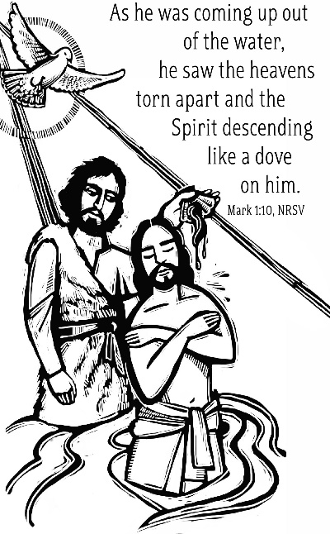Lector: Sherry Dipko

Minister of the Host: Babe Richards

Altar Server: Ana Spangler

Cantor: Amy Spangler

Sunday, January 17 8:00 AM

Lector: Cathy Faher

Minister of the Host: Eric Tedjeske

Altar Server: Michael Kresic

Cantor: Susan Yanzetich

Sunday, January 17 10:30 AM

Lector: Mike Barton

Minister of the Host: Amanda Williamson

Altar Server: Jackson Henderson

Cantor: Elizabeth Dobbins

Sunday, January 17 Collection Counters

Chris Smay & Sara Zybura

Mary Ann DeRosa

Weare placing names of the sick in the bulletin for prayer providing they give permission. *May the* *Divine Physician send healing grace for those for* *whom we pray:* Allen C. Rosemas, Patricia Murphy, Bernice Myers, Dwight Fyock, Dylon Wills, Missy, Joanne (Kolar) Hufford, Christine Flanagan, Ayden Alan Grata, Mary Lou Offman, Mary Zangaglia, Natalie Zerby, Valencia Tursi, Homer Locher, Brayden Schofield, Michelle Kasper, Diane Kingera, Ted Paluch, Pearl Litzinger, Patrick Munro, Fran Baldassarre, Kristen Sinosky Long, Cresta Micik, Basil Costantino, Laura, Joe Yoder, Dolores Yanzetich, Sandy Krug, Wanda Gramling, Jennifer Hagans, Shawn, Holly, Shane, Spencer, Owen Taylor, Derrick Varnish, Vincent Koshute, Michelle Elliott, Heather Romanow, Mackston Barrick, Connor Thomas, Erin, Pat, Mary Agnes Nastase, Mary Ann Bertolino, Dick Wilson, Izzy Bihun, Dorothy Kaminsky, Patricia Oshaben, Ashlee Madison, Susan Yanzetich, Mike, Alina Rusnak, Gary Smay, Elizabeth Howell, Walter Bodziak, Rhonda, Dan Strinkoski, Anne Robinson, Carter Bobak, Vince Arena, Mike Morris, Sarah Kelt, Patty Yanzetich Caldwell, Colton Snyder, Nancy Edmiston, Leonard Oshaben, Adam, Bill Gideos, Janice Dipyatic, Lily Maloney, Scott, Lisa, Audrey Costlow, Cathy Sossong, Rosanne Krug, Becky Kakabar, Catherine Tedjeske, Howard Delaney, Ed Myers, Dolores Mucko, Elliana, Ashlee, Helen Soohy, Carol K. Fabrizio, Peggy Carpenter, Sharon Vance, Janet Minor, Dave Seder and all of the sick of our parish, the homebound, those in nursing homes, those who care for them, and those in the military along with their families. *(Please call the Rectory to have your name removed from the list when no longer seriously ill. Thank You.)*

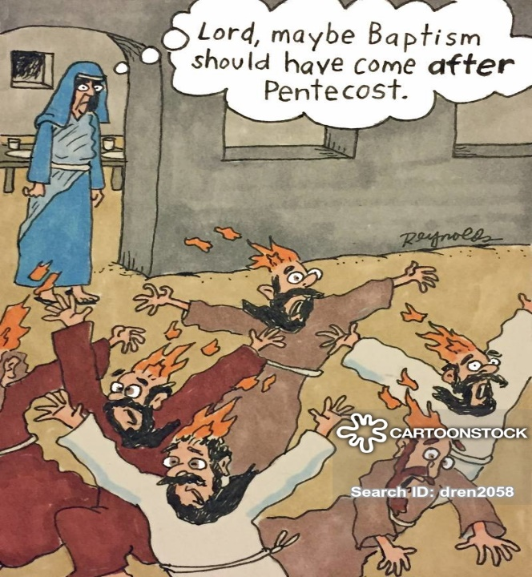

LAST WEEK’S COLLECTION

Adults $1,737.00

Loose $ 72.00

Youth $ 17.50

Monthly $1,300.00

Initial Offering $ 215.00

Candles $ 19.00

Maintenance Fund $ 20.00

Solemnity of Mary $ 751.00

Christmas Offering $ 985.00

Christmas Flowers $ 10.00

Total $5,126.50

We sincerely thank and ask

God’s blessing upon all who

have care and concern for

our parish.

*The Baptism of the Lord Mark 1:7-11*

*The gospel today points to Jesus’ humanity; like us He needed RECOGNITION (“You are my Son”), AFFECTION (“My Beloved Son”) and AFFIRMATION (“With you I am well pleased.”). In our families it is easy to focus on irritating behaviors and take for granted all the positives. This New Year take a lesson from God the Father, be an AFFIRMER and not a BLAMER.*

[](https://images.search.yahoo.com/search/images;_ylt=A0LEV1kSWptXvOwAKINXNyoA;_ylu=X3oDMTEyZGdkcmRoBGNvbG8DYmYxBHBvcwMxBHZ0aWQDQjIwODlfMQRzZWMDc2M-?p=Clipart+of+a+sanctuary+candle&fr=ush-mailn_02&th=110&tw=110&imgurl=http://www.henningers.com/389-168-wall-sanctuary-lamp.jpg&rurl=http://pixshark.com/sanctuary-lamp.htm&size=43KB&name=Sanctuary+Lamp+Bronze+wall+sanctuary+lamp&h=600&w=600&turl=http://ts2.mm.bing.net/th?id%3DOIP.M68453c67108cdc5ab485d309b395bd03o0%26pid%3D15.1%26rs%3D1%26c%3D1%26qlt%3D95%26w%3D110%26h%3D110#inline&tt=Sanctuary+Lamp+Bronze+wall+sanctuary+lamp&sigr=116keh5le&sigit=13gvlt42j&sigi=11ip0pgm4&sign=119kp6100&sigt=119kp6100)

During the week of January 10th, 2021

The Sanctuary Candle will burn for

all people suffering with the COVID-19 Virus

SECOND SUNDAY FOOD PANTRY COLLECTION ~ This weekend is our Second Sunday Food Collection. Please bring in non-perishable food items or toiletries with you. Monetary donations are also appreciated.

COLLECTION ENVELOPES ~ Some people may not have gotten their January/February set of Collection Envelopes. You can still donate to the collection basket. Just write your name, amount of donation, what the donation is for (weekly adult, youth donation, monthly etc..) and your envelope number if you know it on a regular white envelope and put it in the collection basket. Thank-you.

PARISH OFFICES CLOSED ~ Parish Offices will be closed on Monday, January 18th due to the Martin Luther King Jr. Holiday. The Offices will reopen on Tuesday, January 19th at 8:00 AM.

[](http://www.churchart.com/search/ImageDetail.asp?image_id=93074236)CONTRIBUTION STATEMENTS ~The Parish Office has closed the books for 2020 parishioner’s contributions. You may request a statement of your tax-deductible donations at any time by calling the rectory at 495-9640. If a contribution was made to the CMD, you should have received a statement from the diocese. We are updating our parish records, so please remember to notify the Rectory Office of any changes in address or telephone numbers. If you no longer have a land line and your cellphone is your primary house phone, please call us or drop a note in the collection basket.

VIRTUS AWARENESS ARTICLE ~ As a reminder, each month there will be one education article provided by VIRTUS covering topics of interest to create awareness on trending topics. January is known as Human Traffickin gAwareness Month and the featured article is *‘Human Trafficking and Modern Technolosgy: What we can do about it’* by Judith Paparozzi, JD, M.Ed. As a community of faith, we are called to provide prevention efforts supporting safe environments within our parishes and tools for our families. Anyone wanting a copy of this article, can find it at the entrances of the Church and in the green tote box outside the parish Office door.

*Stewardship Reflections…*

Today we celebrate the Baptism of the Lord. The U.S. bishops’ stewardship pastoral letter reminds us about “a fundamental obligation arising from the sacrament of baptism: that the people place their gifts, their resources, and themselves at God’s service in and through the Church…by proclaiming and teaching, serving and sanctifying.” *(Stewardship: A Disciple’s Response,* USCCB, 1992*)*.

Can you say that you are fulfilling the obligation to be a servant king in your baptismal role as Jesus did?



Religious Education And Christian Helping

January 10, 2021

Religious Education News

Home Lesson Packets ~ Distribution of CCD Lesson Packet #4 will take place in the Parish Hall for all Grades 6—11 students Sunday, January 10th from 9—10 AM. Parents of K—5 students had a pick-up from catechists on Thursday, January 7th from 4—5 PM.

Anyone that was unable to be present to either of these pick-up times can make arrangements for another time by contact the RE Office at 495-4873 or the Parish Office at 495-9640.

10th Grade Gifts of the Holy Spirit Retreat: Our 10th grade confirmation candidates will participate in a virtual Gifts of the Holy Spirit Retreat provided through the diocese. This retreat will begin on February 28th via Zoom and home assignments. Information and registration forms were provided with Lesson Packet #4. Candidates registration form needs to be returned to Sr. Suzanne Thibault, C.A. by February 10th to be considered for participation in this virtual retreat.

*******************************************************************************************************************

We are asking that each parish household sell or buy one ticket for $10.00 and return the money and ticket stub as soon as possible, but no later than January 17th. The tickets start on February 1, 2021 and continue the whole month of February. Winning numbers will be determined by the Pennsylvania Lottery Evening Pick Three Drawing. Weekdays payoff is $75, weekends are $100. Valentine’s Day payoff is $150 and Presidents day is $150. If you are unable to sell or don’t want the ticket, PLEASE don’t throw it away, but return it as soon as possible as we always have people looking for extras. If paying by check, please make check payable to St. Michael Church. The money raised from the sale of these tickets will help to build up St. Michael Maintenance Fund.

PLEASE NOTE! If you did not purchase or sell your June and October 2020 tickets, you were not issued the February 2021 ticket. If you did not get a ticket and would like to purchase the February 2021 ticket, please call the office. We apologize if anyone has been accidentally missed. If you would like a ticket, please call the parish office. Thank you.

*Parish and Finance Council Members*

 Sunday, January 10 Mass ~ 8:00 & 10:30 AM

Confessions / 10:00 – 10:15 AM / St. Paul Room

Second Sunday Food Pantry Collection

Monday, January 11 Mass ~ Noon

NO Sunday Choir Practice

 Tuesday, January 12 Mass ~ Noon

Wednesday, January 13 Mass ~ Noon

Thursday, January 14 Mass ~ Noon

NO Saturday Choir Practice

Friday, January 15 Mass ~ Noon

Saturday, January 16 Mass / 4:00 PM

Confessions / 3:30 – 3:45 / St. Paul Room

 UPCOMING EVENTS

January 17 Maintenance Fund Tickets Due to the Office

January 18 Martin Luther King Jr. Day

Parish Offices Closed

January 31 Liturgy Meeting

