ST. MICHAEL ROMAN CATHOLIC CHURCH

751 Locust Street

PO Box 103

St. Michael, Pennsylvania 15951

Rev. Msgr. David A. Lockard, Administrator MASSES:

(814) 495-9640 Saturday 4:00 pm



Sunday Morning 8:00 am

Secretary & Bookkeeper: 10:30 am

Michele Panick Daily Mass: M, T, W, Th, F

Noon

DRE: Laurie Sloan Holy Days: See Bulletin

Maintenance: Rodney Turgeon Office Hours:

PHONES: 8:30 am to 3:30 pm

Rectory / Office: (814) 495-9640 Monday, Tues., Thurs., Friday

Fax: (814) 495-9424 Confessions:

Rel. Education: (814) 495-4873 Saturday 3:30 pm to 3:45 pm

Parish Website Sunday 10:00 am to 10:15 am

[www.saintmichaelchurch.weebly.co](http://www.saintmichaelchurch.weebly.co)m By Appointment

Secretaries’ E-mail

[saintmichaelsecretaries@yahoo.com](mailto:saintmichaelsecretaries@yahoo.com)

Facebook page:

St. Michael Catholic Church/St. Michael, PA

Fourth Sunday of Easter

SERVING GOD AND COMMUNITY FOR OVER ONE HUNDRED YEARS!

April 25th, 2021

BAPTISM: By Appointment. Reserve at least one month in advance.

MARRIAGE: Plan at least nine months in advance.

Preparation sessions are necessary.

FUNERALS: Arrangements are made in conjunction with the funeral home.

REGISTRATION Those new to the area, newlyweds, and single adults, (even if registered

and before with their families) are asked to register by calling the Parish Office.

MEMBERSHIP: Every parishioner must be registered. This is a condition for admission

to our Program and reception of the Sacraments of Baptism, Confirmation,

First Penance, First Eucharist, and Matrimony; also, for testimonial letters or sponsorship

of Baptism and Confirmation outside the Parish.

VISITATION: We are concerned and want to be advised when someone is ill at home or in the hospital.

Call the office to have the shut-in placed on our monthly Holy Communion calls or seriously

ill prayer list.

SACRAMENTAL Parish registration and active Mass participation for Baptism is

POLICY: encouraged and is required for Marriage.

BULLETIN ARTICLES: Articles are due to the Parish Office by Noon on Tuesday.

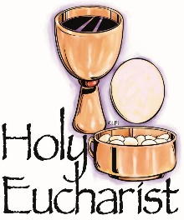 Fourth Sunday of Easter

April 25th, 2021

Month of the Holy Eucharist

**MASS INTENTIONS**: (April 26 – May 2, 2021)

Monday, April 26 Noon John Zibura req. by wife, Agnes & family

Tuesday, April 27 NO MASS

Wednesday, April 28 Noon Paul Susko req. by Mike & Connie Yauneridge

Thursday, April 29 Noon Barb Malchesky req. by George & Janet Minor & family

Friday, April 30 Noon Brandon Baxter req. by Loving family

Saturday May 1 4:00 PM Ed Myers req. by Saturday Choir

Sunday, May 2 8:00 AM People of the Parish

10:30 AM Kristen Deighan req. by Mom & Dad, Rick & Nancy Wessel

LITURGICIAL APPOINTMENTS:

Saturday, May 1 4:00 PM

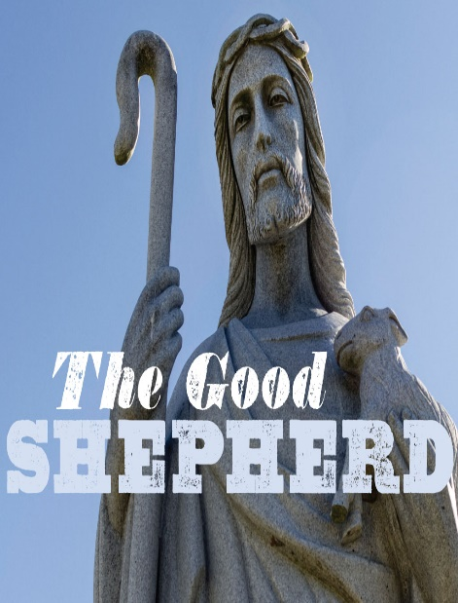Lector: Sherry Dipko

Minister of the Host: Babe Richards

Altar Server: Ana Spangler

Cantor: Amy Spangler

Sunday, May 2 8:00 AM

Lector: Arnold Bernard

Minister of the Host: Marie Bernard

Altar Server: Kaden Christ

Cantor: Anita Lorek

Sunday, May 2 10:30 AM

Lector: James Lashinsky

Minister of the Host: Jennifer Steele

Altar Server: Alexia Steele

Cantor: Lou McCloskey

Sunday, May 2 Collection Counters

Sara Zybura, Chris Smay

Mary Ann DeRosa

Weare placing names of the sick in the bulletin for prayer providing they give permission. *May the* *Divine Physician send healing grace for those for* *whom we pray:* Allen C. Rosemas, Patricia Murphy, Bernice Myers, Dwight Fyock, Dylon Wills, Missy, Joanne (Kolar) Hufford, Christine Flanagan, Ayden Alan Grata, Mary Lou Offman, Mary Zangaglia, Natalie Zerby, Valencia Tursi, Homer Locher, Brayden Schofield, Michelle Kasper, Diane Kingera, Ted Paluch, Pearl Litzinger, Patrick Munro, Fran Baldassarre, Kristen Sinosky Long, Cresta Micik, Basil Costantino, Laura, Joe Yoder, Dolores Yanzetich, Sandy Krug, Wanda Gramling, Jennifer Hagans, Shawn, Holly, Shane, Spencer, Owen Taylor, Derrick Varnish, Vincent Koshute, Michelle Elliott, Heather Romanow, Mackston Barrick, Connor Thomas, Erin, Pat, Mary Agnes Nastase, Mary Ann Bertolino, Dick Wilson, Izzy Bihun, Dorothy Kaminsky, Patricia Oshaben, Ashlee Madison, Susan Yanzetich, Mike, Alina Rusnak, Gary Smay, Elizabeth Howell, Walter Bodziak, Rhonda, Anne Robinson, Carter Bobak, Mike Morris, Sarah Kelt, Patty Yanzetich Caldwell, Colton Snyder, Nancy Edmiston, Leonard Oshaben, Adam, Janice Dipyatic, Lily Maloney, Scott, Lisa, Audrey Costlow, Cathy Sossong, Rosanne Krug, Becky Kakabar, Howard Delaney, Dolores Mucko, Elliana, Ashlee, Helen Soohy, Carol K. Fabrizio, Peggy Carpenter, Dave Seder, Rosalie Ambrose, Pearl Borlie, Joe (Runk) Slonac, Sharon Poldiak, Patty Gdula, Judy Barr, Ric Szelong and all of the sick of our parish, the homebound, those in nursing homes, those who care for them, and those in the military along with their families. *(Please call the Rectory to have your name removed from the list when no longer seriously ill. Thank You.)*

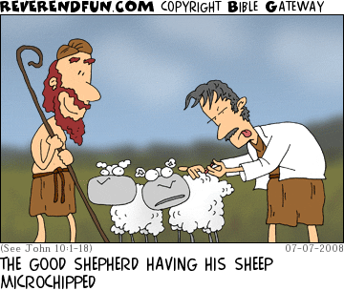

LAST WEEK’S COLLECTION

Adults $2,786.00

Loose $ 93.00

Youth $ 11.00

Monthly $1,485.00

Candles $ 35.00

Maintenance Fund $ 55.00

Easter Offering $ 195.00

Catholic Home Missions $ 20.00

Total $4,680.00

We sincerely thank and ask God’s

blessing upon all who have care

and concern for our parish.

April 25, 2021 John 10:11-18

Today’s gospel is a job description for Christian parents. For most people the most influential shepherds in their lives are their parents. Every parent is called to be a “good shepherd” to “freely lay down their life” for the children, to “love” and “know” their children and to “lead” them so “they know your voice.”

During the week of April 25th, 2021

the Sanctuary Candle will burn in honor of the

2021 First Holy Communion Class

and

the Our Lady of Grace Candle will burn in memory of

Elvida Bovino

requested by daughters, Louise Neff & Joyce Suckenik

[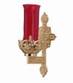](https://images.search.yahoo.com/search/images;_ylt=A0LEV1kSWptXvOwAKINXNyoA;_ylu=X3oDMTEyZGdkcmRoBGNvbG8DYmYxBHBvcwMxBHZ0aWQDQjIwODlfMQRzZWMDc2M-?p=Clipart+of+a+sanctuary+candle&fr=ush-mailn_02&th=110&tw=110&imgurl=http://www.henningers.com/389-168-wall-sanctuary-lamp.jpg&rurl=http://pixshark.com/sanctuary-lamp.htm&size=43KB&name=Sanctuary+Lamp+Bronze+wall+sanctuary+lamp&h=600&w=600&turl=http://ts2.mm.bing.net/th?id=OIP.M68453c67108cdc5ab485d309b395bd03o0&pid=15.1&rs=1&c=1&qlt=95&w=110&h=110#inline&tt=Sanctuary+Lamp+Bronze+wall+sanctuary+lamp&sigr=116keh5le&sigit=13gvlt42j&sigi=11ip0pgm4&sign=119kp6100&sigt=119kp6100)



CONGRATULATIONS! ~ We congratulate Eva Spangler of our parish who won first place last Saturday in the Cambria-Somerset Outstanding Young Woman Scholarship Program which featured 28 contestants from the two counties. Eva is the daughter of Brian and Amy Spangler.

CONGRATULATIONS! ~ We would also like to congratulate Alex Bambino and two of his teammates from Greater Johnstown Career and Technology Center who won 1st place in the state in the Skills USA welding fabrication competition! Alex & the team will compete in Nationals sometime in the near future. Alex is the son of Tony & Sandy Bambino.

CATHOLIC HOME MISSIONS APPEAL ~ Support the Catholic Home Missions Appeal today! Right now, over 40% of dioceses in the United States and its territories are considered mission territory, because they are unable to fund essential pastoral activities needed in their communities. Your support funds religious education, seminary formation, lay ministry training, and other programs that build vibrant faith communities right here in the United States. Please be generous. More information can be found at [www.usccb.org/home-missions](http://www.usccb.org/home-missions). Please place your envelopes in the basket marked “Catholic Home Missions.”

DAILY MASS ~ There will be NO Noon Mass on Tuesday, April 27th, due to Msgr. attending the Spring Clergy Conference at St. Aloysius, Cresson.

MASS FOR WIDOWS AND WIDOWERS ~ Remember your loved ones on Sunday, May 30th, with a televised Mass Celebrated by Bishop Mark Bartchak at 11:00 AM on WATM ABC 23 and will be rebroadcast that night at 9:00 PM on the Atlantic Broadband channel 9. All spouses will be acknowledged and remembered at Mass. All persons who have lost a spouse through death throughout the Altoona-Johnstown Diocese are invited to register by contacting the Family Life Office 814-317-2643 or email [familylife@dioceseaj.org](mailto:familylife@dioceseaj.org). When registering, please give your name, address, phone number and the name of your spouse who has passed away. Deadline to register is May 24th, 2021. Sponsored by the Diocesan Family Life Office.

WORLD DAY OF PRAYER FOR VOCATIONS ~ Will be observed on Sunday, April 25th, also known as “Good Shepherd Sunday.” The purpose of this day is to publicly fulfill the Lord’s instruction to, “Pray the Lord of the harvest to send laborers into his harvest” (Mt 9:38; Lk 10:2). Please pray that young men and women hear and respond generously to the Lord’s call to the priesthood, diaconate, religious life, societies of apostolic life or secular institutes.

ROSARY ~ Every Thursday at 3:00 PM on Franklin Street across from Planned Parenthood. Praying for the pre-born, their Moms, the abortion workers and all those who support abortion.

April is Child Abuse Month

Keeping Children and Teens SAFE ONLINE

Computers and mobile devices can be helpful tools for children and teens to learn and grow in faith and fellowship. Unfortunately, the digital world is also full of unsafe and explicit content. You wouldn’t hand a teen the car keys without first teaching them how to drive. The same should be true for using technology – teach them how to keep themselves and others safe while using it.

You can use the following tips to better protect young people from harm online:

1. Model appropriate online behavior for young people.
2. Teach your children not to share private information or images online.
3. Limit usage of computers and mobile devices to public spaces in the home.
4. Install software that can block or monitor explicit website use.
5. Review and discuss the websites your child has visited and apps they have used.
6. Report online exploitation of minors to public authorities.

TEN TIPS for Protecting Children and Offering Outreach to Victims/Survivors

1. Sexual abuse is about the victim.
2. The residual effects of having been abused can last a lifetime. The sense of violation goes deep into a person’s psyche and feelings of anger, shame, hurt and betrayal can build long after the abuse has taken place.
3. No one has the right to have access to children. No one has an automatic right to be around children without proper screening and without following the rules.
4. Common sense is not all that common. Everyone must be educated on how to protect children.
5. Child sexual abuse can be prevented. It is critical to build safety barriers around children to keep them from harm.
6. Feeling heard leads toward healing. Relief from hurt and anger often comes when one feels heard, when one’s pain and concerns are taken seriously and acknowledged.
7. You cannot always predict who will be an abuser. Experience shows that most abuse is committed by someone who has gained the trust of a victim/survivor and his/her family.
8. There are behavioral warning signs of child abusers. Some abusers isolate a potential victim by giving him or her undue attention or lavish gifts.
9. People can be taught to identify grooming behavior. Grooming behaviors are the actions which abusers take to project the image that they are kind, generous, caring people, while their intent is to lure a minor into an inappropriate relationship.
10. Background checks are important. Background checks in churches, schools and other organizations keep predators away from children.

2021 Catholic Ministries Drive

Youth Ministry

Meet Morgan Casto from Saint Clement Parish in Johnstown, and a new teacher at Bishop McCort Catholic High School in Johnstown. She’ll be the first to tell you that she is alive in her faith as a young adult today thanks to numerous Diocese of Altoona-Johnstown Youth Ministry opportunities in which she participated years ago.

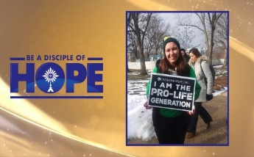Youth Ministry helps the younger generation engage with their Catholic faith through hands-on, fun-filled programs like summer camps, conferences, and retreat days. These opportunities present the chance for diocesan youth to participate in fun activities while learning about the importance of their faith. Seeing the difference their faith has on other people will encourage them to grow in their relationship with Jesus Christ.

Your support of the Catholic Ministries Drive makes possible opportunities such as Camp Zacchaeus, Camp Timothy, Junior High Youth Day, Senior High Youth Conference (SHYCON), Faith Day, and trips to the National Catholic Youth Conference in Indianapolis.

You can mail your gift to the Diocese of Altoona-Johnstown, P.O. Box 409, Hollidaysburg, PA 16648; place in your parish offertory; or make online at [www.dioceseaj.org](http://www.dioceseaj.org)

All gifts received beyond our parish target amount will be used to purchase and install gas furnaces for the Church, Hall and Rectory.

100% of your donation will go to the 14 ministries that gives help, builds hope, and changes lives.

The Year of Saint Joseph

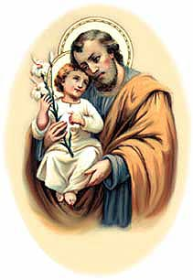 Pope Francis’ Devotion to Sleeping Saint Joseph

In his apostolic letter *Patris Corde,* the Pope describes many of St. Joseph’s qualities as “a true husband and father, the fiancé who accepted Mary unconditionally and the man in whom Jesus saw the tender love of God.” Pope Francis has a practice of placing his concerns under a statue of Sleeping St. Joseph. He speaks of the saint saying, “Joseph is a man who goes unnoticed, who welcomes the mystery and puts himself at its service, never putting himself at the center, but who resolves things that are impossible.”

 Religious Education And Christian Helping

April 25, 2021

Religious Education News

Final Home Lesson Packets ~ April lessons packets for all students in grades K—10 were distributed. When these lessons are completed, they can be returned to the Blue Tote outside our Parish Office Door along with textbooks that were used throughout the year.

For those that missed any lesson pick-ups, your students lessons can be picked-up in the Blue Tote outside the Parish Office door marked: "Religious Education Pick-Ups & Drop Offs".  Look for your "Family Name" on the name tag attached to the bag. You can Drop-off completed lessons by placing them in this bin also.

Camp Zacchaeus Day Camp ~ Our Diocese of Altoona-Johnstown is offering three great days of Faith, Fun and Friendship this summer at Camp Zacchaeus. Day camp is being offered in three areas: Altoona and State College on July 19, 20 and 21, 2021. Our Johnstown area site will be held at Resurrection Picnic Grove on July 26, 27 & 28, 2021. Any students entering grades 3-9 in September of 2021 are eligible to attend. Registrations will be accepted on a first come basis until each site is full with a registration deadline of June 25th.

*\*Note: Date change for Johnstown location.* Brochures that were previously sent home with our students have the old date on the information brochure. Our Diocese has now provided an updated registration brochure. This updated Camp Zacchaeus brochure with the revised dates is available in the Parish Office for those interested in registering.

╬ ╬ ╬ ╬ ╬ ╬ ╬ ╬ ╬ ╬ ╬ ╬ ╬ ╬ ╬ ╬ ╬ ╬ ╬ ╬ ╬ ╬ ╬ ╬ ╬ ╬ ╬

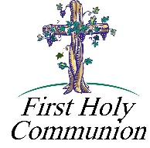

2nd Grade Class Meeting In-Person ~ Due to Forest Hills Elementary being closed this past Thursday, our 2nd Grade students were unable to meet for their scheduled in-person class. We will be meeting at 6:00 PM this Wednesday, April 28th in the church for a review class followed by their celebration of reconciliation.

First Holy Communion ~ Our Second-Grade class is preparing to receive First Holy Communion on Saturday, May 1st, 2021 at a 10:00 AM Mass. They will celebrate Reconciliation on Wednesday, April 28th at 6:00 PM. First Communion Practice will be on Friday, April 30th at 6:30 PM.



11th Grade Class Meeting In-Person ~ Our 11th Grade Confirmation students are attending class on Sunday mornings from 9—10:20 AM in the upstairs hall. They will continue to meet throughout the month of April leading up to receiving their sacrament of Confirmation in May.

Confirmation ~ Our 11th Grade Confirmation candidates will receive their Sacrament of Confirmation on Thursday, May 6, 2021. A 7:00 PM Mass will be celebrated here at our Saint Michael Parish by Msgr. Lockard.

*Confirmation Practice will be held on Wednesday evening, May 5 at 6:30 PM.*

 Sunday, April 25 Mass ~ 8:00 & 10:30 AM

Confessions / 10:00 – 10:15 AM / St. Paul Room

Catholic Home Missions Appeal Collection

Girl Scouts / 1 – 2:30 & 4 – 5:30 PM / Hall

Monday, April 26 Mass ~ Noon

NO Sunday Choir Practice

Team Leadership Meeting / 6:30 PM / Hall Rm #2

Tuesday, April 27 NO Mass

 Spring Clergy Conference

Boy Scouts / 7:30 - 9:00 PM

Wednesday, April 28 Mass ~ Noon

Second Grade Reconciliation / 6:00 PM

Girl Scouts / Pavilion / 6:00 PM

Thursday, April 29 Mass ~ Noon

NO Saturday Choir Practice

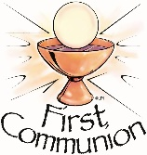 Friday, April 30 Mass ~ Noon

First Communion Practice / 6:30 PM

Saturday, May 1 Mass / 4:00 PM

Confessions / 3:30 – 3:45 / St. Paul Room

First Holy Communion / 10:00 AM

 UPCOMING EVENTS

May 5 Confirmation Practice

May 6 Confirmation

May 8 & 9 Second Sunday Food Pantry Collection

May 9 Mother’s Day

May 15 & 16 Catholic Communication Campaign Collection

JOURNEY THROUGH SCOTLAND & ENGLAND ~ With Fr. Brian Saylor. Nov. 3 – Nov. 16, 2021, 14 Days & 19 Meals. Highlights: Edinburgh Castle, Lake District, Liverpool, Choice on Tour, Cotswolds, Bath, Glastonbury Abbey, Cornwall, Great Western Railway, London. Double: $4,499 pp or Single $5,399 pp. For more information or to sign up call Collette 844-218-2148. Please refer to Booking #987192 or Fr. Brian Saylor 814-944-8509.

SWISS STEAK DRIVE BY ~ The Church of the Transfiguration will be having a Swiss Steak Drive-By Dinner at 201 Third St. on Sunday, April 25th from 10 AM-2 PM. Dinnner includes Swiss Steak, mashed potatoes & gravy, vegetables, salad, roll w/butter & dessert - $10.

SPRING FLING ~ Turkey Dinner (Take out Only) & Basket Auction. Mother’s Day, Sunday, May 9th from

11 AM – 2 PM. St. Benedict Church Hall, Carrolltown. $12 Adults, $6 children up to age 12. Benefits St. Benedict Home School Association.