ST. MICHAEL ROMAN CATHOLIC CHURCH

751 Locust Street

PO Box 103

St. Michael, Pennsylvania 15951

Rev. Msgr. David A. Lockard, Administrator MASSES:

(814) 495-9640 Saturday 4:00 pm



Sunday Morning 8:00 am

Secretary & Bookkeeper: 10:30 am

Michele Panick Daily Mass: M, T, W, Th, F

Noon

DRE: Laurie Sloan Holy Days: See Bulletin

Maintenance: Rodney Turgeon Office Hours:

PHONES: 8:30 am to 3:30 pm

Rectory / Office: (814) 495-9640 Monday, Tues., Thurs., Friday

Fax: (814) 495-9424 Closed Wednesdays

Rel. Education: (814) 495-4873 Confessions:

Parish Website Saturday 3:30 pm to 3:45 pm

[www.saintmichaelchurch.weebly.co](http://www.saintmichaelchurch.weebly.co)m Sunday 10:00 am to 10:15 am

Secretaries’ E-mail By Appointment

[saintmichaelsecretaries@yahoo.com](mailto:saintmichaelsecretaries@yahoo.com)

Facebook page:

St. Michael Catholic Church/St. Michael, PA

Pentecost Sunday

SERVING GOD AND COMMUNITY FOR OVER ONE HUNDRED YEARS!

May 23rd, 2021

BAPTISM: By Appointment. Reserve at least one month in advance.

MARRIAGE: Plan at least nine months in advance.

Preparation sessions are necessary.

FUNERALS: Arrangements are made in conjunction with the funeral home.

REGISTRATION Those new to the area, newlyweds, and single adults, (even if registered

and before with their families) are asked to register by calling the Parish Office.

MEMBERSHIP: Every parishioner must be registered. This is a condition for admission

to our Program and reception of the Sacraments of Baptism, Confirmation,

First Penance, First Eucharist, and Matrimony; also, for testimonial letters or sponsorship of Baptism and Confirmation outside the Parish.

VISITATION: We are concerned and want to be advised when someone is ill at home or in the hospital. Call the office to have the shut-in placed on our monthly Holy Communion calls or seriously ill prayer list.

SACRAMENTAL Parish registration and active Mass participation for Baptism is

POLICY: encouraged and is required for Marriage.

BULLETIN ARTICLES: Articles are due to the Parish Office by Noon on Tuesday.



Pentecost Sunday

May 23rd, 2021

Month of the Blessed Virgin Mother

**MASS INTENTIONS**: (May 24 – May 30, 2021)

Monday, May 24 Noon For the health & well-being of Cathy McMahon req. by

Sondre & Maggie Harteis

Tuesday, May 25 Noon Jason Plummer req. by Joe & Jan Huber

Wednesday, May 26 Noon Agnes Noon req. by Patricia Petrunak

Thursday, May 27 Noon Steve & Marie Faher req. by Mary Jean Brown

Friday, May 28 Noon Joe Ropecka req. by Judith Rigel

Saturday May 29 4:00 PM People of the Parish

Sunday, May 30 8:00 AM Stephen D. Yanzetich Jr. req. by Dolores, Evan & Susan

10:30 AM Florence & Charles Smith req. by Nancy Broad

LITURGICIAL APPOINTMENTS:

Saturday, May 29 4:00 PM

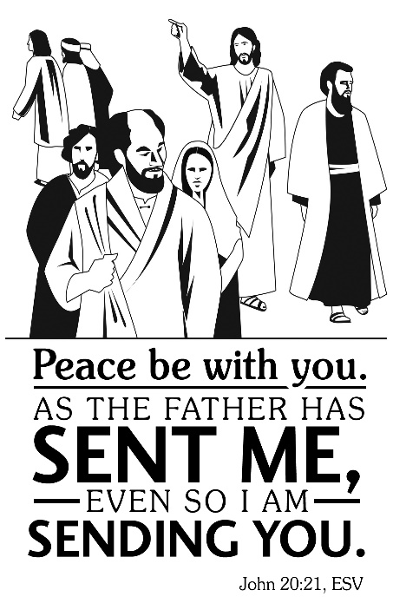Lector: Sandy Bambino

Minister of the Host: Karen Myers

Altar Server: Brooke Williamson

Cantor: Amanda Williamson

Sunday, May 30 8:00 AM

Lector: Arnold Bernard

Minister of the Host: Marie Bernard

Altar Server: Elizabeth Dobbins

Cantor: Sharon Dibble

Sunday, May 30 10:30 AM

Lector: James Lashinsky

Minister of the Host: Jennifer Steele

Altar Server: Alexia Steele

Cantor: Amy Dobbins

Weare placing names of the sick in the bulletin for prayer providing they give permission. *May the* *Divine Physician send healing grace for those for* *whom we pray:* Allen C. Rosemas, Patricia Murphy, Bernice Myers, Dwight Fyock, Dylon Wills, Missy, Joanne (Kolar) Hufford, Christine Flanagan, Ayden Alan Grata, Mary Lou Offman, Mary Zangaglia, Natalie Zerby, Valencia Tursi, Homer Locher, Brayden Schofield, Michelle Kasper, Diane Kingera, Ted Paluch, Pearl Litzinger, Patrick Munro, Fran Baldassarre, Kristen Sinosky Long, Cresta Micik, Basil Costantino, Laura, Joe Yoder, Dolores Yanzetich, Sandy Krug, Wanda Gramling, Jennifer Hagans, Shawn, Holly, Shane, Spencer, Owen Taylor, Derrick Varnish, Vincent Koshute, Michelle Elliott, Heather Romanow, Mackston Barrick, Connor Thomas, Erin, Pat, Mary Agnes Nastase, Mary Ann Bertolino, Dick Wilson, Izzy Bihun, Dorothy Kaminsky, Ashlee Madison, Susan Yanzetich, Mike, Alina Rusnak, Gary Smay, Elizabeth Howell, Walter Bodziak, Rhonda, Anne Robinson, Carter Bobak, Mike Morris, Sarah Kelt, Patty Yanzetich Caldwell, Colton Snyder, Nancy Edmiston, Leonard Oshaben, Adam, Janice Dipyatic, Lily Maloney, Scott, Lisa, Audrey Costlow, Cathy Sossong, Rosanne Krug, Becky Kakabar, Dolores Mucko, Elliana, Ashlee, Helen Soohy, Carol K. Fabrizio, Peggy Carpenter, Dave Seder, Rosalie Ambrose, Pearl Borlie, Joe (Runk) Slonac, Sharon Poldiak, Patty Gdula, Judy Barr, Ric Szelong and all of the sick of our parish, the homebound, those in nursing homes, those who care for them, and those in the military along with their families. *(Please call the Rectory to have your name removed from the list when no longer seriously ill. Thank You.)*

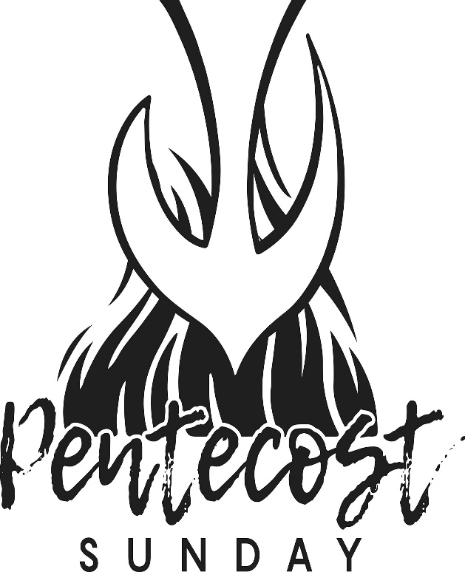

LAST WEEK’S COLLECTION

Adults $2,675.00

Loose $ 53.00

Youth $ 22.00

Monthly $ 385.00

Candles $ 24.00

Maintenance Fund $ 55.00

Mother’s Day $ 120.00

Easter Offering $ 10.00

Ascension Thursday $ 691.00

Cemetery Maintenance $ 105.00

Holy Land $ 5.00

Holy Thursday $ 5.00

Catholic Communication $ 258.00

Total $4,408.00

We sincerely thank and ask God’s

blessing upon all who have care

and concern for our parish.

May 23, 2021 John 20:19-23

Today, on Pentecost, we remember Christ has given us the Holy Spirit to assist us in raising our family and he expects us to use this personal gift. Let us turn-off the noise, apps and distractions in our lives and let the Holy Spirit “guide us to the truth.”

During the week of May 23rd, 2021

the Sanctuary Candle will burn in honor of the

Graduating Seniors of St. Michael Parish

[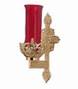](https://images.search.yahoo.com/search/images;_ylt=A0LEV1kSWptXvOwAKINXNyoA;_ylu=X3oDMTEyZGdkcmRoBGNvbG8DYmYxBHBvcwMxBHZ0aWQDQjIwODlfMQRzZWMDc2M-?p=Clipart+of+a+sanctuary+candle&fr=ush-mailn_02&th=110&tw=110&imgurl=http://www.henningers.com/389-168-wall-sanctuary-lamp.jpg&rurl=http://pixshark.com/sanctuary-lamp.htm&size=43KB&name=Sanctuary+Lamp+Bronze+wall+sanctuary+lamp&h=600&w=600&turl=http://ts2.mm.bing.net/th?id=OIP.M68453c67108cdc5ab485d309b395bd03o0&pid=15.1&rs=1&c=1&qlt=95&w=110&h=110#inline&tt=Sanctuary+Lamp+Bronze+wall+sanctuary+lamp&sigr=116keh5le&sigit=13gvlt42j&sigi=11ip0pgm4&sign=119kp6100&sigt=119kp6100)

CONFESSIONS ~ Starting Saturday, June 5th, we will return to the old Reconciliation Room (cry room) as the place for confession. Also, we will return to the old schedule of confession: Saturday from 3:30 PM to 3:45 PM, Sunday from 7:30 AM to 7:45 AM and from 10:00 AM to 10:15 AM.

MEMORIAL DAY ~ Mass for Memorial Day Monday, May 31st will be at St. Joseph Cemetery, Beaverdale at 10:00 AM. There will be NO Mass here at St. Michael. The Parish Offices will be closed on Memorial Day. Office hours will resume on Tuesday, June 1st at 8:00 AM.

MAINTENANCE FUND TICKETS ~ Please remember to return your stub, money or your unsold tickets to the parish office by Monday, May 24th. If anyone would like more tickets, please call the office during office hours.

CEMETERY ENVELOPES ~ In your packet of envelopes, for May 23rd, you will find an envelope for Cemetery Maintenance with the three cemeteries: Corpus Christi, St. Joseph, and St. Michael. You are to circle or underline the cemetery you would like your donation to go towards. If nothing is specified, the donation will be split between the three cemeteries. Thank you.

CATHOLIC COMMUNICATION CAMPAIGN ~ Thank you for your generosity towards last week’s collection for the Catholic Communication Campaign (CCC). Your support helps the CCC spread the Gospel message and connects millions of people with Christ, here in the United States and around the world. If you missed the collection, it’s not too late to give! Visit [www.uscb.org/nationalcollections](http://www.uscb.org/nationalcollections) .

TIME FOR A CHANGE ~ PRECIOUS LIFE will be running a Baby Bottle Campaign. Empty baby bottles will be placed in the Bridal Room beginning this weekend. Please take a bottle, fill it up with change and return it to the Bridal Room by Father’s Day, June 20th. PRECIOUS LIFE is a Christian ministry providing positive alternatives to abortion.

OUTDOOR MASSES ~ Will be celebrated at the Our Lady of the Alleghenies Shrine in Loretto every Sunday night at 7 PM beginning on Memorial Day weekend – May 30 and continuing through Labor Day weekend – September 5. Those attending are asked to bring their own lawn chair. In the event of inclement weather, Mass will be celebrated inside the Basilica of St. Michael the Archangel next to the Shrine. The Prince Gallitzin Chapel House, next to the Shrine, will be open for self-guided tours from 3-6 PM on June 6th & 20th; July 18th; and August 1st, 15th and 29th.

HOLY HOUR ~ Bishop Bartchak will ordain Deacon Mark Groeger & Deacon Michael Pleva on May 29th at 10 AM at the Cathedral of the Blessed Sacrament in Altoona. There will be a Eucharistic Holy Hour to offer prayers for Deacons Groeger & Pleva on May 28th at 6 PM at St. Michael the Archangel Parish, 301 Spruce St., Hollidaysburg. All are welcome. Prayers will also be offered for our current priests & seminarians, and for future seminarians. The Sacrament of Reconciliation will also be available.

 Religious Education And Christian Helping

May 23, 2021

Religious Education News

Final Home Lesson Packets ~ Final lesson packets for April were distributed to all students in grades K—10 and are available in our pick-up tote. When previous month’s lessons are completed, they can be returned to the Blue Tote outside the Parish Office door marked: "Religious Education Pick-Ups & Drop Offs", along with textbooks that were used throughout the year.

*******************************************************************************************************************

Camp Timothy ~ Youth in grades 10—12 and newly graduated Seniors 2021.

Are you tired of the same old, same old?

Are you ready for a much needed change of pace?

Are you looking for a way to increase and strengthen your faith?

Are you ready for something new, challenging and fun??

Then YOU NEED TO JOIN US FOR CAMP TIMOTHY 2021!! June 21, 22, and 23.

Camp Timothy is being held at Resurrection Picnic Grove in Johnstown, PA. We will offer Virtual, Day Camp, and an Overnight Tent camping option! Camp Timothy will be held following all current Federal (CDC), State and Diocesan protocols for COVID. For those who wish to stay over for the two nights of Camp Timothy, we will offer tent camping. The registration deadline is June 7, 2021. A limited number of campers will be accepted on a first come, first serve basis. Brochures are available in the Parish Office for anyone interested in attending. For more information, you can also contact Francine Swope in the Youth Ministry Office at (814)317-2646.

*********************************************************************************************************

Camp Zacchaeus Day Camp ~ Our Diocese of Altoona-Johnstown is offering three great days of Faith, Fun and Friendship this summer at Camp Zacchaeus. Any students entering grades 3-9 in September of 2021 are eligible to attend. Day camp is being offered in three areas: Altoona and State College on July 19, 20 and 21, 2021. Our Johnstown area site will be held at Resurrection Picnic Grove on July 26, 27 & 28, 2021. Registrations will be accepted on a first come basis until each site is full with a registration deadline of June 25th.

*\*Note: Date change for Johnstown location.* Brochures that were previously sent home with our students have the old date on the information brochure. Our Diocese has now provided an updated registration brochure. This updated Camp Zacchaeus brochure with the revised dates is available in the Parish Office for those interested in attending.

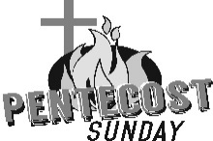

Sunday, May 23 Mass ~ 8:00 & 10:30 AM

Confessions / 10:00 – 10:15 AM / St. Paul Room

Girl Scouts / Hall / 4 – 5:30 PM

Monday, May 24 Mass ~ Noon

NO Sunday Choir Practice

 Tuesday, May 25 Mass ~ Noon

Boy Scouts / 7:30 - 9:00 PM

Wednesday, May 26 Mass ~ Noon

Thursday, May 27 Mass ~ Noon

NO Saturday Choir Practice

Friday, May 28 Mass ~ Noon

Saturday, May 29 Mass / 4:00 PM

Confessions / 3:30 – 3:45 / St. Paul Room

Travis Kopach / Hannah Bennett Nuptials / 1:00 PM



UPCOMING EVENTS

May 31 Memorial Day / Parish Offices Closed

Mass ~ St. Joseph Cemetery



TAKE OUT SPAGHETTI DINNER ~ Sunday, May 23rd, St. Michael Catholic Church, St. Michael. Tickets $10. Take out Spaghetti Dinner ONLY: 11:00 AM – 1:00 PM. Sponsored by team Blue Skies Over Purple Hearts in Memory of Jane Plummer. All proceeds go to Alzheimer’s Association. To purchase tickets, call Janet Minor-814-487-5106, or Mary Ann Tedjeske-814-341-5463. END ALZ.

MAY DAYS ~ At the Basilica of ST. Michael, May 29th & 30th at Our Lady of Loretto Hall – Live entertainment, Cinch Tournament (Call Mag 674-2631 to join) basket auction, flea market, silent auction, food, and beverages. Saturday, 4 – 8 PM and Sunday, 11 AM – 4 PM. Proceeds from the weekend festival benefit Our Lady of Loretto Community Hall. Please see our website [www.basilicasm-loretto.org](http://www.basilicasm-loretto.org). for more information.

STUFFED CHICKEN BREAST DINNER ~ June 6th from 10 AM – 2 PM at The Church of the Transfiguration, Conemaugh. Stuffed Chicken breast, mashed potatoes, vegetable, salad, roll & butter and dessert.

GOB SALE ~ The Church of the Transfiguration, Conemaugh. Orders are due Monday, June 7th. Cost is $1.25/gob, $7.50/half dozen or $15/dozen. Call Irene Cristoff at 814-322-4914 or Andy Solomon 814-322-3287.

CRAFT & VENDOR SHOW ~ Sunday, June 13th, 9 AM – 4 PM at the St. Nicholas Church Hall, Nicktown. There will be a variety of crafters/vendors, food trucks, & Sodality will be having a Bake Sale! Check us on Facebook or contact [hall.stnicholaschurch@gmail.com](mailto:hall.stnicholaschurch@gmail.com) or 814-418-5080 with any questions.