ST. MICHAEL ROMAN CATHOLIC CHURCH

PO Box 103

St. Michael, Pennsylvania 15951

Rev. Brian L. Warchola, Administrator MASSES:



(814) 495-9640 Saturday 4:00 pm

Sunday Morning 8:00 am

Secretary: Michele Panick 10:30 am

Bookkeeper: Kathy Kalicky Daily Mass See Bulletin

DRE: Laurie Sloan Holy Days See Bulletin

Maintenance: Rodney Turgeon

Office Hours:

PHONES: 8:30 am to 3:30 pm

Rectory / Office: (814) 495-9640 Monday, Tues., Thurs., Friday

Fax: (814) 495-9424 Confessions:

Rel. Education: (814) 495-4873 Saturday 3:30 pm to 3:45 pm

Parish Website Sunday 7:30 am to 7:45 am

www.saintmichaelchurch.weebly.com 10:00 am to 10:15 am

Secretaries’ E-mail Anytime Requested

[saintmichaelsecretaries@yahoo.com](mailto:saintmichaelsecretaries@yahoo.com)

YEAR: 2017 NUMBER: 44

SERVING GOD AND COMMUNITY FOR OVER ONE HUNDRED YEARS!

BAPTISM: By Appointment. Reserve at least one month in advance.

Preparation classes are necessary.

MARRIAGE: Plan at least nine months in advance.

Preparation sessions are necessary.

FUNERALS: Arrangements are made in conjunction with the funeral home.

Eulogies should be given at the funeral home at the time of the wake service or at the luncheon.

REGISTRATION Those new to the area, newlyweds, and single adults, (even if registered

and before with their families) are asked to register by calling the Parish Office.

MEMBERSHIP: Every parishioner must be registered. This is a condition for admission

to our Program and reception of the Sacraments of Baptism, Confirmation, First Penance, First Eucharist, and Matrimony; also, for testimonial letters or sponsorship of Baptism and Confirmation outside the Parish.

VISITATION: We are concerned and want to be advised when someone is ill at

home or in the hospital. Call the rectory to have the shut-in placed on our monthly Holy Communion calls or seriously ill prayer list.

SACRAMENTAL Requires parish registration and active Mass participation for Baptism

POLICY: and Marriage.

BULLETIN ARTICLES: Articles are due to the Parish Office by Noon on Mondays.

Thirtieth Sunday in Ordinary Time , October 29, 2017

[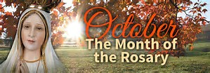](https://www.bing.com/images/search?view=detailV2&ccid=zIjiTZgu&id=11352847EAC1A1C981AD3B124F34C7CC71B4DE8A&thid=OIP.zIjiTZgurig0pLd2ttvA-wEsBo&q=pictures+of+the+holy+rosary&simid=608040377344264588&selectedIndex=217)  **The Holy Rosary**

MASS INTENTIONS: (October 30 – November 5, 2017)

Monday 8:00 AM Helen Varner req. by Joyce Myers

Tuesday 8:00 AM James Hoss Onder req. by Ed Hudak

6:00 PM Ann Blazosky req. by Galen & Lori George

Wednesday 9:00 AM People of the Parish

Thursday 8:00 AM Mildred Beesoick req. by Carrie & Kayla Caputo

6:00 PM All the Deceased

First Friday 8:00 AM Sick and Shut-Ins req. by St. Michael Funeral Committee

Saturday 4:00 PM Andrew Hancharik req. by Helen Petkosh & Family

Sunday 8:00 AM Josh Faher req. by Mom, Dad & Family

Sunday 10:30 AM People of the Parish

LITURGICIAL APPOINTMENTS:

Saturday, November 4 4:00 PM Offertory Procession

Lector: Sherry Dipko Helen Petkosh Family

Minister of the Host: Mary Partsch

Ministers of the Cup: Karen Myers & Helen Slonac

Altar Servers: Victoria Russic & Elisabeth Zajdel

Cantor: David Zajdel

Greeter: Shirley Walls

Sunday, November 5 8:00 AM Offertory Procession

Lector: Peter Bernard Josh Faher Family

Minister of the Host: Beth Kundrod

Ministers of the Cup: Paul Kundrod & Pauline Minor

Altar Servers: Andrew Martin & Michael Kresic

Cantor: Joseph Faher

Greeter: Betty Long

Sunday, November 510:30 AM Offertory Procession

Lector: Carole Kakabar Michael & Linda Caddy

Minister of the Host: Edie Knobloch

Ministers of the Cup: Sharon Paterson & Susan Wieczorek

[](https://www.churchart.com/subscriber/viewimages?topic_id=229&image_type=cl,ph,pp,bc,ca,mv,wt,nt,pt,ft,ch&page=6&ipp=12)Altar Servers: Evan Burkhardt & Zach Fisher

Cantor: Amy Dobbins

Greeter: 7th Grade REACH Students

Sunday, November 5 Collection Counters

Tom & Sharon Paterson

Robert Casti, Sara Zybura

[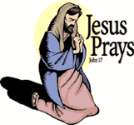](https://www.churchart.com/subscriber/viewimages?book_number=43&chapter=17&verse=1&entry_date=1/1/0001&image_type=cl)[](http://www.churchart.com/Subscriber/ViewImages.aspx?keywords=&entry_date=1/1/0001&image_type=,cl&topic_id=346&image_source_id=&page=1#no)Weare placing names of the sick in the bulletin for prayer providing they give permission. *May the* *Divine Physician send healing grace for those for* *whom we pray:* Allen C. Rosemas, Patricia Murphy, Bernice Myers, Dwight Fyock, Lori Facciani, Dylon Wills, Dawn Hagen, Debbie Dibert, Missy, Joanne (Kolar) Hufford, Christine Flanagan, Ayden Alan Grata, Remy Beaver, Mary Lou Offman, Marian Chuckalovcak, Arlene Diamond, Mary Zangaglia, Dorothy Rosemas, Natalie Zerby, Patricia Grata, Michael Wadsworth, Valencia & Frank Tursi, Homer Locher, Brayden Schofield, Michelle Kasper, Diane Kingera, Allison Krischer, Ted Paluch, Brandt Hutzel, Pearl Litzinger, Patrick Munro, Fran Baldassarre, Corey Lybarger, Kristen Sinosky Long, Helen Ranieri, Cresta Micik, Basil Costantino, Madison McCrory, Laura, Joe Yoder, Dolores Yanzetich, Sandy Krug, Wanda Gramling, Merna Smay, Muriel “Jean” Wiesheier, Heidi Allison, Agnes Plummer, Jennifer Hagans, Mary McCall, Sean, Holly, Shane, Owen Taylor, Keith Hoyer, Gail Faher, Marjorie (Latshaw) Feldman, Derrick Varnish, Daniel Koshute, Vincent Koshute, Karen Lovrich, Melissa Cordek, Michelle Elliott, Shannon Meyers, Heather Romanow, Mackston Barrick, Connor Thomas, Erin, Pat, Mary Agnes Nastase, Mary Ann Bertolino, Dick Wilson, Dan Pauley, Peggy Mulvehill, Jane Plummer, Izzy Bihun, Sharon Poldiak, Erica Mitzelfeld, Heidi Allison, Marlene McCrory, Dorothy Kaminsky and all of the sick of our parish, the homebound, those in nursing homes, those who care for them, and those in the military along with their families. (Please call the Rectory to have your name removed from the list when no longer seriously ill. Thank You.)

[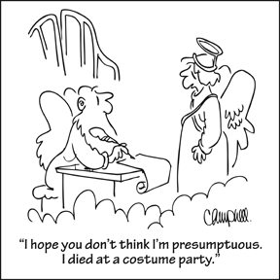](https://www.churchart.com/subscriber/viewimages?topic_id=81&image_type=cl,ph,pp,bc,ca,mv,wt,nt,pt,ft,ch&page=9&ipp=12)

LAST WEEK’S COLLECTION

Adults $3,336.00

Loose $ 181.50

Youth $ 45.00

Monthly $ 155.00

Candles $ 17.00

Maintenance Fund $ 535.00

World Mission Sunday $ 663.00

Total $4,932.50

We sincerely thank and ask God’s blessing upon all who have care and concern for our parish.

*October 29, 2017 Mt. 22:34-40*

In today’s gospel the Pharisees were asking about a commandment (something we have to do)! And Jesus was talking about love (what we want to do with our “whole heart, mind and soul”). In families we daily lay down our lives for one another, not because of a law but out of love.

OCTOBER 2017 PARISH TICKET WINNERS

[](https://images.search.yahoo.com/images/view;_ylt=AwrB8plKK_1XrE8ADDKJzbkF;_ylu=X3oDMTIyajBlaTZqBHNlYwNzcgRzbGsDaW1nBG9pZAM0MTMxYjYxYzY5YzhiNGY5MzEwN2RhMGUyZDZiMDFjMgRncG9zAzcEaXQDYmluZw--?.origin=&back=https://images.search.yahoo.com/search/images?p%3DFree%2BClipart%2Bof%2BLottery%2BWinners%26fr%3Dyfp-t%26tab%3Dorganic%26ri%3D7&w=420&h=589&imgurl=images.clipartpanda.com/winner-clipart-clip-art-lottery-431235.jpg&rurl=http://www.clipartpanda.com/categories/winner-20clipart&size=87.3KB&name=%3cb%3eWinner%3c/b%3e+20clipart+|+%3cb%3eClipart%3c/b%3e+Panda+-+%3cb%3eFree%3c/b%3e+%3cb%3eClipart%3c/b%3e+Images&p=Free+Clipart+of+Lottery+Winners&oid=4131b61c69c8b4f93107da0e2d6b01c2&fr2=&fr=yfp-t&tt=%3cb%3eWinner%3c/b%3e+20clipart+|+%3cb%3eClipart%3c/b%3e+Panda+-+%3cb%3eFree%3c/b%3e+%3cb%3eClipart%3c/b%3e+Images&b=0&ni=192&no=7&ts=&tab=organic&sigr=11n47l7ao&sigb=139407utj&sigi=1223krgs8&sigt=12i151aj8&sign=12i151aj8&.crumb=wKQwdzP0bBS&fr=yfp-t)Day Date Amount Number Winner

Friday October 20, 2017 $ 75 600 Terri Leach

Saturday October 21, 2017 $100 742 Ticket Not Returned

Sunday October 22, 2017 $100 296 Robert R. Blanchetti

Monday October 23, 2017 $ 75 402 Mary Perich

Tuesday October 24, ,2017 $ 75 958 Joe Ropecka

Wednesday October 25, 2017 $ 75 552 Joseph Bukosky

Thursday October 26, 2017 $ 75 213 Joseph Brunberg

WOMEN’S DAY OF PRAYER ~ The Carmelite Community of the Word Sisters are offering a “Women’s Day of Prayer” Saturday, Nov. 11 from 10:00 AM to 3:00 PM at the CCW Incarnation Center, 394 Bem Road, Gallitzin. We extend the invitation to women of all ages to join us for a sacred time with each other and with our God, praying for the intentions of our world, our church, and personal needs and discernment. Please register to attend by Nov. 6. For more information or to register please contact: Sr. Margie McGuire 814-472-8315 or email: [margiemc12@gmail.com](mailto:margiemc12@gmail.com), or website: [www.ccwsisters.org](http://www.ccwsisters.org).

IN THE FOOTSTEPS OF JESUS ~ A Pilgrimage to the Holy Land, with Msgr. Michael Becker as chaplain, is being planned for May 16-26, 2018. Visit those places which are most sacred to all Christians: Bethlehem, Nazareth, Cana, the Sea of Galilee, Mt. Tabor, the Garden of Olives, Jerusalem and Calvary. The trip includes all travel and hotel accommodations, daily breakfast and most dinners, private coach, and daily Mass at each site. The total cost of this pilgrimage is $3,850 per person. A special informational meeting will be held at St. Michael Church Hall in St. Michael, PA. on Monday, November 6th at 7:00 PM. All are welcome! For further information, contact Msgr. Becker at [mbecker253@aol.com](mailto:mbecker253@aol.com) or call 942-5503.

ADULT ENRICHMENT CLASSES ~ Classes are offered through the *Office of Adult Enrichment and Lay Ecclesial Ministry* to help nurture YOUR faith. Beginning Nov. 14th, the 8-week course, Old Testament, taught by Fr. Brian Saylor, will be offered at St. Rose of Lima, Altoona, Tuesdays, 6:30-8:30 PM. The class Sacraments, will be offered in 2 locations this January: Msgr. Robert Mazur will be teaching at the Cathedral of the Blessed Sacrament-Seton Suite, Altoona Mondays, 6:30-9:00 PM, beginning January 8th. Fr. D. Timothy Grimme will be teaching at St. Michael Church Hall, St. Michael Tuesdays 6:30-8:30 PM, beginning Jan. 9th. These classes are open to all interested. For further information and registration please contact Marybeth at (814)361-2000. Class information and forms are available online at [www.dioceneaj.org/lay-ecclesial-ministry/](http://www.dioceneaj.org/lay-ecclesial-ministry/)

COMBINED CHRISTMAS CHOIR ~ Practice will be after the 6:00 PM All Saints Day Vigil Mass on Tuesday, October 31. Please bring your folders

.

*Stewardship Reflections* ~

We fulfill the commandment to love our neighbor when we exercise good stewardship, joyfully sharing our gifts of life, abilities, and resources to meet our neighbor’s needs.

Catholic Ministries Drive $23,811.00

Raised: $15,575.00

Balance: $ 8,236.00

Number of Responses: 92

Please join them in supporting our Parish and our Diocesan ministries.

If you do not have a pledge card, you may send your gift (made payable

to the “Catholic Ministries Drive”) directly to the parish office. Thank you

for your generous response!

ALL SAINTS DAY

(HOLY DAY OF OBLIGATION)

Tuesday October 31 6:00 PM Wednesday November 1 9:00 AM

Lector: Cathy Faher Lector: James Lashinsky

Minister of the Host: Marie Jo Plummer Minister of the Host: Robert Grattan

Ministers of the Cup: Marie Bernard & Sally Kolar Ministers of the Cup: Betty Long & Ellen Grattan

Altar Servers: Alexis Henderson & Abby Jordan Altar Servers: None Scheduled

Cantor: Sharon Dibble Cantor: Theresa Arena

Greeter: Joanne Thomas Greeter: Pauline Minor

Offertory Procession: Blazosky Family Offertory Procession: Nick & Pauline Minor

The Sanctuary Candle will burn in memory of

Carl Tokarsky requested by

Loving wife Hermina, children & grandchildren

and

The Our Lady of Grace Candle will burn in memory of

Ann Blazosky requested by

daughter Susan

during the week of October 29, 2017

[](https://images.search.yahoo.com/search/images;_ylt=A0LEV1kSWptXvOwAKINXNyoA;_ylu=X3oDMTEyZGdkcmRoBGNvbG8DYmYxBHBvcwMxBHZ0aWQDQjIwODlfMQRzZWMDc2M-?p=Clipart+of+a+sanctuary+candle&fr=ush-mailn_02&th=110&tw=110&imgurl=http://www.henningers.com/389-168-wall-sanctuary-lamp.jpg&rurl=http://pixshark.com/sanctuary-lamp.htm&size=43KB&name=Sanctuary+Lamp+Bronze+wall+sanctuary+lamp&h=600&w=600&turl=http://ts2.mm.bing.net/th?id%3DOIP.M68453c67108cdc5ab485d309b395bd03o0%26pid%3D15.1%26rs%3D1%26c%3D1%26qlt%3D95%26w%3D110%26h%3D110#inline&tt=Sanctuary+Lamp+Bronze+wall+sanctuary+lamp&sigr=116keh5le&sigit=13gvlt42j&sigi=11ip0pgm4&sign=119kp6100&sigt=119kp6100)

ALL SOULS DAY MASS ~ A special service for families who suffered the loss of a loved one will be held on Thursday, November 2nd at a 6:00 PM Mass. Although all of the deceased are always remembered, we wish to recognize the families and their loved ones who have died since last October 1, 2016 through September 30th, 2017. A letter is being sent to the families with more information about this very special memorial service. Any names that may have been missed, please call the office. Those being recognized are: Barbara Allison, Colonel Norman Stoker, Mary Elersic, Lois Jean Papcunik, Mary Jane Haddad, Mario DiMarino, Albert Andrykovitch, Patrick O’Donnell, and Rose Ropecka.

APPLEBEE’S DINING TO DONATE ~ This provides an opportunity for us to raise funds and host a fun night at Applebee’s, all while earning 15% of purchases. Applebee’s will donate 15% of your total sales (excluding tax & tip) from the flyers collected during our fundraiser date & time – NOVEMBER 5, 11:00 AM – 9:00 PM at the Johnstown Applebee’s. Flyers will be attached to this week’s bulletin and more will be on the back table in the back of the Church. You can give as many flyers out to family & friends. Flyers are not to be distributed in the restaurant or within the perimeter of the parking lot. Doing so will result in a voided event. Present flyers to your server and St. Michael’s will earn 15% of your total bill.

TIME TO MAKE THE BASKETS! ~ Our annual REACH Basket Social will be held on Sunday, December 3rd. Parishioners can help by assembling a basket alone, or several people together can combine resources for a completed basket. Each basket should be worth $25 to $30. We are in need of any new or unused items you may have for use in assembling extra baskets for the event. This also includes empty baskets or containers you may have too! Your help with this is greatly appreciated! Any donated items can be left in the Bride’s Room of the church or dropped off at the Religious Education Offices during regular office hours.



Religious Education And Christian Helping

October 29, 2017

SHYCON 2017

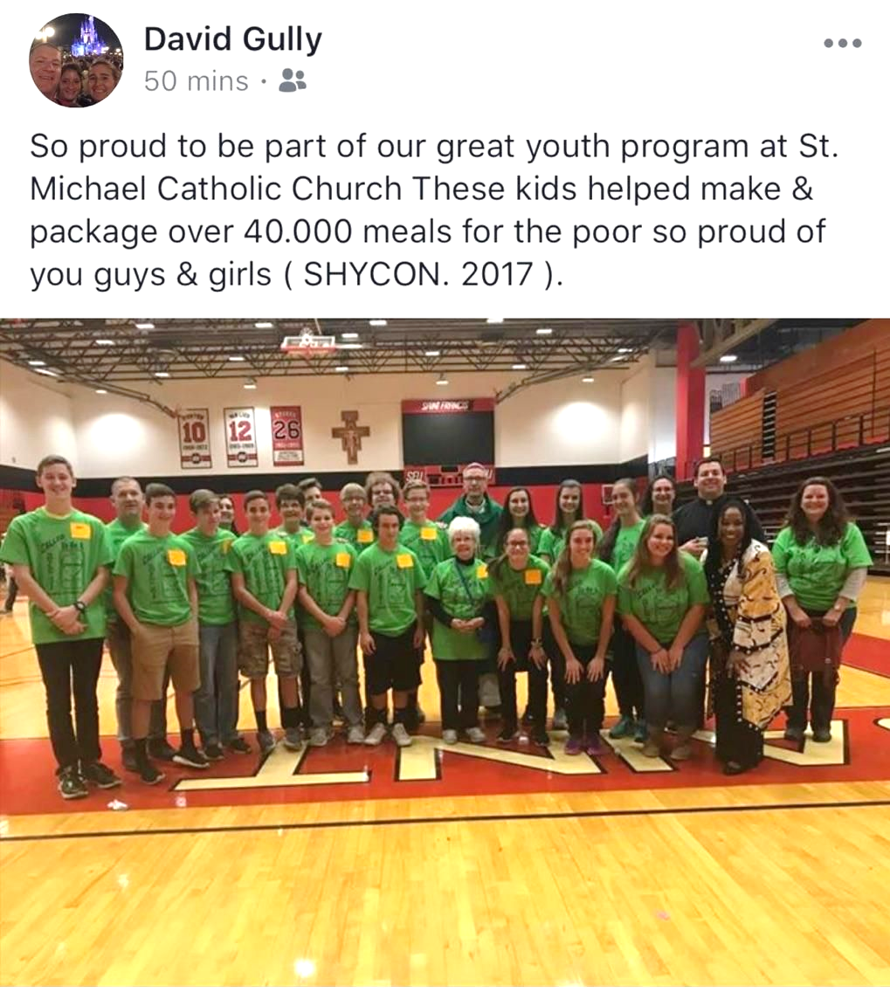

We had an awesome day at SHYCON 2017 last Sunday, October 22nd. Pictured here is our Saint Michael group of 9th,10th, 11th and 12th grade students, our chaperones, Bishop Mark, Fr. Brian and our keynote, ValLimar Jansan. Our kids represented our parish well with enthusiasm and energy that made for a spectacular day together. Our kids were able to participant together with the “Helping Hands” Project to pack meals for the hungry, and together we pack over 40,000 meals!! We ended our day with a wonderful Liturgy with Bishop Mark Bartchak along with diocesan Priests and Deacons.

11th Grade Discipleship Retreat is scheduled for Saturday, November 4th at Saint Francis University. This “FIREstarters Retreat” will be held at the Campus Ministry Center (next to Cafe' Gubbio) in Saint Francis Hall. The retreat will begin at 9:00 a.m. and conclude at 5:00 p.m., which includes a 4:30 p.m. Mass. Lunch will be provided and the $25 cost per student will be paid from our REACH Youth Ministry funds. Parents should have students arrive at 8:45 a.m. and pick-up again at 5:00 p.m. Parents also are invited to return and attend the 4:00 p.m. Mass held at the Immaculate Conception Chapel. "Application for Participation" forms will be provided to the 11th Grade students and permission is required for the students to attend. These forms need returned to the RE Office by October 22nd and forwarded to St. Francis to hold our group reservation.

* If students are not able to make this scheduled retreat date, they are required to attend another parish's Discipleship Retreat to fulfill this requirement. Alternate dates are available throughout the diocese. Inquire in the Religious Education Office.



2nd GRADE PENANCE / RECONCILIATION RETREAT ~ There will be a Penance / Reconciliation Retreat held on Sunday, November 5, 2017 beginning at 11:45 a.m. until 2:30 p.m. in the Parish Hall for all 2nd grade students and their parents. This retreat is part of the preparation process for these students to receive their sacrament of First Reconciliation. A letter with detailed information has been mailed to all 2nd Grade parents.

*\*\*\*\*\*\*\*\*\*\*\*\*\*\*\*\*\*\*\*\*\*\*\*\*\*\*\*\*\*\*\*\*\*\*\*\*\*\*\*\*\*\*\*\*\*\*\*\*\*\*\*\*\*\*\*\*\*\*\*\*\*\*\*\*\*\*\*\*\*\*\*\*\*\*\*\*\*\*\*\*\*\*\*\*\*\*\*\*\*\*\*\*\**

*Veteran's Day Liturgy and Luncheon ~ Sunday, November 12, 2017*

On November 12th at the 10:30 a.m. Sunday Mass, the REACH students will honor all area Veterans including all those men and women who have served and continue to serve our country through the National Guard and all branches of the military.  Everyone is welcome to participate in this event, *even those individuals who are not members of our parish.*  This is to be a community celebration in honor of all those who have helped make and continue to help keep this country free! All attended are invited to our parish hall for a light luncheon following the Mass celebration.

*Cookies and desserts are needed for this Luncheon -* we are in need of donations cookies or desserts. They can be brought to the church hall the morning of November 12th.

*\*\*\*\*\*\*\*\*\*\*\*\*\*\*\*\*\*\*\*\*\*\*\*\*\*\*\*\*\*\*\*\*\*\*\*\*\*\*\*\*\*\*\*\*\*\*\*\*\*\*\*\*\*\*\*\*\*\*\*\*\*\*\*\*\*\*\*\*\*\*\*\*\*\*\*\*\*\*\*\*\*\*\*\*\*\*\*\*\*\*\*\*\**

REACH Basket Social ~ Our REACH Youth Ministry will sponsor their annual REACH Basket Social on Sunday, December 3rd this year!

This basket social fundraiser helps pay for numerous activities like food provided at various service projects, Cookie Bake and Homebound Fruit Baskets, K—5 Easter treats, Mother's Day and Father's Day Gifts. REACH funds also cover the cost of our confirmation retreat expenses along with SHYCON and Junior High Youth Day to help assure students can attend.

*We are asking our Religious Education families to help with the Project:*

*Each Religious Education class, Grades K—12 are asked to sponsor a basket to be chanced off at this social as a classroom service project. Over these next few weeks, students in each grade will pick a theme for their basket. Each class will also decide if they are collecting money or purchased items. We ask that each student then bring their donation in by the beginning of November so that each class has ample time for their class to assemble their class basket by November 19th in time for the social. (There is no RE Class scheduled for Thursday, November 23rd or Sunday, November 26th)!*

*When sending your donations, please be sure to mark the envelope or bag “Basket Social” and also include your “Child's Name” and “Grade” to ensure that the correct grade receives them.* Donation envelopes can be dropped in the weekend collection basket at Masses or bagged items can be placed in the Bridal Room or brought to the Religious Education Office or Rectory Office.

Sunday, October 29 Religious Education / Grades 6–12 / 9:00 –10:20

Monday, October 30 Mass / 8:00 AM

Sunday Choir Practice / 7:00 PM

Tuesday, October 31 Mass / 8:00 AM

Mass / 6:00 PM / All Saints Day Vigil

Combined Christmas Choir Practice / After Vigil Mass

Wednesday, November 1 Mass / 9:00 AM / All Saints Day

Thursday, November 2 Mass / 8:00 AM

Mass / 6:00 PM / All Souls Day

Religious Education / Grades K-5 / 3:30-4:30

Saturday Choir Practice / 5:30 PM

Friday, November 3 Mass / 8:00 AM

First Friday / Exposition of the Blessed Sacrament

Saturday November 4 FIREstarters Retreat

UPCOMING EVENTS

November 5 Daylight Savings Time Ends / Turn Clocks Back

Applebee’s Dining to Donate

2nd Grade Penance / Reconciliation Retreat

Holy Name Society Meeting

November 6 Hall Rental / Msgr. Becker Pilgrmage to the Holy Land

November 11 & 12 Second Sunday Food Collection

November 12 Veteran’s Day Program and Luncheon

ADAMS TOWNSHIP LION’S CLUB ~ Sponsoring a Bus Trip on November 4, 2017 to Rivers Casino, Pittsburgh. $35 per person, $20 back for free play and $5 back for food. Bus leaving from Lone Star Restaurant, Johnstown. Please be there by 9:00 AM. Bus leaving Rivers Casino at 5:00 PM. For more information call Carol at 487-5988 or Bart at 487-4132.

COMMUNITY LAB BLOOD SCREEN ~ St. John the Baptist, 540 Main St., Summerhill, PA, is sponsoring a Community Lab Blood Screen, in conjunction with Chan Soon-Shiong Medical Center at Windber, on Saturday, November 11, 2017 from 7 – 9 AM. Cost is $30. Please call 814-476-3961 to schedule an appointment. Thank you.

ADAMS TOWNSHIP LION’S CLUB ~ Sponsoring a basket party on Sat. November 11th at St. Michael Firehall, St. Michael. Doors open at 5:00 PM. Drawing starts at 7:00 PM. Admission $8.00.

HOLY FAMILY PARISH BINGO ~ 509 Caldwell Ave., Portage. A night of Bingo, Sunday, October 29th in the Parish Hall. Admission is $20 per person. Extra specials and cards will be available. Doors open at 5 PM. Early bird games will begin promptly at 5:30 PM and the regular games will begin at 6:15 PM. Food and refreshments will be available.

BLACK TIE BINGO ~ Catholic Charities is holding its first fundraiser for the Martha & Mary House – Emergency Shelter Program in Johnstown on November 9, 2017 at Ace’s, 316 Chestnut St., Johnstown. $30 individual, $50 per couple includes appetizers, soft drinks and 1 bingo card per person, per game in your party. Cash bar. Wear black tie in any fashion you’d like. If it ties and it’s black you’re all set! To RSVP, please contact by email [jharshberger@dioceseaj.org](mailto:jharshberger@dioceseaj.org) or call 814-944-9388.

RESURRECTION LADIES AUXILIARY BASKET PARTY ~ November 12th at Christ the Savior Reception Hall, 307 Garfield St., Johnstown. Doors open at 12:30 PM. $10 includes lunch, 25 chances & eligibility for door prizes. For tickets call parish office at 539-5788, EXT. #3 and ask for Joann.

Sunday, October 29 Religious Education / Grades 6–12 / 9:00 –10:20

Monday, October 30 Mass / 8:00 AM

Sunday Choir Practice / 7:00 PM

Tuesday, October 31 Mass / 8:00 AM

Mass / 6:00 PM / All Saints Day Vigil

Combined Christmas Choir Practice / After Vigil Mass

Wednesday, November 1 Mass / 9:00 AM / All Saints Day

Thursday, November 2 Mass / 8:00 AM

Mass / 6:00 PM / All Souls Day

Religious Education / Grades K-5 / 3:30-4:30

Saturday Choir Practice / 5:30 PM

Friday, November 3 Mass / 8:00 AM

First Friday / Exposition of the Blessed Sacrament

Saturday November 4 FIREstarters Retreat

UPCOMING EVENTS

November 5 Daylight Savings Time Ends / Turn Clocks Back

Applebee’s Dining to Donate

2nd Grade Penance / Reconciliation Retreat

Holy Name Society Meeting

November 6 Hall Rental / Msgr. Becker Pilgrmage to the Holy Land

November 11 & 12 Second Sunday Food Collection

November 12 Veteran’s Day Program and Luncheon

ADAMS TOWNSHIP LION’S CLUB ~ Sponsoring a Bus Trip on November 4, 2017 to Rivers Casino, Pittsburgh. $35 per person, $20 back for free play and $5 back for food. Bus leaving from Lone Star Restaurant, Johnstown. Please be there by 9:00 AM. Bus leaving Rivers Casino at 5:00 PM. For more information call Carol at 487-5988 or Bart at 487-4132.

COMMUNITY LAB BLOOD SCREEN ~ St. John the Baptist, 540 Main St., Summerhill, PA, is sponsoring a Community Lab Blood Screen, in conjunction with Chan Soon-Shiong Medical Center at Windber, on Saturday, November 11, 2017 from 7 – 9 AM. Cost is $30. Please call 814-476-3961 to schedule an appointment. Thank you.

ADAMS TOWNSHIP LION’S CLUB ~ Sponsoring a basket party on Sat. November 11th at St. Michael Firehall, St. Michael. Doors open at 5:00 PM. Drawing starts at 7:00 PM. Admission $8.00.

HOLY FAMILY PARISH BINGO ~ 509 Caldwell Ave., Portage. A night of Bingo, Sunday, October 29th in the Parish Hall. Admission is $20 per person. Extra specials and cards will be available. Doors open at 5 PM. Early bird games will begin promptly at 5:30 PM and the regular games will begin at 6:15 PM. Food and refreshments will be available.

BLACK TIE BINGO ~ Catholic Charities is holding its first fundraiser for the Martha & Mary House – Emergency Shelter Program in Johnstown on November 9, 2017 at Ace’s, 316 Chestnut St., Johnstown. $30 individual, $50 per couple includes appetizers, soft drinks and 1 bingo card per person, per game in your party. Cash bar. Wear black tie in any fashion you’d like. If it ties and it’s black you’re all set! To RSVP, please contact by email [jharshberger@dioceseaj.org](mailto:jharshberger@dioceseaj.org) or call 814-944-9388.

RESURRECTION LADIES AUXILIARY BASKET PARTY ~ November 12th at Christ the Savior Reception Hall, 307 Garfield St., Johnstown. Doors open at 12:30 PM. $10 includes lunch, 25 chances & eligibility for door prizes. For tickets call parish office at 539-5788, EXT. #3 and ask for Joann.