Rev. 12:7

ST. MICHAEL ROMAN CATHOLIC CHURCH

751 Locust Street

PO Box 103

St. Michael, Pennsylvania 15951

Rev. Msgr. David A. Lockard, Administrator MASSES:



(814) 495-9640 Saturday 4:00 pm

Sunday Morning 8:00 am

10:30 am

Secretary: Michele Panick Daily Mass See Bulletin

Bookkeeper: Kathy Kalicky Holy Days See Bulletin

DRE: Laurie Sloan

Maintenance: Rodney Turgeon Office Hours:

PHONES: 8:30 am to 3:30 pm

Rectory / Office: (814) 495-9640 Monday, Tues., Thurs., Friday

Fax: (814) 495-9424 Confessions:

Rel. Education: (814) 495-4873 Saturday 3:30 pm to 3:45 pm

Parish Website Sunday 7:30 am to 7:45 am

www.saintmichaelchurch.weebly.com 10:00 am to 10:15 am

Secretaries’ E-mail By Appointment

[saintmichaelsecretaries@yahoo.com](mailto:saintmichaelsecretaries@yahoo.com)

YEAR: 2019 NUMBER: 48

SERVING GOD AND COMMUNITY FOR OVER ONE HUNDRED YEARS!

December 1, 2019

BAPTISM: By Appointment. Reserve at least one month in advance.

MARRIAGE: Plan at least nine months in advance.

Preparation sessions are necessary.

FUNERALS: Arrangements are made in conjunction with the funeral home.

REGISTRATION Those new to the area, newlyweds, and single adults, (even if registered

and before with their families) are asked to register by calling the Parish Office.

MEMBERSHIP: Every parishioner must be registered. This is a condition for admission

to our Program and reception of the Sacraments of Baptism, Confirmation, First Penance, First Eucharist, and Matrimony; also, for testimonial letters or sponsorship of Baptism and Confirmation outside the Parish.

VISITATION: We are concerned and want to be advised when someone is ill at

home or in the hospital. Call the rectory to have the shut-in placed on our monthly Holy Communion calls or seriously ill prayer list.

SACRAMENTAL Parish registration and active Mass participation for Baptism is encouraged

POLICY: and is required for Marriage.

BULLETIN ARTICLES: Articles are due to the Parish Office by Noon on TUESDAYS.

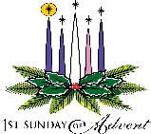 First Sunday in Advent December 1, 2019

Month of The Immaculate Conception

MASS INTENTIONS: (December 2 – December 8, 2019)

Monday 8:00 AM Buddy Andrykovitch req. by Michael & Regina Barton & family

Tuesday 8:00 AM Mary T. Deter req. by Bill Deter

Wednesday NO MASS

Thursday 8:00 AM For Catholics to return to the Church

First Friday 8:00 AM Steve Domen req. by Ed, Mike & Mary Hudak

Saturday 4:00 PM Anna Hudak req. by Ed, Mike & Mary Hudak

Sunday 8:00 AM People of the Parish

10:30 AM Joseph Olszewski req. by Joan & Bob Oshaben

LITURGICIAL APPOINTMENTS:

Saturday, December 7 4:00 PM Offertory Procession

Lector: Sandy Bambino Hudak Family

Minister of the Host: Susan Blazosky

Ministers of the Cup: Alice Podrebarac & Babe Richards

Altar Servers: Alex Bambino & Elisabeth Zajdel

Cantor: Amy Spangler

Greeter: Joanne Thomas

Sunday, December 8 8:00 AM Offertory Procession

Lector: Joseph Faher Paul & Beth Kundrod

Minister of the Host: Sally Kolar

Ministers of the Cup: Eric Tedjeske & Ellen Grattan

Altar Servers: Elizabeth & Ian Dobbins

Cantor: Sharon Dibble

Greeter: Pauline Minor

Sunday, December 810:30 AM Offertory Procession

Lector: Michael Barton Joan & Bob Oshaben

Minister of the Host: Susan Wieczorek

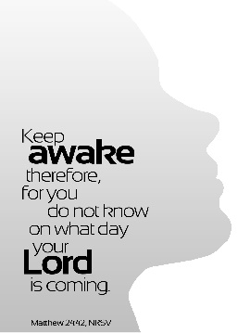Ministers of the Cup: Michael Steele & Amanda Williamson

Altar Servers: Haidyn & Amilyah Koch

Cantor: Anita Lorek

Greeter: REACH Students

Sunday, December 8 Collection Counters

Robert Casti, Camillus Long

Mary Ann DeRosa

The Sanctuary Candle will burn as a Special Intention for a Donor

during the week of December 1, 2019.

[](https://images.search.yahoo.com/search/images;_ylt=A0LEV1kSWptXvOwAKINXNyoA;_ylu=X3oDMTEyZGdkcmRoBGNvbG8DYmYxBHBvcwMxBHZ0aWQDQjIwODlfMQRzZWMDc2M-?p=Clipart+of+a+sanctuary+candle&fr=ush-mailn_02&th=110&tw=110&imgurl=http://www.henningers.com/389-168-wall-sanctuary-lamp.jpg&rurl=http://pixshark.com/sanctuary-lamp.htm&size=43KB&name=Sanctuary+Lamp+Bronze+wall+sanctuary+lamp&h=600&w=600&turl=http://ts2.mm.bing.net/th?id=OIP.M68453c67108cdc5ab485d309b395bd03o0&pid=15.1&rs=1&c=1&qlt=95&w=110&h=110#inline&tt=Sanctuary+Lamp+Bronze+wall+sanctuary+lamp&sigr=116keh5le&sigit=13gvlt42j&sigi=11ip0pgm4&sign=119kp6100&sigt=119kp6100)

FRIST FRIDAY ~ Exposition of the Blessed Sacrament will be First Friday, December 6th with adoration from 8:30 AM until 12:00 PM Noon. Please note that we cut back on the hours so the time slots can be filled. Sign-up sheets can be found at the entrances of the Church.

IMMACULATE CONCEPTION ~ Since December 8th is the Second Sunday of Advent, the Solemnity of the Immaculate Conception of the Blessed Virgin Mary is transferred to Monday, December 9th. While the Solemnity of the Immaculate Conception remains a holy day, it is not a holy day of obligation. There will be two Masses here at St. Michael for the Immaculate Conception on Monday, December 9th at 8:00 AM and 6:00 PM. I encourage our faithful to attend Mass to celebrate the Immaculate Conception.

ADVENT CONFESSIONS ~ Advent Confessions will be here at St. Michael Monday, December 10th at 6:00 PM. Several priests will be present to assist Msgr. Lockard. Mark your calendars now. We will combine with Most Holy Trinity, South Fork. Everyone welcome!

EXTRA CONFESSION TIMES ~ For people who wish to make a Christmas confession, we will offer the sacrament of Reconciliation after the 8:00 AM Masses on Thursday, December 19th, Friday, December 20th and Monday, December 23rd. As always, there will be confessions offered one half hour before the weekend Masses.

RETIREMENT FUND FOR RELIGIOUS ~ Give in thanksgiving. “The nuns left lasting impressions on me,” writes a donor. “I shall always be grateful for my Catholic education.” Please join in thanking the thousands of senior Catholic sisters, brothers, and religious order priests who worked tirelessly to educate the young and serve those in need. Next week’s second collection is for the Retirement Fund for Religious, which helps hundreds of religious communities care for aging members. Please give generously.



CHRISTMAS FLOWERS ~ If you would like to purchase a Christmas flower for a living (In Honor Of) or a deceased (In Memory Of) member of your family, please do so by using the Christmas Flower envelope in your packet. The normal offering is $10.00. Extra envelopes can be found at the church entrances.

OPLATKI ~ Oplatki will be available next weekend (December 7th & 8th) at all Masses.

SECOND SUNDAY FOOD PANTRY COLLECTION ~ Next weekend is our Second Sunday Food Collection. Please bring in non-perishable food items or toiletries with you. Monetary donations are also appreciated.

COMBINED CHRISTMAS CHOIR ~ Combined Choirs for Christmas will rehearse Tuesday, December 3rd, 10th, and 17th at 7:00 PM. Other dates and times TBA.

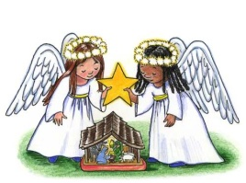

SALVATION ARMY TREASURES FOR CHILDREN PROJECT ~

* Return your UNWRAPPED gift(s) with the tag attached to the St. Michael Catholic Church St. Paul Room

by December 9th so that we can check them off and deliver them to the Salvation Army in time for distribution to the families.

* If you wish, you could provide an “extra” gift of your choice to be used for those tags that are not chosen at all. Gifts and larger clothing for pre-teens ages 11-13 are particularly hard to fill.

Weare placing names of the sick in the bulletin for prayer providing they give permission. *May the* *Divine Physician send healing grace for those for* *whom we pray:* Allen C. Rosemas, Patricia Murphy, Bernice Myers, Dwight Fyock, Dylon Wills, Missy, Joanne (Kolar) Hufford, Christine Flanagan, Ayden Alan Grata, Mary Lou Offman, Mary Zangaglia, Natalie Zerby, Valencia & Frank Tursi, Homer Locher, Brayden Schofield, Michelle Kasper, Diane Kingera, Allison Krischer, Ted Paluch, Brandt Hutzel, Pearl Litzinger, Patrick Munro, Fran Baldassarre, Kristen Sinosky Long, Helen Ranieri, Cresta Micik, Basil Costantino, Madison McCrory, Laura, Joe Yoder, Dolores Yanzetich, Sandy Krug, Wanda Gramling, Merna Smay, Agnes Plummer, Jennifer Hagans, Shawn, Holly, Shane, Spencer, Owen Taylor, Keith & Dawnetta Hoyer, Derrick Varnish, Vincent Koshute, Melissa Cordek, Michelle Elliott, Heather Romanow, Mackston Barrick, Connor Thomas, Erin, Pat, Mary Agnes Nastase, Mary Ann Bertolino, Dick Wilson, Izzy Bihun, Dorothy Kaminsky, Patricia Oshaben, Ashlee Madison, Susan Yanzetich, Mike, Danika Faith, Alina Rusnak, Marcia Costlow, Gary Smay, Elizabeth Howell, Helen Bowen, Walter Bodziak, Rhonda, Dan Strinkoski, Anne Robinson, Marlene McCrory, Sharon Poldiak, Carter Bobak, Vince Arena, Mike Morris, Sarah Kelt, Patty Yanzetich Caldwell, Colton Snyder, Betty Delaney, Nancy Edmiston, Elizabeth Stoker Thomas, Albert Sracic, Joseph Ropecka, Bill Krajewski, Leonard Oshaben, Florence Smith, Michael Chalan Jr., Adam, Bill Gideos, Janice Dipyatic, John Poldiak Jr., Gerald Delaney, Lily Maloney, Adam Wingard, Scott, Lisa, Rosalie Ambrose, John Patrick and all of the sick of our parish, the homebound, those in nursing homes, those who care for them, and those in the military along with their families. *(Please call the Rectory to have your name removed from the list when no longer seriously ill. Thank You.)*

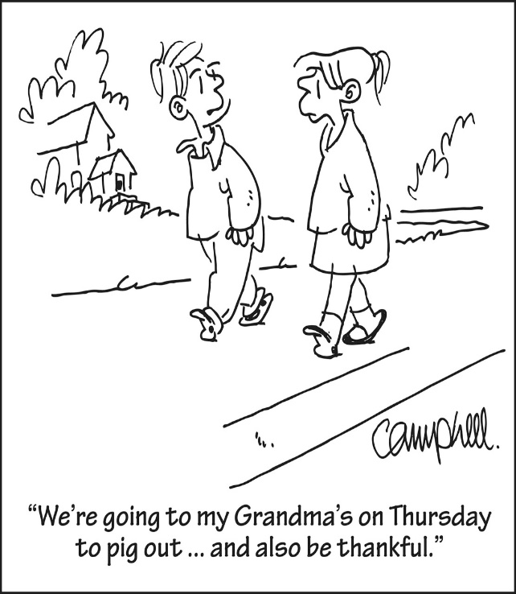

LAST WEEK’S COLLECTION

Adults $3,482.00

Loose $ 195.50

Youth $ 35.50

Monthly $ 156.00

Maintenance Fund $ 475.00

Candles $ 32.00

All Saints $ 5.00

All Souls $ 5.00

Initial Offering $ 10.00

Solemnity of Mary $ 10.00

Immaculate Conception $ 30.00

Religious Retirement $ 10.00

Catholic Charities $ 410.00

Christmas Flowers $ 798.00

Christmas Offering $ 20.00

Total $5,674.00

We sincerely thank and ask God’s

blessing upon all who have care

and concern for our parish.

December 1, 2019 Matthew 24:37-44

In today’s gospel Jesus advises: “Stay awake, watch out, and pray for the strength to hold your ground” when “fearful and bewildering signs” appear threatening your family. Resist being “fearful;” fear cripples! Instead “pray for the strength” to be courageous.



Religious Education And Christian Helping

December 1, 2019

Religious Education Class Schedule

For the Thanksgiving Holiday break, there will be No Religious Education classes on Sunday, December 1st for grades 6—12.

Classes will resume on Thursday, December 5th for our K—5 students and on Sunday, December 8th for our grades 6—12 students.



 *It’s time to make the baskets!* ~ Our REACH Youth Ministry will sponsor their

annual REACH Basket Social on Sunday, December 8th.

Any help with this is greatly appreciated! Any donated items or baskets can be left in the Bride’s Room of the church or dropped off at the Parish or Religious Education Offices.

\*If you are still able to make a donation, please have them in by Friday, December 6th. Our Prep Day is Saturday, December 7th at 11:00 AM.

On Sunday December 8th, tickets will be available at the door for $5.00 each which includes 25 perforated basket chances and 1 door prize chance. Multiple tickets may be purchased. *Doors will open at 1:00 p.m. with 'chancing off' beginning at 2:00 p.m.* Come early to purchase your tickets and have ample time to view all baskets available and place your chances before the drawing begins.

*Attention—Parents of REACH Students:* We are asking each REACH student from grades 6—12 to donate the following items to help with our Basket Social fundraiser. Non-perishable items (Soda, Candy, and Snacks) can be dropped off anytime over the next two weeks. Cakes, Desserts and Ice Tea can be brought to the church hall by Noon on Sunday,

December 8.

Grades 7 & 10 Bag of chocolate candy (Asst. minis, snack size or kisses)

Grades 6 & 8 Cake / Dessert

Grade 11 Two 2-liters of soda

Grade 9 Bags of snacks (potato chips or pretzels)

Grade 12 One Gallon of Ice

*Upcoming REACH Service Projects*

*Holy Name K—5 Treats ~* Our Holy Name Society will sponsor a Christmas Pizza Party for our K—5 students on Thursday, December 19th. REACH students are needed to pack the Christmas treats that they distribute to students. They will be gathering for this task on Tuesday, December 17th at 6:00 p.m. in the Parish Hall. Sign-up in the RE Office at 495-4873.



*Christmas Fruit Baskets for our Homebound Parish Members*

REACH students are needed to help assemble fruit baskets on Tuesday, December 17th at 6:00 PM in the Parish Hall. These fruit baskets will be delivered to the homebound members of our parish for Christmas. Come help spread some holiday cheer and well wishes to our parish shut-ins by being part of this project. Sign-up in the RE Office at 495-4873.

C:\Users\Laurie\Downloads\c_hllybrdr.jpg

MC900436063[1]Eucharistic Adoration Day for Teens in Grades 9—12

High school students in grades 9—12 are invited to attend a Eucharistic Adoration with Bishop Mark Bartchak. This will be hosted here at our Saint Michael Parish on Saturday, December 14, 2019. The day will begin at 10:00 AM in the church with Praise and Worship Music and Eucharistic Adoration celebrated by Bishop Mark with an opportunity for reconciliation. This event is open to all teens throughout the Altoona-Johnstown diocese as part of their Confirmation Process. A social gathering will be held afterwards for fellowship with Bishop Mark.

*Teens must pre-register.*

*Return Registration forms to the Religious Education Office.*

*As part of the new Diocesan Confirmation Revisions, all students in the 3-year confirmation preparation process, (Grades 9, 10 and 11), are required to attend a Eucharistic Adoration Day with*

*Bishop Mark Bartchak at least 1 time within their 3-year process.*

C:\Users\Laurie\Downloads\c_hllybrdr.jpg

Fall Confirmation Session

*Grade 11 ~ Fall Session 11B ~*

*Sacraments and the Paschal Mystery: Sunday, December 15, 2019*

All 11th Grade students will be attending their Fall Session 11B from 9 to 10:20 a.m. in the Saint Paul Room to fulfill this session requirement.

*\* If the students miss this scheduled session, they are required to attend another*

*Parishes scheduled session to fulfill these requirements.*

Sunday, December 1 NO High School Religious Ed.

 Girl Scouts / 1:30 – 3:00 PM & 4 – 5:30 PM

Monday, December 2 Sunday Choir Practice / 7:00 PM

Tuesday, December 3 Combined Christmas Choir / 7:00 PM

Boy Scouts / 7:30 PM

Wednesday, December 4 No Mass

Thursday, December 5 K – 5 Religious Ed / 3:30-4:30 PM

Saturday Choir Practice / 4:30 PM

First Friday, December 6 Exposition of Blessed Sacrament with Adoration / 8:30 AM-Noon

Saturday, December 7 Retirement Fund for Religious / Second Collection

Second Sunday Food Pantry Collection

 UPCOMING EVENTS

December 8 Retirement Fund for Religious / Second Collection

Parish Council Meeting

REACH Basket Social

December 10 Advent Confessions / 6:00 PM

December 14 Eucharistic Adoration with Bishop Mark Bartchak, For Teens, grades 9—12

December 15 Holy Name Meeting

Coffee & Donuts

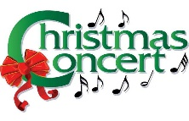

**FOREST HILLS COMMUNITY BAND** ~ Presents their 2019 ***Christmas Concerts***! Sun., Dec. 1st, Mount Hope Church – 6 PM / Sat., Dec. 7th, Ebensburg Center (Mini Mall Road) – 1:30 PM / Sun., Dec. 8th, Dunlo Fire Hall – 6 PM / Sun., Dec.15th, New Germany Grove Hall – 6 PM / Sun., Dec. 22nd, Galleria Mall, Richland – 2 PM.

**COOKIE CONTEST, BAKE SALE AND CHRISTMAS CRAFTS** ~ For kids on Saturday, December 7th from 9 to 11 AM at the Bishop Carroll Library. $5 Entry fee for the cookie contest. Please make 1 dozen cookies for judging. Cookies & Entry fee should be brought to the BCCHS Library by 9:30 AM on Saturday, December 7th. Judging will be at 10:30 AM. Please visit [www.bishopcarroll.com](http://www.bishopcarroll.com).



BASKET PARTY & SPAGHETTI DINNER ~ Greater Johnstown Career and Technology Center Culinary Students are hosting a Basket Party & Spaghetti Dinner on December 15th starting at Noon. Dinner & Basket Chances Ticket is $20. Take outs available for $10. 120 + baskets, 50/50, door prizes and qualifiers. Supports the Trip to Disney Resort for Cook around the world. Info at 814-266-6073.

A PREPARATION FOR CHRISTMAS ~ Living faith with Mary through renewal of the mind and transformation of the heart. It is by refining and deepening our faith, renewing our minds by putting on a new fresh way of thinking, and being open to transformation that we can experience true and lasting spiritual freedom. Join Fr. David Tickerhoof TOR on Monday, December 9th at Sisters of the Sacred Heart Retreat Center, 1872 Munster Road, Portage, Pa from 9:00 AM to 3:30 PM to experience! Cost: Suggested $20. RSVP: Monday, December 2nd, 2019. Fr. David Tickerhoof at 941-243-0372 or frdavidjt@gmail.com.