Rev. 12:7

ST. MICHAEL ROMAN CATHOLIC CHURCH

751 Locust Street

PO Box 103

St. Michael, Pennsylvania 15951

Rev. Msgr. David A. Lockard, Administrator MASSES:

(814) 495-9640 Saturday 4:00 pm



Sunday Morning 8:00 am

Secretary: Michele Panick 10:30 am

Bookkeeper: Kathy Kalicky Daily Mass See Bulletin

DRE: Laurie Sloan Holy Days See Bulletin

Maintenance: Rodney Turgeon

Office Hours:

PHONES: 8:30 am to 3:30 pm

Rectory / Office: (814) 495-9640 Monday, Tues., Thurs., Friday

Fax: (814) 495-9424 Confessions:

Rel. Education: (814) 495-4873 Saturday 3:30 pm to 3:45 pm

Parish Website Sunday 7:30 am to 7:45 am

www.saintmichaelchurch.weebly.com 10:00 am to 10:15 am

Secretaries’ E-mail By Appointment

[saintmichaelsecretaries@yahoo.com](mailto:saintmichaelsecretaries@yahoo.com)

YEAR: 2019 NUMBER: 52

SERVING GOD AND COMMUNITY FOR OVER ONE HUNDRED YEARS!

December 29, 2019

BAPTISM: By Appointment. Reserve at least one month in advance.

MARRIAGE: Plan at least nine months in advance.

Preparation sessions are necessary.

FUNERALS: Arrangements are made in conjunction with the funeral home.

REGISTRATION Those new to the area, newlyweds, and single adults, (even if registered

and before with their families) are asked to register by calling the Parish Office.

MEMBERSHIP: Every parishioner must be registered. This is a condition for admission

to our Program and reception of the Sacraments of Baptism, Confirmation, First Penance, First Eucharist, and Matrimony; also, for testimonial letters or sponsorship of Baptism and Confirmation outside the Parish.

VISITATION: We are concerned and want to be advised when someone is ill at home or in the hospital. Call the rectory to have the shut-in placed on our monthly Holy Communion calls or seriously ill prayer list.

SACRAMENTAL Parish registration and active Mass participation for Baptism is

POLICY: encouraged and is required for Marriage.

BULLETIN ARTICLES: Articles are due to the Parish Office by Noon on Tuesdays.

 The Holy Family of Jesus, Mary and Joseph

December 29, 2019

Month of The Immaculate Conception

**MASS INTENTIONS**: (December 30 – January 5, 2020)

Monday 12:00 PM Rose and Fern Danel req. by Family

Tuesday 5:00 PM Alan Oshaben req. by Joan & Bob Oshaben

Wednesday 10:00 AM People of the Parish

Thursday 12:00 PM For Catholics to return to the Church

Friday 12:00 PM John Vandzura req. by Louise Oblinsky

Saturday 4:00 PM People of the Parish

Sunday 8:00 AM William Shay req. by Joe & Cathy Faher

Sunday 10:30 AM Thomas Murin req. by Mary Ann Murin & Family

LITURGICIAL APPOINTMENTS:

Saturday, January 4 4:00 PM Offertory Procession

Lector: Susan Poldiak John & Bonnie Bizzarri

Ministers of the Host: Janet Minor & Theresa Carlson

Ministers of the Cup: Susan Blazosky & George Minor

Altar Servers: Carson & Dylan Kundrod

Cantor: Amy Spangler

Greeter: Shirley Walls

Sunday, January 5 8:00 AM Offertory Procession

Lector: Cathy Faher Joe & Cathy Faher

Ministers of the Host: Robert Grattan & Sally Kolar

Ministers of the Cup: Paul Kundrod & Marie Jo Plummer

Altar Servers: Elizabeth & Ian Dobbins

Cantor: Joseph Faher

Greeter: Pauline Minor

Sunday, January 510:30 AM Offertory Procession

Lector: Michael Barton Michael Steele Family

Ministers of the Host: Amanda Williamson & Edie Knobloch

Ministers of the Cup: Michael Steele & Robert Oshaben

Altar Servers: Haidyn & Amilyah Koch

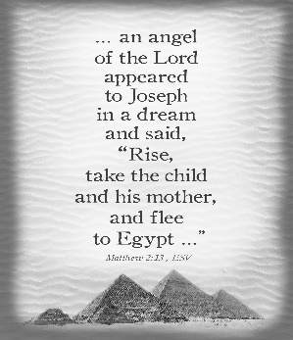Cantor: Louis McCloskey

Greeter: Nancy Wessel

Sunday, January5 Collection Counters

John Bizzarri, Robert Casti

Sharon Paterson

Weare placing names of the sick in the bulletin for prayer providing they give permission. *May the* *Divine Physician send healing grace for those for* *whom we pray:* Allen C. Rosemas, Patricia Murphy, Bernice Myers, Dwight Fyock, Dylon Wills, Missy, Joanne (Kolar) Hufford, Christine Flanagan, Ayden Alan Grata, Mary Lou Offman, Mary Zangaglia, Natalie Zerby, Michael Wadsworth, Valencia & Frank Tursi, Homer Locher, Brayden Schofield, Michelle Kasper, Diane Kingera, Allison Krischer, Ted Paluch, Brandt Hutzel, Pearl Litzinger, Patrick Munro, Fran Baldassarre, Kristen Sinosky Long, Helen Ranieri, Cresta Micik, Basil Costantino, Madison McCrory, Laura, Joe Yoder, Dolores Yanzetich, Sandy Krug, Wanda Gramling, Merna Smay, Agnes Plummer, Jennifer Hagans, Shawn, Holly, Shane, Spencer, Owen Taylor, Keith & Dawnetta Hoyer, Derrick Varnish, Vincent Koshute, Melissa Cordek, Michelle Elliott, Heather Romanow, Mackston Barrick, Connor Thomas, Erin, Pat, Mary Agnes Nastase, Mary Ann Bertolino, Dick Wilson, Izzy Bihun, Dorothy Kaminsky, Patricia Oshaben, Ashlee Madison, Susan Yanzetich, Mike, Danika Faith, Alina Rusnak, Marcia Costlow, Gary Smay, Elizabeth Howell, Helen Bowen, Walter Bodziak, Rhonda, Dan Strinkoski, Anne Robinson, Marlene McCrory, Sharon Poldiak, Carter Bobak, Vince Arena, Mike Morris, Sarah Kelt, Patty Yanzetich Caldwell, Colton Snyder, Betty Delaney, Nancy Edmiston, Elizabeth Stoker Thomas, Albert Sracic, Joseph Ropecka, Bill Krajewski, Leonard Oshaben, Michael Chalan Jr., Adam, Bill Gideos, Janice Dipyatic, John Poldiak Jr., Gerald Delaney, Lily Maloney, Adam Wingard, Scott, Lisa, Rosalie Ambrose, John Patrick, Ellen Grattan and all of the sick of our parish, the homebound, those in nursing homes, those who care for them, and those in the military along with their families. *(Please call the Rectory to have your name removed from the list when no longer seriously ill. Thank You.)*

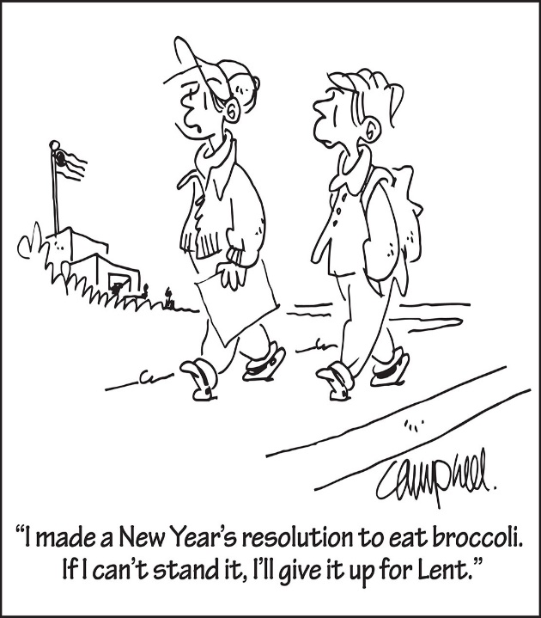

LAST WEEK’S COLLECTION

Adults $3,283.00

Loose $ 145.50

Youth $ 20.50

Monthly $ 150.00

Candles $ 34.00

Maintenance $ 578.00

Immaculate Conception $ 60.00

Christmas $ 695.00

Christmas Flowers $ 20.00

Religious Retirement $ 50.00

Total $5,041.00

We sincerely thank and ask

God’s blessing upon all

who have care and

concern for our

parish.

December 29, 2020 Matthew 2:13-15, 19-23

Today’s gospel says Joseph “made his home in Nazareth.” A “home” is built on the foundation of love, commitment and a shared history and is decorated with forgiveness, acceptance, rituals, discipline and mutual support. The Holy Family challenges us today: Don’t live ‘anyplace’, live at HOME!

The Sanctuary Candle will burn for the

Well-Being of the Parishioners of

St. Michael Parish

during the week of December 29, 2019.

[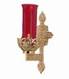](https://images.search.yahoo.com/search/images;_ylt=A0LEV1kSWptXvOwAKINXNyoA;_ylu=X3oDMTEyZGdkcmRoBGNvbG8DYmYxBHBvcwMxBHZ0aWQDQjIwODlfMQRzZWMDc2M-?p=Clipart+of+a+sanctuary+candle&fr=ush-mailn_02&th=110&tw=110&imgurl=http://www.henningers.com/389-168-wall-sanctuary-lamp.jpg&rurl=http://pixshark.com/sanctuary-lamp.htm&size=43KB&name=Sanctuary+Lamp+Bronze+wall+sanctuary+lamp&h=600&w=600&turl=http://ts2.mm.bing.net/th?id=OIP.M68453c67108cdc5ab485d309b395bd03o0&pid=15.1&rs=1&c=1&qlt=95&w=110&h=110#inline&tt=Sanctuary+Lamp+Bronze+wall+sanctuary+lamp&sigr=116keh5le&sigit=13gvlt42j&sigi=11ip0pgm4&sign=119kp6100&sigt=119kp6100)

[](http://www.churchart.com/subscriber/viewimages.aspx?keywords=In%20Sympathy&entry_date=1/1/0001&image_type=,cl#no)

MAY HE REST IN PEACE ~ In your charity, please pray for the eternal rest of Paul Chulick whose Funeral Mass was celebrated on Thursday, December 19th, 2019 by Msgr. David Lockard. May he know the eternal peace and happiness promised by our Savior, Lord Jesus. Please pray for the consolation of all his family and friends.

PLEASE NOTE! ~ Solemnity of Mary is a Holy Day of Obligation. Masses will be at 5:00 PM on Tuesday, December 31st and 10:00 AM on Wednesday, January 1, 2020.

PARISH OFFICES ~ The Parish offices will be closed on Tuesday, December 31st and Wednesday, January 1st, 2020 for the New Year’s Holiday.

CHRISTMAS FLOWERS ~ In Memory of: Mike Hudak, Rose Hudak, Margaret Hudak, and Steve Domen by Edward Hudak. In Honor of: Janet Howell by Ron & Amy Dobbins & Family.

EUCHARISTIC MINISTERS ~ For now, Msgr. Lockard needs four eucharistic ministers for each Mass. Please check the bulletin to see if you are scheduled. As always, if you cannot keep your assignment, please find a replacement.

2020 CALENDARS ~ 2020 calendars are available this weekend. Please, one calendar per family. Special thanks to the C.O. Dimond Funeral Home for donating these calendars to our Parish.

SUNDAY CHOIR ~ No Choir practice on Monday, December 30th. Christmas Break. Regular rehearsals resume Monday, January 6th, 2020 at 7 PM. Thank you for your time and talent.

LAY MINISTRY SCHEDULES REQUESTS ~ Lay Ministry schedule requests are currently being taken for the Spring Schedule which covers February through May 2020. If you have a request for dates you are not available or for dates that you are only available, please contact Suzi Blazosky at 495-5287 or email: [sublazosky@gmail.com](mailto:sublazosky@gmail.com) by Sunday, January 19th. Lay ministers are being sought for all masses and all ministries – Cantors, Readers, Eucharistic Ministers, Greeters, Altar Servers, and Collection Counters. Please contact Msgr. Lockard or Suzi for further details or if you would like to volunteer.

Solemnity of Mary, Holy Mother of God Liturgical Appointments

Tuesday, December 31st 5:00 p.m. Wednesday, January 1st 10:00 a.m.

Lector: Sandy Bambino Lector: Pauline Minor

Ministers of the Host: Sharon Paterson & Beth Kundrod Ministers of the Host: Sally Kolar & Terri Leach

Ministers of the Cup: Eric Tedjeske & Ellen Grattan Ministers of the Cup: Karen Myers & Pauline Minor

Servers: Shannan Elgin & Adalynne Webb Servers: Landon & Zach Fisher

Cantor: Amy Dobbins Cantor: Theresa Arena

Greeter: Phyllis Slonac Greeter: Karen Myers

Offertory Procession: Joan & Bob Oshaben Offertory Procession: Carol Cordek & Terri Leach



Religious Education And Christian Helping

December 29, 2019

*Religious Education Schedule for the Christmas & New Year’s Holiday*

*We will have a holiday break for our Religious Education students and catechists. Religious Education Classes will not be held over the holiday break including the following date:*

*No Class on Sunday, December 29th for Grades 6—12.*

Classes will resume on Thursday, January 2nd for K~5 and Sunday, January 5th for Grades 6~12.

C:\Users\Laurie\Downloads\c_hllybrdr.jpg

*Confirmation Retreat* ~ Grades 9, 10 & 11

Saturday, January 11, 2020, 1—6:30 PM

All students in grades 9, 10, & 11 will take part in their annual confirmation retreat on Saturday, January 11, 2020, 1—6:30 PM. The retreat will focus on the three required retreat topics of ~ “Baptism”, “Gifts of the Holy Spirit” and “Parables”.

The program will begin in the parish hall at 1:00 PM for the students, and continue through our 4:00 Saturday Mass, and conclude with a social in our Parish Hall with students, parents and sponsors.

A Rosary will be led by our 11th grade Confirmation Class prior to Mass at 3:30 PM. During this 4:00 Mass, the 9th grade students will celebrate their “‘Rite of Blessing” and the 10th Grade students will celebrate their “Rite of Commitment” as part of their confirmation journey along with a parent or their confirmation sponsor.

Retreat schedule as follows:

* At 1:00 PM, the students come to the parish hall and join classmates for specific topic discussions with their grade level leader in designated classrooms for their grades retreat.
* At 3:15 PM, each 9th & 10th grade student will need a parent or sponsor to meet them in the Parish Hall to line up and walk over to the church and sit in reserved pews so our confirmation students and their sponsor or parent are together for their Rite ceremony during 4:00 Mass.
* Also, at 3:15 PM, sponsors and / or parents of our 11th grade confirmation students are asked to sit in the church for a Rosary led by our 11th grade Confirmation Class followed by Mass.

Following Mass, all students, parents and sponsors are invited to attend a pizza social in the parish hall including time for reflection on the day and also time for the confirmation candidates and their sponsors to spend time together discussing their sponsor / candidate session activities.

Sunday, December 29 NO High School Religious Ed. / 9:00 – 10:20 AM

Monday, December 30 Mass / 12:00 PM

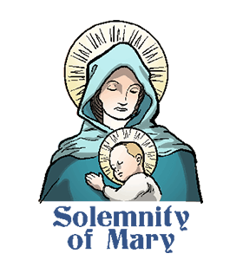

Tuesday, December 31 Vigil of the Solemnity of Mary, Holy Mother of God / 5:00 PM

Parish Offices Closed

Wednesday, January 1, 2020 Solemnity of Mary, Holy Mother of God / 10:00 AM

Holy Day of Obligation

Parish Offices Closed

Thursday, January 2 K—5 Religious Ed. / 3:30 – 4:30 PM

Saturday Choir Practice / 4:30 PM

Friday, January 3 Exposition of the Blessed Sacrament with Adoration / 12:30 – 3:00 PM

Saturday, January 4

UPCOMING EVENTS

January 7 Sacramental Class / Fr. Grimme / Church Hall

POLISH CHRISTMAS CAROLS ~ All Saints Parish in Boswell will be hosting a sing along/concert of beloved Polish Christmas carols (Koledy) as well as exposition and Benediction of the Blessed Sacrament on Sunday December 29th at 3:00 PM at their church located at 325 Quemahoning St., Boswell (Somerset County). Following the event refreshments will be provided. Any questions can be directed to the parish office at 814-629-5551. All are welcome!

JEWELRY RAFFLE ~ Immaculate Conception Church, New Germany. Door ticket includes: Admission, Meal, Dessert and Drinks. Saturday, January 18th, 2020. Grand Prize: $1000 Jewelry shopping spree at Gold Rush Diamonds & Boutique. Doors open at 5 PM, 1st drawing at 6 PM. Pulled winning Door Tickets will be re-entered for Grand Prize. Need not be present to win. Jewelry, Accessories, Instant Bingo & 50/50’s will be chanced during the bash. For tickets contact 814-254-9997 or visit [www.facebook.com/ICJewelryRaffle](http://www.facebook.com/ICJewelryRaffle). Only 500 tickets sold. $25 DONATION. *No Guests.*

SQUARE DANCES ~ Will by held at New Germany Grove, Summerhill on January 4 & 25, February 15 & 29, March 21 & April 4. Music by Klassic Kountry from 7 – 10. Admission is $10 which includes dancing, soft drinks and a light meal. Benefit prolife.