ST. MICHAEL ROMAN CATHOLIC CHURCH

751 Locust Street

PO Box 103

St. Michael, Pennsylvania 15951

Rev. Msgr. David A. Lockard, Administrator MASSES:

(814) 495-9640 Saturday 4:00 pm



Sunday Morning 8:00 am

Secretary: Michele Panick 10:30 am

Bookkeeper: Kathy Kalicky Daily Mass: M,T,W,Th,F Noon

DRE: Laurie Sloan Holy Days: See Bulletin

Maintenance: Rodney Turgeon Office Hours:

PHONES: 8:30 am to 3:30 pm

Rectory / Office: (814) 495-9640 Monday, Tues., Thurs., Friday

Fax: (814) 495-9424 Confessions:

Rel. Education: (814) 495-4873 Saturday 3:30 pm to 3:45 pm

Parish Website Sunday 10:00 am to 10:15 am

[www.saintmichaelchurch.weebly.co](http://www.saintmichaelchurch.weebly.co)m By Appointment

Secretaries’ E-mail

[saintmichaelsecretaries@yahoo.com](mailto:saintmichaelsecretaries@yahoo.com)

Facebook page:

St. Michael Catholic Church/St. Michael, PA

Second Sunday of Advent

SERVING GOD AND COMMUNITY FOR OVER ONE HUNDRED YEARS!

December 6th, 2020

BAPTISM: By Appointment. Reserve at least one month in advance.

MARRIAGE: Plan at least nine months in advance.

Preparation sessions are necessary.

FUNERALS: Arrangements are made in conjunction with the funeral home.

REGISTRATION Those new to the area, newlyweds, and single adults, (even if registered

and before with their families) are asked to register by calling the Parish Office.

MEMBERSHIP: Every parishioner must be registered. This is a condition for admission

to our Program and reception of the Sacraments of Baptism, Confirmation,

First Penance, First Eucharist, and Matrimony; also, for testimonial letters or sponsorship of Baptism and Confirmation outside the Parish.

VISITATION: We are concerned and want to be advised when someone is ill at home or in the hospital. Call the office to have the shut-in placed on our monthly Holy Communion calls or seriously ill prayer list.

SACRAMENTAL Parish registration and active Mass participation for Baptism is

POLICY: encouraged and is required for Marriage.

BULLETIN ARTICLES: Articles are due to the Parish Office by Noon on Tuesday.

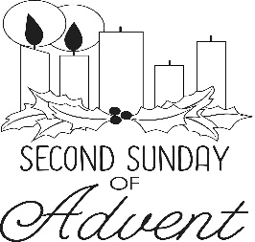

Second Sunday of Advent

December 6th, 2020

The Immaculate Conception

**MASS INTENTIONS**: (December 7 – December 13, 2020 )

Monday Noon Kevin Smay req. by Helen Soohy

Tuesday Noon The Michaels & Starchville Families req. by Mike & Marianne Starchville

6:00 PM People of the Parish

Wednesday Noon Harry Noon req. by Family

Thursday Noon Thomas Paterson req. by Ronald & Sandra Stombaugh

Friday Noon Mary Sivec req. by Grace Wilson

Saturday 4:00 PM Donald Bumbernick req. by Chuck & Mary Ann Tedjeske

Sunday 8:00 AM People of the Parish

10:30 AM Helen McClemens req. by Helen Varney

LITURGICIAL APPOINTMENTS:

Saturday, December 12 4:00 PM

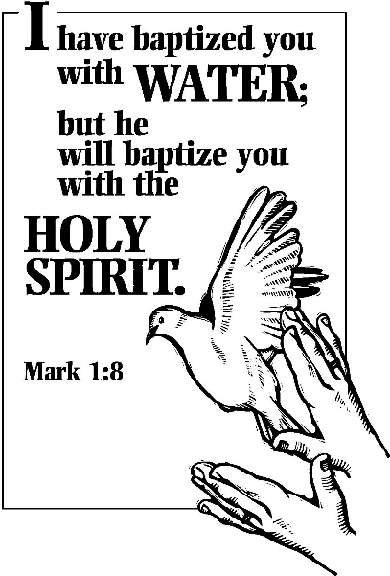Lector: Don Dipko

Minister of the Host: Mike Barton

Altar Server: Carson Kundrod

Cantor: Susan Blazosky

Sunday, December 13 8:00 AM

Lector: Arnold Bernard

Minister of the Host: Marie Bernard

Altar Server: Griffin Christ

Cantor: Sharon Dibble

Sunday, December 13 10:30 AM

Lector: Carole Kakabar

Minister of the Host: Mike Steele

Altar Server: Alexis Henderson

Cantor: Lou McCloskey

During the week of December 6th, 2020

The Sanctuary Candle will burn

in memory of

Paul Rock

requested by Agnes Zibura

[](https://images.search.yahoo.com/search/images;_ylt=A0LEV1kSWptXvOwAKINXNyoA;_ylu=X3oDMTEyZGdkcmRoBGNvbG8DYmYxBHBvcwMxBHZ0aWQDQjIwODlfMQRzZWMDc2M-?p=Clipart+of+a+sanctuary+candle&fr=ush-mailn_02&th=110&tw=110&imgurl=http://www.henningers.com/389-168-wall-sanctuary-lamp.jpg&rurl=http://pixshark.com/sanctuary-lamp.htm&size=43KB&name=Sanctuary+Lamp+Bronze+wall+sanctuary+lamp&h=600&w=600&turl=http://ts2.mm.bing.net/th?id%3DOIP.M68453c67108cdc5ab485d309b395bd03o0%26pid%3D15.1%26rs%3D1%26c%3D1%26qlt%3D95%26w%3D110%26h%3D110#inline&tt=Sanctuary+Lamp+Bronze+wall+sanctuary+lamp&sigr=116keh5le&sigit=13gvlt42j&sigi=11ip0pgm4&sign=119kp6100&sigt=119kp6100)

[](http://www.churchart.com/subscriber/viewimages.aspx?keywords=In%20Sympathy&entry_date=1/1/0001&image_type=,cl#no)

MAY SHE REST IN PEACE ~ In your charity, please pray for the eternal rest of Agnes Noon whose Funeral Mass was celebrated on Thursday, December 3rd, 2020 by Msgr. David Lockard. May she know the eternal peace and happiness promised by our Savior, Lord Jesus. Please pray for the consolation of all her family and friends.

LITURGY COMMITTEE MEETING ~ There will be a Liturgy Committee Meeting this Sunday, December 6th in the Church following the 10:30 AM Mass.

SOLEMNITY OF THE IMMACULATE CONCEPTION ~ Masses here at St. Michael for the Solemnity of the Immaculate Conception will be on Tuesday, December 8th at 12 noon & 6:00 PM.

SALVATION ARMY TREASURES FOR CHILDREN PROJECT ~ There is still time to pick out a tag! Please return your UNWRAPPED gift(s) with the tag attached to the St. Michael Catholic Church Bridal Room by December 9th. The Salvation Army will be picking up the gifts Thursday, December 10th.

PLEASE NOTE!! ~ If you are filling out a tag for the Salvation Army Treasures for Children Project or wanting to light a votive candle, please remember to bring your own pens and your own lighters and take them with you when you leave per the Bishop’s Directives.

SACRAMENT OF RECONCILIATION ~ On Saturday, December 12th at 1:30 PM, Msgr. Lockard, along with Fr. Joseph Nale from Most Holy Trinity & St. Bartholomew Parishes, will be hearing confessions here at St. Michael Church.

RETIREMENT FUND FOR RELIGIOUS ~ In good times and bad, senior Catholic sisters, brothers, and religious order priests have dedicated themselves to service and acts of mercy. Today, they pray for an aching world. Yet years of serving for little or no pay have left their religious communities without enough retirement savings. Your gift to the Retirement Fund for Religious helps provide medications, nursing care, and other necessities. You will find an envelope in your packet. Next week, place your envelope in the basket marked “Retired Religious”.

SECOND SUNDAY FOOD COLLECTION ~ Next weekend is our Second Sunday Food Collection. Please bring in non-perishable food items or toiletries with you. Monetary donations are also appreciated.

OPLATKI ~ Anyone wanting Oplatki, please call the Parish Office during office hours.



CHRISTMAS FLOWERS ~ If you would like to purchase a Christmas flower for a living (In Honor Of) or a deceased (In Memory Of) member of your family, please do so by using the Christmas Flower envelope in your packet. The normal offering is $10.00. Please have envelopes to the office no later than December 15th. Thank you

Weare placing names of the sick in the bulletin for prayer providing they give permission. *May the* *Divine Physician send healing grace for those for* *whom we pray:* Allen C. Rosemas, Patricia Murphy, Bernice Myers, Dwight Fyock, Dylon Wills, Missy, Joanne (Kolar) Hufford, Christine Flanagan, Ayden Alan Grata, Mary Lou Offman, Mary Zangaglia, Natalie Zerby, Valencia Tursi, Homer Locher, Brayden Schofield, Michelle Kasper, Diane Kingera, Allison Krischer, Ted Paluch, Brandt Hutzel, Pearl Litzinger, Patrick Munro, Fran Baldassarre, Kristen Sinosky Long, Cresta Micik, Basil Costantino, Madison McCrory, Laura, Joe Yoder, Dolores Yanzetich, Sandy Krug, Wanda Gramling, Jennifer Hagans, Shawn, Holly, Shane, Spencer, Owen Taylor, Keith & Dawnetta Hoyer, Derrick Varnish, Vincent Koshute, Michelle Elliott, Heather Romanow, Mackston Barrick, Connor Thomas, Erin, Pat, Mary Agnes Nastase, Mary Ann Bertolino, Dick Wilson, Izzy Bihun, Dorothy Kaminsky, Patricia Oshaben, Ashlee Madison, Susan Yanzetich, Mike, Danika Faith, Alina Rusnak, Gary Smay, Elizabeth Howell, Walter Bodziak, Rhonda, Dan Strinkoski, Anne Robinson, Marlene McCrory, Carter Bobak, Vince Arena, Mike Morris, Sarah Kelt, Patty Yanzetich Caldwell, Colton Snyder, Nancy Edmiston, Leonard Oshaben, Adam, Bill Gideos, Janice Dipyatic, Lily Maloney, Scott, Lisa, Rosalie Ambrose, Audrey Costlow, Cathy Sossong, Rosanne Krug, Becky Kakabar, Catherine Tedjeske, Howard Delaney, Alivia Ickes, Ed Myers, Dolores Mucko, Elliana, Ashlee, Helen Soohy, Carol K. Fabrizio, Peggy Carpenter, Mary Kiel, Sharon Vance, Baby Vada Sloan, Janet Minor, Dave Seder and all of the sick of our parish, the homebound, those in nursing homes, those who care for them, and those in the military along with their families. *(Please call the Rectory to have your name removed from the list when no longer seriously ill. Thank You.)*

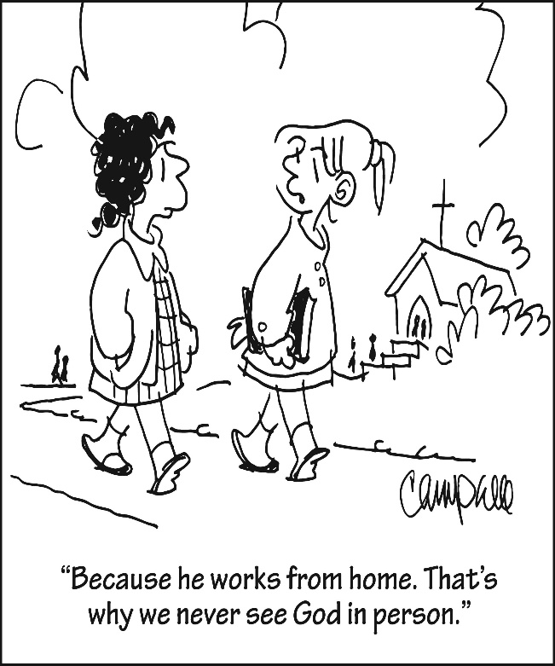

LAST WEEK’S COLLECTION

Adults $1,863.00

Loose $ 47.00

Youth $ 8.00

Monthly $ 575.00

Initial Offering $ 10.00

Candles $ 25.00

Maintenance Fund $ 90.00

All Saints $ 10.00

Immaculate Conception $ 15.00

Christmas Offering $ 520.00

Christmas Flowers $ 135.00

Solemnity of Mary $ 10.00

Religious Retirement $ 10.00

Catholic Charities $ 25.00

Total $3,343.00

We sincerely thank and ask God’s

blessing upon all who have care

and concern for our parish.

*Second Sunday of Advent Mark 1:1-8*

*Why is it so hard to forgive, yet so easy to get even? Listen to John the Baptist in today’s gospel and repent of the anger and ugly feeling which block your ability to forgive. This Christmas give a gift which makes a difference. Give forgiveness.*



Religious Education And Christian Helping

December 6, 2020

Religious Education News

Home Lesson Packets ~ Lesson Packet #3 is ready for Grades K—11.

If you were unable to come to either of the pick-up dates, contact the RE Office at 495-4873 or the Parish Office at 495-9640 to make arrangements for another time to pick up new lessons.

Parables Retreat ~ Our Saint Michael Confirmation students are scheduled for their Virtual Parables Retreat starting on Sunday, December 13th with Sr. Suzanne Thibault at The Bethany Youth Retreat Center via e-mail and Zoom sessions.  Our parish is registered as a whole, and now our students need to register individually with Sr. Suzanne. An email with the registration form has been sent out to all parents who have students scheduled for this retreat. Registration forms need to be returned directly to Sr. Suzanne A.S.A.P. for students to be included.

******************************************************************************************************************

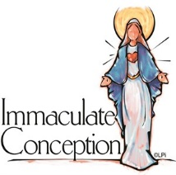**Solemnity of the Immaculate Conception**

**Tuesday, December 8**

**Mass Times: 12:00 Noon & 6:00 PM**

**Noon Mass: 6:00 PM Mass:**

**Lector:** Mary Ann Davis **Lector:** Tony Bambino

**Eucharistic Minister:** Sally Kolar **Eucharistic Minister:** Babe Richards

**Altar Server:** Pauline Minor **Altar Server:** Alex Bambino

**Cantor:** Theresa Arena **Cantor:** David Zajdel

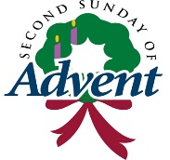 Sunday, December 6 Mass ~ 8:00 & 10:30 AM

Confessions / 10:00 – 10:15 AM / St. Paul Room

Liturgy Meeting / After 10:30 AM Mass / Church

1st Catholic Slovak Union Meeting / 1:30 PM

Girls Scouts / 4:00 – 5:30 PM

Monday, December 7 Mass ~ Noon

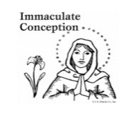 NO Sunday Choir Practice

Tuesday, December 8 Mass ~ Noon / Solemnity of the Immaculate Conception

Mass ~ 6:00 PM / Solemnity of the Immaculate Conception

Concerned Citizens for Human Life Meeting / 7:00 PM

Boy Scouts / 7:30 – 9:00 PM

Wednesday, December 9 Mass ~ Noon

Thursday, December 10 Mass ~ Noon

NO Saturday Choir Practice

Friday, December 11 Mass ~ Noon

Saturday, December 12 Mass / 4:00 PM

Confessions / 3:30 – 3:45 / St. Paul Room

Confessions / 1:30 PM / Msgr. David Lockard & Fr. Joseph Nale

` Retirement for Religious Collection

UPCOMING EVENTS

December 13 Retirement for Religious Collection

Second Sunday Food Pantry Collection

CHRISTMAS SHOPPING EXTRAVAGANZE ~ Bishop Carroll Cafeteria. Saturday, December 12th, 8:00 AM – 2:00 PM. Basket Raffle, Wineries, Soup & Bread Sale, Specialty Vendors, Christmas Cookie Sale, Hand Made Crafts, Christmas Trees. CDC recommendations followed.

SACRAMENTS – 8 WEEK COURSE ~ Fr. Timothy Grimme will be teaching Sacraments at St. Michael Church Hall, St. Michael beginning Tuesday, January 5 from 6:30 – 8:30 PM. The cost for this class is $65, which includes registration & books. These classes may be taken for continuing education credit & Master Catechist requirements. For registration, please contact Marybeth at 814-361-2000 or by email at mheinze@dioceseaj.org . Registration forms are also available online at wwwdioceseaj.org/lay-ecclesial-ministry/ All are welcome!

ST PAUL CLASS VIA ZOOM ~ This 6-week course, taught by Christopher Klopp, investigates the life and writing of St. Paul within the context of early Judaism in order to understand the Apostle’s role as the most significant theologian of the New Testament. Classes will begin Tuesday, January 5th, 6:30-9:00 PM. Costs for this class include a registration fee of $45 and the required book Paul A New Covenant Jew, by Brant Pitre, which can be purchased online at Amazon.com or through the Office of Lay Ministry for $35. Also suggested, but not required is the Ignatius Catholic Study Bible New Testament available online at Amazon.com. For further information and to register for this class please contact Marybeth at 814-361-2000 or by email at [mheinze@dioceseaj.org](mailto:mheinze@dioceseaj.org). All are welcome to attend! Please register by December 16th, 2020.

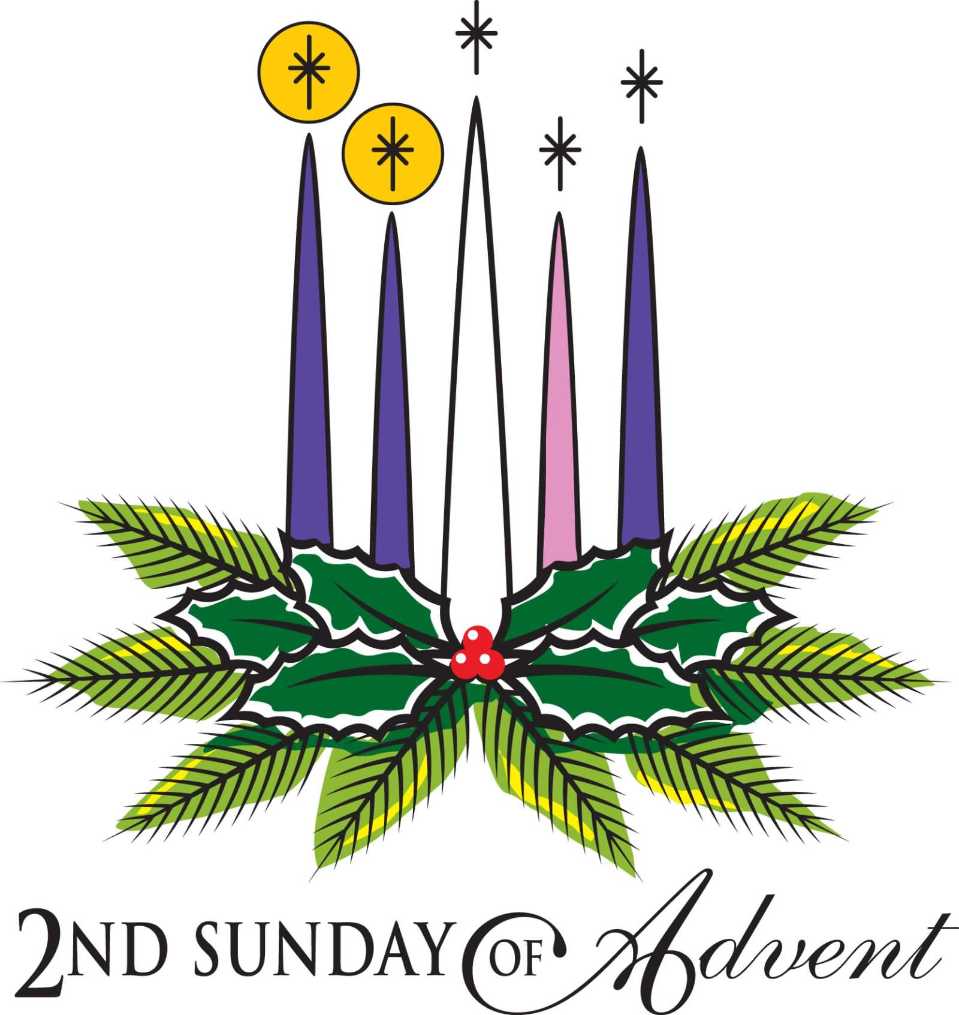

**++++++++++++++++++++++++++++++++++++++++++++++++++++++++++++**

**Diocese of Altoona-Johnstown**

**Year-end giving is happening NOW!**

**Consider a gift that can help you *and* your parish, a ministry, or a special initiative!**

**There’s still time to support the 2020 Catholic Ministries Drive.**

Catholic Charities, Family Life, Seminarian education, youth ministry, and adult education are 14 ministries that rely on parishioner support of the Catholic Ministries Drive to survive and thrive.

You can mail your gift to the Diocese of Altoona-Johnstown, P.O. Box 409, Hollidaysburg, PA 16648; place in your parish offertory; or make online at [www.dioceseaj.org](http://www.dioceseaj.org)/giving

Your support can do great things like:

Keep your parish operating *(lights, heat, building maintenance)*

Educate a seminarian *($100 a day)*

Keep kids connected to their faith *(scholarships for education and camps)*

Provide care for your brothers and sisters in need *($299 to fix a furnace)*

Help families overcome life’s difficulties *(marriage, grief, and addiction counseling)*

*Gifts must be postmarked by December 31, 2020, to receive a tax deduction for 2020.*