John 6:54

ST. MICHAEL ROMAN CATHOLIC CHURCH

751 Locust Street

PO Box 103

St. Michael, Pennsylvania 15951

Rev. Brian L. Warchola, Administrator MASSES:

(814) 495-9640 Saturday 4:00 pm



Sunday Morning 8:00 am

Secretary: Michele Panick 10:30 am

Bookkeeper: Kathy Kalicky Daily Mass See Bulletin

DRE: Laurie Sloan Holy Days See Bulletin

Maintenance: Rodney Turgeon

Office Hours:

PHONES: 8:30 am to 3:30 pm

Rectory / Office: (814) 495-9640 Monday, Tues., Thurs., Friday

Fax: (814) 495-9424 Confessions:

Rel. Education: (814) 495-4873 Saturday 3:30 pm to 3:45 pm

Parish Website Sunday 7:30 am to 7:45 am

www.saintmichaelchurch.weebly.com 10:00 am to 10:15 am

Secretaries’ E-mail Anytime Requested

[saintmichaelsecretaries@yahoo.com](mailto:saintmichaelsecretaries@yahoo.com)

YEAR: 2019 NUMBER: 6

SERVING GOD AND COMMUNITY FOR OVER ONE HUNDRED YEARS!

BAPTISM: By Appointment. Reserve at least one month in advance.

MARRIAGE: Plan at least nine months in advance.

Preparation sessions are necessary.

FUNERALS: Arrangements are made in conjunction with the funeral home.

REGISTRATION Those new to the area, newlyweds, and single adults, (even if registered

and before with their families) are asked to register by calling the Parish Office.

MEMBERSHIP: Every parishioner must be registered. This is a condition for admission

to our Program and reception of the Sacraments of Baptism, Confirmation, First Penance, First Eucharist, and Matrimony; also, for testimonial letters or sponsorship of Baptism and Confirmation outside the Parish.

VISITATION: We are concerned and want to be advised when someone is ill at

home or in the hospital. Call the rectory to have the shut-in placed on our monthly Holy Communion calls or seriously ill prayer list.

SACRAMENTAL Parish registration and active Mass participation for Baptism is

POLICY: encouraged and is required for Marriage.

BULLETIN ARTICLES: Articles are due to the Parish Office by Noon on Tuesdays.

 Fifth Sunday in Ordinary Time

February 10, 2019

**Month of The Holy Family**

**MASS INTENTIONS**: (February 11 – February 17, 2019)

Monday 8:00 AM Fritzie, Michael & Remy Beaver req. by Family

Tuesday 8:00 AM Janet Smith req. by Paul & Susan Snyder

Wednesday NO MASS

Thursday 8:00 AM Michael Hudak req. by Children

Friday 8:00 AM Hermine Sivec req. by Dee & Curt Pieper

Saturday 4:00 PM People of the Parish

Sunday 8:00 AM Tom Malchesky req. by Chuck & Mary Ann Tedjeske

Sunday 10:30 AM Josephine Danel req. by Debi & Steve Horvath

LITURGICIAL APPOINTMENTS:

Saturday, February 16 4:00 PM Offertory Procession

Lector: Devon Michaels Rod Kundrod Family Minister of the Host: Helen Slonac

Choir Minister: Vince Arena

Altar Servers: Mykala Drobnick & Elisabeth Zajdel

Cantor: David Zajdel

Greeter: Darlene Marshall

Sunday, February 17 8:00 AM Offertory Procession

Lector: Joseph Faher Chuck & Mary Ann Tedjeske

Minister of the Host: Sally Kolar

Choir Minister: Terri Leach

Altar Servers: Andrew Martin & Bryce Macy

Cantor: David Knepper

Greeter: Deborah Macy

Sunday, February 1710:30 AM Offertory Procession

Lector: Carole Kakabar Josephine Danel Family

Minister of the Host: Jennifer Steele

Choir Minister: Michael Barton

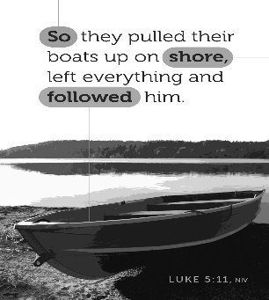Altar Servers: Landon & Zach Fisher

Cantor: Anita Lorek

Greeter: Wendy Blough

Sunday, February 17 Collection Counters

Robert Casti, Sharon Paterson

Sara Zybura

Weare placing names of the sick in the bulletin for prayer providing they give permission. *May the* *Divine Physician send healing grace for those for* *whom we pray:* Allen C. Rosemas, Patricia Murphy, Bernice Myers, Dwight Fyock, Lori Facciani, Dylon Wills, Missy, Joanne (Kolar) Hufford, Christine Flanagan, Ayden Alan Grata, Mary Lou Offman, Mary Zangaglia, Dorothy Rosemas, Natalie Zerby, Patricia Grata, Michael Wadsworth, Valencia & Frank Tursi, Homer Locher, Brayden Schofield, Michelle Kasper, Diane Kingera, Allison Krischer, Ted Paluch, Brandt Hutzel, Pearl Litzinger, Patrick Munro, Fran Baldassarre, Kristen Sinosky Long, Helen Ranieri, Cresta Micik, Basil Costantino, Madison McCrory, Laura, Joe Yoder, Dolores Yanzetich, Sandy Krug, Wanda Gramling, Merna Smay, Muriel “Jean” Wiesheier, Agnes Plummer, Jennifer Hagans, Shawn, Holly, Shane, Spencer, Owen Taylor, Keith & Dawnetta Hoyer, Derrick Varnish, Daniel Koshute, Vincent Koshute, Melissa Cordek, Michelle Elliott, Heather Romanow, Mackston Barrick, Connor Thomas, Erin, Pat, Mary Agnes Nastase, Mary Ann Bertolino, Dick Wilson, Izzy Bihun, Erica Mitzelfeld, Dorothy Kaminsky, Ed Ripper Sr., Patricia Oshaben, Ashlee Madison, Susan Yanzetich, Mike, Mary Sivec, Danika Faith, Alina Rusnak, Marcia Costlow, Gary Smay, Elizabeth Howell, Helen Bowen, Bill Gideos, James Macy, Walter Bodziak, Rhonda, Dan Strinkoski, Anne Robinson, Marlene McCrory, Sharon Poldiak, Carter Bobak, Vince Arena, Mike Morris, Sarah Kelt, Mildred Andrykovitch, Patty Yanzetich Caldwell, Mary Secriskey, Owen Croyle, Colton Snyder, Betty Delaney, Nancy Edmiston, Elizabeth Stoker Thomas, Albert Sracic, Dale Bourdess and all of the sick of our parish, the homebound, those in nursing homes, those who care for them, and those in the military along with their families. *(Please call the Rectory to have your name removed from the list when no longer seriously ill. Thank You.)*



LAST WEEK’S COLLECTION

Adults $3,913.00

Loose $ 239.00

Youth $ 33.30

Monthly $1,388.00

Candles $ 49.00

Maintenance $ 95.00

Initial Offering $ 5.00

Solemnity of Mary $ 10.00

Christmas (2018) $ 25.00

Catholic Education Fund $ 35.00

Total $5,792.30

We sincerely thank and ask God’s

blessing upon all who have

care and concern for

our parish.

*February 10, 2019 Luke 5:1-11*

*In today’s gospel, Jesus asked Simon to start by “going a short distance.” Later he asked Simon to “go into deeper water.” The first stop toward reconciliation is usually a “short distance” which gives us the courage to further “into deeper water.” Reconciliation starts with the first short step!*

SCOUT SUNDAY

On Sunday, February 3rd, St. Michael Parish celebrated Scout Sunday with our parish sponsored troops. Scouting is truly alive at St. Michael Parish. If anyone is interested in learning more about our Girl and Boy Scout Program, please contact Amy and Ron Dobbins at 487-4569.

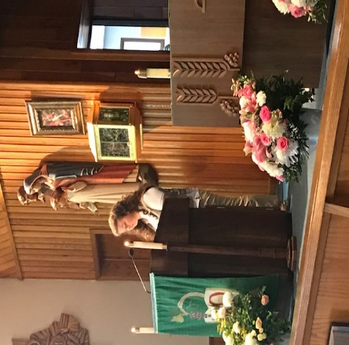

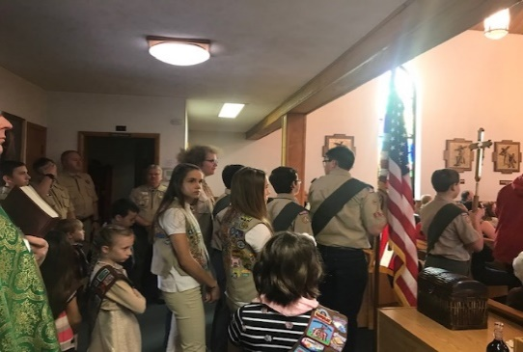

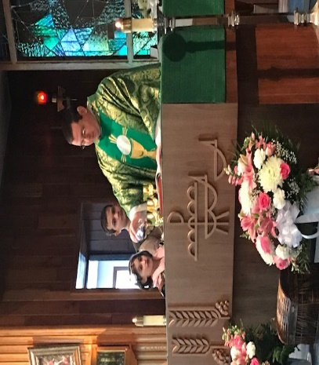

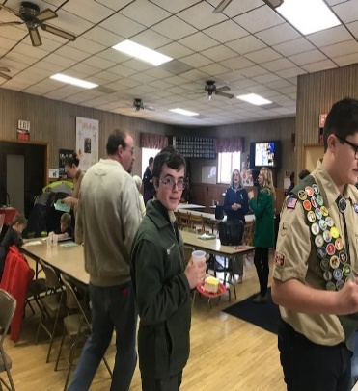

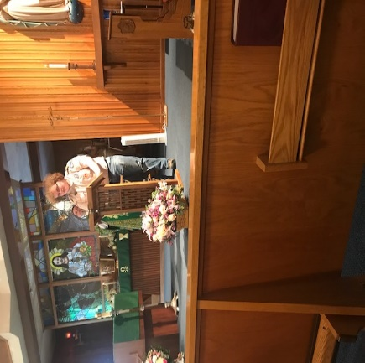

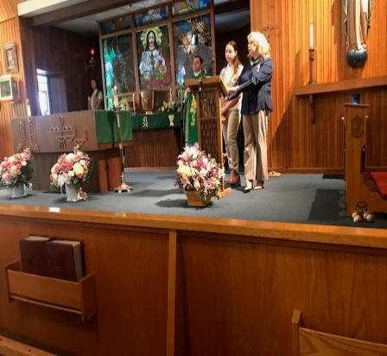

[](https://images.search.yahoo.com/search/images;_ylt=A0LEV1kSWptXvOwAKINXNyoA;_ylu=X3oDMTEyZGdkcmRoBGNvbG8DYmYxBHBvcwMxBHZ0aWQDQjIwODlfMQRzZWMDc2M-?p=Clipart+of+a+sanctuary+candle&fr=ush-mailn_02&th=110&tw=110&imgurl=http://www.henningers.com/389-168-wall-sanctuary-lamp.jpg&rurl=http://pixshark.com/sanctuary-lamp.htm&size=43KB&name=Sanctuary+Lamp+Bronze+wall+sanctuary+lamp&h=600&w=600&turl=http://ts2.mm.bing.net/th?id=OIP.M68453c67108cdc5ab485d309b395bd03o0&pid=15.1&rs=1&c=1&qlt=95&w=110&h=110#inline&tt=Sanctuary+Lamp+Bronze+wall+sanctuary+lamp&sigr=116keh5le&sigit=13gvlt42j&sigi=11ip0pgm4&sign=119kp6100&sigt=119kp6100)

The Sanctuary Candle will burn in memory of our Dad Bruno Bovino

requested by daughters

Louise Neff & Joyce Suckenik

during the week of February 10, 2019.

[](http://www.churchart.com/subscriber/viewimages.aspx?keywords=In%20Sympathy&entry_date=1/1/0001&image_type=,cl#no)MAY SHE REST IN PEACE ~ In your charity, please pray for the eternal rest of Mary Perich whose Funeral Mass was celebrated on Saturday, February 2nd, 2019 by Fr. Brian Warchola. May she know the eternal peace and happiness promised by our Savior, Lord Jesus. Please pray for the consolation of all her family and friends.

[](http://www.churchart.com/subscriber/viewimages.aspx?keywords=In%20Sympathy&entry_date=1/1/0001&image_type=,cl#no)MAY HE REST IN PEACE ~ In your charity, please pray for the eternal rest of Kevin Smay whose Funeral Mass was celebrated on Monday, February 4th, 2019 by Fr. Brian Warchola. May he know the eternal peace and happiness promised by our Savior, Lord Jesus. Please pray for the consolation of all his family and friends.

HOLY NAME SOCIETY ~ Will be holding their monthly meeting today after the 8:00 AM Mass.

COFFEE & DONUTS ~ There will be coffee & donuts after the 8:00 & 10:30 AM Masses today, February 10th.

SECOND SUNDAY FOOD COLLECTION ~ This weekend is our Second Sunday Food Collection. Please bring in non-perishable food items or toiletries with you. Monetary donations are also appreciated.

PARISH COUNCIL ~ The February 10th Parish Council Meeting has been changed to Sunday, February 17th after the 10:30 AM Mass.

RECTORY KEYS ~ Again, anyone still having a key to the rectory, please return them to the office! Thank you!

JO JO’S PIZZA FUNDRAISER ~ Jo Jo’s Pizza, St. Michael, will donate 20% of your total sales (excluding tax & tip) from the flyers collected during our fundraiser dates: Saturday & Sunday, February 9th & 10th, 2019. Flyers were given out last weekend. If you need more flyers, they can be found at the entrances of the Church. You can give out as many flyers to your family & friends. Present flyer to your server and St. Michael will earn 20% of your total bill!

PRECIOUS BLOOD OF THE LORD ~ Because of the seriousness of this flu season, Bishop Bartchak has asked that the Precious Blood of the Lord not be offered at Mass temporarily. Also, the exchange of the sign of peace should avoid bodily contact. These norms are in effect throughout the winter months or until the flu season is over.

*Stewardship Reflections….*

Perhaps feelings of reluctance, inadequacy, and unworthiness have prevented us from fulfilling our portion of God’s divine plan. May we meet Jesus’ challenge, “Do not be afraid,” with “Here I am, send me!”



Religious Education And Christian Helping

February 10, 2019



Snow Tubing at Blue Knob – Our REACH Youth Ministry is taking a trip to Blue Knob All Seasons Resort for a Snow Tubing Session on Friday, February 22, 2019. Students will get a 2-Hour Snow Tubing Session and a boxed Sub sandwich meal. REACH students can also invite a guest to attend. The cost is $2.00 for REACH students and $3.00 for the guests. REACH funds will cover the remaining cost of the bus transportation and the meal for all in attendance.

We will meet at our parish hall at 5:00 p.m. We will then board a bus from the church parking lot to Blue Knob for a Tubing Session from 6—8 p.m. and return again to the hall for pick-up at approximately 9 p.m. We are also in need of parent chaperones for this event. Both Parish Permission forms and Snow Tubing Liability forms have been sent home with our grade 6-12 students that are interested in attending. Signed forms for all students, guests and chaperones need to be returned by next Sunday, along with guest payments so we have an accurate count of attendance prior to our trip. Any further questions can be directed to the RE Office at 495-4873.

*************************************************************************

11th Grade Discipleship Retreat is scheduled for Saturday, February 23rd at Saint Francis University for our 11th Grade Confirmation Class. This “FIREstarters Retreat” will be held at the Campus Ministry Center (next to Cafe' Gubbio) in Saint Francis Hall. The retreat will begin at 9:00 a.m. and conclude at 5:00 p.m., which includes a 4:00 p.m. Mass. Lunch will be provided and the $25 cost per student will be paid from our REACH Youth Ministry funds. Parents should have students arrive at 8:45 a.m. and pick-up again at 5:00 p.m. Parents also are invited to return and attend the 4:00 p.m. Mass held at the Immaculate Conception Chapel. "Application for Participation" forms will be provided to the 11th Grade students and permission is required for the students to attend. These forms need returned to the RE Office by February 10th and forwarded to St. Francis to hold our group reservation.

*************************************************************************

*Junior High Youth Day ~ March 17, 2019 / Students in Grades 6, 7 & 8* can attend. Parents, plans are being made for this year’s Junior High Youth Day 2019 and Registration Forms will be distributed to all students in their Religious Education Classes. JHYD is held at Bishop Carroll Catholic High School from 11 AM – 6 PM on Sunday, March 17, including a 4:30 PM Mass with Bishop Mark Bartchak. This year’s theme is: *“Create in Me a Clean Heart, O God”.*

Our *REACH funds will pay the $15 registration fee for their day* which includes a T-Shirt ~ Games ~ Food ~Fun ~ Friendship! We are looking forward to another great diocesan youth event that will allow them to grow in their faith and spend a wonderful day with other youth from all over our AJ Diocese. *Registration forms are due in the RE Office by March 3rd.*

Questions? Call the RE Office at 495-4873.

2nd GRADE PENANCE / RECONCILIATION RETREAT ~ There will be a Penance / Reconciliation Retreat held on Sunday, February 24, 2019, beginning at 11:45 a.m. until 2:30 p.m. in the Parish Hall for all 2nd grade students and their parents. This retreat is part of the preparation process for these students to receive their sacrament of First Reconciliation. A letter with detailed information has been mailed to all 2nd Grade parents.

*************************************************************************

# **PRIMARY JPG.jpg**

# **NCYC 2019 ~ November 21—23, 2019**

The National Catholic Youth Conference (NCYC) is the largest Catholic youth gathering in the U.S. with over 20,000 young people, clergy and religious, and adult chaperones attending from all over the country. It is a *pilgrimage of faith. NCYC is an exciting,* biennial, three-day experience of prayer, community, and empowerment for Catholic teenagers addressing a wide variety of topics including Catholic spirituality and prayer, social justice issues, sexuality and leadership.

The theme for this year is, *“Blessed, Broken and Given”.*

*Saint Michael Parish is planning to attend NCYC 2019!*

Who Can Attend NCYC?

Any high school aged (Grade 10—12) Catholic member of the Diocese of Altoona-Johnstown aged 16 or over and their adult chaperones (with proper clearances) are invited to attend the pilgrimage to NCYC.

When and Where is NCYC?

NCYC 2019 is scheduled for November 21 to November 23, 2019 in Indianapolis, Indiana. Large group sessions are held in Lucas Oil Stadium and Workshops, sessions and Thematic Village are held in the Indianapolis Convention Center.

The Cost of the trip is $630 per person.

Trip Package Includes:

* Deluxe motor coach travel (round trip) leaving from pick-up spots in Altoona andEbensburg to Indianapolis

(Bus departs late November 15 and returns early November 22)

* 3 nights’ hotel accommodations (Quad occupancy)
* Continental breakfast at hotel each morning
* Lunch each day (ex. Panera / Subway meals)
* A pizza party on Thursday
* A Special Restaurant Luncheon with Bishop Mark Bartchak on Friday
* NCYC Conference Registration, Administrative Fees, Taxes and Tips
* Official NCYC Diocesan T-shirts and sweatshirt

Pre-registration to attend is required. A Payment plan is offered after the initial $100 deposit is paid. *We will plan several fundraisers to help subsidize the expenses.*

Initial Deposit of $100.00…………………………………………….….Due March 31, 2019

Sunday, February 10 High School Religious Ed. / 9:00 – 10:20 AM

Rite of Commitment & Rite of Blessing / 10:30 AM Mass

 Second Sunday Food Collection

Jo Jo’s Pizza Fundraiser

Holy Name Meeting / After 8:00 AM Mass

Coffee & Donuts / After 8:00 & 10:30 AM Masses

Baptism

Monday, February 11 Sunday Choir Practice / 7:00 PM

Tuesday, February 12 Boy Scouts / 7:30-9:00 PM

Wednesday, February 13 NO MASS

Thursday, February 14 K-5 Religious Education / 3:30 – 4:30 PM

Saturday Choir Practice / 4:30 PM

Friday, February 15

Saturday, February 16

UPCOMING EVENTS



February 17 Parish Council Meeting (Moved from February 10th)

Girl Scouts

February 18 Parish Offices Closed / Presidents’ Day

February 19 Girl Scouts / Hall

Boy Scouts

February 21 Knights of Columbus

Girl Scouts

RIGATONI DINNER ~ Take-Out only! Sunday, Feb. 17, 11:00 AM – 2:00 PM. Pasta-2 meatballs-salad-cake-$8.00. St. Anthony of Padua Church, Windber, PA

TRIVIA NIGHT ~ Bishop Carroll Catholic High School. Saturday, February 23, 2019. Doors open at 6 PM, Dinner at 6:30 PM, Game begins at 7:30 PM. Open to anyone 21+. $25 a person. Team can be as large or as small as desired! Register by calling 814-472-7500 ext. 105 or email [jnagy@bishopcarroll.org](mailto:jnagy@bishopcarroll.org) by February 18th. Prize money for first and second place will be donated to the charity of your choice. Raffle chances and 50/50 tickets will be available.

BUS TRIP TO HOLOCAUST MUSEUM ~ There is a day trip planned to the Holocaust Museum in Washington D.C. for Monday, April 8th. A Lodestar charter bus will leave at 6:00 AM from the parking lot of St. Patrick’s Church corner of Park Avenue and Village Street in Moxham) and return around 8:30 PM. Cost of the trip is $70. There are 55 seats available. To reserve seats, please call 814-255-9797 or 814-241-3736 no later than March 20th.