Rev. 12:7

ST. MICHAEL ROMAN CATHOLIC CHURCH

751 Locust Street

PO Box 103

St. Michael, Pennsylvania 15951

Rev. Msgr. David A. Lockard, Administrator MASSES:

(814) 495-9640 Saturday 4:00 pm



Sunday Morning 8:00 am

Secretary: Michele Panick 10:30 am

Bookkeeper: Kathy Kalicky Daily Mass See Bulletin

DRE: Laurie Sloan Holy Days See Bulletin

Maintenance: Rodney Turgeon

Office Hours:

PHONES: 8:30 am to 3:30 pm

Rectory / Office: (814) 495-9640 Monday, Tues., Thurs., Friday

Fax: (814) 495-9424 Confessions:

Rel. Education: (814) 495-4873 Saturday 3:30 pm to 3:45 pm

Parish Website Sunday 7:30 am to 7:45 am

www.saintmichaelchurch.weebly.com 10:00 am to 10:15 am

Secretaries’ E-mail By Appointment

[saintmichaelsecretaries@yahoo.com](mailto:saintmichaelsecretaries@yahoo.com)

Third Sunday of Lent

SERVING GOD AND COMMUNITY FOR OVER ONE HUNDRED YEARS!

March 15, 2020

BAPTISM: By Appointment. Reserve at least one month in advance.

MARRIAGE: Plan at least nine months in advance.

Preparation sessions are necessary.

FUNERALS: Arrangements are made in conjunction with the funeral home.

REGISTRATION Those new to the area, newlyweds, and single adults, (even if registered

and before with their families) are asked to register by calling the Parish Office.

MEMBERSHIP: Every parishioner must be registered. This is a condition for admission

to our Program and reception of the Sacraments of Baptism, Confirmation, First Penance, First Eucharist, and Matrimony; also, for testimonial letters or sponsorship of Baptism and Confirmation outside the Parish.

VISITATION: We are concerned and want to be advised when someone is ill at home or in the hospital. Call the rectory to have the shut-in placed on our monthly Holy Communion calls or seriously ill prayer list.

SACRAMENTAL Parish registration and active Mass participation for Baptism is

POLICY: encouraged and is required for Marriage.

BULLETIN ARTICLES: Articles are due to the Parish Office by Noon on Tuesday.

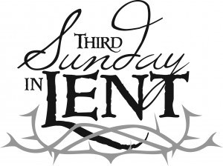

Third Sunday of Lent

March 15, 2020

Month of St. Joseph

**MASS INTENTIONS**: (March 16 – March 22, 2020)

Monday 12:00 PM Steve Domen req. by Ed Hudak

Tuesday 12:00 PM Meg Itle Scott req. by Sondre Harteis & Family

Wednesday 6:00 PM John Vandzura req. by John & Agnes Waksmunski

Thursday 12:00 PM Theresa Podrebarac req. by Alice Podrebarac & Family

Friday 12:00 PM Michele Houghton req. by Mom & Dad

Saturday 4:00 PM People of the Parish

Sunday 8:00 AM Sylvia Michaels req. by Michaels Children

Sunday 10:30 AM Robert Wilson req. by Mary Ann Murin & Family

LITURGICIAL APPOINTMENTS:

Saturday, March 21 4:00 PM Offertory Procession

Lector: Sandy Bambino John & Bonnie Bizzarri

Ministers of the Host: Theresa Carlson & Susan Blazosky

Minister of the Choir: Karen Myers

Altar Servers: Ana & Eva Spangler

Cantor: Amy Spangler

Greeter: Darlene Marshall

Sunday, March 22 8:00 AM Offertory Procession

Lector: Cathy Faher Robert & Ellen Grattan

Ministers of the Host: Pauline Minor & Sally Kolar

Minister of the Choir: Terri Leach

Altar Servers: Griffin & Kaden Christ

Cantor: Joseph Faher

Greeter: Carol Hautz

Sunday, March 2210:30 AM Offertory Procession

Lector: James Lashinsky Michael & Linda Caddy

Ministers of the Host: Susan Wieczorek & Sharon Paterson

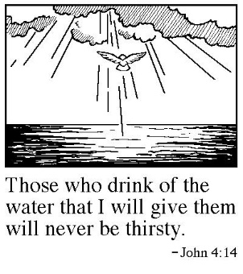Minister of the Choir: Amanda Williamson

Altar Servers: Shannan Elgin & Adalynne Webb

Cantor: Amy Dobbins

Greeter: Wendy Blough

Sunday, March 22 Collection Counters

Christine Smay, Sara Zybura

Debbie Dupnock

Weare placing names of the sick in the bulletin for prayer providing they give permission. *May the* *Divine Physician send healing grace for those for* *whom we pray:* Allen C. Rosemas, Patricia Murphy, Bernice Myers, Dwight Fyock, Dylon Wills, Missy, Joanne (Kolar) Hufford, Christine Flanagan, Ayden Alan Grata, Mary Lou Offman, Mary Zangaglia, Natalie Zerby, Valencia & Frank Tursi, Homer Locher, Brayden Schofield, Michelle Kasper, Diane Kingera, Allison Krischer, Ted Paluch, Brandt Hutzel, Pearl Litzinger, Patrick Munro, Fran Baldassarre, Kristen Sinosky Long, Helen Ranieri, Cresta Micik, Basil Costantino, Madison McCrory, Laura, Joe Yoder, Dolores Yanzetich, Sandy Krug, Wanda Gramling, Agnes Plummer, Jennifer Hagans, Shawn, Holly, Shane, Spencer, Owen Taylor, Keith & Dawnetta Hoyer, Derrick Varnish, Vincent Koshute, Melissa Cordek, Michelle Elliott, Heather Romanow, Mackston Barrick, Connor Thomas, Erin, Pat, Mary Agnes Nastase, Mary Ann Bertolino, Dick Wilson, Izzy Bihun, Dorothy Kaminsky, Patricia Oshaben, Ashlee Madison, Susan Yanzetich, Mike, Danika Faith, Alina Rusnak, Gary Smay, Elizabeth Howell, Helen Bowen, Walter Bodziak, Rhonda, Dan Strinkoski, Anne Robinson, Marlene McCrory, Sharon Poldiak, Carter Bobak, Vince Arena, Mike Morris, Sarah Kelt, Patty Yanzetich Caldwell, Colton Snyder, Betty Delaney, Nancy Edmiston, Joseph Ropecka, Bill Krajewski, Leonard Oshaben, Adam, Bill Gideos, Janice Dipyatic, John Poldiak Jr., Gerald Delaney, Lily Maloney, Adam Wingard, Scott, Lisa, Rosalie Ambrose, John Patrick, Audrey Costlow, Carole Horner, Ross Linert, Mary Ann Peretin DeRosa, Catherine Olszewski, Cathy Sossong, Rosanne Krug, Barbara Malchesky, Paul Snyder and all of the sick of our parish, the homebound, those in nursing homes, those who care for them, and those in the military along with their families. *(Please call the Rectory to have your name removed from the list when no longer seriously ill. Thank You.)*

LAST WEEK’S COLLECTION

Adults $3,775.50

Loose $ 375.53

Youth $ 31.50

Monthly $ 493.00

Candles $ 43.00

Maintenance $ 90.00

Mandeville Diocese $ 39.00

Black & Indian Mission $ 125.00

Catholic Relief Services $ 35.00

Holy Land $ 15.00

Holy Thursday $ 15.00

Catholic Home Missions $ 15.00

Easter $ 105.27

Easter Flowers $ 743.00

Total $5,900.80

We sincerely thank and ask

God’s blessing upon all who

have care and concern for

our parish.

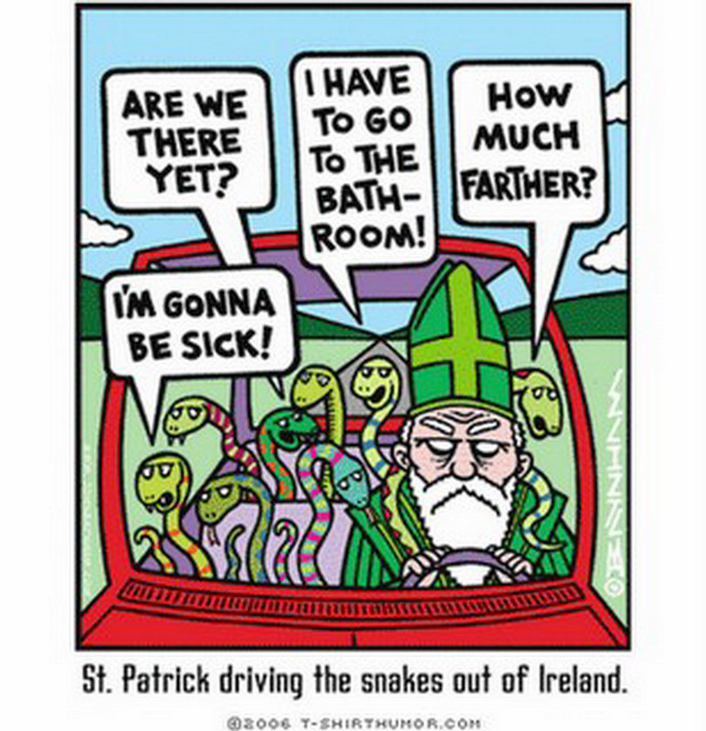

*March 15, 2020 John 4:5-42*

*Our children are like the Samaritan woman in today’s gospel. They need more than material things. They need the “living water” only the adults can give. It will teach them how to make decisions, take responsibility, respect themselves and others and live their commitments. With this “living water” they will “never thirst.”*

HAM AND CHICKEN DINNER ~ Boy Scout Troop #2251 is hosting a Ham & Chicken Dinner, March 21st, 5 – 7:30 PM, St. Michael Church Hall, 751 Locust St., St. Michael. Dinner includes: Ham, Chicken, Potatoes, Green Beans, Coleslaw, Rolls & Butter, Dessert & Drinks. Adults: $10, Children 3-12: $8, under 3: Free. Walk-ins welcome. Take outs are available. For advance tickets, contact Amy Dobbins @ 487-4569. All proceeds benefit the scouting program of Troop #2251.

HEALING MASS ~ Monday, March 16th, 7:00 PM. Very Rev. Alan Thomas Celebrant. Cathedral of the Blessed Sacrament, Altoona. For all in need of physical, emotional or spiritual healing and those who support them. All are welcome! Music led by cathedral prayer group music ministry.

PARISH MISSION ~ The Basilica of St. Michael the Archangel, Loretto will hold their 5th annual Lenten Mission in Honor of Our Lady of Loretto on March 22-27. Fr. Joseph Sioli, St. Louise Parish, Pittsburgh, is the Mission Director. The Mission opens Sunday, March 22 at 7 PM with Prayers, homily & Benediction of the Blessed Sacrament, Bishop Mark Bartchak presiding. Mass with mission prayers & homily will be offered at 7 PM Monday through Friday. Confessions are offered at 6 PM Monday through Friday. Eucharistic Adoration offered at 6 PM Mon.-Fri. Prayer intentions may be sent to: Fr. John D. Byrnes, Rector PO Box 10, Loretto, PA 15940.

ORGAN CONCERT ~ “A Musical Journey through Lent, Holy Week, and the Glory of Resurrection Sunday”. There will be an Organ Concert on Sunday, March 22nd, at 3 PM, at Our Lady of Mount Carmel Church, 1100 8th Ave., Altoona. James Dengler, Mt. Carmel organist, along with several members of the Indiana Chapter of the American Guild of Organists will present music specifically for the Season of Lent, Holy Week, and Easter. A free will offering will be taken to benefit the Organ Fund.



PARISH MISSION POSTPONED ~ Due to the danger of the Corona Virus, St. Benedict’s Parish, Johnstown has decided to postpone their Lenten Parish Mission, which had been scheduled for March 29, 30, and 31.

CRAFT AND VENDOR FAIR ~ Bishop Carroll Catholic High School. Saturday, April 4th from 9:00 AM-4:00 PM. 60+ Crafters and Vendors. Huge Bake Sale, Homemade Foods: Haluski, Ham Pot Pie, Wedding Soup, Pagash Pizza, Gourmet Cinnamon Rolls & Gobs. Kiddy Corner with games & face painting. Easter Bunny visit 11:00 AM-1:30 PM. Egg Hunt, 1:30PM.

SEASONED CATHOLIC SINGLES ~ We are looking to see if there is interest in starting a social group for those Catholic singles in our area (single, divorced, separated, widowed) who are more advanced in their life journey, but would like to spend time with other mature single adults who share their faith. Activities could include: watching movies together, dining out, dining in, sporting events like bowling, service projects or worship events. If you have an interest, please contact the Family Life Office at 814-695-5579 to help organize a group in your area.

FINANCIAL PEACE UNIVERSITY! ~ Take control of your money with Financial Peace University (FPU)! This 9-lesson course uses biblical wisdom and common sense to help you tackle budgeting, pay off debt, and make your money work for you! FPU includes your member workbook and a year of free online resources through Financial Peace Membership. Join an FPU group today! Contact St. Mary’s, Altoona, Parishioners Britney Dodson or Alyssa Claar at 814-934-2820 or 814-312-5238 for more information. Classes will be held on Wednesday evenings beginning April 22 at 6:00 PM in the St. Mary’s Memorial Hall Cafeteria, Altoona.

The Sanctuary Candle will burn for the

Youth of Our Parish

during the week of March 15, 2020.

[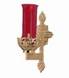](https://images.search.yahoo.com/search/images;_ylt=A0LEV1kSWptXvOwAKINXNyoA;_ylu=X3oDMTEyZGdkcmRoBGNvbG8DYmYxBHBvcwMxBHZ0aWQDQjIwODlfMQRzZWMDc2M-?p=Clipart+of+a+sanctuary+candle&fr=ush-mailn_02&th=110&tw=110&imgurl=http://www.henningers.com/389-168-wall-sanctuary-lamp.jpg&rurl=http://pixshark.com/sanctuary-lamp.htm&size=43KB&name=Sanctuary+Lamp+Bronze+wall+sanctuary+lamp&h=600&w=600&turl=http://ts2.mm.bing.net/th?id=OIP.M68453c67108cdc5ab485d309b395bd03o0&pid=15.1&rs=1&c=1&qlt=95&w=110&h=110#inline&tt=Sanctuary+Lamp+Bronze+wall+sanctuary+lamp&sigr=116keh5le&sigit=13gvlt42j&sigi=11ip0pgm4&sign=119kp6100&sigt=119kp6100)

SECOND SUNDAY FOOD COLLECTION ~ Thank you to all who so generously donated to the Forest Hills Food Pantry. The total money collected was $392.33 and an assortment of non-perishable items.

LENTEN CONFESSIONS ~ Lenten Confessions will be here at St. Michael, Monday, March 23rd at 6:00 PM. Several priests will be present to assist Msgr. Lockard. Mark your calendars now. We will combine with Most Holy Trinity, South Fork and St. Bartholomew, Wilmore. Everyone welcome!

SAVE THE DATE ~ On Wednesday, April 8th after the 6:00 PM Mass, we will be holding a covered dish to commemorate the Lord’s Last Supper. The church will be supplying the main dishes and the beverages. Sign-up sheets can be found in the back and side of the Church.

WEDNESDAY EVENING MASS ~ There will be a 6:00 PM Mass every Wednesday during Lent. This is a wonderful opportunity to attend a daily Mass to help us in our Lenten journey.

STATIONS OF THE CROSS ~ On Friday evenings during Lent at 6:00 PM, we will pray the Stations of the Cross. Lent invites us to meditate on the Passion of Christ.

COMBINED CHOIR FOR EASTER ~ Will practice after Friday Stations at 7:00 PM during Lent.

EASTER FLOWERS ~ If you would like to purchase an Easter flower for a living (In Honor Of) or a deceased (In Memory Of) member of your family, please do so by signing the Easter Flower envelope in your packet. The normal offering is $10. Please return the envelopes on or before April 5th. Extra envelopes can be found at the church entrances.

ST. MICHAEL CEMETERY SPRING CLEAN UP ~ Please remove any decorations, flowers, or anything to be saved from St. Michael Cemetery prior to March 30th. Clean up will be March 30th – April 4th.

EASTER NUT ROLLS ~ Most Holy Trinity, South Fork, is taking orders for their Easter Nut Roll Sale. Orders must be placed by Friday, March 20th. Nut Rolls can be picked up on Friday, March 27th at Most Holy Trinity Church Hall from 9:00 – 11:00 AM. A sign-up sheet is on the table in the back of the Church.

CATHOLIC RELIEF SERVICES COLLECTION ~ Next week, our second collection is for The Catholic Relief Services Collection (CRSC). Funds from this collection provide food to the hungry, support displaced refugees, and bring Christ’s love and mercy to all people here and abroad. Next week, please give generously to the CRSC and help Jesus in disguise. Learn more about the collection at [www.usccb.org/catholic-relief](http://www.usccb.org/catholic-relief)

NOVENA TO THE INFANT OF PRAGUE ~ Will begin on Sunday, March 15th at 7:00 PM at St. Andrew Church, Johnstown and will continue every evening until Monday, March 23rd at 7:00 PM. Adoration will be held nightly for 1 hour before the Novena. We will have additional Priests to hear Confessions after Mass every night. All are welcomed!

HALUPKI DINNER ~ Sunday, March 15th, Prince of Peace Parish, Northern Cambria, 11:00 AM-3:00 PM. Dinner includes 2 Halupki, Homemade Halushki, “Real” mashed potatoes, Green Beans, Roll & Butter, Dessert. Basket Auction, 50/50 Raffle Tickets & Cuisinart Deluxe 4-Burner Gas Grill Prize. Tickets available at the door. Adult Dinner, $10, Children 5-10, $5, Take outs available.

INDOOR YARD SALE, BOOK & BAKE SALE ~ Saturday, March 21st, 8 AM - 1 PM, St. Nicholas Church Hall, Nicktown. Sponsored by NCCS Parents for Students.

HOLY LAND PILGRIMAGE OF A LIFETIME ~ Have you ever wondered what it would be like to witness the events of the Gospels? Imagine sailing in the boat with the disciples on the Sea of Galilee or standing on the Mount of Beatitudes. A Holy Land experience will put you where the events of the Bible took place. A Holy Land experience will bring the Bible to life, inspire passionate faith and Christian living, energize the call to ministry, and enhance your knowledge and understanding of contemporary and cultural issues of the Holy Land. Our 10-day journey (April 16-26, 2021) will take us to all the major sites such as the Sea of Galilee, the Mount of Beatitudes, the Jordan River, Bethlehem, Nazareth, Jerusalem, and more. Each day Mass will be celebrated at a different holy site. This pilgrimage will sell out fast. If you are interested in joining in walking in the footsteps of Jesus, please contact Deacon Michael Russo (288-3036 or [michael.russo@atlanticbb.net](mailto:michael.russo@atlanticbb.net)).

TURKEY DINNER ~ The Basilica of St. Michael the Archangel, Loretto. Annual Men’s Turkey Dinner on Sunday, March 15th from 11 AM – 3 PM. The 58th year the parish men will prepare and serve roasted turkey dinner with all the trimmings and dessert! Will be at Our Lady of Loretto Hall. Adults $11, Children 10 & under $6, & takeouts $12. Enjoy the Dinner and a Basket Raffle!

*PRECIOUS LIFE*  BREAKFAST ~ Is on Saturday, March 21st at 9 AM at the Holiday Inn downtown Johnstown. Tickets are a $10 donation & may be purchased by visiting our website at PreciousLifeInc.com or by calling Precious Life Office at 814-269-4391. A free will offering will be taken.

SLOVAK CLASSES ~ Queen of Angels Parish in Central City will sponsor a 1 session class on Slovak Lent & Easter customs on Monday, March 30th in their activity center (738 Sunshine Ave.). Presenter will be Dr. Michal Kopanic. He is an expert on Slovak customs and the history of central Europe. His class is free – please call the rectory to register at 754-5224.

GORZKIE ZALE DEVOTIONS ~ Queen of Angels in Central City will celebrate the Polish devotion known as “Gorzkie Zale” or Bitter Lamentations on March 22 & April 5. The devotions begin at 3:00 PM at their Sacred Heart site, 738 Sunshine Ave., Central City. The devotions will be in English – all are welcome. On March 22nd the guest homilist will be Fr. Boniface Hicks, O.S.B. who will give a presentation entitled Deliver Us From Evil. Since his ordination to the priesthood in 2004, Fr. Boniface has provided spiritual direction for many men and women, including married couples, seminarians, consecrated religious, and priests. He became the programming manager and an on-air contributor for We Are One Body Catholic radio in 2010 (106.7 FM) and has recorded thousands of radio programs on theology and the spiritual life. Fr. Boniface has extensive experience as a retreat master for laity, consecrated religious, and priests. He became the director of Spiritual Formation for Saint Vincent Seminary in 2016 and has offered courses there on spiritual direction.



Catholic Ministries Drive $25,436.00

Raised: $ 3,060.00

Balance: $22,376.00

Number of responses: 17

Thank you to all parishioners who have responded to the *2020 Catholic Ministries Drive.* Please join them in supporting our Parish and a select group of ministries that provide outreach to the poor, family life, youth and seminarians. If you did not receive a pledge card in the mail, you may give online at [www.dioceseaj.org](http://www.dioceseaj.org).

Religious Education And Christian Helping

March 15, 2020



Rite of Sending ~ Our 11th grade Confirmation class along with their Sponsors will attend the 10:30 AM Mass on Sunday, March 29th. The candidates will celebrate their “Rite of Sending” as our parish “sends them off” to receive their Sacrament of Confirmation in April.

Confirmation ~ Our 11th Grade Confirmation class will receive their Sacrament of Confirmation on Thursday, April 16th, 2020. A 7:00 PM Mass will be celebrated at Saint John Gualbert Cathedral in Johnstown. *Confirmation Practice will be held on Wednesday evening, April 15th at 6:30 PM.*

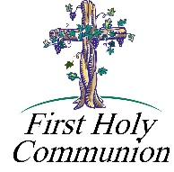

First Holy Communion ~ Our Second Grade class is preparing to receive their Sacrament of Reconciliation on Sunday, May 3rd.

Please continue to remember these students in your prayers as they prepare for the reception of their Sacraments.

*************************************************************************

2020 DIOCESAN SUMMER CAMP OPPORTUNITIES FOR YOUTH

Registration for our diocesan summer camps, Camp Zacchaeus and Camp Timothy are currently being accepted. Registration brochures were sent with students and are also available in our Religious Ed Office.

- Camp “Z” is a week-long summer camp for youth grades 4-9 Campers can look forward to lively Liturgies, inspirational music, prayer experiences, evangelization sessions, campfires, games, skits, a live concert and lots more!

- Camp “T” is for youth in grades 10-12 as well as current year graduating high school seniors.

- Camp “T” campers will experience much the same as Camp Z–but even MORE!! We take the fun, faith and excitement to a higher level! Scholarship money is available to eligible applicants for both camps. For more information or to receive a brochure for either camp, contact our Religious Education Office at 495-4873 or Francine Swope, Diocesan Youth Ministry at (814)317-2646.

*Angel Fund 2020*

*Consider giving a gift now that will enrich the life of a young camper in the Summer of 2020!*

*Camp Zacchaeus Grades 4-9 and Camp Timothy Grades 10-12 (and newly graduated seniors 2020)*

We are looking for people, groups, parishes or organizations to sponsor a child to attend

Camp Zacchaeus 2020 or Camp Timothy 2020 through the *Angel Fund*.

We will accept full or partial sponsorships of any amount to help cover the cost of camp—(100 percent of the funds collected through Angel Fund donations are dispersed to needy campers)! If you are interested in sponsoring a child, or for more information, please contact Francine Swope at the Diocesan Youth Ministry Office (814)317-2646 or mail your contribution directly to Camp Zacchaeus or Camp Timothy Angel Fund, 2713 West Chestnut Avenue, Altoona, PA 16601. Become an Angel Fund sponsor and help send a child to camp to experience a wonderful faith-filled week in the great outdoors!

Sunday, March 15 High School Religious Ed. / 9:00 – 10:20 AM

Girl Scouts Meeting / 1:30 - 3:00 PM & 4 - 5:30 PM

 Monday, March 16 Mass / 12:00 PM

Sunday Choir Practice / 7:00 PM

Tuesday, March 17 Mass / 12:00 PM

Boy Scouts / 7:30 – 9:00 PM

St. Patrick’s Day

Wednesday, March 18 Mass / 6:00 PM

Thursday, March 19 Mass / 12:00 PM

K—5 Religious Ed. / 3:30 – 4:30 PM

Saturday Choir Practice / 4:30 PM

 Girl Scouts Service Unit Meeting / 6:30 PM

Friday, March 20 Mass / 12:00 PM

Stations of the Cross / 6:00 PM

Combined Choir Practice / 7:00 PM

Saturday, March 21 Catholic Relief Services / Second Collection

Boy Scouts Ham & Chicken Dinner / 5 – 7:30 PM / Church Hall

UPCOMING EVENTS

March 22 Catholic Relief Services / Second Collection

Liturgy Committee Meeting

March 23 Lenten Confessions / St. Michael

March 29 11th Grade Rite of Sending

BASKET SOCIAL ~ The Youth Ministry of Holy Name Parish in Ebensburg will hold a Basket Social on Sunday,

March 22nd. Tickets are $5 for 25 chances. Complimentary desserts provided. Doors open at 12 noon with the raffle starting promptly at 1:30 PM.

SQUARE DANCES ~ Will be held at New Germany Grove on March 21 & April 4. Music by Klassic Kountry from 7-10 PM. Admission $10. Benefits ProLife.

FISH FRY

St. Michael Firehall, St. Michael ~ Every Friday thru Lent. Fried or Baked Fish Dinners or Shrimp Dinners. Eat in from 11 AM – 7 PM. Take outs or local delivery available. Phone at 495-4111.

Immaculate Conception, New Germany ~ Every Friday during Lent including Good Friday. New Germany Grove Hall from 4 – 7 PM. Adults $12, Children $6, Children 5 & Under are Free. Fish Sandwich & French Fries $7. Take outs available until 6:00 PM. Please call 495-4298.

Holy Family Parish, Portage ~ Fish Dinners on Friday, April 3rd from 4-6 PM in Parish Hall. 814-736-4279.