John 6:54

ST. MICHAEL ROMAN CATHOLIC CHURCH

751 Locust Street

PO Box 103

St. Michael, Pennsylvania 15951

Rev. Brian L. Warchola, Administrator MASSES:

(814) 495-9640 Saturday 4:00 pm



Sunday Morning 8:00 am

Secretary: Michele Panick 10:30 am

Bookkeeper: Kathy Kalicky Daily Mass See Bulletin

DRE: Laurie Sloan Holy Days See Bulletin

Maintenance: Rodney Turgeon

Office Hours:

PHONES: 8:30 am to 3:30 pm

Rectory / Office: (814) 495-9640 Monday, Tues., Thurs., Friday

Fax: (814) 495-9424 Confessions:

Rel. Education: (814) 495-4873 Saturday 3:30 pm to 3:45 pm

Parish Website Sunday 7:30 am to 7:45 am

www.saintmichaelchurch.weebly.com 10:00 am to 10:15 am

Secretaries’ E-mail Anytime Requested

[saintmichaelsecretaries@yahoo.com](mailto:saintmichaelsecretaries@yahoo.com)

YEAR: 2019 NUMBER: 12

SERVING GOD AND COMMUNITY FOR OVER ONE HUNDRED YEARS!

BAPTISM: By Appointment. Reserve at least one month in advance.

MARRIAGE: Plan at least nine months in advance.

Preparation sessions are necessary.

FUNERALS: Arrangements are made in conjunction with the funeral home.

REGISTRATION Those new to the area, newlyweds, and single adults, (even if registered

and before with their families) are asked to register by calling the Parish Office.

MEMBERSHIP: Every parishioner must be registered. This is a condition for admission

to our Program and reception of the Sacraments of Baptism, Confirmation, First Penance, First Eucharist, and Matrimony; also, for testimonial letters or sponsorship of Baptism and Confirmation outside the Parish.

VISITATION: We are concerned and want to be advised when someone is ill at home or in the hospital. Call the rectory to have the shut-in placed on our monthly Holy Communion calls or seriously ill prayer list.

SACRAMENTAL Parish registration and active Mass participation for Baptism is

POLICY: encouraged and is required for Marriage.

BULLETIN ARTICLES: Articles are due to the Parish Office by Noon on Tuesdays.

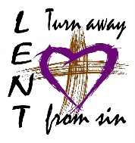 Third Sunday of Lent

March 24, 2019

**Month of St. Joseph**

**MASS INTENTIONS**: (March 25 – March 31, 2019)

Monday 8:00 AM Francis Ritz req. by Joan W. Patterson

Tuesday 8:00 AM Josephine Danel req. by Galen, Ann Marie & Andrew Martin

Wednesday 6:00 PM Tom Paterson req. by Howard & Terri Leach

Thursday 8:00 AM Helen Varner req. by Rick, Mary Lou & Sean Varner

Friday 8:00 AM Mary Yvonne Le Jeune req. by Sara Zybura

Saturday 4:00 PM Joe Soohy req. by The Soohy Family

Sunday 8:00 AM Michael Cononie req. by Michael & Lucia Ann Brezovec

Sunday 10:30 AM People of the Parish

LITURGICIAL APPOINTMENTS:

Saturday, March 30 4:00 PM Offertory Procession

Lector: Devon Michaels Joe Soohy Family

Minister of the Host: Susan Blazosky

Choir Minister: Vince Arena

Altar Servers: Brooke & Chase Williamson

Cantor: Amanda Williamson

Greeter: Carole Mucker

Sunday, March 31 8:00 AM Offertory Procession

Lector: Pauline Minor Michael & Lucia Ann Brezovec

Minister of the Host: Paul Kundrod

Choir Minister: Marie Jo Plummer

Altar Servers: Griffin & Kaden Christ

Cantor: David Knepper

Greeter: Deborah Macy

Sunday, March 3110:30 AM Offertory Procession

Lector: James Lashinsky Michael Steele Family

Minister of the Host: Robert Oshaben

Choir Minister: Susan Wieczorek

Altar Servers: Shannan Elgin & Adalynne Webb

Cantor: Anita Lorek

Greeter: Wendy Blough

Sunday, March 31 Collection Counters

George & Janet Minor

Debbie Dupnock

Weare placing names of the sick in the bulletin for prayer providing they give permission. *May the* *Divine Physician send healing grace for those for* *whom we pray:* Allen C. Rosemas, Patricia Murphy, Bernice Myers, Dwight Fyock, Lori Facciani, Dylon Wills, Missy, Joanne (Kolar) Hufford, Christine Flanagan, Ayden Alan Grata, Mary Lou Offman, Mary Zangaglia, Dorothy Rosemas, Natalie Zerby, Patricia Grata, Michael Wadsworth, Valencia & Frank Tursi, Homer Locher, Brayden Schofield, Michelle Kasper, Diane Kingera, Allison Krischer, Ted Paluch, Brandt Hutzel, Pearl Litzinger, Patrick Munro, Fran Baldassarre, Kristen Sinosky Long, Helen Ranieri, Cresta Micik, Basil Costantino, Madison McCrory, Laura, Joe Yoder, Dolores Yanzetich, Sandy Krug, Wanda Gramling, Merna Smay, Muriel “Jean” Wiesheier, Agnes Plummer, Jennifer Hagans, Shawn, Holly, Shane, Spencer, Owen Taylor, Keith & Dawnetta Hoyer, Derrick Varnish, Daniel Koshute, Vincent Koshute, Melissa Cordek, Michelle Elliott, Heather Romanow, Mackston Barrick, Connor Thomas, Erin, Pat, Mary Agnes Nastase, Mary Ann Bertolino, Dick Wilson, Izzy Bihun, Erica Mitzelfeld, Dorothy Kaminsky, Ed Ripper Sr., Patricia Oshaben, Ashlee Madison, Susan Yanzetich, Mike, Mary Sivec, Danika Faith, Alina Rusnak, Marcia Costlow, Gary Smay, Elizabeth Howell, Helen Bowen, Bill Gideos, James Macy, Walter Bodziak, Rhonda, Dan Strinkoski, Anne Robinson, Marlene McCrory, Sharon Poldiak, Carter Bobak, Vince Arena, Mike Morris, Sarah Kelt, Mildred Andrykovitch, Patty Yanzetich Caldwell, Mary Secriskey, Owen Croyle, Colton Snyder, Betty Delaney, Nancy Edmiston, Elizabeth Stoker Thomas, Albert Sracic, Dale Bourdess, Dana Bolvin, Arthur Byers, Joseph Ropecka and all of the sick of our parish, the homebound, those in nursing homes, those who care for them, and those in the military along with their families. *(Please call the Rectory to have your name removed from the list when no longer seriously ill. Thank You.)*

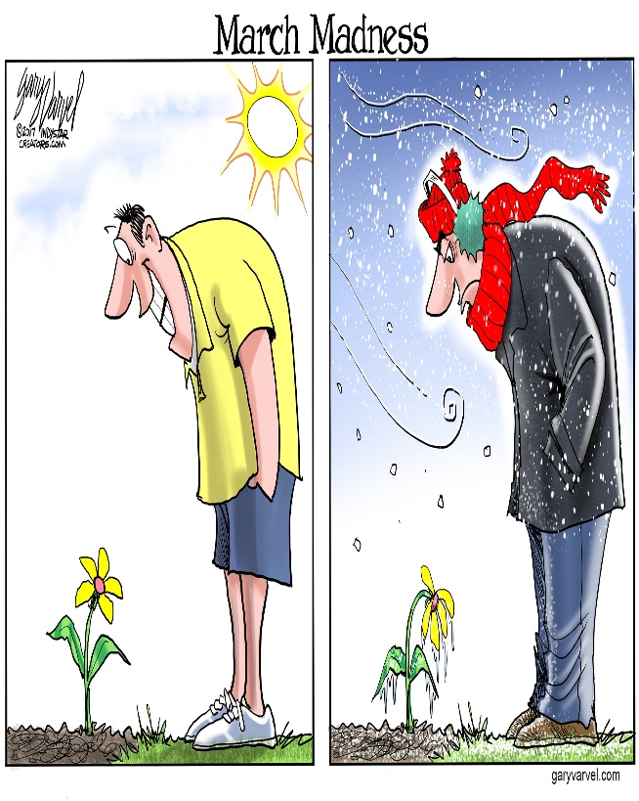

LAST WEEK’S COLLECTION

Adults $3,770.00

Loose $ 387.00

Youth $ 25.00

Monthly $ 76.00

Candles $ 33.00

Maintenance $ 61.00

Initial Offering $ 5.00

Easter $ 35.00

Mandeville Diocese $ 21.00

Black & Indian US Mission $ 85.00

Catholic Relief Services $ 55.00

Holy Land $ 15.00

Holy Thursday/Food Pantry $ 35.00

Easter Flowers $ 305.00

Total $4,908.00

We sincerely thank and ask God’s blessing upon all who have care and concern for

our parish.

*March 24, 2019 Luke 13:1-9*

*The owner of the fig tree was impatient because the tree did not live up to his expectations. In families there are those who don’t live up to our expectations. Imitate the gardener and give them more time and help. Don’t cut them out of your life. Love asks us to be connected, not productive.*



*UNPLANNED -* THE MOVIE ~ There is a new pro-life movie *Unplanned* that is set to be in theaters on March 29th in the Altoona area. The movie presents the story of Abby Johnson who worked for Planned Parenthood for many years but had a conversion after witnessing a live fetus during an ultrasound. This experience transformed her into an ardent pro-life advocate. Check out the trailer on-line.

2019 CATHOLIC MINISTRIES DRIVE: COMMITMENT SUNDAY ~ *Be a Good Shepherd. Give Help. Build Hope. Change Lives.* Through it, your sacrificial gifts of prayer and treasure will make an immediate impact on ministries that care for the poor, strengthen family life, nurture our youth, and provide leadership development for clergy and laity. If you didn’t bring your Commitment Card to mass this weekend, please bring it next weekend or you may make an online gift at [www.dioceseaj.org](http://www.dioceseaj.org). 100% of your gift goes directly to these ministries!

THE CATHOLIC RELIEF SERVICES COLLECTION ~ Next week, our parish will take up The Catholic Relief Services Collection. Funds from this second collection provide food to the hungry, support displaced refugees, and bring Christ’s love and mercy to all people here and abroad. Next week, please give generously to the collection, and help Jesus in disguise. Learn more about the collection at [www.usccb.org/catholic-relief](http://www.usccb.org/catholic-relief).

STAY INFORMED AND ENGAGED IN DIOCESAN NEWS ~ The Diocese of Altoona-Johnstown has launched an on-line newspaper *Proclaim!:* *The Good News of Altoona-Johnstown* featuring diocesan news, information, and commentary-including happenings at parishes and schools. Visit the site at proclaim.dioceseaj.org and sign up for regular e-mail updates delivered to your inbox. Beginning soon, monthly editions of *The Catholic Register* will be available here at the parish.

PARISH MISSION ~ The Basilica of St. Michael the Archangel, Loretto will hold their fourth annual Lenten Mission in Honor of Our Lady of Loretto March 31-April 5. Fr. Michael Caridi, St. Anne Parish, Pitts., PA is the Mission Director. The Mission opens Sunday March 31 at 7 PM with Prayers, homily & Benediction of the Blessed Sacrament, Bishop Mark Bartchak presiding. Mass with mission prayers and homily will be offered at 7 PM Monday through Friday. Confessions are offered at 6 PM Monday through Friday. Eucharistic Adoration offered at 6 PM Monday – Friday. Prayer intentions may be sent to: Fr. John D. Byrnes, Rector, PO Box 10, Loretto, PA 15940.

HEALING MASS ~ will be on Monday, April 8, at 7 PM, at the Cathedral of the Blessed Sacrament. Fr. Jonathan St. Andre TOR, will be the main celebrant. All are welcome, especially those in need of physical, emotional, or spiritual healing, and those who support and care for them as well. For more information call 814-941-3832.

CCW OPPORTUNITIES FOR ENRICHMENT ~ April 12-13: What the “people of the Passion” teach us about Jesus Today. As we journey through Lent to Holy Week, this retreat offers the opportunity to reflect on 7 people who witnessed the death of Jesus. Retreat begins on Friday at 7 PM; ends on Saturday at 3 PM and will include presentations on the theme, guided prayer opportunities and time for quiet personal reflection. Donation: $40/per person or $60/married couple. Includes overnight accommodation, meals and all materials. Pre-registration with donation is required by April 8. To register, get directions, or for more information, call 814-886-4098.

ST. MICHAEL CEMETERY ~ Spring Cleanup! Please have everything removed from the graves NO later than April 6th, 2019. Anything left will be disposed of.

PRAYER CARDS ~ All prayer cards in the bridal room are now 20 for $1.00.

UNUSED CARDS ~ St. Michael is collecting any types of unused cards, (ex.) Birthday, greetings, get well soon, Christmas, etc.…to give to the veterans. Please place your donation of cards in the box in the bridal room. Thank-you!

The Sanctuary Candle will burn in memory

of Jennifer Hudson Mader

requested by Nick & Sally Kolar

during the week of March 24, 2019.

[](https://images.search.yahoo.com/search/images;_ylt=A0LEV1kSWptXvOwAKINXNyoA;_ylu=X3oDMTEyZGdkcmRoBGNvbG8DYmYxBHBvcwMxBHZ0aWQDQjIwODlfMQRzZWMDc2M-?p=Clipart+of+a+sanctuary+candle&fr=ush-mailn_02&th=110&tw=110&imgurl=http://www.henningers.com/389-168-wall-sanctuary-lamp.jpg&rurl=http://pixshark.com/sanctuary-lamp.htm&size=43KB&name=Sanctuary+Lamp+Bronze+wall+sanctuary+lamp&h=600&w=600&turl=http://ts2.mm.bing.net/th?id=OIP.M68453c67108cdc5ab485d309b395bd03o0&pid=15.1&rs=1&c=1&qlt=95&w=110&h=110#inline&tt=Sanctuary+Lamp+Bronze+wall+sanctuary+lamp&sigr=116keh5le&sigit=13gvlt42j&sigi=11ip0pgm4&sign=119kp6100&sigt=119kp6100)

FR. BRIAN’S MESSAGE ~ We remember and pray for the repose of the soul of Bishop Joseph V. Adamec who passed away on March 20th. May he rest in Eternal Peace with Our Heavenly Father and may the souls of the faithful departed through the mercy of God rest in Eternal Peace.

STATIONS OF THE CROSS ~ On Friday evenings during Lent at 6:00 PM, we will pray the Stations of the Cross. Lent invites us to meditate on the Passion of Christ.



EASTER FLOWERS ~ Anyone wanting Easter flowers for a living (In Honor Of) or a deceased (In Memory Of) member of your family, please do so by signing the Easter Flower envelope in your packet. The normal offering is $10. Please return the envelopes on or before April 7th. Extra envelopes can be found at the church entrances.

COMBINED CHOIR ~ Combined Choir Rehearsal for Holy Thursday, Good Friday and Easter Sunday will be on Friday’s March 29 and April 5 following Stations at 7 PM. All are welcome and encouraged to join in preparing for this most sacred time of the liturgical year.

LENTEN CONFESSIONS ~ There will be confessions every Wednesday evening thru Lent from 5:30–5:45 PM. Lenten Confessions will be here on Thursday, April 4th at 6:00 PM. A few priests will be here to assist Fr. Brian.



SAVE THE DATE ~ On Wednesday, April 17th after the 6:00 PM Mass we will be holding a covered dish to commemorate the Lord’s Last Supper. More information and sign-up sheets will be ready in the next two weeks.

VOX NOVA ~ A choral ensemble from Mount Aloysius College, Cresson will present the Scriptural Stations of the Cross here on Friday, April 12th at 6:00 PM. Vox Nova empowers our Lenten reflection on these moments in song, augmenting the impact of each Station. A free will donation is requested.

EASTER NUT ROLLS ~ Most Holy Trinity, South Fork, is taking orders for their Easter Nut Roll Sale. Orders must be placed by Friday, March 29th. Nut Rolls can be picked up on Friday, April 5th at Most Holy Trinity Church Hall from 9:00 – 11:00 AM. A sign-up sheet is on the table in the back of the Church.



ST. MICHAEL FITNESS SERIES CONTINUES ~ Following the success of SoulCore, we will continue with a self-defense workshop on Saturday, March 30th at 1:00 PM at the parish hall. This workshop is perfect for husbands and wives, teenagers, and anyone interested in learning more about self-defense. Anyone interested, please call the parish office to register. Those attending will have to sign a waiver as you arrive to the session. A free will offering will be taken for the instructor.

St. Michael, Defend us in Battle!

 Religious Education And Christian Helping

March 24, 2019

Upcoming Confirmation Sessions

Grade 10 ~ Session 10 B ~ *Witness: Word, Worship, Community & Service*

Sunday, March 31, 2019

All 10th Grade students will attend this Session from 9 to 10:20 a.m.

****************************************************************************

*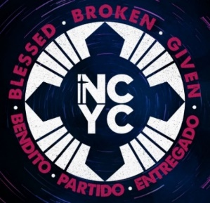Saint Michael Parish is planning to attend NCYC 2019!*

*November 21—23, 2019*

The National Catholic Youth Conference (NCYC) is the largest Catholic youth gathering in the U.S. with over 20,000 young people, clergy and religious, and adult chaperones attending from all over the country.

Any high school aged (Grade 10—12) Catholic member of the Diocese of Altoona-Johnstown aged 16 or over and their adult chaperones (with proper clearances). It is held in Indianapolis, Indiana. Large group sessions are held in Lucas Oil Stadium; Workshops and sessions are held in the Indianapolis Convention Center. Pre-registration to attend is required. A Payment plan is offered after the initial $100 deposit is paid. *We will plan several fundraisers to help subsidize the expenses.*

Initial Deposit of $100.00…………………………………………….….Due March 31, 2019

****************************************************************************

Gardner’s Easter Candy Sale

 Our Saint Michael Parish is sponsoring a Gardener’s Easter Candy Fundraiser. All proceeds from this sale will be placed in our General Fund to be used towards expenditures for our Religious Education Program. A color brochure and order information is included in this bulletin. Extra brochures are also at the church entrances. All orders along with payment are due by March 31st. Orders will be delivered and available for pick-up on April 11th. Any questions can be directed to the Parish Office at 495-9640.

****************************************************************************

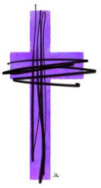K—5 Stations of the Cross ~ Thursday, April 11th ~ Our K—5 Students will join Fr. Brian in the Church on Thursday, April 11 for Stations of the Cross beginning at 4:00 p.m. Parents and parishioners are invited to join us in the church for these stations.

The K—5 students will be dismissed to their parents from the church at the conclusion for

their rides home.

****************************************************************************

Our Saint Michael Parish will be hosting Yee Haw VBS this July along with Most Holy Trinity and Saint Bartholomew Parishes. We will have a planning meeting this Thursday, March 28th at 6:00 p.m. in our Saint Michael Parish Hall. Anyone interested in helping with VBS in any way is invited to attend. Questions can be directed to the RE Office at 495-4873. 

Rite of Sending ~ Our 11th grade Confirmation class along with their Sponsors will attend the 10:30 AM Mass on Sunday, April 7, 2019. The candidates will celebrate their “Rite of Sending” as our parish “sends them off” to receive their Sacrament of Confirmation.

Confirmation ~ Our 11th Grade Confirmation class will receive their Sacrament of Confirmation on Thursday, April 25, 2019. A 7:00 PM Mass will be celebrated at Saint John Gualbert Cathedral in Johnstown.

*Confirmation Practice will be held on Wednesday evening, April 24th at 6:30 PM.*

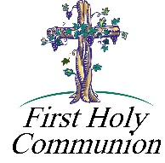

*First Holy Communion ~ Our Second Grade class is preparing to receive their Sacrament of Reconciliation on Saturday, May 4th and*

*First Holy Communion on Sunday, May 5th.*

****************************************************************************





Our REACH Youth Ministry will sponsor an Easter Egg Hunt for Pre-K– Grade 5 students on Sunday, April 14th immediately following the 10:30 a.m. Passion Sunday Liturgy. Any Pre-K—Grade 5 students wishing to participate in our hunt can assemble in the middle parking lot between the church and church hall. Treats will be given even if weather does not permit a hunt.



*There will be NO Religious Education classes held on April 14th for grades 6—12.. REACH student volunteers are needed for this project. We set up during the 10:30 a.m. mass, therefore any REACH students wishing to participate in this service project will need to attend an alternate mass, the 4:00 p.m. Saturday evening mass on April 13th or the 8:00 a.m. Palm Sunday Mass to fulfill their weekend mass obligation.*

*Student volunteers can arrive at the parish hall at 10:00 AM to help prepare for this event during the 10:30 a.m. Mass. Call the RE Office to sign-up at 495-4873.*

************************************************************************

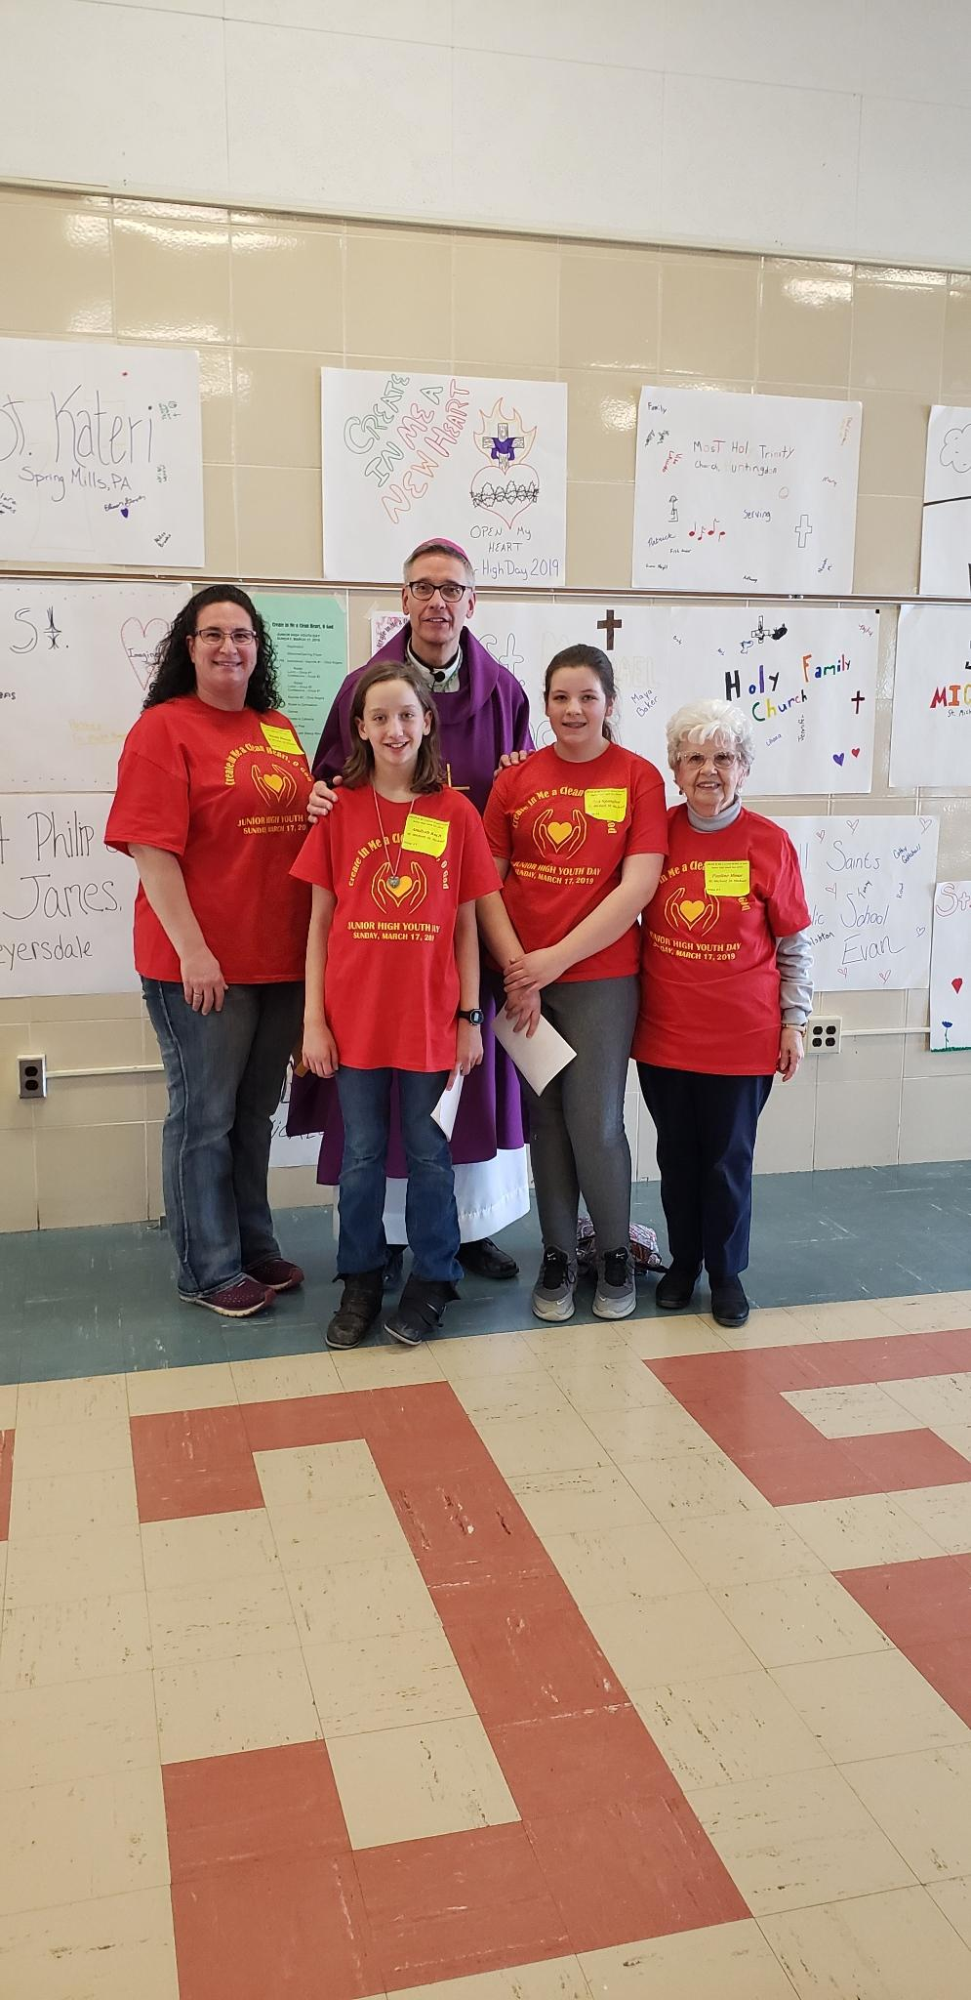

*Junior High Youth Day Attendees*

*March 17, 2019*

Our Saint Michael group had an awesome time at this years’ Junior High Youth Day!

Pictured Left to Right:

Wendy Blough, Amilyah Koch, Bishop Mark Bartchak, Ana Spangler and Pauline Minor.

Local Fish Fries:

St. Michael Fire Department ~ 11 AM- 7 PM. Take outs or local delivery available. Phone 495-4111.

Immaculate Conception Parish ~ Dinners 4-7 PM. Take outs available until 6 PM. Call 495-4298.

Holy Family Parish ~ March 15, 29 & April 12 from 4-6 PM. Take outs available. 814-736-3146

St. Elizabeth Ann Seton ~ Serving from 11 AM – 6:30 PM. 814-467-7191.

ATTENTION ALL BRIDES & BRIDES TO BE ~ Bishop Carroll Lady Huskies soccer team is sponsoring a bridal resale event on Sunday, April 7 from noon – 3 PM at the BC school cafeteria. Sell your new or like-new wedding decorations and supplies or buy your decorations & supplies at a fraction of the cost of new! Sellers can reserve a space for $20 which includes a 12 x 10 area with a table & 2 chairs. The admission fee for shoppers is $5. For more information or to reserve a space, contact Carol at [kcschallfam@yahoo.com](mailto:kcschallfam@yahoo.com).

ADAMS TWP LIONS CLUB BASKET PARTY ~ Saturday, April 27th at St. Michael Firehall. Starts @ 7:00, Doors open @ 5:00, Admission is $8.00. Tickets can be purchased in advance. Phone: 487-4132 or 487-5988 or any Lion Member.

ACTIVE SHOOTER SEMINAR ~ United Methodist Church in Elton, Saturday, March 30th @ 9:00 AM. Done by the Adams Township Police. Please call Tom Fondelier @ 659-7130.

INSPIRATIONAL SPEAKER ~ Dr. John Bergsma on March 31, April 1-2 from 7-8:30 PM at St. Benedict Parish, Johnstown. Tickets not required. A love offering will be taken. For information call 814-288-3036 or [michael.russo@atlanticbb.net](mailto:michael.russo@atlanticbb.net).

Sunday, March 24 High School Religious Ed. / Life Coach Speaker / 9:00 – 10:20 AM

May Treasury Tickets Due

Monday, March 25 Sunday Choir Practice / 7:00 PM

Tuesday, March 26 Boy Scouts / 7:30 – 9:00 PMPMPM



Wednesday, March 27 Confessions / 5:30-5:45 PM

Mass / 6:00 PM

Thursday, March 28 K-5 Religious Ed. / 3:30 – 4:30 PM

Saturday Choir Practice / 4:30 PM

Vacation Bible School Meeting / 6:00 PM

 Friday, March 29 Stations of the Cross / 6:00 PM

Combined Choir Practice / 7:00 PM

Tomahawks Hockey Game / 7:30 PM

Saturday, March 30 Self Defense Class / 1:00 PM

Catholic Relief Services / Second Collection

UPCOMING EVENTS

March 31 Catholic Relief Services / Second Collection

Gr. 10 Confirmation Session

Girl Scouts

April 4 Lenten Confessions / 6:00 PM

April 5 Exposition of Blessed Sacrament with Adoration

April 11 K—5 Stations of the Cross / 4:00 PM

Gardner’s Candy Delivery