John 6:54

ST. MICHAEL ROMAN CATHOLIC CHURCH

751 Locust Street

PO Box 103

St. Michael, Pennsylvania 15951

Rev. Brian L. Warchola, Administrator MASSES:

(814) 495-9640 Saturday 4:00 pm



Sunday Morning 8:00 am

Secretary: Michele Panick 10:30 am

Bookkeeper: Kathy Kalicky Daily Mass See Bulletin

DRE: Laurie Sloan Holy Days See Bulletin

Maintenance: Rodney Turgeon

Office Hours:

PHONES: 8:30 am to 3:30 pm

Rectory / Office: (814) 495-9640 Monday, Tues., Thurs., Friday

Fax: (814) 495-9424 Confessions:

Rel. Education: (814) 495-4873 Saturday 3:30 pm to 3:45 pm

Parish Website Sunday 7:30 am to 7:45 am

www.saintmichaelchurch.weebly.com 10:00 am to 10:15 am

Secretaries’ E-mail Anytime Requested

[saintmichaelsecretaries@yahoo.com](mailto:saintmichaelsecretaries@yahoo.com)

YEAR: 2019 NUMBER: 14

SERVING GOD AND COMMUNITY FOR OVER ONE HUNDRED YEARS!

BAPTISM: By Appointment. Reserve at least one month in advance.

MARRIAGE: Plan at least nine months in advance.

Preparation sessions are necessary.

FUNERALS: Arrangements are made in conjunction with the funeral home.

REGISTRATION Those new to the area, newlyweds, and single adults, (even if registered

and before with their families) are asked to register by calling the Parish Office.

MEMBERSHIP: Every parishioner must be registered. This is a condition for admission

to our Program and reception of the Sacraments of Baptism, Confirmation, First Penance, First Eucharist, and Matrimony; also, for testimonial letters or sponsorship of Baptism and Confirmation outside the Parish.

VISITATION: We are concerned and want to be advised when someone is ill at home or in the hospital. Call the rectory to have the shut-in placed on our monthly Holy Communion calls or seriously ill prayer list.

SACRAMENTAL Parish registration and active Mass participation for Baptism is

POLICY: encouraged and is required for Marriage.

BULLETIN ARTICLES: Articles re due to the Parish Office by Noon on Tuesdays.

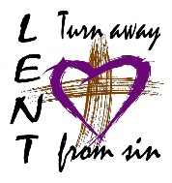 Fifth Sunday of Lent

April 7, 2019

**Month of The Holy Eucharist**

**MASS INTENTIONS**: (April 8 – April 14, 2019)

Monday 8:00 AM Claudia McCloskey req. by Bob Amity & Staff

Tuesday 8:00 AM Kevin Smay req. by John & Josephine Kolonich

Wednesday 6:00 PM Janet L. Smith req. by Connie Hobbs

Thursday 8:00 AM Fritzie, Michael & Remy Beaver req. by Family

Friday 8:00 AM Albert Andrykovitch req. by Susan Chulick

Saturday 4:00 PM Grace & Richard Hautz req. by Children

Sunday 8:00 AM Jane Plummer req. by Paul & Clare Kundrod

Sunday 10:30 AM People of the Parish

LITURGICIAL APPOINTMENTS:

Saturday, April 13 4:00 PM Offertory Procession

Lector: Amy Spinos & Susan Poldiak Hautz Children

Minister of the Host: Babe Richards

Choir Minister: Theresa Carlson

Altar Servers: Ana Spangler & Natalie Stohon

Cantor: Amy Spangler

Greeter: Phyllis Slonac & Shirley Walls

Sunday, April 14 8:00 AM Offertory Procession

Lector: Cathy Faher & Arnold Bernard Jane Plummer Family

Minister of the Host: Pauline Minor

Choir Minister: Ellen Grattan

Altar Servers: Andrew Martin & Bryce Macy

Cantor: Joseph Faher

Greeter: Cheryl Macy & Deborah Macy

Sunday, April 1410:30 AM Offertory Procession

Lector: Carole Kakabar & Peter Bernard Dobbins Family

Minister of the Host: Michael Barton

Choir Minister: Amanda Williamson

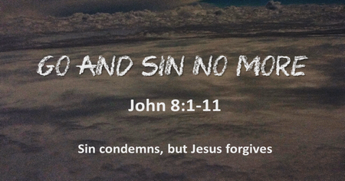Altar Servers: Haidyn & Amilyah Koch

Cantor: Louis McCloskey

Greeter: Sara Wieczorek & REACH Students

Sunday, April 14 Collection Counters

Mary Ann DeRosa, Rod Kundrod

Camillus Long

Weare placing names of the sick in the bulletin for prayer providing they give permission. *May the* *Divine Physician send healing grace for those for* *whom we pray:* Allen C. Rosemas, Patricia Murphy, Bernice Myers, Dwight Fyock, Lori Facciani, Dylon Wills, Missy, Joanne (Kolar) Hufford, Christine Flanagan, Ayden Alan Grata, Mary Lou Offman, Mary Zangaglia, Dorothy Rosemas, Natalie Zerby, Patricia Grata, Michael Wadsworth, Valencia & Frank Tursi, Homer Locher, Brayden Schofield, Michelle Kasper, Diane Kingera, Allison Krischer, Ted Paluch, Brandt Hutzel, Pearl Litzinger, Patrick Munro, Fran Baldassarre, Kristen Sinosky Long, Helen Ranieri, Cresta Micik, Basil Costantino, Madison McCrory, Laura, Joe Yoder, Dolores Yanzetich, Sandy Krug, Wanda Gramling, Merna Smay, Muriel “Jean” Wiesheier, Agnes Plummer, Jennifer Hagans, Shawn, Holly, Shane, Spencer, Owen Taylor, Keith & Dawnetta Hoyer, Derrick Varnish, Daniel Koshute, Vincent Koshute, Melissa Cordek, Michelle Elliott, Heather Romanow, Mackston Barrick, Connor Thomas, Erin, Pat, Mary Agnes Nastase, Mary Ann Bertolino, Dick Wilson, Izzy Bihun, Erica Mitzelfeld, Dorothy Kaminsky, Ed Ripper Sr., Patricia Oshaben, Ashlee Madison, Susan Yanzetich, Mike, Mary Sivec, Danika Faith, Alina Rusnak, Marcia Costlow, Gary Smay, Elizabeth Howell, Helen Bowen, Bill Gideos, James Macy, Walter Bodziak, Rhonda, Dan Strinkoski, Anne Robinson, Marlene McCrory, Sharon Poldiak, Carter Bobak, Vince Arena, Mike Morris, Sarah Kelt, Mildred Andrykovitch, Patty Yanzetich Caldwell, Mary Secriskey, Colton Snyder, Betty Delaney, Nancy Edmiston, Elizabeth Stoker Thomas, Albert Sracic, Arthur Byers, Joseph Ropecka, Bill Krajewski, Leonard Oshaben and all of the sick of our parish, the homebound, those in nursing homes, those who care for them, and those in the military along with their families. *(Please call the Rectory to have your name removed from the list when no longer seriously ill. Thank You.)*

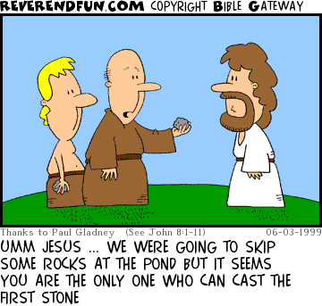

LAST WEEK’S COLLECTION

Adults $3,548.00

Loose $ 250.00

Youth $ 43.50

Monthly $ 241.00

Candles $ 31.00

Maintenance $ 61.00

Catholic Relief Services $ 766.00

Mandeville Diocese $ 25.00

Lenten Folders $ 50.00

Easter Flowers $ 70.00

Total $5,085.50

We sincerely thank and ask God’s

blessing upon all who have care

and concern for our parish.

*April 7, 2019 John 8:1-11*

*Stoning is not just an ancient act of violence. Each day in our homes we throw stones of ridicule, criticism, name-calling and put-downs. All of it is deadly. Hear Jesus in today’s gospel “Whoever is without sin can throw the first stone.” Rid your home of violence. Stop verbal stoning!*

CHILD ABUSE

April is Child Prevention Awareness Month. The Diocese of Altoona-Johnstown is firmly

committed to protecting children and youth.

Reporting Child Abuse

The Diocese of Altoona-Johnstown is firmly committed to protecting children and youth. If you have a reasonable cause of suspected child abuse, general child well-being concerns or know of other abuse of minors please report your concerns to:

* 911 immediately if there is an indication of imminent danger
* PA Child Line 1-800-932-0313 (intake is available 24/7)

Reports of abuse within the Diocese of Altoona-Johnstown

* Pennsylvania Attorney General Hotline (888) 538-8541
* Pennsylvania State Police Headquarters (717) 783-5599 or your local Pennsylvania State Police Station
* Your local police department
* To report to the Diocese any suspected abuse of a minor please call the Diocese of Altoona-Johnstown Independent Reporting Hotline hosted by Nulton Diagnostic and Treatment Center* at this Toll-Free Number: (833) 685-8661. Your call will be answered by a representative of Nulton Diagnostic and Treatment Center. Any information provided to Nulton Diagnostic and Treatment Center will be reported to law enforcement as required by state law. *\*Nulton Diagnostic and Treatment Center is independently owned and operated and not associated with the Diocese of Altoona-Johnstown.*

Victim/Survivor Assistance and Resources

For Victim/Survivor information and resources, please call the Diocese of Altoona-Johnstown Victim/Survivor Assistance Coordinator: Jean Johnstone at (814) 944-9388.

To report the abuse of adults with disabilities, call the Protective Services Hotline at 1-800-490-8505.

OUR LADY OF LOURDES PARISH ~ Welcomes you to a teaching and exposition of over 150 Sacred Relics. Among the treasures will be relics of St. Teresa of Avila, St. Theresa of Lisieux (the Little Flower), St. Francis of Assisi, a piece of a veil which belonged to Our Lady and one of the largest remaining pieces of the True Cross in the world. This will be held in the Church on Tuesday, April 16 at 6:30 PM with a presentation followed by the showing of the relics. This is truly once in a lifetime experience.

CCW ANNUAL “HANDS & HEARTS HAITI FET” ~ The Carmelite Community of the Word invites you to our Annual Hands & Hearts Haiti Fet (Paschal Festival), on Sunday, May 5, at Our Lady of Loretto Hall, 279 St. Elizabeth St., Loretto, PA. Please join us for an afternoon of good food, and enriching entertainment through Haiti stories and information on the CCW Hands & Hearts Ministry efforts. The afternoon will include a silent auction and opportunity to purchase Haitian Art and Craft items. Doors open at 1:15 PM; Dinner and Program at 2:00 PM. Tickets are $35 for adults and $15 for children under 13. In addition, each participate is asked to contribute an item of children’s or teens new underwear or socks. Contact the CCW Incarnation Center at 814-886-4098 for tickets or for more information. Ticket deadline is April 29. All proceeds will benefit the CCW Hands & Hearts Haiti Ministry.

The Sanctuary Candle and

The Our Lady of Grace Candle will burn for

Allen Rosemas

requested by his mother Dorothy Rosemas

and Sister Marissa Rosemas

during the week of April 7, 2019.

[](https://images.search.yahoo.com/search/images;_ylt=A0LEV1kSWptXvOwAKINXNyoA;_ylu=X3oDMTEyZGdkcmRoBGNvbG8DYmYxBHBvcwMxBHZ0aWQDQjIwODlfMQRzZWMDc2M-?p=Clipart+of+a+sanctuary+candle&fr=ush-mailn_02&th=110&tw=110&imgurl=http://www.henningers.com/389-168-wall-sanctuary-lamp.jpg&rurl=http://pixshark.com/sanctuary-lamp.htm&size=43KB&name=Sanctuary+Lamp+Bronze+wall+sanctuary+lamp&h=600&w=600&turl=http://ts2.mm.bing.net/th?id=OIP.M68453c67108cdc5ab485d309b395bd03o0&pid=15.1&rs=1&c=1&qlt=95&w=110&h=110#inline&tt=Sanctuary+Lamp+Bronze+wall+sanctuary+lamp&sigr=116keh5le&sigit=13gvlt42j&sigi=11ip0pgm4&sign=119kp6100&sigt=119kp6100)

HOLY NAME SOCIETY ~ Will hold their monthly meeting today, April 7th after the 8:00 AM Mass.

COMBINED CHOIR ~ Combined Choir Rehearsal for Holy Thursday, Good Friday and Easter Sunday will be on Friday April 12 following Stations at 7 PM. All are welcome and encouraged to join in preparing for this most sacred time of the liturgical year.



SAVE THE DATE ~ On Wednesday, April 17th after the 6:00 PM Mass we will be holding a covered dish to commemorate the Lord’s Last Supper. Sign-up sheets are on the table in the back of the church.

VOX NOVA ~ A choral ensemble from Mount Aloysius College, Cresson will present the Scriptural Stations of the Cross here on Friday, April 12th at 6:00 PM. Vox Nova empowers our Lenten reflection on these moments in song, augmenting the impact of each Station. A free will donation is requested.

SECOND SUNDAY FOOD COLLECTION ~ Next weekend is our Second Sunday Food Collection. Please bring in non-perishable food items or toiletries with you. Monetary donations are also appreciated.

BEAUTIFUL SINGING! ~ We’d like to acknowledge the beautiful singing of our Choir at the close of the Infant Prague Novena at St. Andrew’s Church in Johnstown this past Monday, April 1st. What a blessing it was!

THANKS! ~ Thanks to the Holy Name Society Members that helped with the repair & clean up of the Outdoor Stations this past Tuesday, April 2nd. What a nice job they did!

HEALING MASS ~ Will be on Monday, April 8, at 7 PM, at the Cathedral of the Blessed Sacrament. Fr. Jonathan St. Andre TOR will be the main celebrant. All are welcome, especially those in need of physical, emotional, or spiritual healing, and those who support and care for them as well. For more information call 814-941-3832.

PART-TIME JOB OPENING ~ Bishop Carroll Catholic High School is accepting applications for a Part-Time Bookkeeper with accounting and/or Quickbooks experience. The school’s international program is also seeking to fill full and part-time positions. Inquiries can be directed to Mrs. Lynn Weber at [lweber@bishopcarroll.org](mailto:lweber@bishopcarroll.org) or call 472-7500 ext. 101



2019 CATHOLIC MINISTRIES DRIVE ~ St. Michael’s Parish Goal is $26,768.00.

*Stewardship Reflections…*

Jesus’ disciples do not “cast stones” of apathy and selfishness toward those who are poor, imprisoned, and oppressed in body, mind, and spirit. Living as baptized believers of stewardship will lead us to gift of Eternal Life!



Religious Education And Christian Helping

April 7, 2019



Rite of Sending ~ Our 11th grade Confirmation class along with their Sponsors will celebrate their “Rite of Sending” as our parish “sends them off” to receive their Sacrament of Confirmation. The Members of the 2019 Confirmation Class are:

Mykala Drobnick, Luke Docherty, Shannan Elgin, Luke Hribar, Brycen Rearick,

Hadan Romanow and Elizabeth Zajdel.

Confirmation ~ Our 11th Grade Confirmation class will receive their Sacrament of Confirmation on Thursday, April 25, 2019. A 7:00 PM Mass will be celebrated at Saint John Gualbert Cathedral in Johnstown.

*Confirmation Practice will be held on Wednesday evening, April 24th at 6:30 PM.*

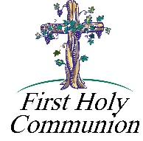

*First Holy Communion ~ Our Second Grade class is preparing to receive their Sacrament of Reconciliation on Saturday, May 4th and*

*First Holy Communion on Sunday, May 5th.*

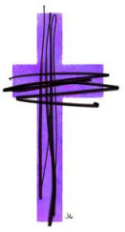

*************************************************************************

K—5 Stations of the Cross ~ Thursday, April 11th ~ Our K—5 Students will join Fr. Brian in the Church this Thursday, April 11 for Stations of the Cross beginning at 4:00 p.m. Parents and parishioners are invited to join us in the church for these stations.

The K—5 students will be dismissed to their parents from the church at the conclusion for their rides home.

*************************************************************************

Gardner’s Easter Candy Delivery

Gardener’s Easter Candy Fundraiser orders will be delivered on Thursday, April 11th.

Orders will be available for pick-up:

In the parish hall Thursday, April 11th from 1:00 to 4:00 p.m., and again on Friday, April 12th; 9 a.m. to 12 Noon and 1:00 to 3:00 p.m., and in the Bridal Room of the church at the weekend masses.

Any questions can be directed to the Parish Office at 495-9640.

*************************************************************************

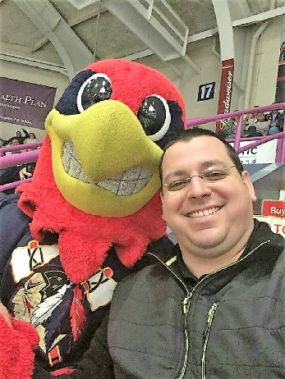

Tomahawks Hockey Game

Our St. Michael Parish attended a Tomahawks Hockey Game last Friday, March 29th at 1st Summit Arena in Johnstown. We had a great time cheering for our home town team.

Here is Fr. Brian with the Tomahawks Mascot, Chopper.

*************************************************************************





Our REACH Youth Ministry will sponsor an Easter Egg Hunt for Pre-K– Grade 5 students on Sunday, April 14th immediately following the 10:30 a.m. Passion Sunday Liturgy. Any Pre-K—Grade 5 students wishing to participate in our hunt can assemble in the middle parking lot between the church and church hall. Treats will be given even if weather does not permit a hunt.



*There will be NO Religious Education classes held on April 14th for grades 6—12.. REACH student volunteers are needed for this project. We set up during the 10:30 a.m. mass, therefore any REACH students wishing to participate in this service project will need to attend an alternate mass, the 4:00 p.m. Saturday evening mass on April 13th or the 8:00 a.m. Palm Sunday Mass to fulfill their weekend mass obligation.*

*Student volunteers can arrive at the parish hall at 10:00 AM to help prepare for this event during the 10:30 a.m. Mass. Call the RE Office to sign-up at 495-4873.*

*************************************************************************

Our Saint Michael Parish will be hosting Yee Haw VBS this summer along with Most Holy Trinity and Saint Bartholomew Parishes. Yee Haw will be held on July16, 17 & 18 from 6—8 p.m.

REACH students and adult volunteers are needed to help with prep ahead of VBS week and we will also need help the week of VBS.

If you are interested in helping with VBS in any way, please contact the Parish Office at 495-9640 or the RE Office at 495-4873.

Prep dates and times will be posted in the bulletin for future meetings.

SELF DEFENSE WORKSHOP

Our self defense workshop this past Saturday was phenomenal! My personal thanks to all those individuals who participated! Our instructor Corrin Dagostin and her assistant Will Kanich demonstrated many self defense techniques to the school students and adults who were present.

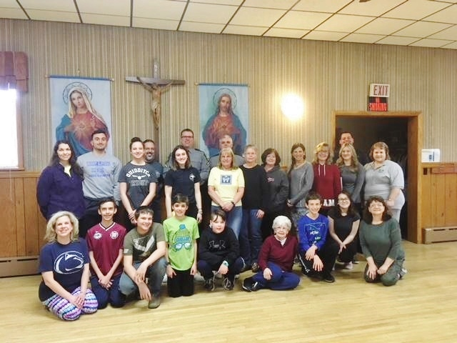

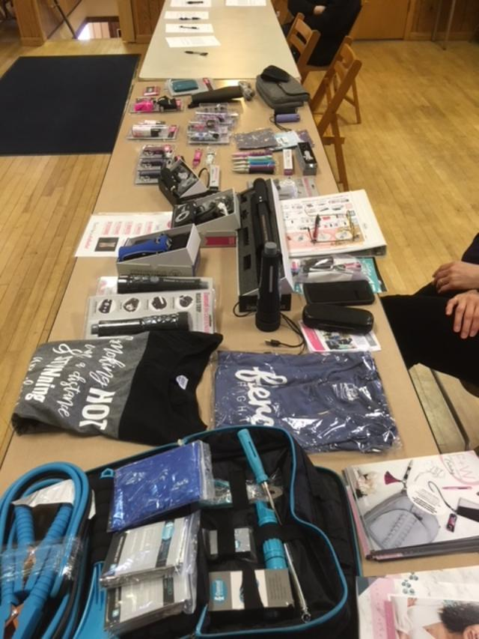

Also, two PA State Troopers Frank Lashinsky and B.J. Kunsman both gave presentations on safety. I am so appreciative of their willingness to be present. A representative from Damsels in Defense, Dee Dee McGowan also came and presented on self defense items, as well as education and information on child protection and safety.

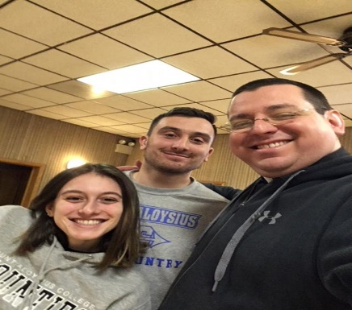

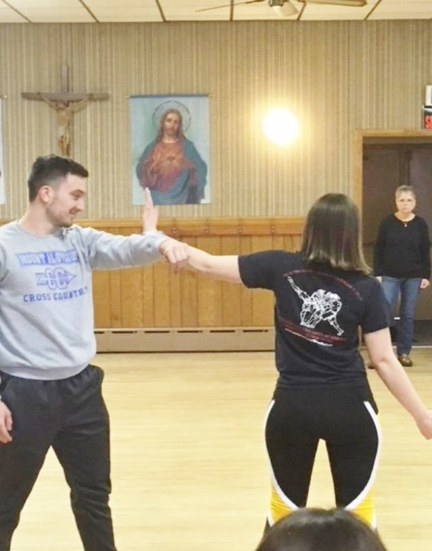

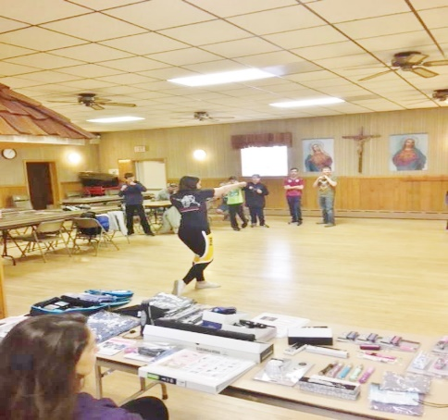

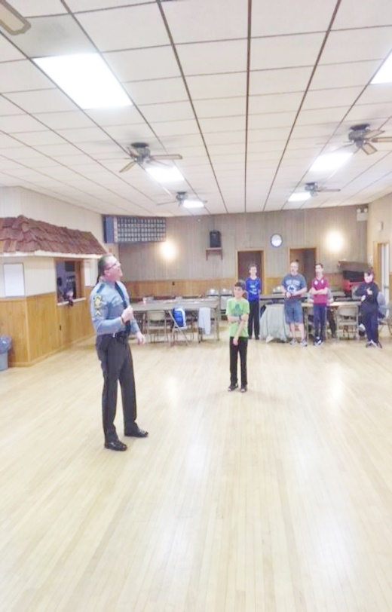

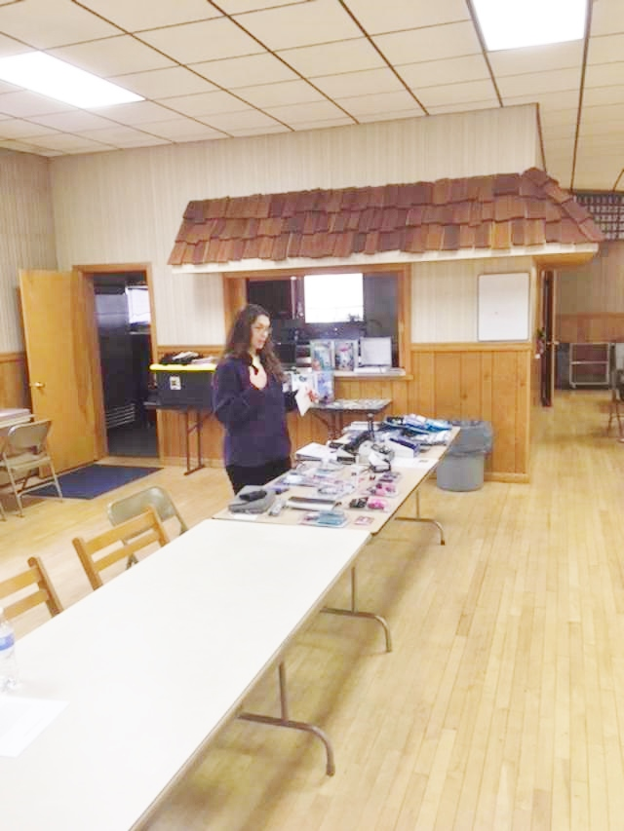

This was a phenomenal opportunity for our parish and community. I hope that the diocese can perhaps do something on a diocesan level for all people who are willing to participate.

St. Michael the Archangel defend us!

Sunday, April 7 Holy Name Society Meeting / After 8:00 AM Mass

 High School Religious Ed. / 9:00–10:20 AM

11th Grade Rite of Sending / 10:30 AM Mass

Monday, April 8 Martha’s Group / 6:00 PM

Sunday Choir Practice / 7:00 PM

Tuesday, April 9 Boy Scouts / 7:30–9:00 PMPMPM

Wednesday, April 10 Confessions / 5:30-5:45 PM

Mass / 6:00 PM

Thursday, April 11 K-5 Stations of the Cross / 4:00 PM

Saturday Choir Practice / 4:30 PM

Gardner’s Candy Delivery & Pick-up / 1:00–4:00 PM

Friday, April 12 Gardner’s Candy Pick – up / 9:00 AM – 12:00 PM & 1:30–3:00 PM

Vox Nova Stations / 6:00 PM

Combined Choir Practice / 7:00 PM

 Saturday, April 13 Second Sunday Food Pantry

Gardner’s Candy Pick-up / After Mass

UPCOMING EVENTS

Sunday, April 14 Second Sunday Food Pantry

Baptism

REACH Easter Egg Hunt

Wednesday, April 17 Commemoration of the Lord’s Last Supper

 Local Fish Fries:

St. Michael Fire Department ~ 11 AM- 7 PM. Take outs or local delivery available. Phone 495-4111.

Immaculate Conception Parish ~ Dinners 4-7 PM. Take outs available until 6 PM. Call 495-4298.

Holy Family Parish ~ April 12 from 4-6 PM. Take outs available. 814-736-3146

St. Elizabeth Ann Seton ~ Serving from 11 AM – 6:30 PM. 814-467-7191.

CRAFT & VENDOR FAIR ~ Bishop Carroll Catholic High School. Saturday, April 13th, 9:00 AM – 4:00 PM. 70 + Crafters/Vendors. Fresh Made Foods, Huge Bake Sale, (Cinnamon Rolls by the Dozen Pre Order Sale), Kiddie Korner, Easter Egg Hunt at 1:30 and Easter Bunny Visit from 11-1:30 – Bring your Camera!

ADAMS TWP LIONS CLUB BASKET PARTY ~ Saturday, April 27th at St. Michael Firehall. Starts @ 7:00, Doors open @ 5:00, Admission is $8.00. Tickets can be purchased in advance. Phone: 487-4132 or 487-5988 or any Lion Member.

CARROLLIAN GALA ~ Saturday, April 27 at Bishop Carroll Catholic High School. Tickets are $50 each. Cocktails begin at 5:30 and dinner will be served at 6:30. Silent and live auctions will take place all evening long, as well as the chance to win baskets and other prize opportunities. For more information, or to purchase ticket, please call 814-472-7500 extensions 104 or 105, or email [jnagy@bishopcarroll.org](mailto:jnagy@bishopcarroll.org).

BUS TRIP ~ Wednesday, August 7th. Sight and Sound “Jesus” includes lunch at Shady Maples. $139 adult/$99 child. For more info or reservations Debbie Poborsky 814-495-3158(home), 814-525-5035(cell). Send payment to 807 Ragers Hill Rd, South Fork, PA 15956.