Rev. 12:7
ST. MICHAEL ROMAN CATHOLIC CHURCH
751 Locust Street
PO Box 103
St. Michael, Pennsylvania 15951

Rev. Msgr. David A. Lockard, Administrator MASSES:
(814) 495-9640 Saturday TBD
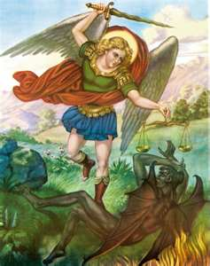
Sunday Morning TBD
Secretary: Michele Panick
Bookkeeper: Kathy Kalicky Daily Mass
DRE: Laurie Sloan Holy Days
Maintenance: Rodney Turgeon Office Hours:
PHONES: 9:00 am to 12:30 pm
Rectory / Office: (814) 495-9640 Monday, Tues., Thurs., Friday
Fax: (814) 495-9424 Confessions:
Rel. Education: (814) 495-4873 Saturday 3:00 pm to 3:15 pm
Parish Website Sunday 11:00 am to11:15 am
www.saintmichaelchurch.weebly.com By Appointment
Secretaries’ E-mail
saintmichaelsecretaries@yahoo.com
Facebook page:
St. Michael Catholic Church/St. Michael, PA

The Most Holy Trinity

SERVING GOD AND COMMUNITY FOR OVER ONE HUNDRED YEARS!

June 7th, 2020

BAPTISM: By Appointment. Reserve at least one month in advance.
MARRIAGE: Plan at least nine months in advance.
Preparation sessions are necessary.
FUNERALS: Arrangements are made in conjunction with the funeral home.
REGISTRATION Those new to the area, newlyweds, and single adults, (even if registered
and before with their families) are asked to register by calling the Parish Office.
MEMBERSHIP: Every parishioner must be registered. This is a condition for admission
to our Program and reception of the Sacraments of Baptism, Confirmation, First Penance, First Eucharist, and Matrimony; also, for testimonial letters or sponsorship of Baptism and Confirmation outside the Parish.
VISITATION: We are concerned and want to be advised when someone is ill at home or in the hospital. Call the rectory to have the shut-in placed on our monthly Holy Communion calls or seriously ill prayer list.
SACRAMENTAL Parish registration and active Mass participation for Baptism is
POLICY: encouraged and is required for Marriage.
BULLETIN ARTICLES: Articles are due to the Parish Office by Noon on Tuesday.

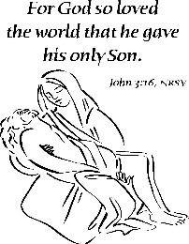
The Most Holy Trinity
June 7th, 2020
The Sacred Heart of Jesus

My brothers and sisters,

It was so good last week that I was at last able to bring Holy Communion to the homebound people of our parish, and to have Holy Communion services in the church itself. These will continue the week of Monday, June 8th. The schedule is in the bulletin, along with times for the Sacrament of Reconciliation and when the church is open for private prayer.
The next stage in the return to normalcy will be to celebrate daily Mass in the church. We will begin this the week of June 15th. The Mass schedule will be Monday, Tuesday, Thursday and Friday at Noon and Wednesdays at 6:00 PM. We will continue to offer Holy Communion on Saturday at 3:30 PM and Sunday at 11:30 AM.
Hopefully, we will be able to celebrate Sunday Masses beginning the weekend of June 20th and 21st, Saturday evening Mass will be at 4:00 PM; Sunday there will be ONE Mass at 9:30 AM. (These times may change.) There is a limit of 50 people at Mass, so we may need to add another Sunday Mass.
Once again, if you can help in some way with the restart of Mass at St. Michael, please let me know ASAP.

Thank you and God bless you all,
Msgr. L.

TIMES FOR COMMUNION SERVICES AT ST. MICHAEL CHURCH

Monday, Tuesday, Thursday, Friday – Noon
Wednesday – 6:00 PM
Saturday – 3:30 PM to 3:45 PM
Sunday – 11:30 AM to 11:45 AM
What to do (instructions of the Bishop)
Come to the door of the Church facing the WPA Road. Form a line to enter the Church one at a time.
Msgr. Lockard will be in the small vestibule.
Please wear a mask and practice “safe distancing” while in line for Holy Communion.
Fast from food for one hour before receiving Holy Communion.
Pray the Lord’s Prayer before receiving.
After receiving, return to your car to make your private Thanksgiving.

During the week of June 7th, 2020
the Sanctuary candle will burn for
the Sick and Shut-ins of our Parish
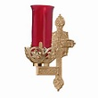

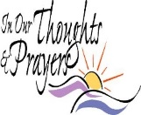
We are placing names of the sick in the bulletin for prayer providing they give permission. May the Divine Physician send healing grace for those for whom we pray: Allen C. Rosemas, Patricia Murphy, Bernice Myers, Dwight Fyock, Dylon Wills, Missy, Joanne (Kolar) Hufford, Christine Flanagan, Ayden Alan Grata, Mary Lou Offman, Mary Zangaglia, Natalie Zerby, Valencia Tursi, Homer Locher, Brayden Schofield, Michelle Kasper, Diane Kingera, Allison Krischer, Ted Paluch, Brandt Hutzel, Pearl Litzinger, Patrick Munro, Fran Baldassarre, Kristen Sinosky Long, Cresta Micik, Basil Costantino, Madison McCrory, Laura, Joe Yoder, Dolores Yanzetich, Sandy Krug, Wanda Gramling, Agnes Plummer, Jennifer Hagans, Shawn, Holly, Shane, Spencer, Owen Taylor, Keith & Dawnetta Hoyer, Derrick Varnish, Vincent Koshute, Melissa Cordek, Michelle Elliott, Heather Romanow, Mackston Barrick, Connor Thomas, Erin, Pat, Mary Agnes Nastase, Mary Ann Bertolino, Dick Wilson, Izzy Bihun, Dorothy Kaminsky, Patricia Oshaben, Ashlee Madison, Susan Yanzetich, Mike, Danika Faith, Alina Rusnak, Gary Smay, Elizabeth Howell, Helen Bowen, Walter Bodziak, Rhonda, Dan Strinkoski, Anne Robinson, Marlene McCrory, Sharon Poldiak, Carter Bobak, Vince Arena, Mike Morris, Sarah Kelt, Patty Yanzetich Caldwell, Colton Snyder, Betty Delaney, Nancy Edmiston, Bill Krajewski, Leonard Oshaben, Adam, Bill Gideos, Janice Dipyatic, John Poldiak Jr., Gerald Delaney, Lily Maloney, Adam Wingard, Scott, Lisa, Rosalie Ambrose, John Patrick, Audrey Costlow, Carole Horner, Ross Linert, Cathy Sossong, Rosanne Krug, Paul Snyder, Becky Kakabar, Catherine Tedjeske and all of the sick of our parish, the homebound, those in nursing homes, those who care for them, and those in the military along with their families. (Please call the Rectory to have your name removed from the list when no longer seriously ill. Thank You.)

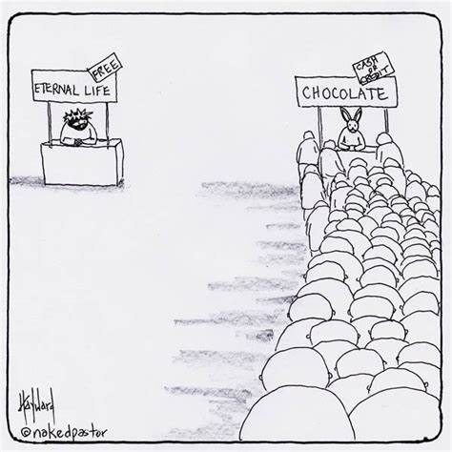

LAST WEEK’S COLLECTION

Adults $2,690.00
Youth $ 18.00
Monthly $2,020.00
Mother’s Day $ 45.00
Father’s Day $ 50.00
Candles $ 5.50
Maintenance Fund $ 135.00
Cemetery Maintenance $ 180.00
Easter $ 75.00
Easter Flowers $ 20.00
Holy Land $ 10.00
Holy Thurs./Food Pantry $ 10.00
Catholic Communication $ 100.00
Catholic Relief Services $ 10.00
Catholic Home Missions $ 10.00
Peter’s Pence (Holy Father) $ 30.00
Ascension Thursday $ 174.00
Total $5,582.50

We sincerely thank and
ask God’s blessing
upon all who have
care and concern
for our parish.

June 7, 2020 The Most Holy Trinity Sunday
“God so loved the world that he gave his only Son.” (Jn 3:16) May we, as Christian disciples, and stewards, always give of ourselves as a grateful response for his perfect gift.

RESCHEDULED BOY SCOUT DINNER ~ Boy Scout Troop #2251 has rescheduled their Ham and Chicken Dinner for Friday, June 19th from 4:00-7:30 PM at St. Michael Catholic Church Hall. All pre-sold tickets from the March 21st date will be honored. Walk-ins are welcome. Dinners will be take-out only. Park in the lot behind the hall and come to the take-out station in the parking lot. Please practice social distancing guidelines. Dinners include: chicken, ham, potatoes, green beans, coleslaw, rolls and butter, and cake. Age 12-Adult: $10 & Children: $8. All proceeds benefit the scouting program of BSA Troop #2251.

**NEW OFFICE HOURS!** ~ The Parish Office will be open Mon, Tues, Thurs, Fri. approximately from 9:00 AM – 12:30 PM. There will be someone in the office at that time to take your calls or to pick up your offertory envelopes from the black locked mailbox or green tote box located outside the Parish Office door. Please try to drop off your offertory envelopes between the hours of 9:00 AM – 12:30 PM. And please do not go to the Rectory!

CHURCH HOURS ~ St. Michael Church will be open for private prayer from 9:00 AM – 2:30 PM daily- (except Wednesdays). Physical distancing of at least 6 feet from others, wear a mask or some other face covering, and no more than 50 people in the church at the same time. Please pick up a colored card when you go into Church & leave it in the pew when you leave. The maintenance staff will then know where you sat. Please bring your own reading materials, pens, lighters, etc... and please take everything with you when you leave.

SACRAMENT OF RECONCILIATION ~ Msgr. Lockard will be hearing confessions every weekend. Confessions on Saturdays will be from 3:00 - 3:15 PM and on Sundays from 11:00 - 11:15 AM in the Sacristy for now. Penitents should wear a mask while waiting in line for confession.

DROP OFFS ~ We now have a locked, black mailbox located on the wall by the office buzzer outside the Parish Office door. You can drop off your envelopes, tickets, letters, forms, etc... for anyone in the office. Please do not go to the Rectory! The mailbox will be checked every Monday, Tuesday, Thursday, and Friday.

TELEVISED MASS ~ Remember that since Churches are closed, you can still “attend” Mass by watching it on television. Every Sunday on WATM ABC 23 at 11:00 AM, Mass is televised from St. John Gualbert Cathedral in Johnstown. And watch PROCLAIM TV program which airs every Sunday at 10:30 AM on WATM ABC 23.

BULLETINS ~ Paper bulletins will now be available every weekend. They will be in the green tote box outside the Parish Office door every Friday afternoon. You are welcome to stop by and pick one up. You can also read the bulletin on our parish website: www.saintmichaelchurch.weebly.com

JUNE 2020 PARISH TICKET WINNERS

UNSOLD TICKETS/NOT RETURNED TICKETS ~ If the winning number is a ticket that was not sold or returned, the money will be split with the number above the winning number and the number below the winning number. If the number above or below the winning number was not returned, we will go above or below that number.

Day Date Amount Number Winner

Monday June 1, 2020 $75 616 Debbie Macy
Tuesday June 2, 2020 $75 716 Brady Paterson
Wednesday June 3, 2020 $75 301 Ticket Not Returned
$37.50 300 Terrence Mikula
$37.50 302 George Minor
Thursday June 4, 2020 $75 743 John Swelfer

