John 6:54

ST. MICHAEL ROMAN CATHOLIC CHURCH

PO Box 103

St. Michael, Pennsylvania 15951

Rev. Brian L. Warchola, Administrator MASSES:

(814) 495-9640 Saturday 4:00 pm



Sunday Morning 8:00 am

Secretary: Michele Panick 10:30 am

Bookkeeper: Kathy Kalicky Daily Mass See Bulletin

DRE: Laurie Sloan Holy Days See Bulletin

Maintenance: Rodney Turgeon

Office Hours:

PHONES: 8:30 am to 3:30 pm

Rectory / Office: (814) 495-9640 Monday, Tues., Thurs., Friday

Fax: (814) 495-9424 Confessions:

Rel. Education: (814) 495-4873 Saturday 3:30 pm to 3:45 pm

Parish Website Sunday 7:30 am to 7:45 am

www.saintmichaelchurch.weebly.com 10:00 am to 10:15 am

Secretaries’ E-mail Anytime Requested

[saintmichaelsecretaries@yahoo.com](mailto:saintmichaelsecretaries@yahoo.com)

YEAR: 2018 NUMBER: 23

SERVING GOD AND COMMUNITY FOR OVER ONE HUNDRED YEARS!

BAPTISM: By Appointment. Reserve at least one month in advance.

Preparation classes are necessary.

MARRIAGE: Plan at least nine months in advance.

Preparation sessions are necessary.

FUNERALS: Arrangements are made in conjunction with the funeral home.

Eulogies should be given at the funeral home at the time of the wake service or at the luncheon.

REGISTRATION Those new to the area, newlyweds, and single adults, (even if registered

and before with their families) are asked to register by calling the Parish Office.

MEMBERSHIP: Every parishioner must be registered. This is a condition for admission

to our Program and reception of the Sacraments of Baptism, Confirmation, First Penance, First Eucharist, and Matrimony; also, for testimonial letters or sponsorship of Baptism and Confirmation outside the Parish.

VISITATION: We are concerned and want to be advised when someone is ill at

home or in the hospital. Call the rectory to have the shut-in placed on our monthly Holy Communion calls or seriously ill prayer list.

SACRAMENTAL Parish registration and active Mass participation for Baptism is

POLICY: encouraged and is required for Marriage.

BULLETIN ARTICLES: Articles are due to the Parish Office by Noon on Tuesdays.

Tenth Sunday in Ordinary Time

June 10, 2018

**Month of The Sacred Heart of Jesus**

**MASS INTENTIONS**: (June 11 – June 17, 2018)

Monday 8:00 AM Fritzie & Michael Beaver req. by Remy (Ray) Beaver

Tuesday 8:00 AM Rose Hudak req. by Ann Volcjak

Wednesday No Mass

Thursday 8:00 AM Sophia Sankovich req. by Henry & Marjorie Zubek

Friday 8:00 AM 70th Wedding Anniversary for Glenn & Ramona Hoffman

req. by Frank & Valencia Tursi

Saturday 4:00 PM Father’s Day Mass Intentions

Sunday 8:00 AM Father’s Day Mass Intentions

Sunday 10:30 AM Father’s Day Mass Intentions

LITURGICIAL APPOINTMENTS:

Saturday, June 16 4:00 PM Offertory Procession

Lector: Susan Poldiak Rod Kundrod Family

Minister of the Host: Theresa Carlson

Ministers of the Cup: Vince Arena & Alice Podrebarac

Altar Servers: Ana & Eva Spangler

Cantor: Amy Spangler

Greeter: Karen Myers

Sunday, June 17 8:00 AM Offertory Procession

Lector: Pauline Minor Jake & Mary Lou Stiffler

Minister of the Host: Robert Grattan

Ministers of the Cup: Paul Kundrod & Marie Jo Plummer

Altar Servers: Griffen & Kaden Christ

Cantor: Joseph Faher

Greeter: Pete Parisi

Sunday, June 1710:30 AM Offertory Procession

Lector: Sandy Bambino John & Michelle Vitez

Minister of the Host: Sharon Paterson

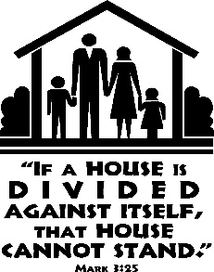Ministers of the Cup: Robert Oshaben & Susan Blazosky

Altar Servers: Shannan Elgin & Adalynne Webb

Cantor: Anita Lorek

Greeter: None Scheduled

Sunday, June 17 Collection Counters

Mary Ann Davis, Christine Smay

Phyllis Slonac

Weare placing names of the sick in the bulletin for prayer providing they give permission. *May the* *Divine Physician send healing grace for those for* *whom we pray:* Allen C. Rosemas, Patricia Murphy, Bernice Myers, Dwight Fyock, Lori Facciani, Dylon Wills, Dawn Hagen, Debbie Dibert, Missy, Joanne (Kolar) Hufford, Christine Flanagan, Ayden Alan Grata, Mary Lou Offman, Mary Zangaglia, Dorothy Rosemas, Natalie Zerby, Patricia Grata, Michael Wadsworth, Valencia & Frank, Tursi, Homer Locher, Brayden Schofield, Michelle Kasper, Diane Kingera, Allison Krischer, Ted Paluch, Brandt Hutzel, Pearl Litzinger, Patrick Munro, Fran Baldassarre, Corey Lybarger, Kristen Sinosky Long, Helen Ranieri, Cresta Micik, Basil Costantino, Madison McCrory, Laura, Joe Yoder, Dolores Yanzetich, Sandy Krug, Wanda Gramling, Merna Smay, Muriel “Jean” Wiesheier, Agnes Plummer, Jennifer Hagans, Mary McCall, Sean, Holly, Shane, Owen Taylor, Keith & Dawnetta Hoyer, Derrick Varnish, Daniel Koshute, Vincent Koshute, Karen Lovrich, Melissa Cordek, Michelle Elliott, Heather Romanow, Mackston Barrick, Connor Thomas, Erin, Pat, Mary Agnes Nastase, Mary Ann Bertolino, Dick Wilson, Izzy Bihun, Erica Mitzelfeld, Heidi Allison, Dorothy Kaminsky, Ed Ripper Sr., Bob Debias, Patricia Oshaben, Craig Kraber, Ashlee Madison, Marlene McCrory, Bob Casti, Susan Yanzetich, Mike, Mary Sivec, Danika Faith, Stacy Jarvis, Alina Rusnak, Fern Swartzentruver, Marcia Costlow, Gary Smay, Tammy Webb, Elizabeth Howell, Charles Smith, Mary Ann Cover, Tom Paterson and all of the sick of our parish, the homebound, those in nursing homes, those who care for them, and those in the military along with their families. (Please call the Rectory to have your name removed from the list when no longer seriously ill. Thank You.)

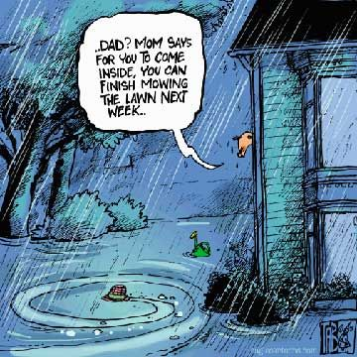

LAST WEEK’S COLLECTION

Adults $3,584.00

Loose $ 264.00

Youth $ 33.60

Monthly $1,183.00

Candles $ 21.00

Maintenance Fund $ 96.00

Cemetery Maintenance $ 63.00

Ascension Thurs. $ 5.00

Catholic Relief Services $ 5.00

Holy Land $ 10.00

Father’s Day $ 30.00

Total $5,294.60

We sincerely thank and ask God’s blessing upon all who have care and concern for our parish.

*June 10, 2018 Mark 3:20-35*

Jesus reminds us in today’s gospel “a house divided against itself will not stand.” Are the tensions and issues which divide your home worth the struggle? Even if you win an argument you lose a relationship. Don’t let pride and pettiness divide your home.



Catholic Ministries Drive $24,043.00

Raised: $ 7,730.00

Balance: $16,313.00

Number of responses: 71

Thank you to all parishioners who have responded to the *2018 Catholic Ministries Drive.* Please join them in supporting our Parish and a select group of ministries that provide outreach to the poor, family life, youth and seminarians. If you did not receive a pledge card in the mail, you may give online at [www.dioceseaj.org](http://www.dioceseaj.org).

*STEWARDSHIP REFLECTIONS*…

The message of the parable in today’s Gospel is that division has no place in relation to God’s will. The family of God is anyone who believes in Jesus and does what God asks. A relative of Jesus does God’s will and as stewards of God’s creation it is our job to safeguard the unity of the Kingdom.

RESURRECTION PARISH PICNIC RENTAL DATES ~ It’s not too early to start planning your important events. There will be plenty of opportunities to bask in the outdoors and enjoy the beautiful weather. Check your calendars to see what important events are coming up in your life, then find out whether Resurrection Picnic Grove might be able to accommodate your needs. Resurrection Grove can be rented for Wedding Receptions, Showers, Birthday Parties, Anniversary Parties, Graduation Parties, Reunions, etc. Call Joann at the Parish Office at 539-5788 #3 today for more details and to make your reservation.

LADIES RETREAT ~ August 10-11-12, 2018 at Mount Saint Ann *Retreat Center,* 1120 N. Center Street, Ebensburg, PA 15931. Spiritual Director, The Rev. Leon Hont, OSB. Pastor of St. John the Baptist Church & Immaculate Conception Church, Summerhill, PA. The Retreat is open to commuters. To reserve a place please call the Sisters of St. Ann 814-472-9354 or email: [sistersann35@gmail.com](mailto:sistersann35@gmail.com)

FATIMA DEVOTIONS ~ The Franciscan Friars, T.O.R., from Loretto, invite you to participate with them in celebrating the Fatima Devotions on Wednesday June 13th, at 6:30 PM in the Sunken Gardens. (In case of inclement weather, the devotions will be at the Immaculate Conception Chapel on the Saint Francis University Campus). The singing will be led by choir from St. Benedict’s Church in Carrolltown and the sermon will be delivered by Fr. Richard Davis, T.O.R. We would like to extend a cordial welcome to all.



“Be Cool! Meet Jesus at Bible School” ~ Plans are underway for Vacation Bible School, sponsored by Most Holy Trinity, Saint Bartholomew and Saint Michael Parishes. It will be held at Most Holy Trinity Church Hall this year on July 17th, 18th & 19th from 6-8 p.m. This year’s theme is “*POLAR BLAST”* and will include games, crafts, songs, bible stories and lot of fun activities for ages 4—14. All children, grandchildren, neighbors and friends are invited to attend.

Adults and REACH students are invited to help create this winter wonderland of fun with our faith. You can RSVP by returning a registration form (available at the church entrances) to MHT Parish or call 495-4419; or email [erosmus@diocesesaj.org](mailto:erosmus@diocesesaj.org). We would like to have reservations by June 25 to help prepare activities, but walk-ins are always welcome. Any students in need of service hours this is a good opportunity to reach the total required.

VBS Planning Meeting ~ REACH student volunteers can help at this year’s VBS! VBS planning meeting on Tuesday, June 19th at 6:00 PM in Most Holy Trinity Church Hall. High school students wishing to help are asked to attend this meeting. If you are unable to attend, please call the parish office so we can get you the needed materials. Students receive service hour credits. If you cannot help during VBS but wish to help with making the decorations and set up beforehand, your assistance will be appreciated

there also.

[](https://images.search.yahoo.com/search/images;_ylt=A0LEV1kSWptXvOwAKINXNyoA;_ylu=X3oDMTEyZGdkcmRoBGNvbG8DYmYxBHBvcwMxBHZ0aWQDQjIwODlfMQRzZWMDc2M-?p=Clipart+of+a+sanctuary+candle&fr=ush-mailn_02&th=110&tw=110&imgurl=http://www.henningers.com/389-168-wall-sanctuary-lamp.jpg&rurl=http://pixshark.com/sanctuary-lamp.htm&size=43KB&name=Sanctuary+Lamp+Bronze+wall+sanctuary+lamp&h=600&w=600&turl=http://ts2.mm.bing.net/th?id%3DOIP.M68453c67108cdc5ab485d309b395bd03o0%26pid%3D15.1%26rs%3D1%26c%3D1%26qlt%3D95%26w%3D110%26h%3D110#inline&tt=Sanctuary+Lamp+Bronze+wall+sanctuary+lamp&sigr=116keh5le&sigit=13gvlt42j&sigi=11ip0pgm4&sign=119kp6100&sigt=119kp6100)

The Sanctuary Candle will burn for

the Sick and the Shut-Ins

of our Parish

during the week of June 10, 2018

FOOD FOR THE POOR ~ Please join us this weekend to hear Rev. James E. Borstelmann speak at all the services about a ministry providing direct relief to the poor throughout Latin America and the Caribbean. Fr. Borstelmann will share personal witness about Food For The Poor’s mission to care for the destitute as a means of living out the Gospel mandate to love one another. Fr. Borstelmann is a priest of the Archdiocese of New York. He was ordained in 1967. Fr. Jim served as Chaplain in Rockville Psychiatric Center and was on the Board for Priest Personnel for the Archdiocese. He served as a pastor in the Bronx, Croton Falls & East Kingston. After retiring in 2016, he began preaching on behalf of Food For The Poor.

HOLY NAME SOCIETY MEETING ~ Will be held today, June 10th after the 8:00 AM Mass.

SECOND SUNDAY FOOD COLLECTION ~ This weekend is our Second Sunday Food Collection. Please bring in non-perishable food items or toiletries with you. Monetary donations are also appreciated.

FATHER’S DAY BRUNCH ~ All fathers and sons of the parish are invited to a Father’s Day Brunch in the church hall immediately following the 10:30 AM Mass on Sunday, June 17th. The ladies and girls of the parish will be preparing and serving the meal. We hope to see all the fathers and sons of the parish there!

HELP NEEDED ~ Help is needed for Father’s Day Brunch. Plans are being made for the Brunch (Sunday, June 17th) sponsored by the women of the parish and REACH girl students in grades 9-12. Please call Pauline Minor (495-5165) to volunteer. Let’s show our appreciation to the Fathers and Sons of this parish family!

FATHER’S DAY INTENTIONS ~ Envelopes for Father’s Day Mass Intentions are in your packet of envelopes. The envelopes will be placed on the altar during the month of June in remembrance of all fathers, both living and deceased. Extra envelopes can be found at the entrances of the church.

PARISH COUNCIL ELECTIONS ~ Next weekend all St. Michael Adult Parishioners will be handed a Parish Council Election Ballot upon entering the Church. Out of the 10 people nominated check the box to the left of the 5 people you wish to be on your Parish Council. Papers will then be collected and counted. The top 5 people will be notified and should be present at the next meeting – Sunday, July 8th, after 10:30 AM Mass.

WEEKDAY MASSES ~ Fr. Brian will be away the week of June 18th. There will be NO weekday Masses on June 18th, 19th, 21st or 22nd. Other weekday Masses in the area are: St. Benedict, Johnstown – 8:00 AM & 12:05 PM (daily); St. John the Baptist, Summerhill – Tues. (6-19) and Wed. (6-20) at 7:45 AM; Immaculate Conception, New Germany – Thurs. (6- 21) and Friday, (6- 22) at 7:45 AM. In case of an emergency please call Fr. Nale at 495-4419.

ST. MICHAEL OUTDOOR MASS/PARISH PICNIC ~ Fr. Brian Warchola will be having an outdoor Mass here at St. Michael on Sunday July 1st at 10:30 AM (weather permitting). Please bring folding lawn chairs. Immediately following will be the parish picnic – 11:30-3:00 PM. The main dish and the drinks will be provided. Please bring a covered dish. Sign-up sheets can be found in the back of the Church.



Religious Education And Christian Helping

June 10, 2018

Senior Sunday Celebration ~ Sunday, June 3, 2018

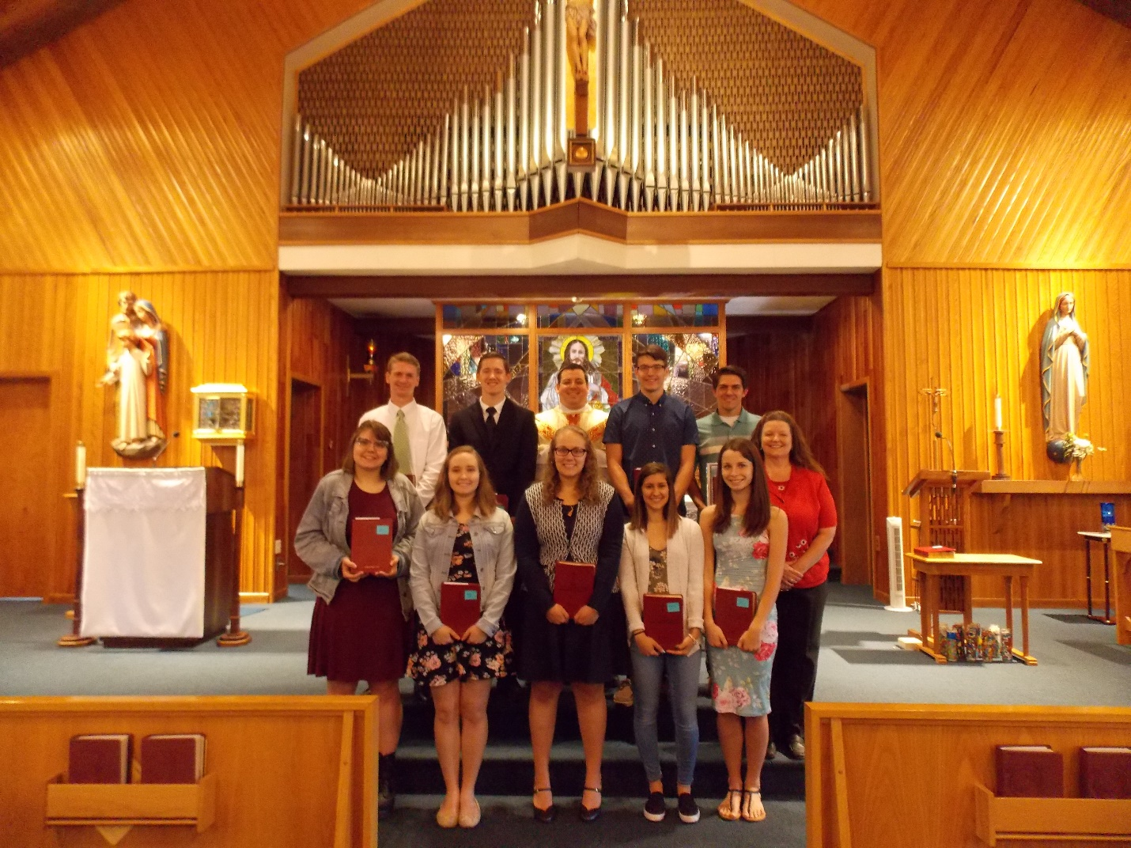

Pictured here left to right, Front Row: Victoria Russic, Abby Jordan,

Sidney Kakabar, Kourtney Walls,

Sarah Deibert and Laurie Sloan, DRE.

Back Row: Evan Kundrod, Adam Bambino,

Fr. Brian Warchola,

Carter Vitez and Brian Bernard.

All of our seniors received The New Catholic Answer Bible as a gift from our parish. *Students that returned and completed their 12th grade year of Religious Education at St. Michael Parish are eligible to receive a $300 Higher Education Grant offered by the parish toward continuing their education.*

Adam Bambino, Adam is the son of Anthony and Sandra Bambino. Adam plans to attend The University of Pittsburgh at Johnstown and study Financial Accounting and Marketing. Adam served our parish as an Altar Server.

Brian Bernard: Brian is the son of Marie and Arnie Bernard. Brian plans to attend Saint Francis University and study Physical Therapy. Brian served our parish as an Altar Server.

Sarah Deibert: Sarah is the daughter of Dave and Jill Deibert. Sarah plans to attend The University of Pittsburgh at Johnstown and study Secondary Education in Mathematics.

Eric Elgin: Eric is the son of Wendy Blough and Travis Whiteh

ead. Eric plans to attend The University of Pittsburgh at Johnstown and study Civil Engineering. Eric served our parish as an Altar Server.

Abigail Jordan: Abby is the daughter of Troy and Debra Jordan. Abby plans to attend Indiana University of Pennsylvania and study Nursing. Abby served our parish as an Altar Server.

Sidney Kakabar: Sidney is the daughter of Tim and Carole Kakabar. Sidney plans to attend Seton Hill University and study Biology / Pre-Medicine.

Evan Kundrod: Evan is the son of Rod and Karen Kundrod. Evan plans to attend The University of Pittsburgh at Johnstown and study Business Economics with a degree in Accounting. Evan served our parish as an Altar Server.

Victoria Russic: Victoria is the daughter of Steve and Lisa Russic. Victoria plans to attend Point Park University and study Writing for Screen and Media. Victoria served our parish as an Altar Server.

Carter Vitez: Carter is the son of John and Michelle Vitez. Carter plans to attend The University of Pittsburgh at Johnstown and study Chemical Engineering. Carter served our parish as an Altar Server.

Kourtney Walls: Kourtney is the daughter of David and JoAnne Walls. Kourtney plans to attend Mount Aloysius College and study Radiation Therapy.

Presentation of our $250.00 REACH Service Award: Each year, a $250 REACH Service Award is given to three seniors who rank the highest in individual cumulative service hours throughout their participation in the REACH program. This service includes all REACH and church sponsored aspects of service to the community along with fundraisers.

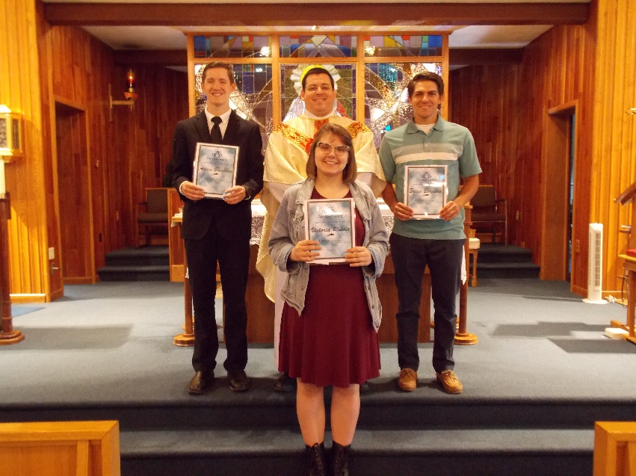In 2007, The REACH Service Award was initially funded through a monetary donation made in honor of a member of our faith community. This award was created through a specific endowment fund with The Community Foundation for the Alleghenies to benefit youth members of the St. Michael REACH Youth Ministry Program here at Saint Michael Catholic Church. This award is only offered to the senior class members that attend their 12th Grade year of Religious Education classes throughout.

The $250 REACH Service Award recipients for 2018 are:

Adam Bambino, Victoria Russic and Brian Bernard, all pictured here left to right along with Fr. Brian Warchola. Their combined cumulative service in REACH is over 600 hours.

*! ! ! ! ! ! ! ! ! ! ! ! ! ! ! ! ! ! ! ! ! ! ! ! ! ! ! ! ! ! ! ! ! ! ! ! ! ! ! ! ! ! ! ! ! ! ! ! ! ! ! ! ! ! ! ! ! ! ! ! ! ! ! ! ! ! ! ! ! ! ! ! ! ! !*

2018 First Holy Communion Class

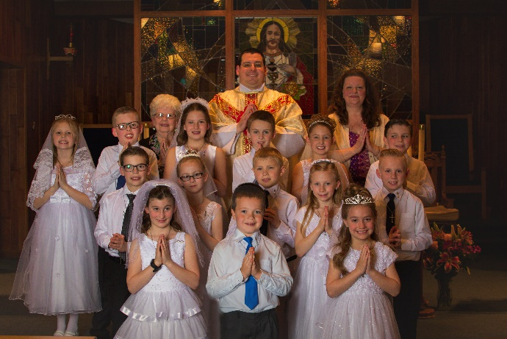Our Communion pictures are here! Our 2nd grade class received their First Holy Communion on Sunday, May 6, 2018. Members of the class are pictured here left to right, Front Row: Kaylee Roberts, Jesse Richards, and Taylor Snyder. Second Row: Logan Tokarsky, Jaclyn Yauneridge, Michael Zeigler, Natalie Stohon and Braydon Smith. Third Row: Maria Stiffler, Blake Shilcosky, Rayna Koch, Noah Eppley, Nicoletta Brezovec and Wyatt Drobnick. Back Row: Pauline Minor, catechist, Fr. Brian Warchola and Laurie Sloan, DRE.

Communion Picture orders are available for our families to pick up on the back table of the church.

Upcoming REACH Service Projects

Father’s Day Brunch ~ The Father’s Day Brunch is scheduled for June 17th. REACH girls are needed to help with preparation, serving and clean-up. / Time frame option: 9 AM to 1 PM.

VBS Planning Meeting ~ REACH student volunteers can help at this year’s VBS! VBS planning meeting on Tuesday, June 19th at 6:00 PM in Most Holy Trinity Church Hall. High school students wishing to help are asked to attend this meeting. If you are unable to attend, please call the parish office so we can get you the needed materials. Students receive service hour credits. If you cannot help during VBS but wish to help with making the decorations and set up beforehand, your assistance will be appreciated there also.



REACH Car Wash ~ Saturday, June 23rd, the youth ministry will hold a car wash in the front parking lot of the church from 9:00 AM to 12 Noon. Cost is $5.00 per vehicle. Featuring DJ Brent Labarko!

Please support the youth of our parish and have your car washed!!!

 Sunday, June 10 Food For The Poor

Holy Name Society Meeting / After 8:00 AM Mass

Second Sunday Food Pantry Collection

Monday, June 11 Martha’s Group / 6:00 PM

Sunday Choir Practice / 7:00 PM

Tuesday, June 12

Wednesday, June 13 NO Mass

Thursday, June 14 Saturday Choir Practice / 5:30 PM

Friday, June 15

Saturday, June 16 Parish Council Elections

 UPCOMING EVENTS

June 17 Father’s Day Brunch

Parish Council Elections

June 23 REACH Youth Ministry Car Wash

Hall Rental

June 24 Parish Council Meeting - Postponed

Faith Day / DelGrosso’s

June 30 & July 1 Peter’s Pence

July 1 Outdoor Mass / Parish Picnic

PARISH SUMMERFEST ~ Sunday, June 10th at their Picnic Grove in Tanneryville (926 Cooper Ave.). The festival will start at 10:30 AM with an outdoor Mass and go until 9:00 PM. Music: 1:00 – 4:30 PM 3 of Hearts; 5:30 – 8:30 PM Flood City Brass. Ethnic Food: Homemade Potato Pancakes, homemade Haluski, German Potato Salad, Pierogi, Pigs, Kielbasa, Pulled Pork, Walking Taco, Grilled Chicken Salad, Hot Sausage, French Fries, Hamburgers, Cheeseburgers, Hot Dogs, and Baked Goods. There will be Games of Chance, a Bar and much more. Free admission! Hope to see you there!



WINE, SWEETS, & STOGIES ~ Most Holy Trinity, South Fork is sponsoring a Wine fest on Friday, June 15th, from 5:30-8:30 PM in the hall as part of the Heritage Days Festival in South Fork. Music will be by Rik Golden. Tickets are available for $10 at the library or at the door.

THE ST. THERESE 71ST ANNUAL SUMMER FESTIVAL ~ Will be held Friday, June 15th from 7 – 10:00 PM. Saturday, June 16th from 5 – 10:30 PM, and Sunday, June 17th from 1 – 10:30 PM on church grounds, Upper Decker Avenue. Come enjoy the rides, Bingo, games, prizes, themed basket chances, ethnic foods and music. On Sunday there will be a Chicken & Biscuit Dinner 11AM to 3 PM, music by the Rhythm Master Sunday from 3 – 6 PM, That Oldies Band from 7 – 10 PM and a 10:30 PM enjoy a spectacular Fireworks display. Everyone is cordially invited!!!

RESURRECTION PARISH IS SPONSORING GROOVIN AT THE GROVE ~ At the Grove in Tanneryville. Each Groovin will start with an Outdoor Mass at 5:30 PM, food will be available after Mass. Music from 7 – 10 PM. June 30th – Boomers, July 21st – Ground Zero, August 18th – Flood City Brass. Come and have a great time.