ST. MICHAEL ROMAN CATHOLIC CHURCH

751 Locust Street

PO Box 103

St. Michael, Pennsylvania 15951

Rev. Msgr. David A. Lockard, Administrator MASSES:

(814) 495-9640 Saturday 4:00 pm



Sunday Morning 9:30 am

Secretary: Michele Panick

Bookkeeper: Kathy Kalicky Daily Mass: M, T, Th, F Noon

DRE: Laurie Sloan Wed. 6:00 pm

Maintenance: Rodney Turgeon Holy Days: See Bulletin

PHONES: Office Hours:

Rectory / Office: (814) 495-9640 9:00 am to 12:30 pm

Fax: (814) 495-9424 Monday, Tues., Thurs., Friday

Rel. Education: (814) 495-4873 Confessions:

Parish Website Saturday 3:30 pm to 3:45 pm www.saintmichaelchurch.weebly.com Sunday 9:00 am to 9:15 am

Secretaries’ E-mail By Appointment

[saintmichaelsecretaries@yahoo.com](mailto:saintmichaelsecretaries@yahoo.com)

Facebook page:

St. Michael Catholic Church/St. Michael, PA

12th Sunday in Ordinary Time

SERVING GOD AND COMMUNITY FOR OVER ONE HUNDRED YEARS!

June 21st, 2020

BAPTISM: By Appointment. Reserve at least one month in advance.

MARRIAGE: Plan at least nine months in advance.

Preparation sessions are necessary.

FUNERALS: Arrangements are made in conjunction with the funeral home.

REGISTRATION Those new to the area, newlyweds, and single adults, (even if registered

and before with their families) are asked to register by calling the Parish Office.

MEMBERSHIP: Every parishioner must be registered. This is a condition for admission

to our Program and reception of the Sacraments of Baptism, Confirmation,

First Penance, First Eucharist, and Matrimony; also, for testimonial letters or sponsorship of Baptism and Confirmation outside the Parish.

VISITATION: We are concerned and want to be advised when someone is ill at home or in the hospital. Call the rectory to have the shut-in placed on our monthly Holy Communion calls or seriously ill prayer list.

SACRAMENTAL Parish registration and active Mass participation for Baptism is

POLICY: encouraged and is required for Marriage.

BULLETIN ARTICLES: Articles are due to the Parish Office by Noon on Tuesday.

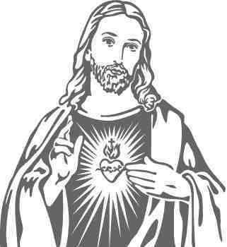

Twelfth Sunday in Ordinary Time

June 21st, 2020

The Sacred Heart of Jesus

**MASS INTENTIONS**: (June 22 – June 28, 2020)

Monday Noon Joseph Ropecka req. by Ed & Karen Myers

Tuesday Noon Ray & Irene Baldwin req. by Carl & Pam Freidhoff

Wednesday 6:00 PM Kevin Smay req. by Terri & Gus Leach

Thursday Noon Janet Smith req. by sister, Reba Vasas & family

Friday Noon Mary Sivec req. by Joe & Mary Ann Daniels

Saturday 4:00 PM People of the Parish

Sunday 9:30 AM Marie Faher req. by Cathy & Joe Faher

LITURGICIAL APPOINTMENTS:

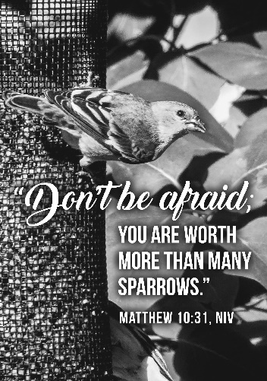Saturday, June 27 4:00 PM

Lector: Don Dipko Minister of the Host: Theresa Carlson

Altar Server: Anna Spangler

Cantor: Amy Spangler

Sunday, June 28 9:30 AM

Lector: Arnold Bernard

Minister of the Host: Marie Bernard

Altar Server: Kaden Christ

Cantor: Amy Dobbins

MINISTRY SCHEDULES ~ Lay ministry schedules are being done week by week until we return to our regular mass schedules. Please check the bulletin for the schedule. If you know a weekend you may not be available, please let Susan Blazosky know at: 495-5287 or [sublazosky@gmail.com](mailto:sublazosky@gmail.com)

Weare placing names of the sick in the bulletin for prayer providing they give permission. *May the* *Divine Physician send healing grace for those for* *whom we pray:* Allen C. Rosemas, Patricia Murphy, Bernice Myers, Dwight Fyock, Dylon Wills, Missy, Joanne (Kolar) Hufford, Christine Flanagan, Ayden Alan Grata, Mary Lou Offman, Mary Zangaglia, Natalie Zerby, Valencia Tursi, Homer Locher, Brayden Schofield, Michelle Kasper, Diane Kingera, Allison Krischer, Ted Paluch, Brandt Hutzel, Pearl Litzinger, Patrick Munro, Fran Baldassarre, Kristen Sinosky Long, Cresta Micik, Basil Costantino, Madison McCrory, Laura, Joe Yoder, Dolores Yanzetich, Sandy Krug, Wanda Gramling, Agnes Plummer, Jennifer Hagans, Shawn, Holly, Shane, Spencer, Owen Taylor, Keith & Dawnetta Hoyer, Derrick Varnish, Vincent Koshute, Melissa Cordek, Michelle Elliott, Heather Romanow, Mackston Barrick, Connor Thomas, Erin, Pat, Mary Agnes Nastase, Mary Ann Bertolino, Dick Wilson, Izzy Bihun, Dorothy Kaminsky, Patricia Oshaben, Ashlee Madison, Susan Yanzetich, Mike, Danika Faith, Alina Rusnak, Gary Smay, Elizabeth Howell, Helen Bowen, Walter Bodziak, Rhonda, Dan Strinkoski, Anne Robinson, Marlene McCrory, Sharon Poldiak, Carter Bobak, Vince Arena, Mike Morris, Sarah Kelt, Patty Yanzetich Caldwell, Colton Snyder, Betty Delaney, Nancy Edmiston, Bill Krajewski, Leonard Oshaben, Adam, Bill Gideos, Janice Dipyatic, John Poldiak Jr., Gerald Delaney, Lily Maloney, Adam Wingard, Scott, Lisa, Rosalie Ambrose, John Patrick, Audrey Costlow, Carole Horner, Ross Linert, Cathy Sossong, Rosanne Krug, Paul Snyder, Becky Kakabar, Catherine Tedjeske and all of the sick of our parish, the homebound, those in nursing homes, those who care for them, and those in the military along with their families. *(Please call the Rectory to have your name removed from the list when no longer seriously ill. Thank You.)*

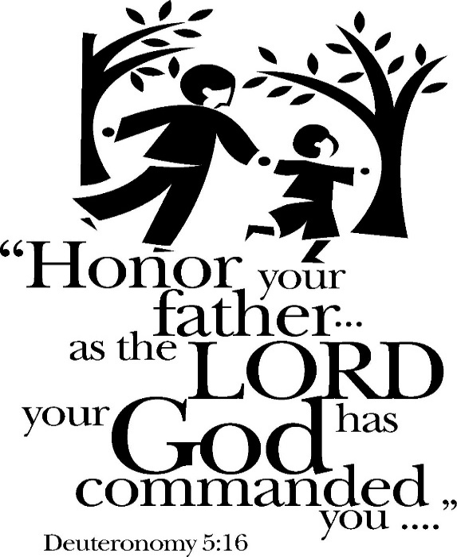

LAST WEEK’S COLLECTION

Adults $1,201.00

Youth $ 3.00

Monthly $ 370.00

Father’s Day $ 171.00

Candles $ 3.00

Maintenance Fund $ 15.00

Cemetery Maintenance $ 15.00

Catholic Register Sub. $ 5.00

Peter’s Pence (Holy Father) $ 15.00

Food Pantry $ 10.00

Total $1,808.00

We sincerely thank and ask

God’s blessing upon all

who have care and

concern for our

parish.

*June 21, 2020*

*God never promised anyone a life that would be untouched by difficulties, hardships and even tragedy. What he did promise, long before Jeremiah in the time of Abraham, that if we were only to trust in him, we would always have his providential care.*

[](https://images.search.yahoo.com/search/images;_ylt=A0LEV1kSWptXvOwAKINXNyoA;_ylu=X3oDMTEyZGdkcmRoBGNvbG8DYmYxBHBvcwMxBHZ0aWQDQjIwODlfMQRzZWMDc2M-?p=Clipart+of+a+sanctuary+candle&fr=ush-mailn_02&th=110&tw=110&imgurl=http://www.henningers.com/389-168-wall-sanctuary-lamp.jpg&rurl=http://pixshark.com/sanctuary-lamp.htm&size=43KB&name=Sanctuary+Lamp+Bronze+wall+sanctuary+lamp&h=600&w=600&turl=http://ts2.mm.bing.net/th?id%3DOIP.M68453c67108cdc5ab485d309b395bd03o0%26pid%3D15.1%26rs%3D1%26c%3D1%26qlt%3D95%26w%3D110%26h%3D110#inline&tt=Sanctuary+Lamp+Bronze+wall+sanctuary+lamp&sigr=116keh5le&sigit=13gvlt42j&sigi=11ip0pgm4&sign=119kp6100&sigt=119kp6100)

During the week of June 21st, 2020

The Sanctuary Candle will burn in memory of

all deceased Fathers & Sons of the Parish

and

The Our Lady of Grace Candle will burn in honor of

all living Fathers and Sons of the Parish

JUNE 2020 PARISH TICKET WINNERS

UNSOLD TICKETS/NOT RETURNED TICKETS ~ If the winning number is a ticket that was not sold or returned, the money will be split with the number above the winning number and the number below the winning number. If the number above or below the winning number was not returned, we will go above or below that number.

Day Date Amount Number Winner

Friday June 12, 2020 $75 735 Andrea Shirdon

Saturday June 13, 2020 $100 782 Eric Tedjeske

Sunday June 14, 2020 $100 664 Mary Oravis

Monday June 15, 2020 $75 456 Roberta Vasbinder

Tuesday June 16, 2020 $75 592 Linda Kovach

Wednesday June 17, 2020 $75 586 Mary Lou Krupka

Thursday June 18, 2020 $75 247 Edie Knobloch



Religious Education And Christian Helping

CAMP ZACCHAEUS GOING VIRTUAL

Camp Zacchaeus will be held July 19—24 for youth entering grades 4—9 in the fall. Registration is $10, which will cover the cost of materials that the diocese will send out in time for camp! Anyone interested, contact the parish office for a registration brochure.

Brochures also available in the green tote outside the parish office outside of office hours.

Catholic Ministries Drive $25,436.00

Raised: $12,568.00

Balance: $12,868.00

Number of responses: 75

Thank you to all parishioners who have responded to the *2020 Catholic Ministries Drive.* Please join them in supporting our Parish and a select group of ministries that provide outreach to the poor, family life, youth, and seminarians. If you did not receive a pledge card in the mail, you may give online at [www.dioceseaj.org](http://www.dioceseaj.org).



Brothers and Sisters,

I will take this time to wish Happy Father’s Day to all of our parish fathers and father figures. My own father passed away eleven years ago and there isn’t a day goes by that I don’t think of him. Dad was a member of the “Greatest Generation” – He survived the Spanish Flu pandemic, the Great Depression, and World War II. In addition, he lost a wife, two sons and a brother and sister to early deaths. He inspires me to get through this time of pandemic, economic depression, and social unrest.

If you are fortunate enough to have your father still with you, be sure to thank him for all he has done for you today. If your father has passed, offer prayers for him frequently. And ask God the Father in heaven, to help this generation of fathers to do what we have to do.

God bless all of you,

Father Lockard

PETER’S PENCE COLLECTION ~ Next week, we will take up the Peter’s Pence Collection, which provides Pope Francis with the funds to carry out his charitable works around the world. The proceeds benefit our brothers and sisters on the margins of society, including victims of war, oppression, and disasters. Please be generous. For more information, visit [*www.usccb.org/peters~pence*](http://www.usccb.org/peters~pence)*.*

SACRAMENT OF RECONCILIATION ~ Msgr. Lockard will be hearing confessions every weekend. Confessions on Saturdays will be from 3:30 - 3:45 PM and on Sundays from 9:00 - 9:15 AM in the Sacristy for now. Penitents should wear a mask while waiting in line for confession.

FLOWERS ~ We thank all those who so generously gave donations for the Easter Flowers. The money collected will help to defray the cost of flowers purchased throughout 2020. The flowers on the Altar this weekend was made possible by your generous donations.

OUR DAD

God took the strength of a mountain,

The majesty of a tree,

The warmth of a summer sun,

The calm of a quiet sea,

The generous soul of nature,

The comforting arm of night,

The wisdom of the ages,

The power of the eagle’s flight,

The joy of a morning in spring,

The faith of a mustard seed,

The patience of eternity,

The depth of a family need,

Then God combined these qualities,

When there was nothing more to add,

He knew His masterpiece was complete,

And so, He called it…

Dad

-Author Unknown

 Sunday, June 21 Mass ~ 9:30 AM

Confessions / 9:00 – 9:15 AM

Monday, June 22 Mass ~ Noon

NO Sunday Choir Practice

Tuesday, June 23 Mass ~ Noon

Wednesday, June 24 Mass ~ 6:00 PM



Thursday, June 25 Mass ~ Noon

NO Saturday Choir Practice

Friday, June 26 Mass ~ Noon

Saturday, June 27 Mass / 4:00 PM

Confessions / 3:30 – 3:45

Peter’s Pence Collection / Envelopes in your packet

UPCOMING EVENTS

June 28 Peter’s Pence Collection / Envelopes in your packet

July 9 Confirmation

July 14 Confirmation

July 20 Finance Council Meeting

FRIAR’S NOOK GIFT SHOP ~ The Friar’s Nook Gift Shop is open and is stocked for your First Communion and Confirmation gift needs! The modified hours for June are Friday and Saturday 10:00 AM – 4:00 PM. The shop is located on the campus of St. Bernardine Monastery at 793 Monastery Road, Hollidaysburg. For any questions, please call 814-695-3802.

FRANCISCAN MASS ASSOCIATION ~ The Franciscan Friars, TOR Mass Association now has office hours Tuesday-Thursday from 8:00 AM-4:00 PM. Masses can be requested anytime by mail, phone, email, or website with the below information:

The Franciscan Friars, TOR

PO Box 139 Hollidaysburg, PA 16648

Phone: 814-695-3802 ext. 211

Email: [Suzi@thefranciscanfriars.org](mailto:Suzi@thefranciscanfriars.org) Website: [www.TheFranciscanFriars.org](http://www.TheFranciscanFriars.org)

CATHOLIC COUNSELORS OF AMERICA ~ St. Aloysius Faith Education & Community Center. 7911 Admiral Peary Highway, Cresson, PA 16630. Tel. No. 814-505-7178. Catholic Counselors of America is a benefit LLC whose purpose is to create a positive impact to society by providing affordable counseling services. Peace! Call Leorosie (Rose) Trexler, Master of Science in Community Counseling at 814-505-7178.