ST. MICHAEL ROMAN CATHOLIC CHURCH

751 Locust Street

PO Box 103

St. Michael, Pennsylvania 15951

Rev. Msgr. David A. Lockard, Administrator MASSES:

(814) 495-9640 Saturday 4:00 pm



Sunday Morning 9:30 am

Secretary: Michele Panick

Bookkeeper: Kathy Kalicky Daily Mass: M, T, Th, F Noon

DRE: Laurie Sloan Wed. 6:00 pm

Maintenance: Rodney Turgeon Holy Days: See Bulletin

PHONES: Office Hours:

Rectory / Office: (814) 495-9640 8:30 am to 3:30 pm

Fax: (814) 495-9424 Monday, Tues., Thurs., Friday

Rel. Education: (814) 495-4873 Confessions:

Parish Website Saturday 3:30 pm to 3:45 pm www.saintmichaelchurch.weebly.com Sunday 9:00 am to 9:15 am

Secretaries’ E-mail By Appointment

[saintmichaelsecretaries@yahoo.com](mailto:saintmichaelsecretaries@yahoo.com)

Facebook page:

St. Michael Catholic Church/St. Michael, PA

13th Sunday in Ordinary Time

SERVING GOD AND COMMUNITY FOR OVER ONE HUNDRED YEARS!

June 28th, 2020

BAPTISM: By Appointment. Reserve at least one month in advance.

MARRIAGE: Plan at least nine months in advance.

Preparation sessions are necessary.

FUNERALS: Arrangements are made in conjunction with the funeral home.

REGISTRATION Those new to the area, newlyweds, and single adults, (even if registered

and before with their families) are asked to register by calling the Parish Office.

MEMBERSHIP: Every parishioner must be registered. This is a condition for admission

to our Program and reception of the Sacraments of Baptism, Confirmation,

First Penance, First Eucharist, and Matrimony; also, for testimonial letters or sponsorship of Baptism and Confirmation outside the Parish.

VISITATION: We are concerned and want to be advised when someone is ill at home or in the hospital. Call the rectory to have the shut-in placed on our monthly Holy Communion calls or seriously ill prayer list.

SACRAMENTAL Parish registration and active Mass participation for Baptism is

POLICY: encouraged and is required for Marriage.

BULLETIN ARTICLES: Articles are due to the Parish Office by Noon on Tuesday.

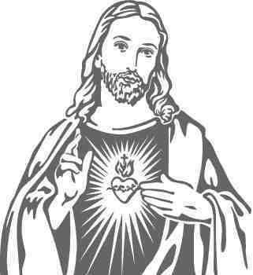

Thirteenth Sunday in Ordinary Time

June 28th, 2020

The Sacred Heart of Jesus

**MASS INTENTIONS**: (June 29 – July 5, 2020)

Monday Noon Anna Fornadel req. by Michael Andrykovitch

Tuesday Noon Frank Brennan req. by John & Patricia Kovach

Wednesday 6:00 PM Nancy Facciani req. by Theresa Krentz

Thursday Noon Pat Hillegas req. by Bob & Terri Feather

Friday Noon Rose Hudak req. by Children

Saturday 4:00 PM People of the Parish

Sunday 9:30 AM Paul Yanzetich req. by daughter, Susan

LITURGICIAL APPOINTMENTS:

Saturday, July 4 4:00 PM

Lector: Sherry Dipko Minister of the Host: Karen Myers

Altar Server: Caden Roberts

Cantor: Susan Blazosky

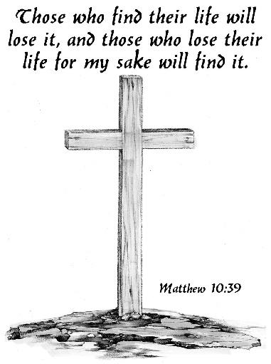Sunday, July 5 9:30 AM

Lector: Carole Kakabar

Minister of the Host: Michael Steele

Altar Server: Alexia Steele

Cantor: Sharon Dibble

Monday, July 6 Collection Counters

George Minor, Pauline Minor

MINISTRY SCHEDULES ~ Lay ministry schedules are being done week by week until we return to our regular mass schedules. Please check the bulletin for the schedule. If you know a weekend you may not be available, please let Susan Blazosky know at: 495-5287 or [sublazosky@gmail.com](mailto:sublazosky@gmail.com)

Weare placing names of the sick in the bulletin for prayer providing they give permission. *May the* *Divine Physician send healing grace for those for* *whom we pray:* Allen C. Rosemas, Patricia Murphy, Bernice Myers, Dwight Fyock, Dylon Wills, Missy, Joanne (Kolar) Hufford, Christine Flanagan, Ayden Alan Grata, Mary Lou Offman, Mary Zangaglia, Natalie Zerby, Valencia Tursi, Homer Locher, Brayden Schofield, Michelle Kasper, Diane Kingera, Allison Krischer, Ted Paluch, Brandt Hutzel, Pearl Litzinger, Patrick Munro, Fran Baldassarre, Kristen Sinosky Long, Cresta Micik, Basil Costantino, Madison McCrory, Laura, Joe Yoder, Dolores Yanzetich, Sandy Krug, Wanda Gramling, Agnes Plummer, Jennifer Hagans, Shawn, Holly, Shane, Spencer, Owen Taylor, Keith & Dawnetta Hoyer, Derrick Varnish, Vincent Koshute, Melissa Cordek, Michelle Elliott, Heather Romanow, Mackston Barrick, Connor Thomas, Erin, Pat, Mary Agnes Nastase, Mary Ann Bertolino, Dick Wilson, Izzy Bihun, Dorothy Kaminsky, Patricia Oshaben, Ashlee Madison, Susan Yanzetich, Mike, Danika Faith, Alina Rusnak, Gary Smay, Elizabeth Howell, Helen Bowen, Walter Bodziak, Rhonda, Dan Strinkoski, Anne Robinson, Marlene McCrory, Sharon Poldiak, Carter Bobak, Vince Arena, Mike Morris, Sarah Kelt, Patty Yanzetich Caldwell, Colton Snyder, Betty Delaney, Nancy Edmiston, Bill Krajewski, Leonard Oshaben, Adam, Bill Gideos, Janice Dipyatic, John Poldiak Jr., Gerald Delaney, Lily Maloney, Adam Wingard, Scott, Lisa, Rosalie Ambrose, John Patrick, Audrey Costlow, Carole Horner, Ross Linert, Cathy Sossong, Rosanne Krug, Paul Snyder, Becky Kakabar, Catherine Tedjeske and all of the sick of our parish, the homebound, those in nursing homes, those who care for them, and those in the military along with their families. *(Please call the Rectory to have your name removed from the list when no longer seriously ill. Thank You.)*

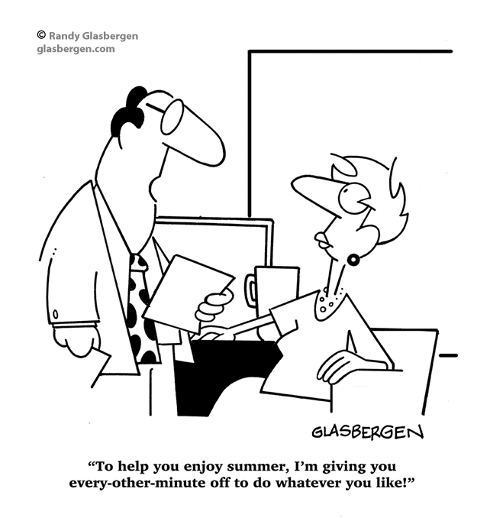

LAST WEEK’S COLLECTION

Adults $2,768.00

Loose $ 9.50

Youth $ 13.00

Monthly $ 390.00

Father’s Day $ 328.00

Mother’s Day $ 40.00

Candles $ 6.00

Maintenance Fund $ 40.00

Cemetery Maintenance $ 65.00

Easter $ 20.00

Ascension Thursday $ 85.00

Peter’s Pence (Holy Father) $ 98.00

Catholic Communication $ 5.00

Food Pantry $ 100.00

Total $3,967.50

We sincerely thank and ask

God’s blessing upon all

who have care and

concern for our parish.

*June 28, 2020*

*Regardless of how wealthy you perceive yourself to be, make time this week to help build up the Kingdom in our midst by being spontaneously hospitable to someone who could not return your kindness.*

During the week of June 28th, 2020

The Sanctuary Candle will burn for

Melissa Cordek

requested by Family

[](https://images.search.yahoo.com/search/images;_ylt=A0LEV1kSWptXvOwAKINXNyoA;_ylu=X3oDMTEyZGdkcmRoBGNvbG8DYmYxBHBvcwMxBHZ0aWQDQjIwODlfMQRzZWMDc2M-?p=Clipart+of+a+sanctuary+candle&fr=ush-mailn_02&th=110&tw=110&imgurl=http://www.henningers.com/389-168-wall-sanctuary-lamp.jpg&rurl=http://pixshark.com/sanctuary-lamp.htm&size=43KB&name=Sanctuary+Lamp+Bronze+wall+sanctuary+lamp&h=600&w=600&turl=http://ts2.mm.bing.net/th?id%3DOIP.M68453c67108cdc5ab485d309b395bd03o0%26pid%3D15.1%26rs%3D1%26c%3D1%26qlt%3D95%26w%3D110%26h%3D110#inline&tt=Sanctuary+Lamp+Bronze+wall+sanctuary+lamp&sigr=116keh5le&sigit=13gvlt42j&sigi=11ip0pgm4&sign=119kp6100&sigt=119kp6100)

PETER’S PENCE COLLECTION ~ Today is the Peter’s Pence Collection, a worldwide collection that supports the charitable works of Pope Francis. Funds from this collection help victims of war, oppression, and natural disasters. Take this opportunity to join with Pope Francis and be a witness of charity to our suffering brothers and sisters. Please be generous today. For more information, visit [*www.usccb.org/peters~pence*](http://www.usccb.org/peters~pence)*.*

PARISH OFFICES ~ The Parish Offices will be closed on Friday, July 3rd for the 4th of July holiday.

COLLECTION COUNTERS ~ Please check this week’s bulletin for the schedule. The schedules will be mailed this week. If you are unable to serve, please trade with another counter or get a substitute.

SACRAMENT OF RECONCILIATION ~ Msgr. Lockard will be hearing confessions every weekend. Confessions on Saturdays will be from 3:30 - 3:45 PM and on Sundays from 9:00 - 9:15 AM in the Sacristy for now. Penitents should wear a mask while waiting in line for confession.

FLOWERS ~ We thank all those who so generously gave donations for Easter Flowers. The money collected will help to defray the cost of flowers purchased throughout 2020.



OUTDOOR MASS HONORING MARRIED COUPLES ~ The Altoona-Johnstown Diocesan Family is invited to participate and to pray for those living the Sacrament of Marriage at an Outdoor Mass honoring Married Couples on Sunday evening, July 19th at 7:00 PM at the Shrine of Our Lady of the Alleghenies in Loretto. Bring a lawn chair. Indoors if rain. Bishop Mark is the celebrant and homilist. This is a wonderful way to celebrate, encourage and support married couples!

YARD SALE ~ At BCCHS July 25, 7:30 AM – 2:30 PM during Ebensburg’s Homecoming and Community Yard Sale. Table Rentals/Space available at Bishop Carroll Cafeteria for $15 each 12 ft table or space. We will also be having a basket raffle, bake sale, food items for breakfast and lunch and drinks for sale. Call Bishop Carrol at 814-472-7500 ext. 101 or email [freidhof.susan@bishopcarroll.org](mailto:freidhof.susan@bishopcarroll.org) to reserve your spot. Vendors get a free hot dog & drink for lunch and free coffee for the day. Benefits Bishop Carroll Girls Soccer.

JUNE 2020 PARISH TICKET WINNERS

UNSOLD TICKETS/NOT RETURNED TICKETS ~ If the winning number is a ticket that was not sold or returned, the money will be split with the number above the winning number and the number below the winning number. If the number above or below the winning number was not returned, we will go above or below that number.

Day Date Amount Number Winner

Friday June 19, 2020 $75 203 Chris Haberl

Saturday June 20, 2020 022 Ticket not returned

$50 021 Mike Faher

$50 023 Elaine Barton

Sunday June 21, 2020 $150 975 Walter Christ III

Monday June 22, 2020 $75 303 Margaret Minor

Tuesday June 23, 2020 $75 383 Tyler & Anne Potter

Wednesday June 24, 2020 $75 809 Chloe Wieczorek

Thursday June 25, 2020 $75 329 Dominic Panick



Religious Education And Christian Helping

CAMP ZACCHAEUS GOING VIRTUAL

Camp Zacchaeus will be held July 19—24 for youth entering grades 4—9 in the fall. Registration is $10, which will cover the cost of materials that the diocese will send out in time for camp! Anyone interested, contact the parish office for a registration brochure.

Brochures also available in the green tote outside the parish office outside of office hours.



Thank you to all parishioners who have responded to the *2020 Catholic Ministries Drive.* Please join them in supporting our Parish and a select group of ministries that provide outreach to the poor, family life, youth, and seminarians. If you did not receive a pledge card in the mail, you may give online at [www.dioceseaj.org](http://www.dioceseaj.org).

Catholic Ministries Drive $25,436.00

Raised: $12,568.00

Balance: $12,868.00

Number of responses: 75

Sunday, June 28 Mass ~ 9:30 AM

Confessions / 9:00 – 9:15 AM

Peter’s Pence Collection / Envelopes in your packet

Monday, June 29 Mass ~ Noon

NO Sunday Choir Practice



Tuesday, June 30 Mass ~ Noon

Wednesday, July 1 Mass ~ 6:00 PM

Thursday, July 2 Mass ~ Noon

NO Saturday Choir Practice

 Friday, July 3 Mass ~ Noon

Parish Offices closed.

Saturday, July 4 Mass / 4:00 PM

Confessions / 3:30 – 3:45

UPCOMING EVENTS

July 9 Confirmation

July 12 Parish Council Meeting

July 14 Confirmation

July 20 Finance Council Meeting

FRIAR’S NOOK GIFT SHOP ~ The Friar’s Nook Gift Shop is open and is stocked for your First Communion and Confirmation gift needs! The modified hours for June are Friday and Saturday 10:00 AM – 4:00 PM. The shop is located on the campus of St. Bernardine Monastery at 793 Monastery Road, Hollidaysburg. For any questions, please call 814-695-3802.

FRANCISCAN MASS ASSOCIATION ~ The Franciscan Friars, TOR Mass Association now has office hours Tuesday-Thursday from 8:00 AM-4:00 PM. Masses can be requested anytime by mail, phone, email, or website with the below information:

The Franciscan Friars, TOR

PO Box 139 Hollidaysburg, PA 16648

Phone: 814-695-3802 ext. 211

Email: [Suzi@thefranciscanfriars.org](mailto:Suzi@thefranciscanfriars.org) Website: [www.TheFranciscanFriars.org](http://www.TheFranciscanFriars.org)

CATHOLIC COUNSELORS OF AMERICA ~ St. Aloysius Faith Education & Community Center. 7911 Admiral Peary Highway, Cresson, PA 16630. Tel. No. 814-505-7178. Catholic Counselors of America is a benefit LLC whose purpose is to create a positive impact to society by providing affordable counseling services. Peace! Call Leorosie (Rose) Trexler, Master of Science in Community Counseling at 814-505-7178