John 6:54

ST. MICHAEL ROMAN CATHOLIC CHURCH

PO Box 103

St. Michael, Pennsylvania 15951

Rev. Brian L. Warchola, Administrator MASSES:

(814) 495-9640 Saturday 4:00 pm



Sunday Morning 8:00 am

Secretary: Michele Panick 10:30 am

Bookkeeper: Kathy Kalicky Daily Mass See Bulletin

DRE: Laurie Sloan Holy Days See Bulletin

Maintenance: Rodney Turgeon

Office Hours:

PHONES: 8:30 am to 3:30 pm

Rectory / Office: (814) 495-9640 Monday, Tues., Thurs., Friday

Fax: (814) 495-9424 Confessions:

Rel. Education: (814) 495-4873 Saturday 3:30 pm to 3:45 pm

Parish Website Sunday 7:30 am to 7:45 am

www.saintmichaelchurch.weebly.com 10:00 am to 10:15 am

Secretaries’ E-mail Anytime Requested

[saintmichaelsecretaries@yahoo.com](mailto:saintmichaelsecretaries@yahoo.com)

YEAR: 2018 NUMBER: 28

SERVING GOD AND COMMUNITY FOR OVER ONE HUNDRED YEARS!

BAPTISM: By Appointment. Reserve at least one month in advance.

Preparation classes are necessary.

MARRIAGE: Plan at least nine months in advance.

Preparation sessions are necessary.

FUNERALS: Arrangements are made in conjunction with the funeral home.

Eulogies should be given at the funeral home at the time of the wake service or at the luncheon.

REGISTRATION Those new to the area, newlyweds, and single adults, (even if registered

and before with their families) are asked to register by calling the Parish Office.

MEMBERSHIP: Every parishioner must be registered. This is a condition for admission

to our Program and reception of the Sacraments of Baptism, Confirmation, First Penance, First Eucharist, and Matrimony; also, for testimonial letters or sponsorship of Baptism and Confirmation outside the Parish.

VISITATION: We are concerned and want to be advised when someone is ill at

home or in the hospital. Call the rectory to have the shut-in placed on our monthly Holy Communion calls or seriously ill prayer list.

SACRAMENTAL Parish registration and active Mass participation for Baptism is

POLICY: encouraged and is required for Marriage.

BULLETIN ARTICLES: Articles are due to the Parish Office by Noon on Tuesdays.

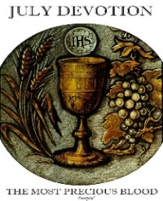 Fifteenth Sunday in Ordinary Time

July 15, 2018

**Month of The Precious Blood of Jesus**

**MASS INTENTIONS**: (July 16 – July 22, 2018)

Monday 8:00 AM Claudia McCloskey req. by Paul, Karen & Kayla Fisher

Tuesday 8:00 AM Mildred Beesoick req. by George & Carol Caroff

Wednesday NO Mass

Thursday 8:00 AM John L. Podrebarac req. by Scott & Candace Malisko

Friday 8:00 AM Helen Varner req. by Rick, Mary Lou & Sean Varner

Saturday 4:00 PM People of the Parish

Sunday 8:00 AM Claudia Mehall req. by John & Carol Cordek

Sunday 10:30 AM Agnes Horvath req. by Richard & Pat Opett

LITURGICIAL APPOINTMENTS:

Saturday, July 21 4:00 PM Offertory Procession

Lector: Susan Poldiak Bryan & Amy Spangler Family

Minister of the Host: Karen Myers

Ministers of the Cup: Vince Arena & Susan Blazosky

Altar Servers: Brooke & Chase Williamson

Cantor: Amanda Williamson

Greeter: Shirley Walls

Sunday, July 22 8:00 AM Offertory Procession

Lector: Joseph Faher Terri Leach & Carol Cordek

Minister of the Host: Marie Jo Plummer

Ministers of the Cup: Beth Kundrod & Marie Bernard

Altar Servers: Elizabeth & Ian Dobbins

Cantor: Susan Yanzetich

Greeter: Lori George

Sunday, July 2210:30 AM Offertory Procession

Lector: Madison Kundrod Agnes Horvath Family

Minister of the Host: Michael Barton

Ministers of the Cup: Greg Stiffler & Sharon Paterson

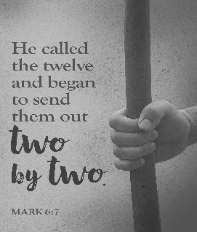Altar Servers: Ericka Frombach & Alexia Steele

Cantor: Ian Wieczorek

Greeter: None Scheduled

Sunday, July 22 Collection Counters

Mary Ann DeRosa, Rod Kundrod

Sara Zybura

Weare placing names of the sick in the bulletin for prayer providing they give permission. *May the* *Divine Physician send healing grace for those for* *whom we pray:* Allen C. Rosemas, Patricia Murphy, Bernice Myers, Dwight Fyock, Lori Facciani, Dylon Wills, Dawn Hagen, Debbie Dibert, Missy, Joanne (Kolar) Hufford, Christine Flanagan, Ayden Alan Grata, Mary Lou Offman, Mary Zangaglia, Dorothy Rosemas, Natalie Zerby, Patricia Grata, Michael Wadsworth, Valencia & Frank, Tursi, Homer Locher, Brayden Schofield, Michelle Kasper, Diane Kingera, Allison Krischer, Ted Paluch, Brandt Hutzel, Pearl Litzinger, Patrick Munro, Fran Baldassarre, Corey Lybarger, Kristen Sinosky Long, Helen Ranieri, Cresta Micik, Basil Costantino, Madison McCrory, Laura, Joe Yoder, Dolores Yanzetich, Sandy Krug, Wanda Gramling, Merna Smay, Muriel “Jean” Wiesheier, Agnes Plummer, Jennifer Hagans, Mary McCall, Sean, Holly, Shane, Owen Taylor, Keith & Dawnetta Hoyer, Derrick Varnish, Daniel Koshute, Vincent Koshute, Karen Lovrich, Melissa Cordek, Michelle Elliott, Heather Romanow, Mackston Barrick, Connor Thomas, Erin, Pat, Mary Agnes Nastase, Mary Ann Bertolino, Dick Wilson, Izzy Bihun, Erica Mitzelfeld, Heidi Allison, Dorothy Kaminsky, Ed Ripper Sr., Bob Debias, Patricia Oshaben, Craig Kraber, Ashlee Madison, Marlene McCrory, Bob Casti, Susan Yanzetich, Mike, Mary Sivec, Danika Faith, Stacy Jarvis, Alina Rusnak, Fern Swartzentruver, Marcia Costlow, Gary Smay, Tammy Webb, Elizabeth Howell, Charles Smith, Mary Ann Cover, Tom Paterson, Dick Minor, Helen Bowen, Bill Gideos and all of the sick of our parish, the homebound, those in nursing homes, those who care for them, and those in the military along with their families. (Please call the Rectory to have your name removed from the list when no longer seriously ill. Thank You.)

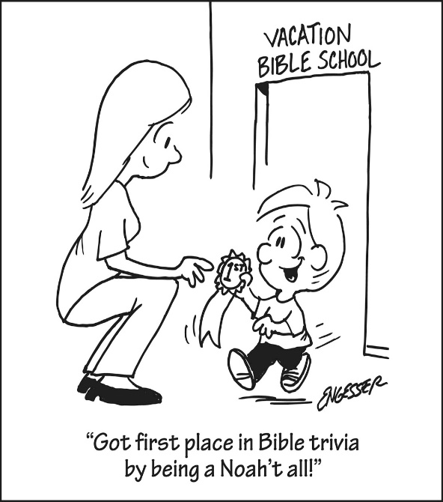

LAST WEEK’S COLLECTION

Adults $4,037.50

Loose $ 353.00

Youth $ 26.50

Monthly $ 510.00

Candles $ 44.50

Maintenance Fund $ 50.00

Feast of the Assumption $ 15.00

Catholic Register $ 177.00

Peter’s Pence $ 168.00

Total $5,381.50

We sincerely thank and ask God’s blessing upon all who have care and concern for our parish.

*July 15, 2018 Mark 6:7-13*

*Jesus sent out His apostles without a lot of “things” because THINGS distract. We collect, argue about and protect our “things.” We even ignore each other because we have “things” to do. What “things” are separating you from your family?*

The Sanctuary Candle

will burn as an Anniversary Remembrance for Andrew & Betty Pcola

requested by Loving Family

during the week of July 15, 2018.

[](https://images.search.yahoo.com/search/images;_ylt=A0LEV1kSWptXvOwAKINXNyoA;_ylu=X3oDMTEyZGdkcmRoBGNvbG8DYmYxBHBvcwMxBHZ0aWQDQjIwODlfMQRzZWMDc2M-?p=Clipart+of+a+sanctuary+candle&fr=ush-mailn_02&th=110&tw=110&imgurl=http://www.henningers.com/389-168-wall-sanctuary-lamp.jpg&rurl=http://pixshark.com/sanctuary-lamp.htm&size=43KB&name=Sanctuary+Lamp+Bronze+wall+sanctuary+lamp&h=600&w=600&turl=http://ts2.mm.bing.net/th?id=OIP.M68453c67108cdc5ab485d309b395bd03o0&pid=15.1&rs=1&c=1&qlt=95&w=110&h=110#inline&tt=Sanctuary+Lamp+Bronze+wall+sanctuary+lamp&sigr=116keh5le&sigit=13gvlt42j&sigi=11ip0pgm4&sign=119kp6100&sigt=119kp6100)

FR. BRIAN’S MESSAGE ~ My sincere thank you to Rick Roberts and family for helping our parish with the Jo Jo’s fundraiser. I’ve heard and have seen many people take part in this over the weekend. Many thanks to all who participated.

SECOND SUNDAY FOOD COLLECTION ~ Thank you to all who so generously donated to the Forest Hills Food Pantry. The total money collected was $622.00 and an assortment of non-perishable items.

KNIGHTS OF COLUMBUS ~ The Knights of Columbus Council 2275 will be collecting for The Arc this weekend (July 14 & 15). With nearly 700 state and local chapters nationwide, The Arc is on the front lines to ensure that people with intellectual and developmental disabilities and their families have the support and services they need to be fully engaged in their communities. The Arc works with its federation of state and local chapters to create an impressive network of human service agencies ensuring they have the strongest civil rights advocates promoting and protecting their needs at all levels. If using a check, make payable to Knights of Columbus Council 2275.

MIRACLE OF LIFE ~ Miracle of Life / Billboard volunteers will be here July 21st & 22nd seeking your continued support in the fight against Abortion. This is our 22nd year of raising Pro-Life billboards and yard signs. We are grateful to everyone at Saint Michael Catholic Church and Fr. Brian for your wonderful support over these many years. America has lost over 55 Million babies lives through the evil of abortion. Your donations have been extremely important. THANK YOU for being so kind and generous. Jerri and Hezekiah Phillips.

ST. ANNE TRIDUUM ~ A triduum in honor of St. Anne will be held July 24, 25 & 26 at St. John Gualbert Cathedral, 117 Clinton St., Johnstown. Mass and devotions will be held at 7 PM each evening with confessions following mass.

PILGRIMAGE TO THE MOTHER OF GOD OF ZARVANYTSIA ~ Every year millions of people go on a pilgrimage to Zarvanytsia in Ukraine to renew their spiritual life through the Sacraments of Reconciliation and the Holy Eucharist. A copy of the Icon of the Mother of God of Zarvanytsia graces the sanctuary of the Protection of the Blessed Virgin Mary Ukrainian Catholic Church, 560 Cambria Avenue, Revloc, PA. We would like to invite you to come and join us for the Pilgrimage to the Mother of God of Zarvanytsia on August 19th at 11 AM. There will be activities throughout the day: confessions, a prayer service to the Mother of God called a Moleben, Divine

Liturgy (Mass), and plenty of time for private meditation.

*Stewardship Reflections…*

Participation in the Church’s mission takes different forms according to people’s different gifts and offices, but there is a fundamental obligation arising from the sacrament Baptism: “that people place their gifts, resources, and themselves at God’s service in and through the Chruch.” (Stewardship: A Disciple’s Response; USCCB; 1992).

Thank you to all parishioners who have responded to the *2018 Catholic Ministries Drive.* Please join them in supporting our Parish and a select group of ministries that provide outreach to the poor, family life, youth and seminarians. If you did not receive a pledge card in the mail, you may give online at [www.dioceseaj.org](http://www.dioceseaj.org).

Catholic Ministries Drive $24,043.00

Raised: $ 9,555.00

Balance: $14,488.00

Number of responses: 81



 Religious Education And Christian Helping

July 15, 2018

Upcoming REACH Service Projects

Vacation Bible School ~ REACH student volunteers can help at this year’s VBS and receive service hour credits. Call the Religious Education Office at 495-4873 to sign-up.

**********************************************************************************

Vacation Bible School

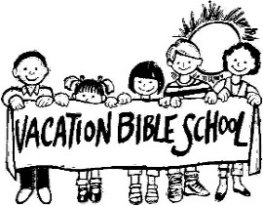 “Be Cool! Meet Jesus at Bible School” ~ “*POLAR BLAST”* Vacation Bible School, sponsored by Most Holy Trinity, Saint Bartholomew and Saint Michael Parishes will be held at Most Holy Trinity Church Hall this week, July 17th, 18th & 19th from 6-8 p.m. VBS will include games, crafts, songs, bible stories and lot of fun activities for ages 4—14. All children, grandchildren, neighbors and friends are invited to attend.

Registration form (available at the church entrances) can be brought to VBS. Call 495-4419; or email [erosmus@diocesesaj.org](mailto:erosmus@diocesesaj.org). Walk-ins welcome.

**********************************************************************************

*New volunteers are always needed to help with our parish children.*

We need your help to carry out our activities and projects.

If you are willing to do so, FIRST we need to obtain your clearances.

The PENNSYLVANIA CHILD PROTECTIVE SERVICE LAW requires clearances and training for anyone working with our parish children. All helpers, volunteers and any other adults who wish to help chaperone and mentor our children in any way are required to have and will need these clearances. These clearances are free of charge for all volunteers. Once completed, you will need to provide copies of clearances and certification to be placed on file in our Parish Office. If you already have these clearances and training completed for your job, you will only need to submit copies to the office.

Please contact the Religious Education Office at 495-4873 or the Rectory Office at 495-9640 to submit copies or for more information to obtain these clearances. Your swiftness to complete the clearance process over the summer will help assure that we have an adequate number of compliant volunteers able to help with our youth when needed and when our Religious Education program resumes.

Sunday, July 15 The Arc Collection / Knights of Columbus

Monday, July 16 Sunday Choir Practice / 7:00 PM

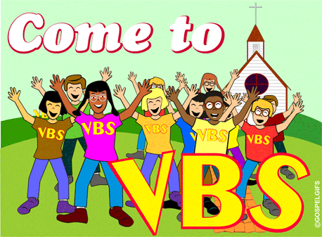 Tuesday, July 17 VBS / Most Holy Trinity / 6:00 – 8:00 PM

Wednesday, July 18 NO Mass

VBS / Most Holy Trinity / 6:00 – 8:00 PM

Thursday, July 19 Saturday Choir Practice / 5:30 PM

VBS / Most Holy Trinity / 6:00 – 8:00 PM

 Pavilion Rental

Friday, July 20

Saturday, July 21 Miracle of Life

Pavilion Rental

UPCOMING EVENTS

July 22 Miracle of Life

August 11 & 12 Mission Appeal / Comboni Missionary Sisters

August 11 Hall Rental

August 18 & 19 Mission Appeal Collection / Second Collection

RESURRECTION PARISH IS SPONSORING GROOVIN AT THE GROVE ~ At the Grove in Tanneryville. Each Groovin will start with an Outdoor Mass at 5:30 PM, food will be available after Mass. Music from 7 – 10 PM. July 21st – Ground Zero, August 18th – Flood City Brass. Come and have a great time.

ANNUAL ALL SCHOOL REUNION ~ Johnstown Catholic/Bishop McCort Catholic High School. Friday,

July 20 – All School Reunion Picnic: Art Works Building of Bottle Works 413 Third Ave., Cambria City, Food/Fun/Entertainment 5 PM – 10 PM. New This Year: Live Music by Candle in the Wind 6 PM – 9 PM. Sponsored by Senior Life. Sunday, July 22 – Mass at 11 AM at St. John Gualbert Cathedral, Brunch following Mass at BMCHS Bach Student Union/Cafeteria. RSVP for Brunch only by July 16 by calling:814-248-3867. All Alumni Welcome!!!

INDOOR YARD SALE ~ Tables/space available to rent at Bishop Carroll cafeteria July 28 during the Ebensburg town wide yard sale $15 each. Call 472-7500 ext. 101 for info. Benefits BC Girls Soccer.

BASKET PARTY ~ Will be held on Sunday, July 29th at 2:00 PM at St, Bartholomew Church Hall, 185 Church Hill Road, Wilmore. Doors open at Noon and the drawing for the Baskets will be at 2:00 PM. Dessert and refreshments will be served. Door Prize: 42” TV.

CAR CRUISE/BLOCK PARTY ~ Queen of Angels Parish Central City will be hosting a Block Party/Car Cruise on Sun. July 29th at their St. John site (162 Wheeler St.) from 1 – 5 PM with all proceeds benefitting Allen Berkey and his battle with Cystic Fibrosis. Live oldies music provided by Krazy Kat Daddies with wings, burgers, hot sausage, and other refreshments available. The first 50 cars will receive a gift. All vehicles blessed upon request. Come out and enjoy a day of cars, wings, burgers, refreshments, and camaraderie. All are welcome!

JULY 8TH, 2018 PARISH COUNCIL MINUTES

Attendance: Amy Dobbins, Suzi Blazosky, Katie Kundrod, Bill Thomas, Pete Parisi, MaryAnn Spangler, Jim Lashinsky, Kathy Kalicky, Michele Panick, Laurie Sloan, John Bizzarri, Donald Dipko, Sally Kolar, Vince Arena, Fr. Brian Warchola

Absent: Catherine Yanzetich, Rodney Turgeon, Paul Kundrod, Amy Spangler

Suzi Blazosky called the meeting to order at 11:25. Father Brian led the council with an opening prayer. The minutes from the March 11, 2018 meeting were reviewed and stood as submitted.

Elections:

Outgoing-Suzi Blazosky, Amy Dobbins, Vince Arena, Don Dipko, Sally Kolar

Incoming-Jim Lashinsky (Chairperson), Amy Spangler(co-chairperson), Katie Kundrod (Secretary), MaryAnn Spangler (Family Life), John Bizzarri (Christian Service)

Discussed elections, 3-year terms, appointing of positions

Welcome of Newly elected, thanks to former council.

New Chairperson Jim Lashinsky continued meeting.

Updated Reports:

Maintenance:

Planted flowers around church and house; Rod Turgeon painted the garage; painting of the hall and house to begin. Arnie and Pete Bernard volunteered to paint for us within a week or two.

Brad Webb to construct roof over DRE Laurie Sloan’s door.

Religious Education:

Laurie Sloan updated council on Religious Education Program. Youth Ministry: Approximately 15-20 people attended the Altoona Curve and watched a good game. Students held a car wash in June with music by DJ Aaron Labarko. Washed about 35 cars, went very well. Discussing possibility of a Kennywood trip?? REACH fundraiser coming up at Labor Day Festival.

Religious Education forms will be going out in August for the 2018-2019 school year.

VBS at Most Holy Trinity, July 17-19. Small number of our parish children signed up.

Holy Name:

Pete Parisi discussed events regarding Holy Name. They helped with the parish picnic and outdoor mass in which both went very well. Brought up Labor Day Festival fundraiser approaching.

Holy Name continues to say the rosary before mass and the Communal Prayer.

Meeting this Thursday, July 12 at 6:30 PM at Morris’s Tavern.

Old Business:

Kathy Kalicky discussed ticket sales. 488 tickets given out---52 weren’t sold/missing/not returned.

Brought in $4480. Paid out $2283. Profit $2197. Everyone agreed to continue ticket sales. Every registered member of the Parish gets a ticket. April Chicken Dinner: $577.50 profit.

New Business:

MaryAnn Spangler brought up the request to remove the kneelers from the handicapped pews. Request to remove due to safety concerns for parish members.

-Ask that we all keep an eye on the handicapped members of our church. Show more

hospitality, at the front door. Don Dipko stated he will bring this up at the next Knights of Columbus meeting.

Suzi Blazosky brought up the need for more individuals to volunteer in the ministries. We would like to see more individuals involved in the TALENT aspect of Time Talent Treasure. (ex: no greeters at the 10:30 am mass; only 5 Eucharistic ministers at 10:30 am mass; short on money counters)

Work on getting more people involved. Amy Dobbins gave an idea to ask the people that weren’t elected for Parish Council for their involvement elsewhere.

ARISE Program:

Father Brian said Missy & Ken Burkhart have volunteered to be the chairperson for the ARISE program. The program is required by the diocese and focuses on small group scripture discussion.

Photo Directory:

Father Brian met with a company in May. Everyone agreed to move forward with the plan. Father to ask Chris Smay if she would like to spearhead the photo directory project. New company this time. Learn from the old proposal and take into consideration for this time. Discussed getting the new proposal in writing.

Items from the floor:

September 29th is the Feast of St. Michael. Father Brian brought up idea of having a mass for all first responders (firefighters, police, etc.) on Sunday September 30th at 10:30 am mass. Discussed possibility of small social or luncheon after mass.

Another spaghetti dinner fundraiser in late September/October. Possibly purchase supplies in bulk and forgo DelGrosso’s?

Mother’s Day Brunch-huge turnout, over 140 moms and daughters

Father’s Day Bruch-good turnout. Thanks to REACH students that helped with both brunches!

Next Meeting:

The council agreed the next meeting is October 14th at 11:30.

Don Dipko made the first motion to adjourn; Sally Kolar second the motion. Newly elected chairperson Jim Lashinsky thanked everyone in attendance and all former members for their service.

The meeting was adjourned at 12:10.

Respectfully submitted,

Katie Kundrod, Parish Council Secretary