ST. MICHAEL ROMAN CATHOLIC CHURCH

751 Locust Street

PO Box 103

St. Michael, Pennsylvania 15951

Rev. Msgr. David A. Lockard, Administrator MASSES:

(814) 495-9640 Saturday 4:00 pm



Sunday Morning 9:30 am

Secretary: Michele Panick

Bookkeeper: Kathy Kalicky Daily Mass: M, T, Th, F Noon

DRE: Laurie Sloan Wed. 6:00 pm

Maintenance: Rodney Turgeon Holy Days: See Bulletin

PHONES: Office Hours:

Rectory / Office: (814) 495-9640 8:30 am to 3:30 pm

Fax: (814) 495-9424 Monday, Tues., Thurs., Friday

Rel. Education: (814) 495-4873 Confessions:

Parish Website Saturday 3:30 pm to 3:45 pm www.saintmichaelchurch.weebly.com Sunday 9:00 am to 9:15 am

Secretaries’ E-mail By Appointment

[saintmichaelsecretaries@yahoo.com](mailto:saintmichaelsecretaries@yahoo.com)

Facebook page:

St. Michael Catholic Church/St. Michael, PA

14th Sunday in Ordinary Time

SERVING GOD AND COMMUNITY FOR OVER ONE HUNDRED YEARS!

July 5th, 2020

BAPTISM: By Appointment. Reserve at least one month in advance.

MARRIAGE: Plan at least nine months in advance.

Preparation sessions are necessary.

FUNERALS: Arrangements are made in conjunction with the funeral home.

REGISTRATION Those new to the area, newlyweds, and single adults, (even if registered

and before with their families) are asked to register by calling the Parish Office.

MEMBERSHIP: Every parishioner must be registered. This is a condition for admission

to our Program and reception of the Sacraments of Baptism, Confirmation,

First Penance, First Eucharist, and Matrimony; also, for testimonial letters or sponsorship of Baptism and Confirmation outside the Parish.

VISITATION: We are concerned and want to be advised when someone is ill at home or in the hospital. Call the rectory to have the shut-in placed on our monthly Holy Communion calls or seriously ill prayer list.

SACRAMENTAL Parish registration and active Mass participation for Baptism is

POLICY: encouraged and is required for Marriage.

BULLETIN ARTICLES: Articles are due to the Parish Office by Noon on Tuesday.

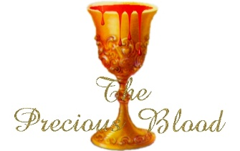

Fourteenth Sunday in Ordinary Time

July 5th, 2020

The Precious Blood of Jesus

**MASS INTENTIONS**: (July 6 – July 12, 2020)

Monday Noon Theressa Stravinsky req. by Helen Slonac

Tuesday Noon Albert & Katherine Demko req. by Carl & Pam Freidhoff

Wednesday 6:00 PM Mindy Scott req. by Carol Debias

Thursday Noon Paul Chulick req. by Irene Chulick

Friday Noon Betty Pcola req. by her Loving Family

Saturday 4:00 PM Francis Andrykovitch req. by Family

The People of the Parish

Sunday 9:30 AM Mike & Rose Chalan req. by Children

LITURGICIAL APPOINTMENTS:

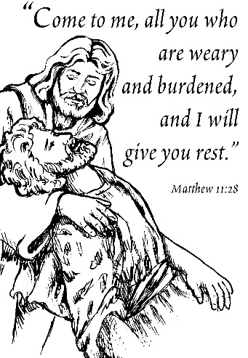Saturday, July 11 4:00 PM

Lector: Volunteer needed Minister of the Host: Susan Blazosky

Altar Server: Volunteer needed

Cantor: David Zajdel

Sunday, July 12 9:30 AM

Lector: Volunteer needed

Minister of the Host: Sally Kolar

Altar Server: Jackson Henderson

Cantor: Louis McCloskey

Sunday, July 12 Collection Counters

Christine Smay, Sara Zybura

MINISTRY SCHEDULES ~ Lay ministry schedules are being done week by week until we return to our regular mass schedules. Please check the bulletin for the schedule. If you know a weekend you may not be available, please let Susan Blazosky know at: 495-5287 or [sublazosky@gmail.com](mailto:sublazosky@gmail.com)

Weare placing names of the sick in the bulletin for prayer providing they give permission. *May the* *Divine Physician send healing grace for those for* *whom we pray:* Allen C. Rosemas, Patricia Murphy, Bernice Myers, Dwight Fyock, Dylon Wills, Missy, Joanne (Kolar) Hufford, Christine Flanagan, Ayden Alan Grata, Mary Lou Offman, Mary Zangaglia, Natalie Zerby, Valencia Tursi, Homer Locher, Brayden Schofield, Michelle Kasper, Diane Kingera, Allison Krischer, Ted Paluch, Brandt Hutzel, Pearl Litzinger, Patrick Munro, Fran Baldassarre, Kristen Sinosky Long, Cresta Micik, Basil Costantino, Madison McCrory, Laura, Joe Yoder, Dolores Yanzetich, Sandy Krug, Wanda Gramling, Agnes Plummer, Jennifer Hagans, Shawn, Holly, Shane, Spencer, Owen Taylor, Keith & Dawnetta Hoyer, Derrick Varnish, Vincent Koshute, Melissa Cordek, Michelle Elliott, Heather Romanow, Mackston Barrick, Connor Thomas, Erin, Pat, Mary Agnes Nastase, Mary Ann Bertolino, Dick Wilson, Izzy Bihun, Dorothy Kaminsky, Patricia Oshaben, Ashlee Madison, Susan Yanzetich, Mike, Danika Faith, Alina Rusnak, Gary Smay, Elizabeth Howell, Helen Bowen, Walter Bodziak, Rhonda, Dan Strinkoski, Anne Robinson, Marlene McCrory, Sharon Poldiak, Carter Bobak, Vince Arena, Mike Morris, Sarah Kelt, Patty Yanzetich Caldwell, Colton Snyder, Betty Delaney, Nancy Edmiston, Bill Krajewski, Leonard Oshaben, Adam, Bill Gideos, Janice Dipyatic, John Poldiak Jr., Gerald Delaney, Lily Maloney, Adam Wingard, Scott, Lisa, Rosalie Ambrose, John Patrick, Audrey Costlow, Carole Horner, Ross Linert, Cathy Sossong, Rosanne Krug, Paul Snyder, Becky Kakabar, Catherine Tedjeske, Pua Ripper and all of the sick of our parish, the homebound, those in nursing homes, those who care for them, and those in the military along with their families. *(Please call the Rectory to have your name removed from the list when no longer seriously ill. Thank You.)*

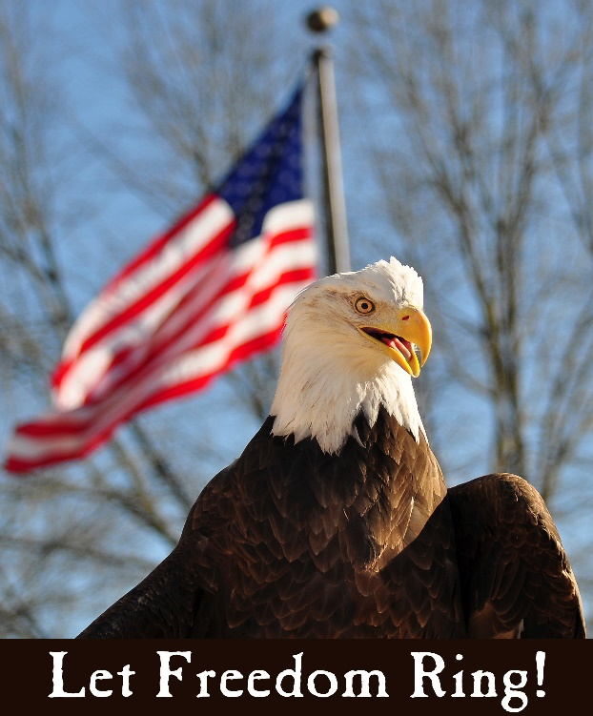

LAST WEEK’S COLLECTION

Adults $3,192.00

Loose $ 46.00

Youth $ 26.00

Monthly $ 425.00

Father’s Day $ 75.00

Candles $ 15.00

Maintenance Fund $ 210.00

Cemetery Maintenance $ 15.00

Easter $ 30.00

Catholic Register Sub. $ 15.00

Holy Land $ 30.00

Peter’s Pence (Holy Father) $ 247.00

Total $4,326.00

We sincerely thank and ask

God’s blessing upon all

who have care and

concern for our

parish.

*July 5, 2020*

*By handing our ordinary lives over to Jesus we can rest in the promise of Jesus that to labor in His name we can learn to be humble and not act as if becoming a Christian steward is burdensome., “For my yoke is easy, and my burden light.” (Mt. 11:30)*

JUNE 2020 PARISH TICKET WINNERS

UNSOLD TICKETS/NOT RETURNED TICKETS ~ If the winning number is a ticket that was not sold or returned, the money will be split with the number above the winning number and the number below the winning number. If the number above or below the winning number was not returned, we will go above or below that number.



Day Date Amount Number Winner

Friday June 26, 2020 $75 735 Andrea Shirdon

Saturday June 27, 2020 $100 040 Heidi Fisher

Sunday June 28, 2020 $100 011 Charles Bodziak

Monday June 29, 2020 $75 177 Geri Fessler

Tuesday June 30, 2020 $75 163 Mike Docherty

90TH BIRTHDAY! ~ Mary Yuhas, a member of St. Michael Church, turned 90 years young on Tuesday, July 2nd. Her daughter asked if the parish would be so nice as to send Mary a birthday card. If you are willing to do so, her address is: Concordia of Cranberry, 10 Adams Ridge Road, Mars, PA 16046.

PROCLAIM *CHRIST IN YOUR LIFE* MAGAZINE ~ Is available digitally at [www.dioceseaj.org/magazinespring2020/](http://www.dioceseaj.org/magazinespring2020/). Please share with your friends & family, especially during this time of continued social distancing!



Religious Education And Christian Helping

Confirmation ~ Some of our 11th Grade Confirmation class will receive their Sacrament of Confirmation on Thursday, July 9th, 2020. A 7:00 PM Mass will be celebrated here at St. Michael Church. Confirmation Practice will be held on Wednesday evening, July 8th at 6:30 PM.

The remainder of the class will receive their Sacrament of Confirmation on Tuesday, July 14th, 2020 at 7:00 PM here at St. Michael Church. Practice for these students will be held on Monday evening, July 13th at 6:30 PM.

CAMP ZACCHAEUS GOING VIRTUAL

Camp Zacchaeus will be held July 19—24 for youth entering grades 4—9 in the fall. Registration is $10, which will cover the cost of materials that the diocese will send out in time for camp! Anyone interested, contact the parish office for a registration brochure.

Brochures also available in the green tote outside the parish office outside of office hours.

During the week of July 5th, 2020

the Sanctuary Candle will burn in memory of

Francis Andrykovitch

requested by Family

[](https://images.search.yahoo.com/search/images;_ylt=A0LEV1kSWptXvOwAKINXNyoA;_ylu=X3oDMTEyZGdkcmRoBGNvbG8DYmYxBHBvcwMxBHZ0aWQDQjIwODlfMQRzZWMDc2M-?p=Clipart+of+a+sanctuary+candle&fr=ush-mailn_02&th=110&tw=110&imgurl=http://www.henningers.com/389-168-wall-sanctuary-lamp.jpg&rurl=http://pixshark.com/sanctuary-lamp.htm&size=43KB&name=Sanctuary+Lamp+Bronze+wall+sanctuary+lamp&h=600&w=600&turl=http://ts2.mm.bing.net/th?id%3DOIP.M68453c67108cdc5ab485d309b395bd03o0%26pid%3D15.1%26rs%3D1%26c%3D1%26qlt%3D95%26w%3D110%26h%3D110#inline&tt=Sanctuary+Lamp+Bronze+wall+sanctuary+lamp&sigr=116keh5le&sigit=13gvlt42j&sigi=11ip0pgm4&sign=119kp6100&sigt=119kp6100)

Happy Birthday, U.S.A.!

Our Nation turns 244 years old this weekend, and if ever our country needs our prayers this is the year! Our economy and social life is crippled by the COVID-19 pandemic, racial strife and hatred are raising their ugly heads in many regions of our society and unemployment and poverty are hurting the poorest of the poor.

Prayer is desperately needed for all the above reasons. Not to be forgotten is the mess our schools are in – we still don’t know what will happen this fall when classes should resume.

So, I seriously invite everyone to join me in prayer for our country for ten minutes each day. You can pray at home if you cannot make it to church. But if you can’t pray now, may I ask, what will it take to convince you to pray?

May God bless us all and help us through this medical, economic, and social crisis!

Msgr. Lockard

PARISH COUNCIL ~ There will be a Parish Council Meeting next Sunday, July 12th after the 9:30 AM Mass.

SECOND SUNDAY FOOD COLLECTION ~ Next weekend is our Second Sunday Food Collection. Please bring in non-perishable food items or toiletries with you. Monetary donations are also appreciated.

PETER’S PENCE COLLECTION ~ Thank you for your generous support in last week’s Peter’s Pence Collection! As a parish, we collected $490.00. Our contributions will be combined with those from our brothers and sisters around the world to help Pope Francis provide essential relief to people in need. If you missed the collection, it is not too later to give. Visit [*www.usccb.org/nationalcollections*](http://www.usccb.org/nationalcollections)*.*

*COLLECTION COUNTERS* ~ Schedules are subject to change so please check the bulletin each week. If you are unable to serve, please trade with another counter or get a substitute.

BISHOP’S DIRECTIVES ~ There is a copy of the Bishop’s newest directives located at the entrances of the Church beside the bulletins. All are welcome to one.

OUTDOOR MASS HONORING MARRIED COUPLES ~ The Altoona-Johnstown Diocesan Family is invited to participate and to pray for those living the Sacrament of Marriage at an Outdoor Mass honoring Married Couples on Sunday evening, July 19th at 7:00 PM at the Shrine of Our Lady of the Alleghenies in Loretto. Bring a lawn chair. Indoors if rain. Bishop Mark is the celebrant and homilist. This is a wonderful way to celebrate, encourage and support married couples!

KNIGHTS OF COLUMBUS SCHOLARSHIP AWARDS ~ Attention 2020 high school graduates and parents! Our Knights of Columbus council #2275 will be awarding two (2) $500 scholarship awards to 2 graduates among the churches we serve in our local area. It does not matter which school you attended as long as you are a member of one of the five churches our council serves. They are St. Michael, Most Holy Trinity, St. Bartholomew or Immaculate Conception and St. Johns. An application and questionnaire can be obtained by contacting Don Dipko, council 2275 Financial Secretary, by phone or e-mail. The phone number is 487-5655 the e-mail address is [djdipko@comcast.net](mailto:djdipko@comcast.net). The paperwork will be sent to respondents by regular U.S. Mail and must be returned to council #2275 by August 1st, 2020.

Sunday, July 5 Mass ~ 9:30 AM

Confessions / 9:00 – 9:15 AM

Monday, July 6 Mass ~ Noon

NO Sunday Choir Practice

Tuesday, July 7 Mass ~ Noon

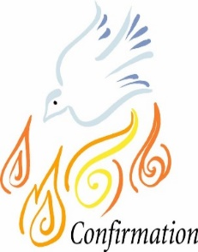

Wednesday, July 8 Mass ~ 6:00 PM

Confirmation Practice / 6:30 PM

Thursday, July 9 Mass ~ Noon

Confirmation / 7:00 PM

NO Saturday Choir Practice

Friday, July 10 Mass ~ Noon

Saturday, July 11 Mass / 4:00 PM

Confessions / 3:30 – 3:45

Second Sunday Food Pantry Collection

UPCOMING EVENTS

July 12 Parish Council Meeting

Second Sunday Food Pantry Collection

July 14 Confirmation

July 20 Finance Council Meeting

THE FRIAR’S NOOK GIFT SHOP ~ Christmas in July is upon us! All clearance items are 75% off through August 1st! Also, the shop is still stocked up for all your sacrament needs! The shop will continue to have modified hours through Labor Day which are Fridays and Saturdays, 10 AM – 4 PM, and is located on the campus of St. Bernardine Monastery at 793 Monastery Road, Hollidaysburg. For any questions, please call 814-695-3802. Please note, face coverings *must* be worn for gift shop entry.

YARD SALE ~ At BCCHS July 25, 7:30 AM – 2:30 PM during Ebensburg’s Homecoming and Community Yard Sale. Table Rentals/Space available at Bishop Carroll Cafeteria for $15 each 12 ft table or space. We will also be having a basket raffle, bake sale, food items for breakfast and lunch and drinks for sale. Call Bishop Carrol at 814-472-7500 ext. 101 or email [freidhof.susan@bishopcarroll.org](mailto:freidhof.susan@bishopcarroll.org) to reserve your spot. Vendors get a free hot dog & drink for lunch and free coffee for the day. Benefits Bishop Carroll Girls Soccer.



Bishop’s Directives on Mask-Wearing

Dear Brothers and Sisters in Christ,

Someone recently told me that she could hear the sigh of relief recently as restrictions were lifted that allowed for our churches to reopen. Numerous people have remarked how grateful they are to attend Sunday Mass and receive the sacraments, especially the Body and Blood of Christ in the Holy Eucharist. And they have mentioned how good it is to pray and worship with others in person.

I have not heard any criticism about the need for distancing or the way in which the financial offerings of the people are collected in a manner that avoids unnecessary physical contact.

However, there is one concern that is increasingly being brought to my attention. It has to do with the use of face masks. A better way to describe it is the growing number of letters and email messages advising me that people are simply not wearing face masks inside church.

A number of reasons for not wearing face masks have been shared with me, including:

* It’s hard to breathe because it is too warm in church
* We are in the green zone, so masks are no longer necessary
* It’s too awkward for my kids who keep pulling them off
* Where I live we are strong people and we have that herd immunity
* As a young adult I have been out socializing with friends and no one has masks

I am well aware that no one wants to tell others to wear a mask. Pastors don’t want to be the bad guy. Ushers don’t want people giving them an earful if they mention anything about masks. Parents are frustrated when they try to get their children to cooperate.

As I listen to all of those comments, I am also mindful of the concerns of people who come to Mass with the reasonable expectation that everyone is doing their part in observing the directives that were announced as a necessary part of the reopening of churches.

I am also mindful of the expert advice I have received and continue to receive. The message remains the same. Masks are the most important means of protecting yourself and others when you find yourself in a group.

In places throughout the country where businesses have reopened and people are gathering without using face masks, there has been an alarming increase in the number of COVID-19 cases. News reports indicate that the number of confirmed cases in the past month have doubled in many of those places. As a result, the restrictions and closures are being reinstated.

The people of the Diocese of Altoona-Johnstown have been known as being pro-life. That value and commitment of being pro-life is not limited to being against abortion of children. It extends from conception to natural death. It extends to every human person because we are all made in the image and likeness of God.

The care we have for ourselves and for the well-being and safety of others is found in Sacred Scripture. Just think of the story of Cain and Abel (Genesis 4:1-15), when the Lord asked Cain, “Where is your brother Abel?” And Cain replied, “Am I my brother’s keeper?”

We know the answer is yes. We are responsible for each other. Our Lord Jesus Christ affirmed that when he reminded us that we are to love our neighbor as we love ourselves (Luke 10:27). And Jesus went on to describe in the story of the Good Samaritan that we must literally go out of our way to help someone in need (Luke 10:29-37).

In that famous Gospel story, Jesus reminds us that there are times when caring for others involves an inconvenience and even a sacrifice on their part. That care for others is to be generous and done with compassion for the other person.

So how does this apply to all of us when it comes to COVID-19, face masks, and being in the parish church for Mass?

Wearing a face mask is a way in which we can love ourselves, since it is for our individual protection. Wearing a face mask is a way in which we can love our neighbors, so that an invisible virus is not spread from one to another. And remember, there are lots of people who have COVID-19, but they don’t have any symptoms; they don’t know that they have it.

I AM REPEATING MY PERSONAL APPEAL TO ALL OF YOU TO USE A FACE MASK WHEN YOU ATTEND MASS AND OTHER PARISH GATHERINGS.

In previously announced guidelines, I advised that the dispensation from the obligation to attend Mass on Sundays and Holy Days remains in effect, but if you cannot or should not attend due to medical conditions, you are encouraged to watch Mass on TV or via the internet.

Some people have chronic health conditions that make it extremely difficult to use a mask. If you are in that category, you are not obliged to attend Mass. At the same time, if you wish to receive Holy Communion, you should make that known so that Holy Communion may be brought to you as long as that is necessary. This can be done by a priest, deacon, or extraordinary minister of Holy Communion.

If it’s just too warm to wear a mask during Mass, you can remain outside, and wait to receive Holy Communion without entering the church according to the plan that each parish should have in place.

ALTAR SERVERS, EXTRAORDINARY MINISTERS, READERS (except for when they are actually reading), AND ANYONE ELSE WHO ENTERS INTO THE SANCTUARY (including deacons/priests) ARE TO WEAR A MASK.

MASKS ARE TO BE WORN BY USHERS, ORGANISTS, SONG LEADERS (except when they are engaged in singing).

When you are in church for Mass, THE MASK SHOULD ONLY BE REMOVED FOR A BRIEF MOMENT WHEN YOU ARE ABOUT TO RECEIVE HOLY COMMUNION, AND THEN IT SHOULD BE PUT BACK IN PLACE UNTIL MASS IS FINISHED AND YOU HAVE EXITED THE CHURCH.

The use of face masks is the number one means of protecting yourself and others from the spread of COVID-19.

I received a number of compliments from public health officials and government leaders for the implementation of the measures that were in place in our churches, schools, and other parish buildings.

I take this opportunity to thank all of you again for your cooperation in this effort. However, I need to be clear that unless the proper precaution of utilizing face masks is observed by everyone, it may result in the closures once again. No one wants to return to that experience.

So here is the bottom line: FACE MASKS ARE NOT OPTIONAL WHEN WE COME TO CHURCH.

As the slogan goes, “We are all in this together.” And that includes the presence of the Lord Jesus among us and with us.

Don’t let yourself even think about a slogan once suggested by Cain in the very first book of the Bible: “Am I my brother’s keeper?” Apparently Cain did not know the answer. But you do. “We are all in this together.”

Enjoy the July 4 Independence Day celebrations; but be safe. And enjoy the rest of the summer by taking good care of each other.

Bishop Mark