John 6:54

ST. MICHAEL ROMAN CATHOLIC CHURCH

PO Box 103

St. Michael, Pennsylvania 15951

Rev. Brian L. Warchola, Administrator MASSES:

(814) 495-9640 Saturday 4:00 pm



Sunday Morning 8:00 am

Secretary: Michele Panick 10:30 am

Bookkeeper: Kathy Kalicky Daily Mass See Bulletin

DRE: Laurie Sloan Holy Days See Bulletin

Maintenance: Rodney Turgeon

Office Hours:

PHONES: 8:30 am to 3:30 pm

Rectory / Office: (814) 495-9640 Monday, Tues., Thurs., Friday

Fax: (814) 495-9424 Confessions:

Rel. Education: (814) 495-4873 Saturday 3:30 pm to 3:45 pm

Parish Website Sunday 7:30 am to 7:45 am

www.saintmichaelchurch.weebly.com 10:00 am to 10:15 am

Secretaries’ E-mail Anytime Requested

[saintmichaelsecretaries@yahoo.com](mailto:saintmichaelsecretaries@yahoo.com)

YEAR: 2018 NUMBER: 27

SERVING GOD AND COMMUNITY FOR OVER ONE HUNDRED YEARS!

BAPTISM: By Appointment. Reserve at least one month in advance.

Preparation classes are necessary.

MARRIAGE: Plan at least nine months in advance.

Preparation sessions are necessary.

FUNERALS: Arrangements are made in conjunction with the funeral home.

Eulogies should be given at the funeral home at the time of the wake service or at the luncheon.

REGISTRATION Those new to the area, newlyweds, and single adults, (even if registered

and before with their families) are asked to register by calling the Parish Office.

MEMBERSHIP: Every parishioner must be registered. This is a condition for admission

to our Program and reception of the Sacraments of Baptism, Confirmation, First Penance, First Eucharist, and Matrimony; also, for testimonial letters or sponsorship of Baptism and Confirmation outside the Parish.

VISITATION: We are concerned and want to be advised when someone is ill at

home or in the hospital. Call the rectory to have the shut-in placed on our monthly Holy Communion calls or seriously ill prayer list.

SACRAMENTAL Parish registration and active Mass participation for Baptism is

POLICY: encouraged and is required for Marriage.

BULLETIN ARTICLES: Articles are due to the Parish Office by Noon on Tuesdays.

Fourteenth Sunday in Ordinary Time

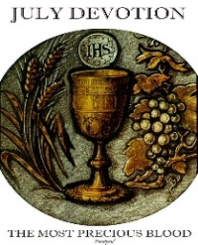 July 8, 2018

**Month of The Precious Blood of Jesus**

**MASS INTENTIONS**: (July 9 – July 15, 2018)

Monday 8:00 AM Agnes Bertolino req. by Jim Single

Tuesday 8:00 AM Betty Pcola req. by her Loving Family

Wednesday NO Mass

Thursday 8:00 AM Fritzie & Michael Beaver req. by Remy (Ray) Beaver

Friday 8:00 AM Michael Hudak req. by Gina Hudak

Saturday 4:00 PM Michele Houghton req. by Mom & Dad

Sunday 8:00 AM Michael & Rose Chalan req. by their Children

Sunday 10:30 AM People of the Parish

LITURGICIAL APPOINTMENTS:

Saturday, July 14 4:00 PM Offertory Procession

Lector: Anthony Bambino Michele Houghton Family

Minister of the Host: Alice Podrebarac

Ministers of the Cup: Theresa Carlson & Babe Richards

Altar Servers: Ana & Eva Spangler

Cantor: Amy Spangler

Greeter: Mary Ann Spangler

Sunday, July 15 8:00 AM Offertory Procession

Lector: Amy Spinos Chalan Family

Minister of the Host: Walter Christ

Ministers of the Cup: Robert Grattan & Paul Kundrod

Altar Servers: Andrew Martin & Michael Kresic

Cantor: Anita Lorek

Greeter: Pete Parisi

Sunday, July 1510:30 AM Offertory Procession

Lector: Michael Caddy Dobbins Family

Minister of the Host: Amanda Williamson

Ministers of the Cup: Robert Oshaben & Michael Barton

Altar Servers: Luke Docherty & Evan Burkhardt

Cantor: Louise McCloskey

Greeter: Cheryl Macy

Sunday, July 15 Collection Counters

Mary Anne Davis, Christine Smay

Phyllis Slonac

Weare placing names of the sick in the bulletin for prayer providing they give permission. *May the* *Divine Physician send healing grace for those for* *whom we pray:* Allen C. Rosemas, Patricia Murphy, Bernice Myers, Dwight Fyock, Lori Facciani, Dylon Wills, Dawn Hagen, Debbie Dibert, Missy, Joanne (Kolar) Hufford, Christine Flanagan, Ayden Alan Grata, Mary Lou Offman, Mary Zangaglia, Dorothy Rosemas, Natalie Zerby, Patricia Grata, Michael Wadsworth, Valencia & Frank, Tursi, Homer Locher, Brayden Schofield, Michelle Kasper, Diane Kingera, Allison Krischer, Ted Paluch, Brandt Hutzel, Pearl Litzinger, Patrick Munro, Fran Baldassarre, Corey Lybarger, Kristen Sinosky Long, Helen Ranieri, Cresta Micik, Basil Costantino, Madison McCrory, Laura, Joe Yoder, Dolores Yanzetich, Sandy Krug, Wanda Gramling, Merna Smay, Muriel “Jean” Wiesheier, Agnes Plummer, Jennifer Hagans, Mary McCall, Sean, Holly, Shane, Owen Taylor, Keith & Dawnetta Hoyer, Derrick Varnish, Daniel Koshute, Vincent Koshute, Karen Lovrich, Melissa Cordek, Michelle Elliott, Heather Romanow, Mackston Barrick, Connor Thomas, Erin, Pat, Mary Agnes Nastase, Mary Ann Bertolino, Dick Wilson, Izzy Bihun, Erica Mitzelfeld, Heidi Allison, Dorothy Kaminsky, Ed Ripper Sr., Bob Debias, Patricia Oshaben, Craig Kraber, Ashlee Madison, Marlene McCrory, Bob Casti, Susan Yanzetich, Mike, Mary Sivec, Danika Faith, Stacy Jarvis, Alina Rusnak, Fern Swartzentruver, Marcia Costlow, Gary Smay, Tammy Webb, Elizabeth Howell, Charles Smith, Mary Ann Cover, Tom Paterson, Dick Minor and all of the sick of our parish, the homebound, those in nursing homes, those who care for them, and those in the military along with their families. (Please call the Rectory to have your name removed from the list when no longer seriously ill. Thank You.)



LAST WEEK’S COLLECTION

Adults $3,243.53

Loose $ 33.00

Youth $ 24.00

Monthly $1,100.00

Candles $ 64.00

Maintenance Fund $ 50.00

Catholic Register $ 422.00

Peter’s Pence $ 838.00

Father’s Day $ 10.00

Total $5,784.53

We sincerely thank and ask God’s blessing upon all who have care and concern for our parish.

*July 8, 2018 Mark 6:1-6*

*Today’s gospel is so familiar, it hurts! The home town folks couldn’t accept the presence of God in Jesus. After all, they had watched him grow up. We can easily make the same mistake if we don’t see God present in the ordinary routines of our family. “The Lord be with you” is a statement of fact. Believe it. Live it.*

OUTDOOR MASS WITH BISHOP MARK ~ Honoring Married Couples. The Altoona-Johnstown Diocesan Family is invited to participate and to pray for those living the Sacrament of Marriage at an Outdoor Mass honoring Married Couples on Sunday evening, July 15 at 7:00 PM at the Shrine of Our Lady of the Alleghenies in Loretto. Bring a lawn chair. Indoors if rain. Bishop Mark is the celebrant and homilist. This is a wonderful way to celebrate, encourage and support married couples!

FATIMA DEVOTIONS ~ The Franciscan Friars, T.O.R., from Loretto, invite you to participate with them in celebrating the Fatima Devotions on Friday July 13th at 6:30 PM in the Sunken Gardens. (In case of inclement weather, the devotions will be at the Basilica of St. Michael the Archangel). The singing will be led by the “T.O.R. Novitiate Choir” and the sermon will be delivered by Bro. Daniel-Maria Klimek, T.O.R. We would like to extend a cordial welcome to all.

ANOINTING MASS ~ will be held 1:30 PM, Sunday, July 15 at St. John Gualbert Cathedral, 117 Clinton St., Johnstown. This liturgy will be especially joyous as we offer praise and thanks to receive God’s healing. We will celebrate the sacrament of Anointing of the Sick within Mass that satisfies the Sunday obligation. For more information, please call 814-539-2611.

ST. ANNE TRIDUUM ~ A triduum in honor of St. Anne will be held July 24, 25 & 26 at St. John Gualbert Cathedral, 117 Clinton St., Johnstown. Mass and devotions will be held at 7 PM each evening with confessions following mass.

PILGRIMAGE TO THE MOTHER OF GOD OF ZARVANYTSIA ~ Every year millions of people go on a pilgrimage to Zarvanytsia in Ukraine to renew their spiritual life through the Sacraments of Reconciliation and the Holy Eucharist. A copy of the Icon of the Mother of God of Zarvanytsia graces the sanctuary of the Protection of the Blessed Virgin Mary Ukrainian Catholic Church, 560 Cambria Avenue, Revloc, PA. We would like to invite you to come and join us for the Pilgrimage to the Mother of God of Zarvanytsia on August 19th at 11 AM. There will be activities throughout the day: confessions, a prayer service to the Mother of God called a Moleben, Divine Liturgy (Mass), and plenty of time for private meditation.



VOLUNTEERS NEEDED ~ St. Michael Rectory and Church Hall are in need of a paint job. We are looking for volunteers to help with this undertaking. Please let the office know by Monday, July 16th if you would be willing to help out!!

*Stewardship Reflections…*

Ezekiel and Jesus were both rejected by those who were close to them. May we be open-minded enough to see God revealing his will for us from those whom we least expect. May we live and act with the heart of Jesus and not let people’s judgements hold us back from being the stewards God has empowered us to be.



Catholic Ministries Drive $24,043.00

Raised: $ 9,035.00

Balance: $15,008.00

Number of responses: 74

Thank you to all parishioners who have responded to the *2018 Catholic Ministries Drive.* Please join them in supporting our Parish and a select group of ministries that provide outreach to the poor, family life, youth and seminarians. If you did not receive a pledge card in the mail, you may give online at [www.dioceseaj.org](http://www.dioceseaj.org).

The Sanctuary Candle

will burn for the health and well-being of

Mary McCall

requested by Bob and Laurie Sloan

during the week of July 8, 2018.

[](https://images.search.yahoo.com/search/images;_ylt=A0LEV1kSWptXvOwAKINXNyoA;_ylu=X3oDMTEyZGdkcmRoBGNvbG8DYmYxBHBvcwMxBHZ0aWQDQjIwODlfMQRzZWMDc2M-?p=Clipart+of+a+sanctuary+candle&fr=ush-mailn_02&th=110&tw=110&imgurl=http://www.henningers.com/389-168-wall-sanctuary-lamp.jpg&rurl=http://pixshark.com/sanctuary-lamp.htm&size=43KB&name=Sanctuary+Lamp+Bronze+wall+sanctuary+lamp&h=600&w=600&turl=http://ts2.mm.bing.net/th?id=OIP.M68453c67108cdc5ab485d309b395bd03o0&pid=15.1&rs=1&c=1&qlt=95&w=110&h=110#inline&tt=Sanctuary+Lamp+Bronze+wall+sanctuary+lamp&sigr=116keh5le&sigit=13gvlt42j&sigi=11ip0pgm4&sign=119kp6100&sigt=119kp6100)

PARISH COUNCIL MEETING ~ Will be held this Sunday, July 8th, after the 10:30 AM Mass. All outgoing and newly elected members please try to attend.

PETER’S PENCE COLLECTION ~ Thank you for your generous support in last week’s Peter’s Pence Collection! As a parish, we collected $838.00. Our contributions will be combined with those from our brothers and sisters around the world to help Pope Francis provide essential relief to people in need. If you missed the collection, it is not too late to give, visit [www.usccb.org/nationalcollections](http://www.usccb.org/nationalcollections), and click on the “How to Give” link.

PLEASE NOTE! ~ If any group would like to use / rent the outside pavilion, they must contact the office first to ask about availability. Thank-you.

HOLY NAME SOCIETY MEETING ~ Will be held Sunday, July 8th, after the 8:00 AM Mass.

SECOND SUNDAY FOOD COLLECTION ~ This weekend is our Second Sunday Food Collection. Please bring in non-perishable food items or toiletries with you. Monetary donations are also appreciated.

JO JO’S PIZZA FUNDRAISER ~ Jo Jo’s Pizza, St. Michael, will donate 20% of your total sales (excluding tax & tip) from the flyers collected this weekend – Saturday & Sunday, July 7th & 8th, Noon to 9 PM. Extra flyers can be found at the entrances of the Church. You can give as many flyers out to family & friends. Flyers are not to be distributed in the restaurant or within the perimeter of the building. Present flyers to your server and St. Michael will earn 20% of your total bill.

KNIGHTS OF COLUMBUS ~ The Knights of Columbus Council 2275 will be collecting for The Arc the weekend of July 14 & 15. With nearly 700 state and local chapters nationwide, The Arc is on the front lines to ensure that people with intellectual and developmental disabilities and their families have the support and services they need to be fully engaged in their communities. The Arc works with its federation of state and local chapters to create an impressive network of human service agencies ensuring they have the strongest civil rights advocates promoting and protecting their needs at all levels. If using a check make payable to Knights of Columbus Council 2275.

FR. CROWE ~ Will be celebrating Mass here on Saturday, July 14th at 4:00 PM due to Fr. Brian having a Wedding in Pittsburgh.

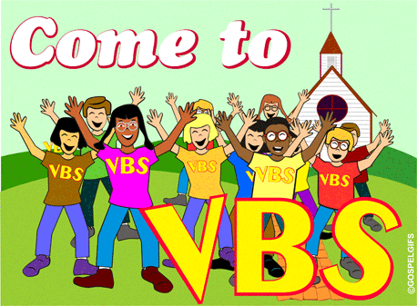VBS ~ All children, ages 4 – 13, are invited to have a “Polar Blast” at Vacation Bible School, July 17 – 19th from 6 – 8 PM at Most Holy Trinity Church, South Fork. This “cool” arctic adventure is sponsored by Most Holy Trinity, St. Bartholomew and Saint Michael Parishes. On the back table of the Church there is a Vacation Bible School donation can. Your donations will help purchase crafts, games and other materials to create a winter wonderland of fun with our faith.

July 1st 10:30 AM Mass

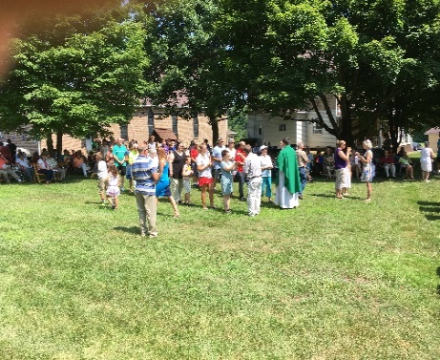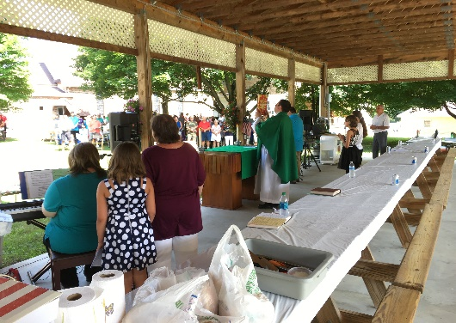

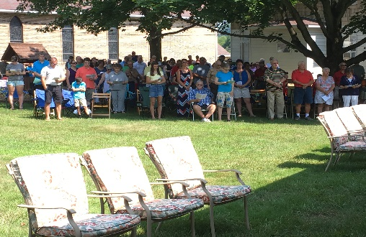

July 1st Parish Picnic

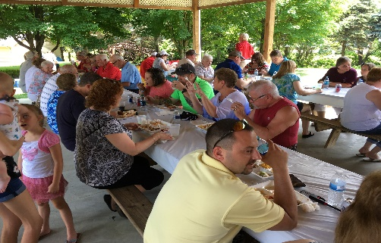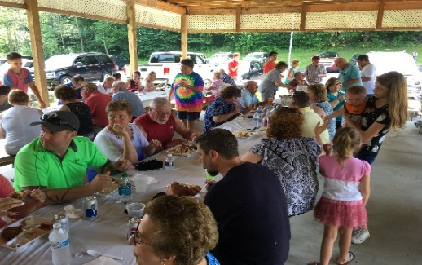

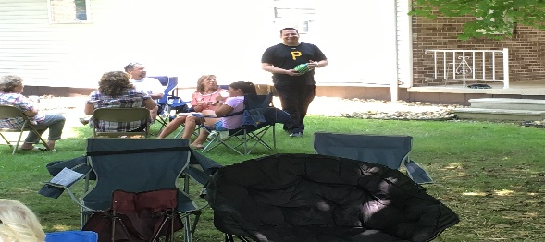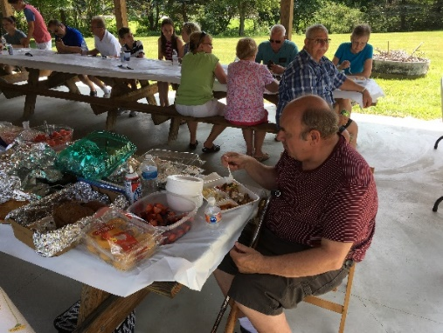

Religious Education And Christian Helping

July 8, 2018

Upcoming REACH Service Projects

VBS Planning ~ REACH student volunteers can help at this year’s VBS . High school students wishing to help receive service hour credits. If you cannot help during VBS but wish to help with making the decorations and set up beforehand, your assistance will be appreciated there also. Call the Religious Education Office at 495-4873 to sign-up.

**********************************************************************************

Vacation Bible School

 “Be Cool! Meet Jesus at Bible School” ~ Plans are underway for Vacation Bible School, sponsored by Most Holy Trinity, Saint Bartholomew and Saint Michael Parishes. It will be held at Most Holy Trinity Church Hall this year on July 17th, 18th & 19th from 6-8 p.m. This year’s theme is “*POLAR BLAST”* and will include games, crafts, songs, bible stories and lot of fun activities for ages 4—14. All children, grandchildren, neighbors and friends are invited to attend.

Adults and REACH students are invited to help create this winter wonderland of fun with our faith. You can RSVP by returning a registration form (available at the church entrances) to MHT Parish or call 495-4419; or email [erosmus@diocesesaj.org](mailto:erosmus@diocesesaj.org). We would like to have reservations ASAP to help prepare activities, but walk-ins are always welcome.

Any students in need of service hours this is a good opportunity to reach the total required.

**********************************************************************************

*New volunteers are always needed to help with our parish children.*

We need your help to carry out our activities and projects.

If you are willing to do so, FIRST we need to obtain your clearances.

The PENNSYLVANIA CHILD PROTECTIVE SERVICE LAW requires clearances and training for anyone working with our parish children. All helpers, volunteers and any other adults who wish to help chaperone and mentor our children in any way are required to have and will need these clearances. These clearances are free of charge for all volunteers. Once completed, you will need to provide copies of clearances and certification to be placed on file in our Parish Office. If you already have these clearances and training completed for your job, you will only need to submit copies to the office.

Please contact the Religious Education Office at 495-4873 or the Rectory Office at 495-9640 to submit copies or for more information to obtain these clearances. Your swiftness to complete the clearance process over the summer will help assure that we have an adequate number of compliant volunteers able to help with our youth when needed and when our Religious Education program resumes.

 Sunday, July 8 Jo Jo’s Pizza Fundraiser

Second Sunday Food Pantry Collection

Holy Name Meeting / After 8:00 AM Mass

Parish Council Meeting / After 10:30 AM Mass

Monday, July 9 Martha’s Group / 6:00 PM

Sunday Choir Practice / 7:00 PM



Tuesday, July 10

Wednesday, July 11 NO Mass

Thursday, July 12 Saturday Choir Practice / 5:30 PM

Friday, July 13

Saturday, July 14 The Arc Collection / Knights of Columbus

 UPCOMING EVENTS

July 15 The Arc Collection / Knights of Columbus

July 17, 18, 19 VBS / Most Holy Trinity

July 21 & 22 Miracle of Life

July 21 Pavilion Rental

August 11 & 12 Mission Appeal / Comboni Missionary Sisters

August 11 Hall Rental

RESURRECTION PARISH IS SPONSORING GROOVIN AT THE GROVE ~ At the Grove in Tanneryville. Each Groovin will start with an Outdoor Mass at 5:30 PM, food will be available after Mass. Music from 7 – 10 PM. July 21st – Ground Zero, August 18th – Flood City Brass. Come and have a great time.

ANNUAL FESTIVAL ~ St. Anthony of Padua Church, Windber, Annual Festival, July 14, 5 – 11 PM and July 15, 3-9 PM. Ethnic food, live music, games, baskets and more!

ST. JOAN OF ARC CATHOLIC CHURCH ~ Route 53, Frugality, PA (near Prince Gallitzin State Park and Glendale Lake) will be holding their annual Festival, Sunday, July 15th, from 11:00 AM to 6:00 PM. We are featuring a Turkey and Noodle Dinner with all the trimmings. Dinner served Family Style from 11:00 AM to 3:00 PM. Adults - $10, Children 5 to 12 - $5, under 5 is free. Takeouts available. Music Entertainment: DJ Bob Taylor from 11:30 AM till ? Basket auction at 5:00 PM. Games, Bingo, Bake Sale, Refreshments and lots more! *Please come, we would like to meet you!*

INDOOR YARD SALE ~ Tables/space available to rent at Bishop Carroll cafeteria July 28 during the Ebensburg town wide yard sale $15 each. Call 472-7500 ext. 101 for info. Benefits BC Girls Soccer.

BASKET PARTY ~ Will be held on Sunday, July 29th at 2:00 PM at St, Bartholomew Church Hall, 185 Church Hill Road, Wilmore. Doors open at Noon and the drawing for the Baskets will be at 2:00 PM. Dessert and refreshments will be served. Door Prize: 42” TV.