John 6:54
ST. MICHAEL ROMAN CATHOLIC CHURCH
751 Locust Street
PO Box 103
St. Michael, Pennsylvania 15951

Rev. Msgr. David A. Lockard, Administrator MASSES:
(814) 495-9640 Saturday 4:00 pm
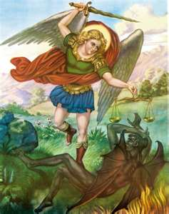
Sunday Morning 8:00 am
Secretary: Michele Panick 10:30 am
Bookkeeper: Kathy Kalicky Daily Mass See Bulletin
DRE: Laurie Sloan Holy Days See Bulletin
Maintenance: Rodney Turgeon
Office Hours:
PHONES: 8:30 am to 3:30 pm
Rectory / Office: (814) 495-9640 Monday, Tues., Thurs., Friday
Fax: (814) 495-9424 Confessions:
Rel. Education: (814) 495-4873 Saturday 3:30 pm to 3:45 pm
Parish Website Sunday 7:30 am to 7:45 am
www.saintmichaelchurch.weebly.com 10:00 am to 10:15 am
Secretaries’ E-mail Anytime Requested
saintmichaelsecretaries@yahoo.com

YEAR: 2019 NUMBER: 35

SERVING GOD AND COMMUNITY FOR OVER ONE HUNDRED YEARS!

September 1, 2019

BAPTISM: By Appointment. Reserve at least one month in advance.
MARRIAGE: Plan at least nine months in advance.
Preparation sessions are necessary.
FUNERALS: Arrangements are made in conjunction with the funeral home.
REGISTRATION Those new to the area, newlyweds, and single adults, (even if registered
and before with their families) are asked to register by calling the Parish Office.
MEMBERSHIP: Every parishioner must be registered. This is a condition for admission
to our Program and reception of the Sacraments of Baptism, Confirmation, First Penance, First Eucharist, and Matrimony; also, for testimonial letters or sponsorship of Baptism and Confirmation outside the Parish.
VISITATION: We are concerned and want to be advised when someone is ill at home or in the hospital. Call the rectory to have the shut-in placed on our monthly Holy Communion calls or seriously ill prayer list.
SACRAMENTAL Parish registration and active Mass participation for Baptism is
POLICY: encouraged and is required for Marriage.
BULLETIN ARTICLES: Articles are due to the Parish Office by Noon on Tuesdays.

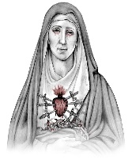
Twenty–Second Sunday in Ordinary Time
September 1, 2019
The Seven Dolors of The Sorrowful Mother

MASS INTENTIONS: (September 2 – September 8, 2019)

Monday 8:00 AM Ray & Irene Baldwin req. by Carl & Pam Freidhoff
Tuesday 8:00 AM Michele Houghton req. by Mary Beyer
Wednesday No Mass
Thursday 8:00 AM For Catholics to return to the Church
First Friday 8:00 AM Cathy McMahon req. by Sondre Harteis
Saturday 4:00 PM Mary Perich req. by The Gladysz Family
Sunday 8:00 AM Margaret Minor req. by Son, Nicholas Minor & Family
Sunday 10:30 AM People of the Parish

LITURGICIAL APPOINTMENTS:

Saturday, September 7 4:00 PM Offertory Procession

Lector: Donald Dipko John & Susan Poldiak
Minister of the Host: Theresa Carlson
Minister of the Cup: Vince Arena & Susan Blazosky
Altar Servers: Carson & Dylan Kundrod
Cantor: Amy Spangler
Greeter: Phyllis Slonac

Sunday, September 8 8:00 AM Offertory Procession

Lector: Terri Leach Nick & Pauline Minor
Minister of the Host: Sally Kolar
Minister of the Cup: Paul Kundrod & Cathy Faher
Altar Servers: Elizabeth & Ian Dobbins
Cantor: Joseph Faher
Greeter: Pauline Minor

Sunday, September 8 10:30 AM Offertory Procession

Lector: Madison Kundrod Bob & Regina Blanchetti
Minister of the Host: Robert Oshaben
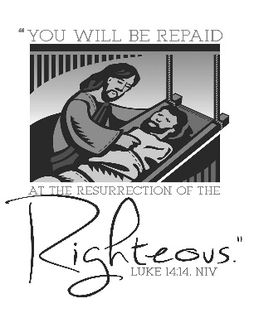
Minister of the Cup: Susan Wieczorek & Amanda Williamson
Altar Servers: Haidyn & Amilyah Koch
Cantor: Anita Lorek
Greeter: Wendy Blough

Sunday, September 8 Collection Counters
George & Janet Minor
Mary Ann DeRosa

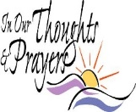
We are placing names of the sick in the bulletin for prayer providing they give permission. May the Divine Physician send healing grace for those for whom we pray: Allen C. Rosemas, Patricia Murphy, Bernice Myers, Dwight Fyock, Dylon Wills, Missy, Joanne (Kolar) Hufford, Christine Flanagan, Ayden Alan Grata, Mary Lou Offman, Mary Zangaglia, Natalie Zerby, Patricia Grata, Michael Wadsworth, Valencia & Frank Tursi, Homer Locher, Brayden Schofield, Michelle Kasper, Diane Kingera, Allison Krischer, Ted Paluch, Brandt Hutzel, Pearl Litzinger, Patrick Munro, Fran Baldassarre, Kristen Sinosky Long, Helen Ranieri, Cresta Micik, Basil Costantino, Madison McCrory, Laura, Joe Yoder, Dolores Yanzetich, Sandy Krug, Wanda Gramling, Merna Smay, Agnes Plummer, Jennifer Hagans, Shawn, Holly, Shane, Spencer, Owen Taylor, Keith & Dawnetta Hoyer, Derrick Varnish, Vincent Koshute, Melissa Cordek, Michelle Elliott, Heather Romanow, Mackston Barrick, Connor Thomas, Erin, Pat, Mary Agnes Nastase, Mary Ann Bertolino, Dick Wilson, Izzy Bihun, Erica Mitzelfeld, Dorothy Kaminsky, Patricia Oshaben, Ashlee Madison, Susan Yanzetich, Mike, Danika Faith, Alina Rusnak, Marcia Costlow, Gary Smay, Elizabeth Howell, Helen Bowen, Walter Bodziak, Rhonda, Dan Strinkoski, Anne Robinson, Marlene McCrory, Sharon Poldiak, Carter Bobak, Vince Arena, Mike Morris, Sarah Kelt, Patty Yanzetich Caldwell, Colton Snyder, Betty Delaney, Nancy Edmiston, Elizabeth Stoker Thomas, Albert Sracic, Joseph Ropecka, Bill Krajewski, Leonard Oshaben, Florence Smith, Michael Chalan Jr., Adam, Bill Gideos, Theressa Stravinsky, Janice Dipyatic, Martha, John Poldiak Jr., Gerald Delaney, Lily Maloney, Adam Wingard and all of the sick of our parish, the homebound, those in nursing homes, those who care for them, and those in the military along with their families. (Please call the Rectory to have your name removed from the list when no longer seriously ill. Thank You.)

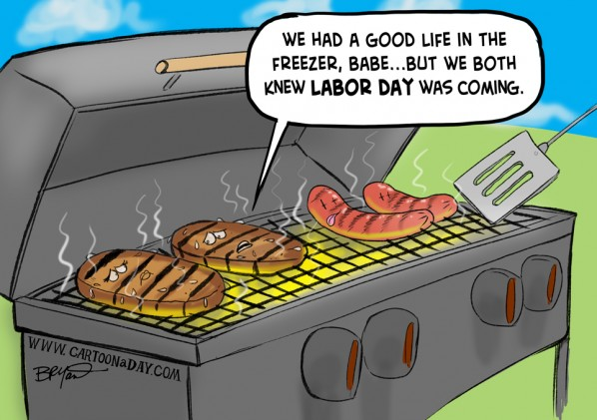

LAST WEEK’S COLLECTION

Adults $3,736.00
Loose $ 188.00
Youth $ 32.00
Monthly $ 15.00
Candles $ 18.00
Maintenance $ 470.00
Feast of the Assumption $ 20.00
Catholic Register $ 10.00
Missionary Co-Op $ 95.00
Total $4,584.00

We sincerely thank and ask God’s
blessing upon all who have care
and concern for our parish.

September 1, 2019 Luke 14: 1, 7-14
In today’s gospel, Jesus used a meal as a place to teach. Too often family meals are rushed, eaten in shifts or in the hypnotic glow of a TV. Meals are sacred times where we listen, share, appreciate and instruct. Jesus promises: “You will be blessed.” Don’t lose the opportunity.

We are asking that each parish household sell or buy one ticket for $10.00 and return the money and ticket stub as soon as possible, but no later than September 8th. The tickets start on October 1, 2019 and continue for the whole month of October. Winning numbers will be determined by the Pennsylvania Lottery Evening Pick Three Drawing. If you are unable to sell or don’t want the ticket, PLEASE don’t throw it away, but return it as soon as possible as we always have people looking for extras. If paying by check, please make check payable to St. Michael Church. The money raised from the sale of these tickets will help to build up our Parish Treasury. The tickets are available this weekend on the table at the back of the Church. We apologize if anyone has been missed. If you would like a ticket, please call the parish office.

Parish and Finance Council Members

BIRTH OF MARY CELEBRATION ~ Sunday, September 8th, Saint Catherine of Siena Shrine, Old Rt.22, Duncansville. 8:00 & 11:00 AM Mass, Celebrant: Msgr. Robert Saly. 9:00-10:30 AM Holy Rosary Commences in the church. 12:00-4:30 PM Rosary in the church & shrine. 5:00 PM Mass, Celebrant/Homilist Most Rev. Bishop Mark Bartchak. Spaghetti Dinner from 12:00-4:00 PM. Coffee & Cake after the evening Mass. Church hall Displays: Life of Mary, Our Mother, Rosary Makers and more. Bring a lawn chair. Address petitions to: Birth of Mary Celebration, PO Box 88, Duncansville, PA 16635. Donations Welcome!

BLUE MASS ~ Honoring First responders for their service at 11 AM, Sunday, Sept. 8th at St. John Gualbert Cathedral, Johnstown. This event is open to all police, law enforcement, public safety, firefighters, and EMTs and their families. The Blue Mass celebration will be open to the general public and honors those who serve our community in a most outstanding way as first responders. Anyone wishing to attend, plus those seeking further information, can contact 814-659-6240 or evyanz@hotmail.com

R.C.I.A. ~ Are you interested in becoming a Catholic? Are you a Catholic who would like to grow in faith understanding or has not been confirmed for one reason or another? The R.C.I.A. program will commence in October. For more information, please call Suzi Blazosky at 495-5287 or e-mail her at sublazosky@gmail.com.

Liturgical Reflection for Labor Day.
Monday, September 2, is a Day of Prayer in the Diocese of Altoona-Johnstown. Please pray the following for all who seek just and rewarding work.

God of compassion and love,
guardian of the oppressed and lover of the poor,
watch over and protect our brothers and sisters
who seek work that meets the needs of their families.
Provide labor that offers just wages and dignity of life
so that all may live comfortably and in peace.
On this Labor Day we ask your blessings
through Christ our Lord. Amen.

Thank you to all parishioners who have responded to the 2019 Catholic Ministries Drive. Please join them in supporting our Parish and a select group of ministries that provide outreach to the poor, family life, youth and seminarians. If you did not receive a pledge card in the mail, you may give online at www.dioceseaj.org.
Catholic Ministries Drive $26,768.00
Raised: $ 9,175.50
Balance: $17,592.50
Number of responses: 69

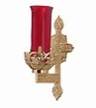
The Sanctuary Candle will burn as a
70th Wedding Anniversary Remembrance for
Paul & Verna Yanzetich
requested by Susan, Dolores & Evan
during the week of September 1st, 2019.

CHURCH DIRECTORIES ~ The 2019 Church Directories are in! Those that had their picture taken or submitted for the Directory can pick up your copy at the back of the Church either before or after all masses this weekend.

PARISH OFFICES ~ The Parish Offices will be closed Monday, September 2nd, due to the Labor Day Holiday.

FIRST FRIDAY ~ Exposition of the Blessed Sacrament with adoration will be Friday, September 6th from 8:30 AM till 3:00 PM. A sign- up sheet can be found at the entrances of the church. Please sign up prior to First Friday, so we know that the time slots are filled.

HOLY NAME SOCIETY ~ Will hold their monthly meeting next Sunday, September 8th after the 8:00 AM Mass.

SECOND SUNDAY FOOD COLLECTION ~ Next weekend is our Second Sunday Food Pantry Collection. Please bring in non-perishable food items or toiletries with you. Monetary donations are also appreciated.

LABOR DAY MASS ~ There will be a Mass on Labor Day Monday, September 2nd at St. Joseph Cemetery, Beaverdale, at 10:00 AM, celebrated by Fr. Brian Warchola. Everyone is invited to attend.

SUNDAY CHOIR PRACTICE ~ Due to the Labor Day holiday and Forest Hills Festival, Monday’s (September 2) choir practice will move to Tuesday, September 3rd at 7 PM. It will return to its usual day and time on Monday, September 9th at 7 PM. New members are always welcome!

RELIGIOUS EDUCATION FUND ~ In your packet of envelopes there is an envelope for our Religious Education Fund which will be taken up as a second collection next weekend. All money collected will go into our Higher Education Account. Any student completing their Senior (12th) year of Religious Education requirements is eligible for a $300 scholarship. Envelopes can be turned in any weekend of September.

ST. MICHAEL BLUE MASS ~ We will be having a Blue Mass honoring all first responders (police, law enforcement, public safety, firefighters and EMT’s and their families) for their service at the 10:30 AM Mass on Sunday, September 29th. A small luncheon will follow for first responders and their families in the Church Hall.

LAY MINISTRY SCHEDULES ~ Lay ministry schedules for the months of October through January are now being made up. Anyone who would like to serve as an Altar Server, Reader, Cantor, Greeter or any current minister who has scheduling preferences at this time, should call Suzi Blazosky at 495-5287 or e-mail her at sublazosky@gmail.com. Deadline is September 22nd, 2019.

Stewardship Reflections…
Jesus’ parable today highlights humility as one of the key qualities of discipleship. Our model for this life of stewardship is Jesus Christ. He is the faithful and loving teacher who embraced the world and gave his life to humanity. By placing others before ourselves, we find that there is no room for a sense of “entitlement” in the life of a Christian steward.

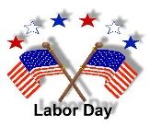
Sunday, September 1 Forest Hills Labor Day Festival

Monday, September 2 Forest Hills Labor Day Festival
Mass at St. Joseph Cemetery / 10:00 AM
Offices Closed

Tuesday, September 3 Sunday Choir Practice / 7:00 PM
Boy Scouts / 7:30 – 9:00 PM

Wednesday, September 4 No Mass

Thursday, September 5 Saturday Choir Practice / 4:30 PM
Boy Scout Round Table / 7 – 8:30 PM

First Friday, September 6 Exposition of the Blessed Sacrament with Adoration / 8:30 AM-3:00 PM
Saturday, September 7 Religious Education Collection / Second Collection
Second Sunday Food Pantry Collection

UPCOMING EVENTS
September 8 Religious Education Collection / Second Collection
Holy Name Society Meeting
Second Sunday Food Pantry Collection
Hall Rental
September 19 Elementary Religious Education Class
Septermber 22 High School Religious Education Class

SPAGHETTI DINNER ~ Ladies Auxiliary Post 573, Dunlo, will be holding a spaghetti dinner on Saturday, September 7th from 4 – 6:30 PM. Spaghetti, meatballs, salad, bread, dessert & drink. Adults $8, children 4-12 $4, children 3 & under, free. Take outs are available. Please call 487-7245.

BASKET RAFFLE & BAKE SALE ~ Sunday, September 8, 11:00 AM – 3:00 PM. Bishop Carroll High School Cafeteria, Ebensburg. Call 814-472-7500 ext. 101 for info.

QUARTER AUCTION ~ Join the Sisters of the Delta Kappa Gamma Society-Beta Epsilon Chapter for a fun filled afternoon on September 8th. Held at St. Michael Church Hall, St. Michael. Doors open at noon, with the auction beginning at 1:00 PM. Vendors from direct sales companies will also be on site. All proceeds will be used for projects that benefit students in local schools, including Forest Hills. Tickets are $6.00, which includes lunch and an auction paddle. For tickets, call Amy 487-4569 or Suzi 242-3329.

ARE YOU READY FOR SOULCORE? ~ We will be having a Soulcore workshop at the Holy Name School Gym, 205 W. Hornier St., Ebensburg on Saturday, September 14th from 1:00-2:30 PM. Open to anyone 18 years of age and older. If anyone is interested, please register by calling Holy Name Parish office at 814-472-7244. There will be a suggested $10 donation for the instructor, if you are able to do so.

WINE TASTING EVENT ~ Join Catholic Charities on Friday, September 13th from 5:30-7:00 PM at The Holiday Inn in Johnstown for their Wines of Italy tasting and pairing event. This will be an extraordinary evening of wine, food and fun, all while supporting families in your community. A wine expert will share six specially selected and spectacular wines from Italy, carefully paired with delicious small bites. Tickets are $50 per person, and all proceeds will go towards funding services for those in need in your community. Tickets are available by calling 814-944-9388 or can be purchased online at: https://www.catholiccharitiesaf.org/index.php?option=com_eventbooking&viewevent&id=10&catid=1&Itemid=563

