ST. MICHAEL ROMAN CATHOLIC CHURCH

751 Locust Street

PO Box 103

St. Michael, Pennsylvania 15951

Rev. Msgr. David A. Lockard, Administrator MASSES:

(814) 495-9640 Saturday 4:00 pm



Sunday Morning 9:30 am

Secretary: Michele Panick

Bookkeeper: Kathy Kalicky Daily Mass: M, T, Th, F Noon

DRE: Laurie Sloan Wed. 6:00 pm

Maintenance: Rodney Turgeon Holy Days: See Bulletin

PHONES: Office Hours:

Rectory / Office: (814) 495-9640 8:30 am to 3:30 pm

Fax: (814) 495-9424 Monday, Tues., Thurs., Friday

Rel. Education: (814) 495-4873 Confessions:

Parish Website Saturday 3:30 pm to 3:45 pm www.saintmichaelchurch.weebly.com Sunday 9:00 am to 9:15 am

Secretaries’ E-mail By Appointment

[saintmichaelsecretaries@yahoo.com](mailto:saintmichaelsecretaries@yahoo.com)

Facebook page:

St. Michael Catholic Church/St. Michael, PA

24thSunday in Ordinary Time

SERVING GOD AND COMMUNITY FOR OVER ONE HUNDRED YEARS!

September 13th, 2020

BAPTISM: By Appointment. Reserve at least one month in advance.

MARRIAGE: Plan at least nine months in advance.

Preparation sessions are necessary.

FUNERALS: Arrangements are made in conjunction with the funeral home.

REGISTRATION Those new to the area, newlyweds, and single adults, (even if registered

and before with their families) are asked to register by calling the Parish Office.

MEMBERSHIP: Every parishioner must be registered. This is a condition for admission

to our Program and reception of the Sacraments of Baptism, Confirmation,

First Penance, First Eucharist, and Matrimony; also, for testimonial letters or sponsorship of Baptism and Confirmation outside the Parish.

VISITATION: We are concerned and want to be advised when someone is ill at home or in the hospital. Call the office to have the shut-in placed on our monthly Holy Communion calls or seriously ill prayer list.

SACRAMENTAL Parish registration and active Mass participation for Baptism is

POLICY: encouraged and is required for Marriage.

BULLETIN ARTICLES: Articles are due to the Parish Office by Noon on Tuesday.

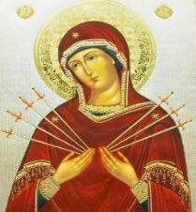

Twenty – Fourth Sunday in Ordinary Time

September 13th, 2020

The Month of the Seven Dolors of the Sorrowful Mother

**MASS INTENTIONS**: (September 14 – September 20, 2020)

Monday Noon Gloria Weyandt req. by Teresa & Jason Lonesky & Family

Tuesday Noon Dan Harteis req. by Harteis Family

Wednesday 6:00 PM John Vandzura req. by Candice & Mark Penatzer

Thursday Noon Albert & Katherine Demko req. by Carl & Pam Freidhoff

Friday Noon Clara Long req. by Camillus & Betty Long

Saturday 4:00 PM People of the Parish

Sunday 8:00 AM Raymond & Jane Plummer req. by Chuck & Mary Ann Tedjeske and Family

10:30 AM Philip Hillegas (1-year Anniversary) req. by Reba Vasas & Family

LITURGICIAL APPOINTMENTS:

Saturday, September 19 4:00 PM

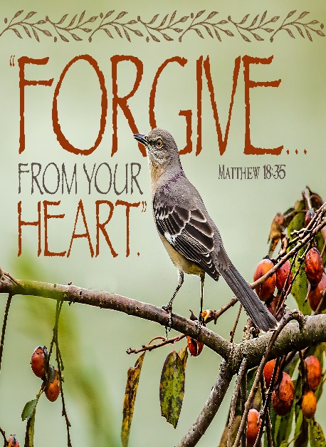Lector: Sherry Dipko

Minister of the Host: Theresa Carlson

Altar Server: Ana Spangler

Cantor: Amy Spangler

Sunday, September 20 8:00 AM

Lector: Pauline Minor

Minister of the Host: Eric Tedjeske

Altar Server: Griffin Christ

Cantor: Susan Yanzetich

Sunday, September 20 10:30 AM

Lector: James Lashinsky

Minister of the Host: Michael Steele

Altar Server: Kirstyn Vitez

Cantor: Lou McCloskey

Weare placing names of the sick in the bulletin for prayer providing they give permission. *May the* *Divine Physician send healing grace for those for* *whom we pray:* Allen C. Rosemas, Patricia Murphy, Bernice Myers, Dwight Fyock, Dylon Wills, Missy, Joanne (Kolar) Hufford, Christine Flanagan, Ayden Alan Grata, Mary Lou Offman, Mary Zangaglia, Natalie Zerby, Valencia Tursi, Homer Locher, Brayden Schofield, Michelle Kasper, Diane Kingera, Allison Krischer, Ted Paluch, Brandt Hutzel, Pearl Litzinger, Patrick Munro, Fran Baldassarre, Kristen Sinosky Long, Cresta Micik, Basil Costantino, Madison McCrory, Laura, Joe Yoder, Dolores Yanzetich, Sandy Krug, Wanda Gramling, Jennifer Hagans, Shawn, Holly, Shane, Spencer, Owen Taylor, Keith & Dawnetta Hoyer, Derrick Varnish, Vincent Koshute, Melissa Cordek, Michelle Elliott, Heather Romanow, Mackston Barrick, Connor Thomas, Erin, Pat, Mary Agnes Nastase, Mary Ann Bertolino, Dick Wilson, Izzy Bihun, Dorothy Kaminsky, Patricia Oshaben, Ashlee Madison, Susan Yanzetich, Mike, Danika Faith, Alina Rusnak, Gary Smay, Elizabeth Howell, Walter Bodziak, Rhonda, Dan Strinkoski, Anne Robinson, Marlene McCrory, Sharon Poldiak, Carter Bobak, Vince Arena, Mike Morris, Sarah Kelt, Patty Yanzetich Caldwell, Colton Snyder, Betty Delaney, Nancy Edmiston, Leonard Oshaben, Adam, Bill Gideos, Janice Dipyatic, Gerald Delaney, Lily Maloney, Scott, Lisa, Rosalie Ambrose, Audrey Costlow, Cathy Sossong, Rosanne Krug, Paul Snyder, Becky Kakabar, Catherine Tedjeske, Pua Ripper, Howard Delaney, Alivia Ickes, John Poldiak Jr., Ed Myers, Dolores Mucko, Tom Vandzura, Elliana, Ashlee and all of the sick of our parish, the homebound, those in nursing homes, those who care for them, and those in the military along with their families. *(Please call the Rectory to have your name removed from the list when no longer seriously ill. Thank You.)*

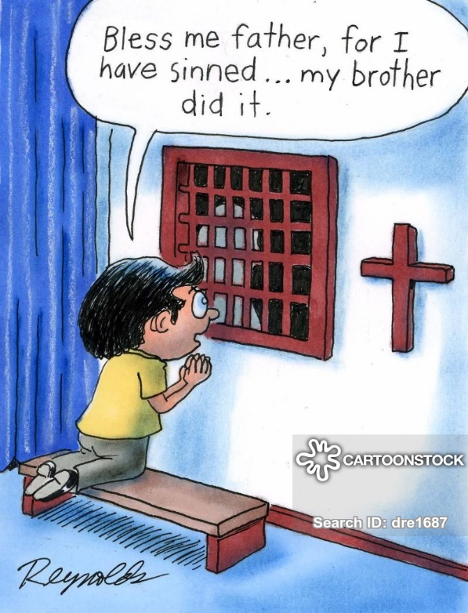

LAST WEEK’S COLLECTION

Adults $2,706.00

Loose $ 5.00

Youth $ 7.00

Monthly $1,797.00

Candles $ 2.65

Maintenance Fund $ 225.00

Assumption $ 10.00

All Saints $ 5.00

All Souls $ 5.00

Ascension Thursday $ 5.00

Religious Ed. Fund $ 145.00

Retired Priests Med. $ 75.00

Religious Retirement $ 10.00

Catholic Register Sub. $ 5.00

Missionary Co-op $ 20.00

Total $5,022.65

We sincerely thank and ask God’s

blessing upon all who have care

and concern for our parish.

*September 13th, 2020 (MT 18:21-35)*

*Unable to forgive another, means we are holding onto a past wrong and hoping for a better past. That is not going to happen. We must move on with our life by accepting we were unjustly treated, and it will not be corrected. We aren’t condoning the injustice. We just don’t let it control our lives any longer. Forgiveness is critical to living a healthy life in the present.*

During the week of September 13th, 2020

the Sanctuary Candle will burn for the

Irish Nuptials of Sandra Oshaben & Connor O’Leary

requested by Bob & Joan Oshaben

[](https://images.search.yahoo.com/search/images;_ylt=A0LEV1kSWptXvOwAKINXNyoA;_ylu=X3oDMTEyZGdkcmRoBGNvbG8DYmYxBHBvcwMxBHZ0aWQDQjIwODlfMQRzZWMDc2M-?p=Clipart+of+a+sanctuary+candle&fr=ush-mailn_02&th=110&tw=110&imgurl=http://www.henningers.com/389-168-wall-sanctuary-lamp.jpg&rurl=http://pixshark.com/sanctuary-lamp.htm&size=43KB&name=Sanctuary+Lamp+Bronze+wall+sanctuary+lamp&h=600&w=600&turl=http://ts2.mm.bing.net/th?id%3DOIP.M68453c67108cdc5ab485d309b395bd03o0%26pid%3D15.1%26rs%3D1%26c%3D1%26qlt%3D95%26w%3D110%26h%3D110#inline&tt=Sanctuary+Lamp+Bronze+wall+sanctuary+lamp&sigr=116keh5le&sigit=13gvlt42j&sigi=11ip0pgm4&sign=119kp6100&sigt=119kp6100)

PARISH PARKING LOT AND SIDEWALK PROJECT…

It is well along, and so for the next few weeks we will need to use the upper parking lot and enter the church by the side door facing the WPA Road. The cost for the much – needed repairs to the lower parking lot and sidewalks is close to $40,000. If you would like to help, you can place a contribution in an envelope marked “Sidewalk & Parking Lot Repairs” and drop it in the basket along with your regular Sunday offering envelope. I thank you for your generosity.

The Parish Offices will be closed for business until the paving & sidewalk project is complete. If you need to drop anything off (offertory envelopes, forms, tickets, etc.…) the green tote box will be placed in the small vestibule at the WPA roadside door. You can drop your items off on Monday, Tuesday, Thursday, and Friday during business hours – 8:30 AM – 3:00 PM or in the offertory collection or you can mail them to the office. Thank you for your patience and cooperation.

RETIRING! ~ After over six years of dedicated and faithful service to St. Michael Parish, our parish bookkeeper, Kathy Kalicky, will be retiring at the end of December. We thank Kathy for all she has done for us over the years and wish her happy times in the future.

Now we must find her replacement. If you are interested in the bookkeeping position at St. Michael Parish, you need to contact the parish office and give us your name and qualifications. This is a sixteen hour a week job (more or less). We will be happy to go over the salary and responsibilities with interested applicants.

PLEASE REMEMBER! ~ Starting next Sunday, September 20th, there will be 2 Masses - 8:00 AM and 10:30 AM. Confessions will be in the Sacristy on Saturday at 3:30 PM and Sunday at 10:00 AM ONLY.

LAY MINISTERS ~ The lay ministry September schedule will be changing after Sunday, September 13th – with the addition of the second Mass on Sunday, September 20th. Please check the bulletin for September 20th and September 27th liturgical assignments.

PARISH COUNCIL ~ There will be a Parish Council Meeting next Sunday, September 20th at the Pavilion after the 10:30 AM Mass if weather permits. If not, the meeting will be in the Church Hall.

SECOND SUNDAY FOOD COLLECTION ~ This weekend is our Second Sunday Food Collection. Please bring in non-perishable food items or toiletries with you and drop your donations in the Bridal Room. Monetary donations are also appreciated.

RELIGIOUS EDUCATION COLLECTION ~ Our Religious Education Fund will be taken up this weekend. All money collected will go into our Higher Education Account. Envelopes can be found in your packet. Please drop your Religious Education Fund envelope in the basket marked “Religious Education Fund”. Envelopes can be turned in any weekend of September.



Religious Education And Christian Helping

Religious Education News

Religious Education registration is planned for our 2020 / 2021 Religious Education Year. We plan to start our fall semester with a Home-Schooling module with necessary materials being sent home with each family. Registration packets were mailed out to all families that are currently registered members of our Saint Michael Parish and have school-aged children. Envelopes contain a new registration form and other related forms for our upcoming year. Please complete and return all forms so your children can be registered for the 2020 / 2021 Religious Education Year.

If you did not receive a mailing, contact the RE Office at 495-4873. More information will follow once registrations are received and our preparation is finalized.

DIOCESE SEEKING VOLUNTEERS ~ Would you like to minister in our diocese to those in need in one of

the following areas? –

1. Pro-Life Team: Two main initiatives.
2. Walking with Moms in Need: A year of service.
3. Reinstating “Project Rachel” in our diocese.
4. Disabilities Awareness Team which will be looking at ways to reach out to those who are underserved

in our parishes due to disabilities.

If you are interested you may contact the Diocesan Family Life Office at 814-695-5579 or [familylife@dioceseaj.org](mailto:familylife@dioceseaj.org). Be prepared to explain how you would be a good fit for one of these ministries.

Andre McCarville – Director of Family Life and Missions



TREASURY TICKETS ~ We are asking that each parish household sell or buy one ticket for $10.00 and return the money and ticket stub as soon as possible, but no later than September 21st. If you are unable to sell or do not want the ticket, PLEASE don’t throw it away, but return it as soon as possible as we always have people looking for extras. If paying by check, please make check payable to St. Michael Church. The money raised from the sale of these tickets will help to build up our Parish Maintenance Fund.

PLEASE NOTE! If you did not purchase or sell your February 2020 and June 2020 tickets, you were not issued the October 2020 ticket. If you did not get a ticket and would like to purchase the October 2020 ticket, please call the office. We apologize if anyone has been accidentally missed. If you would like a ticket, please call the parish office. We do have extra tickets, so anyone wanting more than one ticket, please call the office. Thank you.

*Parish and Finance Council Members*

 Sunday, September 13 Mass ~ 9:30 AM

Confessions / 9:00 – 9:15 AM / Sacristy

Religious Education Collection

Second Sunday Food Pantry Collection

Monday, September 14 Mass ~ Noon

NO Sunday Choir Practice

Tuesday, September 15 Mass ~ Noon

Boy Scout Meeting / 7:30 – 9:00 PM

Wednesday, September 16 Mass ~ 6:00 PM

Thursday, September 17 Mass ~ Noon

NO Saturday Choir Practice

Friday, September 18 Mass ~ Noon

 Saturday, September 19 Mass / 4:00 PM

Confessions / 3:30 – 3:45 / Sacristy

Voytek / Kostan Nuptials / 1:00 PM

UPCOMING EVENTS

September 20 Addition of second Sunday Mass / 8:00 & 10:30 AM

Confessions / 10:00 AM ONLY / Sacristy

Parish Council Meeting / Pavilion

Girl Scout Meeting

September 26 & 27 Retired Priests Medical Collection



BASKET RAFFLE ~ Adams Twp. Lion’s club 2-day event Basket Raffle. Sat. & Sun. Sept. 19th & 20th 10 AM-5 PM at St. Michael Festival Grounds. Need not be present to win – drawing Sun. at 5 PM. For more information phone 487-5988 or 487-4132.

FRIARS’NOOK GIFT SHOP ~ Hours and a Job Opening! We will continue to have modified hours of Friday & Saturday 10:00 AM – 4:00 PM for the month of September. We are seeking a Gift Shop Manager to oversee the day-to-day functions of a Roman Catholic gift shop with a heavy emphasis in standard retail practices. The Gift Shop Manager should be dependable, self-motivated, and can work well with other employees and customers. For a full job description, please visit: [www.thefranciscanfriars.org/jobs](http://www.thefranciscanfriars.org/jobs)



CRESSON CATHOLIC COMMUITY ~ Will hold its annual Festival on the grounds of

St. Aloysius Church on Sunday, September 13th from 9 AM – 8 PM. Although scaled back

this year due to Covid requirements, you may still enjoy the following:

Booths: Gift Basket Fair, Fancy Booth, Rummage Sale, Bake Sale

Games of Chance and Skill: Money Board, 50/50 every 2 hrs., $2,500.00 Grand Prize Raffle

Festival Food: Breakfast Sandwich, Hot Sausage, Pulled Pork, Perogies, Halushki, Hamburgers, Hot Dogs, French Fries, Funnel Cake, Apple Cobbler, Ice Cream, Donuts & more…