ST. MICHAEL ROMAN CATHOLIC CHURCH

751 Locust Street

PO Box 103

St. Michael, Pennsylvania 15951

Rev. Brian Warchola, Administrator MASSES:



(814) 266-9718 / Ext. 507 Saturday 4:00 pm

Sunday Morning 8:00 am

Secretary: Susan Poldiak 10:30 am

Bookkeeper: Kathy Kalicky Daily Mass See Bulletin

DRE: Laurie Sloan Holy Days See Bulletin

Maintenance: Rodney Turgeon

Office Hours:

PHONES: 8:30 am to 3:30 pm

Rectory / Office: (814) 495-9640 Monday, Tues., Thurs., Friday

Fax: (814) 495-9424 Confessions:

Rel. Education: (814) 495-4873 Saturday 3:30 pm to 3:45 pm

Parish Website Sunday 7:30 am to 7:45 am

www.saintmichaelchurch.weebly.com 10:00 am to 10:15 am

Secretaries’ E-mail Anytime Requested

[saintmichaelsecretaries@yahoo.com](mailto:saintmichaelsecretaries@yahoo.com)

YEAR: 2017 NUMBER: 3

SERVING GOD AND COMMUNITY FOR OVER ONE HUNDRED YEARS!

BAPTISM: By Appointment. Reserve at least one month in advance.

Preparation classes are necessary.

MARRIAGE: Make arrangements at least nine months in advance.

Preparation sessions are necessary.

FUNERALS: Arrangements are made in conjunction with the funeral home.

Eulogies should be given at the funeral home at the time of the wake service or at the luncheon.

REGISTRATION Those new to the area, newlyweds, and single adults, (even if registered

and before with their families) are asked to register by calling the Parish Office.

MEMBERSHIP: Every parishioner must be registered. This is a condition for admission

to our Program and reception of the Sacraments of Baptism, Confirmation, First Penance, First Eucharist, and Matrimony; also, for testimonial letters or sponsorship of Baptism and Confirmation outside the Parish.

VISITATION: We are concerned and want to be advised when someone is ill at

home or in the hospital. Call the rectory to have the shut-in placed on our monthly Holy Communion calls or seriously ill prayer list.

SACRAMENTAL Requires parish registration and active Mass participation for Baptism

POLICY: and Marriage.

BULLETIN ARTICLES: Articles are due to the Parish Office by Noon on Mondays.

Second Sunday in Ordinary Time January 15, 2017

**Month of the Holy Name of Jesus**

MASS INTENTIONS: (January 16 – 22, 2017)

[](https://www.churchart.com/subscriber/viewimages?keywords=In%20memory%20of&entry_date=1/1/0001&image_type=cl,wt,nt,pt,ft)Monday No Mass

Tuesday 8:00 AM Mildred Beesoick req. by Pat Mikulsky

Wednesday 9:00 AM For the Reparation of Sins against the Sacred Heart of Jesus

And the Immaculate Heart of Mary

Thursday 8:00 AM Dorothy Selepack req. by Paul & Susan Snyder

Friday 9:00 AM In Honor of Saint Martha req. by Veronica Smith

Saturday 4:00 PM Helen McCall req. by Brian & Debbie Kundrod & Family

Sunday 8:00 AM Stephen Faher req. by Joe & Cathy Faher & Family

Sunday 10:30 AM People of the Parish

LITURGICIAL APPOINTMENTS:

Saturday, January 21 4:00 PM Offertory Procession

Lector: Sherry Dipko Rod Kundrod Family

Minister of the Host: Susan Blazosky

Ministers of the Cup: Theresa Carlson & Mary Partsch

Altar Servers: Victoria Russic & Elisabeth Zajdel

Cantor: David Zajdel

Greeter: Phyllis Slonac

Sunday, January 22 8:00 AM Offertory Procession

Lector: David Knepper Joe & Cathy Faher

Minister of the Host: Pauline Minor

Ministers of the Cup: Cathy Faher & Ellen Grattan

Altar Servers: Quinn & Eva Spangler

Cantor: Anita Lorek

Greeter: Betty Long

Sunday, January 2210:30 AM Offertory Procession

Lector: Jacob Stiffler Reba Vasas

[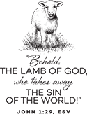](https://www.churchart.com/subscriber/viewimages?book_number=43&chapter=1&verse=29&entry_date=1/1/0001&image_type=cl,bc)Minister of the Host: Robert Oshaben

Ministers of the Cup: Amanda Williamson & Michael Barton

Altar Servers: Ericka Frombach & Alexia Steele

Cantor: Ian Wieczorek

Greeter: Mary Ann Oravis

Sunday, January 22 Collection Counters

John Bizzarri, Rod Kundrod

Mary Ann DeRosa, Phyllis Slonac

CHOIR PRACTICES ~ Practice for the Sunday Choir will be held on Mondays at 7:00 PM.

Practice for the Saturday Choir will be held on Thursdays at 5:30 PM.

SECOND SUNDAY FOOD COLLECTION ~ Thanks to all who so generously donated to the Forest Hill Food Pantry. The total money collected was $585.00 along with an assortment of grocery items.

PARISH COUNCIL MEETING ~ There will be a Parish Council Meeting with Fr. Warchola on Wednesday, January 18th beginning at 6:30 PM. The meeting will be held in the St. Paul Room.

Please make every effort to attend. Please e-mail the Parish Office with items for the agenda.

LITURGY MEETING ~ A meeting of the Liturgy Committee will be held on Sunday, February 5th at

9:00 AM. Fr. Warchola will be setting times and events through the Easter Season.

LAY MINISTRY SCHEDULES ~ Lay ministry schedules for the months of February through April are

now being made up. Anyone who would like to serve as an Altar Server, Reader, Cantor, Greeter or any current minister who has scheduling preferences at this time, should call Suzi Blazosky at 495-5287 or

e-mail her at [sublazosky@gmail.com](mailto:sublazosky@gmail.com) no later than this Sunday, January 15th. Father Warchola will be conducting Altar Server, Lector and Eucharistic Minister training at a later date.

SOUP SALE ~ The Holy Name Society will be making chicken soup for our parish sick and shut-ins on Saturday, January 21st. They are also offering it for sale to members of the parish. The cost is $6.00 per quart. Sign-up sheets are available in the back of the church. Orders can be picked up in the church hall on Saturday, January 21st from 11:00 a.m. to 2:00 p.m. or after each weekend Mass on the 21st and 22nd.

[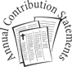](http://www.churchart.com/search/ImageDetail.asp?image_id=93074236)CONTRIBUTION STATEMENTS~The Parish Office has closed the books for 2016 parishioner’s contributions. You may request a statement of your tax-deductible donations at any time by calling the rectory at 495-9640. Tax laws state that any amount given as a donation needs to have documentation if you are claiming the donation for tax purposes. If a contribution was made to the ACA, you should have received a statement from the diocese.

We are updating our parish records, so please remember to notify the Rectory Office of any changes in address or telephone numbers. If you no longer have a land line and your cellphone is your primary house phone, please call us or drop a note in the collection basket.

ENVELOPE REMINDER ~ In order to make the Collection Counters and the Secretaries life a little easier, please remember to mark the amount of your donation on the outside of the envelope. This will also help insure you get proper credit for your donation.

++++++++++++++++++++++++++++++++++++++++++++++++++++++++++++++++++++++++

*Did you ever wonder why there are no dead penguins on the ice in Antarctica - where do they go?*

*Wonder no more. It is a known fact that the penguin is a very ritualistic bird which lives an extremely ordered and complex life. The penguin is very committed to its family and will mate for life, as well as maintaining a form of compassionate contact with its offspring throughout its life.*

*If a penguin is found dead on the ice surface, other members of the family and social circle have been known to dig holes in the ice, using their vestigial wings and beaks, until the hole is deep enough for the dead bird to be rolled into and buried. The male penguins then gather in a circle around the fresh grave and sing:*

*"Freeze a jolly good fellow. Freeze a jolly good fellow." Then they kick him in the ice hole.*

LIGHTING THE SANTUARY CANDLE ~ Lighting the red vigil lights in church for your own special intention has always been a long standing tradition within the Catholic Church. Many parishes also offer the SANCTUARY CANDLE to light for your special intention, living, deceased or special occasion. With a $5.00 donation you may request our sanctuary candle to burn for one week. Simply enclose in an envelope your “In Memory Of” intention. That intention will be announced in the weekly bulletin.

[](https://images.search.yahoo.com/search/images;_ylt=A0LEV1kSWptXvOwAKINXNyoA;_ylu=X3oDMTEyZGdkcmRoBGNvbG8DYmYxBHBvcwMxBHZ0aWQDQjIwODlfMQRzZWMDc2M-?p=Clipart+of+a+sanctuary+candle&fr=ush-mailn_02&th=110&tw=110&imgurl=http://www.henningers.com/389-168-wall-sanctuary-lamp.jpg&rurl=http://pixshark.com/sanctuary-lamp.htm&size=43KB&name=Sanctuary+Lamp+Bronze+wall+sanctuary+lamp&h=600&w=600&turl=http://ts2.mm.bing.net/th?id%3DOIP.M68453c67108cdc5ab485d309b395bd03o0%26pid%3D15.1%26rs%3D1%26c%3D1%26qlt%3D95%26w%3D110%26h%3D110#inline&tt=Sanctuary+Lamp+Bronze+wall+sanctuary+lamp&sigr=116keh5le&sigit=13gvlt42j&sigi=11ip0pgm4&sign=119kp6100&sigt=119kp6100)

The Sanctuary Candle will burn in memory of Mrs. Catherine Bodziak

requested by the Office Staff

the week of January 15, 2017.

CATHERINE BODZIAK ~ Anyone who wishes, please send your expressions of sympathy to

Rev. Charles F. Bodziak, 509 Stonycreek Street, Boswell, PA 15531-1025.

[](http://www.churchart.com/subscriber/viewimages.aspx?keywords=In%20Sympathy&entry_date=1/1/0001&image_type=,cl#no)MAY SHE REST IN PEACE ~ In your charity, please pray for the eternal rest of

Lois Jean Papcunik whose Funeral Mass was celebrated on Monday, January 9th by Fr. Joseph Nale. May she know the eternal peace and happiness promised by our Savior, Lord Jesus. Please pray for the consolation of her children and all of her family and friends.

*Liturgical Reflection...*

The Church has revised the Order of Celebrating Matrimony (2016). In the introduction to the rite of marriage, the Church states that a Marriage is established by the conjugal covenant, that is the irrevocable consent of both spouses, by which they freely give themselves to each other and accept one another. Moreover, this singular union of a man and a woman requires, and the good of the children demands, the complete fidelity of the spouses and the indissoluble unity of the bond. The Church is graced with the love and commitment of our married couples.

2017, Diocese of Altoona-Johnstown, Liturgy Office, 925 South Logan Boulevard, Hollidaysburg, Pennsylvania16648

MOM’S HOUSE COLLECTION ~ This weekend, attached to the bulletin, you will find a Knights of Columbus envelope for your donation to Mom’s House. The organization was founded in 1983 by Johnstown resident Peg Luksik, then president of the Cambria-Somerset Chapter of Citizens for Human Life, as an alternative to abortion. At Mom’s House mothers are plugged into a network of supportive services that enable them to complete their education, find jobs and get off welfare. Mom’s House is free because members of the community and local organizations have believed in them for more than 30 years. Since 1983, Mom’s House® has evolved into a national organization and established a headquarters in Johnstown. There are now seven Mom’s Houses® in four states. This is an annual collection by the Knights of Columbus. The envelopes will be collected the weekend of January 21st and 22nd. If possible, please remember to put your regular envelope number on the Mom’s House contribution envelope.

*January 15th John 1:29-34*

*Can you say “I have testified Jesus is the Son of God?” If you aren’t talking about Jesus in your family, you aren’t testifying. If you are talking and not walking your talk, your children will see your words as meaningless.*

[](http://www.churchart.com/Subscriber/ViewImages.aspx?keywords=&entry_date=1/1/0001&image_type=,cl&topic_id=346&image_source_id=&page=1#no)Weare placing names of the sick in the bulletin for prayer providing they give permission. Although we remember all sick and shut-ins at every Mass, we would like our parish family to be aware of the need for special prayer intentions because of a most serious illness or hospital stay. *May the* *Divine Physician send healing grace for those for* *whom we pray:* Josephine Koshute, Allen C. Rosemas, Patricia Murphy, Todd Euen, Bernice Myers, Dwight Fyock, Lori Facciani, Dylon Wills, Dawn Hagen, Debbie Dibert, Missy, Joanne (Kolar) Hufford, Christine Flanagan, Ayden Alan Grata, Remy Beaver, Mary Lou Offman, Marian Chuckalovcak, Arlene Diamond, Mary Zangaglia, Dorothy Rosemas, Natalie Zerby, Patricia Grata, Michael Wadsworth, Valencia & Frank Tursi, Homer Locher, Brayden Schofield, Michelle Kasper, Diane Kingera, Allison Krischer, Ted Paluch, Brandt Hutzel, Nicholas “Hop” Kolar, Pearl Litzinger, Patrick Munro, Fran Baldassarre, Corey Lybarger, Kristen Sinosky Long, Helen Ranieri, Cresta Micik, Loretta Panick, Basil Costantino, Madison McCrory, Laura, Maria, Joe Yoder, Dolores Yanzetich, Sandy Krug, Wanda Gramling, Merna Smay, Muriel “Jean” Wiesheier, Heidi Allison, Melinda Jerome, Agnes Plummer, Jennifer Hagans, Katie Ansell, Mary McCall, Suzie Thomas, Sean, Holly, Shane, Joan McDowell, Melisa Ruddek, Joanne Serre, Scott N., Patrick O’Donnell, Owen Taylor, Christine Baxter, Keith Hoyer, Gail Faher, Agnes Zibura, Marjorie (Latshaw) Feldman, Jayden Scott Beam, Derrick Varnish, Karen Myers, and all of the sick of our parish, the homebound, those in nursing homes, those who care for them, and those in the military along with their families. (Please call the Rectory to have your name removed from the list when no longer seriously ill. Thank You.)

LAST WEEK’S COLLECTION

Adults $3,801.00 Loose $ 162.00

Youth $ 37.25

Monthly $ 395.00

Maintenance Fund $ 70.00

Candles $ 27.00

Initial Offering $ 90.00

Christmas $ 167.00

Solemnity of Mary $ 129.25

Easter Flowers $ 30.00

Black & Indian Missions $ 15.00

Mandeville $ 15.00

Food Pantry $ 585.00

Total $5,523.50

We sincerely thank and ask God’s blessing

upon all who have care and concern

for our parish.

VOCATIONS: A Message from Father Matthew Reese, Vocations Director  
Consider this:  We currently have 58 active Diocesan Priests in our diocese (under the age of retirement of 75).  We have 88 churches in our Diocese.  At the present moment we have six men preparing to become priests for our Diocese.  If these men all persevere they will be ordained by the year 2023.  However, by that same year at least 14 of our active priests will reach the age of retirement.  That is a net loss of eight, which does not take into account extraordinary circumstances like unexpected deaths, etc.  These are the numbers we face in our Diocese, and everyone will be affected by the dwindling number of diocesan priests here in Altoona-Johnstown.  Ultimately, a call to priesthood is God's grace, but we need to cooperate with that grace!  All clergy and laity must be challenged to do vocational work in their own ministries and parish communities and not rely on others to do it for them!  If we are not actively seeking new vocations to the priesthood, how do we expect these numbers to change for the better?

Religious Education And Christian Helping

January 15, 2017

Upcoming Confirmation Session

11th Grade ~ Session 11C – Morality: Your Call to Christian Living and Social Justice

~ Sunday, January 22, 2017, 9—10:30 a.m.

*Confirmation Retreat* / Saturday, January 28, 2017, 1—6:00 PM

All students in grades 9, 10, & 11 will take part in their annual confirmation retreat. This retreat will take place on Saturday, January 28, 2017, 1—6:00 PM. The retreat will focus on the three required retreat topics of ~ “Baptism”, “Gifts of the Holy Spirit” and “Parables”.

The program will begin in the church hall on Saturday, January 28th for the students. The students come to the church hall and join classmates for specific topic discussions with their grade level leader in designated classrooms for their specific retreat from 1 to 3 PM.

At 3:15 PM, sponsors and/or parents are asked to join the confirmation students in the church for a Rosary lead by our 11th grade Confirmation Class followed by the 4 PM Mass. During this Mass, the 9th grade students will celebrate their “‘Rite of Blessing” and the 10th Grade students will celebrate their “Rite of Commitment” as part of their confirmation journey.

At the conclusion of Mass, students will celebrate the Sacrament of Reconciliation, followed by a pizza social in the church hall for all students, parents and sponsors, including time for reflection on the day and also time for the confirmation candidates and their sponsors to spend time together discussing their sponsor / candidate session activities.

Diocesan Safe Environment Program / Parental Notification Form

TO: Parents of St. Michael Catholic Church Religious Education Students

SUBJECT: Safe Environment Program

The Diocese of Altoona-Johnstown has implemented a program for the protection of our youth known as our Youth Protection Program. The Charter for the Protection of Children and Young People, adopted by the United States Catholic Conference of Bishops in 2002, requires each parish or school to provide formation for children in areas of safety and the integrity of their person. This program is mandatory for all Parish Religious Education programs and Catholic Schools in the Diocese of Altoona-Johnstown. The philosophy is to directly involve parents in the formation of their children with the available lesson material. A classroom presentation of safety issues, adapted for grades 1, 5 and 9 and covering the required lessons will be offered during one of the regular January class times.

If you have any questions, please contact The Religious Education Office at 495-4873. You may request to review the specific content material. If you decide you do not desire your child to participate, there is a Parent Verification/Refusal form, which indicates that this mandated instruction is being offered, and that you choose not to have your child participate. This form is also required if your child is absent the day the instruction was given. You may visit the Protecting God’s Children™ program at [www.virtus.org](http://www.virtus.org).

Sunday, January 15 Religious Education~Grades 6-12 / 9:00-10:20 AM / Hall

Monday, January 16 No Mass

Sunday Choir Practice / 7:00 PM / Church

Tuesday, January 17 Mass / 8:00 AM / Fr. Joseph Nale

Sacraments Class / Fr. Grimme / 6:30-8:30 PM / Hall

Wednesday, January 18 Mass / 9:00 AM / Fr. Brian Warchola

Parish Council Meeting / 6:30 PM / St. Paul Room

Thursday, January 19 Mass / 8:00 AM / Fr. Joseph Nale

Religious Education / Grades K-5 / 3:30 – 4:30 PM / Hall

Saturday Choir Practice / 5:30 PM / Church

Friday, January 20 Mass / 9:00 AM / Fr. Brian Warchola

Saturday, January 21 Holy Name Soup Sale

Mom’s House Collection

Sunday, January 22 Religious Education~Grades 6-12 / 9:00-10:20 AM / Hall

[](http://www.churchart.com/Subscriber/ViewImages.aspx?keywords=%20%20life&entry_date=1/1/0001&image_type=,cl&topic_id=&image_source_id=&page=1#no) Holy Name Soup Sale

Mom’s House Collection

Bus Captains Dinner / March for Life / 12 Noon to 3:00 PM / Hall

UPCOMING EVENTS

Saturday, January 28 Confirmation Retreat Grades 9,10,11 / 1-6 PM / Hall

Sunday, February 5 Liturgy Meeting / 9:00 AM / Church Hall

PRAYER SERVICE ~ Bishop Mark will preside at a prayer service on the eve of the March for Life.

It will be held on January 26 at 7:00 p.m. at the Cathedral of the Blessed Sacrament in Altoona. The gathering will include Evening Prayer, Eucharistic Adoration, and a homily from the Bishop. Bishop Mark will also offer a special blessing to those who will go to Washington, D.C., the following day for the March for Life. All are invited to attend the prayer service to pray for the sanctity of human life.

2016-2017 CLASS SCHEDULES ANNOUNCED ~ The Office of Adult Enrichment and Lay

Ecclesial Ministry has announced the 2016-2017 class schedules which are available online at www.ajdiocese.org/lay-ecclesial-ministry. Classes can be taken for personal spiritual formation

and enrichment or for Lay Ecclesial Basic Certification. Also available online is information on

classes for continuing education credit and Third Year Track options, as well as registration forms

and class descriptions. You can also contact Marybeth at mheinze@dioceseaj.org or at

(814) 361-2000 for further information. All are welcome!

St. Benedict Bible Study Resumes: What we believe as Catholics is found in the Bible in two ways: explicit and implicit. That Jesus called Twelve Apostles to follow him, healed and forgave sins, proclaimed the Kingdom of God, suffered, died and rose again for our sins, are all very explicit in the Bible. The Holy Spirit makes known the full meaning of these events and makes the power of these events effective in our lives today. Join us to learn how God reveals himself to us in Sacred Scripture. Using the weekly readings, Deacon Michael Russo will lead discussions that will add spiritual depth and meaning to our lives today. The Bible Study Group will meet Saturday mornings (weather permitting) from 9:30-11:30 in the Music Room located in the school building. Classes will be held on January 28; February 18, 25; March 4, 25; April 1, 8, 22, 29 and May 13. Handouts will be provided for each session. For more information, contact Deacon Michael at 288-3036. All are welcome!

THE SHROUD OF TURIN

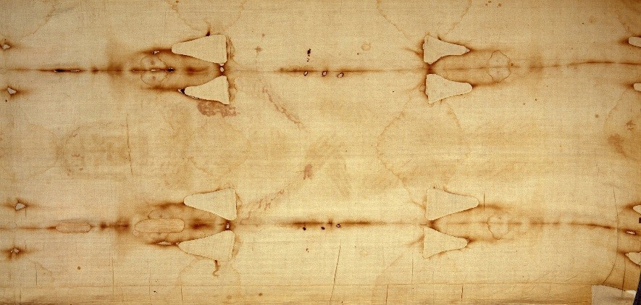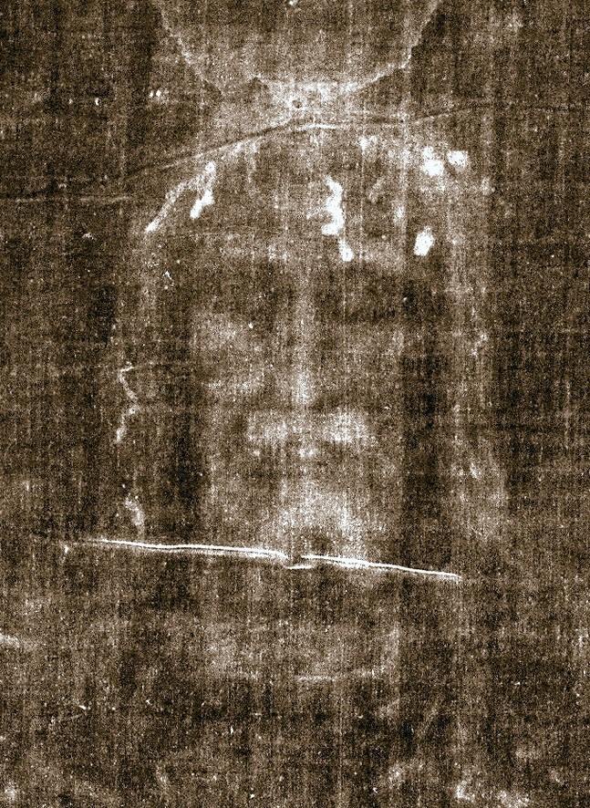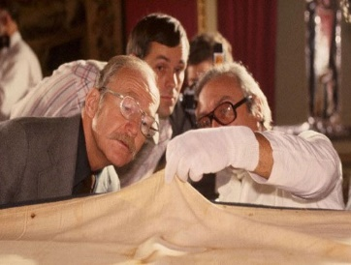

IS THIS THE FACE OF JESUS?

In 2013 Bill Wingard established “Shroud Talks” to present the history and science of the Shroud of Turin and tackle its biggest mystery....*Is the Shroud the actual burial cloth of Jesus?*

Personal research coupled with the knowledge and help of the original photographer, Barrie Schwortz, for scientific evaluation in 1978 make for a powerful and comprehensive presentation that will not disappoint.

YOU ARE INVITED TO HEAR THE TALK AND

SEE THE FULL SIZE REPLICA OF THE SHROUD OF TURIN!

WHEN: Sunday March 26, 2017

Time: 3:00 PM

Where: St. Benedict Parish, Johnstown 2310 Bedford St, Johnstown PA 15904

For more information contact Deacon Michael Russo at; (814) 288-3036 ◻ [michael.russo@atlanticbb.net](mailto:michael.russo@atlanticbb.net)

Tickets are not required. A Free Will offering with be taken.

*ALL ARE WELCOME*