ST. MICHAEL ROMAN CATHOLIC CHURCH

751 Locust Street

PO Box 103

St. Michael, Pennsylvania 15951

Rev. Msgr. David A. Lockard, Administrator MASSES:

(814) 495-9640 Saturday 4:00 pm



Sunday Morning 8:00 am

Secretary & Bookkeeper: 10:30 am

Michele Panick Daily Mass: M,T,W,Th,F Noon

DRE: Laurie Sloan Holy Days: See Bulletin

Maintenance: Rodney Turgeon Office Hours:

PHONES: 8:30 am to 3:30 pm

Rectory / Office: (814) 495-9640 Monday, Tues., Thurs., Friday

Fax: (814) 495-9424 Confessions:

Rel. Education: (814) 495-4873 Saturday 3:30 pm to 3:45 pm

Parish Website Sunday 10:00 am to 10:15 am

[www.saintmichaelchurch.weebly.co](http://www.saintmichaelchurch.weebly.co)m By Appointment

Secretaries’ E-mail

[saintmichaelsecretaries@yahoo.com](mailto:saintmichaelsecretaries@yahoo.com)

Facebook page:

St. Michael Catholic Church/St. Michael, PA

Fourth Sunday in Ordinary Time

SERVING GOD AND COMMUNITY FOR OVER ONE HUNDRED YEARS!

January 31st, 2021

BAPTISM: By Appointment. Reserve at least one month in advance.

MARRIAGE: Plan at least nine months in advance.

Preparation sessions are necessary.

FUNERALS: Arrangements are made in conjunction with the funeral home.

REGISTRATION Those new to the area, newlyweds, and single adults, (even if registered

and before with their families) are asked to register by calling the Parish Office.

MEMBERSHIP: Every parishioner must be registered. This is a condition for admission

to our Program and reception of the Sacraments of Baptism, Confirmation,

First Penance, First Eucharist, and Matrimony; also, for testimonial letters or sponsorship of Baptism and Confirmation outside the Parish.

VISITATION: We are concerned and want to be advised when someone is ill at home or in the hospital. Call the office to have the shut-in placed on our monthly Holy Communion calls or seriously ill prayer list.

SACRAMENTAL Parish registration and active Mass participation for Baptism is

POLICY: encouraged and is required for Marriage.

BULLETIN ARTICLES: Articles are due to the Parish Office by Noon on Tuesday.

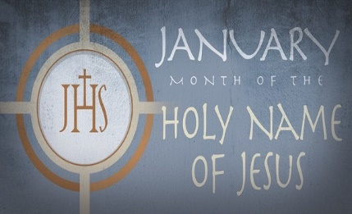

Fourth Sunday in Ordinary Time

January 31st, 2021

Month of The Holy Name of Jesus

**MASS INTENTIONS**: (February 1 – February 7, 2021)

Monday, Feb. 1 Noon Brandon Baxter req. by Loving Family

Tuesday, Feb. 2 Noon Edward & Margaret Yanzetich req. by David & Patricia Caldwell

Wednesday, Feb. 3 Noon Rev. Msgr. Philip P. Saylor req. by Msgr. David Lockard

Thursday, Feb. 4 Noon Barbara (Long) Dumm (Month’s Mind) req. by Pauline Minor

Friday, Feb. 5 Noon B-day Rem. for Benjamin Reid req. by Sondre Harteis & Family

Saturday, Feb. 6 4:00 PM People of the Parish

Sunday, Feb. 7 8:00 AM Josh Faher req. by Mom & Dad

10:30 AM Thomas Paterson req. by Michael & Regina Barton & Family

LITURGICIAL APPOINTMENTS:

Saturday, February 6 4:00 PM

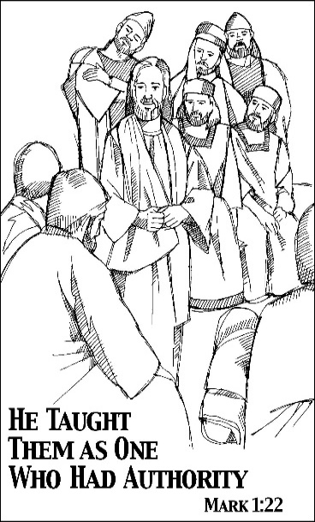Lector: Don Dipko

Minister of the Host: Susan Blazosky

Altar Server: Caden & Kaylee Roberts

Cantor: Susan Blazosky

Sunday, February 7 8:00 AM

Lector: Arnold Bernard

Minister of the Host: Marie Bernard

Altar Server: Ian Dobbins

Cantor: Amy Dobbins

Sunday, February 7 10:30 AM

Lector: Carole Kakabar

Minister of the Host: Jennifer Steele

Altar Server: Amilya Koch

Cantor: Lou McCloskey

Sunday, February 7 Collection Counters

Christ Smay, Sara Zybura

Mary Ann DeRosa

Weare placing names of the sick in the bulletin for prayer providing they give permission. *May the* *Divine Physician send healing grace for those for* *whom we pray:* Allen C. Rosemas, Patricia Murphy, Bernice Myers, Dwight Fyock, Dylon Wills, Missy, Joanne (Kolar) Hufford, Christine Flanagan, Ayden Alan Grata, Mary Lou Offman, Mary Zangaglia, Natalie Zerby, Valencia Tursi, Homer Locher, Brayden Schofield, Michelle Kasper, Diane Kingera, Ted Paluch, Pearl Litzinger, Patrick Munro, Fran Baldassarre, Kristen Sinosky Long, Cresta Micik, Basil Costantino, Laura, Joe Yoder, Dolores Yanzetich, Sandy Krug, Wanda Gramling, Jennifer Hagans, Shawn, Holly, Shane, Spencer, Owen Taylor, Derrick Varnish, Vincent Koshute, Michelle Elliott, Heather Romanow, Mackston Barrick, Connor Thomas, Erin, Pat, Mary Agnes Nastase, Mary Ann Bertolino, Dick Wilson, Izzy Bihun, Dorothy Kaminsky, Patricia Oshaben, Ashlee Madison, Susan Yanzetich, Mike, Alina Rusnak, Gary Smay, Elizabeth Howell, Walter Bodziak, Rhonda, Anne Robinson, Carter Bobak, Vince Arena, Mike Morris, Sarah Kelt, Patty Yanzetich Caldwell, Colton Snyder, Nancy Edmiston, Leonard Oshaben, Adam, Janice Dipyatic, Lily Maloney, Scott, Lisa, Audrey Costlow, Cathy Sossong, Rosanne Krug, Becky Kakabar, Howard Delaney, Ed Myers, Dolores Mucko, Elliana, Ashlee, Helen Soohy, Carol K. Fabrizio, Peggy Carpenter, Janet Minor, Dave Seder, Rosalie Ambrose, Pearl Borlie and all of the sick of our parish, the homebound, those in nursing homes, those who care for them, and those in the military along with their families. *(Please call the Rectory to have your name removed from the list when no longer seriously ill. Thank You.)*

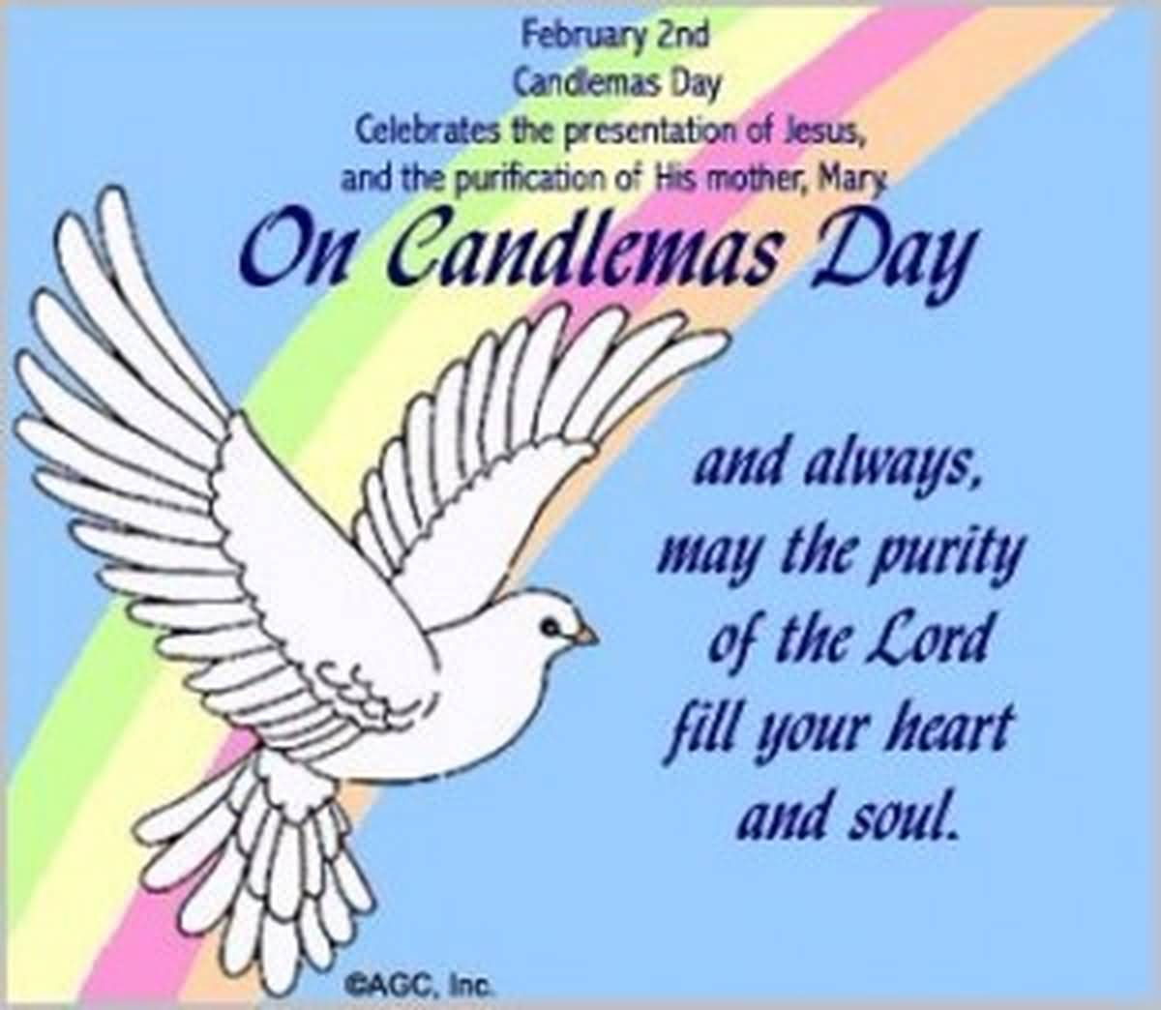

LAST WEEK’S COLLECTION

Adults $2,519.00

Loose $ 5.00

Youth $ 10.00

Monthly $ 710.00

Initial Offering $ 30.00

Candles $ 30.00

Maintenance Fund $ 263.00

Christmas Offering (2020) $ 25.00

Black & Indian $ 10.00

Mandeville Diocese $ 70.00

Total $3,672.00

We sincerely thank and

ask God’s blessing upon

all who have care and

concern for our parish.

*January 31, 2021 Mark 1:21-28*

*Today’s gospel reminds us “unclean spirits” still haunt our families. These “spirits” thrive inside our grudges, punishing silence, impatience and abruptness. Today Jesus offers you the “authority” to cast out these spirits from your life and your family.*

During the week of January 31st, 2021

The Sanctuary Candle will burn in memory of

Francis Powers

requested by Jeanne English

and

The Our Lady of Grace Candle will burn in memory of

Benjamin Reid

requested by Sondre Harteis and Family

[](https://images.search.yahoo.com/search/images;_ylt=A0LEV1kSWptXvOwAKINXNyoA;_ylu=X3oDMTEyZGdkcmRoBGNvbG8DYmYxBHBvcwMxBHZ0aWQDQjIwODlfMQRzZWMDc2M-?p=Clipart+of+a+sanctuary+candle&fr=ush-mailn_02&th=110&tw=110&imgurl=http://www.henningers.com/389-168-wall-sanctuary-lamp.jpg&rurl=http://pixshark.com/sanctuary-lamp.htm&size=43KB&name=Sanctuary+Lamp+Bronze+wall+sanctuary+lamp&h=600&w=600&turl=http://ts2.mm.bing.net/th?id%3DOIP.M68453c67108cdc5ab485d309b395bd03o0%26pid%3D15.1%26rs%3D1%26c%3D1%26qlt%3D95%26w%3D110%26h%3D110#inline&tt=Sanctuary+Lamp+Bronze+wall+sanctuary+lamp&sigr=116keh5le&sigit=13gvlt42j&sigi=11ip0pgm4&sign=119kp6100&sigt=119kp6100)

FEBRUARY 2ND ~ Before it became known as “Groundhog Day”, February 2nd was (and still is) a major Catholic Feast Day – the Feast of the Presentation of the Lord in the Temple in Jerusalem by Mary and Joseph. This day is also called “Candlemas Day”, because at the Mass today we bless candles for people to take home if they want. So, starting on Tuesday, February 2nd after the Noon Mass, blessed candles (two to a box) will be available in the back of the Church for those who want them. We ask an offering of three dollars per box to cover expenses.

BLESSING OF THROATS ~ The traditional blessing of throats in honor of St. Blaise will be given during the weekend Masses of January 30th/31st and February 6th/7th. However, because of the COVID – 19 pandemic, the blessing will be given to the entire congregation at the same time, following the Universal Prayers (Prayers of the Faithful).

MAINTENANCE FUND TICKETS ~ Please have all February Maintenance ticket stubs, money, and unsold tickets returned – NO later than today Sunday, January 31st.

LITURGY MEETING ~ There will be a Liturgy Committee Meeting this Sunday, January 31st after the 10:30 AM Mass in the Church.

*PROCLAIM!* TV MASS ~ In honor of the World Day of Prayer for Consecrated Life, Bishop Mark will celebrate the *Proclaim!* TV Mass on February 7th. The Bishop will acknowledge the men & women religious who serve in the Diocese of Altoona-Johnstown during his homily. The Mass will air live at 11:00 AM on WATM ABC 23 and will be rebroadcast that night at 9:00 PM on Atlantic Broadband channel 9.

*Stewardship Reflections…*

If we willingly give God authority over our lives and trust in His provision, He will take care of us no matter what. Are you not filled with a sense of wonder whenever Jesus speaks to you? As Christian stewards, it is our job to imitate Christ and follow his commands out of gratitude for all that he has given us. We are more willing to live by God’s commands when we are motivated by love and gratitude. May your astonishment cause Jesus’ fame to spread wherever you go. May you serve with deep conviction as a disciple of Jesus Christ with your actions. (2020, January 31, *Stewardship Bulletin Reflection,* Catholic Stewardship Consultants, Evans, Georgia)

Did you know??????



On Candlemas Day, Feb. 2nd, followers of Jesus celebrate his Presentation at the Temple and the Virgin Mary being purified, with many of the faithful bringing candles to their churches to be blessed. The candles represent Jesus and the day of his induction into Judaism, and they go toward explaining the name of the holy day, Candlemas.

The Feast of the Presentation, or the Feast of the Purifiction of the Virgin Mary, on Candlemas Day is one of the oldest, celebrated since the 4th century AD in Jerusalem. You can turn to the relevant Bible verse, Luke 2:22-24. This passage describes how Mary and Jesus follow the rule in Leviticus 12 that says an infant boy should be circumcised on the eighth day after birth, and that, thirty-three days later, the mother is considered “clean” and should burn an offfering at the boys presentation at the temple on that 40th day.



Religious Education And Christian Helping

January 31, 2021

Religious Education News

Home Lesson Packet #5 ~ Distribution of CCD Lesson packet #5 will take place in the Parish Hall for all Grades K—11 students this coming week. Parents of K—5 students can pick-up packets from catechists on Thursday, February 4th from 4—5 PM. Our Grades 6—11 catechists will have packets available to pick-up on Sunday, February 7th from 9—10 AM. Completed lessons from previous lesson packets should be returned at this time.

To make it easier for everyone that didn't make the scheduled pick-up times for our January pick-up or earlier, we have another pick-up option available:

There is a Big Blue Tote outside the Parish Office door marked: "Religious Education Pick-Ups & Drop Offs".  It can be accessed anytime to make it easier to Pick-up missed lessons and also Drop-off the completed ones.  Look for your "Family Name" on the name tag attached to the lesson packet.

You can stop anytime at your convenience even after office hours.  Completed lessons can also be placed in the tote and will be given to each grade’s catechist.

10th Grade Gifts of the Holy Spirit Retreat: Our 10th grade confirmation candidates will participate in a virtual Gifts of the Holy Spirit Retreat provided through the diocese. This retreat will begin on February 28th via Zoom and home assignments. Information and registration forms were provided with Lesson Packet #4. Candidates registration form needs to be returned to Sr. Suzanne Thibault, C.A. by February 10th to be considered for participation in this virtual retreat.

*******************************************************************************************************************

 Sunday, January 31 Mass ~ 8:00 & 10:30 AM

Confessions / 10:00 – 10:15 AM / St. Paul Room

Blessing of Throats

Liturgy Meeting / After 10:30 AM Mass / Church

All February Maintenance Tickets Due Today

Girl Scouts / 4 – 5:30 PM

Monday, February 1 Mass ~ Noon

 NO Sunday Choir Practice

Tuesday, February 2 Mass ~ Noon

Candlemas Day

Groundhog Day

Boy Scouts / 7:30 - 9:00 PM

Wednesday, February 3 Mass ~ Noon

Thursday, February 4 Mass ~ Noon

NO Saturday Choir Practice

Friday, February 5 Mass ~ Noon

Saturday, February 6 Mass / 4:00 PM

Confessions / 3:30 – 3:45 / St. Paul Room

Blessing of Throats

UPCOMING EVENTS

 February 7 Blessing of Throats

February 13 & 14 Second Sunday Food Pantry Collection

February 13 Liam Joseph Marks Baptism

February 14 Valentine’s Day

February 15 President’s Day / Offices Closed

February 17 Ash Wednesday / Mandeville Collection

