ST. MICHAEL ROMAN CATHOLIC CHURCH

751 Locust Street

PO Box 103

St. Michael, Pennsylvania 15951

Rev. Brian L. Warchola, Administrator MASSES:



(814) 266-9718 / Ext. 507 Saturday 4:00 pm

Sunday Morning 8:00 am

Secretary: Susan Poldiak 10:30 am

Bookkeeper: Kathy Kalicky Daily Mass See Bulletin

DRE: Laurie Sloan Holy Days See Bulletin

Maintenance: Rodney Turgeon

Office Hours:

PHONES: 8:30 am to 3:30 pm

Rectory / Office: (814) 495-9640 Monday, Tues., Thurs., Friday

Fax: (814) 495-9424 Confessions:

Rel. Education: (814) 495-4873 Saturday 3:30 pm to 3:45 pm

Parish Website Sunday 7:30 am to 7:45 am

www.saintmichaelchurch.weebly.com 10:00 am to 10:15 am

Secretaries’ E-mail Anytime Requested

[saintmichaelsecretaries@yahoo.com](mailto:saintmichaelsecretaries@yahoo.com)

YEAR: 2017 NUMBER: 13

SERVING GOD AND COMMUNITY FOR OVER ONE HUNDRED YEARS!

BAPTISM: By Appointment. Reserve at least one month in advance.

Preparation classes are necessary.

MARRIAGE: Make arrangements at least nine months in advance.

Preparation sessions are necessary.

FUNERALS: Arrangements are made in conjunction with the funeral home.

Eulogies should be given at the funeral home at the time of the wake service or at the luncheon.

REGISTRATION Those new to the area, newlyweds, and single adults, (even if registered

and before with their families) are asked to register by calling the Parish Office.

MEMBERSHIP: Every parishioner must be registered. This is a condition for admission

to our Program and reception of the Sacraments of Baptism, Confirmation, First Penance, First Eucharist, and Matrimony; also, for testimonial letters or sponsorship of Baptism and Confirmation outside the Parish.

VISITATION: We are concerned and want to be advised when someone is ill at

home or in the hospital. Call the rectory to have the shut-in placed on our monthly Holy Communion calls or seriously ill prayer list.

SACRAMENTAL Requires parish registration and active Mass participation for Baptism

POLICY: and Marriage.

BULLETIN ARTICLES: Articles are due to the Parish Office by Noon on Mondays.

[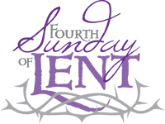](https://www.churchart.com/subscriber/viewimages?topic_id=72&image_type=cl&page=7&ipp=12)

March 26, 2017

**Month of Saint Joseph**

MASS INTENTIONS: (March 27 – April 2, 2017)

Monday No Mass

Tuesday 8:00 AM Theresa Fleck req. by Steve, Dolores, Evan & Susan Yanzetich

Wednesday 9:00 AM Barbara Allison req. by St. Michael Funeral Committee

Thursday 8:00 AM Albert and Clara Long req. by Pam and Carl Freidhoff

Friday 9:00 AM For the Reparation of Sin Against the Most Sacred Heart of Jesus

And the Immaculate Heart of Mary

Saturday 4:00 PM Helen Golian req. by Sister, Agnes Golian

Sunday 8:00 AM People of the Parish

Sunday 10:30 AM Mary Lou Yourich req. by Ron and Amy Dobbins, Elizabeth & Ian

LITURGICIAL APPOINTMENTS:

Saturday, April 1 4:00 PM Offertory Procession

Lector: Sherry Dipko James & Anna Susko

Minister of the Host: Theresa Carlson

Choir Minister: Helen Slonac

Altar Servers: Ashley & Haley Cook

Cantor: Susan Blazosky

Greeter: Joanne Thomas

Sunday, April 2 8:00 AM Offertory Procession

Lector: Amy Spinos Ushers

Minister of the Host: Beth Kundrod

Choir Minister: Cathy Faher

Altar Servers: Quinn & Eva Spangler

Cantor: Joseph Faher

Greeter: Betty Long

Sunday, April 210:30 AM Offertory Procession

Lector: James Lashinsky Dobbins Family

Minister of the Host: Amanda Williamson

Choir Minister: Robert Oshaben

[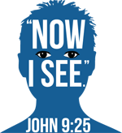](https://www.churchart.com/subscriber/viewimages?book_number=43&chapter=9&entry_date=1/1/0001&image_type=cl)Altar Servers: Carter & Kirstyn Vitez

Cantor: Louis McCloskey

Greeter: Mary Ann Oravis

Sunday, March 26 Collection Counters

Tom Paterson, Sharon Paterson,

Robert Casti, Sara Zybura

[](http://www.churchart.com/Subscriber/ViewImages.aspx?keywords=&entry_date=1/1/0001&image_type=,cl&topic_id=346&image_source_id=&page=1#no)Weare placing names of the sick in the bulletin for prayer providing they give permission. Although we remember all sick and shut-ins at every Mass, we would like our parish family to be aware of the need for special prayer intentions because of a most serious illness or hospital stay. *May the* *Divine Physician send healing grace for those for* *whom we pray:* Josephine Koshute, Allen C. Rosemas, Patricia Murphy, Bernice Myers, Dwight Fyock, Lori Facciani, Dylon Wills, Dawn Hagen, Debbie Dibert, Missy, Joanne (Kolar) Hufford, Christine Flanagan, Ayden Alan Grata, Remy Beaver, Mary Lou Offman, Marian Chuckalovcak, Arlene Diamond, Mary Zangaglia, Dorothy Rosemas, Natalie Zerby, Patricia Grata, Michael Wadsworth, Valencia & Frank Tursi, Homer Locher, Brayden Schofield, Michelle Kasper, Diane Kingera, Allison Krischer, Ted Paluch, Brandt Hutzel, Nicholas “Hop” Kolar, Pearl Litzinger, Patrick Munro, Fran Baldassarre, Corey Lybarger, Kristen Sinosky Long, Helen Ranieri, Cresta Micik, Loretta Panick, Basil Costantino, Madison McCrory, Laura, Maria, Joe Yoder, Dolores Yanzetich, Sandy Krug, Wanda Gramling, Merna Smay, Muriel “Jean” Wiesheier, Heidi Allison, Melinda Jerome, Agnes Plummer, Jennifer Hagans, Katie Ansell, Mary McCall, Suzie Thomas, Sean, Holly, Shane, Melisa Ruddek, Patrick O’Donnell, Owen Taylor, Keith Hoyer, Gail Faher, Marjorie (Latshaw) Feldman, Jayden Scott Beam, Derrick Varnish, Karen Myers, Mark Baloga, Daniel Koshute, Vincent Koshute, Karen Lovrich, Melissa Cordek, Darlene Marshall, Tammy Webb, and all of the sick of our parish, the homebound, those in nursing homes, those who care for them, and those in the military along with their families. (Please call the Rectory to have your name removed from the list when no longer seriously ill. Thank You.)

[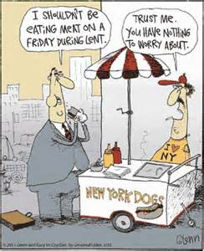](https://images.search.yahoo.com/images/view;_ylt=AwrB8pC0INBYWngA0m.JzbkF;_ylu=X3oDMTIzZ3E2ZGhrBHNlYwNzcgRzbGsDaW1nBG9pZANhYTg1YTJhYzY1MTdkMWU3ZDJjNjE4YjBjZjMwNGM0YQRncG9zAzE2BGl0A2Jpbmc-?.origin=&back=https://images.search.yahoo.com/search/images?p%3Dchristian%2Bcartoons%2Babout%2BLent%26fr%3Dush-mailn%26tab%3Dorganic%26ri%3D16&w=736&h=904&imgurl=s-media-cache-ak0.pinimg.com/736x/26/6b/69/266b6996708321ea7c9fcd1796dc1c94.jpg&rurl=https://www.pinterest.com/EpiscoDeacon/cartoons-featured-on-episcopal-church-memes/&size=139.3KB&name=funny+%3cb%3ecartoons%3c/b%3e+from+cartoonstock+directory+the+world+s+largest+on+line+...&p=christian+cartoons+about+Lent&oid=aa85a2ac6517d1e7d2c618b0cf304c4a&fr2=&fr=ush-mailn&tt=funny+%3cb%3ecartoons%3c/b%3e+from+cartoonstock+directory+the+world+s+largest+on+line+...&b=0&ni=480&no=16&ts=&tab=organic&sigr=12je2usrn&sigb=13cfilevr&sigi=12f8l79ot&sigt=12hrcen5o&sign=12hrcen5o&.crumb=gWBCT9QzMke&fr=ush-mailn)

LAST WEEK’S COLLECTION

Adults $3,277.00

Loose $ 116.00

Youth $ 42.00

Monthly $ 290.00

Maintenance Fund $ 58.00

Candles $ 49.00

Mandeville $ 10.00

Holy Thursday $ 5.00

Holy Land $ 5.00

Easter $ 20.00

Catholic Relief Services $ 5.00

Catholic Home Missions $ 5.00

Flowers $ 140.00

Total $4,022.00

We sincerely thank and ask God’s blessing upon all who have care and concern for our parish.

*John 9: 1-41*

*Failure to forgive blinds us to another's goodness. Lent provides an opportunity to wash away our blind spots in the pool of forgiveness. Listen to Jesus in today's gospel: "Go wash and see."*

LENTEN FAST AND ABSTINENCE ~ Ash Wednesday and Good Friday are obligatory days of fast and abstinence. All Fridays of Lent are obligatory days of abstinence. The Church encourages voluntary fasting on other days of Lent. Abstinence refers to not eating meat at all during the day.

PARISH PRAYER BANNER ~ Once again, our parish family will come together in prayer and petition as we share those needs on the small crosses we place on our Parish Prayer Banner. As you enter the church, please take a few extra minutes to write your personal prayer intentions on the back of the small crosses for Lent, then pin them to the banner.

STATIONS OF THE CROSS ~ On Friday evenings during Lent at 6:00 p.m., we will pray the Stations of the Cross. Lent invites us to meditate on the Passion of Christ.

EASTER FLOWERS ~ If you would like to purchase an Easter flower for a living (In Honor Of) or

a deceased (In Memory Of) member of your family, please do so by using the Easter Flower envelope in your packet. The normal offering is $10.00. Please return the envelopes on, or before, April 3rd. Extra envelopes can be found at the church entrances.

*Liturgical Reflection...*The Church believes in the indissolubility of the marriage bond. Jesus Christ restored the original order of creation that was disturbed by sin. Christ Himself gives the strength and grace to live marriage in the new dimension of the Reign of God. It is by following Christ, renouncing themselves, and taking uptheir crosses that spouses will be able to live the original meaning of marriage and live it with the help of Christ. This grace of Christian marriage is a fruit of Christ's cross, the source of all Christian life (Catechism of the Catholic Church Number 1615).201 7, Diocese of Altoona-Johnstown , Liturgy Office, 925 S. Logan Blvd., Hollidaysburg , Pennsylvania 16648

FATHER BRIAN WARCHOLA’S MESSAGE ~ Christine Smay, one of our long-time bookkeepers n

HOLY THURSDAY

*“If I then, your Lord and Teacher, have washed your feet, you also ought to wash one another’s feet. For I have given you an example, that you should do as I have done to you. Most assuredly, I say to you, a servant is not greater than his master; nor is he who is sent greater than he who sent him. If you know these things, blessed are you if you do them.”*

Father Warchola will be following the beautiful example set by Jesus on Holy Thursday, April

13th at the 7:00 PM Mass. We are asking for volunteers from the different groups in the parish,

i.e. Holy Name, Martha’s Group, choirs, etc. or any parishioner. Anyone interested in

volunteering can call the rectory office at 495-9640. Please leave your name and a phone

number. We will get back to you with the details.

SAVE THE DATE ~ On Wednesday, April 12th we will be holding a covered dish to commemorate the Lord’s Last Supper. The church will be supplying the main dishes and the beverages. Sign up sheets can be found in the back and side of the Church.

[](https://images.search.yahoo.com/search/images;_ylt=A0LEV1kSWptXvOwAKINXNyoA;_ylu=X3oDMTEyZGdkcmRoBGNvbG8DYmYxBHBvcwMxBHZ0aWQDQjIwODlfMQRzZWMDc2M-?p=Clipart+of+a+sanctuary+candle&fr=ush-mailn_02&th=110&tw=110&imgurl=http://www.henningers.com/389-168-wall-sanctuary-lamp.jpg&rurl=http://pixshark.com/sanctuary-lamp.htm&size=43KB&name=Sanctuary+Lamp+Bronze+wall+sanctuary+lamp&h=600&w=600&turl=http://ts2.mm.bing.net/th?id%3DOIP.M68453c67108cdc5ab485d309b395bd03o0%26pid%3D15.1%26rs%3D1%26c%3D1%26qlt%3D95%26w%3D110%26h%3D110#inline&tt=Sanctuary+Lamp+Bronze+wall+sanctuary+lamp&sigr=116keh5le&sigit=13gvlt42j&sigi=11ip0pgm4&sign=119kp6100&sigt=119kp6100)

The Sanctuary Candle will burn in memory of

Josh Faher

requested by Mom and Dad

and

The Our Lady of Grace Candle will burn in memory of

Jennifer Hudson Mader

requested by Sally and Nick Kolar

during the week of March 26, 2017.

**CATHOLIC RELIEF SERVICES COLLECTION** ~ This weekend, we will take up the Catholic Relief Services Collection. This collection supports Catholic agencies that touch more than 100 million lives around the world. The funds from the Collection help provide food to the hungry, welcome and support to displaced refugees, and invaluable life skills to those seeking a better life. Your support funds programs such as religious education, seminary formation, and lay ministry training to build vibrant faith communities right here in the United States. Please be generous!

**CHOIR PRACTICES** ~ Practice for Sunday Choir will be held on Mondays at 7:00 PM.

The Saturday Night Choir will be singing the Easter Vigil this year. Practice for the weekly Saturday Liturgy is on Thursday’s from 5:30 to 6:00 PM: 6:00 PM will begin the practice for the Easter Vigil. There will only be practice for the Vigil on Thursdays.

**COMBINED EASTER CHOIR** ~ After Stations from 7-8 beginning March 10th and continuing every week through April 7th. None on Good Friday.

COMBINED PENANCE SERVICE ~ Father Warchola of St. Michael Parish and Father Nale of St. Bartholomew and Most Holy Trinity Parishes will be having a combined Penance Service at Most Holy Trinity Church in South Fork on Monday, April 3rd beginning at 6:30 PM. Other local Penance Services are: Monday, March 27th at Holy Family Parish, Portage, at 7:00 PM; Sunday, April 2nd at Holy Name Church in Ebensburg, at 2:30 PM; Thursday, April 6th at St. John Gualbert Cathedral, Johnstown at 6:30 PM; and, Monday, April 10th at St. Benedict Church in Geistown at 5:00 PM.

HOLY NAME SOCIETY MEETING ~ Sunday, April 2 after 8:00 AM Mass.

COFFEE & DONUTS ~ Sunday, April 2 after the 8:00 AM and 10:30 AM Masses

BUS TRIP TO SIGHT AND SOUND ~ Spectacular Epic, “Jonah” on Friday, May 19th escorted by Msgr. Michael Becker: Cost of $125 includes bus, show and buffet dinner. Please call Jim at 241-1641.



Religious Education And Christian Helping

March 26, 2017

*Junior High Youth Day Attendees ~ March 19, 2017*

Our Saint Michael group had an awesome time at this years’ Junior High Youth Day 2017!

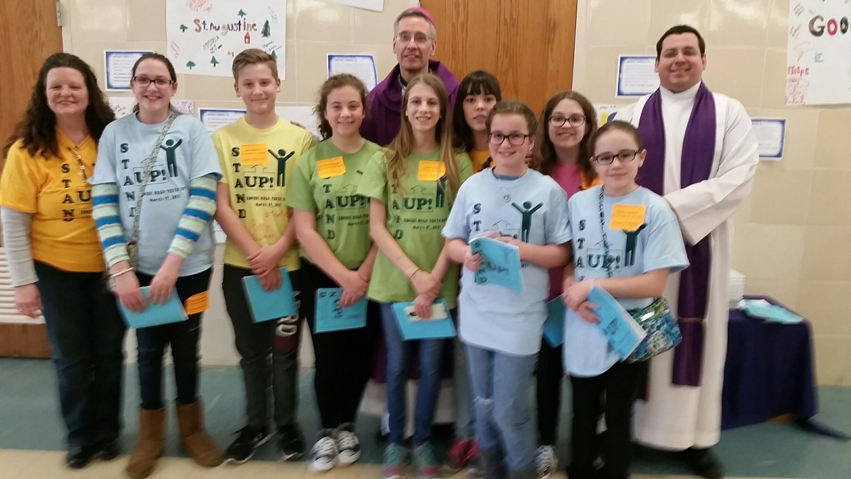

Bishop Mark Bartchak and Fr. Brian Warchola joined our group for this great picture!

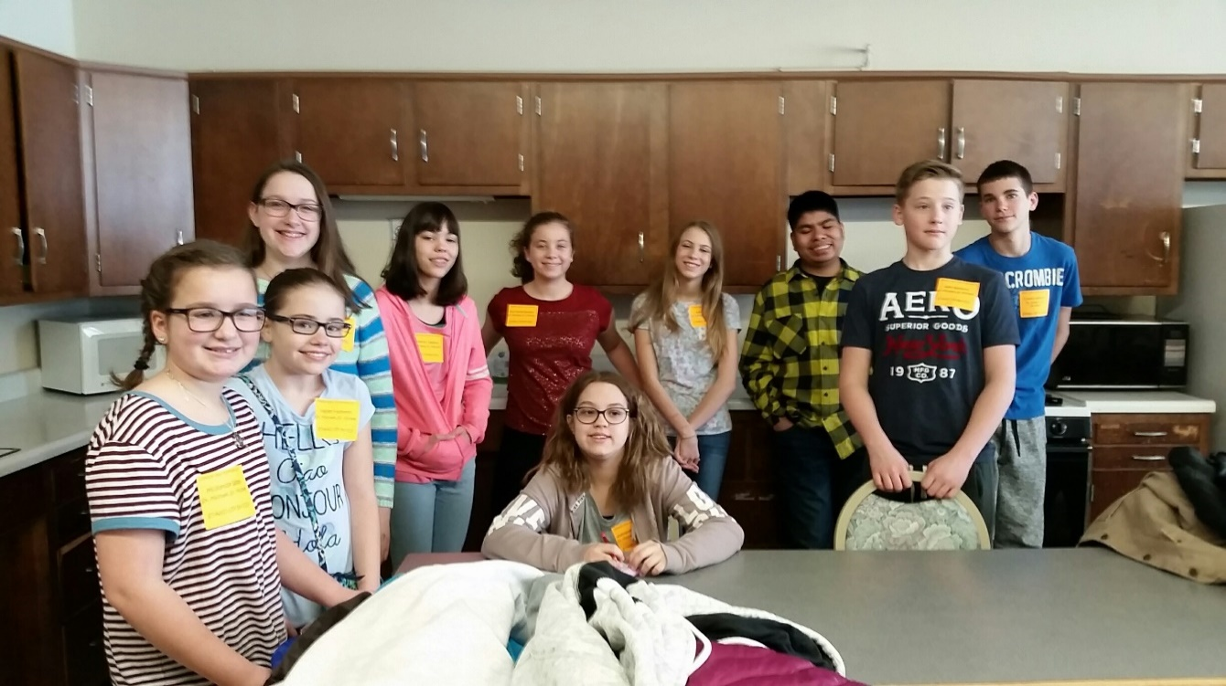

Pictured Left to Right: Mckenzie Webb, Hailey Hampton, Becca Docherty, Kimmy Deighan, Eva Spangler, Alex Deighan (sitting), Alexia Steele, Chris Ramirez, Alex Bambino and Connor Wysocki.

\*\*\*\*\*\*\*\*\*\*\*\*\*\*\*\*\*\*\*\*\*\*\*\*\*\*\*\*\*\*\*\*\*\*\*\*\*\*\*\*\*\*\*\*\*\*\*\*\*\*\*\*\*\*\*\*\*\*\*\*\*\*\*\*\*\*\*\*\*\*\*\*\*\*\*\*\*\*\*\*

*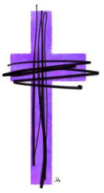*Eucharistic Adoration Day for Teens with Bishop Mark Bartchak

Hosted here at Saint Michael Parish for all diocesan high school students in grades 9—12 on Saturday, April 1, 2017. The day will begin at 10:00 AM in the church with a Lenten reflection presented by our students and Eucharistic Adoration celebrated by Bishop Mark. A social gathering will be held afterwards in the Parish Hall for all participants with an opportunity for fellowship with Bishop Mark.

*Teens should be pre-register by March 19th.*

Rite of Sending ~ Our 11th grade Confirmation class along with their Sponsors will attend the 10:30 AM Mass on Sunday, April 2, 2017. The candidates will celebrate their “Rite of Sending” as our parish “sends them off” to receive their Sacrament of Confirmation.

C:\Users\Laurie\Clip Art\calen4c3_print.tiffConfirmation ~ Our 11th Grade Confirmation class will receive their Sacrament of Confirmation on Thursday, April 20, 2017. A 7:00 PM Mass will be celebrated at Saint John Gualbert Cathedral in Johnstown.

*Confirmation Practice will be held on Wednesday evening April 19th at 6:30 PM.*

First Holy Communion ~ Our Second Grade class is preparing to receive their Sacrament of First Holy Communion on Sunday, May 7, 2017 at 2 PM.

♥=♥=♥=♥=♥=♥=♥=♥=♥=♥=♥=♥=♥=♥=♥=♥=♥=♥=♥=♥=♥=♥=♥=♥=♥=♥=♥=♥=♥=♥=♥=♥=♥=♥

*C:\Users\Laurie\ncyclogo-150w42h.png* The National Catholic Youth Conference is a powerful, biennial, three-day experience of prayer, community, and empowerment for Catholic teenagers (of high school age) and their adult chaperones. The 2017 National Catholic Youth Conference is November 16-18, back in Indianapolis, with the theme *Called/Llamados*.

Who Can Attend NCYC?

Any high school aged member of the Diocese of Altoona-Johnstown aged 16 or over and their adult chaperones (with proper clearances) are invited to attend the pilgrimage to NCYC. Young people must register through their parish or Catholic High Schools.

*Saint Michael Parish is planning to attend NCYC 2017!*

We are offering this trip opportunity to REACH students that will be age 16 or over in the fall of 2017 and also any adult chaperones. The diocese has extended the deadline date for registration to April 15th. Once attendees are registered, there are also possible scholarship opportunities to apply for and more information will follow from the diocese. Many additional “NCYC fundraisers” will be scheduled to raise funds towards the remaining cost of the trip. Please visit: [www.ncyc.info](http://www.ncyc.info) for more information including promotional videos. NCYC Registration forms are available in the RE Office.

*All registrations, along with an initial registration deposit fee of $100.00 is due in the RE Office no later than April 12, 2017 to hold a reservation for this trip. Registrations and deposits will then be sent to the Altoona-Johnstown Diocese Office by the registration deadline to confirm our group.*

Sunday, March 26 Religious Education / Grades 6 - 12 / 9:00—10:20 AM

[](https://www.churchart.com/subscriber/viewimages?topic_id=2&image_type=cl,ea&page=11&ipp=12) Catholic Relief Services Collection

Monday, March 27 No Mass

Sunday Choir Practice / 7:00 PM / Church

Tuesday, March 28 Mass / 8:00 AM / Fr. Joseph Nale

Wednesday, March 29 Mass / 9:00 AM / Fr. Brian Warchola

Thursday, March 30 Mass / 8:00 AM / Fr. Joseph Nale

Religious Education / Grades K - 5 / 3:30—4:30 PM / Hall

Saturday Choir Practice / 5:30 PM / Church

Friday, March 31 Mass / 9:00 AM / Fr. Brian Warchola

Stations of the Cross / 6:00 PM / Church

Combined Easter Choir / 7-8:00 PM

Saturday, April 1 Eucharistic Adoration Day with Bishop Bartchak

For Diocesan Teens ~ Grades 9 – 12 / 10:00 AM / Church

Sunday, April 2 Religious Education / Grades 6 - 12 / 9:00—10:20 AM / Hall

[](https://www.churchart.com/subscriber/viewimages?topic_id=84&image_type=cl&page=1&ipp=12) Rite of Sending / Confirmation Class / 10:30 AM Mass

Holy Name Society Meeting / After 8:00 AM Mass

Coffee & Donuts after 8:00 AM & 10:30 AM Mass

UPCOMING EVENTS

Monday, April 3 Combined Penance Service-Most Holy Trinity, South Fork, 6:30 pm

Wednesday, April 12 Covered Dish commemorating the Lord’s Last Supper (Not a Seder Meal)

Sign up sheets in back of the Church.

YOUNG WOMEN’S RETREAT ~ Sister Servants of the Most Sacred Heart of Jesus are sponsoring a weekend of Conferences, Adoration, Common Prayer, Private Prayer, Mass, and, Confessions for single or married women ages 18-35. It begins Friday, March 31st at 5:30 PM with supper at 7:00 PM. It concludes on Sunday, April 2nd with a 12:30 PM Mass. The retreat will take place at St. Joseph Convent / Sacred Heart Spirituality Center at 1872 Munster Road, Portage, PA. The suggested donation is $40 but is not required. RSVP by Tuesday, March 28th by e-mail [sisterjacinta@gmail.com](mailto:sisterjacinta@gmail.com) or by calling 814-505-2290.

BISHOP’S NIGHT FOR VOCATIONS ~ The Serra Club of Cambria County invites you to the Bishop's Night for Vocations dinner on Friday, April 21, 2017 at Bishop Carroll Catholic High School, 728 Ben Franklin Highway, Ebensburg, PA. A social hour begins at 5:30 p.m. and dinner follows at 6:30 p.m. The event is sponsored jointly by the Serra Club and the Diocesan Vocation Office. Guest speaker is Reverend Stephen P. DeLacy, Vocation Director, Archdiocese of Philadelphia. For tickets please call Marjorie Lechene at 814-255-9797 or 814-255-6563.

SPRING TEA ~ All women of the parish are invited to attend the Annual Spring Tea to be held by the St. Anne’s Society of St. Bartholomew Catholic Church in Wilmore, PA on Sunday, April 30th. Rosary and Benediction begin at 2:00 PM with the tea to follow in the Church Hall. Please RSVP Ann Pershing at 495-9298 or Margy Blaisdell at 495-7020 by Sunday, April 23rd