ST. MICHAEL ROMAN CATHOLIC CHURCH

751 Locust Street

PO Box 103

St. Michael, Pennsylvania 15951

Rev. Msgr. David A. Lockard, Administrator MASSES:

(814) 495-9640 Saturday 4:00 pm



Sunday Morning 8:00 am

Secretary & Bookkeeper: 10:30 am

Michele Panick Daily Mass: M,T,W,Th,F Noon

DRE: Laurie Sloan Holy Days: See Bulletin

Maintenance: Rodney Turgeon Office Hours:

PHONES: 8:30 am to 3:30 pm

Rectory / Office: (814) 495-9640 Monday, Tues., Thurs., Friday

Fax: (814) 495-9424 Confessions:

Rel. Education: (814) 495-4873 Saturday 3:30 pm to 3:45 pm

Parish Website Sunday 10:00 am to 10:15 am

[www.saintmichaelchurch.weebly.co](http://www.saintmichaelchurch.weebly.co)m By Appointment

Secretaries’ E-mail

[saintmichaelsecretaries@yahoo.com](mailto:saintmichaelsecretaries@yahoo.com)

Facebook page:

St. Michael Catholic Church/St. Michael, PA

Second Sunday of Easter

(Sunday of Divine Mercy)

SERVING GOD AND COMMUNITY FOR OVER ONE HUNDRED YEARS!

April 11th, 2021

BAPTISM: By Appointment. Reserve at least one month in advance.

MARRIAGE: Plan at least nine months in advance.

Preparation sessions are necessary.

FUNERALS: Arrangements are made in conjunction with the funeral home.

REGISTRATION Those new to the area, newlyweds, and single adults, (even if registered

and before with their families) are asked to register by calling the Parish Office.

MEMBERSHIP: Every parishioner must be registered. This is a condition for admission

to our Program and reception of the Sacraments of Baptism, Confirmation,

First Penance, First Eucharist, and Matrimony; also, for testimonial letters or sponsorship of Baptism and Confirmation outside the Parish.

VISITATION: We are concerned and want to be advised when someone is ill at home or in the hospital. Call the office to have the shut-in placed on our monthly Holy Communion calls or seriously ill prayer list.

SACRAMENTAL Parish registration and active Mass participation for Baptism is

POLICY: encouraged and is required for Marriage.

BULLETIN ARTICLES: Articles are due to the Parish Office by Noon on Tuesday.

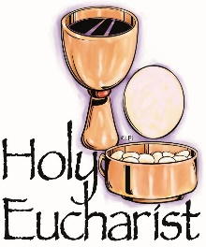

Second Sunday of Easter

(Sunday of Divine Mercy)

April 11th, 2021

Month of the Holy Eucharist

**MASS INTENTIONS**: (April 12 – April 18, 2021)

Monday, April 12 Noon Robert & Hermine Sivec req. by Rose Ann & George Coyle

Tuesday, April 13 Noon Joseph Ropecka req. by Terry & Ethel Sheppard

Wednesday, April 14 Noon John Progar req. by Bev & family

Thursday, April 15 Noon Joseph & Jean Brown req. by Mary Jean Brown

Friday, April 16 Noon Stella Pinkas req. by Tony Pinkas & family

Saturday April 17 4:00 PM Kristen Deighan req. by Mom & Dad

Sunday, April 18 8:00 AM People of the Parish

10:30 AM Thomas Murin req. by Mary Ann Murin & family

LITURGICIAL APPOINTMENTS:

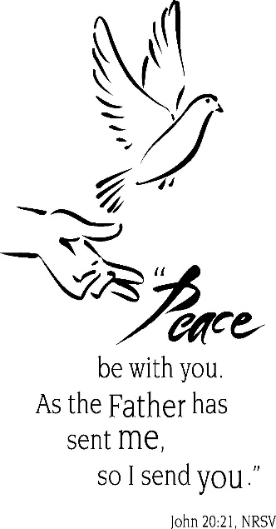Saturday, April 17 4:00 PM

Lector: Sandy Bambino

Minister of the Host: Susan Blazosky

Altar Server: Alex Bambino

Cantor: David Zajdel

Sunday, April 18 8:00 AM

Lector: Cathy Faher

Minister of the Host: Sally Kolar

Altar Server: Michael Kresic

Cantor: Sharon Dibble

Sunday, April 18 10:30 AM

Lector: Mike Barton

Minister of the Host: Mike Steele

Altar Server: Kirstyn Vitez

Cantor: Lou McCloskey

Weare placing names of the sick in the bulletin for prayer providing they give permission. *May the* *Divine Physician send healing grace for those for* *whom we pray:* Allen C. Rosemas, Patricia Murphy, Bernice Myers, Dwight Fyock, Dylon Wills, Missy, Joanne (Kolar) Hufford, Christine Flanagan, Ayden Alan Grata, Mary Lou Offman, Mary Zangaglia, Natalie Zerby, Valencia Tursi, Homer Locher, Brayden Schofield, Michelle Kasper, Diane Kingera, Ted Paluch, Pearl Litzinger, Patrick Munro, Fran Baldassarre, Kristen Sinosky Long, Cresta Micik, Basil Costantino, Laura, Joe Yoder, Dolores Yanzetich, Sandy Krug, Wanda Gramling, Jennifer Hagans, Shawn, Holly, Shane, Spencer, Owen Taylor, Derrick Varnish, Vincent Koshute, Michelle Elliott, Heather Romanow, Mackston Barrick, Connor Thomas, Erin, Pat, Mary Agnes Nastase, Mary Ann Bertolino, Dick Wilson, Izzy Bihun, Dorothy Kaminsky, Patricia Oshaben, Ashlee Madison, Susan Yanzetich, Mike, Alina Rusnak, Gary Smay, Elizabeth Howell, Walter Bodziak, Rhonda, Anne Robinson, Carter Bobak, Vince Arena, Mike Morris, Sarah Kelt, Patty Yanzetich Caldwell, Colton Snyder, Nancy Edmiston, Leonard Oshaben, Adam, Janice Dipyatic, Lily Maloney, Scott, Lisa, Audrey Costlow, Cathy Sossong, Rosanne Krug, Becky Kakabar, Howard Delaney, Dolores Mucko, Elliana, Ashlee, Helen Soohy, Carol K. Fabrizio, Peggy Carpenter, Dave Seder, Rosalie Ambrose, Pearl Borlie, Joe (Runk) Slonac, Diane Neri, Sharon Poldiak, Patty Gdula, Judy Barr and all of the sick of our parish, the homebound, those in nursing homes, those who care for them, and those in the military along with their families. *(Please call the Rectory to have your name removed from the list when no longer seriously ill. Thank You.)*

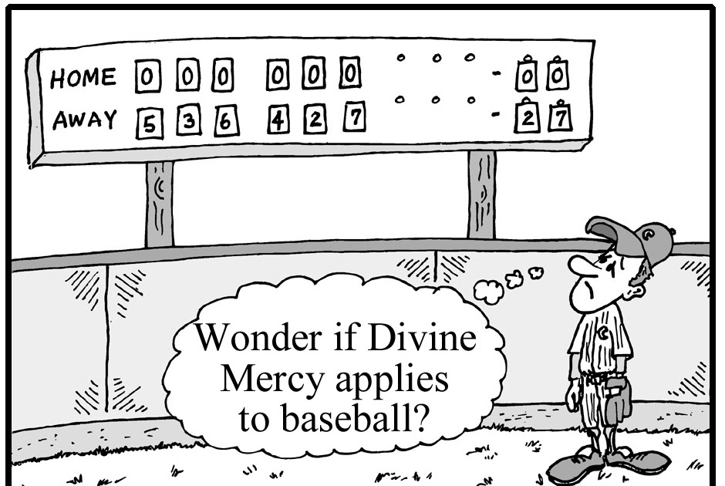

LAST WEEK’S COLLECTION

Adults $1,788.00

Loose $ 189.25

Youth $ 5.00

Monthly $2,240.00

Candles $ 32.00

Maintenance Fund $ 65.00

Easter Offering $4,451.05

Catholic Relief Services $ 20.00

Holy Land $ 508.00

Holy Thurs./Food Pantry $ 589.00

Total $9,887.30

We sincerely thank and ask God’s

blessing upon all who have care

and concern for our parish.

April 11, 2021 JN 20:19-31

“Whose sins you forgive, are forgiven” means the grudges we carry only make us miserable. The Kingdom of God begins in your home where children learn the paths to peace promised in today’s gospel through merciful and forgiving demonstrations by their parents.

During the week of April 11th, 2021

the Sanctuary Candle will burn in memory of

Paul Susko

requested by Mike & Connie Yauneridge

[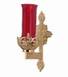](https://images.search.yahoo.com/search/images;_ylt=A0LEV1kSWptXvOwAKINXNyoA;_ylu=X3oDMTEyZGdkcmRoBGNvbG8DYmYxBHBvcwMxBHZ0aWQDQjIwODlfMQRzZWMDc2M-?p=Clipart+of+a+sanctuary+candle&fr=ush-mailn_02&th=110&tw=110&imgurl=http://www.henningers.com/389-168-wall-sanctuary-lamp.jpg&rurl=http://pixshark.com/sanctuary-lamp.htm&size=43KB&name=Sanctuary+Lamp+Bronze+wall+sanctuary+lamp&h=600&w=600&turl=http://ts2.mm.bing.net/th?id=OIP.M68453c67108cdc5ab485d309b395bd03o0&pid=15.1&rs=1&c=1&qlt=95&w=110&h=110#inline&tt=Sanctuary+Lamp+Bronze+wall+sanctuary+lamp&sigr=116keh5le&sigit=13gvlt42j&sigi=11ip0pgm4&sign=119kp6100&sigt=119kp6100)

EASTER THANK YOU’S ~ On behalf of all the people of St. Michael Parish, I wish to thank all those whose efforts helped to make our celebration of Holy Week and Easter so beautiful: our liturgical and music ministers, our church decorators and those who contributed for the flowers and for all who joined us throughout the week and Easter Sunday for Mass. May the beauty of the fifty days of the Easter Season deepen our faith in our own resurrections!

*Msgr. Lockard*

EASTER FLOWERS ~ In Memory Of: Deceased members of my family by Violet Barr. Again, we thank all those who so generously gave donations for the Easter Flowers. The extra money collected will help to defray the cost of flowers purchased throughout 2021.

SECOND SUNDAY FOOD PANTRY COLLECTION ~ This weekend is our Second Sunday Food Collection. Please bring in non-perishable food items or toiletries with you. Monetary donations are also appreciated.

FINANCE COUNCIL MEETING ~ There will be a Finance Council Meeting on Sunday, April 18th in Room #2 of the Church Hall after the 10:30 AM Mass.

CATHOLIC HOME MISSIONS APPEAL ~ The Catholic Home Missions Appeal will be collected the weekend of April 24th & 25th. Special envelopes can be found in your packets.

PRINCE GALLITZIN SCHOLARSHIP PROGRAM ~ Two education Scholarships of $500 each for Graduating High School Seniors in the Class of 2020-2021. Applicants for the scholarships will come from the following churches: St. Michael Catholic Church, St. Michael, PA, St. John’s Catholic Church, Summerhill, PA, St. Bartholomew, Wilmore, PA, Most Holy Trinity, South Fork, PA and Immaculate Conception, New Germany, PA. Seniors can pick up an application at the Parish Office during Parish Office hours.

ROSARY ~ Every Thursday at 3:00 PM on Franklin Street across from Planned Parenthood. Praying for the pre-born, their Moms, the abortion workers and all those who support abortion

PUBLIC ROSARY ~ To honor Police, Firefighters, EMS, Healthcare Workers, Military and to Pray for our Country, Saturday, April 17th at NOON - Central Park, Downtown Johnstown. Covid Precautions.

VIRTUS ARTICLE ~ The Office of Child and Youth Protection has provided an awareness article0 for April. The featured article is : ‘Gratitude form an Active Catholic and a Survivor’ by Michael Hoffman. Articles can be found at the entrances of the church. All VIRTUS articles can be found at <https://youthprotection.dioceseaj.org/virtus-monthly-articles/>

 Religious Education And Christian Helping

April 11, 2021

Religious Education News

Final Home Lesson Packets ~ April lessons packets are prepared for all students in grades K—10. They are being distributed this week. Our K—5 parents can pick up packets on Thursday, April 8 from 4 to 5 PM. Our Grades 6—10 parents can pick up this Sunday, April 11 from 9 to 10:15 AM. Completed lessons can be returned on these days.

For those that missed any lesson pick-ups, your students lessons can be picked-up in the Big Blue Tote outside the Parish Office door marked: "Religious Education Pick-Ups & Drop Offs".  It can be accessed anytime at your convenience to make it easier.  Look for your "Family Name" on the name tag attached to the bag. You can Drop-off completed lessons by placing them in this bin also.

Camp Zacchaeus Day Camp ~ Our Diocese of Altoona-Johnstown is offering three great days of Faith, Fun and Friendship this summer at Camp Zacchaeus on July 19, 20 and 21, 2021. Day camp is being offered in three areas: Altoona, Johnstown, and State College. Our Johnstown area site will be held at Resurrection Picnic Grove. Any students entering grades 3-9 in September of 2021 are eligible to attend. Registrations will be accepted on a first come basis until each site is full with a registration deadline of June 18th.

A Camp Zacchaeus brochure with more information and registration is included with our Saint Michael students in their April Lesson Packet.

╬ ╬ ╬ ╬ ╬ ╬ ╬ ╬ ╬ ╬ ╬ ╬ ╬ ╬ ╬ ╬ ╬ ╬ ╬ ╬ ╬ ╬ ╬ ╬ ╬ ╬ ╬

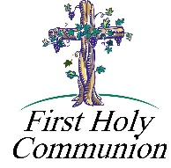2nd Grade Class Meeting In-Person ~ Our 2nd Grade students will be attending in-person classes to continue their preparation for the reception of their First Eucharist. They will attend two classes, one on Saturday, April 17th and a second on Saturday, April 24th from 10:00 to 11:00 AM.

First Holy Communion ~ Our Second-Grade class is preparing to receive First Holy Communion on Saturday, May 1st, 2021 at a 10:00 AM Mass. They will celebrate Reconciliation on Wednesday, April 28th at 6:30 PM. First Communion Practice will be on Friday, April 30th at 6:30 PM.

11th Grade Class Meeting In-Person ~ Our 11th Grade Confirmation students are attending class on Sunday mornings from 9—10:20 AM in the upstairs hall. They will continue to meet throughout the month of April leading up to receiving their sacrament of Confirmation in May.

Confirmation ~ Our 11th Grade Confirmation candidates will receive their Sacrament of Confirmation on Thursday, May 6, 2021. A 7:00 PM Mass will be celebrated here at our Saint Michael Parish by Msgr. Lockard.

*Confirmation Practice will be held on Wednesday evening, May 5 at 6:30 PM.*

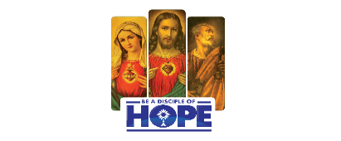

CATHOLIC MINISTRIES DRIVE 2021

Family Life

Families are extremely important to the Catholic Church. God intended family to be a central role in creation. The Family Life ministry assists all ages and stages of families in the Diocese of Altoona-Johnstown. Programs and resources offered through this ministry include natural family planning, marriage preparation, anniversary masses, family counseling, and more. Whether it is preparing to get married or becoming a stepfamily, Family Life provides that help people to be more hopeful for the adventures to come.

BE A DISCIPLE OF HOPE to married couples and families who benefit from the wide variety of programs offered through the diocese’s Family Life Ministry, supported by the Catholic Ministries Drive.

You can mail your gift to the Diocese of Altoona-Johnstown, PO Box 409, Hollidaysburg, PA 16648; place in your parish offertory; or make online at www.dioceseaj.org .

All gifts received beyond our parish target amount will be used for the purchase and installation of new gas furnaces for the Church, Hall & rectory.

100% of your donation will go to the 14 ministries that gives help, builds hope, and changes lives.

APRIL Is Child Abuse Prevention Month

Every April, Catholic parishes and schools across the United States participate in National Child Abuse Prevention Month.

The Effects of ABUSE.

When a child is abused, the effects are grave and can last a lifetime. Some of the most common effects of abuse include:

* Loss of faith and trust in God.
* Post traumatic stress disorder, psychological distress, and other indirect signs of trauma, such as anxiety, trouble sleeping, chronic stomach pain, and headaches.
* A greater risk of developing behavioral problems, substance abuse, and suicide.

The sense of violation goes deep into a person’s psyche and feelings of anger, shame, hurt, and betrayal can build long after the abuse has taken place.

Steps to Prevent ABUSE.

* Communicate with Your Children – It is extremely important to communicate openly with your children. Let them know that they can talk to you about anything that bothers them. This will help you identify warning signs and grooming behaviors perpetrated by offenders before they escalate to abuse.
* Educate Yourself and Your Children on Abuse – Learning how to identify, prevent, and report abuse is key. Parents and guardians should empower their children to protect themselves from harm and to report abuse. Ask your diocesan safe environment coordinator or parish delegate about opportunities for safe environment training.
* Identify and Report Warning Signs of Child Abusers – Grooming Behaviors are the actions abusers take to project the image that they are kind, generous, caring people, while their intent is to lure a minor into an inappropriate relationship. Offenders can be patient and may groom their victim, his or her family, or community for years. Some abusers isolate a potential victim by giving him or her undue attention or lavish gifts, while others allow young people to participate in activities which their parents or guardians would not approve, such as watching pornography, drinking alcohol, using drugs, and excessive touching, such as wrestling and tickling. Abusers also often try to isolate their victims from family or friends and encourage their victims to keep secrets from their parents or other caring adults.

150th Anniversary of Naming Saint Joseph as Patron of the Universal Church

Joseph was warned in a dream that Herod sought to kill the child. He fled with his family to Egypt. In Egypt “parents and child remained until after Herod’s death.” (Mt2:13;19)

One hundred and fifty years after Pope Pius IX named St. Joseph as Patron of the Universal Church, on December 8, 1870, Pope Francis noted the anniversary on December 8, 2020, by dedicating an entire year to the saint. As Pius IX and the entire Church were undergoing great darkness in the world, all were entrusted to the providence of God in 1870 and St. Joseph.

Moving forward to the 21st century, we look at how the Church is again endangered with persecution, troubled by sin and evil, and under attack for her sovereignty and pro-life stance. And who do we turn to? We turn to St. Joseph because he remains our patron in these dark times too.

https://www.ncregister.com/news/pope-francis-proclaims-year-of-st-joseph. 2021, Diocese of Altoona-Johnstown Liturgy Committee, Liturgy Office, *Mary, Mother of the Church Pastoral Center,* 2713 W. Chestnut Avenue, Altoona, PA 16601.

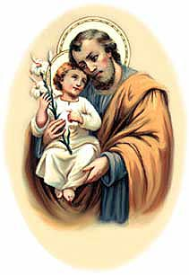

YEAR OF SAINT JOSEPH CELEBRATIONS

*Here ye! Here Ye! All pilgrims of the Diocese of Altoona-Johnstown!*

Saint Joseph the Worker Church, Williamsburg

You are invited for a special day of prayer on May 1, the Feast Day of Saint Joseph the Worker.

Schedule for the Day: 9 AM Morning Prayer; 9:30 AM-Joyful Mysteries of the Rosary; 11:30 AM- Sorrowful Mysteries of the Rosary; 1:30 PM-Luminous Mysteries of the Rosary; 3:30 PM-Glorious Mysteries of the Rosary; 4 PM Confessions; 5 PM Vigil Mass of the 5th Sunday of Easter. *Please stay for as long as you are able to.* Deacon Kevin Nester, Administrator: [knester@dioceseaj.org](mailto:knester@dioceseaj.org). 628 West 1st Street, Williamsburg, PA 16693

Saint Joseph Mission Church, Hart’s Sleeping Place, Carrolltown

This historic Church, blessed by Servant of God, Demetrius Gallitzin himself on October 10, 1830, will be opening once a month for visitation and self-guided tours beginning after May 1, Feast of St. Joseph the Worker. Schedule: The Church will be open from Noon-3 PM on Saturday, May 1, then on Sundays: May 2, June 6, July 4, and September 5. A Special outdoor Mass with Bishop Mark as Main Celebrant, will be held on Sunday August 1 at 4 PM. The Church will be open from Noon-3:30 PM, with Confessions from 1-3 PM. Curator: Marian Farabaugh: [stjosephmissionchurch1830@gmail.com](mailto:stjosephmissionchurch1830@gmail.com)

 Sunday, Apri 11 Mass ~ 8:00 & 10:30 AM

Confessions / 10:00 – 10:15 AM / St. Paul Room

Second Sunday Food Pantry Collection

Girl Scouts / 1-2:30 & 4-5:30 PM

Monday, April 12 Mass ~ Noon

NO Sunday Choir Practice

Team Leadership Meeting / 6:30 PM / Room #2

Tuesday, April 13 Mass ~ Noon

Boy Scouts / 7:30 - 9:00 PM

Citizens Concerned for Human Life Meeting / 7:00 PM

 Wednesday, April 14 Mass ~ Noon

Thursday, April 15 Mass ~ Noon

NO Saturday Choir Practice

Friday, April 16 Mass ~ Noon

Saturday, April 17 Mass / 4:00 PM

Confessions / 3:30 – 3:45 / St. Paul Room

UPCOMING EVENTS

 April 18 Finance Council Meeting

April 19 Knights of Columbus Meeting

April 24 & 25 Catholic Home Missions Appeal Collection

April 28 Second Grade Reconciliation

April 30 First Holy Communion Practice

May 1 First Holy Communion

BASKET RAFFLE ~ The Adams Township Lions Club will be holding a Basket Raffle at the St. Michael Firehall from 10 AM – 5 PM on Saturday April 10th & 10 AM – 3 PM on Sunday April 11th. $5 per ticket. Drawings will be posted on Facebook.

PRO-LIFE DINNER ~ Clear Ridge Independent Fellowship Church, 516 Stayer Rd, Everett on PA rt 26, South of Everett. Featured Speaker: Maria Gallagher. Maria will tell the history of Roe, how we can prepare Pennsylvania for an overtun of Roe, and what life after Roe will mean in PA and beyond. Adults $20, Students $10, 4 & under free. RSVP 276-3638 or 652-6755 by 4/18/21. Checks made payable to Bedford County CCHL 7 mail checks to Pam Lucas; 262 Zion Rd; Everett, PA 15537. Sponsored by Bedford County Citizens Concerned for Human Life.

JOURNEY THROUGH SCOTLAND & ENGLAND ~ With Fr. Brian Saylor. Nov. 3 – Nov. 16, 2021, 14 Days & 19 Meals. Highlights: Edinburgh Castle, Lake District, Liverpool, Choice on Tour, Cotswolds, Bath, Glastonbury Abbey, Cornwall, Great Western Railway, London. Double: $4,499 pp or Single $5,399 pp. For more information or to sign up call Collette 844-218-2148. Please refer to Booking #987192 or Fr. Brian Saylor 814-944-8509.