ST. MICHAEL ROMAN CATHOLIC CHURCH

751 Locust Street

PO Box 103

St. Michael, Pennsylvania 15951

Rev. Msgr. David A. Lockard, Administrator MASSES:

(814) 495-9640 Saturday 4:00 pm

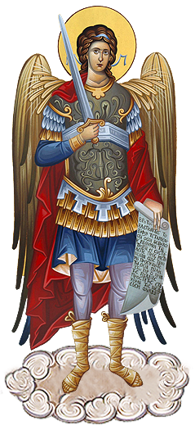 Sunday Morning 8:00 am

Secretary & Bookkeeper: 10:30 am

Michele Panick Daily Mass: M, T, W, Th, F

DRE: Laurie Sloan 9:00 am

Maintenance: Holy Days: See Bulletin

PHONES: Office Hours:

Rectory / Office: (814) 495-9640 8:30 am to 3:30 pm

Fax: (814) 495-9424 Monday, Tues., Thurs., Friday

Rel. Education: (814) 495-4873 Closed Wednesdays

Parish Website Confessions:

[www.saintmichaelchurch.weebly.com](http://www.saintmichaelchurch.weebly.com) Saturday 3:30 pm to 3:45 pm

Secretaries’ E-mail Sunday 7:30 am to 7:45 am

[saintmichaelsecretaries@yahoo.com](mailto:saintmichaelsecretaries@yahoo.com) 10:00 am to 10:15 am

Facebook page: By Appointment

St. Michael Catholic Church/St. Michael, PA

Fourth Sunday of Easter

SERVING GOD AND COMMUNITY FOR OVER ONE HUNDRED YEARS!

May 8th, 2022

BAPTISM: By Appointment. Reserve at least one month in advance.

MARRIAGE: Plan at least nine months in advance.

Preparation sessions are necessary.

FUNERALS: Arrangements are made in conjunction with the funeral home.

REGISTRATION Those new to the area, newlyweds, and single adults, (even if

and registered before with their families) are asked to register by calling

MEMBERSHIP: the Parish Office. Every parishioner must be registered. This is a condition for admission to our Program and reception of the Sacraments of Baptism, Confirmation, First Penance, First Eucharist, and Matrimony; also, for testimonial letters or sponsorship of Baptism and Confirmation outside the Parish.

VISITATION: We are concerned and want to be advised when someone is ill at home or in the hospital. Call the office to have the shut-in placed on our monthly Holy Communion calls or seriously ill prayer list.

SACRAMENTAL Parish registration and active Mass participation for Baptism is

POLICY: encouraged and is required for Marriage.

BULLETIN ARTICLES: Articles are due to the Parish Office by Noon on Tuesday

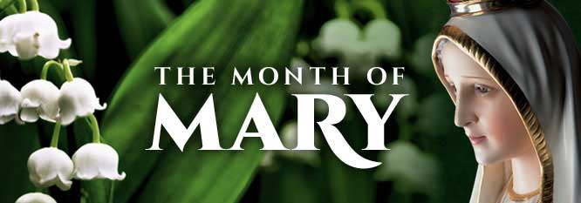Fourth Sunday of Easter

May 8th, 2022

Month of The Blessed Virgin Mary

**MASS INTENTIONS**: (May 9 – May 15, 2022)

Monday, May 9 9:00 AM People of the Parish

Tuesday, May 10 9:00 AM Harry Noon req. by Carol, Susan & Paul

Wednesday, May 11 9:00 AM Albert & Catherine Demko req. by Carl & Pam Freidhoff

Thursday, May 12 9:00 AM John Progar req. by Dennis & Pat Penatzer

Friday, May 13 9:00 AM Thomas Vandzura req. by Barry & Mary Ann Spangler

Saturday, May 14 4:00 PM John Cook req. by Pheobe Burkett

Sunday, May 15 8:00 AM Jane Plummer req. by Mike & Irene Baker

10:30 AM People of the Parish

LITURGICIAL APPOINTMENTS:

Saturday, May 14 4:00 PM Offertory Procession

Lector: Amy Spinos Bryan & Amy Spangler

Minister of the Host: Michael Barton

Choir Minister: Babe Richards

Altar Server: Bella Bambino & Natalie Stohon

Cantor: Susan Blazosky

Greeter: Karen Myers

Sunday, May 15 8:00 AM Offertory Procession

Lector: Arnold Bernard Jane Plummer Family

Minister of the Host: Marie Bernard

Choir Minister: Terri Leach

Altar Server: Ian Dobbins

Cantor: Sharon Dibble

Greeter: Pauline Minor

Sunday, May 15 10:30 AM Offertory Procession

Lector: James Lashinsky Michael Steele Family

Minister of the Host: Jennifer Steele

Choir Minister: Susan Wieczorek

Altar Server: Cameron Vitez

Cantor: Alexis Henderson

Greeter: Wendy Blough

Monday, May 16 Collection Counters

George & Pauline Minor

Weare placing names of the sick in the bulletin for prayer providing they give permission. *May the* *Divine Physician send healing grace for those for* *whom we pray:* Allen C. Rosemas, Patricia Murphy, Dwight Fyock, Dylon Wills, Missy, Joanne (Kolar) Hufford, Christine Flanagan, Ayden Alan Grata, Mary Lou Offman, Natalie Zerby, Brayden Schofield, Michelle Kasper, Diane Kingera, Ted Paluch, Pearl Litzinger, Patrick Munro, Fran Baldassarre, Kristen Sinosky Long, Cresta Micik, Basil Costantino, Laura, Joe Yoder, Dolores Yanzetich, Sandy Krug, Wanda Gramling, Jennifer Hagans, Shawn, Holly, Shane, Spencer, Owen Taylor, Derrick Varnish, Vincent Koshute, Michelle Elliott, Heather Romanow, Mackston Barrick, Connor Thomas, Erin, Pat, Mary Agnes Nastase, Mary Ann Bertolino, Dick Wilson, Izzy Bihun, Dorothy Kaminsky, Ashlee Madison, Susan Yanzetich, Alina Rusnak, Gary Smay, Elizabeth Howell, Walter Bodziak, Rhonda, Anne Robinson, Carter Bobak, Mike Morris, Sarah Kelt, Patty Yanzetich Caldwell, Colton Snyder, Leonard Oshaben, Adam, Janice Dipyatic, Lily Maloney, Scott, Lisa, Audrey Costlow, Rosanne Krug, Becky Kakabar, Dolores Mucko, Elliana, Ashlee, Helen Soohy, Carol K. Fabrizio, Peggy Carpenter, Dave Seder, Rosalie Ambrose, Pearl Borlie, Joe (Runk) Slonac, Lori Gramling, Ruth Ferchalk, Kathy Glenn Ripper, Ernie Martinage, Mildred Andrykovitch, Katelyn Engle, Colin Wingard, Betty Duray, Raymond Partsch, Jim Fisher, Joy McClain, Brenda Kundrod and all of the sick of our parish, the homebound, those in nursing homes, those who care for them, and those in the military along with their families. *(Please call the Rectory to have your name removed from the list when no longer seriously ill. Thank You.)*

During the week of May 8th, 2022

the Sanctuary Candle will burn in memory of all

deceased Mothers and Daughters of the Parish

and the Our Lady of Grace Candle will burn in honor of

all living Mothers and Daughters of the Parish

will

[](https://images.search.yahoo.com/search/images;_ylt=A0LEV1kSWptXvOwAKINXNyoA;_ylu=X3oDMTEyZGdkcmRoBGNvbG8DYmYxBHBvcwMxBHZ0aWQDQjIwODlfMQRzZWMDc2M-?p=Clipart+of+a+sanctuary+candle&fr=ush-mailn_02&th=110&tw=110&imgurl=http://www.henningers.com/389-168-wall-sanctuary-lamp.jpg&rurl=http://pixshark.com/sanctuary-lamp.htm&size=43KB&name=Sanctuary+Lamp+Bronze+wall+sanctuary+lamp&h=600&w=600&turl=http://ts2.mm.bing.net/th?id%3DOIP.M68453c67108cdc5ab485d309b395bd03o0%26pid%3D15.1%26rs%3D1%26c%3D1%26qlt%3D95%26w%3D110%26h%3D110#inline&tt=Sanctuary+Lamp+Bronze+wall+sanctuary+lamp&sigr=116keh5le&sigit=13gvlt42j&sigi=11ip0pgm4&sign=119kp6100&sigt=119kp6100)

LAST WEEK’S COLLECTION

Regular Offertory $6,164.50

Maintenance $ 50.00

Easter Offering $ 145.00

Lenten Folders $ 30.00

Rice Bowls $ 10.00

Diocesan Collections $ 65.00

Mother’s Day $ 117.00

Holy Days $ 47.00

Total $6,628.50

We sincerely thank and ask God’s blessing upon all

who have care and concern for our parish.

*May 8, 2022 John 10:27-30*

*Today’s gospel reminds us to be shepherds for our children who depend on us to be their guides and role models. Where are we leading them? When they “hear our voice” what message do they hear?*

HOLY NAME SOCIETY ~ Will hold their monthly meeting this Sunday, May 8th after the 8:00 AM Mass.

SECOND SUNDAY FOOD PANTRY COLLECTION ~ This weekend is our Second Sunday Food Pantry Collection. Please bring in non-perishable food items or toiletries with you. Monetary donations are also appreciated.

MOTHER’S DAY BRUNCH ~ All mothers and daughters of the parish are invited to a Mother’s Day Brunch this Sunday, May 8th sponsored by the Holy Name Society. They will be paying for, preparing and serving the meal in the church hall immediately following the 10:30 AM Mass. Sunday morning help is needed in the preparation, serving of the meal and the clean up after. Please call Pete Parisi at 814-487-5351. (This is a good way for male REACH students to earn service hours. Contact the Religious Education Office at 814-495-4873 to volunteer.)

MOTHER’S DAY MASS INTENTIONS ~ Envelopes for Mother’s Day Mass Intentions are in your packet of envelopes. The envelopes will be placed on the altar during the month of May in remembrance of all mothers, both living and deceased. Extra envelopes can be found at the entrances of the church.

FINANCE COUNCIL ~ There will be a Finance Council meeting on Tuesday, May 10th at 3:30 PM in Room #2 of the Church Hall.

PASTORAL COUNCIL ~ The Pastoral Council meeting will be on Thursday, May 12th at 6:30 PM in Room #2 of the Church Hall.

CEMETERY ENVELOPES ~ In your packet of envelopes, for May 22rd, you will find an envelope for Cemetery Maintenance with the three cemeteries: Corpus Christi, St. Joseph, and St. Michael. You are to circle or underline the cemetery you would like your donation to go towards. If nothing is specified, the donation will be split between the three cemeteries. Thank you.

A LITTLE CHANGE…CHANGES LIVES! ~ PRECIOUS LIFE will be running a Baby Bottle Campaign. Empty baby bottles will be placed in the Bridal Room beginning this weekend. Please take a bottle, fill it up with change and return it to the Bridal Room by Father’s Day, June 19th. PRECIOUS LIFE is a Christian ministry providing positive alternatives to abortion. For more information: facebook/www.preciouslifeinc.com

POSITIONS OPEN ~ We need to find a replacement or perhaps several replacements here at St. Michael to clean the parish hall, do snow removal, and do all the little repair work that is needed from time to time. If you are interested in any or all of these duties, please notify the parish office. Msgr. Lockard will meet with you to go over the job description in more detail and explain salary and benefits.

LAY MINISTRY SCHEDULE REQUESTS ~ Lay Ministry schedule requests are currently being taken for the Summer Schedule which covers June through September 2022. If you have a request for dates you are not available (vacation) or for dates that you are only available, please contact Suzi Blazosky at 495-5287 or email: [sublazosky@gmail.com](mailto:sublazosky@gmail.com) by Sunday, May 22nd. And please contact Suzi with your holiday preferences. Lay ministers are being sought for all Masses and all ministries – Cantors, Readers, Eucharistic Ministers, Greeters, Altar Servers, and especially Collection Counters.

FATIMA DEVOTIONS ~ The Franciscan Friars, T.O.R., from Loretto, invite you to participate with them in celebrating the Fatima Devotions on Friday, May 13th at 6:30 PM at the Basilica of Saint Michael the Archangel.

MASS FOR WIDOWS AND WIDOWERS ~ On Sunday, May 29th a televised Mass Celebrated by Bishop Mark Bartchak at 11:00 AM on WATM ABC 23 and will rebroadcast that night at 9:00 PM on the Atlantic Broadband channel 9. All spouses will be acknowledged and remembered at Mass. All persons who have lost a spouse through death throughout the Altoona-Johnstown Diocese are invited to register by contacting the Family Life Office 814-317-2643 or email [familylife@dioceseaj.org](mailto:familylife@dioceseaj.org). When registering, please give your name, address, phone number and the name of your spouse who has passed away. The last day to register is Tuesday, May 24th. The event is sponsored by the Diocesan Family Life Office and the Catholic Ministries Drive.

SINGLE CATHOLICS ~ Single and Catholic? We know about the married and religious vocations, but what about the baptismal vocation we all have? Join us this June for a 4-week online interactive series that will help equip you to more fully discover and effectively live your baptismal vocation! Capacity is limited. Sign up today. For more information and to register visit: <https://nationalcatholicsingles.com/mission-possible-living-your-baptismal-vocation/>

OBERAMMERGAU PASSION PLAY ~ 2022 Oberammergau Passion Play *Alpine Wonders* with Deacon Michael Russo & Fr. David Peles, August 1 – 9, 2022. $4,446 from Philadelphia. More information on the poster hanging on the bulletin board.

MAINTENANCE FUND TICKETS ~ We are asking that each active married couple sell or buy two tickets for $10.00 each, and each active single adult buy or sell one ticket for $10.00 and return the money, stub, or ticket as soon as possible but no later than May 29th. The tickets start on June 1, 2022 and continue the whole month of June. Winning numbers will be determined by the Pennsylvania Lottery Evening Pick Three Drawing. Weekdays payoff is $75, weekends are $100 & Father’s Day is $150. The June Maintenance Fund tickets can be found on the back table at the back of the church this weekend. If you are unable to sell or don’t want the ticket, PLEASE don’t throw it away, but return it as soon as possible as we always have people looking for extras. If paying by check, please make check payable to St. Michael Church. The money raised from the sale of these tickets will help to build up St. Michael Maintenance Fund.

PLEASE NOTE! ~ We apologize if anyone has been accidentally missed. If you would like a ticket or if anyone is wanting extra tickets, please call the office during office hours. Thank you.

*Msgr. David Lockard, Administrator*



Religious Education And Christian Helping

May 8, 2022

Congratulations to our First Holy Communion Class of 2022!

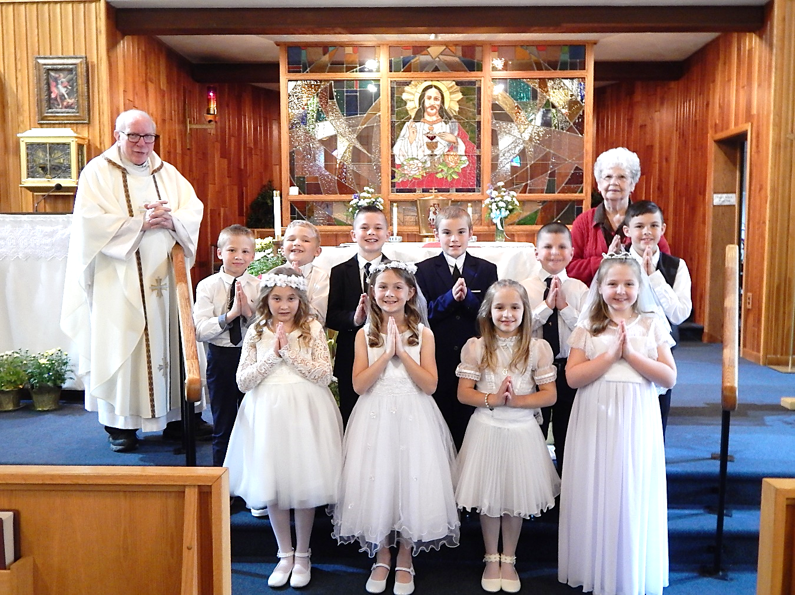

Members that celebrated are as follows; left to right, Front Row:

Kyra Siverd, Anna Eppley, Madeline Pensiero and Kaydien McCloskey.

Second Row: Zeke Zeller, Jack Zeigler, Bronsyn Baxter, Walter Christ IV, Joseph Raptosh and Ryder Ascherl. Back Row:

Msgr. David A. Lockard, and Pauline Minor.

*********************************************************************

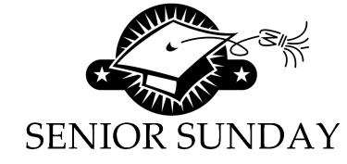On Sunday, May 29th, we will honor our high school seniors at a recognition luncheon in our Parish Hall starting at 11:30 a.m. We will gather together for a light luncheon and celebrate our “Class of 2022” senior members of our Saint Michael Parish that will graduate in June.

All parish seniors were sent an invitation and information for this by mail. Please RSVP to help with preparation for this special celebration.

EDUCATION SCHOLARSHIPS ~ Two Education Scholarships of $500 each for Graduating High School Seniors in the Class of 2021-2022. These 2 scholarships are being sponsored by the Knights of Columbus Prince Gallitzin Council 2275. Applicants for the 2 scholarships will come from these Churches: St. Michael, St. Michael, St. John the Baptist, Summerhill, St. Bartholomew, Wilmore, Most Holy Trinity, South Fork, and Immaculate Conception, New Germany. Applications were sent to this year’s Seniors, but if you did not receive one, please check at the Religious Education Office. Your application must be postmarked by May 15, 2022.

***************************************************************************

Rocky Railway Vacation Bible Camp 2022: All Aboard . . . Rocky Railway VBC will run Monday, June 20th—Friday, June 24th from 9:00 AM—12 PM at The New Germany Grove Grounds. Crew Members, 2018 (Birth Year) through those entering 7th grade, need to be registered by June 5th. There is no cost for VBC. Volunteers, 8th grade through adults also need to be registered by June 5th. Volunteers need to complete all state and diocese clearances to volunteer. Registration forms were distributed in our Religious Education classes and are also available on the table in the WPA Road entrance of the church.

***************************************************************************

2022 DIOCESAN SUMMER CAMP OPPORTUNITIES FOR YOUTH

Registration for our diocesan summer camps, Camp Zacchaeus and Camp Timothy are currently being accepted. Brochures are available in the WPA Road entrance of the church.

- Camp “Z” is a week-long summer camp for youth grades 4-9 Campers can look forward to lively Liturgies, inspirational music, prayer experiences, evangelization sessions, campfires, games, skits, a live concert and lots more!

- Camp “T” is for youth in grades 10-12 as well as current year graduating high school seniors.

- Camp “T” campers will experience much the same –but even MORE!! We take the fun, faith and excitement to a higher level! Scholarship money is available to eligible applicants for both camps. For more information or to receive a brochure for either camp, contact our Religious Education Office at 495-4873 or Francine Swope, Diocesan Youth Ministry at (814)317-2646.

*********************************************************************

Sunday, May 8 Mass ~ 8:00 AM & 10:30 AM

 Confessions / 7:30 – 7:45 AM & 10:00 - 10:15 AM / Confessional

Second Sunday Food Pantry Collection

Holy Name Society Meeting / Hall / After 8:00 AM Mass

Mother’s Day Brunch / Hall / After 10:30 AM Mass

Monday, May 9 Mass ~ 9:00 AM

Sunday Choir Practice / 7:00 PM

Tuesday, May 10 Mass ~ 9:00 AM

Finance Council Meeting / Hall Rm #2 / 3:30 PM

 Boy Scout Meeting / Hall / 7:30 – 9:00 PM

Wednesday, May 11 Mass ~ 9:00 PM

Thursday, May 12 Mass ~ 9:00 AM

Saturday Choir Practice / 4:30 PM

Pastoral Council Meeting / Hall Rm #2 / 6:30 PM

Friday, May 13 Mass ~ 9:00 AM

Saturday, May 14 Mass ~ 4:00 PM

Confessions / 3:30 – 3:45 PM / Confessional

 Isabella Dawn Lampel Baptism / After 4:00 PM Mass

UPCOMING EVENTS

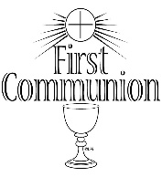

May 15 End Alzheimer’s Spaghetti & Basket Raffle

Hannah Rae Skoner Baptism

Charlie Liam Harris Baptism

May 21 Petrisko/Kundrod Nuptials

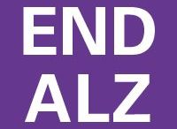SPAGHETTI DINNER & BASKET PARTY ~ Sunday, May 15th, St. Michael Catholic Church Hall, St. Michael. Tickets $15. Doors open at 11:30 AM, basket raffle announced at 1:00 PM. Sponsored by team “Blue Skies Over Purple Hearts” in Memory of Jane Plummer. All proceeds go to Alzheimer’s Association. To purchase tickets, call Mary Ann Tedjeske 814-341-5463, or Janet Minor 814-241-5106. END ALZ. *Any Parishioner wanting to donate an assembled basket would be greatly appreciated. Please drop off assembled baskets in the Bridal Room no later than Friday, May 13th.

GOLF TOURNAMENT ~ Benefits the Carmelite Community of the Word Sisters. Friday, June 3rd at Scotch Valley Country Club. Registration deadline is May 25th. Foursome - $425, Individual - $125. Includes breakfast, golf, refreshments, lunch, and prizes. Call 814-886-4098 or email [communityofficeccw@gmail.com](mailto:communityofficeccw@gmail.com).