ST. MICHAEL ROMAN CATHOLIC CHURCH

751 Locust Street

PO Box 103

St. Michael, Pennsylvania 15951

Rev. Msgr. David A. Lockard, Administrator MASSES:

(814) 495-9640 Saturday 4:00 pm



Sunday Morning 8:00 am

Secretary & Bookkeeper: 10:30 am

Michele Panick Daily Mass: M, T, W, Th, F

Noon

DRE: Laurie Sloan Holy Days: See Bulletin

Maintenance: Rodney Turgeon Office Hours:

PHONES: 8:30 am to 3:30 pm

Rectory / Office: (814) 495-9640 Monday, Tues., Thurs., Friday

Fax: (814) 495-9424 Closed Wednesdays

Rel. Education: (814) 495-4873 Confessions:

Parish Website Saturday 3:30 pm to 3:45 pm

[www.saintmichaelchurch.weebly.co](http://www.saintmichaelchurch.weebly.co)m Sunday 10:00 am to 10:15 am

Secretaries’ E-mail By Appointment

[saintmichaelsecretaries@yahoo.com](mailto:saintmichaelsecretaries@yahoo.com)

Facebook page:

St. Michael Catholic Church/St. Michael, PA

Sixth Sunday of Easter

SERVING GOD AND COMMUNITY FOR OVER ONE HUNDRED YEARS!

May 9th, 2021

BAPTISM: By Appointment. Reserve at least one month in advance.

MARRIAGE: Plan at least nine months in advance.

Preparation sessions are necessary.

FUNERALS: Arrangements are made in conjunction with the funeral home.

REGISTRATION Those new to the area, newlyweds, and single adults, (even if registered

and before with their families) are asked to register by calling the Parish Office.

MEMBERSHIP: Every parishioner must be registered. This is a condition for admission

to our Program and reception of the Sacraments of Baptism, Confirmation,

First Penance, First Eucharist, and Matrimony; also, for testimonial letters or sponsorship of Baptism and Confirmation outside the Parish.

VISITATION: We are concerned and want to be advised when someone is ill at home or in the hospital. Call the office to have the shut-in placed on our monthly Holy Communion calls or seriously ill prayer list.

SACRAMENTAL Parish registration and active Mass participation for Baptism is

POLICY: encouraged and is required for Marriage.

BULLETIN ARTICLES: Articles are due to the Parish Office by Noon on Tuesday.

 Sixth Sunday of Easter

May 9th, 2021

Month of the Blessed Virgin Mother

**MASS INTENTIONS**: (May 10 – May 16, 2021)

Monday, May 10 Noon People of the Parish

Tuesday, May 11 Noon George & Elizabeth Freidhoff req. by Carl & Pam Freidhoff

Wednesday, May 12 Noon Agnes Plummer req. by Jackie & Vince Kalwasinski

Thursday, May 13 Noon Marie Minor req. by Susan Horvath Davis & Joan Horvath Martin

6:00 PM People of the Parish

Friday, May 14 Noon Francis X. Powers req. by the Powers family

Saturday May 15 4:00 PM Vincent Arena req. by Dave & Debi Katich

Sunday, May 16 8:00 AM People of the Parish

10:30 AM Catherine Olszewski req. by family & friends

LITURGICIAL APPOINTMENTS:

Saturday, May 15 4:00 PM

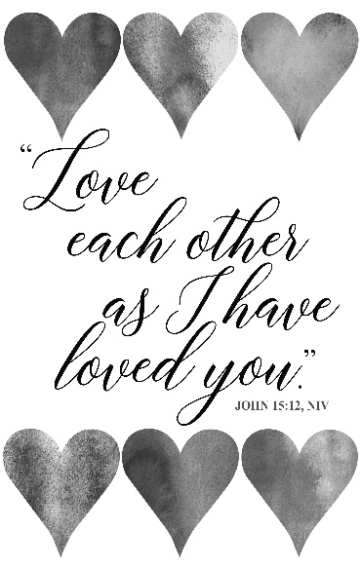Lector: Don Dipko

Minister of the Host: Babe Richards

Altar Servers: Caden & Kaylee Roberts

Cantor: David Zajdel

Sunday, May 16 8:00 AM

Lector: Cathy Faher

Minister of the Host: Terri Leach

Altar Server: Griffin Christ

Cantor: Susan Yanzetich

Sunday, May 16 10:30 AM

Lector: Mike Barton

Minister of the Host: Mike Steele

Altar Server: Kirstyn Vitez

Cantor: Elizabeth Dobbins

Monday, May 17 Collection Counters

George & Pauline Minor

Weare placing names of the sick in the bulletin for prayer providing they give permission. *May the* *Divine Physician send healing grace for those for* *whom we pray:* Allen C. Rosemas, Patricia Murphy, Bernice Myers, Dwight Fyock, Dylon Wills, Missy, Joanne (Kolar) Hufford, Christine Flanagan, Ayden Alan Grata, Mary Lou Offman, Mary Zangaglia, Natalie Zerby, Valencia Tursi, Homer Locher, Brayden Schofield, Michelle Kasper, Diane Kingera, Ted Paluch, Pearl Litzinger, Patrick Munro, Fran Baldassarre, Kristen Sinosky Long, Cresta Micik, Basil Costantino, Laura, Joe Yoder, Dolores Yanzetich, Sandy Krug, Wanda Gramling, Jennifer Hagans, Shawn, Holly, Shane, Spencer, Owen Taylor, Derrick Varnish, Vincent Koshute, Michelle Elliott, Heather Romanow, Mackston Barrick, Connor Thomas, Erin, Pat, Mary Agnes Nastase, Mary Ann Bertolino, Dick Wilson, Izzy Bihun, Dorothy Kaminsky, Patricia Oshaben, Ashlee Madison, Susan Yanzetich, Mike, Alina Rusnak, Gary Smay, Elizabeth Howell, Walter Bodziak, Rhonda, Anne Robinson, Carter Bobak, Mike Morris, Sarah Kelt, Patty Yanzetich Caldwell, Colton Snyder, Nancy Edmiston, Leonard Oshaben, Adam, Janice Dipyatic, Lily Maloney, Scott, Lisa, Audrey Costlow, Cathy Sossong, Rosanne Krug, Becky Kakabar, Howard Delaney, Dolores Mucko, Elliana, Ashlee, Helen Soohy, Carol K. Fabrizio, Peggy Carpenter, Dave Seder, Rosalie Ambrose, Pearl Borlie, Joe (Runk) Slonac, Sharon Poldiak, Patty Gdula, Judy Barr, Ric Szelong and all of the sick of our parish, the homebound, those in nursing homes, those who care for them, and those in the military along with their families. *(Please call the Rectory to have your name removed from the list when no longer seriously ill. Thank You.)*

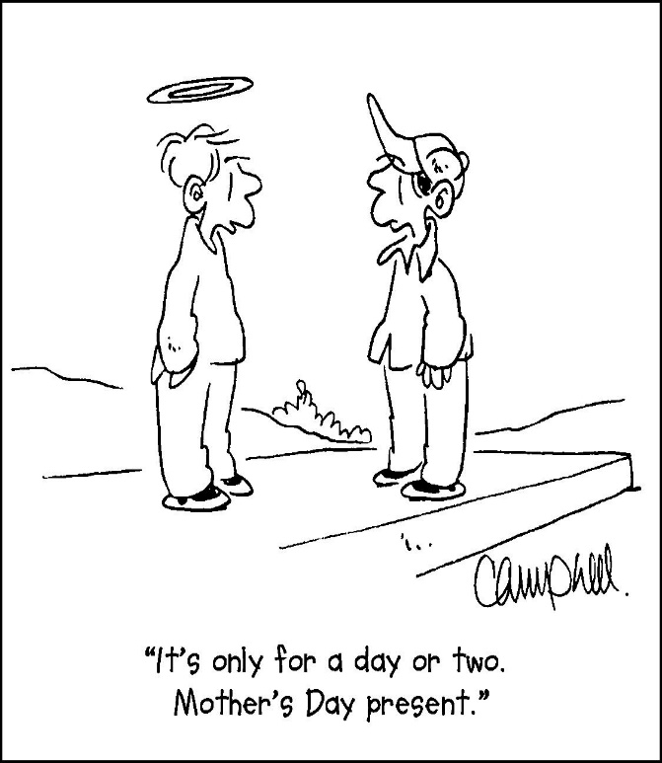

LAST WEEK’S COLLECTION

Adults $3,150.00

Loose $ 101.00

Youth $ 5.00

Monthly $1,896.00

Candles $ 6.00

Maintenance Fund $ 373.00

Mother’s Day $ 360.00

Father’s Day $ 70.00

Easter Offering $ 30.00

Ascension Thursday $ 110.00

Cemetery Maintenance $ 525.00

Catholic Home Missions $ 100.00

Catholic Communication $ 25.00

Total $6,751.00

We sincerely thank and ask God’s

blessing upon all who have care

and concern for our parish.

May 9, 2021 John 15:9-17

Today’s gospel challenges us to “love one another as I have loved you.” Jesus is our model and he

asks us to “lay down our life” (our time, attention, opinions and needs) for each other. This is the sacrament of the family, when God is made visible in our sacrificial love for one another.

During the week of May 9th, 2021

the Sanctuary Candle will burn in memory of

all deceased Mothers & Daughters of the Parish

and

the Our Lady of Grace Candle will burn in honor of

all living Mothers & Daughters of the Parish

[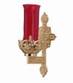](https://images.search.yahoo.com/search/images;_ylt=A0LEV1kSWptXvOwAKINXNyoA;_ylu=X3oDMTEyZGdkcmRoBGNvbG8DYmYxBHBvcwMxBHZ0aWQDQjIwODlfMQRzZWMDc2M-?p=Clipart+of+a+sanctuary+candle&fr=ush-mailn_02&th=110&tw=110&imgurl=http://www.henningers.com/389-168-wall-sanctuary-lamp.jpg&rurl=http://pixshark.com/sanctuary-lamp.htm&size=43KB&name=Sanctuary+Lamp+Bronze+wall+sanctuary+lamp&h=600&w=600&turl=http://ts2.mm.bing.net/th?id=OIP.M68453c67108cdc5ab485d309b395bd03o0&pid=15.1&rs=1&c=1&qlt=95&w=110&h=110#inline&tt=Sanctuary+Lamp+Bronze+wall+sanctuary+lamp&sigr=116keh5le&sigit=13gvlt42j&sigi=11ip0pgm4&sign=119kp6100&sigt=119kp6100)

MOTHER’S DAY MASS INTENTIONS ~ The Mother’s Day envelopes (that can be found in your envelope packet) will be placed on the altar during the month of May in remembrance of all mothers, both living and deceased.

SECOND SUNDAY FOOD PANTRY COLLECTION ~ This weekend is our Second Sunday Food Pantry Collection. Please bring in non-perishable food items or toiletries with you. Monetary donations are also appreciated.

ASCENSION THURSDAY ~ Masses for the Ascension of the Lord will be Thursday, May 13th at NOON and 6:00 PM. Please check the bulletin for Lay Ministry Assignments.

LAY MINISTRY SCHEDULES ~ Lay ministry schedules for the summer months of June through September are now being made. Anyone wanting to return as an Altar Server, Reader, Eucharistic Minister, or Cantor, or any current minister who has scheduling preferences at this time, should call Suzi Blazosky at 814-495-5287 or email her at [sublazosky@gmail.com](mailto:sublazosky@gmail.com) no later than May 21st.

CEMETERY ENVELOPES ~ In your packet of envelopes, for May 23rd, you will find an envelope for Cemetery Maintenance with the three cemeteries: Corpus Christi, St. Joseph, and St. Michael. You are to circle or underline the cemetery you would like your donation to go towards. If nothing is specified, the donation will be split between the three cemeteries. Thank you.

CATHOLIC COMMUNICATION CAMPAIGN ~ Next week our special collection supports the Catholic Communication Campaign. This campaign connects people with Christ and builds Catholic communities in the United States and developing countries using the internet, television, radio, and print media. Half of the money collected remains here in the Altoona-Johnstown Diocese to fund local communications efforts. Your support helps spread the Gospel message! To learn more, visit [www.usccb.org/ccc](http://www.usccb.org/ccc). Envelopes can be found in your packet.

KNIGHTS OF COLUMBUS MEETING ~ The Knights of Columbus Council 2275 and the Ladies Court will be holding their in-person meeting Monday, May 17th at 7:15 PM. The Knights will meet outside at the Pavilion, weather permitting, and the Ladies Court will meet in the hall.

TIME FOR A CHANGE ~ PRECIOUS LIFE will be running a Baby Bottle Campaign. Empty baby bottles will be placed in the Bridal Room beginning this weekend. Please take a bottle, fill it up with change and return it to the Bridal Room by Father’s Day, June 20th. PRECIOUS LIFE is a Christian ministry providing positive alternatives to abortion.

VIRTUS ARTICLE ~ The Office of Child and Youth Protection has provided an awareness article for May. The featured article is : ‘Overcoming Adverse Childhood Experiences Such as Trauma or Abuse’ by J. Bart Klik. Articles can be found at the entrances of the church. All VIRTUS articles can be found at <https://youthprotection.dioceseaj.org/virtus-monthly-articles/>

FATIMA DEVOTIONS ARE BACK ~ The Franciscan Friars, T.O.R., from Loretto, invite you to participate with them in celebrating a Mass for the Ascension of the Lord (May 13th) with Fatima Devotions following immediately after. We will begin at 6 PM and they will be held at the Immaculate Conception Chapel at Saint Francis University. We are really looking forward to seeing you.

MASS FOR WIDOWS AND WIDOWERS ~ Remember your loved ones on Sunday, May 30th, with a televised Mass Celebrated by Bishop Mark Bartchak at 11:00 AM on WATM ABC 23 and will be rebroadcast that night at 9:00 PM on the Atlantic Broadband channel 9. All spouses will be acknowledged and remembered at Mass. All persons who have lost a spouse through death throughout the Altoona-Johnstown Diocese are invited to register by contacting the Family Life Office 814-317-2643 or email [familylife@dioceseaj.org](mailto:familylife@dioceseaj.org). When registering, please give your name, address, phone number and the name of your spouse who has passed away. Deadline to register is May 24th, 2021. Sponsored by the Diocesan Family Life Office.

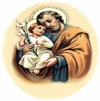THE YEAR OF SAINT JOSEPH PAMPHLETS ~ The diocese has provided pamphlets with information about The Year of Saint Joseph: Saint Joseph in the Diocese of Altoona-Johnstown. In these pamphlets you will find a Litany of Saint Joseph and other special prayers & liturgies throughout the year. The Pamphlets can be found at the entrances of the Church.

Saint Joseph Mission Church, Hart’s Sleeping Place, Carrolltown

This historic Church, blessed by Servant of God, Demetrius Gallitzin himself on October 10, 1830, will be opening once a month for visitation and self-guided tours. Schedule: The Church will be open from Noon – 3 PM on Sundays: June 6th, July 4th, and September 5th. A Special outdoor Mass with Bishop Mark as Main Celebrant, will be held on Sunday August 1st at 4 PM. The Church will be open from Noon – 3:30 PM, with Confessions from 1 PM – 3 PM. Curator: Marian Farabaugh: [stjosephmissionchurch1830@gmail.com](mailto:stjosephmissionchurch1830@gmail.com)

JOB OPENING ~ Part-Time Administrative Assistant – SS Gregory & Barnabas Parish, Johnstown. Seeking a part-time administrative assistant for the Parish. Candidates must be supportive of the Roman Catholic Church and able to satisfactorily complete background checks and training applicable to Diocesan requirements. An Associate degree in accounting and two years of related experience or five years of related work experience are required with a working knowledge of QuickBooks and Microsoft Office. Duties include reception, bookkeeping, and record maintenance. A complete job description is available by calling the parish office at (814) 536-6818. Pay is commensurate with experience. Please submit a cover letter and resume to [celue@dioceseaj.org](mailto:celue@dioceseaj.org). Position will be filled once a suitable candidate is found.

ASCENSION OF THE LORD – THURSDAY, MAY 13th

Ministry Assignments

ASCENSION THURSDAY ASCENSION THURSDAY

Thursday, May 13th NOON Thursday, May 13th 6:00 PM

Lector: Pauline Minor Lector: Tony Bambino

Minister of the Host: Karen Myers Minister of the Host: Sally Kolar

Altar Server: Karen Myers Altar Server: Alex Bambino

Cantor: Theresa Arena Cantor: Susan Yanzetich

*Please check the above schedule. If unable to keep your Lay ministry*

*assignment, please find a replacement.*

******************************************************************************************************************************

MAINTENANCE FUND TICKETS ~ We are asking that each parish household (and adult children living in the household) sell or buy one ticket for $10.00 and return the money and ticket stub as soon as possible, but no later than May 24th. The tickets start on June 1, 2021 and continue the whole month of June. Winning numbers will be determined by the Pennsylvania Lottery Evening Pick Three Drawing. Weekdays payoff is $75, weekends are $100 & Father’s Day is $150.00. The June Maintenance Fund tickets were mailed out this past week. If you are unable to sell or don’t want the ticket, PLEASE don’t throw it away, but return it as soon as possible as we always have people looking for extras. If paying by check, please make check payable to St. Michael Church. The money raised from the sale of these tickets will help to build up St. Michael Maintenance Fund to purchase gas furnaces for the church, hall, and rectory.

PLEASE NOTE! If you did not purchase or sell your October 2020 and February 2021 tickets, you were not issued the June 2021 ticket. If you did not get a ticket and would like to purchase the June 2021 ticket, please call the office. We apologize if anyone has been accidentally missed. If you would like a ticket or if anyone is wanting extra tickets, please call the office during office hours. Thank you.

*Parish and Finance Council Members*

 Religious Education And Christian Helping

May 9, 2021

Religious Education News

Confirmation ~ Congratulations to our Eleventh Graders who received

Confirmation on Thursday, May 6th, 2021 at a 7:00 PM Mass.



Members of the class that celebrated are:

Nicholas Caddy, Colton Cornell, Ian Dobbins,

Haidyn Koch, Lexington Koeck, Haley Myers,

Christopher Ramirez, Tyson Snyder, Eva Spangler,

Alexia Steele, Taylor Vranich, Robert Yauneridge

╬ ╬ ╬ ╬ ╬ ╬ ╬ ╬ ╬ ╬ ╬ ╬ ╬ ╬ ╬ ╬ ╬ ╬ ╬ ╬ ╬ ╬ ╬ ╬ ╬ ╬ ╬

Final Home Lesson Packets ~ April lessons packets for all students in grades K—10 were distributed. Student’s lessons can be picked-up in the Blue Tote outside the Parish Office door marked: "Religious Education Pick-Ups & Drop Offs".  Look for your "Family Name" on the name tag attached to the bag. When these lessons are completed, they can be returned to the Blue Tote outside our Parish Office Door along with textbooks that were used throughout the year.

Camp Zacchaeus Day Camp ~ Our Diocese of Altoona-Johnstown is offering three great days of Faith, Fun and Friendship this summer at Camp Zacchaeus. Day camp is being offered in three areas: Altoona and State College on July 19, 20 and 21, 2021. Our Johnstown area site will be held at Resurrection Picnic Grove on July 26, 27 & 28, 2021. Any students entering grades 3-9 in September of 2021 are eligible to attend. Registrations will be accepted on a first come basis until each site is full with a registration deadline of June 25th.

*\*Note: Date change for Johnstown location.* Brochures that were previously sent home with our students have the old date on the information brochure. Our Diocese has now provided an updated registration brochure. This updated Camp Zacchaeus brochure with the revised dates is available in the Parish Office for those interested in registering.



Sunday, May 9 Mass ~ 8:00 & 10:30 AM

Confessions / 10:00 – 10:15 AM / St. Paul Room

Second Sunday Food Pantry Collection

Monday, May 10 Mass ~ Noon

NO Sunday Choir Practice

Team Leadership Meeting / Hall Rm #2 / 6:30 PM

Tuesday, May 11 Mass ~ Noon

Boy Scouts / 7:30 - 9:00 PM

Citizens Concerned for Human Life Meeting / 7:00 PM

Wednesday, May 12 Mass ~ Noon

Thursday, May 13 Mass ~ Noon & 6:00 PM / The Ascension of the Lord

 NO Saturday Choir Practice

Friday, May 14 Mass ~ Noon

Saturday, May 15 Mass / 4:00 PM

Confessions / 3:30 – 3:45 / St. Paul Room

Catholic Communication Campaign Collection

UPCOMING EVENTS

May 16 Catholic Communication Campaign Collection

May 17 Knights of Columbus Meeting

May 20 & 21 Parish Offices Closed



TAKE OUT SPAGHETTI DINNER ~ Sunday, May 23rd, St. Michael Catholic Church, St. Michael. Tickets $10. Take out Spaghetti Dinner ONLY: 11:00 AM – 1:00 PM. Sponsored by team Blue Skies Over Purple Hearts in Memory of Jane Plummer. All proceeds go to Alzheimer’s Association. To purchase tickets, call Janet Minor-814-487-5106, or Mary Ann Tedjeske-814-341-5463. END ALZ.

FROZEN HALUPKI ~ The Society of Angels at Our Lady Queen of Angels Parish in Central City will be selling raw, frozen Halupki for $15/dozen at the Activities Center (738 Sunshine Ave., Central City, PA 15926) on Saturday, May 15th from 10 AM – 1 PM. Advance orders are recommended. The SOA will be taking orders until Wednesday, May 12th. To place orders, call 814-754-5224.