ST. MICHAEL ROMAN CATHOLIC CHURCH

751 Locust Street

PO Box 103

St. Michael, Pennsylvania 15951

Rev. Brian L. Warchola, Administrator MASSES:



(814) 266-9718 / Ext. 507 Saturday 4:00 pm

Sunday Morning 8:00 am

Secretary: Susan Poldiak 10:30 am

Bookkeeper: Kathy Kalicky Daily Mass See Bulletin

DRE: Laurie Sloan Holy Days See Bulletin

Maintenance: Rodney Turgeon

Office Hours:

PHONES: 8:30 am to 3:30 pm

Rectory / Office: (814) 495-9640 Monday, Tues., Thurs., Friday

Fax: (814) 495-9424 Confessions:

Rel. Education: (814) 495-4873 Saturday 3:30 pm to 3:45 pm

Parish Website Sunday 7:30 am to 7:45 am

www.saintmichaelchurch.weebly.com 10:00 am to 10:15 am

Secretaries’ E-mail Anytime Requested

[saintmichaelsecretaries@yahoo.com](mailto:saintmichaelsecretaries@yahoo.com)

YEAR: 2017 NUMBER: 23

SERVING GOD AND COMMUNITY FOR OVER ONE HUNDRED YEARS!

BAPTISM: By Appointment. Reserve at least one month in advance.

Preparation classes are necessary.

MARRIAGE: Make arrangements at least nine months in advance.

Preparation sessions are necessary.

FUNERALS: Arrangements are made in conjunction with the funeral home.

Eulogies should be given at the funeral home at the time of the wake service or at the luncheon.

REGISTRATION Those new to the area, newlyweds, and single adults, (even if registered

and before with their families) are asked to register by calling the Parish Office.

MEMBERSHIP: Every parishioner must be registered. This is a condition for admission

to our Program and reception of the Sacraments of Baptism, Confirmation, First Penance, First Eucharist, and Matrimony; also, for testimonial letters or sponsorship of Baptism and Confirmation outside the Parish.

VISITATION: We are concerned and want to be advised when someone is ill at

home or in the hospital. Call the rectory to have the shut-in placed on our monthly Holy Communion calls or seriously ill prayer list.

SACRAMENTAL Requires parish registration and active Mass participation for Baptism

POLICY: and Marriage.

BULLETIN ARTICLES: Articles are due to the Parish Office by Noon on Mondays.

Pentecost Sunday June 4, 2017

**Month of the Sacred Heart of Jesus**

MASS INTENTIONS: (June 5 – June 11, 2017)

Monday No Mass

Tuesday 8:00 AM Mary Elersic req. by Ann Novak

Wednesday 9:00 AM James Onder req. by St. Michael Funeral Committee

Thursday 8:00 AM Frank Oshaben req. by Marty Johnson

Friday 9:00 AM Tom Dulashaw req. by Mike & Marie Lau

Saturday 4:00 PM Clarence Seftic req. by Dolores, E.J. & Susan Yanzetich

Sunday 8:00 AM People of the Parish

Sunday 10:30 AM Catherine Bodziak req. by Bernardine Franciscan Sisters

LITURGICIAL APPOINTMENTS:

Saturday, June 10 4:00 PM Offertory Procession

Lector: Donald Dipko Yanzetich Family

Minister of the Host: Theresa Carlson

Ministers of the Cup: Karen Myers & Alice Podrebarac

Altar Servers: Victoria Russic & Elisabeth Zajdel

Cantor: David Zajdel

Greeter: Joanne Thomas

Sunday, June 11 8:00 AM Offertory Procession

Lector: Peter Bernard Richard & Carol Hautz

Minister of the Host: Robert Grattan

Ministers of the Cup: Betty Long & Pauline Minor

Altar Servers: Andrew Martin & Brian Bernard

Cantor: Susan Yanzetich

Greeter: Lori George

Sunday, June 1110:30 AM Offertory Procession

Lector: Michael Barton Robert & Joan Oshaben

Minister of the Host: Amanda Williamson

Ministers of the Cup: Sharon Paterson & Susan Blazosky

[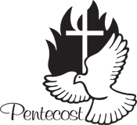](https://www.churchart.com/subscriber/viewimages?topic_id=163&image_type=cl,ph,pp,bc,ca,mv,wt,nt,pt,ft&page=5&ipp=12)Altar Servers: Ericka Frombach & Alexia Steele

Cantor: Shannon Kudlawiec

Greeter: Richard Martyak

Sunday, June 4 Collection Counters

Debbie Dupnock, Camillus Long

Mary Ann Davis, Sara Zybura

[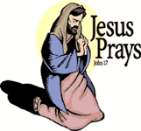](https://www.churchart.com/subscriber/viewimages?book_number=43&chapter=17&verse=1&entry_date=1/1/0001&image_type=cl)

[](http://www.churchart.com/Subscriber/ViewImages.aspx?keywords=&entry_date=1/1/0001&image_type=,cl&topic_id=346&image_source_id=&page=1#no)Weare placing names of the sick in the bulletin for prayer providing they give permission. Although we remember all sick and shut-ins at every Mass, we would like our parish family to be aware of the need for special prayer intentions because of a most serious illness or hospital stay. *May the* *Divine Physician send healing grace for those for* *whom we pray:* Allen C. Rosemas, Patricia Murphy, Bernice Myers, Dwight Fyock, Lori Facciani, Dylon Wills, Dawn Hagen, Debbie Dibert, Missy, Joanne (Kolar) Hufford, Christine Flanagan, Ayden Alan Grata, Remy Beaver, Mary Lou Offman, Marian Chuckalovcak, Arlene Diamond, Mary Zangaglia, Dorothy Rosemas, Natalie Zerby, Patricia Grata, Michael Wadsworth, Valencia & Frank Tursi, Homer Locher, Brayden Schofield, Michelle Kasper, Diane Kingera, Allison Krischer, Ted Paluch, Brandt Hutzel, Pearl Litzinger, Patrick Munro, Fran Baldassarre, Corey Lybarger, Kristen Sinosky Long, Helen Ranieri, Cresta Micik, Loretta Panick, Basil Costantino, Madison McCrory, Laura, Maria, Joe Yoder, Dolores Yanzetich, Sandy Krug, Wanda Gramling, Merna Smay, Muriel “Jean” Wiesheier, Heidi Allison, Agnes Plummer, Jennifer Hagans, Katie Ansell, Mary McCall, Sean, Holly, Shane, Melisa Ruddek, Patrick O’Donnell, Owen Taylor, Keith Hoyer, Gail Faher, Marjorie (Latshaw) Feldman, Jayden Scott Beam, Derrick Varnish, Daniel Koshute, Vincent Koshute, Karen Lovrich, Melissa Cordek, Ron Ripper, Sr., Michelle Elliott, Shannon Meyers, Heather Romanow, Mackston Barrick, Connor Thomas, Erin, Pat, Mary Agnes Nastase and all of the sick of our parish, the homebound, those in nursing homes, those who care for them, and those in the military along with their families. (Please call the Rectory to have your name removed from the list when no longer seriously ill. Thank You.)

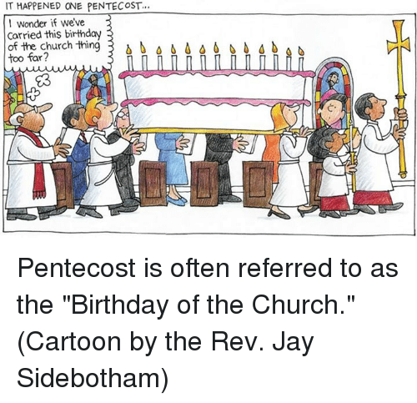

LAST WEEK’S COLLECTION

Adults $ 3,032.00

Loose $ 211.00

Youth $ 48.75

Monthly $ 60.00

Maintenance Fund $ 407.00

Ascension $ 977.50

Catholic Communications $ 418.00

Father’s Day $ 20.00

Cemetery Maintenance $ 529.00

Candles $ 52.00

Total $ 5755.25

We sincerely thank and ask God’s blessing upon all who have care and concern for our parish.

*John 3:16-18*

*Like the disciples in today’s gospel, there are times we shut the doors of our hearts to people or events. It’s how we create emotional distance. Permanent distancing is lethal and prevents the PEACE Jesus offers you today.*

MAY 2017 PARISH TICKET WINNERS

[](https://images.search.yahoo.com/images/view;_ylt=AwrB8plKK_1XrE8ADDKJzbkF;_ylu=X3oDMTIyajBlaTZqBHNlYwNzcgRzbGsDaW1nBG9pZAM0MTMxYjYxYzY5YzhiNGY5MzEwN2RhMGUyZDZiMDFjMgRncG9zAzcEaXQDYmluZw--?.origin=&back=https://images.search.yahoo.com/search/images?p%3DFree%2BClipart%2Bof%2BLottery%2BWinners%26fr%3Dyfp-t%26tab%3Dorganic%26ri%3D7&w=420&h=589&imgurl=images.clipartpanda.com/winner-clipart-clip-art-lottery-431235.jpg&rurl=http://www.clipartpanda.com/categories/winner-20clipart&size=87.3KB&name=%3cb%3eWinner%3c/b%3e+20clipart+|+%3cb%3eClipart%3c/b%3e+Panda+-+%3cb%3eFree%3c/b%3e+%3cb%3eClipart%3c/b%3e+Images&p=Free+Clipart+of+Lottery+Winners&oid=4131b61c69c8b4f93107da0e2d6b01c2&fr2=&fr=yfp-t&tt=%3cb%3eWinner%3c/b%3e+20clipart+|+%3cb%3eClipart%3c/b%3e+Panda+-+%3cb%3eFree%3c/b%3e+%3cb%3eClipart%3c/b%3e+Images&b=0&ni=192&no=7&ts=&tab=organic&sigr=11n47l7ao&sigb=139407utj&sigi=1223krgs8&sigt=12i151aj8&sign=12i151aj8&.crumb=wKQwdzP0bBS&fr=yfp-t) Day Date Amount No. Winner

Friday May 26, 2017 $75.00 271 Nikki Brezovec

Saturday May 27, 2017 $100.00 126 Nicholas Panick

Sunday May 28, 2017 $100.00 241 Bob Debias

Monday May 29,2017 $150.00 389 Vilma McKenna

Tuesday May 30, 2017 $75.00 947 Alan Pcola

Wednesday May 31, 2017 $75.00 750 Patti Raneri Doyle

**CCC** ~ Thank you for your generosity to last week’s collection for the Catholic Communication Campaign (CCC).

Your support will help the CCC connect millions of people with Christ and spread the gospel message. If you missed the collection, it’s not too late to give! Visit [*www.usccb.org/nationalcollections*](http://www.usccb.org/nationalcollections), and click on the “How to Give” link on the left.

Your text here

[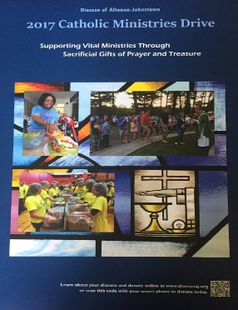](https://www.dioceseaj.org/wp-content/uploads/2017/04/Catholic-Ministries-Drive-2017.jpg)

Catholic Ministries Drive $23,811.00

Raised: $ 6.400.00

Balance: $17,411.00

Number of responses: 39

[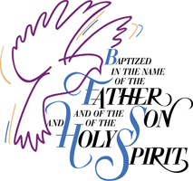](http://www.churchart.com/Subscriber/ViewImages.aspx?keywords=Baptism&entry_date=1/1/0001&image_type=,cl&topic_id=&image_source_id=&page=1#no)BAPTISM ~ On Sunday, May 28th, we celebrated the glorious baptism of Luca Joseph Tononi, son of Paul and Kerri (Krupka) Tononi by Father Brian Warchola. He became a new creation in Christ in the waters of Holy Baptism. Now joined to us by the gifts of faith, hope and charity, we warmly welcome him into our St. Michael Parish Family.

[](http://www.churchart.com/Subscriber/ViewImages.aspx?keywords=Baptism&entry_date=1/1/0001&image_type=,cl&topic_id=&image_source_id=&page=1#no)BAPTISM ~ On Sunday, May 28th, we celebrated the glorious baptism of Auden Joy, Blaken May, and Cameron Lyn, triplet daughters of Andrew and Courtney (Smay) Swanson by Father Brian Warchola. They became a new creation in Christ in the waters of Holy Baptism. Now joined to us by the gifts of faith, hope and charity, we warmly welcome them into our St. Michael Parish Family.

Liturical Reflection…

Fifty days have passed since the glorious celebration of Easter Sunday.

ORDER OF Today we remember the gift of the Holy Spirit given to the Church. It is the Spirit

that enlightens and inspires God’s holy people on way to the kingdom. It is the

Spirit of God that guides the Church until the Lord returns in all his glory. In the

CELEBRATING Sacrament of Marriage the man and woman receive the Holy Spirit as the

Communion of love of Christ and the Church. The Holy Spirit is the seal of their

Covenant, the ever-available source of their love and the strength to renew the

MATRIMONY fidelity.(Catechism of the Catholic Church Number 1624)

2017, Diocese of Altoona-Johnstown, Liturgy Office, 925 S.Logan Blvd., Hollidaysburg, PA 16648

[](https://images.search.yahoo.com/search/images;_ylt=A0LEV1kSWptXvOwAKINXNyoA;_ylu=X3oDMTEyZGdkcmRoBGNvbG8DYmYxBHBvcwMxBHZ0aWQDQjIwODlfMQRzZWMDc2M-?p=Clipart+of+a+sanctuary+candle&fr=ush-mailn_02&th=110&tw=110&imgurl=http://www.henningers.com/389-168-wall-sanctuary-lamp.jpg&rurl=http://pixshark.com/sanctuary-lamp.htm&size=43KB&name=Sanctuary+Lamp+Bronze+wall+sanctuary+lamp&h=600&w=600&turl=http://ts2.mm.bing.net/th?id%3DOIP.M68453c67108cdc5ab485d309b395bd03o0%26pid%3D15.1%26rs%3D1%26c%3D1%26qlt%3D95%26w%3D110%26h%3D110#inline&tt=Sanctuary+Lamp+Bronze+wall+sanctuary+lamp&sigr=116keh5le&sigit=13gvlt42j&sigi=11ip0pgm4&sign=119kp6100&sigt=119kp6100)

The Sanctuary Candle will burn for the health and well - being of

Erin

during the week of June 4, 2017

CHOIR PRACTICES ~ Practice for Sunday Choir is held on Monday’s at 7:00 PM. The Saturday Night Choir practices on Thursdays at 5:30 PM.

**SCHEDULES** ~ Summer Lay Ministry Schedules can be found in the back of the Church.

FIRESIDE BIBLES ~ We have three Burgundy Family Bibles - New American Bible Revised edition. The cost of the bible is $35.00. If interested in purchasing one of them, please call the rectory.

ARC COLLECTION ~ The Prince Gallitzen Council of the Knights of Columbus Council #2275 would like to thank those individuals who have contributed $706.51 so far. It is still possible to turn in your envelope with a donation. Many thanks to all for helping the people that the Arc serves. Anyone interested in joining the K of C, please contact Dave Brown at 487-5525 or any Knight member.

HEALING MASS ~ Tuesday, June 6, 2017 at 7:00 PM at the Cathedral of the Blessed Sacrament. Fr. Bill Kiel, from the Diocese of Greensburg, will be the main celebrant. All are welcome. For more information please call 814-941-3832.

FATHER’S DAY BRUNCH ~ All fathers and sons of the parish are invited to a Father’s Day Brunch in the church hall immediately following the 10:30 AM Mass on Sunday, June 18th. The ladies and girls of the parish will be preparing and serving the meal. We hope to see all the fathers and sons of the parish there!

CALLING ALL WOMEN OF THE PARISH*~* Help Needed for Father's Day Brunch. Plans are being made for the Father's Day Brunch (Sunday, June 18th) sponsored by the women of the parish and REACH students in grades 9 – 12. On Saturday after the 4:00 PM Mass help is needed to cut the fruit. On Sunday, two shifts are available from 9:00 - 10:30 AM for food preparation and 10:30 AM to 1:00 PM for cooking, serving, and cleaning up. (Good way to get service hours).  Please call Pauline Minor at 495-5165 to volunteer.  Let's show our appreciation to the Fathers and Sons of this parish family!

FAITH DAY 2017 ~ will be held on July 2nd at DelGrosso’s Amusement Park in Tipton. Bishop Mark will celebrate Mass on the park stage at 3:00 p.m., which will fulfill the Sunday obligation. A Diocesan picnic supper will be held at 5:00 p.m. Something new this year is a dessert contest! Details on Religious Education pages. Non-perishable food and cash donations will be collected for Catholic Charities of the Diocese of Altoona-Johnstown.

ST. MICHAEL OUTDOOR MASS/PARISH PICNIC ~ Fr. Brian Warchola will be having an outdoor Mass here at St. Michael on Sunday, June 25th at 10:30 AM (Weather permitting). Immediately following will be the parish picnic. Sign up sheets can be found in the back of the Church.



Religious Education And Christian Helping

June 4, 2017

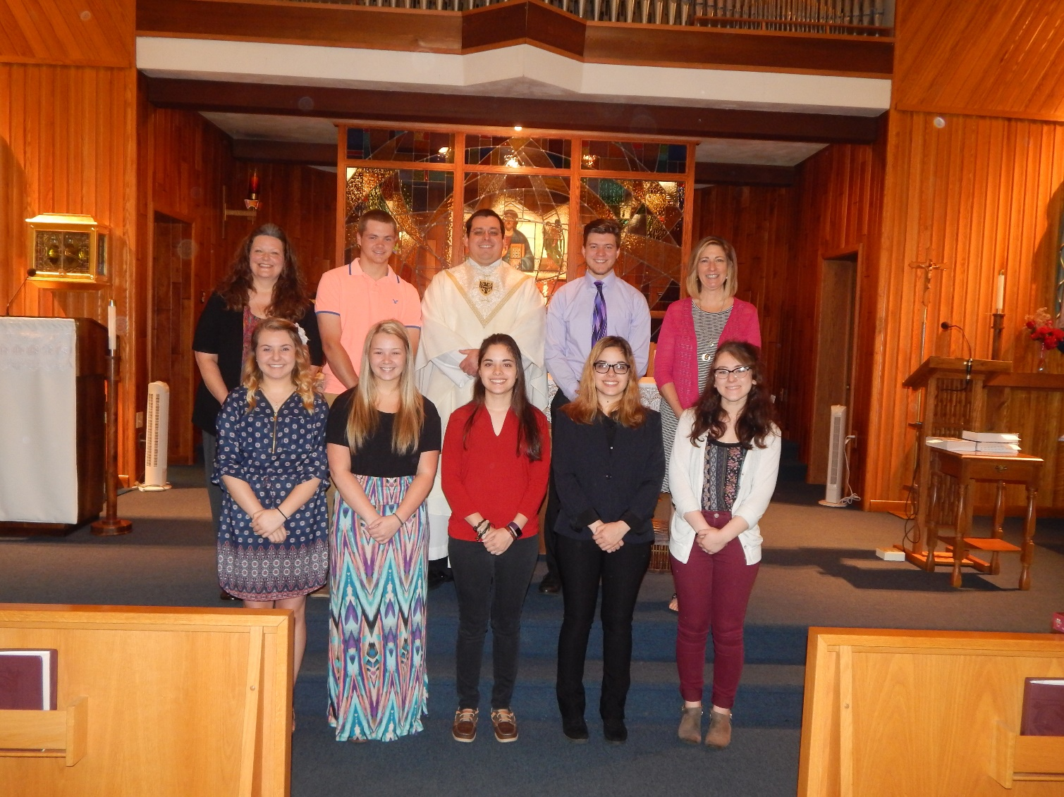Senior Sunday Celebration ~ Sunday, May 28, 2017

*Pictured Here Left to Right, Front Row: Elizabeth Burkardt, Sarah Blanchetti, Haley Cook, Ashley Cook and Elyssa Nagy. Back Row: Laurie Sloan, DRE, Nathan Kundrod, Fr. Brian Warchola, Garrett Kundrod and Missy Burkardt, Catechist.*

All of our seniors received The New Catholic Answer Bible as a gift from our parish. *Alll seniors that returned and completed their 12th grade year of Religious Education here at St. Michael Parish are eligible to receive a $300 Higher Education Grant offered by the parish toward continuing their education. The seniors in attendance for our Senior Sunday celebration:*

Elizabeth Burkardt, daughter of Ken and Missy Burkardt, plans to attend Mount Aloysius College and study to become an Ultrasound Technician.

Sarah Blanchetti, daughter of Robert and Jennifer Blanchetti. plans to attend Robert Morris University and study Nursing.

Haley Cook, daughter of Wayne and Tonya Cook. plans to attend Indiana University of Pennsylvania and study Art History. Haley serves our parish as an Altar Server.

Ashley Cook, daughter of Wayne and Tonya Cook, plans to attend Shippensburg University and study Psychology. Ashley serves our parish as an Altar Server.

Elyssa Nagy, daughter of Louis and Susan Nagy, plans to attend Mount Aloysius College and study Nursing. Elyssa serves our parish as an Altar Server.

Nathan Kundrod, son of Paul and Beth Kundrod, plans to attend The University of Pittsburgh at Johnstown and study Civil Engineering. Nathan serves our parish as an Altar Server.

Garrett Kundrod, son of Gary and Brenda Kundrod, plans to attend The University of Pittsburgh at Johnstown and study Civil Engineering. Garrett serves our parish as an Altar Server.

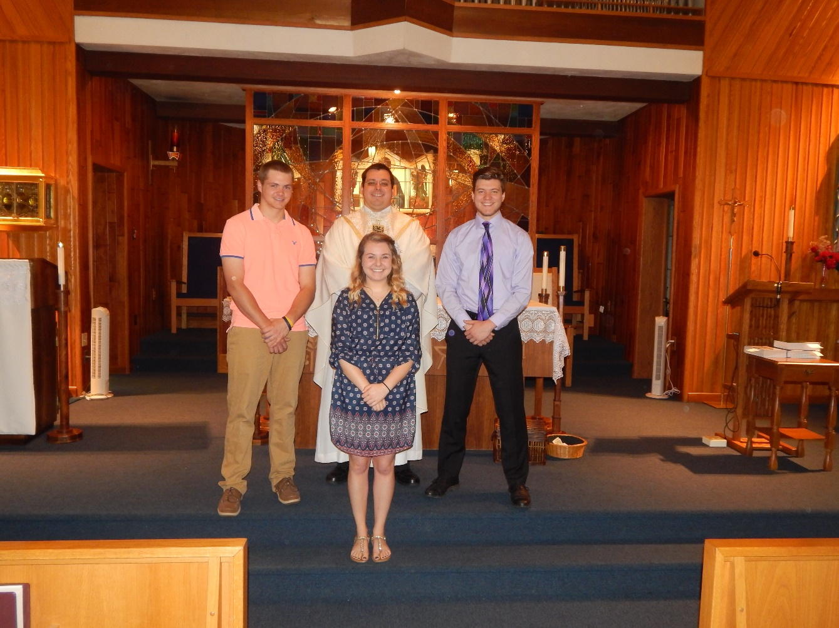

The $250 REACH Service Award recipients are:

Elizabeth Burkardt, Garrett Kundrod

and Nathan Kundrod,

Their combined cumulative service while in REACH is over 500 hours.

Nathan Kundrod, Elizabeth Burkardt and Garrett Kundrod

Presentation of our $250.00 REACH Service Award: Each year, a $250 REACH Service Award is given to three seniors who rank the highest in individual cumulative service hours throughout their participation in the REACH program. This service includes all REACH and church sponsored aspects of service to the community along with fundraisers.

In 2007, The REACH Service Award was initially funded through a monetary donation made in honor of a member of our faith community. This award was created through a specific endowment fund with The Community Foundation for the Alleghenies to benefit youth members of the St. Michael REACH Youth Ministry Program here at Saint Michael Catholic Church. This award is only offered to the senior class members that attend their 12th Grade year of Religious Education classes throughout.

********************************************************************************** Upcoming REACH Service Projects

Flower Planting on Church Grounds ~ REACH student help is needed this Tuesday, June 6 at 1:00 p.m. to plant our annual flowers around the church grounds.

Father’s Day Brunch ~ The Father’s Day Brunch is scheduled for June 18th. REACH girls are needed to help with preparation, serving and clean-up. / Timeframe option: 9 AM to 1 PM.



Summer Vacation Bible School ~ Plans are underway for Vacation Bible School with Most Holy Trinity and Saint Bartholomew Parishes combined. It will be held at Saint Bartholomew Church Hall on July 11th, 12th & 13th from 6-8 p.m. Our Saint Michael students have been invited to participate.

REACH students, parents and catechists are invited to help with preparing for and helping with VBS. There is a need for a Bible Story leader and crew leaders, someone for skits, photographer, and audio visual person. A planning meeting is scheduled for Thursday, June 8 at 6:30 p.m. at Saint Bartholomew Hall.

Registration forms for participants and volunteers are available at our church entrances. Any questions can be directed to Betty at MHT Parish at 495-4419 or email [secretarybr@gmail.com](mailto:secretarybr@gmail.com).

Any students in need of service hours, these events are a good opportunity for receiving them.

**********************************************************************************

Basic Catechist ~ Adult Enrichment Class Being Offered:

A Ten week Basic Catechist Video/Discussion Class is scheduled for Thursday mornings from 9-11am at Most Holy Trinity Parish Hall, South Fork beginning June 8. The cost is $5 for each session to cover the cost of each book.  If any catechist is interested in certification or any parishioner would like to attend for personal enrichment, please call Betty at 495-4419 or email secretarybr@gmail.com to register. This is a Diocesan Certified class open to everyone.

2017 Diocesan Summer Camps ~ Camp Zacchaeus and Camp Timothy

Registrations for our diocesan summer camps,

Camp Zacchaeus and Camp Timothy are currently being accepted. Registration brochures are available at the church entrances.

Camp Timothy takes place June 18—22, 2017.

Camp Zacchaeus takes place two weeks: July 16—21 or July 23—28.

Registration deadline for Camp Z is June 23, 2017.

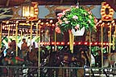 FAITH DAY

Sunday, July 2, 2017

*Sponsored by the Diocese of Altoona-Johnstown*

*Highlights of Faith Day 2017 include:*

Liturgy with Bishop Mark at 3:00 PM With Music by the Greater Johnstown Youth Chorale

* A picnic with delicious DelGrosso’s Food! (5:00 PM) after Liturgy - Pavilion #2

Picnic tickets can be purchased by June 26th from the Youth Ministry Office at (814)693-1401 Ext. 2646.

*(Meal Ticket order forms are also at the church entrances or in the parish office)*

* Non-perishable food item or cash collection to benefit Catholic Charities!
* *Best DAJ Dessert Contest! (Must pre-register by June 26th-forms at [www.diocese.org](http://www.diocese.org))
* Discount All Day Fun Passes! (Available at [www.dioceseaj.org/youthministry](http://www.dioceseaj.org/youthministry))

~All Day Fun Passes are available for a reduced rate of $20 a ($29.95 value) with a diocesan Faith Day vouchers that are available at our church entrances, the Diocesan Youth Ministry Office, or in Pavilion #2 on Faith Day.

*\*DAJ Best Dessert Contest 2017!*

*A cup of Sugar…and a pinch of Faith!! I’ve got Faith in my Dessert!*

*Do you have that special dessert that you are known for?*

*The one that everyone asks you to bring to parties, potlucks and special events?*

*Then YOU need to enter it in our FAITH DAY 2017 DESSERT CONTEST!!*

*\*Who is Eligible? Anyone who can create that special dessert to impress the panel of judges! *What can I make? Any dessert—pies, cakes, cookies, cupcakes, whatever is your specialty!*

*All those entering a dessert must complete a registration form and return it to the Diocesan Youth Ministry Office no later than June 26th. Winners will be awarded 1st, 2nd, and 3rd Place Ribbons. First prize winner will also receive a Deluxe Baker’s Gift Basket! Registration forms are at the church entrances or in the parish office.*

*Enter today and bring your best dessert to Faith Day on July 2nd!*

Sunday, June 4 Pentecost Sunday

Monday, June 5 No Mass

Sunday Choir Practice / 7:00 PM

Tuesday, June 6

Wednesday, June 7

Thursday, June 8 Saturday Choir Practice / 5:30 PM / Church

Friday, June 9

Saturday June 10 Mickus / Minor Wedding

Second Sunday Food Collection

Sunday June 11 Second Sunday Food Collection

[](https://www.bing.com/images/search?q=clipart+of+a+ferris+wheel&id=5E00D2E3AC446CC3BE276C458DB1344CEC85C560&FORM=IQFRBA)

UPCOMING EVENTS

June 18 Father’s Day Brunch after 10:30 AM Mass / Hall

June 25 10:30 AM Outdoor Mass / Parish Picnic

Peter’s Pence Collection

July 2 Faith Day at Del Grosso’s Amusement Park

OUTDOOR MASSES ~ Father John D. Byrnes, Rector, and the Parish Family of St. Michael the Archangel Basilica, Loretto, invite the faithful to join us each Sunday evening at 7:00 p.m. for the outdoor Sunday Mass at the beautiful Shrine of Our Lady of the Alleghenies in Loretto. The first Mass of the season will be celebrated on Sunday, May 28, 2017 and will continue through Labor Day Weekend, September 3, 2017. Please bring a lawn chair. In the event of inclement weather, the Mass will be held in the Basilica of Saint Michael the Archangel.

COMMUNITY BAND ~ The Forest Hills Community Band will present their annual Spring Concert Series throughout the area. All are welcome! If weather permits, concerts will be held outdoors - so please bring chairs. Sunday, June 4th, South Fork UM Church 7 PM.

WINE TASTING ~ Second Annual Wine Tasting Event. Saturday, June 3, 2017, 7:00 – 10:00 PM at Holy Family Parish, Caldwell Avenue, Portage, PA. $20 in advance; $25 at the door. For tickets call Janet @ 487-5106 or the Parish Office @ 736-4279.

MHT WINE TASTING ~ Most Holy Trinity, South Fork on Friday June 16th from 5:30-8:30 PM. Music by Roy Milstead. Tickets are $10 at the South Fork Library or call Patti 322-8840 or at the door. Must be 21 to attend.

HOLY NAME PARISH, EBENSBURG, is sponsoring its 56th Annual Festival on June 2, 3 & 4 featuring a Fish Dinner on Friday from 4–7:00 PM, (Adults $10, children under 12 $5.) Turkey Dinner on Sunday from 11:30 AM to 6:00 PM, (Adults $9.00, children under 12 $4.50). Take outs available.

SPAGHETTI DINNER ~ The Benscreek Club Ladies Auxiliary at 138 Club Road in Lilly, PA is holding a Spaghetti Dinner, Basket Raffle, and Signature HomeStyles benefit on June 10th from 1:00 – 5:00 PM at the Benscreek Club. Benefit is for Michelle Elliott from Cresson, PA who was recently diagnosed with Multiple Myeloma. Any questions or if you would like to donate, please feel free to contact Joyce LaRue at 814-886-5308