John 6:54

ST. MICHAEL ROMAN CATHOLIC CHURCH

PO Box 103

St. Michael, Pennsylvania 15951

Rev. Brian L. Warchola, Administrator MASSES:

(814) 495-9640 Saturday 4:00 pm



Sunday Morning 8:00 am

Secretary: Michele Panick 10:30 am

Bookkeeper: Kathy Kalicky Daily Mass See Bulletin

DRE: Laurie Sloan Holy Days See Bulletin

Maintenance: Rodney Turgeon

Office Hours:

PHONES: 8:30 am to 3:30 pm

Rectory / Office: (814) 495-9640 Monday, Tues., Thurs., Friday

Fax: (814) 495-9424 Confessions:

Rel. Education: (814) 495-4873 Saturday 3:30 pm to 3:45 pm

Parish Website Sunday 7:30 am to 7:45 am

www.saintmichaelchurch.weebly.com 10:00 am to 10:15 am

Secretaries’ E-mail Anytime Requested

[saintmichaelsecretaries@yahoo.com](mailto:saintmichaelsecretaries@yahoo.com)

YEAR: 2018 NUMBER: 40

SERVING GOD AND COMMUNITY FOR OVER ONE HUNDRED YEARS!

BAPTISM: By Appointment. Reserve at least one month in advance.

Preparation classes are necessary.

MARRIAGE: Plan at least nine months in advance.

Preparation sessions are necessary.

FUNERALS: Arrangements are made in conjunction with the funeral home.

Eulogies should be given at the funeral home at the time of the wake service or at the luncheon.

REGISTRATION Those new to the area, newlyweds, and single adults, (even if registered

and before with their families) are asked to register by calling the Parish Office.

MEMBERSHIP: Every parishioner must be registered. This is a condition for admission

to our Program and reception of the Sacraments of Baptism, Confirmation, First Penance, First Eucharist, and Matrimony; also, for testimonial letters or sponsorship of Baptism and Confirmation outside the Parish.

VISITATION: We are concerned and want to be advised when someone is ill at

home or in the hospital. Call the rectory to have the shut-in placed on our monthly Holy Communion calls or seriously ill prayer list.

SACRAMENTAL Parish registration and active Mass participation for Baptism is

POLICY: encouraged and is required for Marriage.

BULLETIN ARTICLES: Articles are due to the Parish Office by Noon on Tuesdays.

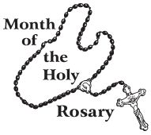 Twenty-seventh Sunday in Ordinary Time

October 7, 2018

**Month of The Holy Rosary**

**MASS INTENTIONS**: (October 8 – October 14, 2018)

Monday 8:00 AM Mary Yvonne Le Jeune req. by Elaine Barton

Tuesday 8:00 AM Fritzie & Michael Beaver req. by Family

Wednesday No Mass

Thursday 8:00 AM Barbara Michaels req. by husband Blaise

Friday 8:00 AM Theresa Fleck req. by Jim Bertolino & Family

Saturday 4:00 PM People of the Parish

Sunday 8:00 AM Walter Christ req. by Susan, Steve, Dolores & Evan Yanzetich

Sunday 10:30 AM Mary McCall req. by Nick & Pauline Minor

LITURGICIAL APPOINTMENTS:

Saturday, October 13 4:00 PM Offertory Procession

Lector: Donald Dipko Ed & Karen Myers

Minister of the Host: Helen Slonac

Ministers of the Cup: Alice Podrebarac & Susan Blazosky

Altar Servers: Ana & Eva Spangler

Cantor: Amy Spangler

Greeter: Shirley Walls

Sunday, October 14 8:00 AM Offertory Procession

Lector: Arnold Bernard Walter Christ Family

Minister of the Host: Tracy Yakicic

Ministers of the Cup: Cathy Faher & Pauline Minor

Altar Servers: Griffen & Kaden Christ

Cantor: Sharon Dibble

Greeter: Carol Hautz

Sunday, October 1410:30 AM Offertory Procession

Lector: Sandy Bambino Bob & Laurie Sloan

Minister of the Host: Robert Oshaben

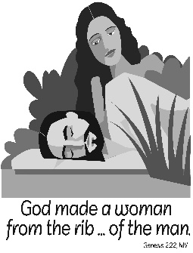Ministers of the Cup: Michael & Jennifer Steele

Altar Servers: Haidyn & Amilyah Koch

Cantor: Amy Dobbins

Greeter: Cheryl Macy

Sunday, October 14 Collection Counters

Mary Ann DeRosa, Rod Kundrod

Sara Zybura

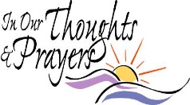Weare placing names of the sick in the bulletin for prayer providing they give permission. *May the* *Divine Physician send healing grace for those for* *whom we pray:* Allen C. Rosemas, Patricia Murphy, Bernice Myers, Dwight Fyock, Lori Facciani, Dylon Wills, Dawn Hagen, Debbie Dibert, Missy, Joanne (Kolar) Hufford, Christine Flanagan, Ayden Alan Grata, Mary Lou Offman, Mary Zangaglia, Dorothy Rosemas, Natalie Zerby, Patricia Grata, Michael Wadsworth, Valencia & Frank Tursi, Homer Locher, Brayden Schofield, Michelle Kasper, Diane Kingera, Allison Krischer, Ted Paluch, Brandt Hutzel, Pearl Litzinger, Patrick Munro, Fran Baldassarre, Corey Lybarger, Kristen Sinosky Long, Helen Ranieri, Cresta Micik, Basil Costantino, Madison McCrory, Laura, Joe Yoder, Dolores Yanzetich, Sandy Krug, Wanda Gramling, Merna Smay, Muriel “Jean” Wiesheier, Agnes Plummer, Jennifer Hagans, Shawn, Holly, Shane, Spencer, Owen Taylor, Keith & Dawnetta Hoyer, Derrick Varnish, Daniel Koshute, Vincent Koshute, Karen Lovrich, Melissa Cordek, Michelle Elliott, Heather Romanow, Mackston Barrick, Connor Thomas, Erin, Pat, Mary Agnes Nastase, Mary Ann Bertolino, Dick Wilson, Izzy Bihun, Erica Mitzelfeld, Dorothy Kaminsky, Ed Ripper Sr., Patricia Oshaben, Craig Kraber, Ashlee Madison, Susan Yanzetich, Mike, Mary Sivec, Danika Faith, Alina Rusnak, Fern Swartzentruver, Marcia Costlow, Gary Smay, Elizabeth Howell, Charles Smith, Mary Ann Cover, Helen Bowen, Bill Gideos, James Macy, Walter Bodziak, Rhonda, Dan Strinkoski, Anne Robinson, Marlene McCrory, Sharon Poldiak, Carter Bobak, Vince Arena, Mike Morris, Georgetta (Minor) Moreau, Sarah Kelt and all of the sick of our parish, the homebound, those in nursing homes, those who care for them, and those in the military along with their families. *(Please call the Rectory to have your name removed from the list when no longer seriously ill. Thank You.)*

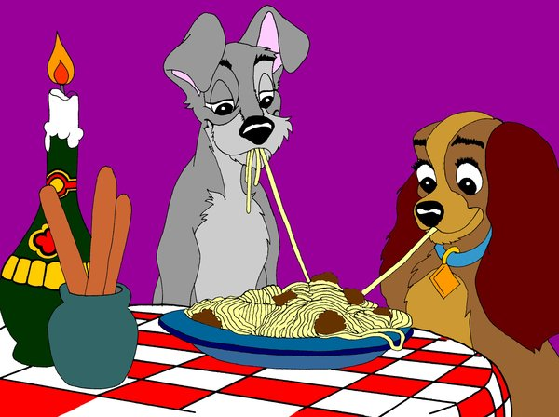

LAST WEEK’S COLLECTION

Adults $2,842.00

Loose $ 214.00

Youth $ 34.00

Monthly $ 205.00

Candles $ 17.00

Maintenance Fund $ 75.00

Retired Priests Medical $ 841.00

Total $4,228.00

We sincerely thank and ask God’s blessing upon all who have care and concern for our parish.

*October 7, 2018 Mk 10:2-16*

*In today’s gospel Jesus encourages married couples to throw away the marriage rule book. Rules are for those with “hardened hearts.” Married couples are called to be a sacramental reflection of God’s faithful and selfless love…a place where people live and love beyond rules and formulas.*

OCTOBER 2018 PARISH TICKET WINNERS

[](https://images.search.yahoo.com/images/view;_ylt=AwrB8plKK_1XrE8ADDKJzbkF;_ylu=X3oDMTIyajBlaTZqBHNlYwNzcgRzbGsDaW1nBG9pZAM0MTMxYjYxYzY5YzhiNGY5MzEwN2RhMGUyZDZiMDFjMgRncG9zAzcEaXQDYmluZw--?.origin=&back=https://images.search.yahoo.com/search/images?p%3DFree%2BClipart%2Bof%2BLottery%2BWinners%26fr%3Dyfp-t%26tab%3Dorganic%26ri%3D7&w=420&h=589&imgurl=images.clipartpanda.com/winner-clipart-clip-art-lottery-431235.jpg&rurl=http://www.clipartpanda.com/categories/winner-20clipart&size=87.3KB&name=%3cb%3eWinner%3c/b%3e+20clipart+|+%3cb%3eClipart%3c/b%3e+Panda+-+%3cb%3eFree%3c/b%3e+%3cb%3eClipart%3c/b%3e+Images&p=Free+Clipart+of+Lottery+Winners&oid=4131b61c69c8b4f93107da0e2d6b01c2&fr2=&fr=yfp-t&tt=%3cb%3eWinner%3c/b%3e+20clipart+|+%3cb%3eClipart%3c/b%3e+Panda+-+%3cb%3eFree%3c/b%3e+%3cb%3eClipart%3c/b%3e+Images&b=0&ni=192&no=7&ts=&tab=organic&sigr=11n47l7ao&sigb=139407utj&sigi=1223krgs8&sigt=12i151aj8&sign=12i151aj8&.crumb=wKQwdzP0bBS&fr=yfp-t)

Day Date Amount Number Winner

Monday October 1, 2018 $ 75 627 No Winner

Tuesday October 2, 2018 $ 75 569 Mike Kachmar

Wednesday October 3, 2018 $ 75 012 Rita Russell

Thursday October 4, 2018 $ 75 649 Jodi Myers

HEALING MASS ~ On Monday, October 8, at 7:00 PM, at the Cathedral of the Blessed Sacrament. Fr. Bill Kiel, from the Diocese of Greensburg, will be the main celebrant. All are welcome, especially those in need of physical, emotional or spiritual healing and those who support and care for them as well. Music for the Mass will be led by the Cathedral Prayer Group Music Ministry. For more information, please call 814-941-3832.

LEGION OF MARY ~ Is holding its *Annual Rosary Devotion with Mary, on Sunday, October 14th at 3:00 PM* at St. Nicholas Roman Catholic Church, Nicktown. All are invited to attend. Students from local grade schools and high schools are encouraged to participate in the “Living Rosary.” If any student is interested in participating, please contact Monica Ludwig (814-948-8776) or Mary Ellen Zunich (814-948-7928). Practice dates will be on Tuesday, September 25th & Tuesday, October 2nd from 6 – 6:45 PM.

EXPOSITITON OF SACRED RELICS ~ Monday, October 8th at 6:00 PM at St. John the Baptist Byzantine Catholic Church, 606 Maple Ave., Johnstown. Fr. Carlos Martins will bring over 150 relics, some as old as 2000 years. Among the treasures will be relics of St. Maria Goretti, St. Therese of Lisieux (the Little Flower), St. Francis of Assisi, St. Anthony of Padua, St. Thomas Aquinas, and St. Faustina Kowalsk. There will also be present a portion of the veil of our Lady, as well as one of the largest remaining pieces of the True Cross in the world. You are encouraged to bring your articles of devotion (rosaries, holy cards, etc.) and pictures of ill friends/family members which you will be able to touch to the reliquaries as means of intercession. A free will basket will be available for those that wish to make a donation.

ADULT ENRICHMENT OLD TESTAMENT CLASS ~ Education is a lifelong journey. Classes are offered through the *Office of Adult Enrichment and Lay Ecclesial Ministry* to help nurture YOUR faith. The 8-week course Old Testament will be offered in two locations this fall. Beginning Tuesdays, October 30th, Fr. Brian Saylor will be teaching at St. Rose of Lima, Altoona and on Wednesdays, October 31st, Fr. Peter Crowe will be teaching at St. Patrick School, Johnstown. Class time for both locations is 6:30-8:30 PM. Class information and registration forms are available online at [www.dioceseaj.org/lay-ecclessial-ministry/](http://www.dioceseaj.org/lay-ecclessial-ministry/) or by contacting Marybeth at (814) [361-2000/mheinze@dioceseaj.org](mailto:361-2000/mheinze@dioceseaj.org). All are welcome to attend!



Catholic Ministries Drive $24,043.00

Raised: $11,605.00

Balance: $12,438.00

Number of responses: 87

Thank you to all parishioners who have responded to the *2018 Catholic Ministries Drive.* Please join them in supporting our Parish and a select group of ministries that provide outreach to the poor, family life, youth and seminarians. If you did not receive a pledge card in the mail, you may give online at [www.dioceseaj.org](http://www.dioceseaj.org).

.

[](https://images.search.yahoo.com/search/images;_ylt=A0LEV1kSWptXvOwAKINXNyoA;_ylu=X3oDMTEyZGdkcmRoBGNvbG8DYmYxBHBvcwMxBHZ0aWQDQjIwODlfMQRzZWMDc2M-?p=Clipart+of+a+sanctuary+candle&fr=ush-mailn_02&th=110&tw=110&imgurl=http://www.henningers.com/389-168-wall-sanctuary-lamp.jpg&rurl=http://pixshark.com/sanctuary-lamp.htm&size=43KB&name=Sanctuary+Lamp+Bronze+wall+sanctuary+lamp&h=600&w=600&turl=http://ts2.mm.bing.net/th?id=OIP.M68453c67108cdc5ab485d309b395bd03o0&pid=15.1&rs=1&c=1&qlt=95&w=110&h=110#inline&tt=Sanctuary+Lamp+Bronze+wall+sanctuary+lamp&sigr=116keh5le&sigit=13gvlt42j&sigi=11ip0pgm4&sign=119kp6100&sigt=119kp6100)

The Sanctuary Candle will burn for

The Sick and Shut-Ins of Our Parish

during the week of October 7, 2018.

THANK-YOU! ~ On behalf of the Discalced Carmelite Nuns of Loretto, and Mother John of the Cross, thank you all for your many donations to the sisters. They were overwhelmed with joy once again to receive such generosity from our parish. I can honestly say, I do not know of any other religious community that dedicates themselves to prayer more than the Carmelite Nuns. Thank you again; you will be blessed by God for your generosity!

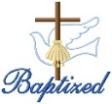

BAPTISM ~ On Saturday, September 29th, we celebrated the glorious baptism of Matthew Michael Nemec, son of Justin Nemec and Marissa Lashley by Father Brian Warchola. He became a new creation in Christ in the waters of Holy Baptism.

[](http://www.churchart.com/Subscriber/ViewImages.aspx?newartdate=6/13/2016#no)

MARRIED IN CHRIST ~ We extend warmest congratulations to Kayla Fetzer and Jared Kostan who were joined in Holy Matrimony on September 29th by Father Brian Warchola. Made one in Christ as husband and wife, we pray they grow in faith, love and trust in the years ahead. Kayla is the daughter of David & Cynthia Fetzer and Jared is the son of Jeff and Michelle Kostan.

SPAGHETTI DINNER ~ St. Michael Spaghetti Dinner will be held this Sunday, October 7th in the Church Hall from 11:30 AM – 2:00 PM. Tickets are: Adults – $8.00, Kids (5 – 12) - $5.00, Kids under 5 are free. Take outs are available. Everyone Welcome!

OFFICES CLOSED ~ Offices will be closed on Monday, October 8th due to the Columbus Holiday.

HOLY NAME SOCIETY ~ Will be having their monthly meeting Sunday, October 14th after the 8:00 AM Mass.

COFFEE & DONUTS ~ The Holy Name Society will be having coffee & donuts next Sunday, October 14th after the 8:00 & 10:30 AM Masses. Everyone Welcome!

SECOND SUNDAY FOOD COLLECTION ~ Next weekend is our Second Sunday Food Collection. Please bring in non-perishable food items or toiletries with you. Monetary donations are also appreciated.

PRAYER CARDS ~ There are some prayer cards left in the bridal room. Price for the cards are 10 for $1.00.

PARISH COUNCIL MEETING ~ Will be next Sunday, October 14th, after the 10:30 AM Mass.

*Stewardship Reflections…*

Today’s readings remind us that God is the Origin of life itself. Thank Him throughout your life by serving others with your time, talent, and treasure.

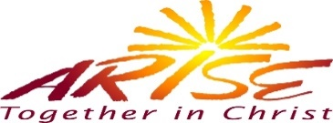



Religious Education And Christian Helping

October 7, 2018

REACH Service Project

WPA Road Clean-up – Saturday, October 13, 2018 – Our Fall WPA Road Clean- up is scheduled for this Saturday, October 13, 2018 at 10:00 AM.

REACH student volunteers as well as Parent chaperones are needed to make this service project a success.

The cleanup will last approximately 1-½ hours (10:00 a.m. to 11:30 a.m.) and then lunch will be provided following the clean-up with our project being complete by 12:30 p.m. for pick up.

Adult / Student Permission / Liability forms are available at the church entrances and during RE classes.

PARTICIPATION IS NOT PERMITTED WITHOUT RETURNED FORMS.

Volunteer Safety is of primary importance!

*********************************************************************************

*Fall Confirmation Session 11 A ~*

*The Rite of Confirmation: Sunday, October 21, 2018*

All 11th Grade students will be attending their Fall Session 11A from 9 to 10:30 a.m. in the Saint Paul Room to fulfill this session requirement.

*\* If the students miss this scheduled session, they are required to attend another*

*parishes scheduled session to fulfill these requirements.*

**********************************************************************************

Our Diocese of Altoona-Johnstown has posted the schedule for Confirmation Masses being celebrated by Bishop Mark L. Bartchak in the Easter season of 2018. Our Saint Michael Parish Confirmation Mass is scheduled for *Thursday, April 25, 2019* at 7:00p.m. and will be held at

Saint John Gualbert Cathedral in Johnstown.

11th Grade Confirmation candidates: With the April 25, 2019 Confirmation date set, keep in mind that as a candidate, you are required to secure at least 25 community service hours for the 11th Grade year by March 1, 2019 to be eligible to receive the sacrament of Confirmation. Community service hours can be acquired within our church through our REACH Youth Ministry Projects or from outside our church community by submitting an individual Service form for each service signed by an adult overseeing that service.

SHYCON 2018 ~ Attention-All High School Students in Grades 9—12, SHYCON 2018 is scheduled for Sunday, October 28, 2018 at the Stokes Center, at Saint Francis University in Loretto.

Our keynote speaker for SHYCON 2018 is Paul J. Kim. Paul has a very special form of faith sharing and a message that really engages our youth! He will encourage them and ignite the fire of faith in them! Check him out on YOUTUBE!

This year’s theme is “STRONG AND COURAGEOUS.” It comes from Joshua 1:9. The message helps us to remember God is with us no matter what happens in our lives! Good or bad he will guide us through.

Registration forms are available and will be giving to students in RE class. The $20 registration fee will come from REACH Youth Ministry funds for students attending.

*This year during SHYCON, we will once again participate and have the chance to pack meals for the hungry. All groups will be packing individual meals with the supplies provided on site that will be boxed and delivered to those in need by the organization Rise Against Hunger.*

Registration forms are due back to our RE Office by Thursday, October 11th.

Saint Michael Parish . . . .You can be a part of SHYCON 2018 !!!

Helping Hands RISE AGAINST HUNGER!!!



CALLED TO Be Disciples! How will you answer??

Please—Help us help others!!

*We are looking for individuals, groups or businesses that would like to participate in SHYCON with us by helping us to purchase the kits needed for our youth to pack these meals for the hungry. This way more than just the participants can participate in the Corporal Work of Mercy! We are hoping this year that more groups will consider collecting at the parish level and donating those funds for the project.*

Lend A Helping Hand!! Every Donation Helps!!

*Your monetary donation will help purchase kits for those that might otherwise go hungry!*

Make checks payable to:

Diocese of Altoona-Johnstown

Helping Hands Project

933 S. Logan Boulevard

Hollidaysburg, PA 16648

For more information, or to make a donation, contact Francine Swope in the Diocesan Youth Ministry Office at (814)317-2646 or by email at [fswope@kioceseaj.org](mailto:fswope@kioceseaj.org)

 Sunday, October 7 High School Religious Education / 9 – 10:20 AM

Spaghetti Dinner / 11:30 AM – 2:00 PM

Girl Scouts Meeting / 4 – 5:30 PM

Monday, October 8 Offices Closed

Martha’s Group / 6:00 PM

Sunday Choir Practice / 7:00 PM

Tuesday, October 9

Wednesday, October 10 No Mass

Parish Directory Pictures / 2 – 9:00 PM

Thursday, October 11 K - 5 Religious Education / 3:30 – 4:30 PM

Saturday Choir Practice / 5:30 PM

Parish Directory Pictures / 2 – 9:00 PM

Friday, October 12 Parish Directory Pictures / 2 – 9:00 PM

Saturday, October 13 Parish Directory Pictures / 10:00 AM – 5:00 PM

Second Sunday Food Colleciton

 UPCOMING EVENTS

October 14 Second Sunday Food Collection

Holy Name Meeting

Holy Name Coffee & Donuts

Parish Council Meeting

October 18 Knights of Columbus Meeting

Girl Scout Service Unit Meeting

October 20 & 21 World Mission Sun

SOUP, BREAD & DESSERT SUPPER ~ Wednesday, October 10th, 4:00 PM -? Marian Hall, New Germany Church. Sponsored by Knights of Columbus and Ladies Court. Free will donation. All proceeds benefit St. Vincent De Paul Food Pantry.

SPAGHETTI DINNER ~ St. Anthony of Padua, Windber. Sunday, October 21, 11 AM – 2 PM, Church Hall. Adults - $8, Children - $4. Everyone is welcome! Take-outs are available.

KNIGHTS OF COLUMBUS ALL SAINTS ASSEMBLY 954 ~ Is sponsoring a Spaghetti Dinner & Basket Party on Sunday, October 14 from 11:00 AM till 3:00 PM at the St. John Gualbert Cathedral Parish Hall, located at 110 Adams St. in Johnstown. Please join your local Knight of Columbus for an afternoon of Catholic fellowship and dinner, and a Chinese Auction/basket party! Meals are $8 per person, with children under 5 free.

NIGHT AT THE RACES ~ St. Demetrius Church in Gallitzin is sponsoring a “Night at the Races” on October 20th held at the church’s Social Hall. Doors open at 5:00 PM and race will start at 6:00 PM. The $25 will get you a horse (while they last) for one race and admission for you and a guest. $10 for a single admission only. Eat-in meal and refreshments will be available. PA SGOC #18-12. To reserve your horse, please call Brenda Smithmyer at 207-5894.

BIRTHRIGHT BASKET PARTY ~ Sunday, Oct. 28 at the Richland Fire Hall from 11 AM – 2 PM. Drawing @ 1:00 PM. $10 includes 25 chances and luncheon. Big prize table and loads of gift baskets. Call Mary Kay @ 535-8231 for tickets.

First Responder Mass

September 30, 2018

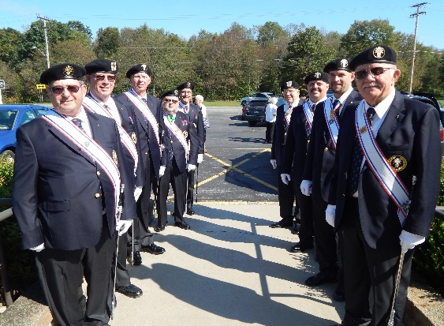

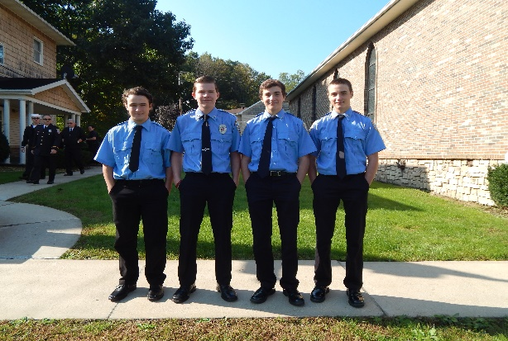

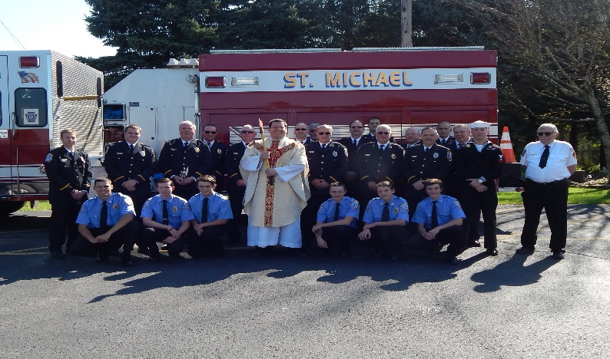

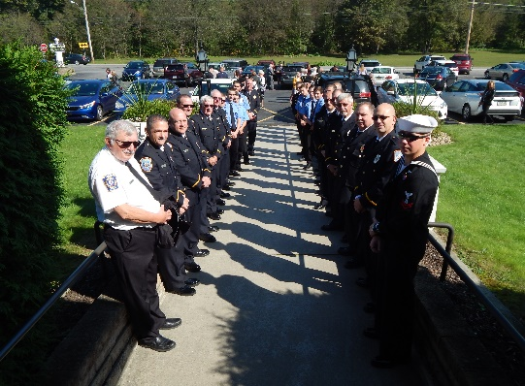



SINCERE GRATITUDE! ~ On behalf of the entire St. Michael Parish, I would like to thank Sara Zybura for her great act of generosity. Since the Bernards painted our buildings this summer, many have asked me about painting the tops of the buildings. This would require professional painters, who have been contacted and agreed to start working on it. Sara has generously offered to donate the funds to cover the cost of the painting. This is my idea to publicly thank her. This is a great act of charity by Sara who, we all know, loves St. Michael Parish. Thank you again Sara; we are eternally grateful! God Bless!

*Fr. Brian*

OUR SAINT MICHAEL CHURCH DIRECTORY

We are getting ready to create a new photo directory and we need you to help make it complete! Our directory will showcase our families, provide contact information, and become a useful resource to keep us connected. By participating, you will receive a printed version of the new directory. Photographs create priceless family treasures and are great gifts. Signup sheets are available this weekend.

Photos will be taken in our church hall. Please check your calendar. Below are the scheduled photography dates and times:

Wednesday, October 10, 2018 2:00pm – 9:00pm (NEW DATE)

Thursday, October 11, 2018 2:00pm – 9:00pm

Friday, October 12, 2018 2:00pm – 9:00pm

Saturday, October 13, 2018 10:00am – 5:00pm (NEW DATE)

Each family receives a FREE 8x10 photograph and directory for participating! Plan one hour for check-in, photography and image viewing and selection. You will have the opportunity to purchase additional photographs for yourself, family and friends. Pets are welcome at your upcoming photography session. Friends and Family can also join us for a complimentary professional photography session even if they do not wish to be in our church directory. Military families, Veterans and their families and Seniors (Age 60 and over) are entitled to 20% off their portrait purchases.

Without you our directory will not be complete! ☺