ST. MICHAEL ROMAN CATHOLIC CHURCH

751 Locust Street

PO Box 103

St. Michael, Pennsylvania 15951

Rev. Msgr. David A. Lockard, Administrator MASSES:

(814) 495-9640 Saturday 4:00 pm



Sunday Morning 8:00 am

Secretary: Michele Panick 10:30 am

Bookkeeper: Kathy Kalicky Daily Mass: M, T, Th, F Noon

DRE: Laurie Sloan Wed. 6:00 pm

Maintenance: Rodney Turgeon Holy Days: See Bulletin

PHONES: Office Hours:

Rectory / Office: (814) 495-9640 8:30 am to 3:30 pm

Fax: (814) 495-9424 Monday, Tues., Thurs., Friday

Rel. Education: (814) 495-4873 Confessions:

Parish Website Saturday 3:30 pm to 3:45 pm www.saintmichaelchurch.weebly.com Sunday 10:00 am to 10:15 am

Secretaries’ E-mail By Appointment

[saintmichaelsecretaries@yahoo.com](mailto:saintmichaelsecretaries@yahoo.com)

Facebook page:

St. Michael Catholic Church/St. Michael, PA

All Saints

SERVING GOD AND COMMUNITY FOR OVER ONE HUNDRED YEARS!

November 1st, 2020

BAPTISM: By Appointment. Reserve at least one month in advance.

MARRIAGE: Plan at least nine months in advance.

Preparation sessions are necessary.

FUNERALS: Arrangements are made in conjunction with the funeral home.

REGISTRATION Those new to the area, newlyweds, and single adults, (even if registered

and before with their families) are asked to register by calling the Parish Office.

MEMBERSHIP: Every parishioner must be registered. This is a condition for admission

to our Program and reception of the Sacraments of Baptism, Confirmation,

First Penance, First Eucharist, and Matrimony; also, for testimonial letters or sponsorship of Baptism and Confirmation outside the Parish.

VISITATION: We are concerned and want to be advised when someone is ill at home or in the hospital. Call the office to have the shut-in placed on our monthly Holy Communion calls or seriously ill prayer list.

SACRAMENTAL Parish registration and active Mass participation for Baptism is

POLICY: encouraged and is required for Marriage.

BULLETIN ARTICLES: Articles are due to the Parish Office by Noon on Tuesday.

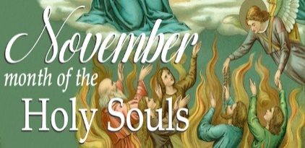

All Saints

November 1st, 2020

The Holy Souls of Purgatory

**MASS INTENTIONS**: (November 2 – November 8, 2020 )

Monday Noon For All the Faithful Departed

Tuesday Noon Robert Oravis req. by Helen Slonac

Wednesday 6:00 PM For the Recently Departed

Thursday Noon For Catholics to Return to Church

Friday Noon John Vandzura req. by St. Michael Funeral Committee

Saturday 4:00 PM Kristan Deighan req. by parents, Rick & Nancy Wessel

Sunday 8:00 AM Staff Sergeant Andrew Chalan req. by sister, Pauline Minor & Family

10:30 AM People of the Parish

LITURGICIAL APPOINTMENTS:

Saturday, November 7 4:00 PM

Lector: Tony Bambino

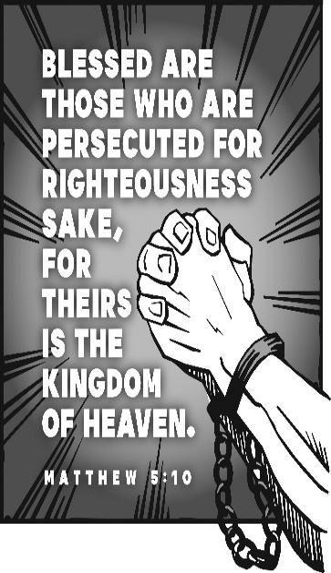Minister of the Host: Alice Podrebarac

Altar Server: Alex Bambino

Cantor: Susan Blazosky

Sunday, November 8 8:00 AM

Lector: Joe Faher

Minister of the Host: Pauline Minor

Altar Server: Griffin Christ

Cantor: Anita Lorek

Sunday, November 8 10:30 AM

Lector: Carole Kakabar

Minister of the Host: Michael Steele

Altar Server: Ian Dobbins

Cantor: Amy Dobbins

Monday, November 9 Collection Counters

George & Pauline Minor

Weare placing names of the sick in the bulletin for prayer providing they give permission. *May the* *Divine Physician send healing grace for those for* *whom we pray:* Allen C. Rosemas, Patricia Murphy, Bernice Myers, Dwight Fyock, Dylon Wills, Missy, Joanne (Kolar) Hufford, Christine Flanagan, Ayden Alan Grata, Mary Lou Offman, Mary Zangaglia, Natalie Zerby, Valencia Tursi, Homer Locher, Brayden Schofield, Michelle Kasper, Diane Kingera, Allison Krischer, Ted Paluch, Brandt Hutzel, Pearl Litzinger, Patrick Munro, Fran Baldassarre, Kristen Sinosky Long, Cresta Micik, Basil Costantino, Madison McCrory, Laura, Joe Yoder, Dolores Yanzetich, Sandy Krug, Wanda Gramling, Jennifer Hagans, Shawn, Holly, Shane, Spencer, Owen Taylor, Keith & Dawnetta Hoyer, Derrick Varnish, Vincent Koshute, Melissa Cordek, Michelle Elliott, Heather Romanow, Mackston Barrick, Connor Thomas, Erin, Pat, Mary Agnes Nastase, Mary Ann Bertolino, Dick Wilson, Izzy Bihun, Dorothy Kaminsky, Patricia Oshaben, Ashlee Madison, Susan Yanzetich, Mike, Danika Faith, Alina Rusnak, Gary Smay, Elizabeth Howell, Walter Bodziak, Rhonda, Dan Strinkoski, Anne Robinson, Marlene McCrory, Sharon Poldiak, Carter Bobak, Vince Arena, Mike Morris, Sarah Kelt, Patty Yanzetich Caldwell, Colton Snyder, Betty Delaney, Nancy Edmiston, Leonard Oshaben, Adam, Bill Gideos, Janice Dipyatic, Gerald Delaney, Lily Maloney, Scott, Lisa, Rosalie Ambrose, Audrey Costlow, Cathy Sossong, Rosanne Krug, Becky Kakabar, Catherine Tedjeske, Howard Delaney, Alivia Ickes, John Poldiak Jr., Ed Myers, Dolores Mucko, Tom Vandzura, Elliana, Ashlee, Helen Soohy, Carol K. Fabrizio, Peggy Carpenter, David Poldiak, Mary Kiel and all of the sick of our parish, the homebound, those in nursing homes, those who care for them, and those in the military along with their families. *(Please call the Rectory to have your name removed from the list when no longer seriously ill. Thank You.)*

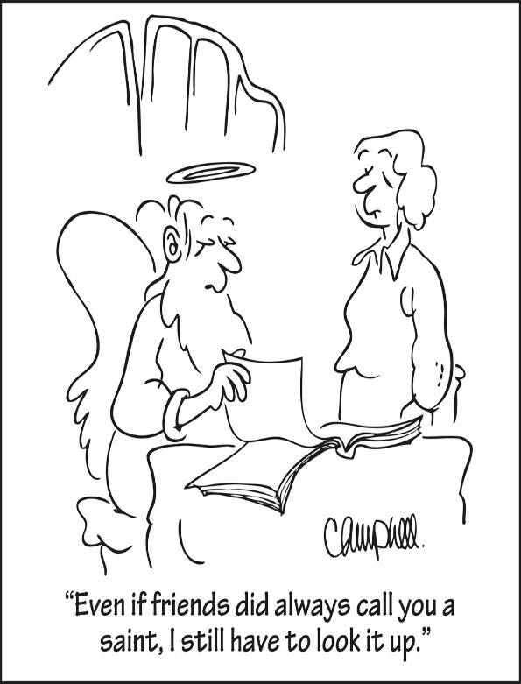

LAST WEEK’S COLLECTION

Adults $2,263.00

Loose $ 75.00

Youth $ 18.00

Monthly $ 630.00

Candles $ 35.00

Maintenance Fund $ 195.00

All Saints $ 50.00

All Souls $ 153.00

Religious Education Fund $ 10.00

Retired Priests Med. Exp. $ 20.00

World Mission Sunday $ 45.00

Total $3,494.00

We sincerely thank and

ask God’s blessing upon

all who have care and

concern for our parish.

*Stewardship Reflections…*

The beatitudes describe the mindset and prioritize the activities of those who are destined for the Kingdom of Heaven. The only way to understand the beatitudes and to experience the realities they promise is to reframe our views and reshape our daily lives around them.

[](https://images.search.yahoo.com/search/images;_ylt=A0LEV1kSWptXvOwAKINXNyoA;_ylu=X3oDMTEyZGdkcmRoBGNvbG8DYmYxBHBvcwMxBHZ0aWQDQjIwODlfMQRzZWMDc2M-?p=Clipart+of+a+sanctuary+candle&fr=ush-mailn_02&th=110&tw=110&imgurl=http://www.henningers.com/389-168-wall-sanctuary-lamp.jpg&rurl=http://pixshark.com/sanctuary-lamp.htm&size=43KB&name=Sanctuary+Lamp+Bronze+wall+sanctuary+lamp&h=600&w=600&turl=http://ts2.mm.bing.net/th?id%3DOIP.M68453c67108cdc5ab485d309b395bd03o0%26pid%3D15.1%26rs%3D1%26c%3D1%26qlt%3D95%26w%3D110%26h%3D110#inline&tt=Sanctuary+Lamp+Bronze+wall+sanctuary+lamp&sigr=116keh5le&sigit=13gvlt42j&sigi=11ip0pgm4&sign=119kp6100&sigt=119kp6100)

During the week of November 1st, 2020

The Sanctuary Candle

will burn for

All the Lost Souls in Purgatory



ALL SOULS DAY ~ Monday, November 2nd is All Souls Day. There will be one Mass that day for All the Faithful Departed at Twelve NOON.

BEREAVEMENT LITURGY ~ A special service for families who suffered the loss of a loved one, buried from St. Michael Church, will be held on Wednesday, November 4th at 6:00 PM. We wish to recognize the families and their loved ones who have died since last October 1st, 2019 through September 30th, 2020. A letter has been sent to the families with more information about this very special memorial service. All are welcome.

DAILY MASS ~ Starting Wednesday November 11th, the Mass time will be moved from 6:00 PM to Twelve Noon. This will make it easier to see this time of year when darkness comes earlier.

LECTOR WORKBOOKS ~ The new Lector Workbooks are available. Please come to the parish office during office hours to pick up your book. The readings start with the First Sunday of Advent which is November 29th.

SECOND SUNDAY FOOD COLLECTION ~ Next weekend is our Second Sunday Food Collection. Please bring in non-perishable food items or toiletries with you. Monetary donations are also appreciated.

BOOKKEEPING POSITION ~ If you are interested in the bookkeeping position at St. Michael Parish, you need to contact the parish office and give us your name and qualifications. This is a sixteen hour a week job (more or less). We will be happy to go over the salary and responsibilities with interested applicants.

THANKSGIVING NUT ROLLS ~ Please remember that Friday, November 6th is pick up day for nut roll orders. Pick up is from 9:00 AM – Noon at Most Holy Trinity Church, South Fork.

FRIAR’S NOOK GIFT SHOP ~ Kick off your Christmas shopping by stopping at The Friar’s Nook Gift Shop! Normal business hours will resume Monday, November 2nd and hours will be Monday-Saturday 10AM-4 PM (always closed on Sundays). The address is 793 Monastery Road, Hollidaysburg and our phone number is 814-695-3802 if you have any questions. Please follow us on Facebook for updates!

JOB OPENING ~ St. Michael school in Loretto currently has an opening for a part-time custodian with a work schedule of 20 hours per week. Interested candidates can apply online at [www.dioceseaj.org/employment](http://www.dioceseaj.org/employment) or drop off a resume at the school or Basilica offices.

JEWELRY FUNDRAISER ~ For the Beaverdale Public Library, 506 Jefferson Ave., Beaverdale on Sunday, November 1st from 11 AM – 3 PM at the Library. Jewelry by the Rhinestone Diva Sherri Smay. All necessary COVID precautions will be in place. Can shop online or at the Beaverdale Library Facebook page. For more information call Beaverdale Library 487-7742.

PORK & SAUERKRAUT SUPPER ~ *TAKE OUT ONLY*, on Sunday, November 1st, at St. John the Baptist Social Hall, 540 Main St., Summerhill. 4 PM – until sold out. All Dinners - $10. Everyone is Welcome!

OCTOBER 2020 PARISH TICKET WINNERS

UNSOLD TICKETS/NOT RETURNED TICKETS ~ If the winning number is a ticket that was not sold or returned, the money will be split with the number above the winning number and the number below the winning number. If the number above or below the winning number was not returned, we will go above or below that number.

Day Date Amount Number Winner

Friday October 23, 2020 $75 426 Amy Miller

Saturday October 24, 2020 $100 691 Ken Schaffranek

Sunday October 25, 2020 $100 989 Sandra Brunberg

Monday October 26, 2020 $75 974 Adrianne Varner

Tuesday October 27, 2020 $75 897 Not Returned

$37.50 896 Gino & Amy Spinos

$37.50 898 Carole Mucker

Wednesday October 28, 2020 $75 050 Courtney Swanson

Thursday October 29, 2020 $75 156 Not Returned

$37.50 155 Dominic Panick

$37.50 157 Joan Oshaben



Religious Education And Christian Helping

November 1, 2020

Religious Education News

Home Lesson Packet #2 ~ Distribution of CCD Lesson packet #2 has taken place for all students in Grades K—11. If you were unable to be present to either of these pick-up times, contact the RE Office at 495-4873 or the Parish Office at 495-9640 to make arrangements for another time.

*********************************NATIONAL VOCATION AWARENESS WEEK*********************************

National Vocation Awareness Week will be celebrated in our country November 1 – 7, 2020. Please ask Our Lord for more dedicated, holy priests, deacons and consecrated men and women. May they be inspired by Jesus Christ, supported by our faith community, and respond generously to God’s gift of a vocation.

College and young adult men: An opportunity to discern your vocation is being made available via the convenience of Zoom. Every Friday evening at 8:30 PM join others in an organized discussion about different aspects of prayer and vocational discernment. We will use the book “To Save a Thousand Souls” which can be ordered for FREE by going to GoPriest.com and selecting “free resources.” If you are interested, please contact Fr. Peter Crowe at [vocations@dioceseaj.org](mailto:vocations@dioceseaj.org) to receive the zoom link. There is no commitment or pressure, just an opportunity to be with others, at least digitally, to gather in prayer and have a good discussion that could be very helpful. If we don’t know about a vocation, it is not possible to properly discern it. We need good men to say yes to our Lord. Could that man be you? Come and see!

Prayer for Vocations:

O God, we earnestly beseech Thee to bless this diocese with many priests, brothers, and sisters, who will gladly spend their entire lives to serve Thy Church and to make Thee known and loved. Bless our families. Bless our children. Choose from our homes those who are needed for Thy work. Mary, Queen of the Clergy! Pray for us. Pray for our priests and religious. Obtain for us many more.

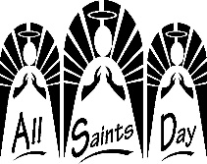

Sunday, November 1 Mass ~ 8:00 & 10:30 AM

Confessions / 10:00 – 10:15 AM ONLY / St. Paul Room

All Saints Day

National Vocations Awareness Week

Girl Scouts / 1 – 2:30 PM

Monday, November 2 Mass ~ Noon

All Souls Day

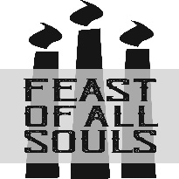 NO Sunday Choir Practice

Tuesday, November 3 Mass ~ Noon

Boy Scout Meeting / 7:30 – 9:00 PM

Election Day

Wednesday, November 4 Mass ~ 6:00 PM / Bereavement Liturgy

Thursday, November 5 Mass ~ Noon

NO Saturday Choir Practice

First Friday, November 6 Mass ~ Noon

Exposition of the Blessed Sacrament with Adoration / 12:30 – 2:30 PM

 Saturday, November 7 Mass / 4:00 PM

Confessions / 3:30 – 3:45 / St. Paul Room

Glessner / Wiesheier Nuptials / 1:30 PM

Second Sunday Food Pantry Collection

UPCOMING EVENTS

November 8 Second Sunday Food Pantry Collection

November 11 Veteran’s Day

November 14 McClelland Baptism

November 21 & 22 Catholic Charities Collection

WALK-THRU BASKET RAFFLE & SOUP SALE ~ Our Lady of the Alleghenies Roman Catholic Parish, Lilly, is hosting a COVID compliant Basket Raffle & Soup Sale on Saturday, November 7th from 10 AM to 6 PM in the Church Hall. Chances are $5 for 25 tickets. Cost of soup is $8/quart.

GRATEFUL GIVING BASKET RAFFLE ~ Our Lady of Loretto Community Hall, Loretto, on Saturday, November 7th: 4-7 PM; Sunday, November 8th: 8 AM-Noon; Saturday, November 14th: 4-7 PM; Sunday, November 15th: 8 AM-Noon. All winners will be contacted November 15th at noon. For additional information: Amber Mitchell: 814-932-8540.



ELECTION DAY SPAGHETTI & MEATBALL DINNER ~ All Saints Parish in Boswell will host their annual Spaghetti & Meatball dinner on Election Day, Tuesday, November 3rd from 11 AM to 2 PM and again from 4 PM to 7 PM at their parish hall, 502 Center St., Boswell. The dinner is TAKEOUT ONLY. Price is $8 for adults & $4 for children. For more information please call 629-5551.

SPORTSMEN RAFFLE TICKET ~ Queen of Angels Parish in Central City is sponsoring a Sportsmen Raffle ticket with a prize every night from Thanksgiving until Christmas Eve. The ticket includes over $13,000 in high quality prizes. The tickets are $25 each & are based on the Pennsylvania Daily Number – Evening Drawing. For more information or to purchase a ticket please call the parish office at 754-5224.