ST. MICHAEL ROMAN CATHOLIC CHURCH

751 Locust Street

PO Box 103

St. Michael, Pennsylvania 15951

Rev. Msgr. David A. Lockard, Administrator MASSES:

(814) 495-9640 Saturday 4:00 pm



Sunday Morning 8:00 am

Secretary: Michele Panick 10:30 am

Bookkeeper: Kathy Kalicky Daily Mass: M,T,W,Th,F Noon

DRE: Laurie Sloan Holy Days: See Bulletin

Maintenance: Rodney Turgeon Office Hours:

PHONES: 8:30 am to 3:30 pm

Rectory / Office: (814) 495-9640 Monday, Tues., Thurs., Friday

Fax: (814) 495-9424 Confessions:

Rel. Education: (814) 495-4873 Saturday 3:30 pm to 3:45 pm

Parish Website Sunday 10:00 am to 10:15 am

[www.saintmichaelchurch.weebly.co](http://www.saintmichaelchurch.weebly.co)m By Appointment

Secretaries’ E-mail

[saintmichaelsecretaries@yahoo.com](mailto:saintmichaelsecretaries@yahoo.com)

Facebook page:

St. Michael Catholic Church/St. Michael, PA

Our Lord Jesus Christ, King of the Universe

SERVING GOD AND COMMUNITY FOR OVER ONE HUNDRED YEARS!

November 22nd, 2020

BAPTISM: By Appointment. Reserve at least one month in advance.

MARRIAGE: Plan at least nine months in advance.

Preparation sessions are necessary.

FUNERALS: Arrangements are made in conjunction with the funeral home.

REGISTRATION Those new to the area, newlyweds, and single adults, (even if registered

and before with their families) are asked to register by calling the Parish Office.

MEMBERSHIP: Every parishioner must be registered. This is a condition for admission

to our Program and reception of the Sacraments of Baptism, Confirmation,

First Penance, First Eucharist, and Matrimony; also, for testimonial letters or sponsorship of Baptism and Confirmation outside the Parish.

VISITATION: We are concerned and want to be advised when someone is ill at home or in the hospital. Call the office to have the shut-in placed on our monthly Holy Communion calls or seriously ill prayer list.

SACRAMENTAL Parish registration and active Mass participation for Baptism is

POLICY: encouraged and is required for Marriage.

BULLETIN ARTICLES: Articles are due to the Parish Office by Noon on Tuesday.

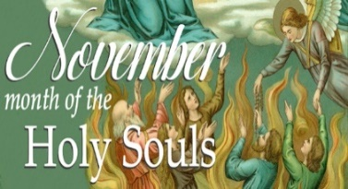

Thirty-Third Sunday in Ordinary Time

November 22nd, 2020

The Holy Souls of Purgatory

**MASS INTENTIONS**: (November 23 – November 29, 2020 )

Monday Noon Paul “Goose” Eugene Renyck req. by Joseph Doyle

Tuesday Noon Anna Podrebarac req. by Ray Katrancha Family

Wednesday Noon George & Elizabeth Freidhoff req. by Carl & Pam Freidhoff

Thursday 9:00 AM Michael Bidelman & Stephen Yanzetich Sr. req. by Susan Yanzetich

Friday Noon Charlene Kusher req. by Matilda Blozevich

Saturday 4:00 PM Michael Koshute (B-day rem.) req. by Paul & Cindy McCloskey

Sunday 8:00 AM People of the Parish

10:30 AM William Wilson req. by Mary Ann Murin & Family

LITURGICIAL APPOINTMENTS:

Saturday, November 28 4:00 PM

Lector: Sandy Bambino

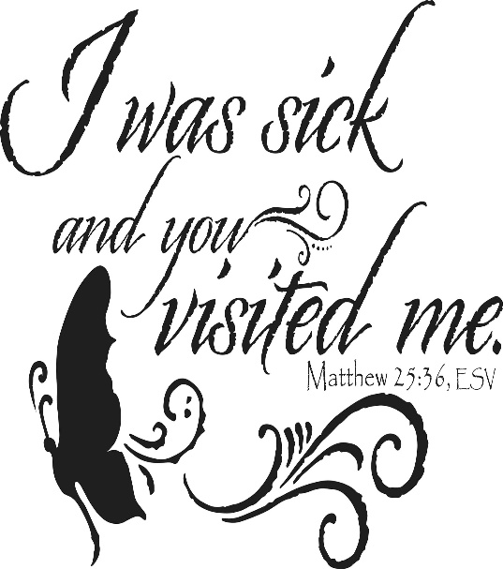Minister of the Host: Susan Blazosky

Altar Server: Dylan Kundrod

Cantor: David Zajdel

Sunday, November 29 8:00 AM

Lector: Pauline Minor

Minister of the Host: Sally Kolar

Altar Server: Bryce Macy

Cantor: Anita Lorek

Sunday, November 29 10:30 AM

Lector: Mike Barton

Minister of the Host: Robert Oshaben

Altar Server: Jackson Henderson

Cantor: Lou McCloskey

Monday, November 30 Collection Counters

George & Pauline Minor

Weare placing names of the sick in the bulletin for prayer providing they give permission. *May the* *Divine Physician send healing grace for those for* *whom we pray:* Allen C. Rosemas, Patricia Murphy, Bernice Myers, Dwight Fyock, Dylon Wills, Missy, Joanne (Kolar) Hufford, Christine Flanagan, Ayden Alan Grata, Mary Lou Offman, Mary Zangaglia, Natalie Zerby, Valencia Tursi, Homer Locher, Brayden Schofield, Michelle Kasper, Diane Kingera, Allison Krischer, Ted Paluch, Brandt Hutzel, Pearl Litzinger, Patrick Munro, Fran Baldassarre, Kristen Sinosky Long, Cresta Micik, Basil Costantino, Madison McCrory, Laura, Joe Yoder, Dolores Yanzetich, Sandy Krug, Wanda Gramling, Jennifer Hagans, Shawn, Holly, Shane, Spencer, Owen Taylor, Keith & Dawnetta Hoyer, Derrick Varnish, Vincent Koshute, Melissa Cordek, Michelle Elliott, Heather Romanow, Mackston Barrick, Connor Thomas, Erin, Pat, Mary Agnes Nastase, Mary Ann Bertolino, Dick Wilson, Izzy Bihun, Dorothy Kaminsky, Patricia Oshaben, Ashlee Madison, Susan Yanzetich, Mike, Danika Faith, Alina Rusnak, Gary Smay, Elizabeth Howell, Walter Bodziak, Rhonda, Dan Strinkoski, Anne Robinson, Marlene McCrory, Sharon Poldiak, Carter Bobak, Vince Arena, Mike Morris, Sarah Kelt, Patty Yanzetich Caldwell, Colton Snyder, Betty Delaney, Nancy Edmiston, Leonard Oshaben, Adam, Bill Gideos, Janice Dipyatic, Gerald Delaney, Lily Maloney, Scott, Lisa, Rosalie Ambrose, Audrey Costlow, Cathy Sossong, Rosanne Krug, Becky Kakabar, Catherine Tedjeske, Howard Delaney, Alivia Ickes, John Poldiak Jr., Ed Myers, Dolores Mucko, Elliana, Ashlee, Helen Soohy, Carol K. Fabrizio, Peggy Carpenter, David Poldiak, Mary Kiel, Sarah Vance, Sharon Vance and all of the sick of our parish, the homebound, those in nursing homes, those who care for them, and those in the military along with their families. *(Please call the Rectory to have your name removed from the list when no longer seriously ill. Thank You.)*

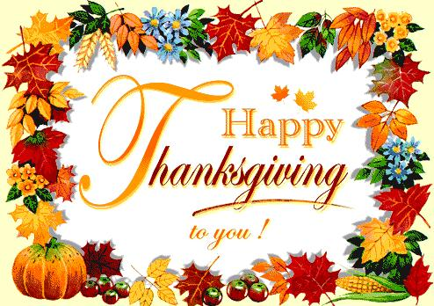

LAST WEEK’S COLLECTION

Adults $2,182.00

Loose $ 89.00

Youth $ 19.00

Monthly $1,465.00

Maintenance Fund $ 10.00

All Souls $ 30.00

Immaculate Conception $ 10.00

Christmas Flowers $ 35.00

Catholic Charities $ 407.00

Religious Education Fund $ 10.00

Total $4,257.00

We sincerely thank and ask God’s

blessing upon all who have care

and concern for our parish.

*Stewardship Reflections…*

When the Son of Man comes in glory, may we be among those who feed the hungry, nourish the thirsty, welcome the stranger, clothe the naked, and visits and care for the ill and imprisoned. By sharing our gifts through the practice of good stewardship, Jesus tells us that we will receive God’s blessing. You will find a glimpse of the Kingdom whenever you use God-given resources to help the lost, strayed, injured and sick. What are you planning to do this Advent as we look to the beginning of a new Church year? Think about what you and your family can do to serve the needs of “*the least of God’s children.”*

During the week of November 22nd, 2020

The Our Lady of Grace Candle will burn

as a birthday remembrance for

Michael Koshute

requested by Paul & Cindy McCloskey

[](https://images.search.yahoo.com/search/images;_ylt=A0LEV1kSWptXvOwAKINXNyoA;_ylu=X3oDMTEyZGdkcmRoBGNvbG8DYmYxBHBvcwMxBHZ0aWQDQjIwODlfMQRzZWMDc2M-?p=Clipart+of+a+sanctuary+candle&fr=ush-mailn_02&th=110&tw=110&imgurl=http://www.henningers.com/389-168-wall-sanctuary-lamp.jpg&rurl=http://pixshark.com/sanctuary-lamp.htm&size=43KB&name=Sanctuary+Lamp+Bronze+wall+sanctuary+lamp&h=600&w=600&turl=http://ts2.mm.bing.net/th?id%3DOIP.M68453c67108cdc5ab485d309b395bd03o0%26pid%3D15.1%26rs%3D1%26c%3D1%26qlt%3D95%26w%3D110%26h%3D110#inline&tt=Sanctuary+Lamp+Bronze+wall+sanctuary+lamp&sigr=116keh5le&sigit=13gvlt42j&sigi=11ip0pgm4&sign=119kp6100&sigt=119kp6100)

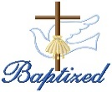BAPTISM ~ On Saturday November 14th, 2020, we celebrated the glorious baptism of Olivia Rose McClelland daughter of Donald and Karah (Rusnak) McClelland by Fr. Brian Warchola. Olivia Rose became a new creation in Christ in the waters of Holy Baptism. Now joined to us by the gifts of faith, hope, and charity, we warmly welcome her into our St. Michael Parish Family.

[](http://www.churchart.com/subscriber/viewimages.aspx?keywords=In%20Sympathy&entry_date=1/1/0001&image_type=,cl#no)MAY HE REST IN PEACE ~ In your charity, please pray for the eternal rest of Thomas Vandzura whose funeral Mass was held on Saturday November 21st, 2020. May he know the eternal peace and happiness promised by our Savior, Lord Jesus. Please pray for the consolation of all his family and friends.

THANKSGIVING DAY MASS ~ Thanksgiving Day Mass will be at 9:00 AM.

PARISH OFFICES ~ Parish Offices will be closed on Wednesday, November 25th, Thursday, November 26th, and Friday November 27th for the Thanksgiving Day Holiday.

DAILY MASS ~ The Mass time on Wednesday has been moved from 6:00 PM to Twelve Noon. This will make it easier to see this time of year when darkness comes earlier.

LECTOR WORKBOOKS ~ The new Lector Workbooks are available. Please come to the parish office during office hours to pick up your book. The readings start with the First Sunday of Advent – Nov. 29th.

PARISH COUNCIL ~ There will be a Parish Council Meeting this Sunday, November 22nd in the Church Hall following the 10:30 AM Mass.

CATHOLIC CHARITIES ~ There will be a second collection basket this weekend for the Catholic Charities Collection. Your support is appreciated and makes a difference year-round to help struggling individuals and families: stay in their homes, keep their heat & utilities running, afford basic necessities. Use the envelope provided in your packet, give online at [www.catholiccharitiesaj.org](http://www.catholiccharitiesaj.org) or mail to Catholic Charities, 1300 Twelfth Ave, Altoona, PA 16601. Thank you for your generosity.

SACRAMENTS – 8 WEEK COURSE ~ Fr. Timothy Grimme will be teaching Sacraments at St. Michael Church Hall, St. Michael beginning Tuesday, January 5 from 6:30 – 8:30 PM. The cost for this class is $65, which includes registration & books. These classes may be taken for continuing education credit & Master Catechist requirements. For registration, please contact Marybeth at 814-361-2000 or by email at mheinze@dioceseaj.org . Registration forms are also available online at wwwdioceseaj.org/lay-ecclesial-ministry/ All are welcome!



Religious Education And Christian Helping

November 22, 2020

Religious Education News

Home Lesson Packets ~ Lesson Packet #3 were distributed for Grades K—5 on Thursday, November 19th and will be for Grades 6—11 on Sunday, November 22nd.

If you were unable to be present to either of these pick-up times, contact the RE Office at 495-4873 or the Parish Office at 495-9640 to make arrangements for another time to pick up new lessons and to drop off the completed lessons.

Parables Retreat ~ Our Saint Michael Confirmation students are scheduled for their Virtual Parables Retreat starting on Sunday, December 13th with Sr. Suzanne Thibault at The Bethany Youth Retreat Center via e-mail and Zoom sessions.  Our parish is registered as a whole, and now our students need to register individually with Sr. Suzanne. An email with the registration form has been sent out to all parents who have students scheduled for this retreat. Registration forms need to be returned directly to Sr. Suzanne A.S.A.P. for students to be included.

Thanksgiving Day Mass is at 9:00 AM.

THANKSGIVING DAY LITURGY

Thursday, November 26 9:00 AM

Lector: Don Dipko

Minister of the Host: Eric Tedjeske

Altar Server: Adam Bambino

Cantor: Theresa Arena

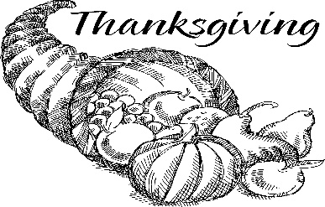

Sunday, November 22 Mass ~ 8:00 & 10:30 AM

Confessions / 10:00 – 10:15 AM / St. Paul Room

Catholic Charities Collection

Parish Council Meeting / After 10:30 AM Mass / Church Hall

Girls Scouts / 4:00 – 5:30 PM

Monday, November 23 Mass ~ Noon

 NO Sunday Choir Practice

Tuesday, November 24 Mass ~ Noon

Boy Scout Meeting / 7:30 – 9:00 PM

Wednesday, November 25 Mass ~ Noon

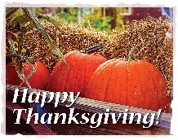 Thursday, November 26 Mass ~ 9:00 AM / Thanksgiving

NO Saturday Choir Practice

Parish Offices Closed

Friday, November 27 Mass ~ Noon

Parish Offices Closed

Saturday, November 28 Mass / 4:00 PM

Confessions / 3:30 – 3:45 / St. Paul Room

UPCOMING EVENTS

December 4 Exposition of the Blessed Sacrament with Adoration

December 6 Liturgy Committee Meeting

December 12 & 13 Retirement for Religious Collection

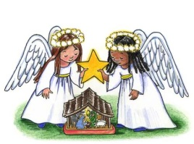

SALVATION ARMY TREASURES FOR CHILDREN PROJECT

*Our parish will again participate in the Salvation Army*

*Treasures for Children Project. We have tags available for both*

*children and senior citizens. The guidelines are as follows:*

* Tags include first name, sex, age, clothing sizes and some gift ideas for a child or senior citizen.
* The tags are displayed along the walls of the church. After you’ve chosen a tag, please write your name and phone number on the copy and leave ONLY the copy on a windowsill.
* Return your UNWRAPPED gift(s) with the tag attached to the St. Michael Catholic Church

St. Paul Room by December 6th so that we can check them off and deliver them to the

Salvation Army in time for distribution to the families.

* If you wish, you could provide an “extra” gift of your choice to be used for those tags that are not chosen at all. Gifts and larger clothing for pre-teens ages 11-13 are particularly hard to fill.

The tags are displayed along the walls of the Church & are available beginning this weekend.