Rev. 12:7
ST. MICHAEL ROMAN CATHOLIC CHURCH
751 Locust Street
PO Box 103
St. Michael, Pennsylvania 15951

Rev. Msgr. David A. Lockard, Administrator MASSES:
(814) 495-9640 Saturday 4:00 pm
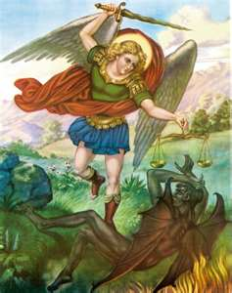
Sunday Morning 8:00 am
Secretary: Michele Panick 10:30 am
Bookkeeper: Kathy Kalicky Daily Mass See Bulletin
DRE: Laurie Sloan Holy Days See Bulletin
Maintenance: Rodney Turgeon
Office Hours:
PHONES: 8:30 am to 3:30 pm
Rectory / Office: (814) 495-9640 Monday, Tues., Thurs., Friday
Fax: (814) 495-9424 Confessions:
Rel. Education: (814) 495-4873 Saturday 3:30 pm to 3:45 pm
Parish Website Sunday 7:30 am to 7:45 am
www.saintmichaelchurch.weebly.com 10:00 am to 10:15 am
Secretaries’ E-mail By Appointment
saintmichaelsecretaries@yahoo.com
YEAR: 2019 NUMBER: 47

SERVING GOD AND COMMUNITY FOR OVER ONE HUNDRED YEARS!

November 24, 2019

BAPTISM: By Appointment. Reserve at least one month in advance.
MARRIAGE: Plan at least nine months in advance.
Preparation sessions are necessary.
FUNERALS: Arrangements are made in conjunction with the funeral home.
REGISTRATION Those new to the area, newlyweds, and single adults, (even if registered
and before with their families) are asked to register by calling the Parish Office.
MEMBERSHIP: Every parishioner must be registered. This is a condition for admission
to our Program and reception of the Sacraments of Baptism, Confirmation, First Penance, First Eucharist, and Matrimony; also, for testimonial letters or sponsorship of Baptism and Confirmation outside the Parish.
VISITATION: We are concerned and want to be advised when someone is ill at home or in the hospital. Call the rectory to have the shut-in placed on our monthly Holy Communion calls or seriously ill prayer list.
SACRAMENTAL Parish registration and active Mass participation for Baptism is
POLICY: encouraged and is required for Marriage.
BULLETIN ARTICLES: Articles are due to the Parish Office by Noon on Tuesdays.

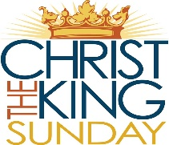
Our Lord Jesus Christ, King of the Universe
November 24, 2019
Month of The Holy Souls in Purgatory

MASS INTENTIONS: (November 25 – December 1, 2019)

Monday 8:00 AM Theressa Stravinsky (Months Mind) req. by Marya Pepoy
Tuesday 8:00 AM Michael Koshute (B-day remembrance) req. by Cindy & Paul
McCloskey
Wednesday No Mass
Thursday 9:00 AM Michael Bidelman & Stephen D. Yanzetich Sr. req. by Susan
Friday 9:00 AM Fr. Anthony Legarski req. by Msgr. David Lockard
Saturday 4:00 PM Andrew Pcola Sr. req. by Loving Family
Sunday 8:00 AM People of the Parish
Sunday 10:30 AM Arleen Diamond req. by sister, Helen McClemens

LITURGICIAL APPOINTMENTS:

Saturday, November 30 4:00 PM Offertory Procession

Lector: Susan Poldiak Galen & Ann Marie Martin Minister of the Host: George Minor Minister of the Cup: Karen Myers & Janet Minor
Altar Servers: Brooke & Chase Williamson
Cantor: Amanda Williamson
Greeter: Phyllis Slonac

Sunday, December 1 8:00 AM Offertory Procession

Lector: Peter Bernard Nick & Sally Kolar
Minister of the Host: Pauline Minor
Minister of the Cup: Marie Bernard & Cathy Faher
Altar Servers: Griffen & Kaden Christ
Cantor: Joseph Faher
Greeter: Deborah Macy

Sunday, December 1 10:30 AM Offertory Procession

Lector: James Lashinsky Arleen Diamond Family
Minister of the Host: Charlotte Crissey
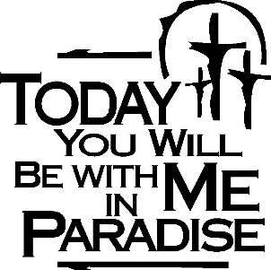
Minister of the Cup: Robert Oshaben & Terry Crissey
Altar Servers: Landon & Zach Fisher
Cantor: Elizabeth Dobbins
Greeter: Nancy Wessel

Sunday, December 1 Collection Counters
George & Janet Minor
Sharon Paterson

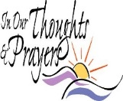
We are placing names of the sick in the bulletin for prayer providing they give permission. May the Divine Physician send healing grace for those for whom we pray: Allen C. Rosemas, Patricia Murphy, Bernice Myers, Dwight Fyock, Dylon Wills, Missy, Joanne (Kolar) Hufford, Christine Flanagan, Ayden Alan Grata, Mary Lou Offman, Mary Zangaglia, Natalie Zerby, Valencia & Frank Tursi, Homer Locher, Brayden Schofield, Michelle Kasper, Diane Kingera, Allison Krischer, Ted Paluch, Brandt Hutzel, Pearl Litzinger, Patrick Munro, Fran Baldassarre, Kristen Sinosky Long, Helen Ranieri, Cresta Micik, Basil Costantino, Madison McCrory, Laura, Joe Yoder, Dolores Yanzetich, Sandy Krug, Wanda Gramling, Merna Smay, Agnes Plummer, Jennifer Hagans, Shawn, Holly, Shane, Spencer, Owen Taylor, Keith & Dawnetta Hoyer, Derrick Varnish, Vincent Koshute, Melissa Cordek, Michelle Elliott, Heather Romanow, Mackston Barrick, Connor Thomas, Erin, Pat, Mary Agnes Nastase, Mary Ann Bertolino, Dick Wilson, Izzy Bihun, Dorothy Kaminsky, Patricia Oshaben, Ashlee Madison, Susan Yanzetich, Mike, Danika Faith, Alina Rusnak, Marcia Costlow, Gary Smay, Elizabeth Howell, Helen Bowen, Walter Bodziak, Rhonda, Dan Strinkoski, Anne Robinson, Marlene McCrory, Sharon Poldiak, Carter Bobak, Vince Arena, Mike Morris, Sarah Kelt, Patty Yanzetich Caldwell, Colton Snyder, Betty Delaney, Nancy Edmiston, Elizabeth Stoker Thomas, Albert Sracic, Joseph Ropecka, Bill Krajewski, Leonard Oshaben, Florence Smith, Michael Chalan Jr., Adam, Bill Gideos, Janice Dipyatic, John Poldiak Jr., Gerald Delaney, Lily Maloney, Adam Wingard, Scott, Lisa, Rosalie Ambrose, John Patrick and all of the sick of our parish, the homebound, those in nursing homes, those who care for them, and those in the military along with their families. (Please call the Rectory to have your name removed from the list when no longer seriously ill. Thank You.)

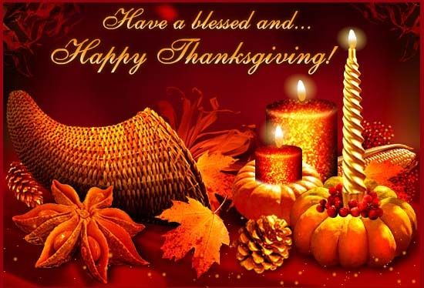

LAST WEEK’S COLLECTION

Adults $3,558.65
Loose $ 169.25
Youth $ 37.50
Monthly $ 225.00
Candles $ 23.00
Maintenance $ 50.00
Catholic Charities $ 483.25
Christmas Flowers $ 65.00
All Souls $ 5.00
Total $4,616.65

We sincerely thank and ask
God’s blessing upon all
who have care and
concern for our
parish.

November 24, 2019 Luke 23:35-43
Today’s gospel reminds us the Kingdom of Heaven is not like Disney’s Magic Kingdom. Admission to Christ’s Kingdom is paid with the currency of acceptance, forgiveness, attention to the poor and love of one’s enemy.
.

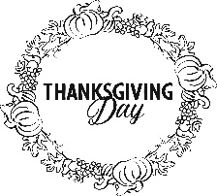

Thanksgiving Day Mass is at 9:00 AM.

THANKSGIVING DAY LITURGY

Thursday, November 28 9:00 AM

Lector: David Knepper
Minister of the Host: Michael Barton
Ministers of the Cup: Marie Jo Plummer & Beth Kundrod
Altar Servers: Andrew Martin & Michael Kresic
Cantor: Louis McCloskey
Greeter: Karen Myers
Offertory Procession: Yanzetich Family

#######################################################################

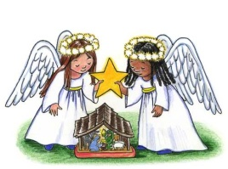
SALVATION ARMY TREASURES FOR CHILDREN PROJECT
Our parish will again participate in the Salvation Army
Treasures for Children Project. We have tags available for both

children and senior citizens. The guidelines are as follows:

- Tags include first name, sex, age, clothing sizes and some gift ideas for a child or senior citizen. The Salvation Army has asked that you consider providing a gift equal to or around $25.00 PLUS an outfit if possible (not mandatory). The Salvation Army will provide each family with a voucher for a local grocery store for their Christmas meal.

- The tags are displayed along the walls of the church. After you’ve chosen a tag, please write your name and phone number on the copy and leave ONLY the copy on a windowsill.

- Return your UNWRAPPED gift(s) with the tag attached to the St. Michael Catholic Church
St. Paul Room by December 8th so that we can check them off and deliver them to the
Salvation Army in time for distribution to the families.

- If you wish, you could provide an “extra” gift of your choice to be used for those tags that are not chosen at all. Gifts and larger clothing for pre-teens ages 11-13 are particularly hard to fill.

The tags will be displayed along the walls of the Church and will be available on
Thanksgiving (November 29th).

The Sanctuary Candle will burn for
the safety of the Thanksgiving Holiday Travelers
during the week of November 24th, 2019.

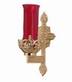

PARISH OFFICES ~ Will be closed on Wednesday, November 27th, Thursday, November 28th, and Friday, November 29th for the Thanksgiving Day Holiday.

THANKSGIVING DAY MASS ~ Thanksgiving Day Mass will be at 9:00 AM.

DAILY MORNING MASS ~ Friday, November 29th morning Mass will be at 9:00 AM

ADVENT “LITTLE BLUE BOOK” ~ December 1st is the beginning of the Advent Season. The parish is providing the Little Blue Book free of charge to all parishioners. This booklet is available at the side entrance and on the table at the back of the Church this weekend.

ADVENT CONFESSIONS ~ Advent Confessions will be here at St. Michael Tuesday, December 10th at 6:00 PM. Other priests will be present to assist Msgr. Lockard. Mark your calendars now. We will combine with Most Holy Trinity, South Fork & St. Bartholomew, Wilmore.

COMBINED CHRISTMAS CHOIR ~ Rehearsal dates are November 26 at 7 PM. December dates TBA. Watch bulletin for changes and further details.

LECTOR WORKBOOKS ~ The New Lector Workbooks are available in the Sacristy. The readings start with the First Sunday of Advent (December 1st).

CHRISTMAS NUT ROLLS ~ Most Holy Trinity Church, South Fork, is taking orders for Christmas Nut Rolls for $9.00 each. Orders due by Nov. 27th and pick up on Friday, December 6th, 9 – Noon or after weekend Masses. A sign-up sheet is on the table in the back of the church.

FAMILY OF THE MONTH ~ The family of David Brown has been selected as the October Family of the Month for Knights of Columbus Council 2275. David and his deceased wife Betsy, who passed away in 2012, have 2 grown children. David has 5 grandchildren ages 1 to 18. David is a Eucharistic minister here at St. Michael Church and helps Msgr. Lockard with his Communion Calls and Nursing Home Masses. He is also a member of the Holy Name Society and he volunteers at St. Joseph cemetery, Beaverdale and has just retired from Beaverdale Public Library where he volunteered for 30 years serving as Board President for many of those years. He also belongs to American Legion post 2275 where he is the Chaplain and serves on the honor guard for funerals and is also a member of the Knights of Columbus since 1983 and served as several officer positions including Grand Knight 3 separate times for 12 years. He is a Sir Knight of Assembly No 919.

Stewardship Reflections…
Jesus comes to us without earthly glory but on a cross, crowned by thorns. “The grandeur of his kingdom is not power as defined in this world, but the love of God, a love capable of encountering and healing all things.” (Pope Francis, Homily, November 20, 2016). Reflect on possibilities of how you can honor God through stewardship.

Sunday, November 24 High School Religious Ed. / 9:00 – 10:20 AM
Girl Scouts 1 - 3:30 PM / 4 – 5:30 PM

Monday, November 25 Sunday Choir Practice / 7:00 PM

Tuesday, November 26 Combined Christmas Choir / 7:00 PM
Boy Scouts / 7:30 PM

Wednesday, November 27 No Mass
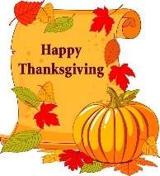
Parish Offices Closed

Thursday, November 28 Mass / 9:00 AM
Thanksgiving Day / Parish Offices Closed

Friday, November 29 Mass / 9:00 AM
Thanksgiving Holiday / Parish Offices Closed

Saturday, November 30

UPCOMING EVENTS

December 6 Exposition of the Blessed Sacrament with Adoration / 8:30 am - Noon
December 7 & 8 Retirement Fund for Religious / Second Collection
Second Sunday Food Pantry Collection
December 8 Parish Council Meeting
REACH Basket Social
December 10 Advent Confessions / 6:00 PM
December 14 Eucharistic Adoration with Bishop Mark Bartchak
December 15 Holy Name Meeting
Coffee & Donuts

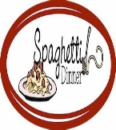
BASKET PARTY & SPAGHETTI DINNER ~ Greater Johnstown Career and Technology Center Culinary Students are hosting a Basket Party & Spaghetti Dinner on December 15th starting at Noon. Dinner & Basket Chances Ticket is $20. Take out available for $10. 120 + baskets, 50/50, door prizes and qualifiers. Supports the Trip to Disney Resort for Cook around the world. Info at 814-266-6073.

A PREPARATION FOR CHRISTMAS ~ Living faith with Mary through renewal of the mind and transformation of the heart. It is by refining and deepening our faith, renewing our minds by putting on a new fresh way of thinking, and being open to transformation that we can experience true and lasting spiritual freedom. Join Fr. David Tickerhoof TOR on Monday, December 9th at Sisters of the Sacred Heart Retreat Center, 1872 Munster Road, Portage, Pa from 9:00 AM to 3:30 PM to experience! Cost: Suggested $20. RSVP: Monday, December 2nd, 2019. Fr. David Tickerhoof at 941-243-0372 or frdavidjt@gmail.com.

