ST. MICHAEL ROMAN CATHOLIC CHURCH

751 Locust Street

PO Box 103

St. Michael, Pennsylvania 15951

Rev. Msgr. David A. Lockard, Administrator MASSES:

(814) 495-9640 Saturday 4:00 pm



Sunday Morning 8:00 am

Secretary: Michele Panick 10:30 am

Bookkeeper: Kathy Kalicky Daily Mass: M,T,W,Th,F Noon

DRE: Laurie Sloan Holy Days: See Bulletin

Maintenance: Rodney Turgeon Office Hours:

PHONES: 8:30 am to 3:30 pm

Rectory / Office: (814) 495-9640 Monday, Tues., Thurs., Friday

Fax: (814) 495-9424 Confessions:

Rel. Education: (814) 495-4873 Saturday 3:30 pm to 3:45 pm

Parish Website Sunday 10:00 am to 10:15 am

[www.saintmichaelchurch.weebly.co](http://www.saintmichaelchurch.weebly.co)m By Appointment

Secretaries’ E-mail

[saintmichaelsecretaries@yahoo.com](mailto:saintmichaelsecretaries@yahoo.com)

Facebook page:

St. Michael Catholic Church/St. Michael, PA

Third Sunday of Advent

SERVING GOD AND COMMUNITY FOR OVER ONE HUNDRED YEARS!

December 13th, 2020

BAPTISM: By Appointment. Reserve at least one month in advance.

MARRIAGE: Plan at least nine months in advance.

Preparation sessions are necessary.

FUNERALS: Arrangements are made in conjunction with the funeral home.

REGISTRATION Those new to the area, newlyweds, and single adults, (even if registered

and before with their families) are asked to register by calling the Parish Office.

MEMBERSHIP: Every parishioner must be registered. This is a condition for admission

to our Program and reception of the Sacraments of Baptism, Confirmation,

First Penance, First Eucharist, and Matrimony; also, for testimonial letters or sponsorship of Baptism and Confirmation outside the Parish.

VISITATION: We are concerned and want to be advised when someone is ill at home or in the hospital. Call the office to have the shut-in placed on our monthly Holy Communion calls or seriously ill prayer list.

SACRAMENTAL Parish registration and active Mass participation for Baptism is

POLICY: encouraged and is required for Marriage.

BULLETIN ARTICLES: Articles are due to the Parish Office by Noon on Tuesday.

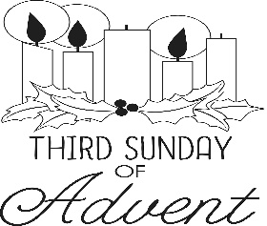 Third Sunday of Advent

December 13th, 2020

The Immaculate Conception

**MASS INTENTIONS**: (December 14 – December 20, 2020 )

Monday Noon Anna Fornadel req. by Paul & Susie Snyder

Tuesday Noon Bob Oravis req. by Family of Butch Pcola

Wednesday Noon Hermine Sivec req. Galen, Ann Marie & Andrew Martin

Thursday Noon For the Health of Ed Myers req. by wife, Karen & Family

Friday Noon Thomas Vandzura (Months Mind) req. by Ed & Karen Myers

Saturday 4:00 PM Francis Andrykovitch req. by Family

Sunday 8:00 AM Marie Faher req. by Cathy & Joe Faher

10:30 AM People of the Parish

LITURGICIAL APPOINTMENTS:

Saturday, December 19 4:00 PM

Lector: Sherry Dipko

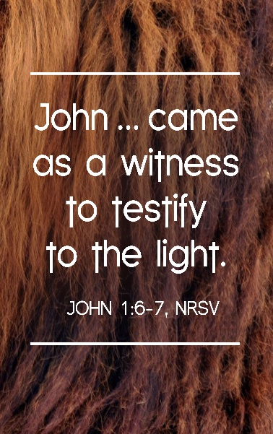Minister of the Host: Susan Blazosky

Altar Server: Ana Spangler

Cantor: Amy Spangler

Sunday, December 20 8:00 AM

Lector: Cathy Faher

Minister of the Host: Pauline Minor

Altar Server: Michael Kresic

Cantor: Anita Lorek

Sunday, December 20 10:30 AM

Lector: James Lashinsky

Minister of the Host: Amanda Williamson

Altar Server: Kirstyn Vitez

Cantor: Elizabeth Dobbins

Monday, December 21 Collection Counters

George & Pauline Minor

During the week of December 13th, 2020

The Sanctuary Candle will burn

in memory of

Francis Andrykovitch

requested by Family

[](https://images.search.yahoo.com/search/images;_ylt=A0LEV1kSWptXvOwAKINXNyoA;_ylu=X3oDMTEyZGdkcmRoBGNvbG8DYmYxBHBvcwMxBHZ0aWQDQjIwODlfMQRzZWMDc2M-?p=Clipart+of+a+sanctuary+candle&fr=ush-mailn_02&th=110&tw=110&imgurl=http://www.henningers.com/389-168-wall-sanctuary-lamp.jpg&rurl=http://pixshark.com/sanctuary-lamp.htm&size=43KB&name=Sanctuary+Lamp+Bronze+wall+sanctuary+lamp&h=600&w=600&turl=http://ts2.mm.bing.net/th?id%3DOIP.M68453c67108cdc5ab485d309b395bd03o0%26pid%3D15.1%26rs%3D1%26c%3D1%26qlt%3D95%26w%3D110%26h%3D110#inline&tt=Sanctuary+Lamp+Bronze+wall+sanctuary+lamp&sigr=116keh5le&sigit=13gvlt42j&sigi=11ip0pgm4&sign=119kp6100&sigt=119kp6100)

[](http://www.churchart.com/subscriber/viewimages.aspx?keywords=In%20Sympathy&entry_date=1/1/0001&image_type=,cl#no)

MAY HE REST IN PEACE ~ In your charity, please pray for the eternal rest of Kyle Scott whose Funeral Mass was celebrated on Friday, December 11th, 2020 by Msgr. David Lockard. May he know the eternal peace and happiness promised by our Savior, Lord Jesus. Please pray for the consolation of all his family and friends.

RETIREMENT FUND FOR RELIGIOUS ~ “Every dollar makes a difference in covering our expenses,” says a Trappist abbot. Hundreds of US religious communities struggle to provide for aging members because most senior Catholic sisters, brothers, and religious order priests served for little pay. Your gift to the Retirement Fund Religious helps these communities bridge the gap, offering support for medications, nursing care, and other necessities. Please be generous. Please place your envelope in the basket marked “Retired Religious”.

SECOND SUNDAY FOOD COLLECTION ~ This weekend is our Second Sunday Food Collection. Please bring in non-perishable food items or toiletries with you. Monetary donations are also appreciated. Please be as generous as possible.

OPLATKI ~ Anyone wanting Oplatki, please call the Parish Office during the hours 8:30 AM – 3:00 PM.

CHRISTMAS FLOWERS ~ If you would like to purchase a Christmas flower for a living (In Honor Of) or a deceased (In Memory Of) member of your family, please do so by using the Christmas Flower envelope in your packet. The normal offering is $10.00. Please have envelopes to the office no later than December 15th. Thank you.

ST. MICHAEL’S CHRISTMAS AND NEW YEAR’S DAY MASSES ~ Christmas Masses here at St. Michael are: Christmas Eve: 3:00 PM and 7:00 PM; Christmas Day: 9:00 AM. Solemnity of Mary Vigil Mass (December 31st): 4:00 PM and Solemnity of Mary (January 1st): 9:00 AM.

LOCAL CHURCH CONFESSIONS FOR CHRISTMAS ~ Immaculate Conception, New Germany: Tuesday, December 15th, 10-11 AM & 5-7 PM; Wednesday, December 16th, 5-7 PM; Saturday, December 19th, 3-3:50 PM; Tuesday, December 22nd, 3-4 PM & 5-7 PM. St. John, Summerhill: Monday, December 21st, 3-4 PM & 5-7 PM; Wednesday, December 16th, 3-4 PM; Saturday, December 19th, 4-4:50 PM; Monday, December 21st, 3-4 PM & 5-7 PM.

LOCAL CHURCHES CHRISTMAS SCHEDULES ~ Immaculate Conception, New Germany: Christmas Eve: 4 PM, 6 PM, and 8 PM. Christmas Day: 9 AM. St. John, Summerhill: Christmas Eve: 5 PM, 7 PM, 9 PM. Christmas Day: 10 AM.

Weare placing names of the sick in the bulletin for prayer providing they give permission. *May the* *Divine Physician send healing grace for those for* *whom we pray:* Allen C. Rosemas, Patricia Murphy, Bernice Myers, Dwight Fyock, Dylon Wills, Missy, Joanne (Kolar) Hufford, Christine Flanagan, Ayden Alan Grata, Mary Lou Offman, Mary Zangaglia, Natalie Zerby, Valencia Tursi, Homer Locher, Brayden Schofield, Michelle Kasper, Diane Kingera, Allison Krischer, Ted Paluch, Brandt Hutzel, Pearl Litzinger, Patrick Munro, Fran Baldassarre, Kristen Sinosky Long, Cresta Micik, Basil Costantino, Madison McCrory, Laura, Joe Yoder, Dolores Yanzetich, Sandy Krug, Wanda Gramling, Jennifer Hagans, Shawn, Holly, Shane, Spencer, Owen Taylor, Keith & Dawnetta Hoyer, Derrick Varnish, Vincent Koshute, Michelle Elliott, Heather Romanow, Mackston Barrick, Connor Thomas, Erin, Pat, Mary Agnes Nastase, Mary Ann Bertolino, Dick Wilson, Izzy Bihun, Dorothy Kaminsky, Patricia Oshaben, Ashlee Madison, Susan Yanzetich, Mike, Danika Faith, Alina Rusnak, Gary Smay, Elizabeth Howell, Walter Bodziak, Rhonda, Dan Strinkoski, Anne Robinson, Marlene McCrory, Carter Bobak, Vince Arena, Mike Morris, Sarah Kelt, Patty Yanzetich Caldwell, Colton Snyder, Nancy Edmiston, Leonard Oshaben, Adam, Bill Gideos, Janice Dipyatic, Lily Maloney, Scott, Lisa, Rosalie Ambrose, Audrey Costlow, Cathy Sossong, Rosanne Krug, Becky Kakabar, Catherine Tedjeske, Howard Delaney, Alivia Ickes, Ed Myers, Dolores Mucko, Elliana, Ashlee, Helen Soohy, Carol K. Fabrizio, Peggy Carpenter, Mary Kiel, Sharon Vance, Baby Vada Sloan, Janet Minor, Dave Seder and all of the sick of our parish, the homebound, those in nursing homes, those who care for them, and those in the military along with their families. *(Please call the Rectory to have your name removed from the list when no longer seriously ill. Thank You.)*

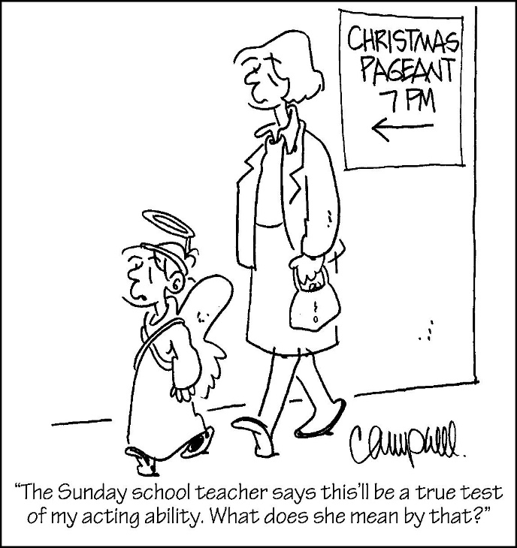

LAST WEEK’S COLLECTION

Adults $2,645.50

Loose $ 67.00

Youth $ 11.50

Monthly $2,235.00

Initial Offering $ 30.00

Candles $ 49.00

Maintenance Fund $ 155.00

Immaculate Conception $ 222.00

Christmas Offering $ 420.00

Christmas Flowers $ 230.00

Solemnity of Mary $ 25.00

Religious Retirement $ 95.00

Catholic Charities $ 5.00

Total $6,190.00

We sincerely thank and ask God’s

blessing upon all who have care

and concern for our parish.

*Third Sunday of Advent John 1:6-8, 19-28*

*Today’s gospel reports “there is one among you whom you do not recognize.” It is hard to believe Christ is present in a family with crazy schedules, suppers that start too late and end too early, cars that don’t start, misunderstandings, frustration, piles of laundry, unmatched socks and stretched food budgets. The list is endless. The words spoken at mass, The Lord is with you,” are not a hop0e, they are a fact.*

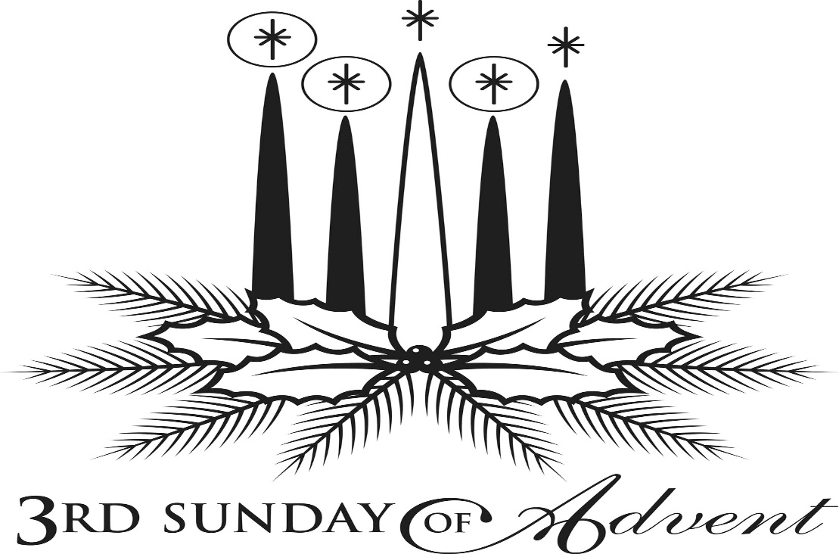

**++++++++++++++++++++++++++++++++++++++++++++++++++++++++++++**

**Diocese of Altoona-Johnstown**

**Year-end giving is happening NOW!**

**Consider a gift that can help you *and* your parish, a ministry, or a special initiative!**

**There’s still time to support the 2020 Catholic Ministries Drive.**

Catholic Charities, Family Life, Seminarian education, youth ministry, and adult education are 14 ministries that rely on parishioner support of the Catholic Ministries Drive to survive and thrive.

You can mail your gift to the Diocese of Altoona-Johnstown, P.O. Box 409, Hollidaysburg, PA 16648; place in your parish offertory; or make online at [www.dioceseaj.org](http://www.dioceseaj.org)/giving

Your support can do great things like:

Keep your parish operating *(lights, heat, building maintenance)*

Educate a seminarian *($100 a day)*

Keep kids connected to their faith *(scholarships for education and camps)*

Provide care for your brothers and sisters in need *($299 to fix a furnace)*

Help families overcome life’s difficulties *(marriage, grief, and addiction counseling)*

*Gifts must be postmarked by December 31, 2020, to receive a tax deduction for 2020.*

Diocese of Altoona-Johnstown

Year-end giving is happening NOW!

Opportunities that allow you to give today and tomorrow!

*Qualified Charitable Distribution*

A qualified charitable distribution (QCD) allows individuals 70 ½ or older to donate up to $100,000 total to one or more charities directly from a taxable IRA instead of taking their required minimum distribution. The amount of the QCD is excluded from taxable income. As a result, donors may avoid being pushed into higher income tax brackets and prevent phase outs of other tax deductions, though there are some other limitations. QCDs are also called IRA charitable distributions or IRA charitable rollovers.

Contact your IRA administrator for the necessary paperwork and indicate the area you want to support. Be sure to alert your parish or the Office of Stewardship and Development of your intention.

*Donation of Appreciated Stock or Mutual Funds!* If you have shares of stock or mutual funds that have grown in value over the years, or low basis stock, consider gifting the shares rather than giving cash. At the time of the donation, you get a tax deduction equal to the stock's fair market value and avoid paying the capital gains on the shares donated.

Visit www.dioceseaj.org/ways-to-give/ for transfer instructions or contact Pam Seasoltz, director of Stewardship and Development, at 814.695.5577 or [email: pseasoltz@dioceseaj.org.](mailto:pseasoltz@dioceseaj.org)



Religious Education And Christian Helping

December 13, 2020

Religious Education News

Home Lesson Packets ~ Lesson Packet #3 is ready for Grades K—11.

If you were unable to come to either of the pick-up dates, contact the RE Office at 495-4873 or the Parish Office at 495-9640 to make arrangements for another time to pick up new lessons.

Parables Retreat ~ Our Saint Michael Confirmation students are scheduled for their Virtual Parables Retreat starting on Sunday, December 13th with Sr. Suzanne Thibault at The Bethany Youth Retreat Center via e-mail and Zoom sessions.  Our parish is registered as a whole, and now our students need to register individually with Sr. Suzanne. An email with the registration form has been sent out to all parents who have students scheduled for this retreat. Registration forms need to be returned directly to Sr. Suzanne A.S.A.P. for students to be included.

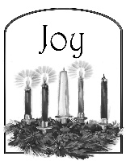 Sunday, December 13 Mass ~ 8:00 & 10:30 AM

Confessions / 10:00 – 10:15 AM / St. Paul Room

Retirement Fund for Religious Collection

Second Sunday Food Pantry Collection

Girls Scouts / 1:00 – 2:30 PM

Monday, December 14 Mass ~ Noon

NO Sunday Choir Practice

Tuesday, December 15 Mass ~ Noon

 Boy Scouts / 7:30 – 9:00 PM

Wednesday, December 16 Mass ~ Noon

Thursday, December 17 Mass ~ Noon

NO Saturday Choir Practice

Friday, December 18 Mass ~ Noon

Saturday, December 19 Mass / 4:00 PM

Confessions / 3:30 – 3:45 / St. Paul Room



UPCOMING EVENTS

December 24 Christmas Eve Masses / 3:00 PM & 7:00 PM

December 25 Christmas Day Mass / 9:00 AM

December 31 Solemnity of Mary Vigil Mass / 4:00 PM

January 1, 2021 Solemnity of Mary Mass / 9:00 AM

SACRAMENTS – 8 WEEK COURSE ~ Fr. Timothy Grimme will be teaching Sacraments at St. Michael Church Hall, St. Michael beginning Tuesday, January 5 from 6:30 – 8:30 PM. The cost for this class is $65, which includes registration & books. These classes may be taken for continuing education credit & Master Catechist requirements. For registration, please contact Marybeth at 814-361-2000 or by email at mheinze@dioceseaj.org . Registration forms are also available online at wwwdioceseaj.org/lay-ecclesial-ministry/ All are welcome!

ST PAUL CLASS VIA ZOOM ~ This 6-week course, taught by Christopher Klopp, investigates the life and writing of St. Paul within the context of early Judaism in order to understand the Apostle’s role as the most significant theologian of the New Testament. Classes will begin Tuesday, January 5th, 6:30-9:00 PM. Costs for this class include a registration fee of $45 and the required book Paul A New Covenant Jew, by Brant Pitre, which can be purchased online at Amazon.com or through the Office of Lay Ministry for $35. Also suggested, but not required is the Ignatius Catholic Study Bible New Testament available online at Amazon.com. For further information and to register for this class please contact Marybeth at 814-361-2000 or by email at [mheinze@dioceseaj.org](mailto:mheinze@dioceseaj.org). All are welcome to attend! Please register by December 16th, 2020.