ST. MICHAEL ROMAN CATHOLIC CHURCH
751 Locust Street
PO Box 103
St. Michael, Pennsylvania 15951

Rev. Msgr. David A. Lockard, Administrator MASSES:
(814) 495-9640 Saturday 4:00 pm
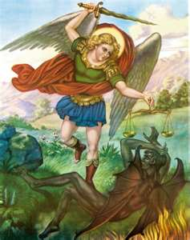
Sunday Morning 8:00 am
Secretary: Michele Panick 10:30 am
Bookkeeper: Kathy Kalicky Daily Mass: M,T,W,Th,F Noon
DRE: Laurie Sloan Holy Days: See Bulletin
Maintenance: Rodney Turgeon Office Hours:
PHONES: 8:30 am to 3:30 pm
Rectory / Office: (814) 495-9640 Monday, Tues., Thurs., Friday
Fax: (814) 495-9424 Confessions:
Rel. Education: (814) 495-4873 Saturday 3:30 pm to 3:45 pm
Parish Website Sunday 10:00 am to 10:15 am
www.saintmichaelchurch.weebly.com By Appointment
Secretaries’ E-mail
saintmichaelsecretaries@yahoo.com
Facebook page:
St. Michael Catholic Church/St. Michael, PA

Fourth Sunday of Advent

SERVING GOD AND COMMUNITY FOR OVER ONE HUNDRED YEARS!

December 20th, 2020

BAPTISM: By Appointment. Reserve at least one month in advance.
MARRIAGE: Plan at least nine months in advance.
Preparation sessions are necessary.
FUNERALS: Arrangements are made in conjunction with the funeral home.
REGISTRATION Those new to the area, newlyweds, and single adults, (even if registered
and before with their families) are asked to register by calling the Parish Office.
MEMBERSHIP: Every parishioner must be registered. This is a condition for admission
to our Program and reception of the Sacraments of Baptism, Confirmation,
First Penance, First Eucharist, and Matrimony; also, for testimonial letters or sponsorship of Baptism and Confirmation outside the Parish.
VISITATION: We are concerned and want to be advised when someone is ill at home or in the hospital. Call the office to have the shut-in placed on our monthly Holy Communion calls or seriously ill prayer list.
SACRAMENTAL Parish registration and active Mass participation for Baptism is
POLICY: encouraged and is required for Marriage.
BULLETIN ARTICLES: Articles are due to the Parish Office by Noon on Tuesday.

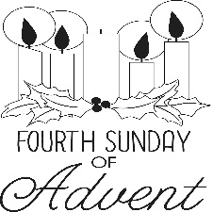
Fourth Sunday of Advent
December 20th, 2020
The Immaculate Conception

MASS INTENTIONS: (December 21 – December 27, 2020 )

Monday Noon Irene & Ray Baldwin req. by Carl & Pam Freidhoff
Tuesday Noon Theresa Fleck req. by Helen Slonac & Family
Wednesday Noon Ann Marie Swelfer req. by husband, Louis Swelfer
Thursday 3:00 PM For the Health & Wellbeing of All Lay Ministers
7:00 PM People of the Parish
Friday 9:00 AM Anna Wilson req. by Mary Ann Murin & Family
Saturday 4:00 PM Paul & Anna Pavlik req. by Helen Slonac & Family
Sunday 8:00 AM Michael Chalan req. by daughter, Pauline Minor & Family
10:30 AM People of the Paris

LITURGICIAL APPOINTMENTS:

Saturday, December 26 4:00 PM

Lector: Susan Poldiak
Minister of the Host: Veronica Richards
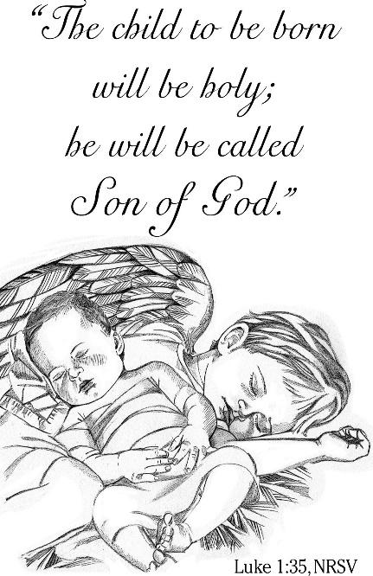
Altar Server: Caden & Kaylee Roberts
Cantor: David Zajdel

Sunday, December 27 8:00 AM

Lector: Joe Faher
Minister of the Host: Marie Bernard
Altar Server: Griffen Christ
Cantor: Sharon Dibble

Sunday, December 27 10:30 AM

Lector: Tony Bambino
Minister of the Host: Robert Oshaben
Altar Server: Jackson Henderson
Cantor: Lou McCloskey

Sunday, December 27 Collection Counters
Christ Smay, Sara Zybura
Mary Ann DeRosa

During the week of December 20th, 2020
The Sanctuary Candle will burn in memory of
Suzie Thomas
requested by Helen Slonac & Family

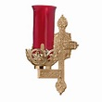

RETIREMENT FUND FOR RELIGIOUS ~ “We are conscious of the great generosity of the many benefactors who support the Retirement Fund for Religious each year,” says a Catholic sister. “Support from the fund has been a tremendous blessing to our retired sisters.” Thank you for donating to last week’s special collection.

SECOND SUNDAY FOOD COLLECTION ~ Thank you to all who so generously donated to the Forest Hills Food Pantry. The total money collected was $1,152.00 and an assortment of non-perishable items.

OPLATKI ~ Anyone wanting Oplatki, please call the Parish Office during the hours 8:30 AM – 3:00 PM.

ST MICHAEL’S CONFESSIONS ~ Saturday from 3:30 PM to 3:45 PM and Sunday from 10:00 AM to 10:15 AM or call the rectory to make an appointment with Msgr. Lockard.

ST. MICHAEL’S CHRISTMAS AND NEW YEAR’S DAY MASSES ~ Christmas Masses here at St. Michael are: Christmas Eve: 3:00 PM and 7:00 PM (No NOON Mass); Christmas Day: 9:00 AM. Solemnity of Mary Vigil Mass (December 31st): 4:00 PM and Solemnity of Mary (January 1st): 9:00 AM.

LOCAL CHURCH CONFESSIONS FOR CHRISTMAS ~ St. John, Summerhill: Monday, December 21st, 3-4 PM and 5-7 PM. Immaculate Conception, New Germany: Tuesday, December 22nd, 3-4 PM & 5-7 PM.

LOCAL CHURCHES CHRISTMAS SCHEDULES ~ Immaculate Conception, New Germany: Christmas Eve: 4 PM, 6 PM, and 8 PM. Christmas Day: 9 AM. St. John, Summerhill: Christmas Eve: 5 PM, 7 PM, and 9 PM. Christmas Day: 10 AM. St. Bartholomew, Wilmore: Tentatively; Christmas Eve: 2 PM and 6 PM. (No Christmas Day Mass). Most Holy Trinity, South Fork: Tentatively; Christmas Eve: 4 PM. Christmas Day: 9 AM.

DIOCESE TO AIR CHRISTMAS MASSES AND TELEVISION SPECIAL ~ As part of its continuing efforts to keep local Catholics connected during the coronavirus pandemic, the Diocese of Altoona-Johnstown is pleased to offer expanded television opportunities through its Proclaim! TV Ministry this Christmas. Bishop Mark Bartchak will celebrate Mass on Christmas Eve at St. John Gualbert Cathedral in Johnstown, which will air live at 7 PM on WWCP FOX 8. The Christmas Day Mass at St. John Gualbert will air at Noon on WATM ABC 23 with the Very Rev. James Crookston, Rector, as celebrant. This year, the diocese is also presenting a television special “Joy to the World: Christmas in the Diocese of Altoona-Johnstown.” The show will highlight beloved Christmas traditions, the overwhelming spirit of giving, and beautiful music from parish and school musicians. It will air on Dec. 20th at 1 PM on WATM ABC 23 and on Christmas morning at 7 AM on WWCP FOX 8.

We are placing names of the sick in the bulletin for prayer providing they give permission. May the Divine Physician send healing grace for those for whom we pray: Allen C. Rosemas, Patricia Murphy, Bernice Myers, Dwight Fyock, Dylon Wills, Missy, Joanne (Kolar) Hufford, Christine Flanagan, Ayden Alan Grata, Mary Lou Offman, Mary Zangaglia, Natalie Zerby, Valencia Tursi, Homer Locher, Brayden Schofield, Michelle Kasper, Diane Kingera, Allison Krischer, Ted Paluch, Brandt Hutzel, Pearl Litzinger, Patrick Munro, Fran Baldassarre, Kristen Sinosky Long, Cresta Micik, Basil Costantino, Madison McCrory, Laura, Joe Yoder, Dolores Yanzetich, Sandy Krug, Wanda Gramling, Jennifer Hagans, Shawn, Holly, Shane, Spencer, Owen Taylor, Keith & Dawnetta Hoyer, Derrick Varnish, Vincent Koshute, Michelle Elliott, Heather Romanow, Mackston Barrick, Connor Thomas, Erin, Pat, Mary Agnes Nastase, Mary Ann Bertolino, Dick Wilson, Izzy Bihun, Dorothy Kaminsky, Patricia Oshaben, Ashlee Madison, Susan Yanzetich, Mike, Danika Faith, Alina Rusnak, Gary Smay, Elizabeth Howell, Walter Bodziak, Rhonda, Dan Strinkoski, Anne Robinson, Marlene McCrory, Carter Bobak, Vince Arena, Mike Morris, Sarah Kelt, Patty Yanzetich Caldwell, Colton Snyder, Nancy Edmiston, Leonard Oshaben, Adam, Bill Gideos, Janice Dipyatic, Lily Maloney, Scott, Lisa, Rosalie Ambrose, Audrey Costlow, Cathy Sossong, Rosanne Krug, Becky Kakabar, Catherine Tedjeske, Howard Delaney, Ed Myers, Dolores Mucko, Elliana, Ashlee, Helen Soohy, Carol K. Fabrizio, Peggy Carpenter, Mary Kiel, Sharon Vance, Janet Minor, Dave Seder and all of the sick of our parish, the homebound, those in nursing homes, those who care for them, and those in the military along with their families. (Please call the Rectory to have your name removed from the list when no longer seriously ill. Thank You.)

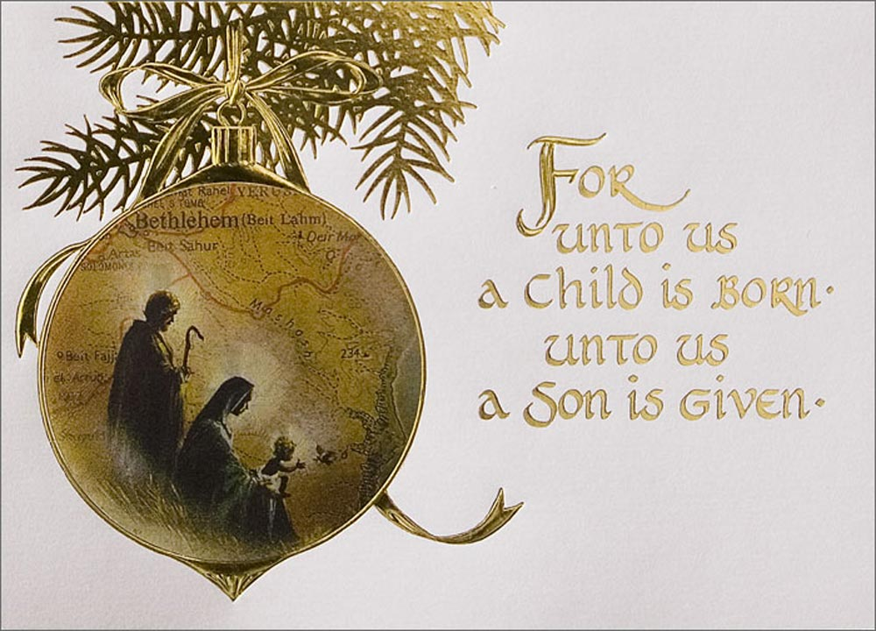

LAST WEEK’S COLLECTION

Adults $3,022.00
Loose $ 35.00
Youth $ 19.00
Monthly $1,345.00
Initial Offering $ 15.00
Candles $ 28.00
Maintenance Fund $ 105.00
Immaculate Conception $ 517.00
Christmas Offering $ 475.00
Christmas Flowers $ 145.00
Solemnity of Mary $ 65.00
Religious Retirement $ 573.00
Catholic Charities $ 35.00
Total $6,379.00

We sincerely thank and ask God’s
blessing upon all who have care
and concern for our parish.

Fourth Sunday of Advent Luke 1:26-38
QUESTION: What do you call a family which began with an unmarried pregnant teen and had a twelve-year-old son who ran away from home and was eventually executed as a criminal?
ANSWER: HOLY! Two lessons in today’s gospel: (1) No matter what is happening in your family, “The Lord is with you.” (2) “Do not be afraid” for “nothing is impossible with God.”

Christmas Eve & Christmas Day Liturgical Appointments

Please check the following schedules. If unable to keep your Lay ministry
assignment, please find a replacement.

Christmas Eve December 24th 3:00 PM

Lector: Sandy Bambino
Minister of the Host: Pauline Minor
Altar Server: Dylan Kundrod
Cantor: Susan Blazosky

Christmas Eve December 24th 7:00 PM

Lector: Mary Anne Davis
Minister of the Host: Eric Tedjeske
Altar Server: Ian Dobbins
Cantor: Amy Dobbins

Christmas Day December 25th 9:00:00 AM

Lector: Mike Barton
Minister of the Host: Sally Kolar
Altar Server: Kaden Christ
Cantor: Susan Yanzetich

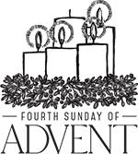
Sunday, December 20 Mass ~ 8:00 & 10:30 AM
Confessions / 10:00 – 10:15 AM / St. Paul Room
Girls Scouts / 1:00 – 2:30 PM & 4:00 – 5:30 PM
Monday, December 21 Mass ~ Noon
NO Sunday Choir Practice

Tuesday, December 22 Mass ~ Noon
Boy Scouts / 7:30 – 9:00 PM

Wednesday, December 23 Mass ~ Noon
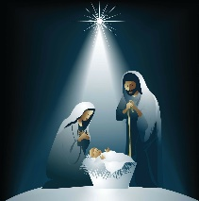
Thursday, December 24 No Noon Mass
Christmas Eve Masses ~ 3:00 & 7:00 PM
Parish Offices Closed

Friday, December 25 Christmas Day Mass ~ 9:00 AM
Parish Offices Closed

Saturday, December 26 Mass / 4:00 PM
Confessions / 3:30 – 3:45 / St. Paul Room

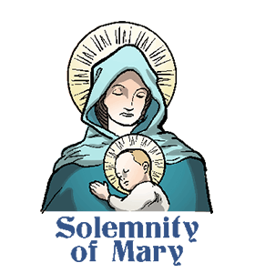
UPCOMING EVENTS

December 31 Solemnity of Mary Vigil Mass / 4:00 PM
Parish Offices Closed
January 1, 2021 Solemnity of Mary Mass / 9:00 AM
Parish Offices Closed

FRIAR’S NOOK GIFT SHOP – CHRISTMAS SALE! ~ Finish up (or start!) your Christmas shopping! Save 20% off the ENTIRE store Dec. 18th – 23rd (CLOSED DEC 20th) including nativities, flags, home décor, cards, gifts & much more! The Friar’s Nook Gift Shop is located on the campus of St. Bernardine Monastery at 793 Monastery Road, Hollidaysburg. With any questions, please call 814-695-3802 or message us on Facebook at “The Friar’s Nook Gift Shop”. Please note: The Friar’s Nook Gift Shop will be closed the following days in observance of the holidays: Dec. 24th – 27th and Dec.31st – Jan.1st.As always, thank you so much for all the hard work you do to spread God’s message, and please have a safe and blessed Christmas season!

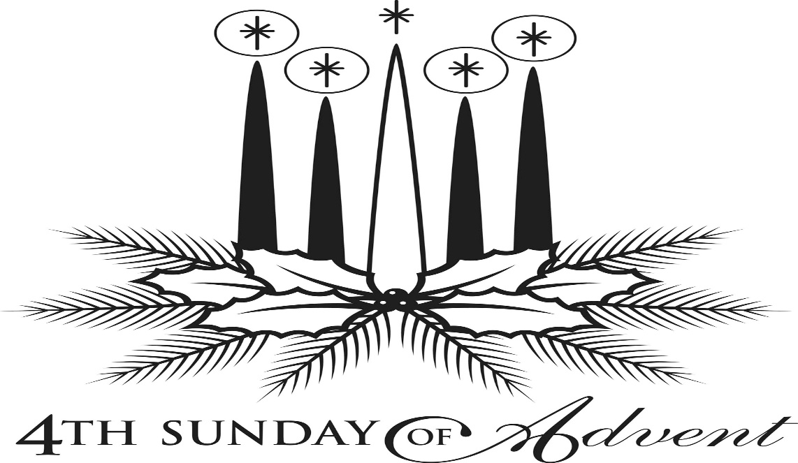

+++++++++++++++++++++++++++++++++++++++++++++++++++++

dIOCESE OF aLTOONA-johnstown
YEAR END GIVING IS HAPPENING NOW!

A bequest through your Will!
What will you be known for when you leave this earth? Perhaps you want your faith to be at the top of the list. Consider leaving a legacy through your Will. It’s simple to do by including the following statement when you create or amend your Will.
I give, devise, and bequeath to [the Diocese of Altoona-Johnstown, or specific parish, school, or ministry], or its successor, in [city, state] all [or a percentage] of the remainder of my estate, both real and personal, for use [its general support or a specific ministry or initiative].

Need more info or help?

Visit www.dioceseaj.org/ways-to-give/ or contact Pam Seasoltz, Director of Stewardship and Development, at 814.695.5577 or email: pseasoltz@dioceseaj.org

CHRISTMAS MEMORIAL FLOWERS 2020

IN MEMORY OF:

John Papcun by Violet Barr
John Barr by Violet Barr
Stanley & Barb Brezovec by J. Eric & Susan Wieczorek
Steve & Diane Bernot by J. Eric & Susan Wieczorek
Mike & Luba Slanoc by J. Eric & Susan Wieczorek
Joseph & Catherine Lucas by J. Eric & Susan Wieczorek
Bernard & Betty Neff by Karen Neff
John Neff by Karen Neff
Our Parents by Frank & Deborah Dupnock
Anna Myers by Frank & Deborah Dupnock
Gladys Pepoy by Steve Pepoy
Judy Pepoy by Steve Pepoy
Michael & Josephine Koshute by Paul & Cynthia McCloskey
Daniel Koshute by Paul & Cynthia McCloskey
Louis & Bernice McCloskey by Paul & Cynthia McCloskey
Deceased members of the Estok, Barton, Homolish, Flick Family & Leskanic Families
by Elaine Barton
Deceased members of Ray Plummer Family by William & Betty Plummer
Deceased members of Joseph Surkosky Family by William & Betty Plummer
Podrebarac Family by Alice Podrebarac
DiMarino Family by Alice Podrebarac
Podrebarac Family by Robert Podrebarac
Brindak Family by Robert Podrebarac
Joe & Antoinette Evanchick by Dennis & Veronica Richards
Harry & Bertha Richards by Dennis & Veronica Richards
Deceased Classmates of Adams Class 1962 by Dennis & Veronica Richards
Betty Zaluski by Dennis & Veronica Richards
Betsy Brown by David Brown
David & Hannah Brown by David Brown
Ann Bernat by David Brown
Art & Joan Zibura by David Brown
Mildred Facciani by Rob Facciani
Rose Marie Bambino by Tony & Sandy Bambino
William Stanko by Tony & Sandy Bambino
Mary Michaels by Tony & Sandy Bambino
Lloyd Michaels by Tony & Sandy Bambino
Panek Family by Barry & Mary Ann Spangler
Spangler Family by Barry & Mary Ann Spangler
Deceased Stoker Family by Sara Wieczorek
Deceased Wieczorek Family by Sara Wieczorek
Francis Andrykovitch by Michael Andrykovitch
Mr. & Mrs. Clyde Baumgardner by Bryan & Amy Spangler
Mr. & Mrs. Carl Huber by Bryan & Amy Spangler
Mr. & Mrs. Jack Spangler by Bryan & Amy Spangler
Mr. & Mrs. Bernard Panek by Bryan & Amy Spangler
Betty & Earl Penatzer by Gary & Denise Breto
Louise & Sylvester Bentkowski by Gary & Denise Breto
Mr. & Mrs. John Glovany by Paul Glovany
Mrs. Ann Blazosky by Paul Glovany
John Musilek by Paul Glovany
Carlos Diaz by Paul Glovany
Stoker & Gallaher Families by Wayne & Helen Gallaher
Marcella Bridge by Christine Rose
Howard Rose Jr. by Christine Rose
Michael Davis by Mary Anne Davis
Mary Costlow by Mary Anne Davis
Clair Costlow by Mary Anne Davis
Anna Owens by Mary Anne Davis
Deceased Members of the Bernard Family by Arnold & Marie Bernard Sr.
Deceased Members of the Sholtis Family by Arnold & Marie Bernard Sr.
Albert & Katherine Demko by Camillus & Betty Long
Albert & Clara Long by Camillus & Betty Long
Walter M. Lorek by Jeannine & Rick Roberts
Frank & Margaret Snyder by Paul & Susan Snyder
Harry & Agnes Noon by Paul & Susan Snyder
Our Grandparents by Matthew & Laura Docherty
Theresa Sager by Matthew & Laura Docherty
Olszewski & Habas Families by Robert & Joan Oshaben
Oshaben & Luberto Families by Robert & Joan Oshaben
Charles Vasas by Reba Vasas
Janet Smith by Reba Vasas
Boniface & Charlotte Smith by Reba Vasas
Philip Hillegas by Reba Vasas
Walter M. Lorek by Anita Lorek
Levia & Louis A. Kuhar by Anita Lorek
Margaret & Walter S. Lorek by Anita Lorek
Rhoads Family by Nicholas & Sally Kolar
Kolar Family by Nicholas & Sally Kolar
Ed & Kitty Yakicic by Martin & Tracy Yakicic
Edward & Margaret Yanzetich by Catherine Yanzetich
Deceased Members of Evan & Luba Yanzetich Family by Catherine Yanzetich
Michael & Rose Chalan by daughter, Pauline Minor & Family
Sam & Margaret Minor by son, Nicholas Minor & Family
Our Chalan & Minor Brothers & Sisters by Nicholas & Pauline Minor & Family
Flossie by Pauline Minor
Tony Smay by Kathleen Smay
My Gram & Pap Pcola by Andrew Martin
My Sister Adrienne by Andrew Martin
Francis Andrykovitch by Mildred Andrykovitch
John Stupi by Mildred Andrykovitch
Single Family by Marian Single
John Zibura by Agnes Zibura
Joe & Eileen Zibura by Eileen Zibura
Mr. & Mrs. Michael Cononie Jr. by Michael & Lucia Ann Brezovec
Mr. & Mrs. Stanley Brezovec by Michael & Lucia Ann Brezovec
Mr. & Mrs. John Lidonnice by Michael & Lucia Ann Brezovec
Mr. & Mrs. Larry Lucas by Michael & Lucia Ann Brezovec
John & Nora Ripper by Jeffry & Carol Schofield
Deceased Members of Shay & Faher Families by Joe & Cathy Faher
Stephen Faher by Joe & Cathy Faher
Josh Faher by Mom & Dad
Lehman Family by Michael & Linda Caddy
Caddy Family by Michael & Linda Caddy
Carole Leonard (Mom) by R. Timothy & Carole Kakabar
A and PopPop Sills by R. Timothy & Carole Kakabar
Mae Austin (Grandma) by R. Timothy & Carole Kakabar
Aunt Rita & Uncle Les Martin by R. Timothy & Carole Kakabar
Irene Hribar (Smith) by Frank Hribar
Donna Reuscher by David & Sarah Zajdel
Conrad Reuscher by David & Sarah Zajdel
Ted Zajdel by David & Sarah Zajdel
Pete Parisi by Joseph & Karen Parisi
Violet Parisi by Joseph & Karen Parisi
Emma Diaz (Parisi) by Joseph & Karen Parisi
Mr. & Mrs. Stanley Spanogle by Joseph & Karen Parisi
Ann Marie Swelfer from Husband Louis
Ann Marie Swelfer by Granddaughter Jenna Weis
Ann Marie Swelfer by Diane & Brian Weis
Ann Marie Swelfer by Grandson Jeremy Weis

Matt & Anna Rus by Hermina Tokarsky
Carl Tokarsky by Hermina Tokarsky
Joseph Rus by Hermina Tokarsky
Ann M. Swelfer by Hermina Tokarsky
Deceased Members of the Selepack & Yanzetich Families by Dolores & Evan Yanzetich
Deceased Members of the Stridinger & Yanzetich Families by Susan Yanzetich
Aloysius Neff by Grandchildren Emma, Rachel, Julia, Andrew & Tyler
Albert and Clara Long by Galen & Lorraine George
Bella & Katherine Demko by Galen & Lorraine George
Chester & Margaret George by Galen & Lorraine George
Paul & Violet Cummings by Galen & Lorraine George
Peter & Mary Ann Poldiak by John & Susan Poldiak
George & Jeanne Borenish by John & Susan Poldiak
Deceased Members of the Leonard Jasiecki Family by John & Susan Poldiak
Bruno & Elvida Bovino from Great Grandchildren Emma, Rachel, Julie, Andrew, Tyler,
Shawn & Elizabeth
Mary & Stanley Zybura Family by Sara Jane Zybura
Linda Bovina from Sisters Louise Neff & Joyce Suckenik
Mary Lou Yourich by Grandchildren Libby & Ian Dobbins
John & Nora Ripper by Mrs. Annette Kensinger
Valeria & Andrew Kush by Lawrence & Suellen Kush
Fremont & Dorothy Thomas by Lawrence & Suellen Kush
Michelle Poborski by Gloria Tompkins
Henry & Fran Zakraysek by Karen A. Zakraysek
Carol Horner by Loving Husband, Children & Grandchildren
Brandon Baxter by Loving Family
Wayne & Shirley Baxter by Loving Family
Stanley & Mary McCloskey by Loving Family
Verde & Vera Horner by Loving Family
Mike Hudak, Sr. by Edward Hudak
Rose Hudak by Edward Hudak
Margaret Hudak by Edward Hudak
Steve Domen by Edward Hudak
Kyle Fleck by Helen Slonac & Family
Nick Somonick by Helen Slonac & Family
Classmates of Adams-Summerhill Class 1964-1965 by Helen Slonac & Family

IN HONOR OF:

Ronald & Joanne Thomas by Martin & Tracy Yakicic
U.S. Military by Michael & Linda Caddy

DONATIONS:

Helen Petkosh
Carol Podrebarac
Jenna Frampton
William & Dee Kostan
Adam Bambino
Mark Bambino
Robert Bambino
Shirley Walls
Andrea Shirdon
James Shirdon Jr.
Ray & Christine Baxter
Elizabeth Zajdel
Kathy Kalicky
John & Bonnie Bizzarri

Thank you to everyone who donated to our Holiday Flowers.
We will use any extra monies to provide flowers in the church throughout 2021.

A charming story is told of Pepita, a poor Mexican girl who had no gift to present the Christ Child at Christmas Eve Services. As Pepita walked slowly to the chapel with her cousin Pedro, her heart was filled with sadness rather than joy.
"I am sure, Pepita, that even the most humble gift, if given in love, will be acceptable in His eyes," said Pedro consolingly.
Not knowing what else to do, Pepita knelt by the roadside and gathered a handful of common weeds, fashioning them into a small bouquet. Looking at the scraggly bunch of weeds, she felt more saddened and embarrassed than ever by the humbleness of her offering. She fought back a tear as she entered the small village chapel.
As she approached the altar, she remembered Pedro's kind words: "Even the most humble gift, if given in love, will be acceptable in His eyes." She felt her spirit lift as she knelt to lay the bouquet at the foot of the nativity scene. Suddenly, the bouquet of weeds burst into blooms of brilliant red, and all who saw them were certain that they had witnessed a Christmas miracle right before their eyes.
From that day on, the bright red flowers were known as the Flores de Noche Buena, or Flowers of the Holy Night, for they bloomed each year during the Christmas season.
Today, the common name for this plant is the poinsettia!
The shape of the poinsettia flower and leaves are sometimes thought as a symbol of the Star of Bethlehem which led the Wise Men to Jesus. The red colored leaves symbolize the blood of Christ. The white leaves represent his purity.

