ST. MICHAEL ROMAN CATHOLIC CHURCH

751 Locust Street

PO Box 103

St. Michael, Pennsylvania 15951

Rev. Msgr. David A. Lockard, Administrator MASSES:

(814) 495-9640 Saturday 4:00 pm

 Sunday Morning 8:00 am

Secretary & Bookkeeper: 10:30 am

Michele Panick Daily Mass: M, T, W, Th, F

DRE: Laurie Sloan 9:00 am

Maintenance: Rodney Turgeon Holy Days: See Bulletin

PHONES: Office Hours:

Rectory / Office: (814) 495-9640 8:30 am to 3:30 pm

Fax: (814) 495-9424 Monday, Tues., Thurs., Friday

Rel. Education: (814) 495-4873 Closed Wednesdays

Parish Website Confessions:

[www.saintmichaelchurch.weebly.com](http://www.saintmichaelchurch.weebly.com) Saturday 3:30 pm to 3:45 pm

Secretaries’ E-mail Sunday 7:30 am to 7:45 am

[saintmichaelsecretaries@yahoo.com](mailto:saintmichaelsecretaries@yahoo.com) 10:00 am to 10:15 am

Facebook page: By Appointment

St. Michael Catholic Church/St. Michael, PA

Seventh Sunday in Ordinary Time

SERVING GOD AND COMMUNITY FOR OVER ONE HUNDRED YEARS!

February 20th, 2022

BAPTISM: By Appointment. Reserve at least one month in advance.

MARRIAGE: Plan at least nine months in advance.

Preparation sessions are necessary.

FUNERALS: Arrangements are made in conjunction with the funeral home.

REGISTRATION Those new to the area, newlyweds, and single adults, (even if

and registered before with their families) are asked to register by calling

Membership: the Parish Office. Every parishioner must be registered. This is a condition for admission to our Program and reception of the Sacraments of Baptism, Confirmation, First Penance, First Eucharist, and Matrimony; also, for testimonial letters or sponsorship of Baptism and Confirmation outside the Parish.

VISITATION: We are concerned and want to be advised when someone is ill at home or in the hospital. Call the office to have the shut-in placed on our monthly Holy Communion calls or seriously ill prayer list.

SACRAMENTAL Parish registration and active Mass participation for Baptism is

POLICY: encouraged and is required for Marriage.

BULLETIN ARTICLES: Articles are due to the Parish Office by Noon on Tuesday

Seventh Sunday in Ordinary Time

February 20th, 2022

Month of The Holy Family

**MASS INTENTIONS**: (February 21 - February 27, 2022)

Monday, February 21 9:00 AM Agnes Plummer req. by Joe & Jan Huber

Tuesday, February 22 9:00 AM Michael Martinez, Sr. req. by Msgr. Lockard

Wednesday, February 23 9:00 AM Robert & Dolores Meier req. by son, Michael Meier

Thursday, February 24 9:00 AM Marie Minor req. by Susan Horvath Davis & Joan Horvath

Martin

Friday, February 25 9:00 AM John Estok req. by sister, Elaine Barton

Saturday, February 26 4:00 PM People of the Parish

Sunday, February 27 8:00 AM Guy Galosi req. by Jennifer & Rick Chimelewski

10:30 AM Janet Smith req. by Stella Strittmatter

LITURGICIAL APPOINTMENTS:

Saturday, February 26 4:00 PM Offertory Procession

Lector: Sherry Dipko Karen Myers & Mary Ann Spangler

Minister of the Host: Helen Slonac

Choir Minister: Michael Barton

Altar Server: Ana Spangler

Cantor: Amy Spangler

Greeter: Mary Ann Spangler

Sunday, February 27 8:00 AM Offertory Procession

Lector: Terri Leach Terry Leach Family

Minister of the Host: Eric Tedjeske

Choir Minister: Marie Bernard

Altar Server: Michael Kresic

Cantor: Anita Lorek

Greeter: Pauline Minor

Sunday, February 27 10:30 AM Offertory Procession

Lector: Ryan Jones John & Michelle Vitez

Minister of the Host: Jennifer Steele

Choir Minister: Susan Wieczorek

Altar Server: Cameron Vitez

Cantor: Sharon Dibble

Greeter: REACH Students

Monday, February 28 Collection Counters

George & Pauline Minor

Weare placing names of the sick in the bulletin for prayer providing they give permission. *May the* *Divine Physician send healing grace for those for* *whom we pray:* Allen C. Rosemas, Patricia Murphy, Dwight Fyock, Dylon Wills, Missy, Joanne (Kolar) Hufford, Christine Flanagan, Ayden Alan Grata, Mary Lou Offman, Natalie Zerby, Valencia Tursi, Brayden Schofield, Michelle Kasper, Diane Kingera, Ted Paluch, Pearl Litzinger, Patrick Munro, Fran Baldassarre, Kristen Sinosky Long, Cresta Micik, Basil Costantino, Laura, Joe Yoder, Dolores Yanzetich, Sandy Krug, Wanda Gramling, Jennifer Hagans, Shawn, Holly, Shane, Spencer, Owen Taylor, Derrick Varnish, Vincent Koshute, Michelle Elliott, Heather Romanow, Mackston Barrick, Connor Thomas, Erin, Pat, Mary Agnes Nastase, Mary Ann Bertolino, Dick Wilson, Izzy Bihun, Dorothy Kaminsky, Ashlee Madison, Susan Yanzetich, Alina Rusnak, Gary Smay, Elizabeth Howell, Walter Bodziak, Rhonda, Anne Robinson, Carter Bobak, Mike Morris, Sarah Kelt, Patty Yanzetich Caldwell, Colton Snyder, Nancy Edmiston, Leonard Oshaben, Adam, Janice Dipyatic, Lily Maloney, Scott, Lisa, Audrey Costlow, Rosanne Krug, Becky Kakabar, Dolores Mucko, Elliana, Ashlee, Helen Soohy, Carol K. Fabrizio, Peggy Carpenter, Dave Seder, Rosalie Ambrose, Pearl Borlie, Joe (Runk) Slonac, Patty Gdula, Lori Gramling, Babe Richards, Ruth Ferchalk, Kathy Glenn Ripper, Ernie Martinage, Mildred Andrykovitch, Katelyn Engle, John Patterson, Colin Wingard, Betty Duray and all of the sick of our parish, the homebound, those in nursing homes, those who care for them, and those in the military along with their families. *(Please call the Rectory to have your name removed from the list when no longer seriously ill. Thank You.)*

LAST WEEK’S COLLECTION

Regular Offertory $4,429.00

Maintenance $ 30.00

Total $4,459.00

We sincerely thank

and ask God’s blessing

upon all who have care

and concern for

our parish.

*February 20th, 2022 LK 6:27-38*

*In studying the effects of religion upon family relationships, researchers inform us hostility and prayer can’t coexist. You cannot be hostile toward someone for whom you are praying. Today’s gospel encourages us: “Bless those who curse you. Pray for those who treat you badly.”*

During the week of February 20th, 2022

the Sanctuary Candle will burn in memory of

Dennis Carosi

requested by Helen Slonac & family

and the Our Lady of Grace Candle will burn in memory of

Aloysius Neff

requested by wife Louise & sons, John, David & families

[](https://images.search.yahoo.com/search/images;_ylt=A0LEV1kSWptXvOwAKINXNyoA;_ylu=X3oDMTEyZGdkcmRoBGNvbG8DYmYxBHBvcwMxBHZ0aWQDQjIwODlfMQRzZWMDc2M-?p=Clipart+of+a+sanctuary+candle&fr=ush-mailn_02&th=110&tw=110&imgurl=http://www.henningers.com/389-168-wall-sanctuary-lamp.jpg&rurl=http://pixshark.com/sanctuary-lamp.htm&size=43KB&name=Sanctuary+Lamp+Bronze+wall+sanctuary+lamp&h=600&w=600&turl=http://ts2.mm.bing.net/th?id%3DOIP.M68453c67108cdc5ab485d309b395bd03o0%26pid%3D15.1%26rs%3D1%26c%3D1%26qlt%3D95%26w%3D110%26h%3D110#inline&tt=Sanctuary+Lamp+Bronze+wall+sanctuary+lamp&sigr=116keh5le&sigit=13gvlt42j&sigi=11ip0pgm4&sign=119kp6100&sigt=119kp6100)

LENT ~ Ash Wednesday, the first day of Lent, falls on March 2nd this year. Blessed ashes will be distributed during a 9:00 AM and a 6:00 PM Mass that day. There will also be a prayer service at Noon on Ash Wednesday during which blessed ashes will be distributed. Plan now to attend. Ash Wednesday is a day of Fast and Abstinence – no meat, no eating between meals and only one “big meal”.

CONFESSIONS & STATIONS OF THE CROSS ~ We will pray the Stations of the Cross on the Fridays of Lent at 6:00 PM. Following the Stations there will be an opportunity to go to confession. Let us make the most of this opportunity to participate in these Lenten devotions.

LENTEN “LITTLE BLACK BOOK” ~ Once again, the parish is providing the Lenten “Little Black Book” free of charge to all parishioners. The “Little Black Book” can be found at the side entrance of the Church and on the table at the back of the Church.

LENTEN FOLDERS ~ Lenten folders are available at the side entrance and on the table at the back of the Church. Your contribution will be added to your Easter Collection and will be a financial help to our local Forest Hills Food Pantry.

CRS RICE BOWLS ~ Catholic Relief Services Rice Bowls are being distributed to the Religious Education students, one per family, in their RE classes. The extra Rice Bowls can be found at the side entrance and on the table at the back of the Church for anyone that wants one. Your Rice Bowl donations will support the missions. Please, one per family.

SECOND SUNDAY FOOD COLLECTION ~ Thank you to all who so generously donated to the Forest Hills Food Pantry. The total money collected was $1,020.00 and an assortment of non-perishable items.

SCRIPTURAL FAITH SHARING GROUP ~ Scriptural faith sharing groups are forming for the Lenten season. Consider joining a Synodal Faith Sharing Group based on scripture, to be held during the Lenten season. Two groups are offered to best suit your schedule. Each group will run for six consecutive weeks. Group 1: Starting Tuesday, March 8th in the Church Hall at 9:30 AM (after the morning Mass). Group 2: Starting Wednesday, March 9th, in the Church Hall at 6:30 PM (after the evening Mass). Sign-up sheets are in the back of the Church.

FEBRUARY 2022 PARISH TICKET WINNERS

UNSOLD TICKETS/NOT RETURNED TICKETS ~ If the winning number is a ticket that was not sold or returned, the money will be split with the number above the winning number and the number below the winning number. If the number above or below the winning number was not returned, we will go above or below that number.

Day Date Amount Number Winner

Friday February 11 $75 256 Carole Mucker

Saturday February 12 $100 544 Pete Bernard

Sunday February 13 $100 501 No Winner

$50 502 Karen Myers

$50 500 No Winner

$50 499 Mary Adams

Monday February 14 $150 071 Michael Yauneridge

Tuesday February 15 $75 925 Bob MacTavish

Wednesday February 16 $75 606 No Winner

$37.50 605 Pauline Minor

$37.50 607 Melanie Wotkowski

Thursday February 17 $75 608 Christine Rose

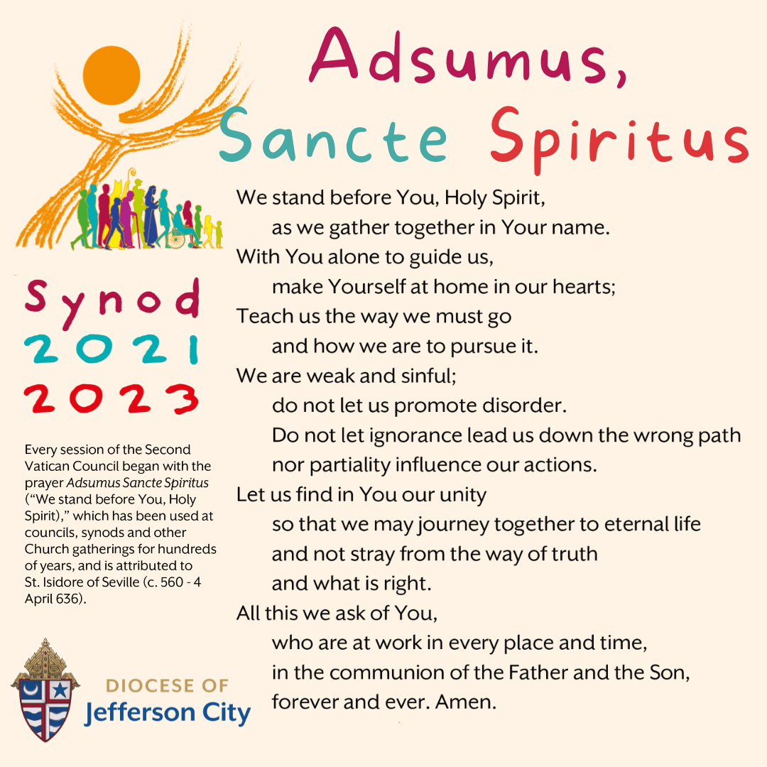

SYNOD SURVEY ~ We want to hear your thoughts on how we can move forward as a Church! Complete the Diocesan Synod Questionnaire by going to dioceseaj.org/synod for the online survey or pick up a paper survey located at the entrances of the Church or join one of the local Scriptural Faith Sharing groups! Please return the paper surveys to the Church either through the offertory collection, by mailing, or by dropping them in the black drop off box by the office door. Thank you.

*Stewardship Reflections….*

Today’s gospel is full of stewardship advice: give to everyone who asks; expect nothing in return; do not judge or condemn; love your enemies. Live your life with great kindness and mercy! Jesus offers a very challenging, seemingly impossible approach to daily life. It makes one want to say, “Seriously, Lord?” And he doesn’t stop there. Jesus adds, “’Give to everyone who asks of you, and from the one who takes what is yours do not demand it back.’”

 Religious Education And Christian Helping

February 20, 2022

Spring Confirmation Sessions

Grade 9 ~ Session 9 B ~ Prayer: Communion with God

Our 9th Grade students will be participating in their Spring Session 9 B from 9 to 10:20 a.m. with their classmates on Sunday, March 6, 2022.

***************************************************************************

*Confirmation Retreats*

Confirmation retreats are scheduled to take place for our 10th, and 11th grade candidates during class time, 9—10:20 a.m. as follows:

Sunday, March 6th ~ 10th Grade – Baptism Retreat (Make-up from 9th Grade year)

11th Grade – Parables Retreat

*Confirmation candidates must be present for their retreat date to fulfill their confirmation requirements and be eligible to receive their Sacrament of Confirmation*

***************************************************************************

*Sacrament of First Reconciliation ~* Our First Holy Communion class has been preparing for and will receive their Sacrament of Reconciliation for the first time on Saturday, March12, 2022 at 1:00 PM in the church.

Please remember these children in your prayers as they prepare and anticipate the arrival of this very special day.

*********************************************************************

Catholic Relief Services ~ RICE BOWLS

Catholic Relief Services Rice Bowls are being distributed to the Religious Education students, one per family, in their RE classes. These Rice Bowls can be used by families during the Lenten season. Through CRS, your donations can help reach more than 140 Million people with lifesaving support.

Thank You for changing lives this Lent!

Junior High Youth Day ~ Sunday, March 20, 2022 ~ Grades 6, 7 & 8

Junior High Youth Day 2022 is scheduled for Sunday, March 20.  JHYD is now part of our Religious Education curriculum for our 6th, 7th & 8th grade students in our Diocese of Altoona-Johnstown. All of our students in grades 6th, 7th and 8th will participate in JHYD in lieu of their CCD class for that Sunday.

Due to continued COVID issues, JHYD will be will be a virtual Zoom event on site at our Saint Michael Parish. The day will begin at 10:00 AM and last until 12:30 PM. Refreshments will be provided for the day.

Jesse Mannibusan will be the keynote speaker this year. He is a very engaging person who shares his faith through humor, stories and his awesome music. Bishop Mark will also be joining us. There is no fee to participate. We will be on a zoom link with all the other parishes throughout our Altoona/Johnstown Diocese and will participate in group activities together.

\**Since JHYD is taking place over our 10:30 AM Mass, students will need to attend our Saturday, 4 PM Mass or the Sunday, 8:00 AM Mass to fulfill their Sunday Mass obligation.*

A completed registration/permission form is required and is due back to the RE Office by Sunday, March 13th so I can register our group with the diocese.

*********************************************************************

Confirmation ~ Our 11th Grade Confirmation class is preparing to receive their Sacrament of Confirmation on Thursday, April 21st, 2022. A 7:00 PM Mass will be celebrated at Saint John Gualbert Cathedral in Johnstown. *Confirmation Practice will be held on Wednesday evening, April 20th at 6:30 PM.*

First Holy Communion ~ Our First Holy Communion class is preparing to

receive their Sacrament of First Holy Communion on Sunday, May 1, 2022 at 2:00 PM.

Sunday, February 20 Mass ~ 8:00 AM & 10:30 AM

Confessions / 7:30 – 7:45 AM & 10:00 - 10:15 AM / Confessional

HS Religious Education / Hall / 9 – 10:15 AM

Decorating Committee Meeting / After 10:30 AM Mass



Monday, February 21 Mass ~ 9:00 AM

President’s Day / Parish Offices Closed

Sunday Choir Practice / 7:00 PM

Knights of Columbus Meeting / Hall / 6:00 PM

Tuesday, February 22 Mass ~ 9:00 AM

Boy Scout Meeting / Hall / 7:30 – 9:00 PM

Wednesday, February 23 Mass ~ 9:00 AM

Boy Scouts Painting Party / Hall / 6 – 8:30 PM

Thursday, February 24 Mass ~ 9:00 AM

K – 5 Religious Education / Hall / 3:30 – 4:30 PM

Saturday Choir Practice / 4:30 PM

Friday, February 25 Mass ~ 9:00 AM

Saturday, February 26 Mass ~ 4:00 PM

Confessions / 3:30 – 3:45 PM / Confessional

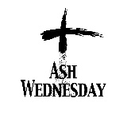 UPCOMING EVENTS

March 2 Ash Wednesday / Mandeville Diocese Collection

March 4 Stations of the Cross / 6:00 PM

March 5 & 6 Black & Indian Mission Second Collection

LENTEN FISH FRY ~ The St. Michael Fire Department is hosting our annual Lenten Fish Fries – beginning this Friday, February 25th and will run thru Good Friday – April 15th. Meals are Fried or Baked Fish or Shrimp Dinners. A Grab-n-Go sandwich and child’s dinners are also available. Meals are takeout only and local delivery. Adult Fish Dinners are $11 and Adult Shrimp dinners are $12. Please Phone at 814-495-4111. Hours are 11 AM to 6 PM.

PUBLIC ROSARY ~ To Pray for Our Country. Saturday, February 26th at NOON. St. John Gualbert Cathedral – St. Ann Shrine – Downtown Johnstown.

TRIVIA NIGHT! ~ Bishop Carroll Catholic High School, Saturday, February 26th. Doors open at 6 PM, Dinner at 6:30 PM. Game begins at 7:30 PM. Open to age 21 and over. Pre-paid ticket $30, Door $35. Registration deadline February 21st. For information email [jnagy@bishopcarroll.org](mailto:jnagy@bishopcarroll.org).

LENTEN JOURNEY SERIES AT ST. BERNARDINE MONASTERY ~ “As We Journey Through Lent” – Join the Friars at St. Bernardine Monastery, 768 Monastery Rd, Hollidaysburg, for a time of reflection, prayer, and fellowship during this Lenten season. Wednesday – March 9th, 16th, 23rd and 30th from 10 AM – 1 PM. Lunch is included and a free-will offering will be taken. Registration is necessary by calling the Monastery office by Friday, March 4th at 814-695-3802.