Rev. 12:7
ST. MICHAEL ROMAN CATHOLIC CHURCH
751 Locust Street
PO Box 103
St. Michael, Pennsylvania 15951

Rev. Msgr. David A. Lockard, Administrator MASSES:
(814) 495-9640 Saturday 4:00 pm
Sunday Morning 8:00 am
Secretary: Michele Panick 10:30 am
Bookkeeper: Kathy Kalicky Daily Mass See Bulletin
DRE: Laurie Sloan Holy Days See Bulletin
Maintenance: Rodney Turgeon
Office Hours:
PHONES: 8:30 am to 3:30 pm
Rectory / Office: (814) 495-9640 Monday, Tues., Thurs., Friday
Fax: (814) 495-9424 Confessions:
Rel. Education: (814) 495-4873 Saturday 3:30 pm to 3:45 pm
Parish Website Sunday 7:30 am to 7:45 am
www.saintmichaelchurch.weebly.com 10:00 am to 10:15 am
Secretaries’ E-mail By Appointment
saintmichaelsecretaries@yahoo.com
Fourth Sunday of Lent

SERVING GOD AND COMMUNITY FOR OVER ONE HUNDRED YEARS!

March 22, 2020

BAPTISM: By Appointment. Reserve at least one month in advance.
MARRIAGE: Plan at least nine months in advance.
Preparation sessions are necessary.
FUNERALS: Arrangements are made in conjunction with the funeral home.
REGISTRATION Those new to the area, newlyweds, and single adults, (even if registered
and before with their families) are asked to register by calling the Parish Office.
MEMBERSHIP: Every parishioner must be registered. This is a condition for admission
to our Program and reception of the Sacraments of Baptism, Confirmation, First Penance, First Eucharist, and Matrimony; also, for testimonial letters or sponsorship of Baptism and Confirmation outside the Parish.
VISITATION: We are concerned and want to be advised when someone is ill at home or in the hospital. Call the rectory to have the shut-in placed on our monthly Holy Communion calls or seriously ill prayer list.
SACRAMENTAL Parish registration and active Mass participation for Baptism is
POLICY: encouraged and is required for Marriage.
BULLETIN ARTICLES: Articles are due to the Parish Office by Noon on Tuesday.

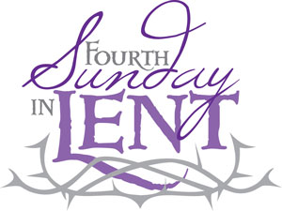
Fourth Sunday of Lent
March 22, 2020
Month of St. Joseph

MASS INTENTIONS: (March 23 – March 29, 2020)

Monday No Mass
Tuesday No Mass
Wednesday No Mass
Thursday No Mass
Friday No Mass
Saturday Joe Soohy req. by The Soohy Family (Done privately by Msgr.)
Sunday Michael Cononie req. by Mike & Lucia Ann Brezovec (Done privately by Msgr.)
Sunday People of the Parish

The Sanctuary Candle will burn in memory of
Susie Thomas
requested by Helen Slonac & Family
during the week of March 22, 2020.

PRIVATE PRAYER ~ The Church will be open weekdays for private prayer from 8:30 AM – 3:00 PM and on the weekend from 9:00 AM – 4:00 PM.

MASSES ~ There will be no Daily Masses, Wednesday Evening Mass, or Weekend Masses until further notice. Stations of the Cross have also been cancelled. Please see the Bishop’s Letter on the bulletin insert or go to the Diocesan website - dioceseaj.org

LENTEN CONFESSIONS ~ Lenten Confessions scheduled here at St. Michael, Monday, March 23rd at 6:00 PM has been cancelled due to the dangers of the Corona Virus.

WEEKEND CONFESSIONS ~ Msgr. will be hearing confessions on Saturday’s at 3:30 PM and on Sunday’s at 10:00 AM in the Confessional.

CANCELLED! ~ Due to the Corona Virus danger, The Commemoration of the Lord’s Last Supper has been cancelled which was scheduled here for Wednesday, April 8th.

WEEKLY OFFERING ~ Parishioners can continue to support their Parish of St. Michael either by mailing their envelopes, dropping them in the treasury basket inside the Church, putting them in the green tote outside the Parish Office door or by dropping them off at the Parish Office (if still open).

EASTER FLOWERS ~ Any Easter Flower donations that we have received or continue to receive will be used to purchase flowers for the Church throughout the year. Please return the envelopes on or before April 5th.

CATHOLIC RELIEF SERVICES COLLECTION ~ This week, the collection is for The Catholic Relief Services Collection (CRSC) to help Jesus in disguise. This collection helps six Catholic agencies to provide struggling communities with relief and support and to work for peace and reconciliation among our marginalized brothers and sisters here and around the world. Please prayerfully consider how you can support the collection. Envelopes can be found in your packet and can be dropped off at the Church, or at the Church office, or can be mailed in. Learn more about the collection at www.usccb.org/catholic-relief

We are placing names of the sick in the bulletin for prayer providing they give permission. May the Divine Physician send healing grace for those for whom we pray: Allen C. Rosemas, Patricia Murphy, Bernice Myers, Dwight Fyock, Dylon Wills, Missy, Joanne (Kolar) Hufford, Christine Flanagan, Ayden Alan Grata, Mary Lou Offman, Mary Zangaglia, Natalie Zerby, Valencia & Frank Tursi, Homer Locher, Brayden Schofield, Michelle Kasper, Diane Kingera, Allison Krischer, Ted Paluch, Brandt Hutzel, Pearl Litzinger, Patrick Munro, Fran Baldassarre, Kristen Sinosky Long, Helen Ranieri, Cresta Micik, Basil Costantino, Madison McCrory, Laura, Joe Yoder, Dolores Yanzetich, Sandy Krug, Wanda Gramling, Agnes Plummer, Jennifer Hagans, Shawn, Holly, Shane, Spencer, Owen Taylor, Keith & Dawnetta Hoyer, Derrick Varnish, Vincent Koshute, Melissa Cordek, Michelle Elliott, Heather Romanow, Mackston Barrick, Connor Thomas, Erin, Pat, Mary Agnes Nastase, Mary Ann Bertolino, Dick Wilson, Izzy Bihun, Dorothy Kaminsky, Patricia Oshaben, Ashlee Madison, Susan Yanzetich, Mike, Danika Faith, Alina Rusnak, Gary Smay, Elizabeth Howell, Helen Bowen, Walter Bodziak, Rhonda, Dan Strinkoski, Anne Robinson, Marlene McCrory, Sharon Poldiak, Carter Bobak, Vince Arena, Mike Morris, Sarah Kelt, Patty Yanzetich Caldwell, Colton Snyder, Betty Delaney, Nancy Edmiston, Joseph Ropecka, Bill Krajewski, Leonard Oshaben, Adam, Bill Gideos, Janice Dipyatic, John Poldiak Jr., Gerald Delaney, Lily Maloney, Adam Wingard, Scott, Lisa, Rosalie Ambrose, John Patrick, Ellen Grattan, Audrey Costlow, Carole Horner, Ross Linert, Mary Ann Peretin DeRosa, Catherine Olszewski, Cathy Sossong, Rosanne Krug, Paul Snyder, Becky Kakabar and all of the sick of our parish, the homebound, those in nursing homes, those who care for them, and those in the military along with their families. (Please call the Rectory to have your name removed from the list when no longer seriously ill. Thank You.)

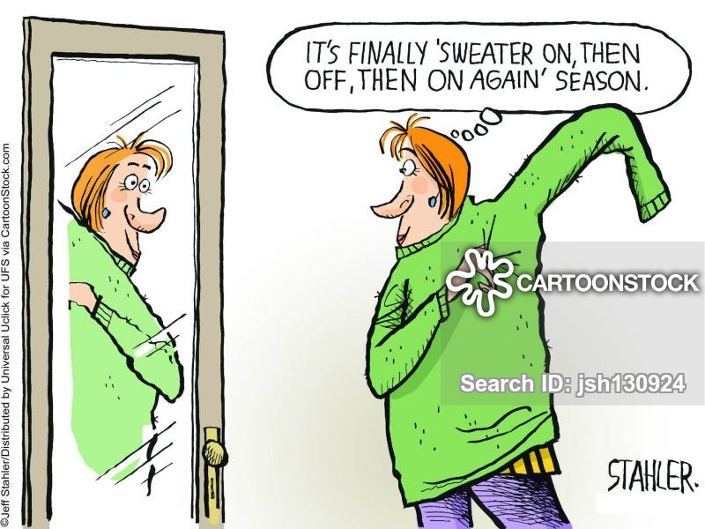

LAST WEEK’S COLLECTION

Adults $2,913.00
Loose $ 173.00
Youth $ 17.00
Monthly $ 95.00
Candles $ 20.00
Catholic Relief Services $ 30.00
Holy Thursday $ 5.00
Easter $ 25.00
Easter Flowers $ 110.00
Total $3,388.00

We sincerely thank and ask
God’s blessing upon all
who have care and
concern for our
parish.

March 22, 2020 John 9:1-41
Failure to forgive blinds us to another’s goodness. Lent provides and opportunity to wash away our blind spots in the pool of forgiveness. Listen to Jesus in today’s gospel: “Go wash and see.”

COVID-19 RESTRICTIONS
In light of the COVID-19 epidemic, Bishop Mark requires that priests and deacons of the Altoona-Johnstown Diocese observe the following directives, effective immediately.

Suspension of Public Masses
Churches and other public places of worship in the Altoona-Johnstown Diocese are to remain open for private prayer. However, effective immediately, there will be no public liturgies of any sort. That is, there will be no public daily Masses or weekend Masses, no public novenas, communal stations of the cross, ecumenical services, or other public worship until the current COVID-19 crisis has passed. The purpose of this is to retard the spread of the coronavirus. The Bishop will be reviewing the situation daily and will alert priests and deacons immediately when Masses and other public worship can be resumed.

The Bishop authorizes and expects priests to celebrate a private Mass each day during this crisis. This should be done in the rectory or at a private chapel. Priests should celebrate a single Mass in place of Saturday evening and Sunday Masses. The Bishop directs that, in light of the unprecedented situation in which we find ourselves, multiple Mass intentions should be coalesced in the one Sunday Mass. Provisions regarding the accounting of Mass stipends continue to pertain. That is, priests may keep the stipend of one Mass intention per day. All other stipends from additional intentions should be forwarded to the Diocese in keeping with canon law and diocesan policy. Coalescing Mass intentions into a single Sunday Mass includes the pastor’s pro populo obligation. The Mass will continue to be broadcast at 11:00am on Sundays. The Bishop will be the presider at this liturgy and these broadcasts will be available on the Diocesan website and social media.

Christian Initiation of Adults
Because this crisis is coming at the very time when the Christian Initiation of Adults would reach its apex, the rites regarding the reception of adults into the Church will be suspended until after the crisis has passed. These rites may then be celebrated at parish weekend liturgies once weekend Masses have been restored.

Easter Triduum
Because it seems unlikely that public Masses will be permitted until after Easter, priests should begin making arrangements for the private celebration of the liturgies associated with the Easter Triduum. It would be advisable for materials to be placed near the entrances of churches so that the faithful can take these home and participate in some way in these important liturgies. Priests should retain and make use of the existing paschal candle as well as the oils blessed last year. The Bishop will authorize new Paschal candles to be blessed and holy oils to be distributed once restrictions have been lifted.

Baptisms
Baptisms of children and adults may be held during the restricted period, but they should be limited to members of the immediate family only.

Confirmations
All currently scheduled confirmation Masses have been postponed. The Bishop plans to reschedule confirmations after the crisis has passed. These confirmations will most likely occur in a specific location in each of the five deaneries. In order to accommodate the greatest number of people, multiple confirmation liturgies in some deaneries may need to be scheduled.

First Holy Communion
First communion liturgies should be postponed until after the crisis has ended.

The Sacrament of Penance
In terms of the celebration of penance, the Bishop requires that all penance services be canceled until after current restrictions on crowd size have been lifted. He encourages priests to offer specific times when the faithful can come for individual confessions. Priests should make use of the confessional barrier between themselves and the penitents, and provide ways for surfaces in the confessional to be disinfected after each penitent, if possible. Should the crisis escalate to the point where there is a grave danger of death for many, the bishop will authorize the use of general absolution. Priests will be made aware of this if the necessity arises. In the meantime, the ordinary form of the sacrament of penance should be observed.

Weddings
Priests and deacons are encouraged to contact couples who are planning weddings in the next several months to determine if these plans have been altered. It is possible, and even likely, that venue changes and cancelations may already have affected couples with scheduled weddings. Because most weddings are not scheduled earlier than mid-April, it should be possible to give more accurate guidance in the next couple of weeks.

Funerals
Funerals may continue to be celebrated but only for immediate family members. The time of the Mass should not be published. It is acceptable for families who wish to avoid coming to a parish church to have a funeral liturgy outside of Mass celebrated at the funeral home. Vigils should be conducted at the discretion of the families and funeral directors in keeping with the requirements of public safety.

Pastoral Care of the Sick
The Bishop directs that priests and deacons follow these protocols with regard to the visitation and pastoral care of the sick. Those who are hospitalized should continue to receive visitation and sacraments as permitted by hospital policy. Thus priests and deacons who serve as hospital chaplains and in emergent coverage should continue these functions. Priests and deacons should visit parishioners in nursing facilities and rehab units only in danger of death. Similarly, priests and deacons should visit parishioners in their private homes only in danger of death.

Pastoral Care in General
Priests and deacons should continue to meet on a one-to-one basis with parishioners for appointments and pastoral counseling. The Diocesan Pastoral Center will be closed for two weeks or until the current situation abates. Email and phone calls will be answered remotely. Similarly, Catholic Charities will be closed but it is possible to leave messages for Catholic Charities staff.

Graduations
Until the Diocesan Education Office receives instruction from the Pennsylvania Department of Education, all graduations are temporarily postponed.

Fundraisers
By direct order of the Bishop, all social gatherings are prohibited until further notice. This includes parish gatherings, meetings of parish groups, fish fries, and other fundraisers. These measures are required in order to avoid person-to-person contact and the spread of COVID-19. Furthermore, because it is impossible to observe the necessary sterile procedures and because of the possibility of gatherings of people in excess of what is required for public safety, all takeout meals for fundraising must also be suspended immediately.
Financial Considerations and Payroll
All priests and deacons are encouraged, with the assistance of their finance council members, to consider what are the most essential tasks required in their parishes at present and which employees are necessary for these tasks. In order to deal with the projected shortfall in income which will be occurring in many parishes, it may be necessary to make use of temporary layoffs as a way of dealing with financial obligations. In the case of such layoffs, these employees are eligible to apply for unemployment compensation. Telecommuting (working from home over computer or phone) is recommended as a way to continue to have employees work for the parish. With Matt Stever’s assistance, the Bishop hopes to publish directives about ways in whichfinancially-strained parishes should go about meeting their current financial obligations.
It is recognized that certain employees are essential to parish functioning at this time and should continue working, if possible. Consult with Lynette McEvoy with any questions about whether an employee should report for work.
The Catholic Ministries Drive will continue.
For those parishes which have already established online giving, priests and deacons should encourage parishioners to continue their giving in this way. Effective March 18, 2019, it will be possible for parishes without online giving to receive offertory online through a new Diocesan portal at www.dioceseaj.org/giving. Priests and deacons should inform their parishioners about this way of giving. For parishioners who are not computer-savvy, priests and deacons may want to encourage the use of US Mail as a way of continuing to support their parish.

Sunday, March 22 NO High School Religious Ed.
Catholic Relief Services Collection
NO Liturgy Committee Meeting

Monday, March 23 NO Mass
NO Lenten Confessions
NO Sunday Choir Practice

Tuesday, March 24 NO Mass

Wednesday, March 25 NO Mass
Thursday, March 26 NO Mass
NO K—5 Religious Ed.
NO Saturday Choir Practice
Friday, March 27 NO Mass
NO Stations of the Cross
NO Combined Choir Practice

Saturday, March 28 NO Mass

UPCOMING EVENTS

OFFICE OF CHILD AND YOUTH PROTECTION ~ Each month there will be one educational article provided by VIRTUS covering topics of interest to create awareness on trending topics. This month’s featured article is: “Mobile Device Dangers: Snapchat, Snap Map and Caller ID Spoofing” By Robert Hugh Farley. Copies of the article can be found on the table at the back of the Church.

FISH FRY

St. Michael Firehall, St. Michael ~ Take outs or local delivery available. Phone at 495-4111.

