Rev. 12:7

ST. MICHAEL ROMAN CATHOLIC CHURCH

751 Locust Street

PO Box 103

St. Michael, Pennsylvania 15951

Rev. Msgr. David A. Lockard, Administrator MASSES:

(814) 495-9640 Saturday 4:00 pm



Sunday Morning 8:00 am

Secretary: Michele Panick 10:30 am

Bookkeeper: Kathy Kalicky Daily Mass See Bulletin

DRE: Laurie Sloan Holy Days See Bulletin

Maintenance: Rodney Turgeon

Office Hours:

PHONES: 8:30 am to 3:30 pm

Rectory / Office: (814) 495-9640 Monday, Tues., Thurs., Friday

Fax: (814) 495-9424 Confessions:

Rel. Education: (814) 495-4873 Saturday 3:30 pm to 3:45 pm

Parish Website Sunday 7:30 am to 7:45 am

www.saintmichaelchurch.weebly.com 10:00 am to 10:15 am

Secretaries’ E-mail By Appointment

[saintmichaelsecretaries@yahoo.com](mailto:saintmichaelsecretaries@yahoo.com)

Fifth Sunday of Lent

SERVING GOD AND COMMUNITY FOR OVER ONE HUNDRED YEARS!

March 29, 2020

BAPTISM: By Appointment. Reserve at least one month in advance.

MARRIAGE: Plan at least nine months in advance.

Preparation sessions are necessary.

FUNERALS: Arrangements are made in conjunction with the funeral home.

REGISTRATION Those new to the area, newlyweds, and single adults, (even if registered

and before with their families) are asked to register by calling the Parish Office.

MEMBERSHIP: Every parishioner must be registered. This is a condition for admission

to our Program and reception of the Sacraments of Baptism, Confirmation, First Penance, First Eucharist, and Matrimony; also, for testimonial letters or sponsorship of Baptism and Confirmation outside the Parish.

VISITATION: We are concerned and want to be advised when someone is ill at home or in the hospital. Call the rectory to have the shut-in placed on our monthly Holy Communion calls or seriously ill prayer list.

SACRAMENTAL Parish registration and active Mass participation for Baptism is

POLICY: encouraged and is required for Marriage.

BULLETIN ARTICLES: Articles are due to the Parish Office by Noon on Tuesday.

Fifth Sunday of Lent

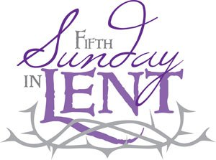 March 29, 2020

Month of St. Joseph

**MASS INTENTIONS**: (March 30 – April 5, 2020)

Monday No Mass

Tuesday No Mass

Wednesday No Mass

Thursday No Mass

Friday No Mass

Saturday No Mass

Sunday No Mass

Sunday People of the Parish (Done privately by Msgr. Lockard)

NEW OFFICE HOURS! ~ The Parish Office will now be open Mon, Tues, Thurs, Fri. from

8:30 AM – 2:00 PM.

PRIVATE PRAYER ~ The Church will be open weekdays for private prayer from 8:30 AM – 3:00 PM and on the weekend from 9:00 AM – 4:00 PM.

WEEKLY OFFERING ~ Parishioners can continue to support their Parish of St. Michael either by mailing their envelopes to the Parish address, dropping them off at the Parish Office or the Diocese has provided the use of their online giving platform and created a specific “Your Parish Offertory” giving site. “Your Parish Offertory” is available on the diocese’s home page featuring a GIVING button located at the top of the home page in the right-hand corner that directly takes you to the portal. Go to [www.dioceseaj.org/giving](http://www.dioceseaj.org/giving). All funds donated will be credited to St. Michael and we will be made aware of your continued generosity.

MASSES ~ There will be no Daily Masses, Wednesday Evening Mass, or Weekend Masses until further notice. Stations of the Cross have also been cancelled.

WEEKEND CONFESSIONS ~ Msgr. will be hearing confessions on Saturday’s at 3:30 PM. The Confession time for Sunday’s has changed to 10:30 AM. All confessions will be heard in the Confessional.

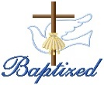BAPTISM ~ On Friday March 27th, 2020, we celebrated the glorious baptism of Aubrey Grace and Jordan Alexander Carl, daughter and son of Robert and Shirley Carl, by Msgr. David Lockard. Aubrey Grace and Jordan Alexander became new creations in Christ in the waters of Holy Baptism. Now joined to us by the gifts of faith, hope and charity, we warmly welcome them into our St. Michael Parish Family.

CATHOLIC RELIEF SERVICES COLLECTION ~ Thank you for your generous support of The Catholic Relief Services Collection and for helping Jesus in disguise. Your contributions make a difference for the poor and marginalized around the world. If you missed the collection, it’s not too late! Visit [www.usccb.org/nationalcollections](http://www.usccb.org/nationalcollections) for more information on how to give.

Weare placing names of the sick in the bulletin for prayer providing they give permission. *May the* *Divine Physician send healing grace for those for* *whom we pray:* Allen C. Rosemas, Patricia Murphy, Bernice Myers, Dwight Fyock, Dylon Wills, Missy, Joanne (Kolar) Hufford, Christine Flanagan, Ayden Alan Grata, Mary Lou Offman, Mary Zangaglia, Natalie Zerby, Valencia Tursi, Homer Locher, Brayden Schofield, Michelle Kasper, Diane Kingera, Allison Krischer, Ted Paluch, Brandt Hutzel, Pearl Litzinger, Patrick Munro, Fran Baldassarre, Kristen Sinosky Long, Helen Ranieri, Cresta Micik, Basil Costantino, Madison McCrory, Laura, Joe Yoder, Dolores Yanzetich, Sandy Krug, Wanda Gramling, Agnes Plummer, Jennifer Hagans, Shawn, Holly, Shane, Spencer, Owen Taylor, Keith & Dawnetta Hoyer, Derrick Varnish, Vincent Koshute, Melissa Cordek, Michelle Elliott, Heather Romanow, Mackston Barrick, Connor Thomas, Erin, Pat, Mary Agnes Nastase, Mary Ann Bertolino, Dick Wilson, Izzy Bihun, Dorothy Kaminsky, Patricia Oshaben, Ashlee Madison, Susan Yanzetich, Mike, Danika Faith, Alina Rusnak, Gary Smay, Elizabeth Howell, Helen Bowen, Walter Bodziak, Rhonda, Dan Strinkoski, Anne Robinson, Marlene McCrory, Sharon Poldiak, Carter Bobak, Vince Arena, Mike Morris, Sarah Kelt, Patty Yanzetich Caldwell, Colton Snyder, Betty Delaney, Nancy Edmiston, Joseph Ropecka, Bill Krajewski, Leonard Oshaben, Adam, Bill Gideos, Janice Dipyatic, John Poldiak Jr., Gerald Delaney, Lily Maloney, Adam Wingard, Scott, Lisa, Rosalie Ambrose, John Patrick, Audrey Costlow, Carole Horner, Ross Linert, Mary Ann Peretin DeRosa, Cathy Sossong, Rosanne Krug, Paul Snyder, Becky Kakabar and all of the sick of our parish, the homebound, those in nursing homes, those who care for them, and those in the military along with their families. *(Please call the Rectory to have your name removed from the list when no longer seriously ill. Thank You.)*

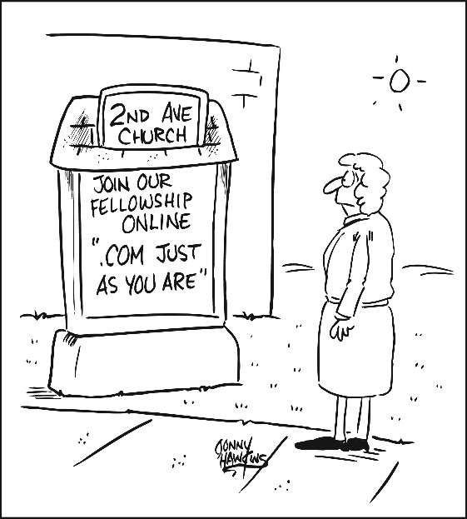

LAST WEEK’S COLLECTION

Adults $ 577.00

Monthly $ 550.00

Candles $ 33.00

Maintenance $ 145.00

Catholic Relief Services $ 30.00

Solemnity of Mary $ 1.00

Easter Flowers $ 10.00

Total $1,346.00

We sincerely thank and ask

God’s blessing upon all

who have care and

concern for our

parish.

*March 29, 2020 John 11:1-45*

*Our families can become wrapped up chasing things we perceive will make us happy. Jesus’ words to Lazarus, He says to us: “Come out” from what entombs you. In this fifth week of Lent “untie” yourself and be free from unnecessary possessions.*

The Sanctuary Candle will burn in memory of

Carl Tokarsky

requested by Loving Wife Hermine,

Children and Grandchildren

and

The Our Lady of Grace Candle

will burn in memory of

Matthew & Anna Rus & Joseph Rus

requested by Family

during the week of March 29, 2020.

[](https://images.search.yahoo.com/search/images;_ylt=A0LEV1kSWptXvOwAKINXNyoA;_ylu=X3oDMTEyZGdkcmRoBGNvbG8DYmYxBHBvcwMxBHZ0aWQDQjIwODlfMQRzZWMDc2M-?p=Clipart+of+a+sanctuary+candle&fr=ush-mailn_02&th=110&tw=110&imgurl=http://www.henningers.com/389-168-wall-sanctuary-lamp.jpg&rurl=http://pixshark.com/sanctuary-lamp.htm&size=43KB&name=Sanctuary+Lamp+Bronze+wall+sanctuary+lamp&h=600&w=600&turl=http://ts2.mm.bing.net/th?id=OIP.M68453c67108cdc5ab485d309b395bd03o0&pid=15.1&rs=1&c=1&qlt=95&w=110&h=110#inline&tt=Sanctuary+Lamp+Bronze+wall+sanctuary+lamp&sigr=116keh5le&sigit=13gvlt42j&sigi=11ip0pgm4&sign=119kp6100&sigt=119kp6100)



BLESSED PALMS ~ Msgr. will be blessing Palms privately. The palms will be available the weekend of Palm Sunday, April 4th & 5th in the back of the Church from 9:00 AM – 4:00 PM. Please feel free to visit the Church and take a palm home with you!



EASTER FLOWERS ~ Any Easter Flower donations that we have received or continue to receive will be used to purchase flowers for the Church throughout the year. Please return the envelopes on or before April 5th.



Religious Education And Christian Helping

Worship@Home ~ Free Sunday Prayer Service for families

In this challenging time when many of us are unable to attend Mass in person,

here’s a great way that you can pray together as a family at home.

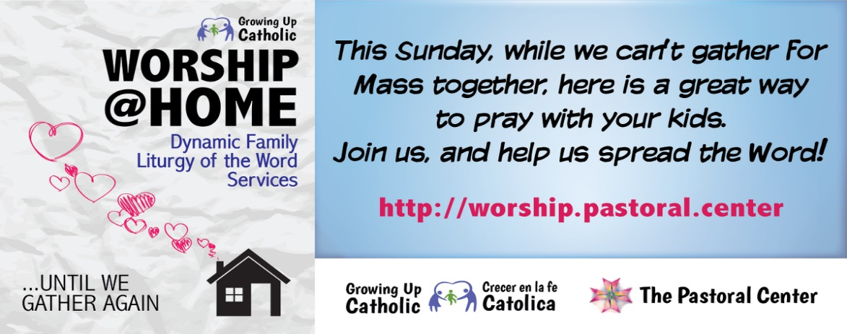

Dear Parishioners and Friends of St. Michael Parish:

As we prepare to enter our second weekend without Mass, I want to share some thoughts with you.

First there is an old saying that “absence makes the heart grow fonder.” Hopefully, our inability to receive Holy Communion during this time will result in all of us having a greater devotion to it when at last we can do so again.

Second, I am reminded of a practice we Catholics had in my youth. Many of us could not receive every Sunday because we could not bear the lengthy fast from midnight, or perhaps we could not go to confession in order to receive worthily. In such cases the Church encouraged us to make a “Spiritual Communion” where we united ourselves in prayer to the Body of Christ we couldn’t receive physically. I think we need to practice this custom once again in these circumstances.

Third, although we cannot go to Mass, we can, and should, still pray. There is the old favorite, the rosary; we can pray the stations of the Cross privately – we need not even go to Church to do so. We can gather with our families to pray night prayers together. But now above all we really need to pray. Pray for ourselves, pray for our country and its leaders, pray for the sick and dying here and around the world, pray for our doctors and nurses. Never doubt the power of prayer.

I have heard people say over and over again, “We will get through this”. I feel a need to add “We will get through this with the help of God. Politicians, doctors and economists need God’s help to save us. So, let’s crank up the prayers, brothers and sisters!

God bless all of you, till we meet again.

Msgr. Lockard

Financial Report

In this time of crisis, when Sunday Masses have been suspended because of the pandemic, our parish needs your support. Please bring or mail your collection envelope to our parish office. Thank you, thank you, thank you for your sacrifices!

Msgr. Lockard

SPIRITUAL COMMUNION OF ST. ALPHONSUS

My Jesus, I believe that You are in the Blessed Sacrament. I love You above all things,

and I long for You in my soul. Since I cannot now receive You sacramentally,

come at least spiritually into my heart. As though You have already come, I embrace

You and unite myself entirely to You. Never permit me to be separated from You.

Amen.

New Parish Office Hours: Mon, Tues, Thurs, Fri. from 8:30 AM – 2:00 PM

Church is open for private prayer daily from 8:30 AM-3:00 PM & Weekends 9:00 AM-4:00 PM.

Sunday, March 29 NO Mass

NO High School Religious Ed.

Confessions / 10:30 AM (Moved from 10:00 AM)

 Monday, March 30 NO Mass

NO Sunday Choir Practice

Tuesday, March 31 NO Mass

Wednesday, April 1 NO Mass

Thursday, April 2 NO Mass

NO K—5 Religious Ed.

NO Saturday Choir Practice

Friday, March April 3 NO Mass

NO Stations of the Cross

NO Combined Choir Practice

Saturday, April 4 NO Mass

Confessions / 3:30 PM

UPCOMING EVENTS

OFFICE OF CHILD AND YOUTH PROTECTION ~ Each month there will be one educational article provided by VIRTUS covering topics of interest to create awareness on trending topics. This month’s featured article is: *“Mobile Device Dangers: Snapchat, Snap Map and Caller ID Spoofing” By Robert Hugh Farley.* Copies of the article can be found on the table at the back of the Church.

FISH FRY

St. Michael Firehall, St. Michael ~ Take outs or local delivery available. Phone at 495-4111.