ST. MICHAEL ROMAN CATHOLIC CHURCH

PO Box 103

St. Michael, Pennsylvania 15951

Rev. Brian L. Warchola, Administrator MASSES:

(814) 495-9640 Saturday 4:00 pm



Sunday Morning 8:00 am

Secretary: Michele Panick 10:30 am

Bookkeeper: Kathy Kalicky Daily Mass See Bulletin

DRE: Laurie Sloan Holy Days See Bulletin

Maintenance: Rodney Turgeon

Office Hours:

PHONES: 8:30 am to 3:30 pm

Rectory / Office: (814) 495-9640 Monday, Tues., Thurs., Friday

Fax: (814) 495-9424 Confessions:

Rel. Education: (814) 495-4873 Saturday 3:30 pm to 3:45 pm

Parish Website Sunday 7:30 am to 7:45 am

www.saintmichaelchurch.weebly.com 10:00 am to 10:15 am

Secretaries’ E-mail Anytime Requested

[saintmichaelsecretaries@yahoo.com](mailto:saintmichaelsecretaries@yahoo.com)

YEAR: 2018 NUMBER: 15

SERVING GOD AND COMMUNITY FOR OVER ONE HUNDRED YEARS!

BAPTISM: By Appointment. Reserve at least one month in advance.

Preparation classes are necessary.

MARRIAGE: Plan at least nine months in advance.

Preparation sessions are necessary.

FUNERALS: Arrangements are made in conjunction with the funeral home.

Eulogies should be given at the funeral home at the time of the wake service or at the luncheon.

REGISTRATION Those new to the area, newlyweds, and single adults, (even if registered

and before with their families) are asked to register by calling the Parish Office.

MEMBERSHIP: Every parishioner must be registered. This is a condition for admission

to our Program and reception of the Sacraments of Baptism, Confirmation, First Penance, First Eucharist, and Matrimony; also, for testimonial letters or sponsorship of Baptism and Confirmation outside the Parish.

VISITATION: We are concerned and want to be advised when someone is ill at

home or in the hospital. Call the rectory to have the shut-in placed on our monthly Holy Communion calls or seriously ill prayer list.

SACRAMENTAL Requires parish registration and active Mass participation for Baptism

POLICY: and Marriage.

BULLETIN ARTICLES: Articles are due to the Parish Office by Noon on Tuesdays.

Third Sunday of Easter

April 15, 2018

**Month of The Holy Eucharist**

**MASS INTENTIONS**: (April 16 – April 22, 2018)

Monday 8:00 AM Lois Jean Papcunik req. by Steve, Tom & Joe McAneny

Tuesday 8:00 AM Rose Hudak req. by Ann Volcjak

Wednesday No Mass

Thursday 8:00 AM Josephine Koshute req. by Cindy & Paul McCloskey & Family

Friday 8:00 AM Mary Chuckalovcak req. by St. Michael Funeral Committee

Saturday 4:00 PM Raymond Plummer Sr. req. by Chuck & Mary Ann Tedjeski & Family

Sunday 8:00 AM People of the Parish

Sunday 10:30 AM Josephine Danel req. by Daniel & Shelley DeLuca

LITURGICIAL APPOINTMENTS:

Saturday, April 21 4:00 PM Offertory Procession

Lector: Donald Dipko Raymond Plummer Sr. Family

Minister of the Host: Vince Arena

Ministers of the Cup: Babe Richards & Susan Blazosky

Altar Servers: Ana Spangler & Mykala Drobnick

Cantor: Amy Spangler

Greeter: Joanne Thomas

Sunday, April 22 8:00 AM Offertory Procession

Lector: David Knepper Nick & Sally Kolar

Minister of the Host: Eric Tedjeske

Ministers of the Cup: Robert Grattan & Paul Kundrod

Altar Servers: Elizabeth & Ian Dobbins

Cantor: Susan Yanzetich

Greeter: Pauline Minor

Sunday, April 2210:30 AM Offertory Procession

Lector: James Lashinsky Josephine Danel Family

Minister of the Host: Greg Stiffler

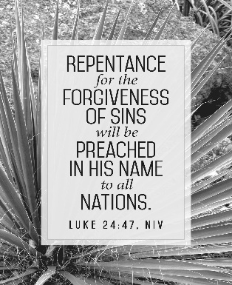Ministers of the Cup: Robert Oshaben & Sharon Paterson

Altar Servers: Eric & Shannan Elgin

Cantor: Amy Dobbins

Greeter 10th Grade REACH Students

Sunday, April 22 Collection Counters

Mary Ann Davis, Christine Smay

Sara Zybura

[](http://www.churchart.com/Subscriber/ViewImages.aspx?keywords=&entry_date=1/1/0001&image_type=,cl&topic_id=346&image_source_id=&page=1#no)[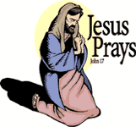](https://www.churchart.com/subscriber/viewimages?book_number=43&chapter=17&verse=1&entry_date=1/1/0001&image_type=cl)Weare placing names of the sick in the bulletin for prayer providing they give permission. *May the* *Divine Physician send healing grace for those for* *whom we pray:* Allen C. Rosemas, Patricia Murphy, Bernice Myers, Dwight Fyock, Lori Facciani, Dylon Wills, Dawn Hagen, Debbie Dibert, Missy, Joanne (Kolar) Hufford, Christine Flanagan, Ayden Alan Grata, Mary Lou Offman, Mary Zangaglia, Dorothy Rosemas, Natalie Zerby, Patricia Grata, Michael Wadsworth, Valencia & Frank, Tursi, Homer Locher, Brayden Schofield, Michelle Kasper, Diane Kingera, Allison Krischer, Ted Paluch, Brandt Hutzel, Pearl Litzinger, Patrick Munro, Fran Baldassarre, Corey Lybarger, Kristen Sinosky Long, Helen Ranieri, Cresta Micik, Basil Costantino, Madison McCrory, Laura, Joe Yoder, Dolores Yanzetich, Sandy Krug, Wanda Gramling, Merna Smay, Muriel “Jean” Wiesheier, Agnes Plummer, Jennifer Hagans, Mary McCall, Sean, Holly, Shane, Owen Taylor, Keith & Dawnetta Hoyer, Derrick Varnish, Daniel Koshute, Vincent Koshute, Karen Lovrich, Melissa Cordek, Michelle Elliott, Heather Romanow, Mackston Barrick, Connor Thomas, Erin, Pat, Mary Agnes Nastase, Mary Ann Bertolino, Dick Wilson, Izzy Bihun, Erica Mitzelfeld, Heidi Allison, Dorothy Kaminsky, Ed Ripper Sr., Bob Debias, Patricia Oshaben, Craig Kraber, Ashlee Madison, Marlene McCrory, Bob Casti, Susan Yanzetich, Mike, Mary Sivec, Danika Faith, Stacy Jarvis, Alina Rusnak, Fern Swartzentruver, Carol Hautz, Marcia Costlow, Gary Smay, Tammy Webb, Elizabeth Howell, Charles Smith, Mary Ann Cover, Jane Plummer and all of the sick of our parish, the homebound, those in nursing homes, those who care for them, and those in the military along with their families. (Please call the Rectory to have your name removed from the list when no longer seriously ill. Thank You.)

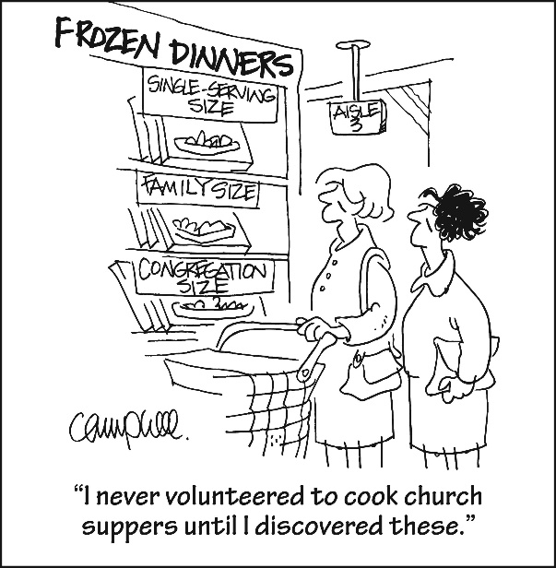

LAST WEEK’S COLLECTION

Adults $3,248.00

Loose $ 270.00

Youth $ 33.50

Monthly $ 370.00

Candles $ 38.00

Maintenance Fund $ 20.00

Catholic Home Missions $ 25.00

Holy Land $ 45.00

Holy Thurs./Food Pantry $ 45.00

Easter $ 516.00

Total $4,610.50

We sincerely thank and ask God’s blessing upon all who have care and concern for our parish.

*April 15, 2018 Luke 24:35-48*

*The apostles were afraid of Jesus until he ate with them and they touched him. In your family the ordinary acts of eating together, touching, embracing not only confirm our love for each other, but also celebrate God’s presence in your family. These ‘ordinary’ moments contain the “Extraordinary.”*



We are asking that each parish household sell or buy one ticket for $10.00 and return the money and ticket stub as soon as possible, but no later than April 22nd. The tickets start on May 1, 2018 and continue for the whole month of May. If you are unable to sell or don’t want the ticket, PLEASE don’t throw them away, but return them as soon as possible as we always have people looking for extras. If paying by check, please make check payable to St. Michael Church. The money raised from the sale of these tickets will help to build up our Parish Treasury. Tickets not picked up in the Church will be mailed out.

*Parish and Finance Council Members*

Anyone wanting more tickets, please call the office!

SAVE THE DATE! ~ Join us at St. Benedict Parish, Johnstown for “Life in Christ: Mission, Mass & Mary”. In this dynamic three-night mission, Catholic author and retreat director Thomas Smith will begin by sharing how we can embrace our baptismal mission to share the faith with others. Next, we will reflect on the Mass as the source of our strength, a model for personal prayer and an invitation to intimacy. On night three, we will explore the indispensable role of Mary as a model disciple, powerful intercessor and protector. The parish mission will be held April 22-24th, 7 PM nightly at St. Benedict Parish, 2310 Bedford Street, Johnstown. This event is open to all in the Altoona-Johnstown Diocese. Tickets are not required. A love offering will be taken. For more information please contact Deacon Michael Russo at 814-288-3036 or [michael.russo@atlanticbb.net](mailto:michael.russo@atlanticbb.net).

CHEERS WINE FEST ~ A Toast to our St. Croix Mission! Saturday, April 21, 2018, 6PM – 9 PM. Saint

John Gualbert Cathedral Activity Center, 110 Adams St., Johnstown, PA. Benefits St. John Gualbert Mission Travelers to our Sister Parish in Jamaica. Tickets: $20/person in advance, $25/person at the door. Includes admission, unlimited wine tasting, souvenir wine glass, delicious hors d’oeuvres, and lots of giveaways! Must be 21 or older to attend. Tickets on sale at St. John Gualbert Cathedral Rectory and ONLINE at [www.eventbrite.com](http://www.eventbrite.com)

CARROLLIAN GALA ~ Bishop Carroll Catholic High School will hold the eleventh annual Carrollian Gala on Sat., April 28 at the school. Tickets are $50 each. Cocktails begin at 5:30 and dinner will be served at 6:30. The Cornerstone and Distinguished Alumni Awards will be presented following dinner. Silent and live auctions will take place all evening long, as well as the chance to win baskets and other prize opportunities. For more information, or to purchase tickets, please call 472-7500 extensions 104 or 105, or email [jnagy@bishopcarroll.org](mailto:jnagy@bishopcarroll.org)

BISHOP’S NIGHT FOR VOCATIONS DINNER ~ The Serra Club of Cambria County invites you to the Bishop’s Night for Vocations dinner on Fri., May 11th at Bishop Carroll Catholic High School, Ebensburg, PA. A social hour begins at 5:30 PM and dinner follows at 6:30 PM. The event is sponsored jointly by the Serra Club and the Diocesan Vocation Office. The theme for the event is: *“Listening, Discerning, Living.”* Guest speaker is Sister Joseph Andrew, Vocation Director of the Dominican Sisters of Mary, Mother of the Eucharist. Tickets can be purchased by calling: Marjorie Lechene at 814-255-9797 or 814-241-3736 by April 20th.



Thank you to all parishioners who have responded to the *2018 Catholic Ministries Drive.* Please join them in supporting our Parish and a select group of ministries that provide outreach to the poor, family life, youth and seminarians. If you did not receive a pledge card in the mail, you may give online at [www.dioceseaj.org](http://www.dioceseaj.org).

Catholic Ministries Drive $24,043.00

Raised: $ 3,615.00

Balance: $20,428.00

Number of responses: 30

SECOND SUNDAY FOOD COLLECTION ~ Thank you to all who so generously donated to the Forest Hills Food Pantry. The total money collected was $598.40 and an assortment of non-perishable items.

APRIL CHICKEN DINNER MEETING ~ On Monday, April 16th at 6:00 PM in the hall, there will be a meeting with Fr. Brian, the Funeral Committee, Holy Name Society and anybody else in the Parish interested in helping with the St. Michael’s Chicken Dinner Fundraiser to be held on Sunday, April 29th, 2018.

RECTORY KEYS ~ Anyone having a rectory key, please turn it in to the office. However, if there’s a reason that you need it, call the office. Thank-you.

MARTHA’S GROUP ~ The 2018 schedule for Martha’s Group is: April 9 & 23, May 14, June 11 & 25,

July 9 & 23, August 13 & 27, September 10 & 24, October 8 & 22.

SCOUT FOOD WARS ~ The Cadettes and Senior Girl Scouts in Troop #40991 have challenged the Boy Scouts in Troop #2251 to a Food Drive War. Thirteen million children in the US are currently living in food insecure homes. The scouts have made it a goal to assist local families by waging a war against hunger. Can we count on you to help us wage our war? We are asking for non-perishable food items to be donated at our church this weekend - April 14th & 15th, 2018. All donations should be placed in the Bridal Room. We thank you in advance for your support of our project. Troop #40091 Girl Scouts.

BUS TRIP TO SIGHT AND SOUND THEATER ~ “Jesus” ~ the new spectacular show! Friday, May 4th, 2018. Cost is $130 per person which includes ticket, bus & buffet dinner at Hershey Farms. Call Jim @ 814-241-1641 or call our office @ 495-9640.

LAY MINISTRY SCHEDULES ~ Lay ministry schedules for the summer months of June through September are now being made up. Anyone who would like to serve as an Altar Server, Reader, Cantor, Greeter or any current minister who has scheduling preferences at this time, should call Suzi Blazosky at 495-5287 or e-mail her at [sublazosky@gmail.com](mailto:sublazosky@gmail.com) no later than Sunday, May 20th.

VACATION BIBLE SCHOOL MEETING ~ Scheduled this Monday, April 16th, at 6:00 PM at Most Holy Trinity Hall. Everyone interested in helping is invited to join this planning meeting. We need a music coordinator, crew leaders, and lots of help. If unable to attend this meeting, but you are interested in helping, please call Betty at 495-4419 or [erosmus@diocese.org](mailto:erosmus@diocese.org).

GOLF TOURNAMENT ~ The Carmelite Community of the Word sisters will hold our 14th Annual Golf Tournament on Friday, June 8 at Scotch Valley Country Club. This event has proven to be a fun day for all, and includes a Shotgun start at 12:00 noon. Golf, Lunch, Course Refreshments, Dinner, Prizes and a Live Auction. Dinner is served at 5:00 PM.

Take advantage of our *Early “Birdie” Special!* If you register before May 20, the cost is $115 per golfer; $425 per foursome. After May 20, the cost is $125 per golfer; $475 per foursome. Cost to attend dinner only is $25 per person. Final deadline for Registration is May 31. To register, or for more information, contact Sr. Jane Miller at 814-886-4098 or email at [jmseashell@msn.com](mailto:jmseashell@msn.com).

*STEWARDSHIP REFLECTIONS*...

Throughout the day we have many opportunities to “see the face of Jesus” in others and to “be the face of Jesus” to others. Do we take that opportunity to provide “peace” to those we encounter or are we afraid of what others will think of us and do nothing? Pray for the strength to live a “God-centered” life and not a “self-centered” life.

CARMELITE COMMUNITY OF THE WORD HANDS & HEARTS HAITI FET ~ The Paschal Festival on Sunday, April 22 at Our Lady of Loretto Hall, Elizabeth St., Loretto. Please join us for an afternoon focusing on the culture of Haiti, the music and cuisine. The meal will feature Haitian dishes prepared by Chef Gina Tusing. Some of the afternoon will include a few Haitian songs performed by a small choral group who has studied and practiced the music of the Little Sisters of the Incarnation of Haiti for this event. Doors open at 1:45 PM; Dinner & Silent Auction at 2:30 PM followed by entertainment. Tickets are $35 for adults and $15 for children under 13. In addition, each participant is asked to contribute new underwear or socks for children, infant to teen sizes, girls or boys. Contact the CCW Incarnation Center at 814-886-4098 for tickets or for more information. Ticket deadline is April 16. All proceeds will help us continue our ministry in Haiti.

GIRLSCOUT GOLD AWARD PROJECT ~ Kelsey Josephson is currently working on earning her Girl Scout Gold Award, the highest award any Girl Scout can earn. It is earned by completing badges that promote community service, personal growth, positive values and leadership skills. The last step is a community project. “I have decided to base my Gold Award project on helping children feel less fear when they are staying in the hospital. I plan on sewing 250 pillowcases, knitting 100 hats, and donating books that can be used time and time again.” Helen Knavel, Kelsey’s Project Advisor, would like to request a donation for her to accomplish this project. Items needed are new or gently used children’s books, 100% cotton material in a juvenile colorful pattern, white sewing thread, Bernat Baby Blanket yarns, monetary donations and/or gift cards to Walmart, Michael’s Craft or JoAnn Fabric Stores. You can drop off your donations in a collection box in the Bridal Room. Any questions concerning this request, please call Helen Knavel at 487-7081.

************************************************************************************************************

2018 DIOCESAN SUMMER CAMP OPPORTUNITIES FOR YOUTH

Registration for our diocesan summer camps, Camp Zacchaeus and Camp Timothy are currently being accepted. Registration brochures are available in the Religious Education Office.

- Camp “Z” is a week-long summer camp for youth grades 4-9 Campers can look forward to lively Liturgies, inspirational music, prayer experiences, evangelization sessions, campfires, games, skits, a live concert and lots more!

- Camp “T” is for youth in grades 10-12 as well as current year graduating high school seniors.

- Camp “T” campers will experience much the same –but even MORE!! We take the fun, faith and excitement to a higher level! Scholarship money is available to eligible applicants for both camps. For more information or to receive a brochure for either camp, contact our Religious Education Office at 495-4873 or Francine Swope, Diocesan Youth Ministry at (814)693-1401.

*Angel Fund 2018*

*Consider giving a gift now that will enrich the life of a young camper in the Summer of 2017!*

*Camp Zacchaeus Grades 4-9*

*and Camp Timothy Grades 10-12(and newly graduated seniors 2018)*

We are looking for people, groups, parishes or organizations to sponsor a child to attend

Camp Zacchaeus 2018 or Camp Timothy 2018 through the *Angel Fund*.

We will accept full or partial sponsorships of any amount to help cover the cost of camp—(100 percent of the funds collected through Angel Fund donations are dispersed to needy campers)! If you are interested in sponsoring a child, or for more information, please contact Francine Swope at the Diocesan Youth Ministry Office (814)317-2646 or mail your contribution directly to Camp Zacchaeus or Camp Timothy Angel Fund, 933 S. Logan Boulevard, Hollidaysburg, PA 16648. Become an Angel Fund sponsor and help send a child to camp to experience a wonderful faith-filled week in the great outdoors!

Religious Education And Christian Helping

April 15, 2018

Upcoming Service Project

WPA Road Clean-up – Saturday, April 21, 2018 – The Spring WPA Road Clean-up for REACH students and parent chaperones is scheduled for Saturday, April 21, 2018 at 10:00 AM. The cleanup will last approximately 1-½ hours (10:00 a.m. to 11:30 a.m.) and then lunch will be provided following the clean-up with our project being complete by 12:30 p.m. for pick up.

Adult / Student Permission / Liability forms will be available at the church entrances and during RE classes.

PARTICIPATION IS NOT PERMITTED WITHOUT RETURNED FORMS.

Volunteer Safety is of primary importance!

1. Proper clothing should be worn -- i.e., tennis shoes -- NO FLIP FLOPS/SANDALS!

Long pants/long-sleeve shirts may also be appropriate.

Safety Vests and gloves will be provided.

1. Please be sure to indicate any allergies on the Waiver/Consent Form.

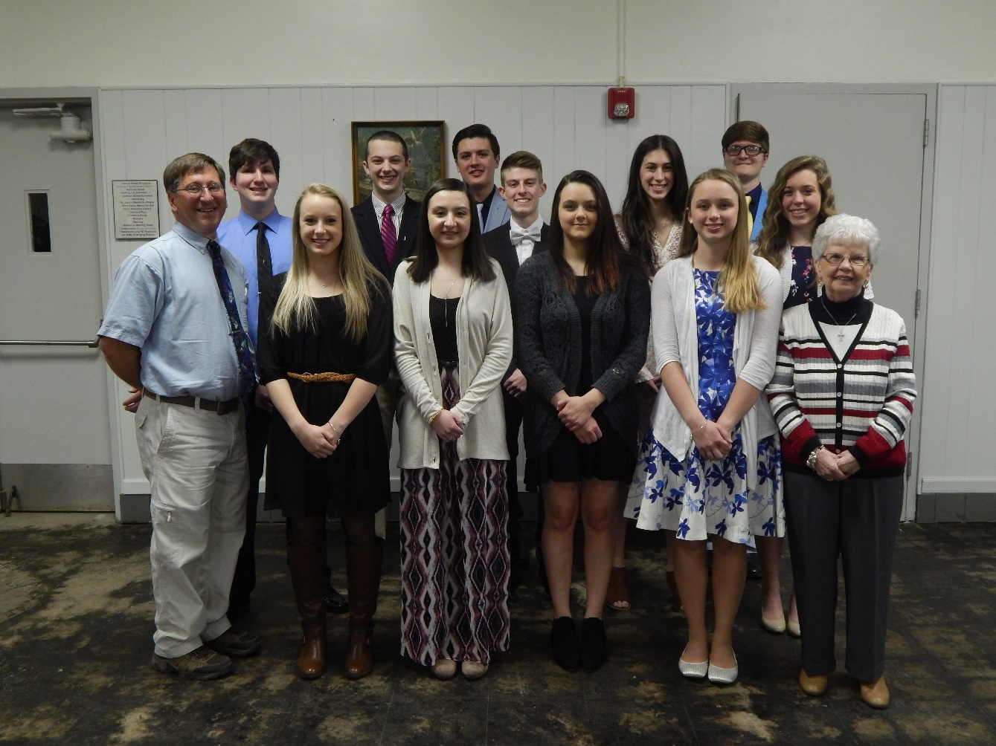

*Congratulations to our Saint Michael Confirmation Class of 2018!*

*They received their sacrament of Confirmation on Thursday, April 5th at Saint John Gualbert Cathedral in Johnstown. Pictured above, left to right, First Row: Michael J. Barton (catechist), Megan Jennings, Jordan Burda, Chloe Valinsky, Alyssa Penrod and Pauline Minor (catechist). Row Two: Anthony Stigers, Quinn Spangler, Jeremy Weis, Victoria Koeck and Ericka Frombach. Row Three: Devyn Miller and Dylan Miller.*

*************************************************************************



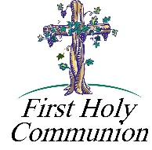*First Reconciliation and First Holy Communion*

*Our Second-Grade class is preparing to receive their Sacrament of First Reconciliation, on Saturday, May 5 at 10:00 A.M. Immediately following their Reconciliation, they will have a practice for First Communion.*

*Their First Holy Communion is scheduled for Sunday, May 6 at 2:00 PM.*

Sunday, April 15 Religious Education Classes / 6 – 12 / 9:00 – 10:20 AM

Monday, April 16 Sunday Choir Practice / 7:00 PM

Chicken Dinner Committee Meeting / 6:00 PM

Tuesday, April 17

Wednesday, April 18 No Mass

Thursday, April 19 K – 5 Religious Education Classes / 3:30-4:30 PM

 Saturday Choir Practice / 5:30 PM

Friday, April 20

Saturday, April 21 WPA Road Clean-up / 10:00 AM

UPCOMING EVENTS

April 28 & 29 Catholic Home Missions Appeal – Second Collection

April 29 Chicken Dinner Fundraiser

May 5 1st Reconciliation / Practice / 2nd Graders

May 6 First Holy Communion / 2nd Graders

HOLY FAMILY PARISH BINGO ~ 509 Caldwell Ave., Portage, Sunday, April 22nd in the Parish Hall. Admission is $20 per person. Extra specials and cards will be available. Doors open at 5 PM. Early bird games will begin promptly at 5:30 PM and the regular games will begin at 6:15 PM. Food and refreshments will be available.

POLKA DANCE ~ There will be a Polka Dance at the St. Michael American Legion on Sunday, April 15th from

2 – 5:00 PM. Music will be provided by Bronco and the Rhinelanders. Everyone is welcome to attend!

GNOCCHI DINNER ~ St. Anthony of Padua, Windber Gnocchi Dinner: Take Out Only! Saturday, April 14th,

5-6:30 PM and Sunday, April 15, 9:00 AM – 1:00 PM. Pasta & 2 meatballs - $7.00, Salads & Cake. Offered by the Ladies Guild.

BASKET PARTY ~ Adams TWP Lions Club is having a Basket Party on Saturday, April 21, 2018 at the St. Michael Fire Hall. Starts at 7:00 PM, doors open at 5:00 PM. Admission is $8.00. Tickets can be purchased in advance. Phone: 487-4132 or 487-5988 or any Lion Member.

SPRING CONCERT ~ The Greater Johnstown Community Chorus will present their spring concert You’ve Got the Time – We’ve Got the Music – a program based on the theme of time. Selections will include “Just in Time”, “Seasons of Love”, and “This Is the moment.” Concert dates are Friday, April 27th at Christ Lutheran Church, 337 Elknud Lane, Westmont and Saturday, April 28th at Belmont United Methodist Church, 107 Coldren Street., Johnstown. Performances begin at 7:00 PM.

CALICO QUILTERS OF NEW GERMANY ~ Will hold their annual quilt show and pie social on Sunday, April 29th from 6 – 8 PM at the New Germany Grove Hall. Doors open at 5:30. Many pieced and hand quilted items will be displayed. Chinese auction and door prize drawing will begin at 7:30. Admission is $3.00 and includes pie and beverage. Proceeds benefit local charities.