Rev. 12:7

ST. MICHAEL ROMAN CATHOLIC CHURCH

751 Locust Street

PO Box 103

St. Michael, Pennsylvania 15951

Rev. Msgr. David A. Lockard, Administrator MASSES:

(814) 495-9640 Saturday TBD



Sunday Morning TBD

Secretary: Michele Panick

Bookkeeper: Kathy Kalicky Daily Mass

DRE: Laurie Sloan Holy Days

Maintenance: Rodney Turgeon Office Hours:

PHONES: 9:00 am to 12:30 pm

Rectory / Office: (814) 495-9640 Monday, Tues., Thurs., Friday

Fax: (814) 495-9424 Confessions:

Rel. Education: (814) 495-4873 Saturday 3:00 pm to 3:15 pm

Parish Website Sunday 11:00 am to 11:15 am

www.saintmichaelchurch.weebly.com By Appointment

Secretaries’ E-mail

[saintmichaelsecretaries@yahoo.com](mailto:saintmichaelsecretaries@yahoo.com)

Facebook page:

St. Michael Catholic Church/St. Michael, PA

Pentecost Sunday

SERVING GOD AND COMMUNITY FOR OVER ONE HUNDRED YEARS!

May 31, 2020

BAPTISM: By Appointment. Reserve at least one month in advance.

MARRIAGE: Plan at least nine months in advance.

Preparation sessions are necessary.

FUNERALS: Arrangements are made in conjunction with the funeral home.

REGISTRATION Those new to the area, newlyweds, and single adults, (even if registered

and before with their families) are asked to register by calling the Parish Office.

MEMBERSHIP: Every parishioner must be registered. This is a condition for admission

to our Program and reception of the Sacraments of Baptism, Confirmation, First Penance, First Eucharist, and Matrimony; also, for testimonial letters or sponsorship of Baptism and Confirmation outside the Parish.

VISITATION: We are concerned and want to be advised when someone is ill at home or in the hospital. Call the rectory to have the shut-in placed on our monthly Holy Communion calls or seriously ill prayer list.

SACRAMENTAL Parish registration and active Mass participation for Baptism is

POLICY: encouraged and is required for Marriage.

BULLETIN ARTICLES: Articles are due to the Parish Office by Noon on Tuesday.

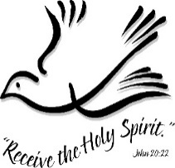

Pentecost Sunday

May 31st, 2020

The Blessed Virgin Mary

My brothers and sisters,

Our Bishop is permitting us to resume the celebration of public Masses in St. Michael Church beginning June 14th if the proper procedures to ensure safety are followed. Bishop Bartchak has issued each parish instructions on how to do this, and I will need help in carrying them out.

So, I am asking for volunteers to help with “crowd control” before Mass so we can practice “safe distancing” and also help with disinfecting the church after Mass. If you can help in some capacity, please contact the parish office by phone, text, email or whatever.

Also, we will need Eucharistic Ministers, Lectors, Ushers, Counters, and Servers as we did before. Please let the Parish Office know if for some reason you no longer wish to serve in one of these ministries.

Some people have said they are afraid to come to the church now for fear of the COVID-19 virus. As a 72-year-old man with diabetes and Parkinson’s Disease, I understand these fears. But I think our church is safer than some ice cream stands, and grocery stores that people are flocking to now. So, if we use masks and hand sanitizer and practice safe distancing, it should be alright.

Once again, if you can help in some way with the restart of Mass at St. Michael, please let the office know ASAP.

Thank you and God bless you,

Msgr. L.

TIMES FOR COMMUNION SERVICES AT ST. MICHAEL CHURCH ~ Starts Monday, June 1, 2020.

Monday, Tuesday, Thursday, Friday – Noon

Wednesday – 6:00 PM

Saturday – 3:30 PM to 3:45 PM

Sunday – 11:30 AM to 11:45 AM

What to do (instructions of the Bishop)

Come to the door of the Church facing the WPA Road. Form a line to enter the Church one at a time.

Msgr. Lockard will be in the small vestibule.

Please wear a mask and practice “safe distancing” while in line for Holy Communion.

Fast from food for one hour before receiving Holy Communion.

Pray the Lord’s Prayer before receiving.

After receiving, return to your car to make your private Thanksgiving.

During the week of May 31st, 2020

The Sanctuary candle will burn for

All Our 2020 Graduates

[](https://images.search.yahoo.com/search/images;_ylt=A0LEV1kSWptXvOwAKINXNyoA;_ylu=X3oDMTEyZGdkcmRoBGNvbG8DYmYxBHBvcwMxBHZ0aWQDQjIwODlfMQRzZWMDc2M-?p=Clipart+of+a+sanctuary+candle&fr=ush-mailn_02&th=110&tw=110&imgurl=http://www.henningers.com/389-168-wall-sanctuary-lamp.jpg&rurl=http://pixshark.com/sanctuary-lamp.htm&size=43KB&name=Sanctuary+Lamp+Bronze+wall+sanctuary+lamp&h=600&w=600&turl=http://ts2.mm.bing.net/th?id%3DOIP.M68453c67108cdc5ab485d309b395bd03o0%26pid%3D15.1%26rs%3D1%26c%3D1%26qlt%3D95%26w%3D110%26h%3D110#inline&tt=Sanctuary+Lamp+Bronze+wall+sanctuary+lamp&sigr=116keh5le&sigit=13gvlt42j&sigi=11ip0pgm4&sign=119kp6100&sigt=119kp6100)

Weare placing names of the sick in the bulletin for prayer providing they give permission. *May the* *Divine Physician send healing grace for those for* *whom we pray:* Allen C. Rosemas, Patricia Murphy, Bernice Myers, Dwight Fyock, Dylon Wills, Missy, Joanne (Kolar) Hufford, Christine Flanagan, Ayden Alan Grata, Mary Lou Offman, Mary Zangaglia, Natalie Zerby, Valencia Tursi, Homer Locher, Brayden Schofield, Michelle Kasper, Diane Kingera, Allison Krischer, Ted Paluch, Brandt Hutzel, Pearl Litzinger, Patrick Munro, Fran Baldassarre, Kristen Sinosky Long, Cresta Micik, Basil Costantino, Madison McCrory, Laura, Joe Yoder, Dolores Yanzetich, Sandy Krug, Wanda Gramling, Agnes Plummer, Jennifer Hagans, Shawn, Holly, Shane, Spencer, Owen Taylor, Keith & Dawnetta Hoyer, Derrick Varnish, Vincent Koshute, Melissa Cordek, Michelle Elliott, Heather Romanow, Mackston Barrick, Connor Thomas, Erin, Pat, Mary Agnes Nastase, Mary Ann Bertolino, Dick Wilson, Izzy Bihun, Dorothy Kaminsky, Patricia Oshaben, Ashlee Madison, Susan Yanzetich, Mike, Danika Faith, Alina Rusnak, Gary Smay, Elizabeth Howell, Helen Bowen, Walter Bodziak, Rhonda, Dan Strinkoski, Anne Robinson, Marlene McCrory, Sharon Poldiak, Carter Bobak, Vince Arena, Mike Morris, Sarah Kelt, Patty Yanzetich Caldwell, Colton Snyder, Betty Delaney, Nancy Edmiston, Bill Krajewski, Leonard Oshaben, Adam, Bill Gideos, Janice Dipyatic, John Poldiak Jr., Gerald Delaney, Lily Maloney, Adam Wingard, Scott, Lisa, Rosalie Ambrose, John Patrick, Audrey Costlow, Carole Horner, Ross Linert, Cathy Sossong, Rosanne Krug, Paul Snyder, Becky Kakabar, Catherine Tedjeske and all of the sick of our parish, the homebound, those in nursing homes, those who care for them, and those in the military along with their families. *(Please call the Rectory to have your name removed from the list when no longer seriously ill. Thank You.)*

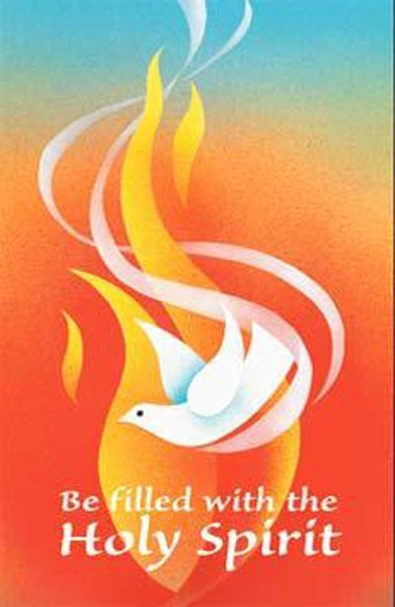

LAST WEEK’S COLLECTION

Adults $1,716.00

Youth $ 12.00

Monthly $ 460.00

Mother’s Day $ 30.00

Father’s Day $ 30.00

Candles $ 3.00

Maintenance Fund $ 190.00

Cemetery Maintenance $ 210.00

Easter $ 40.00

Holy Land $ 10.00

Holy Thurs./Food Pantry $ 10.00

Catholic Communication $ 81.00

Ascension Thursday $ 113.00

Total $2,905.00

We sincerely thank and

ask God’s blessing

upon all who have

care and concern

for our parish.

CHURCH HOURS ~ St. Michael Church will be open for private prayer from 9:00 AM – 2:30 PM daily- (except Wednesdays). Physical distancing of at least 6 feet from others, wear a mask or some other face covering, and no more than 25 people in the church at the same time. Please bring your own reading material, pens, lighters, etc... and please take everything with you when you leave.

SACRAMENT OF RECONCILIATION ~ Msgr. Lockard will be hearing confessions every weekend. Confessions on Saturdays will be from 3:00 - 3:15 PM and on Sundays from 11:00 - 11:15 AM in the Sacristy for now. Penitents should wear a mask while waiting in line for confession.

**NEW OFFICE HOURS!** ~ The Parish Office will be open Mon, Tues, Thurs, Fri. approximately from 9:00 AM – 12:30 PM. There will be someone in the office at that time to take your calls or to pick up your offertory envelopes from the black locked mailbox or green tote box located outside the Parish Office door. Please try to drop off your offertory envelopes between the hours of 9:00 AM – 12:30 PM. And please do not go to the Rectory!

**DROP OFFS** ~ We now have a locked, black mailbox located on the wall by the office buzzer outside the Parish Office door. You can drop off your envelopes, tickets, letters, forms, etc... for anyone in the office. Please **do not** go to the Rectory! The mailbox will be checked every Monday, Tuesday, Thursday, and Friday.

**CEMETERY ENVELOPES** ~ In your packet of envelopes, you will find an envelope with the three cemeteries: St. Michael, St. Joseph, and Corpus Christi. You are to **circle** or **underline** the cemetery that you would like your contribution to go. If there is no preference, the money will be split between the three cemeteries. Thank – you.

**TELEVISED MASS** ~ Remember that since Churches are closed, you can still “attend” Mass by watching it on television. Every Sunday on WATM ABC 23 at 11:00 AM, Mass is televised from St. John Gualbert Cathedral in Johnstown. And watch PROCLAIM TV program which airs every Sunday at 10:30 AM on WATM ABC 23.

BULLETINS ~ Paper bulletins will now be available every weekend. They will be in the green tote box outside the Parish Office door every Friday afternoon. You are welcome to stop by and pick one up. You can also read the bulletin on our parish website: [www.saintmichaelchurch.weebly.com](http://www.saintmichaelchurch.weebly.com)



TREASURY TICKETS ~ Please remember that our treasury tickets begin on Monday, June 1st, 2020. All ticket stubs, money & unsold tickets must be turned in by Sunday, May 31st, 2020. Watch the Pennsylvania Lottery Evening Pick Three Drawing for the winning numbers.

Office Hours: Mon, Tues, Thurs, Fri: 10:00 AM – 12:30 PM

Church is closed until further notice!

Sunday, April 26 NO Mass

NO High School Religious Ed.

Catholic Home Missions / Envelopes in your packet

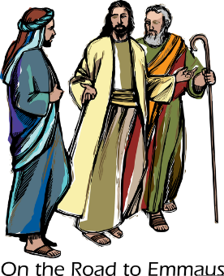

Monday, April 27 NO Mass

NO Sunday Choir Practice

Tuesday, April 28 NO Mass

Wednesday, April 29 NO Mass

Thursday, April 30 NO Mass

NO K—5 Religious Ed.

NO Saturday Choir Practice

Friday, May 1 NO Mass

Bulletins in Green Tote

Saturday, May 2 NO Mass

UPCOMING EVENTS



Religious Education And Christian Helping

Worship@Home ~ Free Sunday Prayer Service for families

In this challenging time when many of us are unable to attend Mass in person,

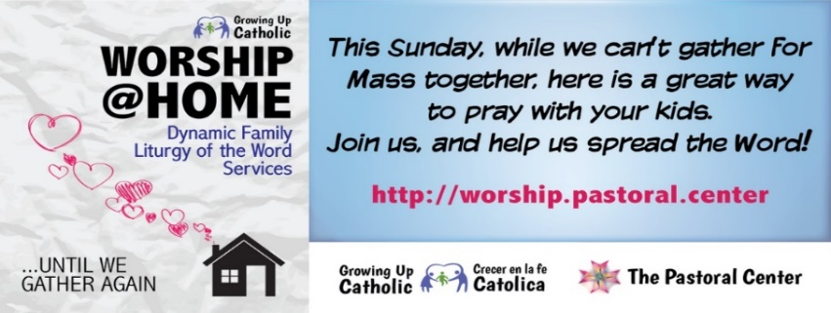 here’s a great way that you can pray together as a family at home.