John 6:54

ST. MICHAEL ROMAN CATHOLIC CHURCH

751 Locust Street

PO Box 103

St. Michael, Pennsylvania 15951

Rev. Brian L. Warchola, Administrator MASSES:

(814) 495-9640 Saturday 4:00 pm



Sunday Morning 8:00 am

Secretary: Michele Panick 10:30 am

Bookkeeper: Kathy Kalicky Daily Mass See Bulletin

DRE: Laurie Sloan Holy Days See Bulletin

Maintenance: Rodney Turgeon

Office Hours:

PHONES: 8:30 am to 3:30 pm

Rectory / Office: (814) 495-9640 Monday, Tues., Thurs., Friday

Fax: (814) 495-9424 Confessions:

Rel. Education: (814) 495-4873 Saturday 3:30 pm to 3:45 pm

Parish Website Sunday 7:30 am to 7:45 am

www.saintmichaelchurch.weebly.com 10:00 am to 10:15 am

Secretaries’ E-mail Anytime Requested

[saintmichaelsecretaries@yahoo.com](mailto:saintmichaelsecretaries@yahoo.com)

YEAR: 2019 NUMBER: 18

SERVING GOD AND COMMUNITY FOR OVER ONE HUNDRED YEARS!

BAPTISM: By Appointment. Reserve at least one month in advance.

MARRIAGE: Plan at least nine months in advance.

Preparation sessions are necessary.

FUNERALS: Arrangements are made in conjunction with the funeral home.

REGISTRATION Those new to the area, newlyweds, and single adults, (even if registered

and before with their families) are asked to register by calling the Parish Office.

MEMBERSHIP: Every parishioner must be registered. This is a condition for admission

to our Program and reception of the Sacraments of Baptism, Confirmation, First Penance,

First Eucharist, and Matrimony; also, for testimonial letters or sponsorship of Baptism and Confirmation outside the Parish.

VISITATION: We are concerned and want to be advised when someone is ill at home or in the hospital.

Call the rectory to have the shut-in placed on our monthly Holy Communion calls or seriously

ill prayer list.

SACRAMENTAL Parish registration and active Mass participation for Baptism is

POLICY: encouraged and is required for Marriage.

BULLETIN ARTICLES: Articles are due to the Parish Office by Noon on Tuesdays.

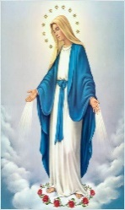 Third Sunday of Easter

May 5, 2019

**Month of The Blessed Virgin Mary**

**MASS INTENTIONS**: (May 6 – May 12, 2019)

Monday 8:00 AM Kevin Smay req. by Jim Bertolino

Tuesday 8:00 AM Ray & Irene Baldwin req. by Carl & Pam Freidhoff

Wednesday NO MASS

Thursday 8:00 AM Frances Ritz req. by Janice Gracner

Friday 8:00 AM Loretta Panick req. by Randy Ruddek

Saturday 4:00 PM Mother’s Day Intentions

Sunday 8:00 AM Mother’s Day Intentions

Sunday 10:30 AM Mother’s Day Intentions

LITURGICIAL APPOINTMENTS:

Saturday, May 11 4:00 PM Offertory Procession

Lector: Susan Poldiak John & Bonnie Bizzarri

Minister of the Host: Susan Blazosky

Minister of the Cup: Vince Arena & Alice Podrebarac

Altar Servers: Mykala Drobnick & Elisabeth Zajdel

Cantor: David Zajdel

Greeter: REACH Students

Sunday, May 12 8:00 AM Offertory Procession

Lector: Cathy Faher Mike & Lucia Ann Brezovec

Minister of the Host: Walter Christ

Minister of the Cup: Eric Tedjeske & Robert Grattan

Altar Servers: Andrew Martin & Bryce Macy

Cantor: Sharon Dibble

Greeter: REACH Students

Sunday, May 1210:30 AM Offertory Procession

Lector: Jacob Stiffler Rick Roberts Family

Minister of the Host: Amanda Williamson

Minister of the Cup: Jennifer Steele & Michael Barton

Altar Servers: Alexia Steele & Luke Docherty

Cantor: Amy Dobbins

Greeter: REACH Students

Sunday, May 12 Collection Counters

John Bizzarri, Rod Kundrod

Camillus Long

Weare placing names of the sick in the bulletin for prayer providing they give permission. *May the* *Divine Physician send healing grace for those for* *whom we pray:* Allen C. Rosemas, Patricia Murphy, Bernice Myers, Dwight Fyock, Lori Facciani, Dylon Wills, Missy, Joanne (Kolar) Hufford, Christine Flanagan, Ayden Alan Grata, Mary Lou Offman, Mary Zangaglia, Dorothy Rosemas, Natalie Zerby, Patricia Grata, Michael Wadsworth, Valencia & Frank Tursi, Homer Locher, Brayden Schofield, Michelle Kasper, Diane Kingera, Allison Krischer, Ted Paluch, Brandt Hutzel, Pearl Litzinger, Patrick Munro, Fran Baldassarre, Kristen Sinosky Long, Helen Ranieri, Cresta Micik, Basil Costantino, Madison McCrory, Laura, Joe Yoder, Dolores Yanzetich, Sandy Krug, Wanda Gramling, Merna Smay, Muriel “Jean” Wiesheier, Agnes Plummer, Jennifer Hagans, Shawn, Holly, Shane, Spencer, Owen Taylor, Keith & Dawnetta Hoyer, Derrick Varnish, Vincent Koshute, Melissa Cordek, Michelle Elliott, Heather Romanow, Mackston Barrick, Connor Thomas, Erin, Pat, Mary Agnes Nastase, Mary Ann Bertolino, Dick Wilson, Izzy Bihun, Erica Mitzelfeld, Dorothy Kaminsky, Ed Ripper Sr., Patricia Oshaben, Ashlee Madison, Susan Yanzetich, Mike, Mary Sivec, Danika Faith, Alina Rusnak, Marcia Costlow, Gary Smay, Elizabeth Howell, Helen Bowen, James Macy, Walter Bodziak, Rhonda, Dan Strinkoski, Anne Robinson, Marlene McCrory, Sharon Poldiak, Carter Bobak, Vince Arena, Mike Morris, Sarah Kelt, Mildred Andrykovitch, Patty Yanzetich Caldwell, Mary Secriskey, Colton Snyder, Betty Delaney, Nancy Edmiston, Elizabeth Stoker Thomas, Albert Sracic, Arthur Byers, Joseph Ropecka, Bill Krajewski, Leonard Oshaben, Florence Smith, Michael Chalan Jr., Adam and all of the sick of our parish, the homebound, those in nursing homes, those who care for them, and those in the military along with their families. *(Please call the Rectory to have your name removed from the list when no longer seriously ill. Thank You.)*



LAST WEEK’S COLLECTION

Adults $2,937.00

Loose $ 250.00

Youth $ 37.50

Monthly $ 100.00

Candles $ 49.00

Maintenance $ 483.00

Catholic Home Missions $ 439.00

Holy Land $ 51.00

Holy Thursday/Food Pantry $ 109.00

Lenten Folders $ 10.00

Easter Offering $ 450.00

Mother’s Day $ 80.00

Ascension Thursday $ 10.00

Total $5,005.50

We sincerely thank and ask God’s

blessing upon all who have care

and concern for our parish.

*May 5, 2019 John 21:1-19*

*When Peter announced, “I am going fishing” he was doing something that he had done everyday since childhood. Little did he know that he would meet the risen Christ in such an ordinary activity. Today’s gospel teaches us to expect to encounter the Lord in the ordinary routines of our family life.*

 MAY 2018 PARISH TICKET WINNERS

Day Date Amount No. Winner

Wednesday May 1, 2018 $75 898 Tom Zeigler

Thursday May 2, 2018 $75 287 Darlene Marshall

CATHOLIC HOME MISSIONS APPEAL ~ Thank you for your generous support of last week’s Catholic Home Missions Appeal. Our parish raised a total amount of $509.00 to strengthen the Church at home and ensure that the Gospel spreads across the United States. If you missed the appeal, it’s not too late to give! Just visit [www.usccb.org/nationalcollections](http://www.usccb.org/nationalcollections) and click on the “How to Give” link on the left.

FATIMA DEVOTIONS ~ The Franciscan Friars, T.O.R., from Loretto, invite you to participate with them in celebrating the Fatima Devotions on Monday May 13th at 6:30 PM at the Basilica of St. Michael the Archangel. The singing will be led by the Basilica of St. Michael the Archangel and the sermon will be delivered by Fr. Peter Lyons, T.O.R. We would like to extend a cordial welcome to all.

TIME FOR A CHANGE ~ PRECIOUS LIFE will be undertaking the Baby Bottle Campaign. They will deliver the empty baby bottles to St. Michael in time for Mother’s Day, May 12th. They will be placed in the Bridal Room. Please take as many as you like, fill them, and bring them back by Father’s Day, June 16th. PRECIOUS LIFE is a Christian ministry dedicated to providing positive alternatives to abortion. We provide free pregnancy testing, confidential counseling, material support and housing to young women in need. This simple fundraiser has been very successful. Last year close to 110 churches & businesses participated, and we raised over $85,000 just through change.

CARMELITE COMMUNITY OF THE WORD GOLF TOURNAMENT ~ The Carmelite Community of the Word sisters will hold our 15th Annual Golf Tournament on Friday, June 7 at Scotch Valley Country Club. This event has proven to be a fun day for all, and includes a Shotgun start at 12:00 noon., Golf, Lunch, Course Refreshments, Casual Dinner, Prizes and a Live Auction. Casual Dinner is served at 4:30 PM. Live auction begins at 5 PM. Take advantage of our *Early “Birdie” Special!* If you register before May 22, the cost is $115 per golfer; $425 per foursome. After May 22, the cost is $125 per golfer; $475 per foursome. Cost to attend dinner only is $20 per person. Final deadline for Registration is May 31. To register, or for more information, contact Kelli Murphy at 814-886-4098 or email at [communityoffice@gmail.com](mailto:communityoffice@gmail.com).

NATIONAL CENTER FOR ST. PADRE PIO ~ Join Fr. Dave Peles and Deacon Michael Russo for a day-long Pilgrimage to the National Center for St. Padre Pio, June 26, 2019. Round trip bus fare is $55 per person (based on 40 passengers). Lunch is $21 per person. *All gratuities are included.* Located in beautiful Barto, PA, the National Centre for Padre Pio is a scenic destination filled with the peace and prayerfulness of Padre Pio’s spirit. Built to resemble Padre Pio’s friary in San Giovanni Rotondo, Italy, the Centre offers a number of outdoor statues, a magnificent chapel, and a full museum filled with cultural and religious relics. Explore the gallery and visit the center to see each location for yourself. The bus for the Pilgrimage will leave the upper parking lot of St. Benedict Church at 7:00 AM on June 26th. The bus will depart from the Padre Pio Center at 4:30 PM. For more information contact: Deacon Michael Russo 814-288-3036 or email [michael.russo@atlanticbb.net](mailto:michael.russo@atlanticbb.net). *All Are Welcome!*

Catholic Ministries Drive $26,768.00

Raised: $ 2,925.00

Balance: $23,843.00

Number of responses: 23

Thank you to all parishioners who have responded to the *2018 Catholic Ministries Drive.* Please join them in supporting our Parish and a select group of ministries that provide outreach to the poor, family life, youth and seminarians. If you did not receive a pledge card in the mail, you may give online at [www.dioceseaj.org](http://www.dioceseaj.org).



[](https://images.search.yahoo.com/search/images;_ylt=A0LEV1kSWptXvOwAKINXNyoA;_ylu=X3oDMTEyZGdkcmRoBGNvbG8DYmYxBHBvcwMxBHZ0aWQDQjIwODlfMQRzZWMDc2M-?p=Clipart+of+a+sanctuary+candle&fr=ush-mailn_02&th=110&tw=110&imgurl=http://www.henningers.com/389-168-wall-sanctuary-lamp.jpg&rurl=http://pixshark.com/sanctuary-lamp.htm&size=43KB&name=Sanctuary+Lamp+Bronze+wall+sanctuary+lamp&h=600&w=600&turl=http://ts2.mm.bing.net/th?id=OIP.M68453c67108cdc5ab485d309b395bd03o0&pid=15.1&rs=1&c=1&qlt=95&w=110&h=110#inline&tt=Sanctuary+Lamp+Bronze+wall+sanctuary+lamp&sigr=116keh5le&sigit=13gvlt42j&sigi=11ip0pgm4&sign=119kp6100&sigt=119kp6100)

The Sanctuary Candle will burn in honor of the First Holy Communion Class

during the week of May 5, 2019.

ATTENTION! ~ Recently, several parishioners have contacted the parish about receiving text messages from someone impersonating me. Know that this is definitely a SCAM; It has been happening with other priests in the diocese as well. I have never asked parishioners for money in my life, and I never will, so if this happens to you, you know it’s not from Fr. Brian. I have contacted the state police, attorney general’s office, and the local Adams Twp. Police to report this. Please pray for the individual/s involved in trying to scam people; they are truly in need of God’s mercy and guidance.

HOLY NAME SOCIETY ~ Will hold their monthly meeting this Sunday, May 5th after the 8:00 AM Mass.

SECOND SUNDAY FOOD COLLECTION ~ Next weekend is our Second Sunday Food Collection. Please bring in non-perishable food items or toiletries with you. Monetary donations are also appreciated.

LAY MINISTRY SCHEDULES ~ Lay ministry schedules for the summer months of June through September are now being made up. Anyone who would like to serve as an Altar Server, Reader, Cantor, Greeter or any current minister who has scheduling preferences at this time, should call Suzi Blazosky at 495-5287 or e-mail her at [sublazosky@gmail.com](mailto:sublazosky@gmail.com) no later than Sunday, May 19th.

ST. MICHAEL’S FITNESS SERIES CONTINUES ~ There will be a Jazzercize class here at our Church hall from 11:00 AM – 12:00 PM on Saturday June 1st. Please call the Parish Office to register at 495-9640.

MOTHER’S DAY BRUNCH ~ All mothers and daughters of the parish are invited to a Mother’s Day Brunch on Sunday, May 12th sponsored by the Holy Name Society. They will be paying for, preparing and serving the meal in the church hall immediately following the 10:30 a.m. Mass. Sunday morning help is needed in the preparation, serving of the meal and the clean up after. Please call Pete Parisi at 487-5351. (This is a good way for male REACH students to earn service hours. Contact the Religious Education Office at 495-4873 to volunteer.)

MOTHER’S DAY MASS INTENTIONS ~ Envelopes for Mother’s Day Mass Intentions are in your packet of envelopes. The envelopes will be placed on the altar during the month of May in remembrance of all mothers, both living and deceased. Extra envelopes can be found at the entrances of the church.

C:\Documents and Settings\Susan\Local Settings\Temporary Internet Files\Content.IE5\XHXVAJYK\CAK5OTOS.wmf

MOTHER’S DAY CARNATIONS FOR BIRTHRIGHT ~ REACH students will be handing out carnations before each Mass on Mother's Day weekend to the women of the parish.  REACH funds will make a donation to Birthright for their Pro-Life efforts. Birthright is an interdenominational pregnancy support service that enables women who are facing an unintended pregnancy to choose life for their unborn babies by providing emotional and material support. Birthright helps women in these situations find medical care, clothing, food, even housing. For thousands of women, Birthright is hope. Hope that they, and their unborn children, are not alone. Since 1980, over 5,000 babies have been born in our area under the auspices of Birthright.

2019 DIOCESAN SUMMER CAMP OPPORTUNITIES FOR YOUTH

Registration for our diocesan summer camps, Camp Zacchaeus and Camp Timothy are currently being accepted. Registration brochures are available in the Religious Education Office.

- Camp “Z” is a week-long summer camp for youth grades 4-9 Campers can look forward to lively Liturgies, inspirational music, prayer experiences, evangelization sessions, campfires, games, skits, a live concert and lots more!

- Camp “T” is for youth in grades 10-12 as well as current year graduating high school seniors.

- Camp “T” campers will experience much the same –but even MORE!! We take the fun, faith and excitement to a higher level! Scholarship money is available to eligible applicants for both camps. For more information or to receive a brochure for either camp, contact our Religious Education Office at 495-4873 or Francine Swope, Diocesan Youth Ministry at (814)693-1401.

*Angel Fund 2019*

*Consider giving a gift now that will enrich the life of a young camper in the Summer of 2019!*

*Camp Zacchaeus Grades 4-9*

*and Camp Timothy Grades 10-12 (and newly graduated seniors 2019)*

We are looking for people, groups, parishes or organizations to sponsor a child to attend

Camp Zacchaeus 2019 or Camp Timothy 2019 through the *Angel Fund*.

We will accept full or partial sponsorships of any amount to help cover the cost of camp—(100 percent of the funds collected through Angel Fund donations are dispersed to needy campers)! If you are interested in sponsoring a child, or for more information, please contact Francine Swope at the Diocesan Youth Ministry Office (814)317-2646 or mail your contribution directly to Camp Zacchaeus or Camp Timothy Angel Fund, 933 S. Logan Boulevard, Hollidaysburg, PA 16648. Become an Angel Fund sponsor and help send a child to camp to experience a wonderful faith-filled week in the great outdoors!

Our Saint Michael Parish will be hosting Yee Haw VBS this summer along with Most Holy Trinity and Saint Bartholomew Parishes. Yee Haw will be held on July16, 17 & 18 from 6—8 p.m. in our Saint Michael Parish Hall. VBS Registration forms are being sent home with our students from Religious Education classes and are also available on the tables at the entrances of the church along with our Volunteers Registration forms.

REACH students and adult volunteers are needed to help with prep ahead of VBS week and we will also need help the week of VBS. High School students can earn service hour credits for helping. Please join us to make this a wonderful adventure for our kids. If you would like to share in the fun, call the Parish Office at 495-9640 or the RE Office at 495-4873.

Religious Education And Christian Helping

May 5, 2019

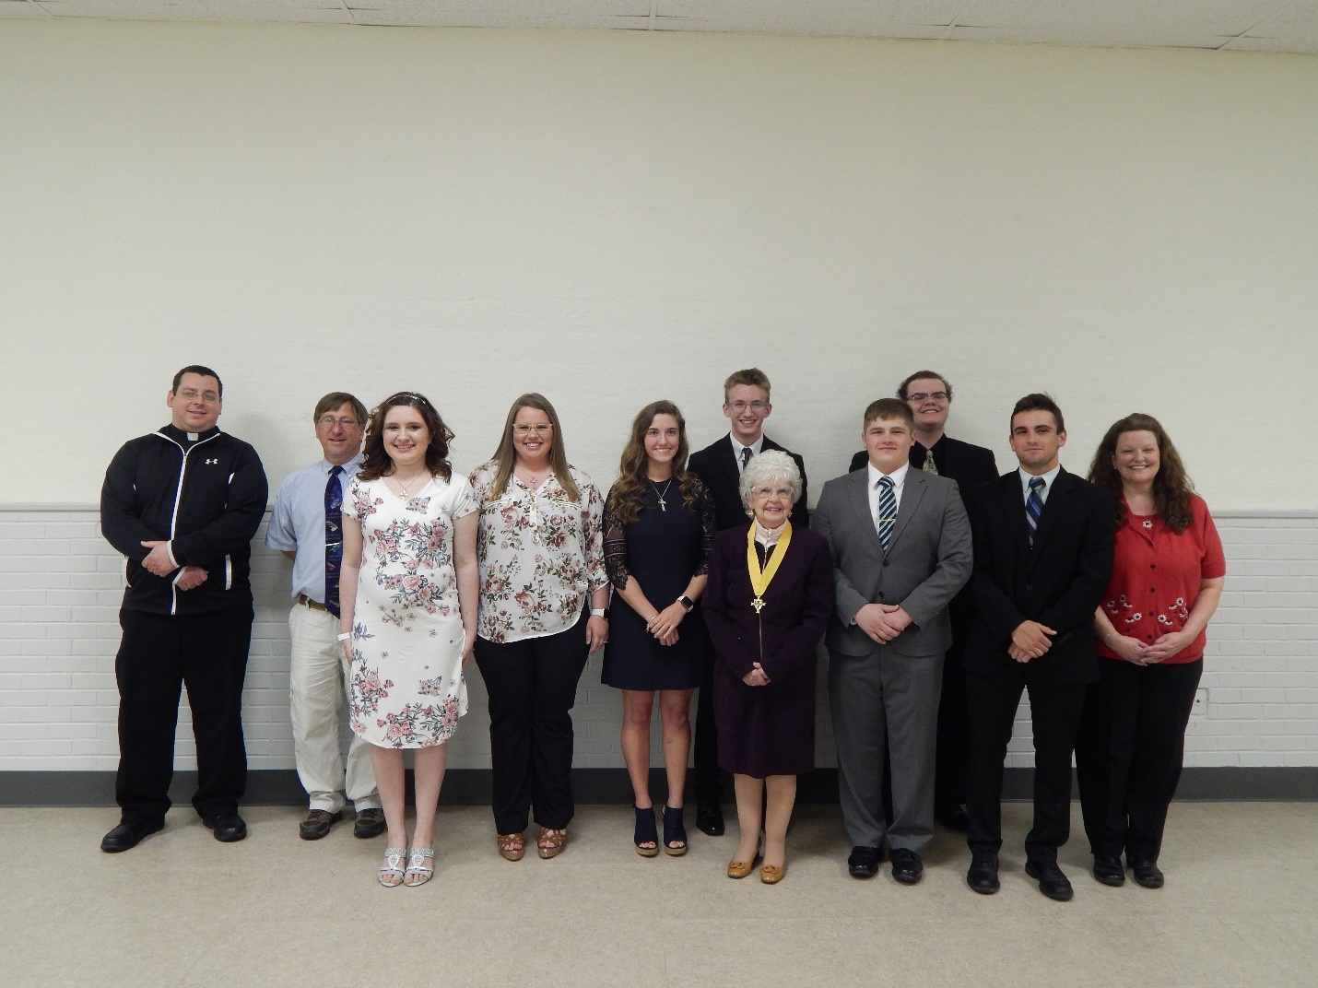

*Congratulations to our Saint Michael Confirmation Class of 2019!*

*They received their sacrament of Confirmation on Thursday, April 25th at Saint John Gualbert Cathedral in Johnstown. Pictured above, left to right: Fr. Brian, Michael J. Barton (catechist), Mykala Drobnick, Shannan Elgin, Elisabeth Zajdel, Luke Docherty, Pauline Minor (catechist), Luke Hribar, Hadan Romanow, Brycen Rearick, and Laurie Sloan, DRE.*

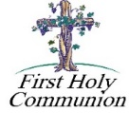*************************************************************************************

*First Holy Communion ~ Our Second Grade class received their Sacrament of Reconciliation on Saturday, May 4th at 10:00 AM. They will receive their First Holy Communion on Sunday, May 5th at the 10:30 Mass.*

*********************************************************************************************

Upcoming REACH Service Projects

Mother’s Day Carnations ~ Help pass out carnations before any of the masses May 11 & 12.

Mother’s Day Brunch ~ Male REACH students are needed to help our Holy Name men with the meal on May 12th.

If interested in helping, contact the Religious Education Office at 495-4873.

WPA Road Clean-up – Saturday, May 18, 2019 – The Spring WPA Road Clean-up for REACH students and parent chaperones is scheduled for Saturday, May 18, 2019 at 10:00 AM. The cleanup will last approximately 1-½ hours (10:00 a.m. to 11:30 a.m.) with lunch provided following the clean-up with our project being complete between 11:30 and 12 noon for pick up.

Adult / Student Permission / Liability forms will be available at the church entrances and during RE classes.

PARTICIPATION IS NOT PERMITTED WITHOUT RETURNED FORMS.

Volunteer Safety is of primary importance!

1. Proper clothing should be worn -- i.e., tennis shoes -- NO FLIP FLOPS/SANDALS!

Long pants/long-sleeve shirts may also be appropriate.

Safety Vests and gloves will be provided.

1. Please be sure to indicate any allergies on the Waiver/Consent Form.

 Sunday, May 5 First Holy Communion / May Crowning / 10:30 AM Mass

Holy Name Society Meeting / After 8:00 AM Mass

Girl Scouts

Monday, May 6 Sunday Choir Practice / 7:00 PM

Tuesday, May 7 Boy Scouts / 7:30–9:00 PMPMPM

Wednesday, May 8 No Mass

Thursday, May 9 Saturday Choir Practice / 4:30 PM

Friday, May 10

Saturday, May 11 Second Sunday Food Pantry

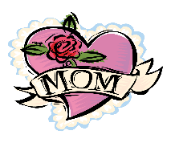 UPCOMING EVENTS

May 12 Second Sunday Food Pantry Collection

Mother’s Day Brunch

Girl Scouts

May 19 ALZ Spaghetti dinner & basket party

Baptism

May 26 Baptism

May 27 Memorial Day / Parish Offices Closed

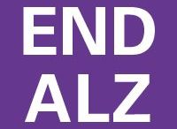

SPAGHETTI DINNER & BASKET PARTY ~ Sunday, May 19th. St. Michael Catholic Church Hall, St. Michael. Tickets $15. Doors open at 12, Dinner at 12:30 & basket raffle to follow dinner. Sponsored by team “Blue Skies Over Purple Hearts” in Memory of Jane Plummer. All proceeds go to Alzheimer’s Association. To purchase tickets, call Mary Ann Tedjeske–814-341-5463, Janet Minor-814-241-5106 & Krista Hershberger-814-421-9325. END ALZ *Any Parishioner wanting to donate an assembled basket would be greatly appreciated. Please drop off assembled baskets in the Bridal Room no later than Friday, May 17th

GREATER JOHNSTOWN COMMUNITY CHORUS ~ Presents “To Visions and Dreams” directed by Kim Rauch. Sunday May 5th at 3 PM at Grove Avenue United Methodist Church located at 501 Grove Ave. Johnstown. Suggested donation of $10 at the door.

CHRISTIAN BOOK STORE ~ We are sad to inform you that we are going out of business. Our Johnstown store (1238 Scalp Ave.) will be closing on Saturday, June 15, 2019. Everything must go! Almost everything 25% off! Open Mon. – Sat. 9 AM – 7 PM. We want to say a heartfelt Thank You to all of our customers for your support over the years. May God Bless & Keep You!

58th ANNUAL FESTIVAL ~ HOLY NAME PARISH, EBENSBURG, is sponsoring its 58th Annual Festival on May 31, June 1 & 2 featuring a Fish Dinner (Fried or Baked) on Friday from 4:00 to 7:00 PM, (Adults $10, children under 12 $5). Take out dinners available. Refreshments, rides, games, baked goods, activities for kids, flea market, basket raffle with over 100 baskets and more!

FOREST HILLS COMMUNITY BAND ~ Concert Schedule – Thurs., May 9 Forest Hills School Art Show 7 PM, Sun. May 19, New Germany Grove Hall 7 PM, Sun. May 26 Galleria Mall Richland 2 PM, Sun. June 2 Mount Hope Church 6 PM, Sunday June 9, South Fork U.M. Church 7 PM. Bring Chairs.