ST. MICHAEL ROMAN CATHOLIC CHURCH

751 Locust Street

PO Box 103

St. Michael, Pennsylvania 15951

Rev. Msgr. David A. Lockard, Administrator MASSES:

(814) 495-9640 Saturday 4:00 pm



Sunday Morning 9:30 am

Secretary: Michele Panick

Bookkeeper: Kathy Kalicky Daily Mass: M, T, Th, F Noon

DRE: Laurie Sloan Wed. 6:00 pm

Maintenance: Rodney Turgeon Holy Days: See Bulletin

PHONES: Office Hours:

Rectory / Office: (814) 495-9640 9:00 am to 12:30 pm

Fax: (814) 495-9424 Monday, Tues., Thurs., Friday

Rel. Education: (814) 495-4873 Confessions:

Parish Website Saturday 3:30 pm to 3:45 pm www.saintmichaelchurch.weebly.com Sunday 10:00 am to10:15 am

Secretaries’ E-mail By Appointment

[saintmichaelsecretaries@yahoo.com](mailto:saintmichaelsecretaries@yahoo.com)

Facebook page:

St. Michael Catholic Church/St. Michael, PA

The Most Holy Body and Blood of Christ

SERVING GOD AND COMMUNITY FOR OVER ONE HUNDRED YEARS!

June 14th, 2020

BAPTISM: By Appointment. Reserve at least one month in advance.

MARRIAGE: Plan at least nine months in advance.

Preparation sessions are necessary.

FUNERALS: Arrangements are made in conjunction with the funeral home.

REGISTRATION Those new to the area, newlyweds, and single adults, (even if registered

and before with their families) are asked to register by calling the Parish Office.

MEMBERSHIP: Every parishioner must be registered. This is a condition for admission

to our Program and reception of the Sacraments of Baptism, Confirmation,

First Penance, First Eucharist, and Matrimony; also, for testimonial letters or sponsorship of Baptism and Confirmation outside the Parish.

VISITATION: We are concerned and want to be advised when someone is ill at home or in the hospital. Call the rectory to have the shut-in placed on our monthly Holy Communion calls or seriously ill prayer list.

SACRAMENTAL Parish registration and active Mass participation for Baptism is

POLICY: encouraged and is required for Marriage.

BULLETIN ARTICLES: Articles are due to the Parish Office by Noon on Tuesday.

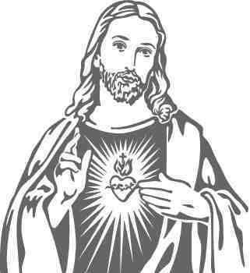

The Most Holy Body and Blood of Christ

June 14th, 2020

The Sacred Heart of Jesus

**MASS INTENTIONS**: (June 15 – June 21, 2020)

Monday Noon Marianne Bodenschatz req. by Debbie Conway (from 5-2-20)

Tuesday Noon Margaret Hudak req. by Nieces & Nephews

Wednesday 6:00 PM Ed Yauneridge req. by Mom & Dad

Thursday Noon John Vandzura req. by John & Agnes Waksmunski (from 3-18-20)

Friday Noon People of the Parish

Saturday 4:00 PM Father’s Day Intentions

Sunday 9:30 AM Father’s Day Intentions

LITURGICIAL APPOINTMENTS:

Saturday, June 20 4:00 PM

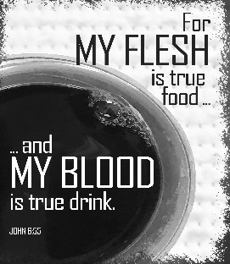

Lector: Volunteer Needed Minister of the Host: Alice Podrebarac

Altar Servers: Dylan Kundrod

Cantor: Susan Blazosky

Sunday, June 21 9:30 AM

Lector: Terri Leach

Minister of the Host: Pauline Minor

Altar Servers: Griffin Christ

Cantor: Anita Lorek

MINISTRY SCHEDULES ~ Lay ministry schedules are being done week by week until we return to our regular mass schedules. Please check the bulletin for the schedule. If you know a weekend you may not be available, please let Susan Blazosky know at: 495-5287 or [sublazosky@gmail.com](mailto:sublazosky@gmail.com)

Weare placing names of the sick in the bulletin for prayer providing they give permission. *May the* *Divine Physician send healing grace for those for* *whom we pray:* Allen C. Rosemas, Patricia Murphy, Bernice Myers, Dwight Fyock, Dylon Wills, Missy, Joanne (Kolar) Hufford, Christine Flanagan, Ayden Alan Grata, Mary Lou Offman, Mary Zangaglia, Natalie Zerby, Valencia Tursi, Homer Locher, Brayden Schofield, Michelle Kasper, Diane Kingera, Allison Krischer, Ted Paluch, Brandt Hutzel, Pearl Litzinger, Patrick Munro, Fran Baldassarre, Kristen Sinosky Long, Cresta Micik, Basil Costantino, Madison McCrory, Laura, Joe Yoder, Dolores Yanzetich, Sandy Krug, Wanda Gramling, Agnes Plummer, Jennifer Hagans, Shawn, Holly, Shane, Spencer, Owen Taylor, Keith & Dawnetta Hoyer, Derrick Varnish, Vincent Koshute, Melissa Cordek, Michelle Elliott, Heather Romanow, Mackston Barrick, Connor Thomas, Erin, Pat, Mary Agnes Nastase, Mary Ann Bertolino, Dick Wilson, Izzy Bihun, Dorothy Kaminsky, Patricia Oshaben, Ashlee Madison, Susan Yanzetich, Mike, Danika Faith, Alina Rusnak, Gary Smay, Elizabeth Howell, Helen Bowen, Walter Bodziak, Rhonda, Dan Strinkoski, Anne Robinson, Marlene McCrory, Sharon Poldiak, Carter Bobak, Vince Arena, Mike Morris, Sarah Kelt, Patty Yanzetich Caldwell, Colton Snyder, Betty Delaney, Nancy Edmiston, Bill Krajewski, Leonard Oshaben, Adam, Bill Gideos, Janice Dipyatic, John Poldiak Jr., Gerald Delaney, Lily Maloney, Adam Wingard, Scott, Lisa, Rosalie Ambrose, John Patrick, Audrey Costlow, Carole Horner, Ross Linert, Cathy Sossong, Rosanne Krug, Paul Snyder, Becky Kakabar, Catherine Tedjeske and all of the sick of our parish, the homebound, those in nursing homes, those who care for them, and those in the military along with their families. *(Please call the Rectory to have your name removed from the list when no longer seriously ill. Thank You.)*

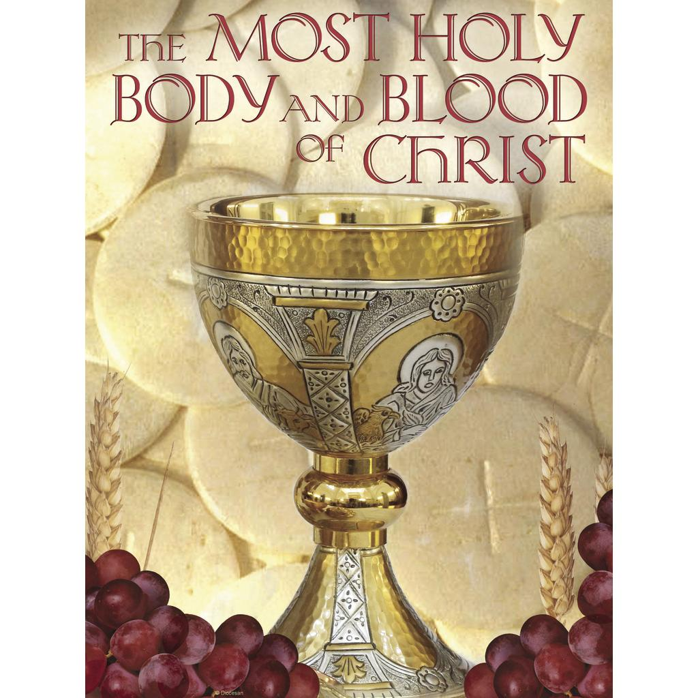

LAST WEEK’S COLLECTION

Adults $2,090.00

Youth $ 4.00

Monthly $1,755.00

Mother’s Day $ 1.00

Father’s Day $ 90.00

Candles $ 3.00

Maintenance Fund $ 85.00

Cemetery Maintenance $ 25.00

Catholic Register Sub. $ 10.00

Easter $ 3.00

Holy Thurs./Food Pantry $ 111.00

Catholic Communication $ 10.00

Peter’s Pence (Holy Father) $ 85.00

Ascension Thursday $ 25.00

Total $4,297.00

We sincerely thank and ask

God’s blessing upon all

who have care and

concern for our parish.

*June 14, 2020*

*As we are only beginning to celebrate the Most Holy Eucharist again as a community, no matter how small, take this opportunity to express your gratitude to our heavenly Father for the gift of “the living bread that came down from heaven.” (John 6:51)*

My brothers and sisters,

As we prepare to celebrate weekend Mass once again here at St. Michael parish, I have just a few directives.

Please wear a mask to church and observe a safe distance of six feet between each other (husbands and wives, parents and children may sit together.) In effect, this means that we can only sit in every other pew as well as spacing six feet from the people in the same pew.

The total number of people that can fit in our church with maintaining a safe distance is fifty. If there are more than 50 people here for Mass, the last to arrive need to wait in their cars till Mass is over, then come to the side door or the front door to receive Holy Communion.

Also, there is no presentation of the gifts during Mass. This means that there is no Offertory Collection or Offertory Procession. Ushers will be at each door of the church before and at the end of Mass. They will be directing parishioners to simply drop their contributions into a container as they enter or exit the church.

Weekend Masses will be at 4:00 PM Saturday and 9:30 AM Sunday for the time being. The Liturgy Committee is looking into the possibility of having outdoor Masses in the pavilion if there is a need. Stay tuned for possible changes in times and places for Sunday Mass as the summer goes on.

Thank you and God bless,

Msgr. L.

[](http://www.churchart.com/subscriber/viewimages.aspx?keywords=In%20Sympathy&entry_date=1/1/0001&image_type=,cl#no)

MAY HE REST IN PEACE ~ In your charity, please pray for the eternal rest of Joseph Bukosky whose Funeral Mass was celebrated on Saturday, June 6th, 2020 by Fr. Brian Warchola. May he know the eternal peace and happiness promised by our Savior, Lord Jesus. Please pray for the consolation of all his family and friends.

[](http://www.churchart.com/subscriber/viewimages.aspx?keywords=In%20Sympathy&entry_date=1/1/0001&image_type=,cl#no)MAY SHE REST IN PEACE ~ In your charity, please pray for the eternal rest of Helen McClemens whose Funeral Mass was celebrated on Thursday, June 11th, 2020 by Fr. Joseph Nale. May she know the eternal peace and happiness promised by our Savior, Lord Jesus. Please pray for the consolation of all her family and friends.

SACRAMENT OF RECONCILIATION ~ Msgr. Lockard will be hearing confessions every weekend. Confessions on Saturdays will be from 3:30 - 3:45 PM and on Sundays from 9:00 - 9:15 AM in the Sacristy for now. Penitents should wear a mask while waiting in line for confession.

During the week of June 14th, 2020

The Sanctuary Candle will burn for

All Law Enforcement

[](https://images.search.yahoo.com/search/images;_ylt=A0LEV1kSWptXvOwAKINXNyoA;_ylu=X3oDMTEyZGdkcmRoBGNvbG8DYmYxBHBvcwMxBHZ0aWQDQjIwODlfMQRzZWMDc2M-?p=Clipart+of+a+sanctuary+candle&fr=ush-mailn_02&th=110&tw=110&imgurl=http://www.henningers.com/389-168-wall-sanctuary-lamp.jpg&rurl=http://pixshark.com/sanctuary-lamp.htm&size=43KB&name=Sanctuary+Lamp+Bronze+wall+sanctuary+lamp&h=600&w=600&turl=http://ts2.mm.bing.net/th?id%3DOIP.M68453c67108cdc5ab485d309b395bd03o0%26pid%3D15.1%26rs%3D1%26c%3D1%26qlt%3D95%26w%3D110%26h%3D110#inline&tt=Sanctuary+Lamp+Bronze+wall+sanctuary+lamp&sigr=116keh5le&sigit=13gvlt42j&sigi=11ip0pgm4&sign=119kp6100&sigt=119kp6100)

RESCHEDULED BOY SCOUT DINNER ~ Boy Scout Troop #2251 has rescheduled their Ham and Chicken Dinner for Friday, June 19th from 4:00-7:30 PM at St. Michael Catholic Church Hall. All pre-sold tickets from the March 21st date will be honored. Walk-ins are welcome. Dinners will be take-out only. Park in the lot behind the hall and come to the take-out station in the parking lot. Please practice social distancing guidelines. Dinners include: chicken, ham, potatoes, green beans, coleslaw, rolls and butter, and cake. Age 12-Adult: $10 & Children: $8. All proceeds benefit the scouting program of BSA Troop #2251.



Religious Education And Christian Helping

CAMP TIMOTHY AND CAMP ZACCHAEUS GOING VIRTUAL

The Diocese of Altoona-Johnstown plan to hold both of their summer camps virtually! Camp Timothy will be held June 21—26 for youth entering grades 10—12 in the fall and newly graduated seniors. Camp Zacchaeus will be held July 19—24 for youth entering grades 4—9 in the fall. Registration is $10, which will cover the cost of materials that the diocese will send out in time for camp! Anyone interested, contact the parish office for a registration brochure.

Brochures also available in the green tote outside the parish office outside of office hours.

JUNE 2020 PARISH TICKET WINNERS

UNSOLD TICKETS/NOT RETURNED TICKETS ~ If the winning number is a ticket that was not sold or returned, the money will be split with the number above the winning number and the number below the winning number. If the number above or below the winning number was not returned, we will go above or below that number.

Day Date Amount Number Winner

Friday June 5, 2020 $75 268 Terri Leach

Saturday June 6, 2020 $100 091 Theresa Arena

Sunday June 7, 2020 $100 090 Violet Barr

Monday June 8, 2020 $75 852 Patricia Raneri-Doyle

Tuesday June 9, 2020 $75 554 Janet Howell

Wednesday June 10, 2020 $75 393 Lynn Rake

Thursday June 11, 2020 $75 113 Matilda Blozevich

Sunday, June 14 NO Mass

Confessions / 11:00 – 11:15 AM

Communion Distribution / 11:30 AM

Monday, June 15 Mass ~ Noon

 NO Sunday Choir Practice

Tuesday, June 16 Mass ~ Noon

Wednesday, June 17 Mass ~ 6:00 PM

Thursday, June 18 Mass ~ Noon

NO Saturday Choir Practice

Friday, June 19 Mass ~ Noon

Boy Scouts Chicken Dinner (Take outs only) / 4 – 7:30PM

Saturday, June 20 Mass / 4:00 PM

Confessions / 3:30 PM

UPCOMING EVENTS

June 21 Mass / 9:30 AM

June 27 & 28 Peter’s Pence Collection / Envelopes in your packet

FRIAR’S NOOK GIFT SHOP ~ The Friar’s Nook Gift Shop is open and is tocked for your First Communion and Confirmation gift needs! The modified hours for June are Friday and Saturday 10:00 AM – 4:00 PM. The shop is located on the campus of St. Bernardine Monastery at 793 Monastery Road, Hollidaysburg. For any questions, please call 814-695-3802.

FRANCISCAN MASS ASSOCIATION ~ The Franciscan Friars, TOR Mass Association now has office hours Tuesday-Thursday from 8:00 AM-4:00 PM. Masses can be requested anytime by mail, phone, email, or website with the below information:

The Franciscan Friars, TOR

PO Box 139 Hollidaysburg, PA 16648

Phone: 814-695-3802 ext. 211

Email: [Suzi@thefranciscanfriars.org](mailto:Suzi@thefranciscanfriars.org) Website: [www.TheFranciscanFriars.org](http://www.TheFranciscanFriars.org)

CATHOLIC COUNSELORS OF AMERICA ~ St. Aloysius Faith Education & Community Center. 7911 Admiral Peary Highway, Cresson, PA 16630. Tel. No. 814-505-7178. Catholic Counselors of America is a benefit LLC whose purpose is to create a positive impact to society by providing affordable counseling services. Peace! Call Leorosie (Rose) Trexler, Master of Science in Community Counseling at 814-505-7178.