John 6:54
ST. MICHAEL ROMAN CATHOLIC CHURCH
751 Locust Street
PO Box 103
St. Michael, Pennsylvania 15951

Rev. Brian L. Warchola, Administrator MASSES:
(814) 495-9640 Saturday 4:00 pm
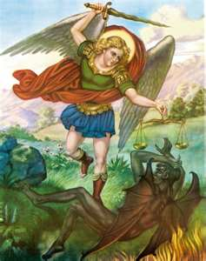
Sunday Morning 8:00 am
Secretary: Michele Panick 10:30 am
Bookkeeper: Kathy Kalicky Daily Mass See Bulletin
DRE: Laurie Sloan Holy Days See Bulletin
Maintenance: Rodney Turgeon
Office Hours:
PHONES: 8:30 am to 3:30 pm
Rectory / Office: (814) 495-9640 Monday, Tues., Thurs., Friday
Fax: (814) 495-9424 Confessions:
Rel. Education: (814) 495-4873 Saturday 3:30 pm to 3:45 pm
Parish Website Sunday 7:30 am to 7:45 am
www.saintmichaelchurch.weebly.com 10:00 am to 10:15 am
Secretaries’ E-mail Anytime Requested
saintmichaelsecretaries@yahoo.com

YEAR: 2019 NUMBER: 24

SERVING GOD AND COMMUNITY FOR OVER ONE HUNDRED YEARS!

BAPTISM: By Appointment. Reserve at least one month in advance.
MARRIAGE: Plan at least nine months in advance.
Preparation sessions are necessary.
FUNERALS: Arrangements are made in conjunction with the funeral home.
REGISTRATION Those new to the area, newlyweds, and single adults, (even if registered
and before with their families) are asked to register by calling the Parish Office.
MEMBERSHIP: Every parishioner must be registered. This is a condition for admission
to our Program and reception of the Sacraments of Baptism, Confirmation, First Penance, First Eucharist, and Matrimony; also, for testimonial letters or sponsorship of Baptism and Confirmation outside the Parish.
VISITATION: We are concerned and want to be advised when someone is ill at home or in the hospital. Call the rectory to have the shut-in placed on our monthly Holy Communion calls or seriously ill prayer list.
SACRAMENTAL Parish registration and active Mass participation for Baptism is
POLICY: encouraged and is required for Marriage.
BULLETIN ARTICLES: Articles are due to the Parish Office by Noon on Tuesdays.

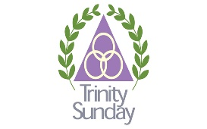
Most Holy Trinity
June 16, 2019
Month of The Sacred Heart of Jesus

MASS INTENTIONS: (June 17 – June 23, 2019)

Monday 8:00 AM Margaret Hudak req. by Ed, Mike & Mary Hudak
Tuesday 8:00 AM Mary Sivec req. by Steve & Debi Horvath
Wednesday No Mass
Thursday 8:00 AM Albert & Katherine Demko req. by Carl & Pam Freidhoff
Friday 8:00 AM Kevin Smay req. by Helen Soohy
Saturday 4:00 PM Leo Gressick req. by Bill & Jessica Gressick & Family
Sunday 8:00 AM People of the Parish
Sunday 10:30 AM Josephine Oshaben req. by Joan & Bob Oshaben

LITURGICIAL APPOINTMENTS:

Saturday, June 22 4:00 PM Offertory Procession

Lector: Amy Spinos Bill & Jessica Gressick
Minister of the Host: Helen Slonac Family
Minister of the Cup: Theresa Carlson & Karen Myers
Altar Servers: Carson & Dylan Kundrod
Cantor: Amy Spangler
Greeter: Joanne Thomas

Sunday, June 23 8:00 AM Offertory Procession

Lector: David Knepper Dick & Carol Hautz
Minister of the Host: Pauline Minor
Minister of the Cup: Cathy Faher & Ellen Grattan
Altar Servers: Ana & Eva Spangler
Cantor: Joseph Faher
Greeter: Lori George

Sunday, June 23 10:30 AM Offertory Procession

Lector: Terry Crissey Joan & Bob Oshaben
Minister of the Cup: Amanda Williamson
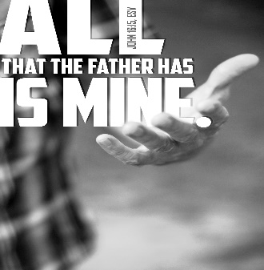
Minister of the Host: Jennifer Steele & Sharon Paterson
Altar Servers: Luke Docherty & Alexia Steele
Cantor: Anita Lorek
Greeter: Sara Wieczorek

Sunday, June 23 Collection Counters
Bob Casti, Sharon Paterson
Camillus Long

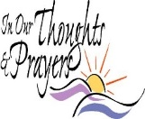
We are placing names of the sick in the bulletin for prayer providing they give permission. May the Divine Physician send healing grace for those for whom we pray: Allen C. Rosemas, Patricia Murphy, Bernice Myers, Dwight Fyock, Lori Facciani, Dylon Wills, Missy, Joanne (Kolar) Hufford, Christine Flanagan, Ayden Alan Grata, Mary Lou Offman, Mary Zangaglia, Dorothy Rosemas, Natalie Zerby, Patricia Grata, Michael Wadsworth, Valencia & Frank Tursi, Homer Locher, Brayden Schofield, Michelle Kasper, Diane Kingera, Allison Krischer, Ted Paluch, Brandt Hutzel, Pearl Litzinger, Patrick Munro, Fran Baldassarre, Kristen Sinosky Long, Helen Ranieri, Cresta Micik, Basil Costantino, Madison McCrory, Laura, Joe Yoder, Dolores Yanzetich, Sandy Krug, Wanda Gramling, Merna Smay, Agnes Plummer, Jennifer Hagans, Shawn, Holly, Shane, Spencer, Owen Taylor, Keith & Dawnetta Hoyer, Derrick Varnish, Vincent Koshute, Melissa Cordek, Michelle Elliott, Heather Romanow, Mackston Barrick, Connor Thomas, Erin, Pat, Mary Agnes Nastase, Mary Ann Bertolino, Dick Wilson, Izzy Bihun, Erica Mitzelfeld, Dorothy Kaminsky, Patricia Oshaben, Ashlee Madison, Susan Yanzetich, Mike, Danika Faith, Alina Rusnak, Marcia Costlow, Gary Smay, Elizabeth Howell, Helen Bowen, Walter Bodziak, Rhonda, Dan Strinkoski, Anne Robinson, Marlene McCrory, Sharon Poldiak, Carter Bobak, Vince Arena, Mike Morris, Sarah Kelt, Patty Yanzetich Caldwell, Mary Secriskey, Colton Snyder, Betty Delaney, Nancy Edmiston, Elizabeth Stoker Thomas, Albert Sracic, Arthur Byers, Joseph Ropecka, Bill Krajewski, Leonard Oshaben, Florence Smith, Michael Chalan Jr., Adam, Bill Gideos, Theressa Stravinsky, Janice Dipyatic, Martha, John Poldiak Jr., Nancy Faccini, Gerald Delaney and all of the sick of our parish, the homebound, those in nursing homes, those who care for them, and those in the military along with their families. (Please call the Rectory to have your name removed from the list when no longer seriously ill. Thank You.)

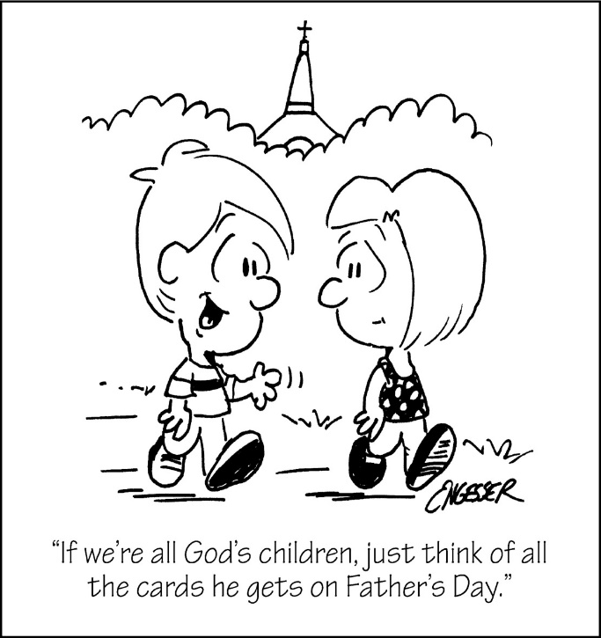

LAST WEEK’S COLLECTION

Adults $4,101.00
Loose $ 234.00
Youth $ 29.50
Monthly $ 505.00
Candles $ 46.00
Maintenance $ 58.00
Ascension Thursday $ 11.50
Cemetery Maintenance $ 30.00
Holy Father (Peter’s Pence) $ 45.00
Catholic Communication $ 95.00
Father’s Day $ 275.00
Catholic Register Sub. $ 3.00 Total $5,432.50

We sincerely thank and ask God’s
blessing upon all who have care
and concern for our parish.

June 16, 2019 The Most Holy Trinity
It is interesting that today we celebrate Father’s Day and Trinity Sunday. Dad’s reflect the Fatherhood of God to their children by the way they love, protect, teach and care for them. Being a dad is an awesome responsibility and a sacramental act.

MASS INTENTIONS ~ These mass intentions were said by Fr. Brian while on his retreat:
Monday, June 10 Ed Yauneridge req. by Mr. & Mrs. Maiocco
Tuesday, June 11 Tom Paterson req. by Caroline Drakster
Wednesday, June 12 Barbara Brezovec req. by Frank Oshaben, Bob & Joan Oshaben
Thursday, June 13, Claudia McCloskey req. by Louise Katcher Eakle

OUTDOOR MASS FOR MARRIED COUPLES ~ Sunday, July 14th at 7:00 PM at Our Lady of the Alleghenies Shrine in Loretto. Bishop Mark will be celebrant and homilist. Bring your own lawn chairs. Mass will be celebrated in the Basilica of Saint Michael the Archangel if it rains.

ALTOONA-JOHNSTOWN DIOCESE ~ Our central offices will be moving the week of June 17th. They will be moving from Hollidaysburg to the former Our Lady of Lourdes School in Altoona. The new location called the Mary Mother of the Church Pastoral Center is located on West Chestnut Ave., behind Our Lady of Lourdes Church building. The Family Life Office, located in Lilly, will also move to the new pastoral center. All mail to the diocese should be sent to the new Altoona address beginning June 17th. Phone & email will remain unchanged.
Diocese of Altoona-Johnstown
2713 West Chestnut Ave.
Altoona, PA 16601-1720

CONGRATULATIONS! ~ Congratulations to Donald Dipko and his family for being selected May’s “Family of the Month” for Knights of Columbus Council 2275. Donald and Sherry have been married for 49 years. Don is a past president of the Parish council and is a member of the liturgy committee. Don and Sherry are lectors at St. Michael Church and taught CCD for 7 years. He is a third-degree knight for the Knights of Columbus council #2275 and is the councils Financial Secretary. Don and Sherry have two adult children.

SAFE ENVIRONMENT TRAINING ~ Diocese of Altoona-Johnstown Office of Child and Youth Protection. Two-part training Workshop (attend one or both): Youth Protection Awareness and/or Mandated Reporting. Saturday, July 13th from 8:30 AM – 12:30 PM at Cathedral of the Blessed Sacrament Church Hall, One Cathedral Square, Altoona, PA 16601. To register please visit: Virtusonline.Org. Choose: First Time Registrant. At the screen: “your organization” please select Altoona-Johnstown Diocese. Click registration, you will be prompted to create an account and select a training date. If you do not have an option to register on-line or have questions, please call: Justin Kirkland at 814-695-5579, ext. 2620 or email @ jkirkland@dioceseaj.org.

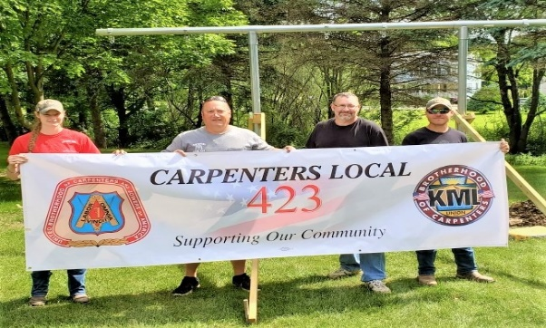

Thanks to Scott Burkey, Theresa Schachte, Troy Houghton and Kyle Meanor for getting us in the Full Swing by installing a brand-new swing set on our parish grounds. Carpenters Local 423.

The Sanctuary Candle will burn in honor of
all the Fathers & Sons of the Parish
and
The Our Lady of Grace Candle will burn as a birthday remembrance for our sister,
Linda Bovino
requested by Louise Neff and Joyce Suckenik
during the week of June 16, 2019.

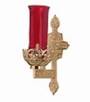

FR. BRIAN’S MESSAGE ~ Please know of my continued thanks for all who are so faithful to St. Michael Parish. I am more than happy to help in any way I can with any of your spiritual needs. If there is anyone who may be in the need of getting married or have their civil marriage convalidated or in need of a declaration of nullity, I would be more than happy to assist you. Call the parish office, and we can set up an appointment to meet.
Fr. Brian

SECOND SUNDAY FOOD COLLECTION ~ Thank you to all who so generously donated to the Forest Hills Food Pantry. The total money collected was $540.00 and an assortment of non-perishable items.
FATHER’S DAY BRUNCH ~ All fathers and sons of the parish are invited to a Father’s Day Brunch in the church hall immediately following the 10:30 AM Mass today. The ladies and REACH girls of the parish will be preparing and serving the meal. We hope to see all the fathers and sons of the parish there!

FATHER’S DAY INTENTIONS ~ Envelopes for Father’s Day Mass Intentions are in your packet of envelopes. The envelopes will be placed on the altar during the month of June in remembrance of all fathers, both living and deceased. Extra envelopes can be found at the entrances of the church.

BABY BOTTLE CAMPAIGN ~ Baby bottles are due by Sunday, June 16th. Please place the filled baby bottles in the box located in the bridal room. There are still plenty of bottles left to fill so feel free to take as many as you like.

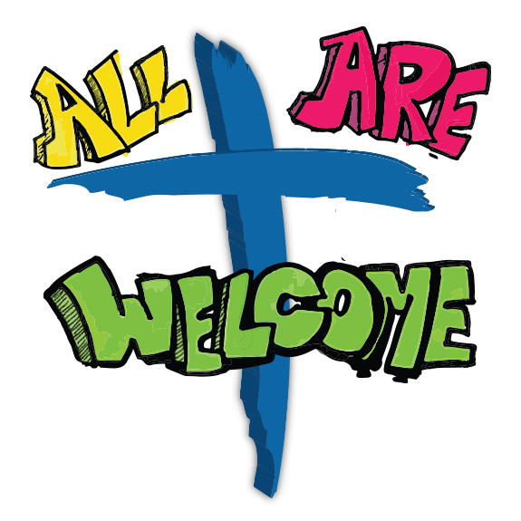
CATHOLIC RALLY ~ On Sunday, June 23rd, we will be having a CATHOLIC RALLY, which includes an Outdoor Mass at 10:30 AM and a picnic to follow. Also, the Christian Band, “Finding the Lost”, will be performing as well as Anita Lorek’s Le Dance Academie’. Please feel free to invite your friends, family, and fallen away to rally at St. Michael. The main dish and the drinks will be provided. We ask that you bring folding lawn chairs for the Mass and please bring a covered dish. Sign-up sheets can be found in the back of the Church. Please pray for good weather and spend an afternoon with the Archangel!

STATUE OF JESUS ~ Many thanks to Pops Painting for the painting of our beautiful statue! If you haven’t already, please take a minute to look at the beautiful job they have done!

Catholic Ministries Drive $26,768.00
Raised: $ 5,368.00
Balance: $21,400.00
Number of responses: 53
Thank you to all parishioners who have responded to the 2019 Catholic Ministries Drive. Please join them in supporting our Parish and a select group of ministries that provide outreach to the poor, family life, youth and seminarians. If you did not receive a pledge card in the mail, you may give online at www.dioceseaj.org.

Sunday, June 16 Father’s Day Brunch / After 10:30 AM Mass

Monday, June 17 Pavilion Reserved
Sunday Choir Practice / 7:00 PM

Tuesday, June18 Kennywood Trip

Wednesday, June 19 No Mass
VBS Prep Day / 10:00 AM to 12:00 Noon

Thursday, June 20 Saturday Choir Practice / 4:30 PM
Knights of Columbus / 6:00 PM / Pavilion

Friday, June 21 First Day of Summer!

Saturday, June 22

UPCOMING EVENTS

June 23 Catholic Rally / Outdoor Mass / Picnic
June 29 & 30 Peter’s Pence Second Collection
June 29 Hall Rental
July 4 Fourth of July / Offices Closed
July 5 Exposition of the Blessed Sacrament with Adoration
July 15 VBS Set up
July 16-18 VBS

WINEFEST ~ As part of the South Fork Heritage Days, please join Most Holy Trinity for Wine, Sweets, and Stogies at the Church hall on Friday, June 21st from 5:30-8:30 PM with music by Dawn & Johann Acoustic. Tickets are $10 at the parish office, Patti Good 322-8840 or at the S. Fork Library 495-4812.

SOUTH FORK HERITAGE DAYS BANQUET ~ Thursday, June 20th at 6 PM at the First United Methodist Church. Advance Tickets only are $11 at the South Fork Library or call 1st UM at 495-9633.

FOURTH OF JULY PICNIC ~ Immaculate Conception Church, New Germany Grove. 11:00 AM – 8:00 PM – Buffet Chicken & Ham Dinner with homemade noodle soup. Adults $10/Children under 12 $5. Crafts, Food, Refreshments & Games! Beverage Hall open Wednesday, July 3rd from 7 – 10 PM & Cornhole Tournament (must be over 21) at 7:30 PM.

ST. ANTHONY OF PADUA, WINDBER ~ Annual Festival, July 13 & 14. Sat. July 13: 5-11 PM “The Boomer” 4-10 PM. Sun., July 14: 3-9 PM “That Oldies Band” 4-8 PM. Ethnic Foods, Games, Baskets, Music, Children’s Corner, Bake Sale & More!

June 9th, 2019 Parish Council Meeting Minutes:

Attendance: Katie Kundrod, Jim Lashinsky, Rod Turgeon, Amy Dobbins, MaryAnn Spangler, Michele Panick, Kathy Kalicky, John Bizzarri, Laurie Sloan, Father Brain Warchola
Absent: Amy Spangler, Pete Parisi

Jim Lashinsky called the meeting to order at 11:35. Father Brian led the council with an opening prayer. The February 17, 2019 meeting minutes were reviewed and submitted.

Updated Reports:

Maintenance:
Rod Turgeon discussed the general maintenance of the church grounds. The painting of the statue was finished (done by Pop’s Painting). Rod and Father Brian planted flowers. New microphones were installed in the alter.

Religious Education:
Laurie Sloan updated council on the Religious Education Program and events. 3 students made their First Holy Communion and 11 students were confirmed this year. Recently celebrated Senior Sunday.
-Hosted Blue Knob Tubing, Chuck E Cheese, and Tomahawks Game for students and families—great turnout for events. Kennywood trip is scheduled for June 18th
-St. Michael is hosting Bible School this year, July 16-17-18 with St. Bartholomew and Most Holy Trinity parishes
-NCYC is in November, 3 girls and 2 chaperones to attend: may try and do another fundraiser
-Labor Day Festival coming end of summer, continue to do apple dumpling and sundae booth
-Religious Ed. to start back up in September, registration to begin end of July/early August

Boy Scout Charter:
Amy Dobbins discussed the progress with the Boys Scouts. Currently there are 17 on the charter, 15 of them are active. Recently held the Court of Honor. There were 5 rank advancements, as well as many badges and awards given.
-Car wash was held 6/8 at church: Huge Success!
-12 members signed up to attend camp in July
-This fall, they will hold another event to introduce scouts and seek interest of others
-Continue to clean/cut/maintain the legion grounds

Holy Name:
Father Brian informed the council on the happenings with the Holy Name Society.
-Mother’s Day Brunch went well, approximately 87 women and daughters in attendance
-Knights of Columbus/Holy Name and Rod Turgeon maintained the outdoor stations
-Don Dipko and Mike Barton assisted in cutting trees
-Outdoor picnic to take place on June 23rd
-Continue to have the funnel cake and toasted cheese booth at the Labor Day Festival

Old Business:
Father Brian discussed the photo directory. Done for the most part, cleaning up some last-minute matters. Should take approximately 2 months after final glitches are taken care off.
-JoJo’s fundraiser going well, hope to continue doing every couple of months

New Business:
Kathy Kalicky discussed the May ticket sales. Took in $4,480. Pay out $2,338. Profit $2,142. There were 52 tickets issued out that were not returned.

Father Brian’s remarks: Scott Burkey and the Carpenter’s Union donated their services installing the swing set for the kids. Thanks to them!

-Catholic Rally on 6/23: outdoor mass, picnic, Finding the Lost band to be there, Le Dance Academie to do a routine, Chopper from the Tomahawks to be in attendance, encourage attendance, invite outsiders as well—hoping for a big turnout!
-Question arose about charging for use of the church hall for small meetings/gatherings: Father Brian made a motion to recommend/suggest a $20 donation for any adult group wanting to hold a meeting. MaryAnn Spangler second that motion. All in favor—motion carried.
-Father Brian-fitness program going well, would like to do Soul Core again
-Cemetery cleanup: Charlie Roberts is cutting Dunlo cemetery; John Bizzarri – Beaverdale; Mr. Partsch does St. Michael cemetery
-Fireman’s convention in St. Michael this July
-Hold 1st Responder Mass September 29th
-Hold another spaghetti dinner in October
Chairperson Jim Lashinsky asked any further questions from the floor.
Next meeting will be scheduled for Sunday, October 13th, 2019.
Father Brian concluded with a prayer.
The meeting was adjourned at 12:10.

Respectfully Submitted,
Katie Kundrod, Parish Council Secretary

