John 6:54

ST. MICHAEL ROMAN CATHOLIC CHURCH

751 Locust Street

PO Box 103

St. Michael, Pennsylvania 15951

Rev. Brian L. Warchola, Administrator MASSES:

(814) 495-9640 Saturday 4:00 pm



Sunday Morning 8:00 am

Secretary: Michele Panick 10:30 am

Bookkeeper: Kathy Kalicky Daily Mass See Bulletin

DRE: Laurie Sloan Holy Days See Bulletin

Maintenance: Rodney Turgeon

Office Hours:

PHONES: 8:30 am to 3:30 pm

Rectory / Office: (814) 495-9640 Monday, Tues., Thurs., Friday

Fax: (814) 495-9424 Confessions:

Rel. Education: (814) 495-4873 Saturday 3:30 pm to 3:45 pm

Parish Website Sunday 7:30 am to 7:45 am

www.saintmichaelchurch.weebly.com 10:00 am to 10:15 am

Secretaries’ E-mail Anytime Requested

[saintmichaelsecretaries@yahoo.com](mailto:saintmichaelsecretaries@yahoo.com)

YEAR: 2019 NUMBER: 26

SERVING GOD AND COMMUNITY FOR OVER ONE HUNDRED YEARS!

June 30, 2019

BAPTISM: By Appointment. Reserve at least one month in advance.

MARRIAGE: Plan at least nine months in advance.

Preparation sessions are necessary.

FUNERALS: Arrangements are made in conjunction with the funeral home.

REGISTRATION Those new to the area, newlyweds, and single adults, (even if registered

and before with their families) are asked to register by calling the Parish Office.

MEMBERSHIP: Every parishioner must be registered. This is a condition for admission

to our Program and reception of the Sacraments of Baptism, Confirmation, First Penance, First Eucharist, and Matrimony; also, for testimonial letters or sponsorship of Baptism and Confirmation outside the Parish.

VISITATION: We are concerned and want to be advised when someone is ill at home or in the hospital. Call the rectory to have the shut-in placed on our monthly Holy Communion calls or seriously ill prayer list.

SACRAMENTAL Parish registration and active Mass participation for Baptism is

POLICY: encouraged and is required for Marriage.

BULLETIN ARTICLES: Articles are due to the Parish Office by Noon on Tuesdays.

 Thirteenth Sunday in Ordinary Time

June 30, 2019

**Month of The Sacred Heart of Jesus**

**MASS INTENTIONS**: (July 1 – July 7, 2019)

Monday 8:00 AM Yvonne (Estok) LeJeune req.by Sister Natalie Lann, OSJ

Tuesday 8:00 AM William S. Single req. by Mrs. Joanne Single

Wednesday No Mass

Thursday 8:00 AM For Catholics to return to the Church

First Friday 8:00 AM Rose Hudak req. by Children

Saturday 4:00 PM Francis Andrykovitch req. by Millie & Family

Sunday 8:00 AM Paul Yanzetich req. by daughter Susan

Sunday 10:30 AM People of the Parish

LITURGICIAL APPOINTMENTS:

Saturday, July 6 4:00 PM Offertory Procession

Lector: Sherry Dipko Francis Andrykovitch

Minister of the Host: Theresa Carlson Family

Minister of the Cup: Karen Myers & Susan Blazosky

Altar Servers: Alex Bambino & Elisabeth Zajdel

Cantor: Amanda Williamson

Greeter: Shirley Walls

Sunday, July 7 8:00 AM Offertory Procession

Lector: Terri Leach Paul Yanzetich Family

Minister of the Host: Beth Kundrod

Minister of the Cup: Walter Christ & Marie Bernard

Altar Servers: Griffen & Kaden Christ

Cantor: Susan Yanzetich

Greeter: Pauline Minor

Sunday, July 710:30 AM Offertory Procession

Lector: Jacob Stiffler James Fisher Family

Minister of the Host: George Minor

Minister of the Cup: Susan Wieczorek & Janet Minor

Altar Servers: Shannan Elgin & Adalynne Webb

Cantor: Louis McCloskey

Greeter: Wendy Blough

Sunday, July 7 Collection Counters

Christine Smay, Sara Zybura

Debbie Dupnock

Weare placing names of the sick in the bulletin for prayer providing they give permission. *May the* *Divine Physician send healing grace for those for* *whom we pray:* Allen C. Rosemas, Patricia Murphy, Bernice Myers, Dwight Fyock, Lori Facciani, Dylon Wills, Missy, Joanne (Kolar) Hufford, Christine Flanagan, Ayden Alan Grata, Mary Lou Offman, Mary Zangaglia, Dorothy Rosemas, Natalie Zerby, Patricia Grata, Michael Wadsworth, Valencia & Frank Tursi, Homer Locher, Brayden Schofield, Michelle Kasper, Diane Kingera, Allison Krischer, Ted Paluch, Brandt Hutzel, Pearl Litzinger, Patrick Munro, Fran Baldassarre, Kristen Sinosky Long, Helen Ranieri, Cresta Micik, Basil Costantino, Madison McCrory, Laura, Joe Yoder, Dolores Yanzetich, Sandy Krug, Wanda Gramling, Merna Smay, Agnes Plummer, Jennifer Hagans, Shawn, Holly, Shane, Spencer, Owen Taylor, Keith & Dawnetta Hoyer, Derrick Varnish, Vincent Koshute, Melissa Cordek, Michelle Elliott, Heather Romanow, Mackston Barrick, Connor Thomas, Erin, Pat, Mary Agnes Nastase, Mary Ann Bertolino, Dick Wilson, Izzy Bihun, Erica Mitzelfeld, Dorothy Kaminsky, Patricia Oshaben, Ashlee Madison, Susan Yanzetich, Mike, Danika Faith, Alina Rusnak, Marcia Costlow, Gary Smay, Elizabeth Howell, Helen Bowen, Walter Bodziak, Rhonda, Dan Strinkoski, Anne Robinson, Marlene McCrory, Sharon Poldiak, Carter Bobak, Vince Arena, Mike Morris, Sarah Kelt, Patty Yanzetich Caldwell, Mary Secriskey, Colton Snyder, Betty Delaney, Nancy Edmiston, Elizabeth Stoker Thomas, Albert Sracic, Arthur Byers, Joseph Ropecka, Bill Krajewski, Leonard Oshaben, Florence Smith, Michael Chalan Jr., Adam, Bill Gideos, Theressa Stravinsky, Janice Dipyatic, Martha, John Poldiak Jr., Nancy Faccini, Gerald Delaney, Lily Maloney and all of the sick of our parish, the homebound, those in nursing homes, those who care for them, and those in the military along with their families. *(Please call the Rectory to have your name removed from the list when no longer seriously ill. Thank You.)*

LAST WEEK’S COLLECTION

Adults $3,245.00

Loose $ 358.00

Youth $ 20.75

Monthly $ 130.00

Candles $ 54.00

Maintenance $ 451.00

Father’s Day $ 20.00

Catholic Register Sub. $ 20.00 Total $4,298.75

We sincerely thank and ask

God’s blessing upon all who

have care and concern

for our parish.



June 30, 2019 Luke 9:51-62

In today’s gospel Jesus left for Jerusalem. This was dangerous and His friends could not prevent Him because He was “resolutely determined.” Family life is a series of leaving – letting-go for school, jobs, marriage and finally in death. We are able to let go because we believe and anticipate we will be reunited again.

OUTDOOR MASS FOR MARRIED COUPLES ~ Sunday, July 14th at 7:00 PM at Our Lady of the Alleghenies Shrine in Loretto. Bishop Mark will be celebrant and homilist. Bring your own lawn chairs. Mass will be celebrated in the Basilica of Saint Michael the Archangel if it rains.

FATIMA DEVOTIONS ~ The Franciscan Friars, T.O.R., from Loretto, invite you to participate with them in celebrating the Fatima Devotions on Saturday July 13th, at 6:30 PM in the Gardens at Mount Assisi (in case of inclement weather, will be at the Basilica of St. Michael the Archangel.) The singing will be led by St. John the Evangelist in Altoona and the sermon will be delivered by Bishop Mark L. Bartchak, JCD. We would like to extend a cordial welcome to all.

AN ANOINTING MASS ~ Will be held 1:30 PM, Sunday, July 14 at St. John Gualbert Cathedral, 117 Clinton Street, Johnstown. This particular liturgy will be especially joyous as we offer praise and thanks to receive God’s healing. We will celebrate the sacrament of Anointing of the Sick within Mass that satisfies the Sunday obligation. For more information please call 814-539-2611.

SAFE ENVIRONMENT TRAINING ~ Diocese of Altoona-Johnstown Office of Child and Youth Protection. Two-part training Workshop (attend one or both): Youth Protection Awareness and/or Mandated Reporting. Saturday, July 13th from 8:30 AM – 12:30 PM at Cathedral of the Blessed Sacrament Church Hall, One Cathedral Square, Altoona, PA 16601. To register please visit: Virtusonline.Org. Choose: First Time Registrant. At the screen: “your organization” please select Altoona-Johnstown Diocese. Click registration, you will be prompted to create an account and select a training date. If you do not have an option to register on-line or have questions, please call: Justin Kirkland at 814-695-5579, ext. 2620 or email @ [jkirkland@dioceseaj.org](mailto:jkirkland@dioceseaj.org).

ALL YOU CAN EAT BREAKFAST ~ Queen of Angels Parish in Central City will be hosting an All You Can Eat Breakfast on July 21st from 8:30 AM – 11:00 AM at their St. John Site (162 Wheeler Street). The breakfast includes scrambled eggs, bacon, sausage, hash browns, sausage gravy and biscuits, pancakes, French toast, donuts, toast, juice and coffee. The price is $8 for adults, $4 for children ages 8 – 4, children under 4, free. All are welcome – bring your appetite. Proceeds benefit parish religious education activities.

CAR CRUISE – BLOCK PARTY ~ On Saturday July 28th Queen of Angels Parish in Central City will sponsor their third annual Block Party and Classic and Antique Car Cruise form 1 PM – 5 PM at the St. John site. A band will be playing live oldies music from 2 – 5 PM. The parish will be preparing and serving wings, burgers, hot sausage, beer, and pop. All who have a classic or antique car, or those who simply take pleasure in music and an evening out are welcome to come and enjoy a day of cars, food, and camaraderie. All proceeds will benefit Michelle Moore, a local community member battling cancer. Any questions can be directed to the parish office at 814-754-5224.

Catholic Ministries Drive $26,768.00

Raised: $ 5,368.00

Balance: $21,400.00

Number of responses: 53



Thank you to all parishioners who have responded to the *2019 Catholic Ministries Drive.* Please join them in supporting our Parish and a select group of ministries that provide outreach to the poor, family life, youth and seminarians. If you did not receive a pledge card in the mail, you may give online at [www.dioceseaj.org](http://www.dioceseaj.org).

The Sanctuary Candle will burn in memory of

Francis Andrykovitch

requested by Millie & Family

and the Our Lady of Grace will burn for

the health and well-being of

Marcia Costlow

requested by Helen Slonac & Family

during the week of June 30, 2019.

[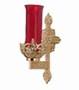](https://images.search.yahoo.com/search/images;_ylt=A0LEV1kSWptXvOwAKINXNyoA;_ylu=X3oDMTEyZGdkcmRoBGNvbG8DYmYxBHBvcwMxBHZ0aWQDQjIwODlfMQRzZWMDc2M-?p=Clipart+of+a+sanctuary+candle&fr=ush-mailn_02&th=110&tw=110&imgurl=http://www.henningers.com/389-168-wall-sanctuary-lamp.jpg&rurl=http://pixshark.com/sanctuary-lamp.htm&size=43KB&name=Sanctuary+Lamp+Bronze+wall+sanctuary+lamp&h=600&w=600&turl=http://ts2.mm.bing.net/th?id=OIP.M68453c67108cdc5ab485d309b395bd03o0&pid=15.1&rs=1&c=1&qlt=95&w=110&h=110#inline&tt=Sanctuary+Lamp+Bronze+wall+sanctuary+lamp&sigr=116keh5le&sigit=13gvlt42j&sigi=11ip0pgm4&sign=119kp6100&sigt=119kp6100)

FR. BRIAN’S MESSAGE ~ Please know of my continued thanks for all who are so faithful to St. Michael Parish. I am more than happy to help in any way I can with any of your spiritual needs. If there is anyone who may be in the need of getting married or have their civil marriage convalidated or in need of a declaration of nullity, I would be more than happy to assist you. Call the parish office, and we can set up an appointment to meet.

*Fr. Brian*

[](http://www.churchart.com/subscriber/viewimages.aspx?keywords=In%20Sympathy&entry_date=1/1/0001&image_type=,cl#no)MAY HE REST IN PEACE ~ In your charity, please pray for the eternal rest of Arthur Byers whose Funeral Mass was celebrated on Saturday, June 22nd, by Fr. Brian Warchola. May he know the eternal peace and happiness promised by our Savior, Lord Jesus. Please pray for the consolation of all his family and friends.

[](http://www.churchart.com/subscriber/viewimages.aspx?keywords=In%20Sympathy&entry_date=1/1/0001&image_type=,cl#no)MAY SHE REST IN PEACE ~ In your charity, please pray for the eternal rest of Mary Secriskey whose Funeral Mass was celebrated on Monday June 24th, by Fr. Brian Warchola. May she know the eternal peace and happiness promised by our Savior, Lord Jesus. Please pray for the consolation of all her family and friends.

PETER’S PENCE COLLECTION ~ Today is the Peter’s Pence Collection, a worldwide collection that supports the charitable works of Pope Francis. Funds from this collection help victims of war, oppression, and natural disasters. Take this opportunity to join with Pope Francis and be a witness of charity to our suffering brothers and sisters. Please be generous. For more information, visit [www.usccb.org/peters-pence](http://www.usccb.org/peters-pence).

PARISH OFFICES ~ The parish offices will be closed Thursday, July 4th.

*Stewardship Reflections…*

In today’s Gospel, two disciples agreed to follow Jesus, but only on the condition that they first take care of what they needed to. They claimed that they had more important matters. May we remember that Jesus calls us to deepen our bond with God by sharing our time and talents with all families in the community, not only our own.



Religious Education And Christian Helping

June 30, 2019

*********************************************************************************************************************************

VBS Meeting ~ A VBS meeting is scheduled for Tuesday, July 9th at 6:00 p.m. We will meet in our Saint Michael Parish Hall and be making final decorations for our sets and preparations for VBS week. REACH students can earn service credit for attending.

*********************************************************************************************************************************

Our joint Vacation Bible School for St. Michael, Most Holy Trinity and St. Bartholomew parishes is:

*Yee Haw: Celebrating God's greatest gift*

Here at St. Michael Parish

July 16, 17 & 18 from 6—8:00 PM

VBS is an opportunity to reach children with God's love. We invite you to join our team of volunteers to share your love of God in a fun, exciting three days of adventure. VBS is open to all children ages 4—14. Everyone is asked to help by volunteering, donating, and praying for the success of our program and the enjoyment of all involved. Please join us to make this a wonderful adventure for our kids.

VBS Registration forms are available on the back table and at the side entrance of the church along with our Volunteers Registration forms.

REACH students and adult volunteers are needed to help with prep ahead of VBS week and we will also need help the week of VBS. High School students can earn service hour credits for helping.

We are planning a VBS Prep night on Tuesday, July 9th at 6:00 p.m. We will meet in our Saint Michael Parish Hall and be making final decorations for our sets and preparations for VBS week. REACH students can earn service credit for attending. If you would like to share in the fun, call the Parish Office at 495-9640 or the RE Office at 495-4873.

Chance on a Fleece Blanket (Benefits our VBS) attached below: Donation of $1.00

*******************************************************************

Name: ____________________ *Hand-Made Fleece Blanket*

*Benefits Yee Haw Vacation Bible School*

Address: __________________ *at St. Michael Church, St. Michael – July 16—18*

*Drawing July 18, 2019 Donation $ 1.00*

Phone: ____________________ *Sponsored by St. Bartholomew, Most Holy Trinity and St. Michael*

VBS Volunteers are needed as:

*Snack helpers: prepare and handout snacks Tuesday and Wednesday.

Serve picnic lunch Thursday to children and their families.

*Make decorations:  can be done from now to VBS.

                       Wagon wheels from hula hoops; Covered chuck wagon, barn doors

Backdrops, cactus, fences, campfire

*Decorate and set up Monday before VBS

*Station helpers: help station leaders with activities

*Crew leaders: lead a group of five students to various

station activities and share in the fun adventures.

*Photographer: take candid shots, group pics and create a

slide show for the Thursday family celebration.

*Video Technician: run the audio-visual systems

*Registration: help register students each evening

Donations are needed:

Snacks: hot dogs/buns; baked beans; wagon wheel pasta

brownie mixes; rice krispie treats or ingredients

green Hawaiian punch

trail mix or ingredients; bags of mini cow tail candy

paper plates, napkins, plastic ware

Decorations: (will be returned after VBS-mark your name)

cowboy boots, hats, chaps…

saddle, blanket, bridle, lasso, harness, horseshoes

hay bales, barrels, milk can / buckets, cow bells

guitar, western/country theme items

Monetary donations: Place in envelope marked VBS

*************************************************************************

Yee Haw Vacation Bible School

Name: ________________________________Phone: _________________

Email: _______________________________________________________

I would like to volunteer to: _______________________________________

I can donate: ______________________________________________

_________________________________________________________

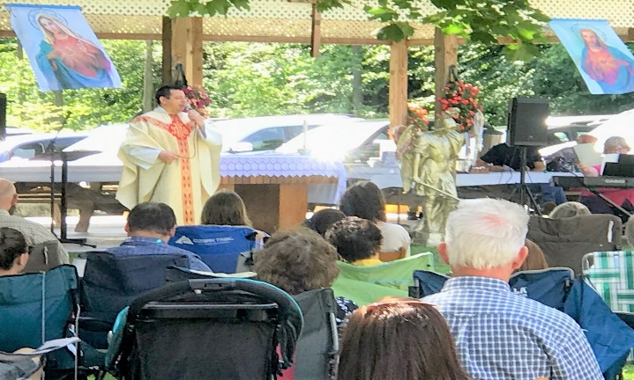

My sincere thank you to all who help coordinate our

parish family picnic and those who attended.

What a Catholic Rally it was!

Special thank you goes out to the band

“*Finding The Lost”*, *Le Dance Academie,*

and Johnstown Tomahawks Mascot

“Chopper” for entertaining us as well.

God bless you all!

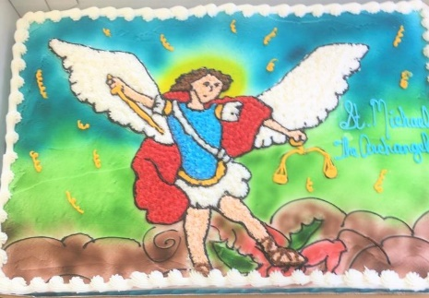

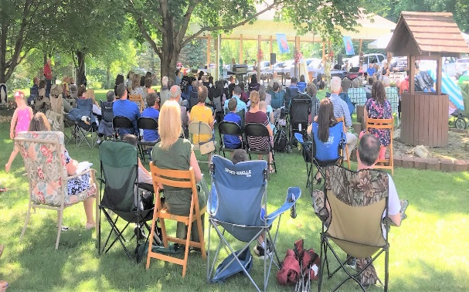

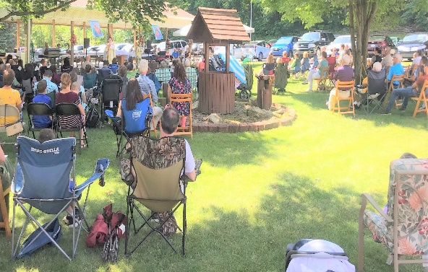

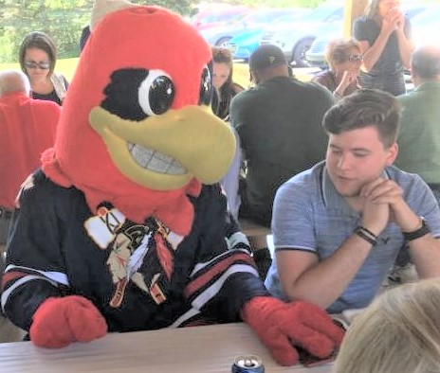

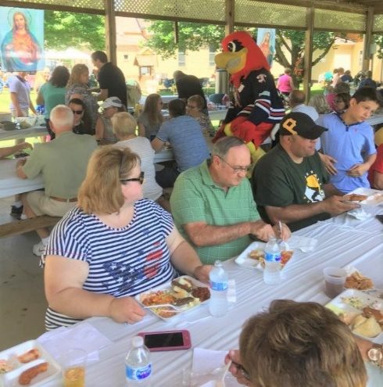

“Chopper”

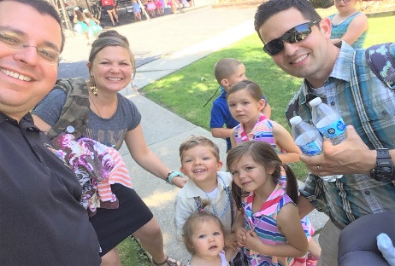

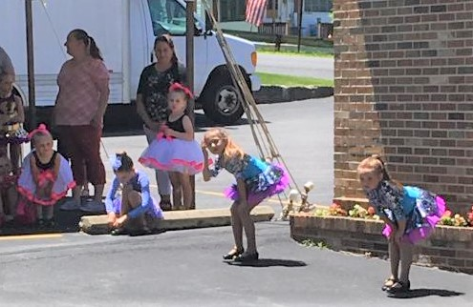

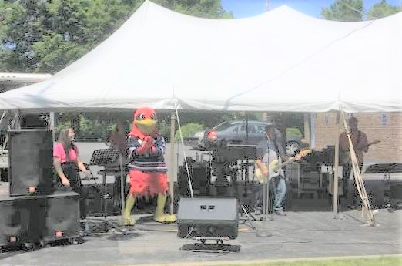

“Le Dance Academie”

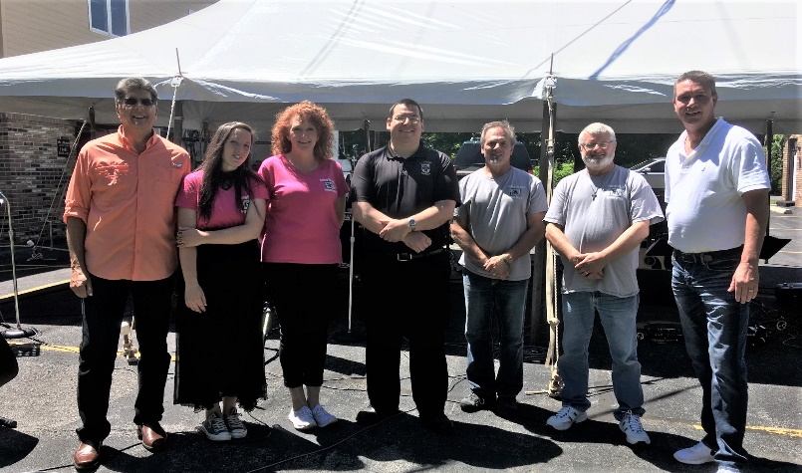

*“Finding The Lost”*



Sunday, June 30 Peter’s Pence / Second Collection

Monday, July 1 Sunday Choir Practice / 7:00 PM

Tuesday, July 2



Wednesday, July 3 No Mass

Thursday, July 4 4th of July / Offices Closed

First Friday, July 5 Exposition of the Blessed Sacrament with Adoration / 8:30 AM-3:00 PM

Saturday, July 6

UPCOMING EVENTS

July 9 VBS Meeting

July 13 & 14 Second Sunday Food Pantry Collection

July 14 Holy Name Meeting

July 15 VBS Set up

July 16-18 VBS

July 20 & 21 Miracle of Life Billboard / Donations

FOURTH OF JULY PICNIC ~ Immaculate Conception Church, New Germany Grove. 11:00 AM – 8:00 PM – Buffet Chicken & Ham Dinner with homemade noodle soup. Adults $10/Children under 12 $5. Crafts, Food, Refreshments & Games! Beverage Hall open Wednesday, July 3rd from 7 – 10 PM & Cornhole Tournament (must be over 21) at 7:30 PM.

ST. ANTHONY OF PADUA, WINDBER ~ Annual Festival, July 13 & 14. Sat. July 13: 5-11 PM “The Boomer” 4-10 PM. Sun., July 14: 3-9 PM “That Oldies Band” 4-8 PM. Ethnic Foods, Games, Baskets, Music, Children’s Corner, Bake Sale & More!

ANNUAL ETHNIC FESTIVAL ~ Sunday, July 14 – Noon-8 PM. Affordable Family Fun! “Hallmarks” playing live from Noon – 3:30 PM. “Full Kilt” Celtic Rock playing live from 4:30-8:00 PM. SS. Peter & Paul Byzantine Catholic Church, Munster Road in Portage.

ST. JOAN OF ARC CHURCH ~ Route 53, Frugality, PA (near Prince Gallitzin State Park and Glendale Lake) will be holding their annual Festival, Sunday, July 21st, from 11:00 AM – 6:00 PM, featuring a Turkey & Noodle Dinner with all the trimmings. Dinner served Family Style from 11:00 AM – 3:00 PM. Adults $10, Children 5-12 $5, under 5 free. Take outs available. Music Entertainment: St. Joan Praise Band Noon till? Basket auction at 4:00 PM.

YARD SALE ~ Table Rentals/Space available at Bishop Carroll Cafeteria Saturday, July 27 during the Ebensburg town wide Yard Sale event. $15 each. Call 814-472-7500 ext. 101 or email [sfeidhof@bishopcarroll.org](mailto:sfeidhof@bishopcarroll.org) to reserve a spot.