John 6:54

ST. MICHAEL ROMAN CATHOLIC CHURCH

751 Locust Street

PO Box 103

St. Michael, Pennsylvania 15951

Rev. Brian L. Warchola, Administrator MASSES:

(814) 495-9640 Saturday 4:00 pm



Sunday Morning 8:00 am

Secretary: Michele Panick 10:30 am

Bookkeeper: Kathy Kalicky Daily Mass See Bulletin

DRE: Laurie Sloan Holy Days See Bulletin

Maintenance: Rodney Turgeon

Office Hours:

PHONES: 8:30 am to 3:30 pm

Rectory / Office: (814) 495-9640 Monday, Tues., Thurs., Friday

Fax: (814) 495-9424 Confessions:

Rel. Education: (814) 495-4873 Saturday 3:30 pm to 3:45 pm

Parish Website Sunday 7:30 am to 7:45 am

www.saintmichaelchurch.weebly.com 10:00 am to 10:15 am

Secretaries’ E-mail Anytime Requested

[saintmichaelsecretaries@yahoo.com](mailto:saintmichaelsecretaries@yahoo.com)

YEAR: 2019 NUMBER: 23

SERVING GOD AND COMMUNITY FOR OVER ONE HUNDRED YEARS!

BAPTISM: By Appointment. Reserve at least one month in advance.

MARRIAGE: Plan at least nine months in advance.

Preparation sessions are necessary.

FUNERALS: Arrangements are made in conjunction with the funeral home.

REGISTRATION Those new to the area, newlyweds, and single adults, (even if registered

and before with their families) are asked to register by calling the Parish Office.

MEMBERSHIP: Every parishioner must be registered. This is a condition for admission

to our Program and reception of the Sacraments of Baptism, Confirmation, First Penance, First Eucharist, and Matrimony; also, for testimonial letters or sponsorship of Baptism and Confirmation outside the Parish.

VISITATION: We are concerned and want to be advised when someone is ill at home or in the hospital. Call the rectory to have the shut-in placed on our monthly Holy Communion calls or seriously ill prayer list.

SACRAMENTAL Parish registration and active Mass participation for Baptism is

POLICY: encouraged and is required for Marriage.

BULLETIN ARTICLES: Articles are due to the Parish Office by Noon on Tuesdays.

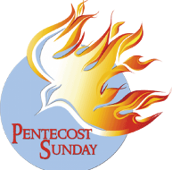 Pentecost Sunday

June 9, 2019

**Month of The Sacred Heart of Jesus**

**MASS INTENTIONS**: (June 10 – June 17, 2019)

Monday 8:00 AM No Mass

Tuesday 8:00 AM No Mass

Wednesday No Mass

Thursday 8:00 AM No Mass

Friday 8:00 AM Joseph Barton req. by Anne Lukicek

Saturday 4:00 PM Father’s Day Intentions

Sunday 8:00 AM Father’s Day Intentions

Sunday 10:30 AM Father’s Day Intentions

LITURGICIAL APPOINTMENTS:

Saturday, June 15 4:00 PM Offertory Procession

Lector: Anthony Bambino Bryan & Amy Spangler

Minister of the Host: Susan Blazosky Family

Minister of the Cup: Vince Arena & Alice Podrebarac

Altar Servers: Brooke & Chase Williamson

Cantor: Amanda Williamson

Greeter: Phyllis Slonac

Sunday, June 16 8:00 AM Offertory Procession

Lector: Arnold Bernard Joe & Cathy Faher

Minister of the Host: Eric Tedjeske

Minister of the Cup: Robert Grattan & Paul Kundrod

Altar Servers: Griffin & Kaden Christ

Cantor: Sharon Dibble

Greeter: Pete Parisi

Sunday, June 1610:30 AM Offertory Procession

Lector: Michael Barton Michael Steele Family

Minister of the Cup: Michael Steele

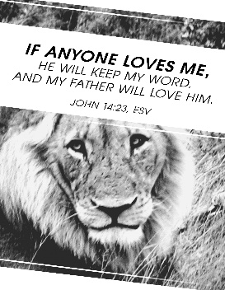Minister of the Host: Robert Oshaben & Susan Wieczorek

Altar Servers: Colby Rearick & Ian Dobbins

Cantor: Louis McCloskey

Greeter: REACH Students

Sunday, June 16 Collection Counters

George & Janet Minor

Mary Ann DeRosa

Weare placing names of the sick in the bulletin for prayer providing they give permission. *May the* *Divine Physician send healing grace for those for* *whom we pray:* Allen C. Rosemas, Patricia Murphy, Bernice Myers, Dwight Fyock, Lori Facciani, Dylon Wills, Missy, Joanne (Kolar) Hufford, Christine Flanagan, Ayden Alan Grata, Mary Lou Offman, Mary Zangaglia, Dorothy Rosemas, Natalie Zerby, Patricia Grata, Michael Wadsworth, Valencia & Frank Tursi, Homer Locher, Brayden Schofield, Michelle Kasper, Diane Kingera, Allison Krischer, Ted Paluch, Brandt Hutzel, Pearl Litzinger, Patrick Munro, Fran Baldassarre, Kristen Sinosky Long, Helen Ranieri, Cresta Micik, Basil Costantino, Madison McCrory, Laura, Joe Yoder, Dolores Yanzetich, Sandy Krug, Wanda Gramling, Merna Smay, Agnes Plummer, Jennifer Hagans, Shawn, Holly, Shane, Spencer, Owen Taylor, Keith & Dawnetta Hoyer, Derrick Varnish, Vincent Koshute, Melissa Cordek, Michelle Elliott, Heather Romanow, Mackston Barrick, Connor Thomas, Erin, Pat, Mary Agnes Nastase, Mary Ann Bertolino, Dick Wilson, Izzy Bihun, Erica Mitzelfeld, Dorothy Kaminsky, Patricia Oshaben, Ashlee Madison, Susan Yanzetich, Mike, Danika Faith, Alina Rusnak, Marcia Costlow, Gary Smay, Elizabeth Howell, Helen Bowen, Walter Bodziak, Rhonda, Dan Strinkoski, Anne Robinson, Marlene McCrory, Sharon Poldiak, Carter Bobak, Vince Arena, Mike Morris, Sarah Kelt, Mildred Andrykovitch, Patty Yanzetich Caldwell, Mary Secriskey, Colton Snyder, Betty Delaney, Nancy Edmiston, Elizabeth Stoker Thomas, Albert Sracic, Arthur Byers, Joseph Ropecka, Bill Krajewski, Leonard Oshaben, Florence Smith, Michael Chalan Jr., Adam, Bill Gideos, Theressa Stravinsky, Janice Dipyatic, Martha, John Poldiak Jr. and all of the sick of our parish, the homebound, those in nursing homes, those who care for them, and those in the military along with their families. *(Please call the Rectory to have your name removed from the list when no longer seriously ill. Thank You.)*

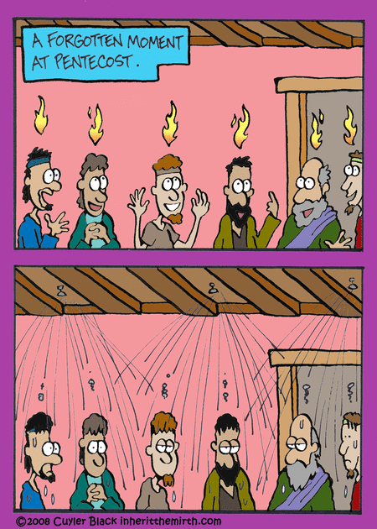

LAST WEEK’S COLLECTION

Adults $4,043.00

Loose $ 255.00

Youth $ 27.50

Monthly $1,150.00

Candles $ 73.00

Maintenance $ 25.00

Ascension Thursday $1,162.50

Easter $ 75.00

Cemetery Maintenance $ 197.00

Holy Father (Peter’s Pence) $ 5.00

Catholic Communication $ 341.00

Father’s Day $ 55.00 Total $7,409.00

We sincerely thank and ask God’s

blessing upon all who have care

and concern for our parish.

June 9, 2019 Pentecost Sunday

Today’s gospel tells us God actually wants to take up residence in your family. “We will come and make our home with you.” Every family is called to be a tabernacle where God dwells. Is Jesus a permanent member of your family or temporary guest? Today the promise is given. The choice is ours.

 MAY 2019 PARISH TICKET WINNERS

Day Date Amount No. Winner

Friday May 31, 2019 $75 207 Dennis Plummer



JO JO’S PIZZA FUNDRAISER ~ This weekend is our last days of our Jo Jo’s Pizza Fundraiser which ends Sunday, June 9th. Flyers are located at the entrances of the church. You can use as many flyers as you like or give them to your family & friends!

CATHOLIC RALLY ~ On Sunday, June 23rd, we will be having a CATHOLIC RALLY, which includes an Outdoor Mass at 10:30 AM and a picnic to follow. Also, the Christian Band, “Finding the Lost”, will be performing as well as Anita Lorek’s *Le Dance Academie’*. Please feel free to invite your friends, family, and fallen away to rally at St. Michael. The main dish and the drinks will be provided. We ask that you bring folding lawn chairs for the Mass and please bring a covered dish. Sign-up sheets can be found in the back of the Church. Please pray for good weather and spend an afternoon with the Archangel!

CATHOLIC COMMUNICATION CAMPAIGN ~ Thank you for your generosity to last week’s collection for the Catholic Communication Campaign (CCC). Your support helps the CCC spread the Gospel message and connect millions of people with Christ, here in the United States and around the world. If you missed the collection, it’s not too late to give! Visit [www.usccb.org/nationalcollections](http://www.usccb.org/nationalcollections), and click on the “How to Give” link on the left.

LAY MINISTRY SCHEDULES ~ The Summer Lay Ministry Schedules are available, and they can be found on the wall inside the front doors.

Catholic Ministries Drive $26,768.00

Raised: $ 5,368.00

Balance: $21,400.00

Number of responses: 53

Thank you to all parishioners who have responded to the *2019 Catholic Ministries Drive.* Please join them in supporting our Parish and a select group of ministries that provide outreach to the poor, family life, youth and seminarians. If you did not receive a pledge card in the mail, you may give online at [www.dioceseaj.org](http://www.dioceseaj.org).



ST. JOSEPH CEMETERY, MEMORIAL DAY MASS ~ Fr. Brian blessed 2 new statues after the Memorial Day Mass that was attended by 83 people plus 7 Beaverdale American Legion Honor Guard.

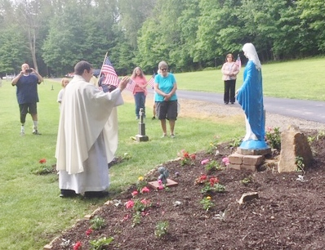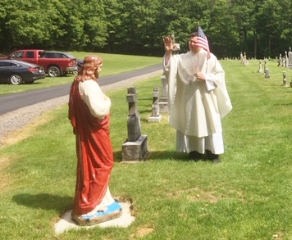

[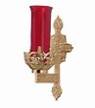](https://images.search.yahoo.com/search/images;_ylt=A0LEV1kSWptXvOwAKINXNyoA;_ylu=X3oDMTEyZGdkcmRoBGNvbG8DYmYxBHBvcwMxBHZ0aWQDQjIwODlfMQRzZWMDc2M-?p=Clipart+of+a+sanctuary+candle&fr=ush-mailn_02&th=110&tw=110&imgurl=http://www.henningers.com/389-168-wall-sanctuary-lamp.jpg&rurl=http://pixshark.com/sanctuary-lamp.htm&size=43KB&name=Sanctuary+Lamp+Bronze+wall+sanctuary+lamp&h=600&w=600&turl=http://ts2.mm.bing.net/th?id=OIP.M68453c67108cdc5ab485d309b395bd03o0&pid=15.1&rs=1&c=1&qlt=95&w=110&h=110#inline&tt=Sanctuary+Lamp+Bronze+wall+sanctuary+lamp&sigr=116keh5le&sigit=13gvlt42j&sigi=11ip0pgm4&sign=119kp6100&sigt=119kp6100)

The Sanctuary Candle will burn in honor of

All Our 2019 Graduates

during the week of June 9, 2019.

FR. BRIAN’S MESSAGE ~ Please know of my continued thanks for all who are so faithful to St. Michael Parish. I am more than happy to help in any way I can with any of your spiritual needs. If there is anyone who may be in the need of getting married or have their civil marriage convalidated or in need of a declaration of nullity, I would be more than happy to assist you. Call the parish office, and we can set up an appointment to meet.

*Fr. Brian*

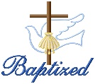

BAPTISM ~ On Sunday, June 2nd, we celebrated the glorious baptism of Avery Rose Hershberger, daughter of Joshua Hershberger and Krista (Tedjeske) Hershberger by Fr. Brian Warchola. She became a new creation in Christ in the waters of Holy Baptism. Now joined to us by the gifts of faith, hope and charity, we warmly welcome her into our St. Michael Parish Family.

WEEKDAY MASSES ~ There will be NO weekday Masses on Monday, June 10th, Tuesday, June 11th and Thursday June 13th due to Fr. Brian attending a Mandatory Diocesan Priest Retreat. In case of an emergency, please contact the parish office at 814-495-9640.



CONGRATULATIONS! ~ Congratulations to Fr. Brian Warchola for celebrating his 8th year Ordination Anniversary on Tuesday, June 4th!

HOLY NAME SOCIETY ~ Will hold their monthly meeting today, June 9th after the 8:00 AM Mass.

SECOND SUNDAY FOOD COLLECTION ~ This weekend is our Second Sunday Food Collection. Please bring in non-perishable food items or toiletries with you. Monetary donations are also appreciated.

PARISH COUNCIL ~ There will be a Parish Council Meeting today after the 10:30 AM Mass.

FATHER’S DAY BRUNCH ~ All fathers and sons of the parish are invited to a Father’s Day Brunch in the church hall immediately following the 10:30 AM Mass on Sunday, June 16th. The ladies and REACH girls of the parish will be preparing and serving the meal. We hope to see all the fathers and sons of the parish there! HELP IS NEEDED! Please call Pauline Minor (495-5165) to volunteer. This is a good way to earn service hours! Let’s show our appreciation to the Fathers and Sons of this parish family!

FATHER’S DAY INTENTIONS ~ Envelopes for Father’s Day Mass Intentions are in your packet of envelopes. The envelopes will be placed on the altar during the month of June in remembrance of all fathers, both living and deceased. Extra envelopes can be found at the entrances of the church.

BABY BOTTLE CAMPAIGN ~ Baby bottles are due by Sunday, June 16th. Please place the filled baby bottles in the box located in the bridal room. There are still plenty of bottles left to fill so feel free to take as many as you like.



THANKS! ~ Thanks to Stephanie Strittmatter for coming to instruct us in our Jazzercise class and thanks to those that were in attendance!



Religious Education And Christian Helping

June 9, 2019

Senior Sunday Celebration ~ Sunday, June 2, 2019

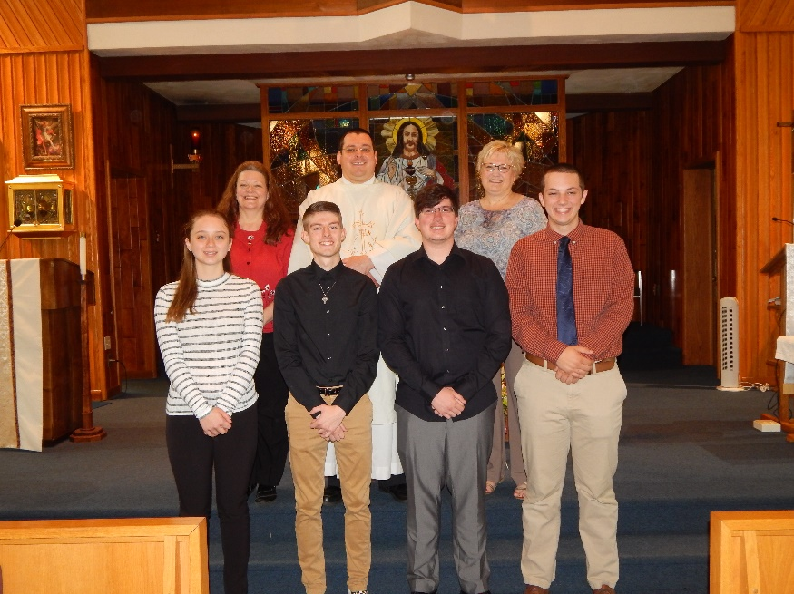

All of our seniors received The New Catholic Answer Bible as a gift from our parish. *Students that completed their 12th grade year of Religious Education are eligible to receive a $300 Higher Education Grant from the parish toward continuing their education.*

Pictured here left to right, Front Row: Alyssa Penrod, Jeremy Weis, Anthony Stigers and Quinn Spangler.

Back Row: Laurie Sloan, DRE, Fr. Brian Warchola and Susan Wieczorek, catechist.

Alyssa Penrod, Alyssa is the daughter of David and Jennifer Penrod. After high school, Alyssa plans to attend Penn State University and major in Architecture.

Jeremy Weis, Jeremy is the son of Brian and Diane Weis. After high school, Jeremy plans to attend Penn Highlands Community College and study Business Administration.

Anthony Stigers, Anthony is the son of Terry and Theresa Stigers. After high school, Anthony plans to attend University of Pittsburgh at Johnstown and study Pre-Dental / Biology.

Quinn Spangler, Quinn is the son of Bryan and Amy Spangler. After high school, Quinn plans to attend Syracuse University and study Sport Analytics. Quinn currently serves our parish as an Altar Server.

Seniors not able to attend:

Ericka Frombach, Ericka is the daughter of Richard and Stephanie Frombach. After high school, Ericka plans to attend Indiana University of Pennsylvania and study Education - Nutrition. Ericka served our parish as an Altar Server.

Jordan Burda, Jordan is the daughter of James and Jennifer Burda. .

Others not present: Megan Jennings, Victoria Koeck, Devyn Miller, Dylan Miller and Chloe Valinsky.

Presentation of our $500.00 REACH Service Awards: This year, our REACH Service Award was raised to $500 and given to two seniors who ranked the highest in individual cumulative service hours throughout their participation in the REACH program. This service includes all REACH and church sponsored aspects of service to the community along with fundraisers.

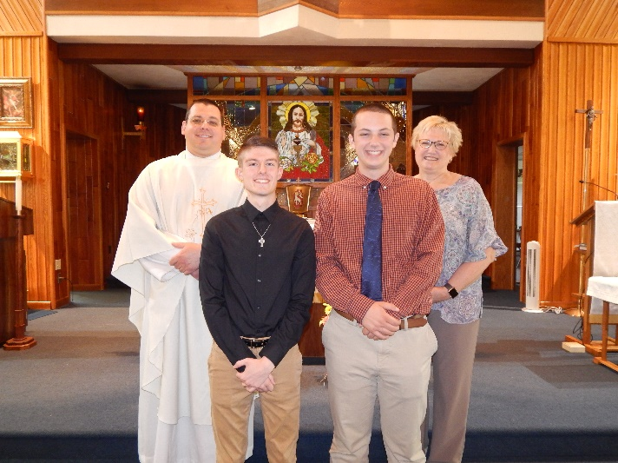In 2007, The REACH Service Award was initially funded through a monetary donation made in honor of a member of our faith community. This award was created through a specific endowment fund with The Community Foundation for the Alleghenies to benefit youth members of the St. Michael REACH Youth Ministry Program here at Saint Michael Catholic Church. This award is only offered to the senior class members that attend their 12th Grade year of Religious Education classes throughout.

The $500 REACH Service Award recipients for 2019 are: Jeremy Weis and Quinn Spangler, pictured here left to right along with Fr. Brian Warchola and Susan Wieczorek. Their combined cumulative service in REACH is over 300 hours.

*REACH Summer Trip to Kennywood*

Our REACH Youth Ministry is planning a trip to Kennywood Park on Tuesday, June 18, 2019. All REACH students, Grades 6—12, are invited to participate. REACH students can also bring a guest! We also extend this invitation to this years’ 5th Grade Class, who officially become members of REACH on June 1, 2019. Due to liability issues, no younger students may attend.

Adult chaperones are needed to make this trip possible, and all chaperones are required to have their clearances to attend. We will need at least 1 adult chaperone per 7 students. The cost of this trip is $20.00 for REACH students and $35 for their guests. Checks need to be made payable to “St. Michael REACH”. The remainder of admission and transportation by bus will be covered by our REACH funds. An information letter and Registration/Permission forms have been mailed to all REACH families with students in grades 6—12.

*Reservations will require a returned Reservation/Permission form and also include the appropriate payment due to Confirm your seat on the bus.* Reservations are due ASAP and can be returned via the weekend collection in an envelope marked “Kennywood Park” or by returning them to the RE / Parish Office during office hours, or by placing them in the “Green Container” outside the Parish Office entrance if the office is closed. Any questions, call Laurie Sloan in the Religious Education Office at 495-4873 or e-mail [lsloan@dioceseaj.org](mailto:lsloan@dioceseaj.org).

*********************************************************************************************************************************

Upcoming REACH Service Projects

Father’s Day Brunch ~ The Father’s Day Brunch is scheduled for June 16th. REACH girls are needed to help with preparation, serving and clean-up. / Time frame option: 9 AM to 1 PM.

VBS Prep Day ~ A VBS Prep day is scheduled for Wednesday, June 19th from 10AM to 12 noon. We will meet in our Saint Michael Parish Hall and be making decorations for our sets and also be preparing some of our crafts. REACH students can earn service credit if attending.

*********************************************************************************************************************************



Our joint Vacation Bible School for St. Michael, Most Holy Trinity and St. Bartholomew parishes is:

*Yee Haw: Celebrating God's greatest gift*

Here at St. Michael Parish

July 16, 17 & 18 from 6—8:00 PM

VBS is an opportunity to reach children with God's love. We invite you to join our team of volunteers to share your love of God in a fun, exciting three days of adventure. VBS is open to all children ages 4—14. Everyone is asked to help by volunteering, donating, and praying for the success of our program and the enjoyment of all involved.

VBS Registration forms are available on the back table and at the side entrance of the church along with our Volunteers Registration forms.

REACH students and adult volunteers are needed to help with prep ahead of VBS week and we will also need help the week of VBS. High School students can earn service hour credits for helping.

We are planning a VBS Prep day on Wednesday, June 19th from 10AM to 12 noon. We will meet in our Saint Michael Parish Hall and be making decorations for our sets and also be preparing some of our crafts. Please join us to make this a wonderful adventure for our kids.

If you would like to share in the fun, call the Parish Office at 495-9640 or the RE Office at 495-4873.

 Sunday, June 9 Second Sunday Food Pantry Collection

Holy Name Meeting / After 8:00 AM Mass

Parish Council Meeting / After 10:30 AM Mass

Last Day for Jo Jo’s Pizza Fundraiser!

Monday, June 10 No Mass / Priest Retreat

Martha’s Group / 6:00 PM

Tuesday, June11 No Mass / Priest Retreat

Wednesday, June 12 No Mass / Priest Retreat

 Thursday, June 13 No Mass / Priest Retreat

Friday, June 14 Flag Day

Saturday, June 15



UPCOMING EVENTS

June 16 Father’s Day Brunch

June 18 Kennywood Trip

June 23 Catholic Rally / Outdoor Mass / Picnic

June 29 & 30 Peter’s Pence Second Collection

FOREST HILLS COMMUNITY BAND ~ Concert Schedule – Sunday, June 9th, South Fork U.M. Church 7 PM.

ST. PATRICK CHURCH (JOHNSTOWN) FESTIVAL ~ June 14th, 15th, and 16th. Enjoy great food (Italian sausage or pulled pork sandwiches, chicken tenders, homemade haluski, hamburgers, hot dogs, French fries, funnel cakes, ice cream, homemade gobs and more) along with basement sale, bake sale, bingo, games, theme baskets and other booths, petting zoo for children, raffle tickets for cash prizes ($500-$300-$200-$100) and live entertainment. Festival hours-Friday: 6 PM-10 PM (Tree); Saturday: 5 PM-10 PM (Rosie and the Jammers); Sunday: Noon-5 PM (Kitchen and Basement Sale); Sunday: 1 PM-5 PM, Bingo, Booths, Petting Zoo and Music (DJ).

15TH ANNUAL CENTRAL PA RODEO ~ When: Friday, June 14th at 7:30 PM & Saturday, June 15th at 7:30 PM. Where: Huntingdon County Fairgrounds. Advance Ticket Pricing: Adults $13, Children (4-12) $5. Gate Tickets: Adults $17, Children (4-12) $7 and children 3 & under free. This year our specialty act is THE RAWHIDE & DUSTY SHOW. Advance tickets are available online at [www.CentralParodeo.com](http://www.CentralParodeo.com). You may also bring a copy of your bulletin announcement and get $2 off each ticket you buy at the gates which opens 3 hours prior to the events. Parking is free. On Friday we will be honoring all members of our military by offering a free ticket to those actively serving, those in reserves and retired veterans with a valid military ID. Those tickets can be picked up at the gate on Friday. All proceeds support St. Matthew Catholic School in Tyrone, PA.



WINEFEST ~ As part of the South Fork Heritage Days, please join Most Holy Trinity for Wine, Sweets, and Stogies at the Church hall on Friday, June 21st from 5:30-8:30 PM with music by Dawn & Johann Acoustic. Tickets are $10 at the parish office, Patti Good 322-8840 or at the S. Fork Library 495-4812.