ST. MICHAEL ROMAN CATHOLIC CHURCH

751 Locust Street

PO Box 103

St. Michael, Pennsylvania 15951

Rev. Msgr. David A. Lockard, Administrator MASSES:

(814) 495-9640 Saturday 4:00 pm



Sunday Morning 9:30 am

Secretary: Michele Panick

Bookkeeper: Kathy Kalicky Daily Mass: M, T, Th, F Noon

DRE: Laurie Sloan Wed. 6:00 pm

Maintenance: Rodney Turgeon Holy Days: See Bulletin

PHONES: Office Hours:

Rectory / Office: (814) 495-9640 8:30 am to 3:30 pm

Fax: (814) 495-9424 Monday, Tues., Thurs., Friday

Rel. Education: (814) 495-4873 Confessions:

Parish Website Saturday 3:30 pm to 3:45 pm www.saintmichaelchurch.weebly.com Sunday 9:00 am to 9:15 am

Secretaries’ E-mail By Appointment

[saintmichaelsecretaries@yahoo.com](mailto:saintmichaelsecretaries@yahoo.com)

Facebook page:

St. Michael Catholic Church/St. Michael, PA

15th Sunday in Ordinary Time

SERVING GOD AND COMMUNITY FOR OVER ONE HUNDRED YEARS!

July 12th, 2020

BAPTISM: By Appointment. Reserve at least one month in advance.

MARRIAGE: Plan at least nine months in advance.

Preparation sessions are necessary.

FUNERALS: Arrangements are made in conjunction with the funeral home.

REGISTRATION Those new to the area, newlyweds, and single adults, (even if registered

and before with their families) are asked to register by calling the Parish Office.

MEMBERSHIP: Every parishioner must be registered. This is a condition for admission

to our Program and reception of the Sacraments of Baptism, Confirmation,

First Penance, First Eucharist, and Matrimony; also, for testimonial letters or sponsorship of Baptism and Confirmation outside the Parish.

VISITATION: We are concerned and want to be advised when someone is ill at home or in the hospital. Call the rectory to have the shut-in placed on our monthly Holy Communion calls or seriously ill prayer list.

SACRAMENTAL Parish registration and active Mass participation for Baptism is

POLICY: encouraged and is required for Marriage.

BULLETIN ARTICLES: Articles are due to the Parish Office by Noon on Tuesday.

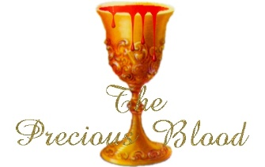 Fifteenth Sunday in Ordinary Time

July 12th, 2020

The Precious Blood of Jesus

**MASS INTENTIONS**: (July 13 – July 19, 2020)

Monday Noon Charlene Kusher req. by Matilda Blozevich

Tuesday Noon Mr. & Mrs. James Lehman req. by John & Patricia Kovach

Wednesday 6:00 PM Kristan Deighan req. by Parents, Rick & Nancy Wessel

Thursday Noon Michael Hudak req. by Eileen Zibura

Friday Noon Mary Secriskey req. by St. Michael Funeral Committee

Saturday 4:00 PM People of the Parish

Sunday 9:30 AM Michael Cononie req. by Mike & Lucia Ann Brezovec

LITURGICIAL APPOINTMENTS:

Saturday, July 18 4:00 PM

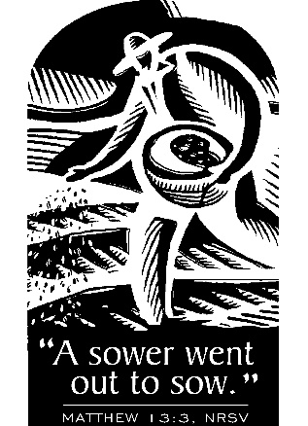

Lector: Tony Bambino

Minister of the Host: Babe Richards

Altar Server: Brooke Williamson

Cantor: Amanda Williamson

Sunday, July 19 9:30 AM

Lector: Joe Faher

Minister of the Host: Jennifer Steele

Altar Server: Ian Dobbins

Cantor: Elizabeth Dobbins

MINISTRY SCHEDULES ~ Lay ministry schedules are being done week by week until we return to our regular mass schedules. Please check the bulletin for the schedule. If you know a weekend you may not be available, please let Susan Blazosky know at: 495-5287 or [sublazosky@gmail.com](mailto:sublazosky@gmail.com)

Weare placing names of the sick in the bulletin for prayer providing they give permission. *May the* *Divine Physician send healing grace for those for* *whom we pray:* Allen C. Rosemas, Patricia Murphy, Bernice Myers, Dwight Fyock, Dylon Wills, Missy, Joanne (Kolar) Hufford, Christine Flanagan, Ayden Alan Grata, Mary Lou Offman, Mary Zangaglia, Natalie Zerby, Valencia Tursi, Homer Locher, Brayden Schofield, Michelle Kasper, Diane Kingera, Allison Krischer, Ted Paluch, Brandt Hutzel, Pearl Litzinger, Patrick Munro, Fran Baldassarre, Kristen Sinosky Long, Cresta Micik, Basil Costantino, Madison McCrory, Laura, Joe Yoder, Dolores Yanzetich, Sandy Krug, Wanda Gramling, Agnes Plummer, Jennifer Hagans, Shawn, Holly, Shane, Spencer, Owen Taylor, Keith & Dawnetta Hoyer, Derrick Varnish, Vincent Koshute, Melissa Cordek, Michelle Elliott, Heather Romanow, Mackston Barrick, Connor Thomas, Erin, Pat, Mary Agnes Nastase, Mary Ann Bertolino, Dick Wilson, Izzy Bihun, Dorothy Kaminsky, Patricia Oshaben, Ashlee Madison, Susan Yanzetich, Mike, Danika Faith, Alina Rusnak, Gary Smay, Elizabeth Howell, Helen Bowen, Walter Bodziak, Rhonda, Dan Strinkoski, Anne Robinson, Marlene McCrory, Sharon Poldiak, Carter Bobak, Vince Arena, Mike Morris, Sarah Kelt, Patty Yanzetich Caldwell, Colton Snyder, Betty Delaney, Nancy Edmiston, Leonard Oshaben, Adam, Bill Gideos, Janice Dipyatic, John Poldiak Jr., Gerald Delaney, Lily Maloney, Adam Wingard, Scott, Lisa, Rosalie Ambrose, John Patrick, Audrey Costlow, Carole Horner, Ross Linert, Cathy Sossong, Rosanne Krug, Paul Snyder, Becky Kakabar, Catherine Tedjeske, Pua Ripper, Howard Delaney and all of the sick of our parish, the homebound, those in nursing homes, those who care for them, and those in the military along with their families. *(Please call the Rectory to have your name removed from the list when no longer seriously ill. Thank You.)*

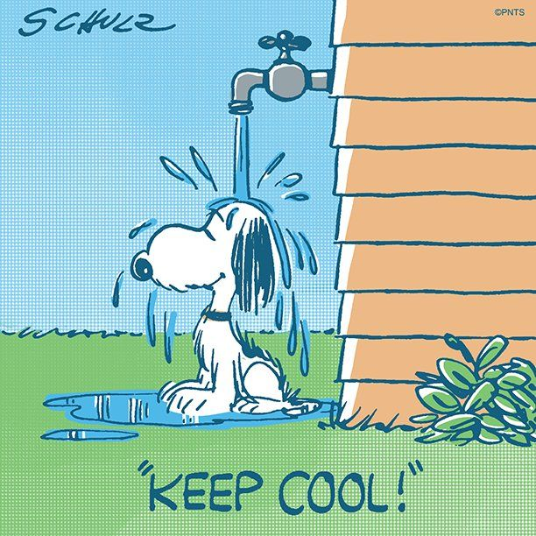

LAST WEEK’S COLLECTION

Adults $2,045.00

Youth $ 31.50

Monthly $ 750.00

Father’s Day $ 10.00

Candles $ 20.00

Maintenance Fund $ 80.00

Cemetery Maintenance $ 10.00

Assumption $ 5.00

Catholic Register Sub. $ 110.00

Peter’s Pence (Holy Father) $ 105.00

Total $3,166.50

We sincerely thank and ask

God’s blessing upon all

who have care and

concern for our

parish.

*July 12, 2020*

*As Jesus teaches with parables about the growth in faith for the disciples in His time we are called to “hear and listen” so we can also understand the Truth of the love that will grow God’s Kingdom. To love as Jesus did will “bear fruit and yield a hundred or sixty or thirty- fold.” (Mt. 13:23)*

During the week of July 12th, 2020

the Sanctuary Candle will burn as an

Anniversary Remembrance for

Andrew & Betty Pcola

requested by Loving Family

and the Our Lady of Grace Candle will burn in honor of

the 2020 Confirmation Class

requested by the Religious Education Teachers

[](https://images.search.yahoo.com/search/images;_ylt=A0LEV1kSWptXvOwAKINXNyoA;_ylu=X3oDMTEyZGdkcmRoBGNvbG8DYmYxBHBvcwMxBHZ0aWQDQjIwODlfMQRzZWMDc2M-?p=Clipart+of+a+sanctuary+candle&fr=ush-mailn_02&th=110&tw=110&imgurl=http://www.henningers.com/389-168-wall-sanctuary-lamp.jpg&rurl=http://pixshark.com/sanctuary-lamp.htm&size=43KB&name=Sanctuary+Lamp+Bronze+wall+sanctuary+lamp&h=600&w=600&turl=http://ts2.mm.bing.net/th?id%3DOIP.M68453c67108cdc5ab485d309b395bd03o0%26pid%3D15.1%26rs%3D1%26c%3D1%26qlt%3D95%26w%3D110%26h%3D110#inline&tt=Sanctuary+Lamp+Bronze+wall+sanctuary+lamp&sigr=116keh5le&sigit=13gvlt42j&sigi=11ip0pgm4&sign=119kp6100&sigt=119kp6100)

PARISH COUNCIL ~ There will be a Parish Council Meeting this Sunday, July 12th after the 9:30 AM Mass.

SECOND SUNDAY FOOD COLLECTION ~ This weekend is our Second Sunday Food Collection. Please bring in non-perishable food items or toiletries with you. Monetary donations are also appreciated. Items may be put in the Bridal room this weekend.

OUTDOOR MASS HONORING MARRIED COUPLES ~ The Altoona-Johnstown Diocesan Family is invited to participate and to pray for those living the Sacrament of Marriage at an Outdoor Mass honoring Married Couples on Sunday evening, July 19th at 7:00 PM at the Shrine of Our Lady of the Alleghenies in Loretto. Bring a lawn chair. Indoors if rain. Bishop Mark is the celebrant and homilist. This is a wonderful way to celebrate, encourage and support married couples!

GIRL SCOUT GOLD AWARD ~ I, Elizabeth Dobbins, am a Girl Scout with Troop #40991 and am currently working on my Gold Award. The Gold Award is the highest award in Girl Scouting. For my Gold Award Project, I will be cleaning children’s tombstones that are located towards the bottom of the St. Michael Catholic Church Cemetery. I am also hoping to place markers for the tombstones that are unreadable. To clean the tombstones, I will be using water and toothbrushes to ensure the safety of the stones. Additionally, I am creating a website discussing infant mortality causes in the 20th century. The website will also highlight my Tombstone Restoration Project. The tombstones I will be restoring belong to the following children: John Bendas, Annie Franky, Annie Melik, Margaret Garcolona, Margaret Margo, Cattenna Gianetta, Edward Bakale, Teresa Ellis, Annie Mahowst, Evan Jr. Yakicic, and Victor Florina. I am asking permission fromany living relatives of these children to restore the tombstones to honor their memory. If there are any concerns about restoring the stones, please contact me at 487-4569.

Thank-you,

Elizabeth Dobbins.

CONGRATULATIONS! ~ We would like to congratulate our St. Michael Confirmation Class of 2020! These students received their Sacrament of Confirmation on Thursday July 9th:

Alexander Bambino Daniel Blanchetti

Joshua Blanchetti Alyssa Caddy

Griffin Christ Carson Kundrod

Shane McCall Anna Stigers

And these students will receive their Sacrament of Confirmation on Tuesday, July 14th:

Taylor Burda Elizabeth Dobbins

Dylan Kundrod Andrew Martin

Kirstyn Vitez Jamie Kostan



Religious Education And Christian Helping

CONFIRMATION ~ The remainder of our 11th grade class will receive their Sacrament of Confirmation on Tuesday, July 14th, 2020 at 7:00 PM here at St. Michael Church. Practice for these students will be held on Monday evening, July 13th at 6:30 PM.

FIRST HOLY COMMUNION ~ Our Second-Grade class is preparing to receive First Holy Communion on Saturday, August 1st, 2020 at a 10:00 AM Mass. Their 2nd Reconciliation will be on Wednesday, July 29th at 6:30 PM. First Communion Practice will be on Friday, July 31st at 6:30 PM.

CAMP ZACCHAEUS GOING VIRTUAL

Camp Zacchaeus will be held July 19—24 for youth entering grades 4—9 in the fall. Registration is $10, which will cover the cost of materials that the diocese will send out in time for camp! Anyone interested, contact the parish office for a registration brochure.

Brochures also available in the green tote outside the parish office outside of office hours.

KNIGHTS OF COLUMBUS SCHOLARSHIP AWARDS ~ Attention 2020 high school graduates and parents! Our Knights of Columbus council #2275 will be awarding two (2) $500 scholarship awards to 2 graduates among the churches we serve in our local area. It does not matter which school you attended as long as you are a member of one of the five churches our council serves. They are St. Michael, Most Holy Trinity, St. Bartholomew or Immaculate Conception and St. Johns. An application and questionnaire can be obtained by contacting Don Dipko, council 2275 Financial Secretary, by phone or e-mail. The phone number is 487-5655 the e-mail address is [djdipko@comcast.net](mailto:djdipko@comcast.net). The paperwork will be sent to respondents by regular U.S. Mail and must be returned to council #2275 by August 1st, 2020.

Sunday, July 12 Mass ~ 9:30 AM

Confessions / 9:00 – 9:15 AM

Parish Council Meeting / After 9:30 AM Mass

Second Sunday Food Pantry Collection



Monday, July 13 Mass ~ Noon

NO Sunday Choir Practice

Confirmation Practice / 6:30 PM

Tuesday, July 14 Mass ~ Noon

Confirmation / 7:00 PM

Wednesday, July 15 Mass ~ 6:00 PM

Thursday, July 16 Mass ~ Noon

NO Saturday Choir Practice

Friday, July 17 Mass ~ Noon

Saturday, July 18 Mass / 4:00 PM

Confessions / 3:30 – 3:45

UPCOMING EVENTS

July 20 Finance Council Meeting

August 1 First Holy Communion

THE FRIAR’S NOOK GIFT SHOP ~ Christmas in July is upon us! All clearance items are 75% off through August 1st! Also, the shop is still stocked up for all your sacrament needs! The shop will continue to have modified hours through Labor Day which are Fridays and Saturdays, 10 AM – 4 PM, and is located on the campus of St. Bernardine Monastery at 793 Monastery Road, Hollidaysburg. For any questions, please call 814-695-3802. Please note, face coverings *must* be worn for gift shop entry.

YARD SALE ~ At BCCHS July 25, 7:30 AM – 2:30 PM during Ebensburg’s Homecoming and Community Yard Sale. Table Rentals/Space available at Bishop Carroll Cafeteria for $15 each 12 ft table or space. We will also be having a basket raffle, bake sale, food items for breakfast and lunch and drinks for sale. Call Bishop Carrol at 814-472-7500 ext. 101 or email [freidhof.susan@bishopcarroll.org](mailto:freidhof.susan@bishopcarroll.org) to reserve your spot. Vendors get a free hot dog & drink for lunch and free coffee for the day. Benefits Bishop Carroll Girls Soccer.

