John 6:54

ST. MICHAEL ROMAN CATHOLIC CHURCH

751 Locust Street

PO Box 103

St. Michael, Pennsylvania 15951

Rev. Brian L. Warchola, Administrator MASSES:

(814) 495-9640 Saturday 4:00 pm



Sunday Morning 8:00 am

Secretary: Michele Panick 10:30 am

Bookkeeper: Kathy Kalicky Daily Mass See Bulletin

DRE: Laurie Sloan Holy Days See Bulletin

Maintenance: Rodney Turgeon

Office Hours:

PHONES: 8:30 am to 3:30 pm

Rectory / Office: (814) 495-9640 Monday, Tues., Thurs., Friday

Fax: (814) 495-9424 Confessions:

Rel. Education: (814) 495-4873 Saturday 3:30 pm to 3:45 pm

Parish Website Sunday 7:30 am to 7:45 am

www.saintmichaelchurch.weebly.com 10:00 am to 10:15 am

Secretaries’ E-mail Anytime Requested

[saintmichaelsecretaries@yahoo.com](mailto:saintmichaelsecretaries@yahoo.com)

YEAR: 2019 NUMBER: 28

SERVING GOD AND COMMUNITY FOR OVER ONE HUNDRED YEARS!

July 14, 2019

BAPTISM: By Appointment. Reserve at least one month in advance.

MARRIAGE: Plan at least nine months in advance.

Preparation sessions are necessary.

FUNERALS: Arrangements are made in conjunction with the funeral home.

REGISTRATION Those new to the area, newlyweds, and single adults, (even if registered

and before with their families) are asked to register by calling the Parish Office.

MEMBERSHIP: Every parishioner must be registered. This is a condition for admission

to our Program and reception of the Sacraments of Baptism, Confirmation, First Penance, First Eucharist, and Matrimony; also, for testimonial letters or sponsorship of Baptism and Confirmation outside the Parish.

VISITATION: We are concerned and want to be advised when someone is ill at home or in the hospital. Call the rectory to have the shut-in placed on our monthly Holy Communion calls or seriously ill prayer list.

SACRAMENTAL Parish registration and active Mass participation for Baptism is

POLICY: encouraged and is required for Marriage.

BULLETIN ARTICLES: Articles are due to the Parish Office by Noon on Tuesdays.

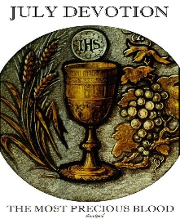

Fifteenth Sunday in Ordinary Time

July 14, 2019

The Precious Blood of Jesus

**MASS INTENTIONS**: (July 15 – July 21, 2019)

Monday 8:00 AM Betty Pcola req. by Loving Family

Tuesday 8:00 AM George & Elizabeth Freidhoff req. by Carl & Pam Freidhoff

Wednesday No Mass

Thursday 8:00 AM Hermine Sivec req. by George & Carol Sivec

Friday 8:00 AM Michael Hudak Sr. req. by John Slivenik

Saturday 4:00 PM Mindy Scott req. by Marcella & Bob Scott

Sunday 8:00 AM People of the Parish

Sunday 10:30 AM Terry McClemens req. by wife Kathy, children & grandchildren

LITURGICIAL APPOINTMENTS:

Saturday, July 20 4:00 PM Offertory Procession

Lector: Sandy Bambino Marcella & Bob Scott

Minister of the Host: Alice Podrebarac

Minister of the Cup: Theresa Carlson & Karen Myers

Altar Servers: Brooke & Chase Williamson

Cantor: Amanda Williamson

Greeter: Karen Myers

Sunday, July 21 8:00 AM Offertory Procession

Lector: Cathy Faher George & Janet Minor

Minister of the Host: Paul Kundrod

Minister of the Cup: Pauline Minor & Ellen Grattan

Altar Servers: Andrew Martin & Bryce Macy

Cantor: Joseph Faher

Greeter: Pete Parisi

Sunday, July 2110:30 AM Offertory Procession

Lector: Madison Kundrod Terry McClemens Family

Minister of the Host: Robert Oshaben

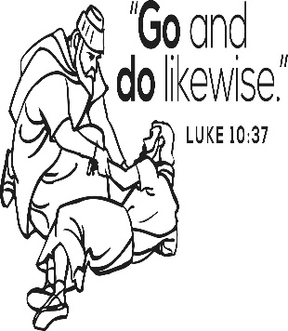Minister of the Cup: Jennifer Steele & Michael Barton

Altar Servers: Haidyn & Amilyah Koch

Cantor: Anita Lorek

Greeter: Deborah Macy

Sunday, July 21 Collection Counters

Robert Casti, Camillus Long

Mary Ann DeRosa

Weare placing names of the sick in the bulletin for prayer providing they give permission. *May the* *Divine Physician send healing grace for those for* *whom we pray:* Allen C. Rosemas, Patricia Murphy, Bernice Myers, Dwight Fyock, Dylon Wills, Missy, Joanne (Kolar) Hufford, Christine Flanagan, Ayden Alan Grata, Mary Lou Offman, Mary Zangaglia, Dorothy Rosemas, Natalie Zerby, Patricia Grata, Michael Wadsworth, Valencia & Frank Tursi, Homer Locher, Brayden Schofield, Michelle Kasper, Diane Kingera, Allison Krischer, Ted Paluch, Brandt Hutzel, Pearl Litzinger, Patrick Munro, Fran Baldassarre, Kristen Sinosky Long, Helen Ranieri, Cresta Micik, Basil Costantino, Madison McCrory, Laura, Joe Yoder, Dolores Yanzetich, Sandy Krug, Wanda Gramling, Merna Smay, Agnes Plummer, Jennifer Hagans, Shawn, Holly, Shane, Spencer, Owen Taylor, Keith & Dawnetta Hoyer, Derrick Varnish, Vincent Koshute, Melissa Cordek, Michelle Elliott, Heather Romanow, Mackston Barrick, Connor Thomas, Erin, Pat, Mary Agnes Nastase, Mary Ann Bertolino, Dick Wilson, Izzy Bihun, Erica Mitzelfeld, Dorothy Kaminsky, Patricia Oshaben, Ashlee Madison, Susan Yanzetich, Mike, Danika Faith, Alina Rusnak, Marcia Costlow, Gary Smay, Elizabeth Howell, Helen Bowen, Walter Bodziak, Rhonda, Dan Strinkoski, Anne Robinson, Marlene McCrory, Sharon Poldiak, Carter Bobak, Vince Arena, Mike Morris, Sarah Kelt, Patty Yanzetich Caldwell, Colton Snyder, Betty Delaney, Nancy Edmiston, Elizabeth Stoker Thomas, Albert Sracic, Joseph Ropecka, Bill Krajewski, Leonard Oshaben, Florence Smith, Michael Chalan Jr., Adam, Bill Gideos, Theressa Stravinsky, Janice Dipyatic, Martha, John Poldiak Jr., Gerald Delaney, Lily Maloney and all of the sick of our parish, the homebound, those in nursing homes, those who care for them, and those in the military along with their families. *(Please call the Rectory to have your name removed from the list when no longer seriously ill. Thank You.)*

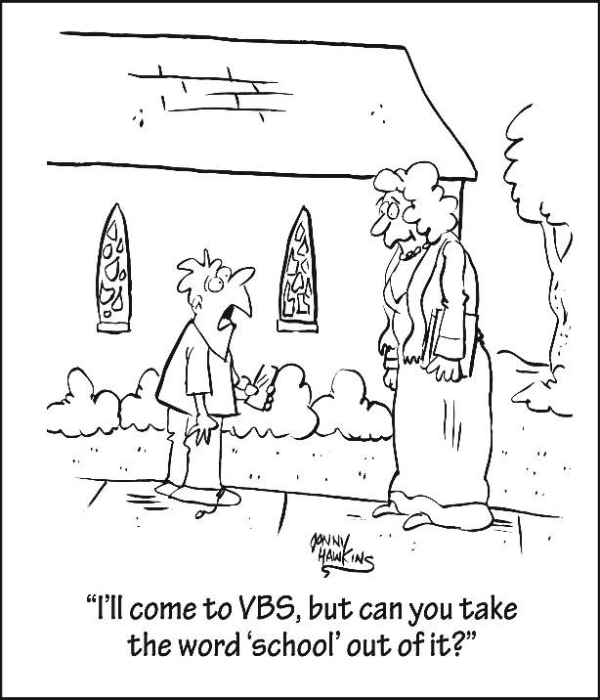

LAST WEEK’S COLLECTION

Adults $4,112.00

Loose $ 214.00

Youth $ 28.75

Monthly $ 979.00

Candles $ 29.00

Maintenance $ 180.00

Catholic Register Sub. $ 271.00

Feast of the Assumption $ 20.00

Cemetery Maintenance $ 20.00

Peter’s Pence (Holy Father) $ 50.00

Total $5,903.75

We sincerely thank and ask God’s

blessing upon all who have care and

concern for our parish.

July 14, 2019 Luke 10:25-37

Children learn by watching us. Do they see you helping others like the Good Samaritan, or do they see you avoiding others like the Levite in today’s gospel. Worry more about what your children see in YOUR LIFE than what they see

on TV.

ANNUAL ALL SCHOOL REUNION ~ Johnstown Catholic/Bishop McCort Catholic High School! Friday, July 19; All School Reunion Picnic at Art Works Building of Bottle Works 5 – 10 PM. Sunday, July 21; Mass at 11 AM at St. John Gualbert Cathedral, Brunch following at BMCHS Bach Student Union/Cafeteria. RSVP for Brunch only by July 16 by calling: 814-248-3867.

ST. ANNE TRIDUUM ~ A triduum in honor of St. Anne will be held July 24, 25, & 26 at St. John Gualbert Cathedral, 117 Clinton St., Johnstown. Mass and devotions will be held at 7 PM each evening with confessions following mass.

OFFICE OF ADULT ENRICHMENT AND LAY ECCLESIAL MINISTRY ~ Has announced classes for 2019-2020 which begin this fall. For class information and registration forms, please visit us online at [www.dioceseaj.org/lay-ecclesial-ministry/](http://www.dioceseaj.org/lay-ecclesial-ministry/) or contact us directly at 814-361-2000 or by email at [mheinze@dioceseaj.org](mailto:mheinze@dioceseaj.org). All are welcome!

OUTDOOR MASS FOR NEWLY GRADUATED ~ The annual outdoor Mass for students entering or returning to college will be celebrated on August 4 at 7 PM at the Our Lady of the Alleghenies Shrine in Loretto. Bishop Mark L. Bartchak will be the celebrant and homilist. All college students, as well as 2019 high school graduates who are entering the military or workforce, are invited with their family. The Bishop will offer a special blessing to the students, words of wisdom, and a small gift. Bring your own lawn chair. If it rains, the Liturgy will be celebrated inside the Basilica of Saint Michael the Archangel next to the Shrine.

PADRE PIO FAMILY FEST ~ At St. John the Baptist New Baltimore. All are invited to New Baltimore on Sunday, September 8 for an exciting program of prayer, music, games & food. There will be an outdoor Mass at noon. During the afternoon there will be music & games. At 5 PM there will be a healing prayer service in honor of Padre Pio. Relics of Padre Pio, including a glove he wore and blood from his stigmata will be available for veneration. The Fest is sponsored by the Capuchin Franciscan Friars.

CAR CRUISE – BLOCK PARTY ~ On Saturday July 28th Queen of Angels Parish in Central City will sponsor their third annual Block Party and Classic and Antique Car Cruise from 1 PM – 5 PM at the St. John site. A band will be playing live oldies music from 2 – 5 PM. All who have a classic or antique car, or those who simply take pleasure in music and an evening out are welcome to come and enjoy a day of cars, food, and camaraderie. All proceeds will benefit Michelle Moore, a local community member battling cancer. Any questions can be directed to the parish office at 814-754-5224.

*Stewardship Reflections…*

May we follow the example of the Good Samaritan by spontaneously showing compassion and mercy to others we meet on our journey of life. May we share our time and treasure with an abundance of generosity.



Catholic Ministries Drive $26,768.00

Raised: $ 8,000.50

Balance: $18,767.50

Number of responses: 63

Thank you to all parishioners who have responded to the *2019 Catholic Ministries Drive.* Please join them in supporting our Parish and a select group of ministries that provide outreach to the poor, family life, youth and seminarians. If you did not receive a pledge card in the mail, you may give online at [www.dioceseaj.org](http://www.dioceseaj.org).

The Sanctuary Candle will burn as an

Anniversary Remembrance for

Andrew & Betty Pcola

requested by Loving Family

during the week of July 14th, 2019.

[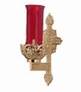](https://images.search.yahoo.com/search/images;_ylt=A0LEV1kSWptXvOwAKINXNyoA;_ylu=X3oDMTEyZGdkcmRoBGNvbG8DYmYxBHBvcwMxBHZ0aWQDQjIwODlfMQRzZWMDc2M-?p=Clipart+of+a+sanctuary+candle&fr=ush-mailn_02&th=110&tw=110&imgurl=http://www.henningers.com/389-168-wall-sanctuary-lamp.jpg&rurl=http://pixshark.com/sanctuary-lamp.htm&size=43KB&name=Sanctuary+Lamp+Bronze+wall+sanctuary+lamp&h=600&w=600&turl=http://ts2.mm.bing.net/th?id=OIP.M68453c67108cdc5ab485d309b395bd03o0&pid=15.1&rs=1&c=1&qlt=95&w=110&h=110#inline&tt=Sanctuary+Lamp+Bronze+wall+sanctuary+lamp&sigr=116keh5le&sigit=13gvlt42j&sigi=11ip0pgm4&sign=119kp6100&sigt=119kp6100)

FR. BRIAN’S MESSAGE ~ Please know of my continued thanks for all who are so faithful to St. Michael Parish. I am more than happy to help in any way I can with any of your spiritual needs. If there is anyone who may be in the need of getting married or have their civil marriage convalidated or in need of a declaration of nullity, I would be more than happy to assist you. Call the parish office, and we can set up an appointment to meet.

*Fr. Brian*

CROSS CATHOLIC OUTREACH VISITING PRIEST ~ Please welcome Rev. Fr. David Fisher who will speak at all the Masses on behalf of Cross Catholic Outreach which was founded to create a meaningful link between parishes in America and the priests and nuns working in the Church overseas in the Caribbean, Africa, Asia, Central and South America. Please be generous in your response to Father’s appeal. Brochures will be provided if you wish to support this worthy Catholic ministry.

Rev. Fr. David Fisher was born and raised in “Buckeye Country”, Columbus, Ohio where he grew up attending Catholic schools and the Pontifical College Josephinum Seminary. He received a Bachelor of Art in Philosophy from Ohio Dominican University and then completed graduate degrees in Theology from the pontifical Gregorian University, while living & receiving formation for the priesthood at the North American College in Rome, Italy. He was ordained to the Diaconate in 1983 and to the Priesthood in 1984 by His Holiness, Saint John Paul II in St. Peter’s Basilica. Father Fisher has served on the faculties of Ohio Dominican University, Columbus State, University of Dayton, Xavier University of Cincinnati, Rosemont College and presently the Byzantine Catholic Seminary of Saints Cyril and Methodius. He has done further research at the Pontifical Gregorian Univ., Eichstatt Univ. in Germany, worked with Oblates of Mary Immaculate in their Swedish missions and was pastor for 5 years of the Maronite Parish Cincinnati, OH. “My work with Cross Catholic Outreach has led me to reflect upon, how the Cross reveals to us the true nature of love, power, richness & sacrifice. It calls us to faith & action, to minister in the name of *the poor man Jesus Christ;* to embrace those who are living images of the Word who became flesh-the poorest of the poor.”

SECOND SUNDAY FOOD COLLECTION ~ This weekend is our Second Sunday Food Collection. Please bring in non-perishable food items or toiletries with you. Monetary donations are also appreciated.

HOLY NAME SOCIETY ~ Will hold their monthly meeting today after the 8:00 AM Mass.

MIRACLE OF LIFE ~ Billboard volunteers will be here July 20th & 21st seeking your continued support in the fight against Abortion. This is our 23rd year of raising Pro-Life billboards and yard signs. We are grateful to parishioners at St. Michael Parish and Fr. Brian for your continued support over these past 23 years. America has lost over 56 Million babies lives through the evil of abortion. Great progress is being made thanks to everyone at St. Michael. THANK YOU for being so kind and generous. Contact: Jerri L. or Hezekiah D. Phillips / 814-736-8426. Miracle of Life/Pro Life Billboard & yard signs, 721 Grant St. / Portage, PA 15946.

KNIGHTS OF COLUMBUS ~ Meeting will be held Thursday, July 18 at 6:00 PM at Most Holy Trinity Church in South Fork, PA.



Religious Education And Christian Helping

July 14, 2019



Vacation Bible School is here:

*Yee Haw: Celebrating God's greatest gift*

Here at St. Michael Parish Hall

July 16, 17 & 18 from 6—8:00 PM

VBS is an opportunity to reach children with God's love. VBS is open to all children ages 4—14. We invite you to join us to share your love of God in a fun, exciting three days of adventure. VBS Registration forms are available on the back table and at the side entrance of the church. Walk-ins are welcome! It’s not too late to attend!

If you would like to share in the fun, and have not registered yet, just call to be added to our list at the Parish Office at 495-9640 or the RE Office at 495-4873.

*************************************************************************

VBS Set-up Night ~ A VBS meeting is scheduled for this Monday, July 15th at 6:00 p.m. We will meet in our Saint Michael Parish Hall and be setting up our Parish Hall and classrooms for our VBS on July 16, 17 & 18. REACH students can earn service credit for attending.

*************************************************************************

Donations still needed:

Snacks: hot dogs/buns; baked beans; wagon wheel pasta; brownie mixes;

Green Hawaiian punch; trail mix or ingredients;

Decorations: (will be returned after VBS-mark your name)

cowboy boots, hats, chaps…; saddle, blanket, bridle, lasso, harness, horseshoes, hay bales, barrels, milk can / buckets, cow bells, western/country theme items

Monetary donations: Place in envelope marked VBS

*************************************************************************

*A GREAT BIG Thank You to all parishioners that have generously donated supplies or made monetary donations, and also those who have*

*purchased chances on our Fleece Blanket which will be chanced off*

*the evening of July 18th at our closing night of VBS.*

DIOCESE of ALTOONA-JOHNSTOWN OFFICE OF CHILD AND YOUTH PROTECTION

ANY PARISH MEMBERS CURRENTLY VOLUNTEERING OR NEW VOLUNTEERS INTERESTED IN VOLUNTEERING WITH YOUTH UNDER THE AGE OF 18 for PARISH FUNCTIONS / COMMITTEES MUST COMPLETE THE FOLLOWING:

Our Diocese of Altoona-Johnstown requirements are that all volunteers be registered with VIRTUS Online and complete the Youth Protection Awareness Training and The Mandated Reporting Training along with the required paperwork. These trainings are both free of charge and available online by going to the Diocese of Altoona-Johnstown website at [www.dioceseaj.org](http://www.dioceseaj.org) and clicking on the Youth Protection Tab. Instructions, paperwork and links to register for these trainings are all available there. All information and paperwork can also be picked up in the Parish Office or the Religious Education Office.

Step Two: In addition, the PENNSYLVANIA CHILD PROTECTIVE SERVICE LAW also requires all Pennsylvania clearances to be obtained for anyone working with our parish children. These clearances are free of charge for all volunteers. All helpers, volunteers and any other adults who wish to help chaperone or mentor our children in any way are required to have and will need these clearances. These links are also included within the instructions under the Youth Protection Icon on the diocesan website listed above. Please contact the Religious Education Office at 495-4873 or the Parish Office at 495-9640 for information and assistance obtaining these clearances.

Once completed, our Parish is then required to have copies of all of these clearances, certificates and paperwork on file in our Parish Office and the Diocesan Youth Protection Office. Your swiftness to complete the clearance process will help assure that we have an adequate number of compliant volunteers able to help with our youth when needed and aid in maintaining a Safe Environment for all of our Parish Children.

TEEN VOLUNTEERS AGES 14 TO 17 / DIOCESE OF ALTOONA-JOHNSTOWN

The following safeguards and guidelines must be followed for minor volunteers (14 to 17 years of age) to be a volunteer with parish youth programming and activities within our Saint Michael Parish. *(NOTE: All Teens planning to work at our Vacation Bible School will need to have this training completed to volunteer.)*

Minor volunteers (non-paid) ages 14-17, do not need their PA clearances, but must review and sign a youth code of conduct with parent/guardian approval and signature; and fill out Youth Protection paperwork. Students need to create an account on VIRTUS Online ([www.virtusonline.org](http://www.virtusonline.org)) and complete the Youth Protection Awareness Training.

Detailed information and paperwork for Teen volunteers can be picked up in the Religious Education Office or the Parish Office.

*Questions regarding any of the above information can be directed to Laurie Sloan in the Religious Education office at 495-4873.*

Sunday, July 14 Second Sunday Food Pantry Collection

Holy Name Society Meeting / After 8:00 AM Mass

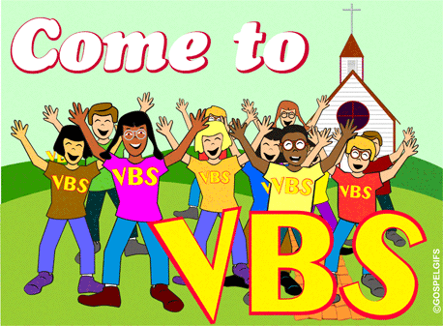 Monday, July 15 VBS Set Up / 6:00 PM

Sunday Choir Practice / 7:00 PM

Tuesday, July 16 VBS / 6:00 – 8:00 PM

Wednesday, July 17 No Mass

VBS / 6:00 – 8:00 PM

Thursday, July 18 Saturday Choir Practice / 4:30 PM

 VBS / 6:00 – 8:00 PM

First Friday, July 19

Saturday, July 20 Miracle of Life Billboard / Donations

UPCOMING EVENTS

July 21 Miracle of Life Billboard / Donations

July 28 Pavilion Rental

August 1 Pavilion / Boy Scout Troop Leaders Meeting

August 2 Hall Rental

NO Adoration

ST. JOAN OF ARC CHURCH ~ Route 53, Frugality, PA (near Prince Gallitzin State Park & Glendale Lake) will be holding their annual Festival, Sunday, July 21st, from 11:00 AM – 6:00 PM, featuring a Turkey & Noodle Dinner. Dinner served 11:00 AM – 3:00 PM. Adults $10, Children 5-12 $5, under 5 free. Take outs available. Music Entertainment, Basket auction at 4:00 PM.

BASKET RAFFLE ~ Holy Family Church 5th St. in Colver is hosting a Basket Raffle on Sunday July 21. Doors open at 4 PM & drawing will begin at 6 PM. There will be 50/50 & “Big Ticket” items. Tickets are $5 a sheet at the door. Please call Lynn Walwro at 814-207-5563, if any questions. Leave a message.

ALL YOU CAN EAT BREAKFAST ~ Queen of Angels Parish in Central City will be hosting an All You Can Eat Breakfast on July 21st from 8:30 AM – 11:00 AM at their St. John Site (162 Wheeler Street). The price is $8 for adults, $4 for children ages 8 – 4, children under 4, free. All are welcome! Proceeds benefit parish religious education activities.

YARD SALE ~ Table Rentals/Space available at Bishop Carroll Cafeteria Saturday, July 27 during the Ebensburg town wide Yard Sale event. $15 each. Call 814-472-7500 ext. 101 or email [sfeidhof@bishopcarroll.org](mailto:sfeidhof@bishopcarroll.org) to reserve a spot.

BASKET PARTY ~ St. Bartholomew Parish, Wilmore. July 28th. Doors open at Noon and drawing of 200 baskets will begin at 2:00 PM. Door Prize: 43” Colored TV. $500 money tree. Dessert & refreshments will be served.