John 6:54

ST. MICHAEL ROMAN CATHOLIC CHURCH

751 Locust Street

PO Box 103

St. Michael, Pennsylvania 15951

Rev. Brian L. Warchola, Administrator MASSES:

(814) 495-9640 Saturday 4:00 pm



Sunday Morning 8:00 am

Secretary: Michele Panick 10:30 am

Bookkeeper: Kathy Kalicky Daily Mass See Bulletin

DRE: Laurie Sloan Holy Days See Bulletin

Maintenance: Rodney Turgeon

Office Hours:

PHONES: 8:30 am to 3:30 pm

Rectory / Office: (814) 495-9640 Monday, Tues., Thurs., Friday

Fax: (814) 495-9424 Confessions:

Rel. Education: (814) 495-4873 Saturday 3:30 pm to 3:45 pm

Parish Website Sunday 7:30 am to 7:45 am

www.saintmichaelchurch.weebly.com 10:00 am to 10:15 am

Secretaries’ E-mail Anytime Requested

[saintmichaelsecretaries@yahoo.com](mailto:saintmichaelsecretaries@yahoo.com)

YEAR: 2019 NUMBER: 29

SERVING GOD AND COMMUNITY FOR OVER ONE HUNDRED YEARS!

July 21, 2019

BAPTISM: By Appointment. Reserve at least one month in advance.

MARRIAGE: Plan at least nine months in advance.

Preparation sessions are necessary.

FUNERALS: Arrangements are made in conjunction with the funeral home.

REGISTRATION Those new to the area, newlyweds, and single adults, (even if registered

and before with their families) are asked to register by calling the Parish Office.

MEMBERSHIP: Every parishioner must be registered. This is a condition for admission

to our Program and reception of the Sacraments of Baptism, Confirmation, First Penance, First Eucharist, and Matrimony; also, for testimonial letters or sponsorship of Baptism and Confirmation outside the Parish.

VISITATION: We are concerned and want to be advised when someone is ill at home or in the hospital. Call the rectory to have the shut-in placed on our monthly Holy Communion calls or seriously ill prayer list.

SACRAMENTAL Parish registration and active Mass participation for Baptism is

POLICY: encouraged and is required for Marriage.

BULLETIN ARTICLES: Articles are due to the Parish Office by Noon on Tuesdays.

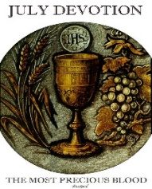

Sixteenth Sunday in Ordinary Time

July 21, 2019

The Precious Blood of Jesus

**MASS INTENTIONS**: (July 22 – July 28, 2019)

Monday 8:00 AM Theresa Podrebarac req. by Robert Podrebarac Family

Tuesday 8:00 AM Kevin Smay req. by Kosmac Family

Wednesday No Mass

Thursday 8:00 AM Rose & Fern Danel req. by Family

Friday 8:00 AM Lois Chapman req. by Jim Bertolino

Saturday 4:00 PM Sam Martin req. by Ed & Karen Myers

Sunday 8:00 AM Verna Yanzetich req. by daughter, Susan

Sunday 10:30 AM People of the Parish

LITURGICIAL APPOINTMENTS:

Saturday, July 27 4:00 PM Offertory Procession

Lector: Amy Spinos Ed & Karen Myers

Minister of the Host: Susan Blazosky

Minister of the Cup: Vince Arena & Babe Richards

Altar Servers: Ana Spangler & Natalie Stohon

Cantor: Amy Spangler

Greeter: Darlene Marshall

Sunday, July 28 8:00 AM Offertory Procession

Lector: Arnold Bernard Verna Yanzetich Family

Minister of the Host: Cathy Faher

Minister of the Cup: Marie Jo Plummer & Sally Kolar

Altar Servers: Griffen & Kaden Christ

Cantor: Susan Yanzetich

Greeter: Lori George

Sunday, July 2810:30 AM Offertory Procession

Lector: Michael Barton Cheryl & Deborah Macy

Minister of the Host: Charlotte Crissey

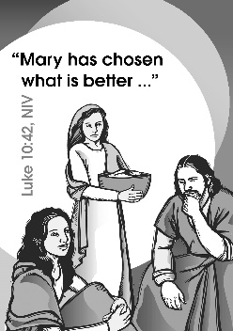Minister of the Cup: Susan Wieczorek & Terry Crissey

Altar Servers: Colby Rearick, Ian Dobbins & Noah Eppley

Cantor: Elizabeth Dobbins

Greeter: Wendy Blough

Sunday, July 28 Collection Counters

John Bizzarri, Rod Kundrod

Phyllis Slonac

Weare placing names of the sick in the bulletin for prayer providing they give permission. *May the* *Divine Physician send healing grace for those for* *whom we pray:* Allen C. Rosemas, Patricia Murphy, Bernice Myers, Dwight Fyock, Dylon Wills, Missy, Joanne (Kolar) Hufford, Christine Flanagan, Ayden Alan Grata, Mary Lou Offman, Mary Zangaglia, Dorothy Rosemas, Natalie Zerby, Patricia Grata, Michael Wadsworth, Valencia & Frank Tursi, Homer Locher, Brayden Schofield, Michelle Kasper, Diane Kingera, Allison Krischer, Ted Paluch, Brandt Hutzel, Pearl Litzinger, Patrick Munro, Fran Baldassarre, Kristen Sinosky Long, Helen Ranieri, Cresta Micik, Basil Costantino, Madison McCrory, Laura, Joe Yoder, Dolores Yanzetich, Sandy Krug, Wanda Gramling, Merna Smay, Agnes Plummer, Jennifer Hagans, Shawn, Holly, Shane, Spencer, Owen Taylor, Keith & Dawnetta Hoyer, Derrick Varnish, Vincent Koshute, Melissa Cordek, Michelle Elliott, Heather Romanow, Mackston Barrick, Connor Thomas, Erin, Pat, Mary Agnes Nastase, Mary Ann Bertolino, Dick Wilson, Izzy Bihun, Erica Mitzelfeld, Dorothy Kaminsky, Patricia Oshaben, Ashlee Madison, Susan Yanzetich, Mike, Danika Faith, Alina Rusnak, Marcia Costlow, Gary Smay, Elizabeth Howell, Helen Bowen, Walter Bodziak, Rhonda, Dan Strinkoski, Anne Robinson, Marlene McCrory, Sharon Poldiak, Carter Bobak, Vince Arena, Mike Morris, Sarah Kelt, Patty Yanzetich Caldwell, Colton Snyder, Betty Delaney, Nancy Edmiston, Elizabeth Stoker Thomas, Albert Sracic, Joseph Ropecka, Bill Krajewski, Leonard Oshaben, Florence Smith, Michael Chalan Jr., Adam, Bill Gideos, Theressa Stravinsky, Janice Dipyatic, Martha, John Poldiak Jr., Gerald Delaney, Lily Maloney and all of the sick of our parish, the homebound, those in nursing homes, those who care for them, and those in the military along with their families. *(Please call the Rectory to have your name removed from the list when no longer seriously ill. Thank You.)*



LAST WEEK’S COLLECTION

Adults $3,514.00

Loose $ 168.00

Youth $ 24.00

Monthly $ 580.00

Candles $ 6.00

Maintenance $ 30.00

Catholic Register Sub. $ 48.00

Feast of the Assumption $ 5.00

Peter’s Pence (Holy Father) $ 5.00

Total $4,380.00

We sincerely thank and ask God’s

blessing upon all who have

care and concern

for our parish.

July 21, 2019 Luke 10:38-42

In today’s gospel Martha planned to visit with Jesus after her work was done. If Jesus were to visit your home today, what would he say distracts you from giving more attention to family and friends?

ST. ANNE TRIDUUM ~ A triduum in honor of St. Anne will be held July 24, 25, & 26 at St. John Gualbert Cathedral, 117 Clinton St., Johnstown. Mass and devotions will be held at 7 PM each evening with confessions following mass.

OFFICE OF ADULT ENRICHMENT AND LAY ECCLESIAL MINISTRY ~ Has announced classes for 2019-2020 which begin this fall. For class information and registration forms, please visit us online at [www.dioceseaj.org/lay-ecclesial-ministry/](http://www.dioceseaj.org/lay-ecclesial-ministry/) or contact us directly at 814-361-2000 or by email at [mheinze@dioceseaj.org](mailto:mheinze@dioceseaj.org). All are welcome!

OUTDOOR MASS FOR NEWLY GRADUATED ~ The annual outdoor Mass for students entering or returning to college will be celebrated on August 4 at 7 PM at the Our Lady of the Alleghenies Shrine in Loretto. Bishop Mark L. Bartchak will be the celebrant and homilist. All college students, as well as 2019 high school graduates who are entering the military or workforce, are invited with their family. The Bishop will offer a special blessing to the students, words of wisdom, and a small gift. Bring your own lawn chair. If it rains, the Liturgy will be celebrated inside the Basilica of Saint Michael the Archangel next to the Shrine.

PADRE PIO FAMILY FEST ~ At St. John the Baptist New Baltimore. All are invited to New Baltimore on Sunday, September 8 for an exciting program of prayer, music, games & food. There will be an outdoor Mass at noon. During the afternoon there will be music & games. At 5 PM there will be a healing prayer service in honor of Padre Pio. Relics of Padre Pio, including a glove he wore and blood from his stigmata will be available for veneration. The Fest is sponsored by the Capuchin Franciscan Friars.

VBS FLEECE BLANKET ~ Unfortunately the VBS “Yee Haw” fleece blanket has disappeared. Fr. Brian has reported the “possible theft” to the Adams Township Police. The drawing has already occurred, and the winner will be notified and receive something in its place.

*Stewardship Reflections…*

Martha was too busy to recognize the importance of Jesus’ presence. Mary was a good steward of her time, choosing to pause and listen to Him. Without spiritual nourishment our lives become unbalanced. May we learn from Mary the gift of listening and then share with Martha the message of how to grow in faith and the love of Jesus. “The Challenge, then, is to understand our role (our vocation) and to respond generously to this call from God. Christian vocation entails the practice of stewawrdship. In addition, Christ calls each of us to be stewards of our personal vocation, which we receive from God.” (*Stewardship: A Disciples’ Response,* U.S. Bishop’s Pastoral Letter, 1992)

Catholic Ministries Drive $26,768.00

Raised: $ 8,588.00

Balance: $18,180.00

Number of responses: 66



Thank you to all parishioners who have responded to the *2019 Catholic Ministries Drive.* Please join them in supporting our Parish and a select group of ministries that provide outreach to the poor, family life, youth and seminarians. If you did not receive a pledge card in the mail, you may give online at [www.dioceseaj.org](http://www.dioceseaj.org).

The Sanctuary Candle will burn in memory of

Terry McClemens

requested by wife Kathy, children

and grandchildren

during the week of July 21st, 2019.

[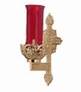](https://images.search.yahoo.com/search/images;_ylt=A0LEV1kSWptXvOwAKINXNyoA;_ylu=X3oDMTEyZGdkcmRoBGNvbG8DYmYxBHBvcwMxBHZ0aWQDQjIwODlfMQRzZWMDc2M-?p=Clipart+of+a+sanctuary+candle&fr=ush-mailn_02&th=110&tw=110&imgurl=http://www.henningers.com/389-168-wall-sanctuary-lamp.jpg&rurl=http://pixshark.com/sanctuary-lamp.htm&size=43KB&name=Sanctuary+Lamp+Bronze+wall+sanctuary+lamp&h=600&w=600&turl=http://ts2.mm.bing.net/th?id=OIP.M68453c67108cdc5ab485d309b395bd03o0&pid=15.1&rs=1&c=1&qlt=95&w=110&h=110#inline&tt=Sanctuary+Lamp+Bronze+wall+sanctuary+lamp&sigr=116keh5le&sigit=13gvlt42j&sigi=11ip0pgm4&sign=119kp6100&sigt=119kp6100)

FR. BRIAN’S FAREWELL ~ My good and holy people of St. Michael Parish. I want to start off by thanking all of you for your prayerful support, faithfulness, and dedication. I often tell people the most difficult part of being a priest is transfers. I’ve loved every parish and assignment I’ve been in, and I am looking forward to my new assignment as Pastor of Holy Name in Ebensburg, but leaving St. Michael is difficult in many ways. Thanks be to God, so many good things have taken place here for example, First Friday Eucharistic Adoration, priests’ picnic, the Catholic Rally, the scouting program, etc., etc. Also, we were honored to celebrate our Fire Department and Veterans.

Thanks to financial contributions and faithful volunteers, we were able to paint our parish buildings and Statue of Jesus, as well as other renovations. We began a fitness program at St. Michael like SoulCore and so many other memorable moments.

I’m amazed at the countless number of faithful volunteers and parishioners who commit themselves to Faith and Fellowship. I am eternally grateful to my staff, parishioners, and the entire St. Michael Community. This parish will forever remain in my heart and soul. Please pray for me, Msgr. Lockard and the entire Church, so that we can build up The Kingdom of Heaven on earth. Know of my continued love, prayers, and support for all of you. Once again, thank you all so much, and may Almighty God continue to bless you now and always!

*Fr. Brian*

[](http://www.churchart.com/subscriber/viewimages.aspx?keywords=In%20Sympathy&entry_date=1/1/0001&image_type=,cl#no)MAY SHE REST IN PEACE ~ In your charity, please pray for the eternal rest of Ann Novak whose Funeral Mass was celebrated on Wednesday, July 17th, 2019 by Fr. Brian Warchola. May she know the eternal peace and happiness promised by our Savior, Lord Jesus. Please pray for the consolation of all her family and friends.

SECOND SUNDAY FOOD COLLECTION ~ Thank you to all who so generously donated to the Forest Hills Food Pantry. The total money collected was $493.00 and an assortment of non-perishable items.

FAMILY OF THE MONTH ~ The family of Anthony Bambino has been selected as the June Family of the Month for Council 2275. Anthony and wife Sandra have 5 children and have been married for 25 years. They are a close family spending many hours of quality time together. Sandra and Anthony have been members of St. Michael Church for 20 years and are lectors. Both being teachers, their students get a chance to copy and put into practice many of their values which will last the students a lifetime.

MIRACLE OF LIFE ~ Billboard volunteers will be here this weekend, July 20th & 21st seeking your continued support in the fight against Abortion. This is our 23rd year of raising Pro-Life billboards and yard signs. We are grateful to parishioners at St. Michael Parish and Fr. Brian for your continued support over these past 23 years. America has lost over 56 Million babies lives through the evil of abortion. Great progress is being made thanks to everyone at St. Michael. THANK YOU for being so kind and generous. Contact: Jerri L. or Hezekiah D. Phillips / 814-736-8426. Miracle of Life/Pro Life Billboard & yard signs, 721 Grant St. / Portage, PA 15946.



Religious Education And Christian Helping

July 21, 2019

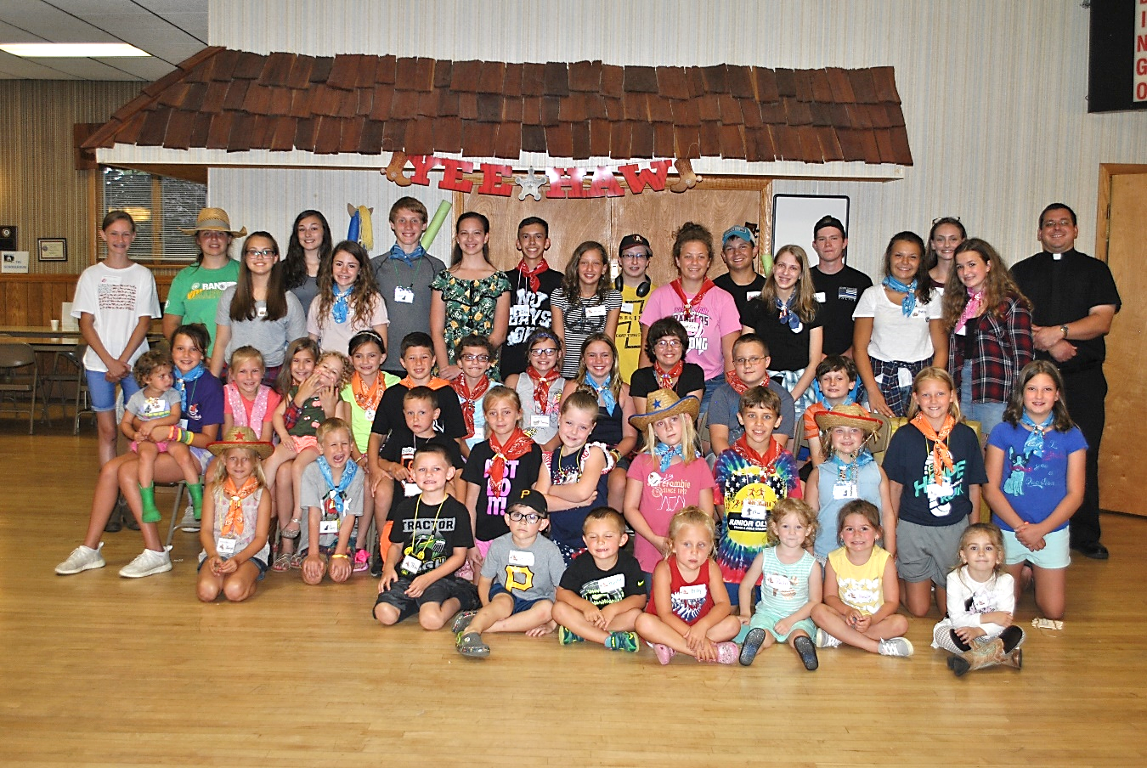



YEE HAW

Vacation Bible School 2019

How-dee! We had a swash buckling good time at Vacation Bible School this year. Pictured above in the front three rows are all the buckaroos that came to hear about God’s Greatest Gift of all—Jesus! Yee-Haw! In the back row are all our hard working ranch-hands that help coral all our trailblazers for this exciting 3-day adventure.

*A GREAT BIG Thank You also goes out to ALL our adult volunteers that lead our Moosic & More, Bible Adventures, Saddle Up Sports, Projects with a Purpose and our Closing Corral, and a lot of behind the scenes people too! Thank You, Thank You! We had such an awesome adventure on the Ranch.*

*See Ya’ll next year! YEE-HAW!*

DIOCESE of ALTOONA-JOHNSTOWN OFFICE OF CHILD AND YOUTH PROTECTION

ANY PARISH MEMBERS CURRENTLY VOLUNTEERING OR NEW VOLUNTEERS INTERESTED IN VOLUNTEERING WITH YOUTH UNDER THE AGE OF 18 for PARISH FUNCTIONS / COMMITTEES MUST COMPLETE THE FOLLOWING:

Our Diocese of Altoona-Johnstown requirements are that all volunteers be registered with VIRTUS Online and complete the Youth Protection Awareness Training and The Mandated Reporting Training along with the required paperwork. These trainings are both free of charge and available online by going to the Diocese of Altoona-Johnstown website at [www.dioceseaj.org](http://www.dioceseaj.org) and clicking on the Youth Protection Tab. Instructions, paperwork and links to register for these trainings are all available there. All information and paperwork can also be picked up in the Parish Office or the Religious Education Office.

Step Two: In addition, the PENNSYLVANIA CHILD PROTECTIVE SERVICE LAW also requires all Pennsylvania clearances to be obtained for anyone working with our parish children. These clearances are free of charge for all volunteers. All helpers, volunteers and any other adults who wish to help chaperone or mentor our children in any way are required to have and will need these clearances. These links are also included within the instructions under the Youth Protection Icon on the diocesan website listed above. Please contact the Religious Education Office at 495-4873 or the Parish Office at 495-9640 for information and assistance obtaining these clearances.

Once completed, our Parish is then required to have copies of all of these clearances, certificates and paperwork on file in our Parish Office and the Diocesan Youth Protection Office. Your swiftness to complete the clearance process will help assure that we have an adequate number of compliant volunteers able to help with our youth when needed and aid in maintaining a Safe Environment for all of our Parish Children.

TEEN VOLUNTEERS AGES 14 TO 17 / DIOCESE OF ALTOONA-JOHNSTOWN

The following safeguards and guidelines must be followed for minor volunteers (14 to 17 years of age) to be a volunteer with parish youth programming and activities within our Saint Michael Parish. *(NOTE: All Teens planning to work at our Vacation Bible School will need to have this training completed to volunteer.)*

Minor volunteers (non-paid) ages 14-17, do not need their PA clearances, but must review and sign a youth code of conduct with parent/guardian approval and signature; and fill out Youth Protection paperwork. Students need to create an account on VIRTUS Online ([www.virtusonline.org](http://www.virtusonline.org)) and complete the Youth Protection Awareness Training.

Detailed information and paperwork for Teen volunteers can be picked up in the Religious Education Office or the Parish Office.

*Questions regarding any of the above information can be directed to Laurie Sloan in the Religious Education office at 495-4873.*

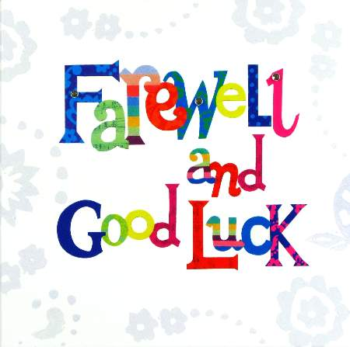 Sunday, July 21 Miracle of Life Billboard / Donations

Monday, July 22 Martha’s Group / 6:00 PM

Sunday Choir Practice / 7:00 PM

Tuesday, July 23

Wednesday, July 24 No Mass

Thursday, July 25 Saturday Choir Practice / 4:30 PM



Friday, July 26

Saturday, July 27

UPCOMING EVENTS

July 28 Pavilion Rental

August 1 Boy Scout Troop Leaders Meeting / Pavilion

August 2 NO Adoration

Hall Rental

Red Cross Blood Drive

August 15 Assumption of the Blessed Virgin Mary / Holy Day of Obligation

Offices Closed

Knights of Columbus Meeting / Pavilion

ST. JOAN OF ARC CHURCH ~ Route 53, Frugality, PA (near Prince Gallitzin State Park & Glendale Lake) will be holding their annual Festival, Sunday, July 21st, from 11:00 AM – 6:00 PM, featuring a Turkey & Noodle Dinner. Dinner served 11:00 AM – 3:00 PM. Adults $10, Children 5-12 $5, under 5 free. Take outs available. Music Entertainment, Basket auction at 4:00 PM.

BASKET RAFFLE ~ Holy Family Church 5th St. in Colver is hosting a Basket Raffle on Sunday July 21. Doors

open at 4 PM & drawing will begin at 6 PM. There will be 50/50 & “Big Ticket” items. Tickets are $5 a sheet at the door. Please call Lynn Walwro at 814-207-5563, if any questions. Leave a message.

YARD SALE ~ Indoor yard sale at Bishop Carroll Cafeteria on July 27th from 8 AM – 3 PM. Rain or Shine. Multiple

Families. Hot Lunch, Drinks, Bake Sale & Basket Raffle. Table Rental space still available at $15 each. Call 472-7500 ext. 101 or email [sfreidhof@bishopcarroll.org](mailto:sfreidhof@bishopcarroll.org)

BASKET PARTY ~ St. Bartholomew Parish, Wilmore. July 28th. Doors open at Noon and drawing of 200 baskets

will begin at 2:00 PM. Door Prize: 43” Colored TV. $500 money tree. Dessert & refreshments will be served.

CAR CRUISE – BLOCK PARTY ~ On Saturday July 28th Queen of Angels Parish in Central City will sponsor their third annual Block Party and Classic and Antique Car Cruise from 1 PM – 5 PM at the St. John site. A band will be playing live oldies music from 2 – 5 PM. All who have a classic or antique car, or those who simply take pleasure in music and an evening out are welcome to come and enjoy a day of cars, food, and camaraderie. All proceeds will benefit Michelle Moore, a local community member battling cancer. Any questions can be directed to the parish office at 814-754-5224.