ST. MICHAEL ROMAN CATHOLIC CHURCH

751 Locust Street

PO Box 103

St. Michael, Pennsylvania 15951

Rev. Msgr. David A. Lockard, Administrator MASSES:

(814) 495-9640 Saturday 4:00 pm



Sunday Morning 8:00 am

Secretary: Michele Panick 10:30 am

Bookkeeper: Kathy Kalicky Daily Mass: M, T, Th, F Noon

DRE: Laurie Sloan Wed. 6:00 pm

Maintenance: Rodney Turgeon Holy Days: See Bulletin

PHONES: Office Hours:

Rectory / Office: (814) 495-9640 8:30 am to 3:30 pm

Fax: (814) 495-9424 Monday, Tues., Thurs., Friday

Rel. Education: (814) 495-4873 Confessions:

Parish Website Saturday 3:30 pm to 3:45 pm www.saintmichaelchurch.weebly.com Sunday 10:00 am to 10:15 am

Secretaries’ E-mail By Appointment

[saintmichaelsecretaries@yahoo.com](mailto:saintmichaelsecretaries@yahoo.com)

Facebook page:

St. Michael Catholic Church/St. Michael, PA

26thSunday in Ordinary Time

SERVING GOD AND COMMUNITY FOR OVER ONE HUNDRED YEARS!

September 27th, 2020

BAPTISM: By Appointment. Reserve at least one month in advance.

MARRIAGE: Plan at least nine months in advance.

Preparation sessions are necessary.

FUNERALS: Arrangements are made in conjunction with the funeral home.

REGISTRATION Those new to the area, newlyweds, and single adults, (even if registered

and before with their families) are asked to register by calling the Parish Office.

MEMBERSHIP: Every parishioner must be registered. This is a condition for admission

to our Program and reception of the Sacraments of Baptism, Confirmation,

First Penance, First Eucharist, and Matrimony; also, for testimonial letters or sponsorship of Baptism and Confirmation outside the Parish.

VISITATION: We are concerned and want to be advised when someone is ill at home or in the hospital. Call the office to have the shut-in placed on our monthly Holy Communion calls or seriously ill prayer list.

SACRAMENTAL Parish registration and active Mass participation for Baptism is

POLICY: encouraged and is required for Marriage.

BULLETIN ARTICLES: Articles are due to the Parish Office by Noon on Tuesday.

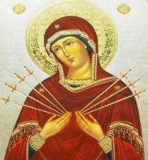 Twenty – Sixth Sunday in Ordinary Time

September 27th, 2020

The Month of the Seven Dolors of the Sorrowful Mother

**MASS INTENTIONS**: (September 28 – October 4, 2020)

Monday Noon Charlene Kusher req. by Matilda Blozevich

Tuesday Noon Katherine Demko req. by Camillus & Betty Long

Wednesday 6:00 PM Ed Yauneridge req. by Mom & Dad

Thursday Noon Helen McClemens req. by Kathy McClemens

Friday Noon Martin Walat req. by Sondre Harteis

Saturday 4:00 PM People of the Parish

Sunday 8:00 AM Evelyn Shay req. by Cathy & Joe Faher

10:30 AM Mary Lou Yourich req. by Grandchildren; Elizabeth & Ian Dobbins

LITURGICIAL APPOINTMENTS:

Saturday, October 3 4:00 PM

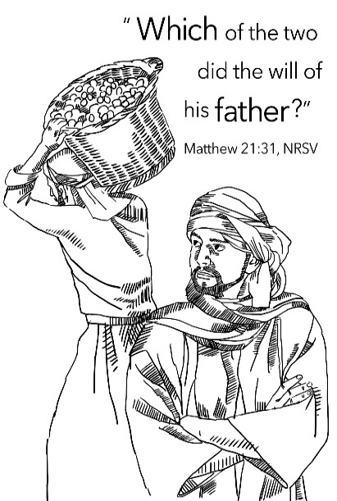Lector: Susan Poldiak

Minister of the Host: Babe Richards

Altar Server: Alex Bambino

Cantor: Susan Blazosky

Sunday, October 4 8:00 AM

Lector: Amy Spinos

Minister of the Host: Pauline Minor

Altar Server: Natalie Stohon

Cantor: Sharon Dibble

Sunday, October 4 10:30 AM

Lector: Jacob Stiffler

Minister of the Host: Jennifer Steele

Altar Server: Ian Dobbins

Cantor: Amy Dobbins

Sunday, October 4 Collection Counters

Chris Smay, Sara Zybura

Mary Ann DeRosa

Weare placing names of the sick in the bulletin for prayer providing they give permission. *May the* *Divine Physician send healing grace for those for* *whom we pray:* Allen C. Rosemas, Patricia Murphy, Bernice Myers, Dwight Fyock, Dylon Wills, Missy, Joanne (Kolar) Hufford, Christine Flanagan, Ayden Alan Grata, Mary Lou Offman, Mary Zangaglia, Natalie Zerby, Valencia Tursi, Homer Locher, Brayden Schofield, Michelle Kasper, Diane Kingera, Allison Krischer, Ted Paluch, Brandt Hutzel, Pearl Litzinger, Patrick Munro, Fran Baldassarre, Kristen Sinosky Long, Cresta Micik, Basil Costantino, Madison McCrory, Laura, Joe Yoder, Dolores Yanzetich, Sandy Krug, Wanda Gramling, Jennifer Hagans, Shawn, Holly, Shane, Spencer, Owen Taylor, Keith & Dawnetta Hoyer, Derrick Varnish, Vincent Koshute, Melissa Cordek, Michelle Elliott, Heather Romanow, Mackston Barrick, Connor Thomas, Erin, Pat, Mary Agnes Nastase, Mary Ann Bertolino, Dick Wilson, Izzy Bihun, Dorothy Kaminsky, Patricia Oshaben, Ashlee Madison, Susan Yanzetich, Mike, Danika Faith, Alina Rusnak, Gary Smay, Elizabeth Howell, Walter Bodziak, Rhonda, Dan Strinkoski, Anne Robinson, Marlene McCrory, Sharon Poldiak, Carter Bobak, Vince Arena, Mike Morris, Sarah Kelt, Patty Yanzetich Caldwell, Colton Snyder, Betty Delaney, Nancy Edmiston, Leonard Oshaben, Adam, Bill Gideos, Janice Dipyatic, Gerald Delaney, Lily Maloney, Scott, Lisa, Rosalie Ambrose, Audrey Costlow, Cathy Sossong, Rosanne Krug, Paul Snyder, Becky Kakabar, Catherine Tedjeske, Pua Ripper, Howard Delaney, Alivia Ickes, John Poldiak Jr., Ed Myers, Dolores Mucko, Tom Vandzura, Elliana, Ashlee, Helen Soohy and all of the sick of our parish, the homebound, those in nursing homes, those who care for them, and those in the military along with their families. *(Please call the Rectory to have your name removed from the list when no longer seriously ill. Thank You.)*

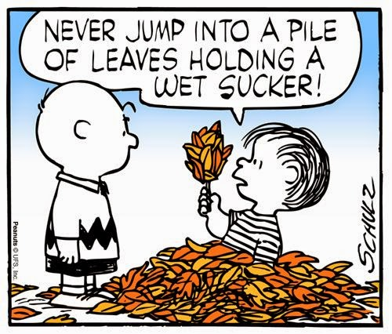

LAST WEEK’S COLLECTION

Adults $2,495.00

Loose $ 67.00

Youth $ 18.00

Monthly $1,066.00

Candles $ 23.00

Maintenance Fund $ 25.00

Religious Ed. Fund $ 150.00

Retired Priests Med. $ 55.00

Total $3,899.00

We sincerely thank and

ask God’s blessing upon

all who have care and

concern for our parish.

*September 27th, 2020 (MT 21:28-32)*

*In today’s gospel Jesus asked, “What is your opinion?” Why do we think our opinion is dogma or fact? An opinion is only how we perceive a situation or how we feel comfortable doing something. Don’t argue over or become divided by “your opinion.”*

[](https://images.search.yahoo.com/search/images;_ylt=A0LEV1kSWptXvOwAKINXNyoA;_ylu=X3oDMTEyZGdkcmRoBGNvbG8DYmYxBHBvcwMxBHZ0aWQDQjIwODlfMQRzZWMDc2M-?p=Clipart+of+a+sanctuary+candle&fr=ush-mailn_02&th=110&tw=110&imgurl=http://www.henningers.com/389-168-wall-sanctuary-lamp.jpg&rurl=http://pixshark.com/sanctuary-lamp.htm&size=43KB&name=Sanctuary+Lamp+Bronze+wall+sanctuary+lamp&h=600&w=600&turl=http://ts2.mm.bing.net/th?id%3DOIP.M68453c67108cdc5ab485d309b395bd03o0%26pid%3D15.1%26rs%3D1%26c%3D1%26qlt%3D95%26w%3D110%26h%3D110#inline&tt=Sanctuary+Lamp+Bronze+wall+sanctuary+lamp&sigr=116keh5le&sigit=13gvlt42j&sigi=11ip0pgm4&sign=119kp6100&sigt=119kp6100)

During the week of September 27th, 2020

the Sanctuary Candle will burn for the

Sick and Shut Ins of Our Parish

[](http://www.churchart.com/subscriber/viewimages.aspx?keywords=In%20Sympathy&entry_date=1/1/0001&image_type=,cl#no)

MAY HE REST IN PEACE ~ In your charity, please pray for the eternal rest of Derek Yoder whose funeral service was held on Saturday September 26th, 2020. May he know the eternal peace and happiness promised by our Savior, Lord Jesus. Please pray for the consolation of all his family and friends.

LITURGY COMMITTEE MEETING ~ There will be a Liturgy Committee meeting next Sunday, October 4th after the 10:30 AM Mass upstairs in the Church Hall. An agenda has been sent out. If you cannot attend, please call the parish office.

FIRST FRIDAY ~ Exposition of the Blessed Sacrament will be First Friday, October 2nd with adoration from 12:30 PM until 2:30 PM. Please follow the churches guidelines for social distancing.

BOOKKEEPING POSITION ~ If you are interested in the bookkeeping position at St. Michael Parish, you need to contact the parish office and give us your name and qualifications. This is a sixteen hour a week job (more or less). We will be happy to go over the salary and responsibilities with interested applicants.

WEEKEND MASS ~ There are now TWO Sunday Masses – 8:00 AM and 10:30 AM with Confession at 10:00 AM in the Sacristy, and the 4:00 PM Mass on Saturday with Confession at 3:30 PM in the Sacristy.

PRIESTS MEDICAL & RETIREMENT COLLECTION ~ This weekend, there will be a second collection basket for the medical and retirement needs of our diocesan priests. Your generous response will provide relief to the men who bring us closer to Christ through worship, service, and community. Please use the special envelope provided in your packet or donate online through the diocese’s website at [www.dioceseaj.org/ways-to-give/](http://www.dioceseaj.org/ways-to-give/). Thank you.

TREASURY TICKETS ~ Please remember that our treasury tickets begin on Thursday, October 1st, 2020. All ticket stubs, money & unsold tickets must be turned in by Wednesday, September 30th, 2020. Watch the Pennsylvania Lottery Evening Pick Three Drawing for the winning numbers.



Religious Education And Christian Helping

September 27, 2020

Religious Education News

Religious Education is underway for our 2020 / 2021 Religious Education Year. We have officially started our fall semester with a Home-Schooling module. Distribution of Lesson packets took place in the Parish Pavilion for our Grades K—5 Families on Thursday, September 24th.

Our students in Grades 6—11 Families pick up is Sunday, September 27, 9:00 a.m. to 10:00 a.m.

Anyone who may have missed either of these pick-up times can contact the RE Office at

495-4873 or the Parish Office at 495-9640 to make arrangements for another pick-up time.

Registration packets were mailed out to all families that are currently registered members of our Saint Michael Parish and have school-aged children. Envelopes contain a new registration form and other pertinent forms for our 2020 / 2021 Religious Education Year. Registration are still being accepted. If you have not yet returned your family RE registration forms, please do so. Completed forms are required before participation in our parish program. If you did not receive a mailing, and wish to receive one contact the office with your request.

*******************************************************************************************************************

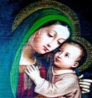ANNUAL MARIAN CELEBRATION FAMILY MASS AND ROSARY ~ Sunday, October 4th at 3:00 PM. *Our Mother of Good Council in a Time of Pandemic.* Principal Celebrant, Bishop Mark Bartchak. St. Benedict Church, 2310 Bedford St. Johnstown, PA 15904. Masks and Social Distancing will be required.

*Stewardship Reflections…*

Stewards of God’s gifts are not passive beneficiaries according to today’s Gospel parable, putting into practice a life of discipleship and stewardship is what counts, “actions speak louder than words.” We are obliged to be stewards of the Church, collaborators and cooperators in continuing the redemptive work of Jesus Christ, which is the Church’s essential mission. This mission, proclaiming and teaching, serving and sanctifying, is our task. It is the personal responsibility of each one of us as stewards of the Church. All members of the Church have their own roles to play in carrying out its mission: parents parishioners, all Catholics as members of diocesan families, and to the Universal Church. Try to make an action plan to fulfill your role as we enter into fall.

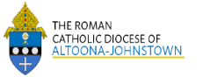 Sunday, September 27 Mass ~ 8:00 & 10:30 AM

Confessions / 10:00 – 10:15 AM ONLY / Sacristy

Priests Medical & Retirement Collection

Grades 6-11 RE Lesson packet distribution / Pavilion / 9:00 – 10:00 AM

Monday, September 28 Mass ~ Noon

NO Sunday Choir Practice



Tuesday, September 29 Mass ~ Noon

Boy Scout Meeting / 7:30 – 9:00 PM

Wednesday, September 30 Mass ~ 6:00 PM

Thursday, October 1 Mass ~ Noon

NO Saturday Choir Practice

Friday, October 2 Mass ~ Noon

Exposition of the Blessed Sacrament with Adoration / 12:30 – 2:30 PM

Saturday, October 3 Mass / 4:00 PM

Confessions / 3:30 – 3:45 / Sacristy

 UPCOMING EVENTS

October 12 Columbus Day / Parish Offices Closed

October 17 & 18 World Mission Sunday Collection

BBQ CHICKEN DINNER ~ St. Demetrius Church in Gallitzin, PA will be holding their Famous BBQ Chicken Dinner on Sunday, Sept. 27th, as a Drive-thru/Pick-up Dinner only. Cost: $10/dinner will include their Delicious ½ BBQ Chicken, 2-Sides and Dessert. Dinners will be available from11:00 AM until sold out. Come and get one of the best Chicken BBQ Dinners in the area! Please note this is a Drive-up dinner only. No festival will be held this year due to coronavirus guidelines. Enter via the Activities Center driveway below 611 Church St., obtain your meals, and exit onto Convent St.

WINE WALK ~ Saturday, Oct. 31st. Walk begins at 10 AM at BCCHS. $20 registration fee. $25 registration fee including exclusive 2020 Wine Walk t-shirt-limited to first 250 participants. Pre-purchase wine from these wineries and have them delivered the day of the walk: Groundhog Winery, Germantown Winery, Laurel Mountain Winery, Winery at Wilcox Shadow Vineyard. Optional costume contest with prizes. Food trucks will be on hand for lunch as well as crafters. Register by calling 814-472-7500. More information at [www.bishopcarroll.com](http://www.bishopcarroll.com)



CARROLL CLASSIC GOLF TOURNAMENT ~ Saturday, Oct. 17th. 12:15 PM Registration, 1:00 PM shotgun. Summit Country Club in Cresson. 4-person scramble, $125 per golfer. Cart & tournament sponsorships available. Picnic dinner. Tournament and skill prizes. For more information or to register a team, please call 814-472-7500 or email [jnagy@bishopcarroll.org](mailto:jnagy@bishopcarroll.org)