ST. MICHAEL ROMAN CATHOLIC CHURCH

751 Locust Street

PO Box 103

St. Michael, Pennsylvania 15951

Rev. Msgr. David A. Lockard, Administrator MASSES:

(814) 495-9640 Saturday 4:00 pm



Sunday Morning 9:30 am

Secretary: Michele Panick

Bookkeeper: Kathy Kalicky Daily Mass: M, T, Th, F Noon

DRE: Laurie Sloan Wed. 6:00 pm

Maintenance: Rodney Turgeon Holy Days: See Bulletin

PHONES: Office Hours:

Rectory / Office: (814) 495-9640 8:30 am to 3:30 pm

Fax: (814) 495-9424 Monday, Tues., Thurs., Friday

Rel. Education: (814) 495-4873 Confessions:

Parish Website Saturday 3:30 pm to 3:45 pm www.saintmichaelchurch.weebly.com Sunday 9:00 am to 9:15 am

Secretaries’ E-mail By Appointment

[saintmichaelsecretaries@yahoo.com](mailto:saintmichaelsecretaries@yahoo.com)

Facebook page:

St. Michael Catholic Church/St. Michael, PA

23rd Sunday in Ordinary Time

SERVING GOD AND COMMUNITY FOR OVER ONE HUNDRED YEARS!

September 6th, 2020

BAPTISM: By Appointment. Reserve at least one month in advance.

MARRIAGE: Plan at least nine months in advance.

Preparation sessions are necessary.

FUNERALS: Arrangements are made in conjunction with the funeral home.

REGISTRATION Those new to the area, newlyweds, and single adults, (even if registered

and before with their families) are asked to register by calling the Parish Office.

MEMBERSHIP: Every parishioner must be registered. This is a condition for admission

to our Program and reception of the Sacraments of Baptism, Confirmation,

First Penance, First Eucharist, and Matrimony; also, for testimonial letters or sponsorship of Baptism and Confirmation outside the Parish.

VISITATION: We are concerned and want to be advised when someone is ill at home or in the hospital. Call the office to have the shut-in placed on our monthly Holy Communion calls or seriously ill prayer list.

SACRAMENTAL Parish registration and active Mass participation for Baptism is

POLICY: encouraged and is required for Marriage.

BULLETIN ARTICLES: Articles are due to the Parish Office by Noon on Tuesday.

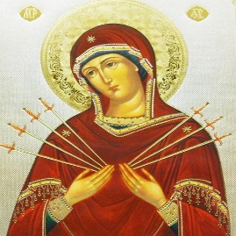 Twenty - Third Sunday in Ordinary Time

September 6th, 2020

The Month of the Seven Dolors of the Sorrowful Mother

**MASS INTENTIONS**: (September 7 – September 13, 2020)

Monday Noon Florence Smith req. by James Bertolino & Family

Tuesday Noon Kevin Smay req. by John & Susan Poldiak

Wednesday 6:00 PM Theressa Stravinsky req. by Jon & Irene Gindlesperger

Thursday Noon Arleen Diamond req. by sister, Helen McClemens

Friday Noon Francis Ritz req. by St. Michael Funeral Committee

Saturday 4:00 PM People of the Parish

Sunday 9:30 AM Verna Yanzetich req. by daughter, Susan

LITURGICIAL APPOINTMENTS:

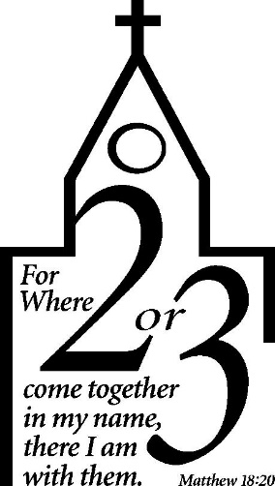

Saturday, September 12 4:00 PM

Lector: Don Dipko

Minister of the Host: Alice Podrebarac

Altar Server: Dylan Kundrod

Cantor: Susan Blazosky

Sunday, September 13 9:30 AM

Lector: Arnold Bernard

Minister of the Host: Marie Bernard

Altar Server: Ian Dobbins

Cantor: Sharon Dibble

Sunday, September 13 Collection Counters

Christine Smay, Sara Zybura

Mary Ann DeRosa

Weare placing names of the sick in the bulletin for prayer providing they give permission. *May the* *Divine Physician send healing grace for those for* *whom we pray:* Allen C. Rosemas, Patricia Murphy, Bernice Myers, Dwight Fyock, Dylon Wills, Missy, Joanne (Kolar) Hufford, Christine Flanagan, Ayden Alan Grata, Mary Lou Offman, Mary Zangaglia, Natalie Zerby, Valencia Tursi, Homer Locher, Brayden Schofield, Michelle Kasper, Diane Kingera, Allison Krischer, Ted Paluch, Brandt Hutzel, Pearl Litzinger, Patrick Munro, Fran Baldassarre, Kristen Sinosky Long, Cresta Micik, Basil Costantino, Madison McCrory, Laura, Joe Yoder, Dolores Yanzetich, Sandy Krug, Wanda Gramling, Jennifer Hagans, Shawn, Holly, Shane, Spencer, Owen Taylor, Keith & Dawnetta Hoyer, Derrick Varnish, Vincent Koshute, Melissa Cordek, Michelle Elliott, Heather Romanow, Mackston Barrick, Connor Thomas, Erin, Pat, Mary Agnes Nastase, Mary Ann Bertolino, Dick Wilson, Izzy Bihun, Dorothy Kaminsky, Patricia Oshaben, Ashlee Madison, Susan Yanzetich, Mike, Danika Faith, Alina Rusnak, Gary Smay, Elizabeth Howell, Helen Bowen, Walter Bodziak, Rhonda, Dan Strinkoski, Anne Robinson, Marlene McCrory, Sharon Poldiak, Carter Bobak, Vince Arena, Mike Morris, Sarah Kelt, Patty Yanzetich Caldwell, Colton Snyder, Betty Delaney, Nancy Edmiston, Leonard Oshaben, Adam, Bill Gideos, Janice Dipyatic, Gerald Delaney, Lily Maloney, Scott, Lisa, Rosalie Ambrose, Audrey Costlow, Cathy Sossong, Rosanne Krug, Paul Snyder, Becky Kakabar, Catherine Tedjeske, Pua Ripper, Howard Delaney, Alivia Ickes, John Poldiak Jr., Ed Myers, Dolores Mucko, Tom Vandzura, Elliana, Ashlee and all of the sick of our parish, the homebound, those in nursing homes, those who care for them, and those in the military along with their families. *(Please call the Rectory to have your name removed from the list when no longer seriously ill. Thank You.)*

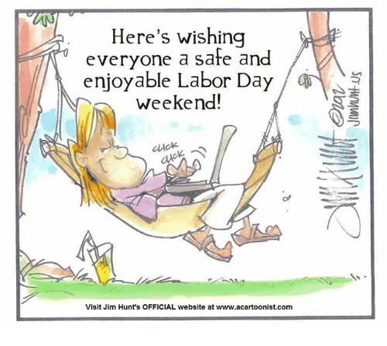

LAST WEEK’S COLLECTION

Adults $3,026.00

Loose $ 29.00

Youth $ 15.75

Monthly $ 705.00

Candles $ 16.00

Maintenance Fund $ 95.00

Assumption $ 80.00

All Saints $ 25.00

All Souls $ 25.00

Religious Ed. Fund $ 20.00

Retired Priests Med. $ 25.00

World Mission Sunday $ 15.00

Missionary Co-op $ 120.00

Total $4,196.75

We sincerely thank and ask God’s

blessing upon all who have care

and concern for

our parish.

*September 6th, 2020 (MT 18:15-20)*

*The key word in today’s gospel is “listen.” We cannot change another person; not alone, not with others and not with a whole Church. All we can do is state our position and “if he listens to you” then he / she can take the steps necessary to change themselves. Change comes from within.*

During the week of September 6th, 2020

The Sanctuary Candle will burn for

all the Parishioners of St. Michael Parish

[](https://images.search.yahoo.com/search/images;_ylt=A0LEV1kSWptXvOwAKINXNyoA;_ylu=X3oDMTEyZGdkcmRoBGNvbG8DYmYxBHBvcwMxBHZ0aWQDQjIwODlfMQRzZWMDc2M-?p=Clipart+of+a+sanctuary+candle&fr=ush-mailn_02&th=110&tw=110&imgurl=http://www.henningers.com/389-168-wall-sanctuary-lamp.jpg&rurl=http://pixshark.com/sanctuary-lamp.htm&size=43KB&name=Sanctuary+Lamp+Bronze+wall+sanctuary+lamp&h=600&w=600&turl=http://ts2.mm.bing.net/th?id%3DOIP.M68453c67108cdc5ab485d309b395bd03o0%26pid%3D15.1%26rs%3D1%26c%3D1%26qlt%3D95%26w%3D110%26h%3D110#inline&tt=Sanctuary+Lamp+Bronze+wall+sanctuary+lamp&sigr=116keh5le&sigit=13gvlt42j&sigi=11ip0pgm4&sign=119kp6100&sigt=119kp6100)

MASS SCHEDULE CHANGE ~ It looks like we need to add a second Mass on Sunday mornings so we can maintain safe distance and fit everyone in Church. So, on Sunday, September 20th we will return to the “old” Mass schedule of 8:00 AM and 10:30 AM. Confessions will be available at 10:00 AM in the Sacristy or by appointment anytime. We will continue to have Mass at 4:00 PM Saturday with confessions at 3:30 PM. Spread the word to family and friends and pray that the pandemic will go away!

*Msgr. Lockard*

LAY MINISTERS ~ The lay ministry September schedule will be changing after Sunday, September 13th – with the addition of the second Mass on Sunday, September 20th. Please check the bulletin for September 20th and September 27th liturgical assignments.

PAVING PROJECT ~ Our parking lots paving, and sidewalk construction will be starting Tuesday, September 8th. Please use the upper parking lot until this project is complete. Thank you.

PARISH COUNCIL ~ There will be a Parish Council Meeting next Sunday, September 20th at the Pavilion after the 10:30 AM Mass

if weather permits. If not, the meeting will be in the Church Hall.

SECOND SUNDAY FOOD COLLECTION ~ Next weekend is our Second Sunday Food Collection. Please bring in non-perishable food items or toiletries with you and drop your donations in the Bridal Room. Monetary donations are also appreciated.

DIOCESE SEEKING VOLUNTEERS ~ Would you like to minister in our diocese to those in need in one of

the following areas? –

1. Pro-Life Team: Two main initiatives.
2. Walking with Moms in Need: A year of service.
3. Reinstating “Project Rachel” in our diocese.
4. Disabilities Awareness Team which will be looking at ways to reach out to those who are underserved

in our parishes due to disabilities.

If you are interested you may contact the Diocesan Family Life Office at 814-695-5579 or [familylife@dioceseaj.org](mailto:familylife@dioceseaj.org). Be prepared to explain how you would be a good fit for one of these ministries.

Andre McCarville – Director of Family Life and Missions

*Stewardship Reflections…*

Am I my brother’s keeper? All three readings today suggest the answer is “yes” for the Christian steward. Jesus’ disciples and Christian stewards recognize God as the origin of life, giver of freedom, and source of all things. We are grateful for the gifts we have received and are eager for you to use them to show our love for God and for one another.

 Religious Education And Christian Helping

Religious Education News

Religious Education registration is planned for our 2020 / 2021 Religious Education Year. We plan to start our fall semester with a Home-Schooling module with necessary materials being sent home with each family. Registration packets were mailed out to all families that are currently registered members of our Saint Michael Parish and have school-aged children. Envelopes contain a new registration form and other related forms for our upcoming year. Please complete and return all forms so your children can be registered for the 2020 / 2021 Religious Education Year.

If you did not receive a mailing, contact the RE Office at 495-4873. More information will follow once registrations are received and our preparation is finalized.

CONGRATULATIONS! ~ Our Knights of Columbus council #2275 has awarded two $500.00 awards to two students in our councils’ service area. Congratulations to Elisabeth Zajdel from St. Michael parish and a Forest Hills graduate and to Tyler Spaid who attends St. Bartholomew parish in Wilmore. Tyler is a graduate of Portage Area high school. Congratulations to you both and best of luck in your studies at St. Francis University and University of Pittsburgh at Johnstown! God Bless you both!



TREASURY TICKETS ~ We are asking that each parish household sell or buy one ticket for $10.00 and return the money and ticket stub as soon as possible, but no later than September 21st. The tickets start on October 1st, 2020 and continue for the whole month of October. Winning numbers will be determined by the Pennsylvania Lottery Evening Pick Three Drawing. Weekdays payoff is $75, and weekends are $100. Columbus Day and Halloween payoff is $150. If you are unable to sell or do not want the ticket, PLEASE don’t throw it away, but return it as soon as possible as we always have people looking for extras. If paying by check, please make check payable to St. Michael Church. The money raised from the sale of these tickets will help to build up our Parish Maintenance Fund.

PLEASE NOTE! Tickets were mailed out this week. If you did not purchase or sell your February 2020 and June 2020 tickets, you were not issued the October 2020 ticket. If you did not get a ticket and would like to purchase the October 2020 ticket, please call the office. We apologize if anyone has been accidentally missed. If you would like a ticket, please call the parish office. We do have extra tickets, so anyone wanting more than one ticket, please call the office. Thank you.

*Parish and Finance Council Members*

 Sunday, September 6 Mass ~ 9:30 AM

Confessions / 9:00 – 9:15 AM / Sacristy

Monday, September 7 Mass ~ Noon

Labor Day / Parish Offices Closed

NO Sunday Choir Practice

Tuesday, September 8 Mass ~ Noon

Wednesday, September 9 Mass ~ 6:00 PM

Thursday, September 10 Mass ~ Noon

NO Saturday Choir Practice

Friday, September 11 Mass ~ Noon

Saturday, September 12 Mass / 4:00 PM

 Confessions / 3:30 – 3:45 / Sacristy

Religious Education Collection

Second Sunday Food Pantry Collection

UPCOMING EVENTS

September 13 Religious Education Collection

Second Sunday Food Pantry Collection

September 19 Voytek/Kostan Nuptials

September 20 Addition of second Sunday Mass / 8:00 & 10:30 AM

Parish Council Meeting

September 26 & 27 Retired Priests Medical Collection



BASKET RAFFLE ~ Adams Twp. Lion’s club 2-day event Basket Raffle. Sat. & Sun. Sept. 19th & 20th 10 AM-5 PM at St. Michael Festival Grounds. Need not be present to win – drawing Sun. at 5 PM. For more information phone 487-5988 or 487-4132.

FRIARS’NOOK GIFT SHOP ~ Hours and a Job Opening! We will continue to have modified hours of Friday & Saturday 10:00 AM – 4:00 PM for the month of September. We are seeking a Gift Shop Manager to oversee the day-to-day functions of a Roman Catholic gift shop with a heavy emphasis in standard retail practices. The Gift Shop Manager should be dependable, self-motivated, and can work well with other employees and customers. For a full job description, please visit: [www.thefranciscanfriars.org/jobs](http://www.thefranciscanfriars.org/jobs)

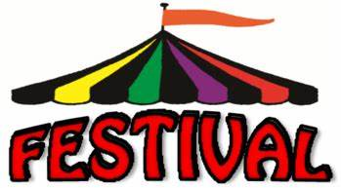

CRESSON CATHOLIC COMMUITY ~ Will hold its annual Festival on the grounds of

St. Aloysius Church on Sunday, September 13th from 9 AM – 8 PM. Although scaled back

this year due to Covid requirements, you may still enjoy the following:

Booths: Gift Basket Fair, Fancy Booth, Rummage Sale, Bake Sale

Games of Chance and Skill: Money Board, 50/50 every 2 hrs., $2,500.00 Grand Prize Raffle

Festival Food: Breakfast Sandwich, Hot Sausage, Pulled Pork, Perogies, Halushki, Hamburgers, Hot Dogs, French Fries, Funnel Cake, Apple Cobbler, Ice Cream, Donuts & more…